**Front End Engineering-II**

Project Report

Semester-IV (Batch-2022)

**Template(44)**



**Supervised By: Submitted By:**

Raveesh Samkaria Vivek Goyal

RollNumber - 2210990968

Group - 14

**Department of Computer Science and Engineering**

**Chitkara University Institute of Engineering & Technology,**

**Chitkara University, Punjab**

* **ABSTRACT:**

The hospitality industry, including restaurants like Hotel America, is witnessing a rapid transformation driven by digitalization. However, amidst this evolution, many establishments encounter hurdles in crafting an online presence that truly reflects their brand essence and engages customers effectively. Without a well-designed website, Hotel America risks missing out on opportunities to showcase its unique offerings, connect with potential patrons, and expand its reach in an increasingly competitive market. Thus, the challenge lies in developing a dynamic and user-friendly website that captures the essence of Hotel America's hospitality, showcases its amenities, and facilitates seamless interaction with its audience.

* **Introduction:**In the ever-evolving realm of hospitality, Hotel America stands as a beacon of exceptional service and timeless elegance. Nestled amidst the bustling streets, it offers a sanctuary for travelers seeking a blend of comfort, luxury, and unparalleled experiences. As the digital era reshapes the landscape of the hospitality industry, Hotel America recognizes the pivotal role of a captivating online presence in fostering connections with its guests and showcasing its distinctive offerings.
* This project endeavors to introduce an immersive and informative website for Hotel America, poised to serve as a digital gateway to its world-renowned hospitality. With meticulous attention to detail, the website aims to encapsulate the essence of Hotel America's charm, from its opulent accommodations to its culinary delights and array of amenities. Through seamless navigation and engaging content, the website aspires to captivate visitors, inspire exploration, and foster a sense of anticipation for the unforgettable experiences that await within the walls of Hotel America.
* In this introduction, we embark on a journey to unveil the vision behind Hotel America's digital transformation, highlighting the significance of creating a compelling online platform that transcends geographical boundaries and beckons travelers to embark on an extraordinary journey of discovery and indulgence

**Background: -** In an era where digital presence is paramount for businesses across industries, the hospitality sector stands at the forefront of this digital revolution. As travelers increasingly rely on online platforms to research, book, and share their experiences, hotels like Hotel America must adapt to meet the evolving needs and expectations of their guests. Recognizing the transformative power of technology in shaping guest interactions and brand perceptions, Hotel America embarks on the journey to enhance its online presence through the development of a dynamic and user-centric website.

**Significance:**

**Background:**

In an era where digital presence is paramount for businesses across industries, the hospitality sector stands at the forefront of this digital revolution. As travelers increasingly rely on online platforms to research, book, and share their experiences, hotels like Hotel America must adapt to meet the evolving needs and expectations of their guests. Recognizing the transformative power of technology in shaping guest interactions and brand perceptions, Hotel America embarks on the journey to enhance its online presence through the development of a dynamic and user-centric website.

Objectives:

Showcase the Essence of Hotel America: The primary objective of this project is to create a visually captivating and informative website that encapsulates the essence of Hotel America's hospitality. Through engaging content, stunning visuals, and intuitive navigation, the website aims to convey the unique atmosphere, amenities, and experiences that define the hotel.

Facilitate Seamless Guest Experience: Another key objective is to ensure that the website serves as more than just a digital brochure but as a seamless extension of the hotel's guest experience. By providing essential information, intuitive booking functionalities, and personalized recommendations, the website aims to streamline the guest journey from the initial exploration to the final booking and beyond.

Enhance Brand Visibility and Engagement: In an increasingly competitive market, maintaining visibility and engaging with potential guests are critical for hotel success. Through strategic digital marketing initiatives, interactive features, and social media integration, the website seeks to enhance Hotel America's brand visibility and foster meaningful connections with its target audience.

**Significance:**

The significance of this project lies in its ability to position Hotel America as a leader in the digital realm of hospitality, enabling the hotel to effectively reach, engage, and delight guests in a highly competitive landscape. By investing in a compelling online presence, Hotel America not only enhances its brand perception but also expands its reach to new markets and secures its position as a preferred destination for travelers seeking unparalleled experiences. Furthermore, the website serves as a testament to Hotel America's commitment to innovation, guest satisfaction, and excellence in hospitality, setting a new standard for digital engagement within the industry

* **Problem Definition And Requirement:**

**2.1Problem Statement:**Despite Hotel America's distinguished reputation and commitment to excellence in hospitality, the absence of a robust online presence poses significant challenges in effectively reaching and engaging with its target audience. The current lack of an immersive and informative website limits the hotel's ability to showcase its unique offerings, amenities, and experiences to potential guests. This hinders the hotel's competitiveness in the digital landscape and potentially leads to missed opportunities for attracting and retaining guests in an increasingly competitive market.

Furthermore, without a user-friendly and intuitive online platform, potential guests may encounter difficulties in accessing essential information, making reservations, or engaging with the hotel's brand digitally. This not only results in a suboptimal user experience but also undermines Hotel America's ability to capitalize on digital channels for driving bookings, enhancing brand visibility, and fostering guest loyalty.

Therefore, the primary problem statement revolves around the urgent need for Hotel America to develop a dynamic and user-centric website that effectively communicates its unique value proposition, facilitates seamless guest interactions, and strengthens its digital presence to remain competitive and relevant in the evolving hospitality landscape

**2.2 Software Requirement:**

**2.2.1 Web Development Platform:** Utilize a web development platform, such as HTML, CSS, and JavaScript, to create the website's front-end.

**2.2.2. Text Editor (e.g., Visual Studio Code):** A reliable text editor is necessary for coding and maintaining the HTML and CSS files.

**2.2.3. Responsive Design:** Ensure the website is responsive and compatible with various devices, including desktops, tablets, and smartphones or any one of them, to provide a seamless user experience across platforms.

* **Hardware Requirement:**
* **Computer or Laptop:** For coding, testing, and development of the web pages.
* **Internet Connection:** Necessary for accessing online resources, including external libraries and fonts.

**4.Result:**

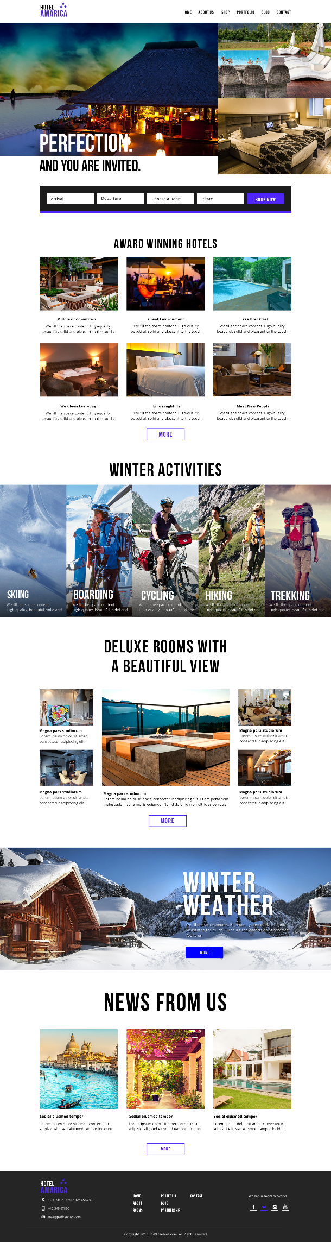

**Code:**

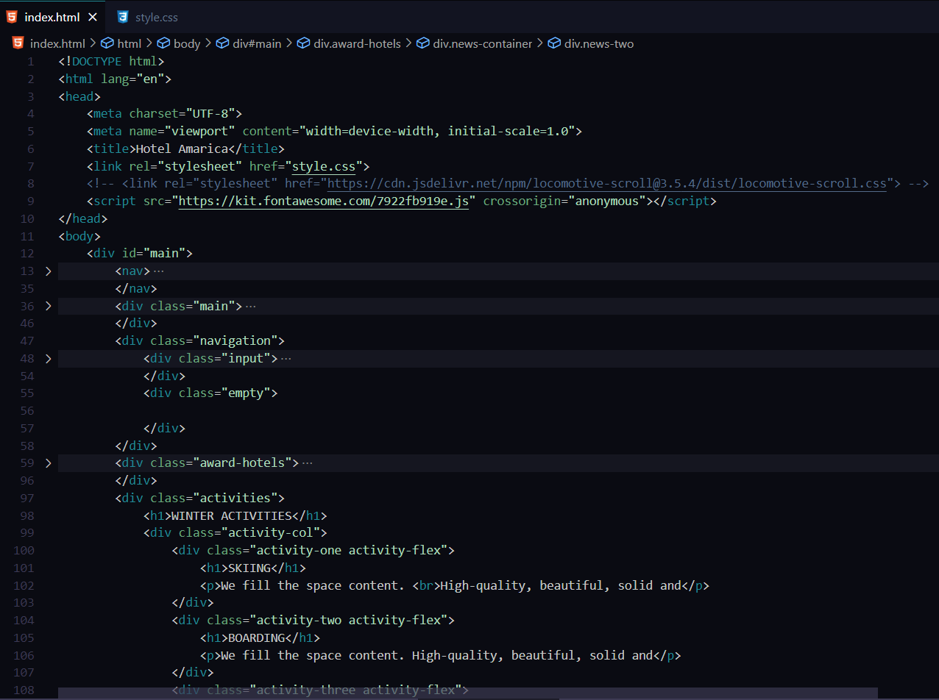

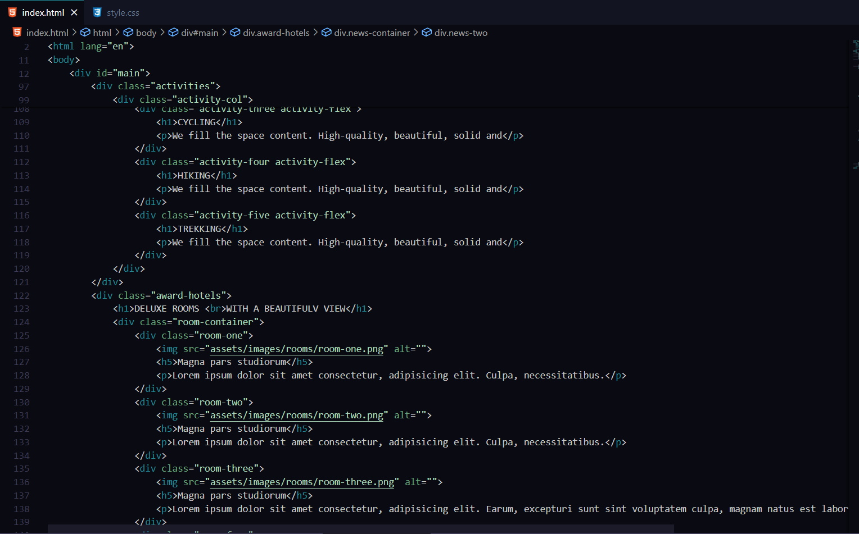

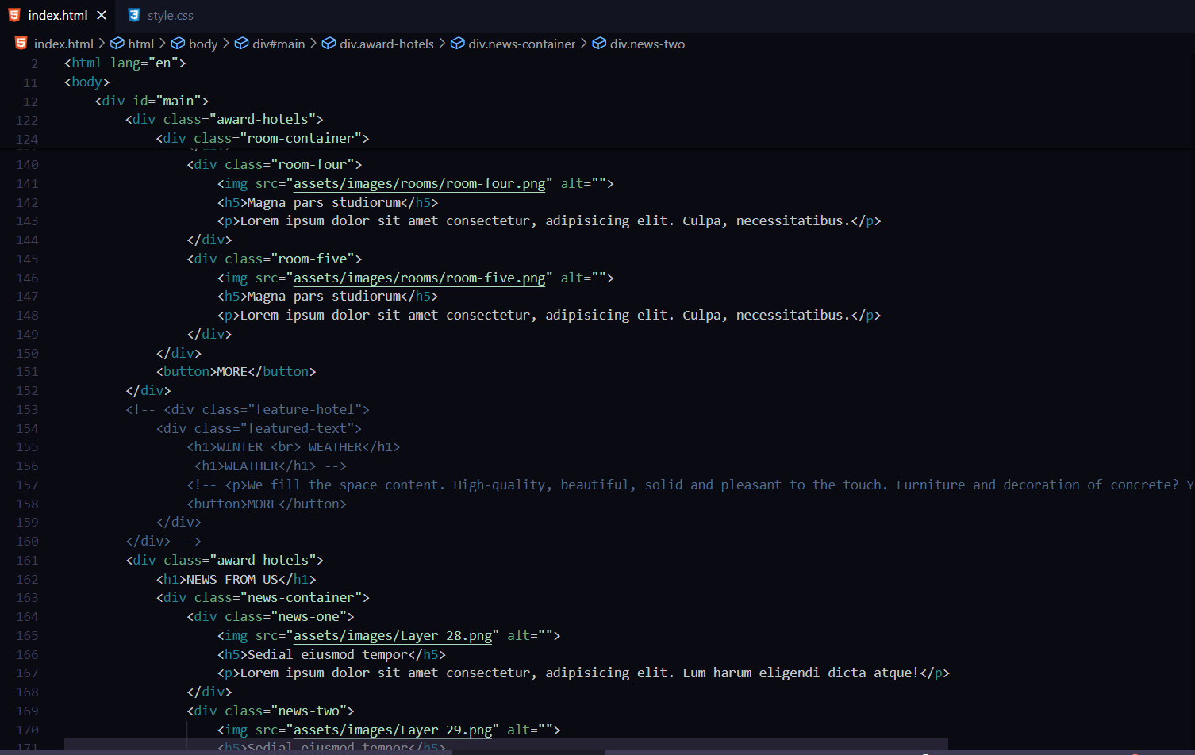

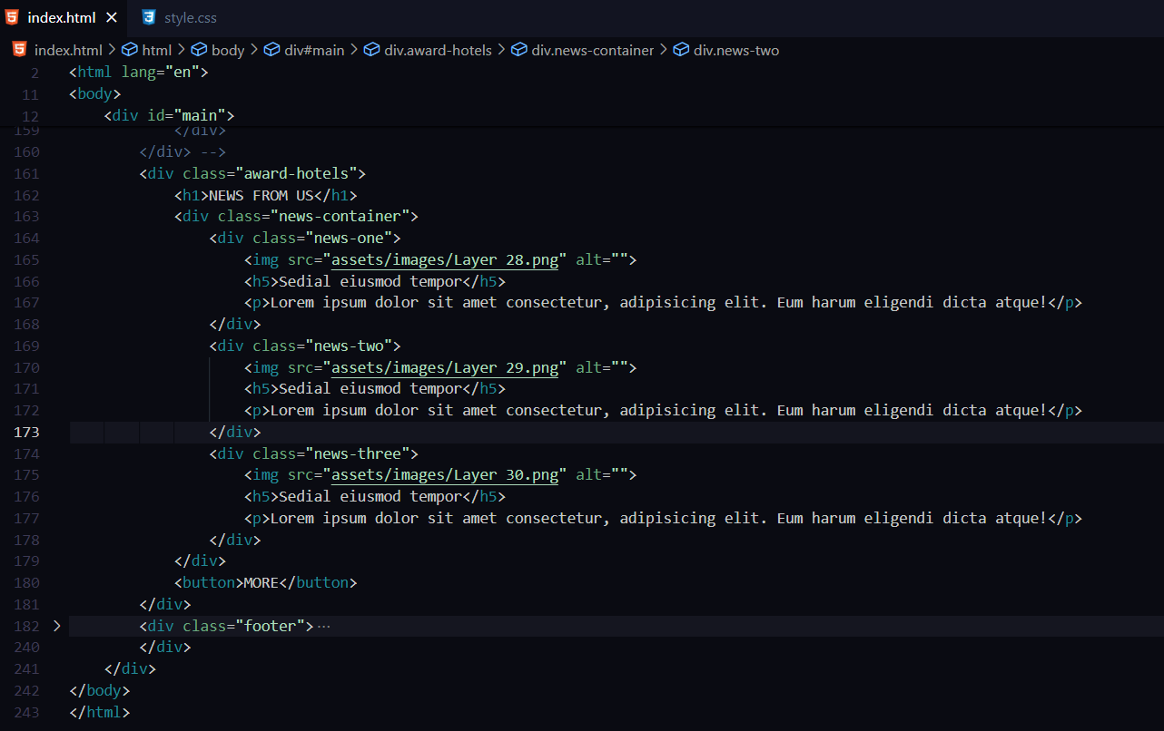

**Conclusion:**

In conclusion, the development and implementation of the restaurant website project have yielded a comprehensive digital platform that not only meets the functional objectives but also enhances the overall online presence of the culinary establishment. The amalgamation of visually engaging elements, intuitive navigation, and dynamic content showcases the commitment to providing an immersive experience for visitors.