**Question 1:**

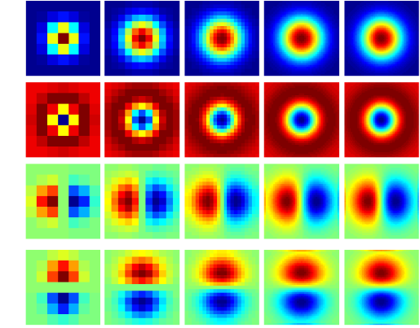

1. The first set of filters in row wise is the gaussian filters which are used to reduce the noise by blurring the image.
2. The second set of filters in row wise the Laplacian of Guassian (LOG) which is used to detect edges in any orientation.
3. The third set of filters in row wise is the derivative along x, which is used to pickup the vertical lines.
4. The fourth set of filters in row wise is the derivative along y, which is used to pickup the horizontal lines.

**Question 1.1**

Montage of 20 images with filter responses.

**Original Image**

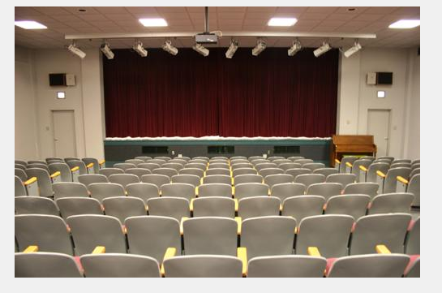

**Monatge**

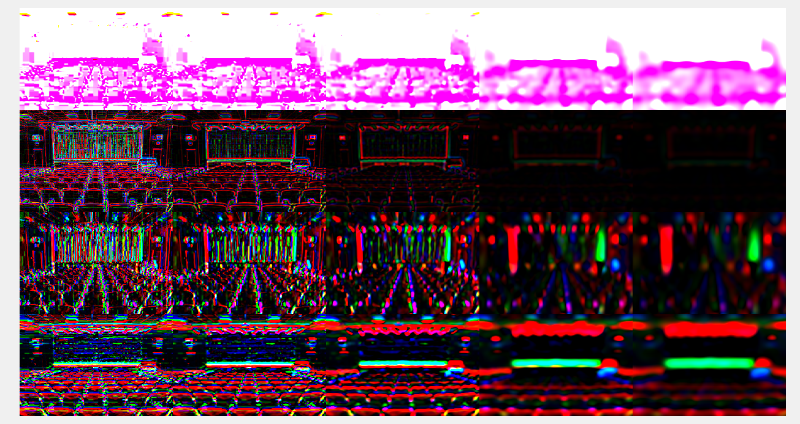

**Question 1.3**

I have taken images from the kitchen folder:

In the visualization, I see that the system is able to classify the edges well specially on the kitchen floors, the edges on the chairs and also it able to classify and differentiate between the cabinets and the washing machine.

**Original Image Word Map**

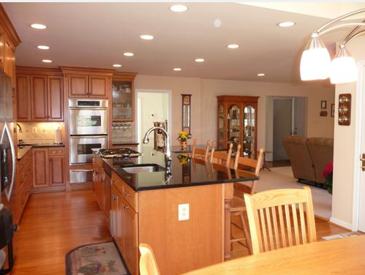 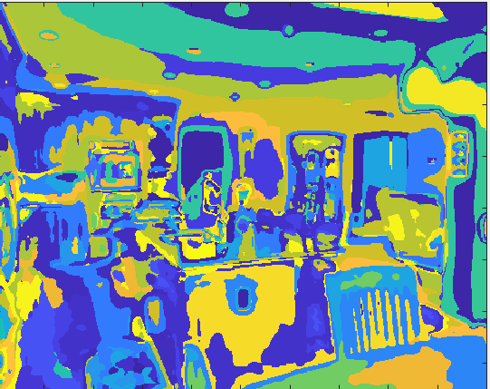

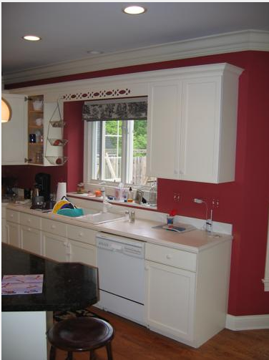 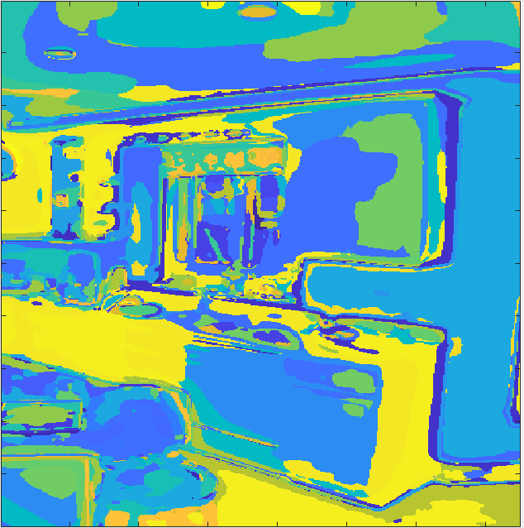

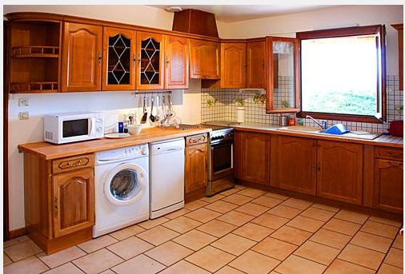 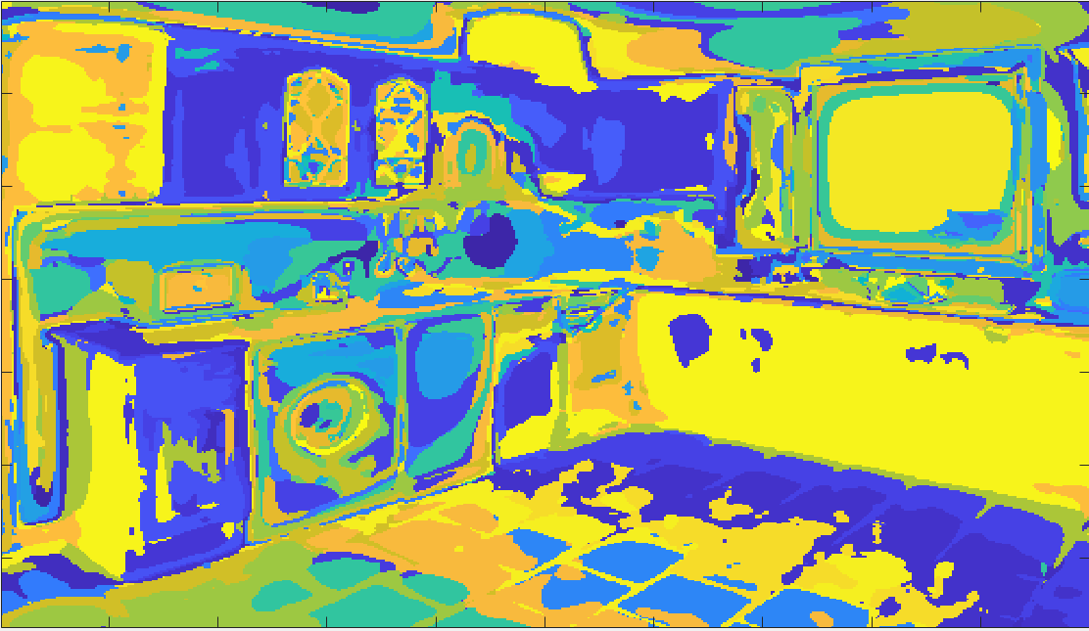

**Q 2.5:**

**Confusion Matrix:**

|  |  |  |  |  |  |  |  |  |
| --- | --- | --- | --- | --- | --- | --- | --- | --- |
|  | Auditorium | Baseball Field | desert | Highway | kitchen | laundromat | waterfall | windmill |
| Auditorium | 9 | 1 | 0 | 0 | 3 | 4 | 2 | 0 |
| Baseball Field | 0 | 6 | 0 | 1 | 1 | 0 | 1 | 0 |
| Desert | 1 | 2 | 9 | 2 | 0 | 2 | 0 | 3 |
| Highway | 1 | 3 | 4 | 10 | 0 | 0 | 1 | 3 |
| Kitchen | 4 | 0 | 2 | 0 | 13 | 6 | 1 | 0 |
| Laundromat | 3 | 1 | 2 | 0 | 1 | 5 | 2 | 0 |
| Waterfall | 0 | 2 | 1 | 3 | 0 | 3 | 13 | 2 |
| Windmill | 2 | 5 | 2 | 4 | 2 | 0 | 0 | 12 |

9 1 0 0 3 4 2 0

0 6 0 1 1 0 1 0

1 2 9 2 0 2 0 3

1 3 4 10 0 0 1 3

4 0 2 0 13 6 1 0

3 1 2 0 1 5 2 0

0 2 1 3 0 3 13 2

2 5 2 4 2 0 0 12

I am getting an accuracy of **48.13% with K=200 and alpha=125.**

**Q2.6:**

In my case, there are these classes which results in the failed cases

**Kitchen and Laundromat:** They are more difficult to classify because in certain images the image features like that of a washing machine in laundromat are a match to that of the features in a kitchen where there is a washing machine and dishwashers. Therefore, the system gets confused.

**Highway and Windmill:** Similar results, where the system gets confused when image features of sky in both the images match. In my case, the system mostly failed when the size of the windmill was small.

Also referring to the confusion matrix on general, one can see that the auditorium is the easiest to classify as it has a lot of entities which give good set of image features and the windmill is the most difficult to classify as it has a very few entities which results in a fewer distinguishable image features.