Assignment 3

Id: [vgramasw@andrew.cmu.edu](mailto:vgramasw@andrew.cmu.edu)

VIVEK GOPAL RAMASWAMY

Q1.1

1. It is called the Jacobian of the Warp

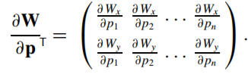

b)



Here **A** is called the Steepest Descent Images

It is the product of the gradient of the image and the jacobian.

**b** is the difference between the template Image T(x) and the Image I warped with W(x;p) . It basically represents the error.



c) The condition that A’A should meet so that a unique solution to exists is that the matrix should be invertible or non-singular.

Q1.2 Lukas kanade

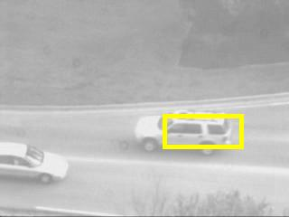 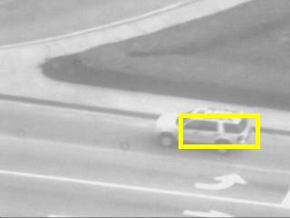 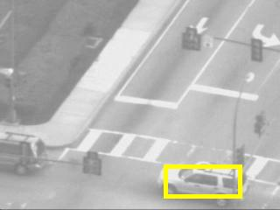

Frame : 1 Frame :100 Frame :200

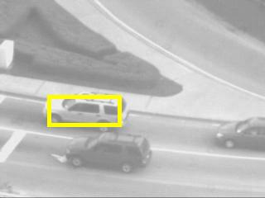 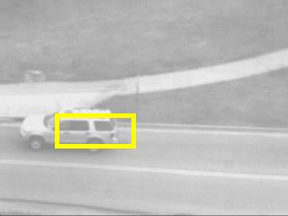

Frame : 300 Frame : 400

Q1.4 Lukas Kande with Template Correction

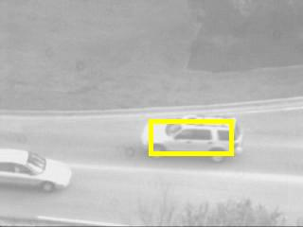 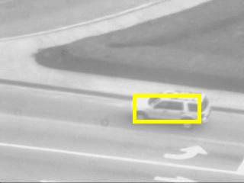 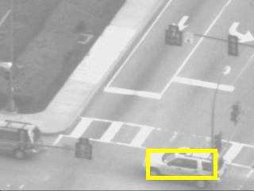

Frame : 1 Frame : 100 Frame : 200

 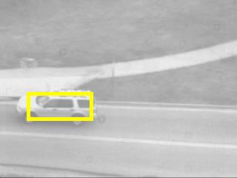

Frame : 300 Frame: 400

Q2.1 Derivation

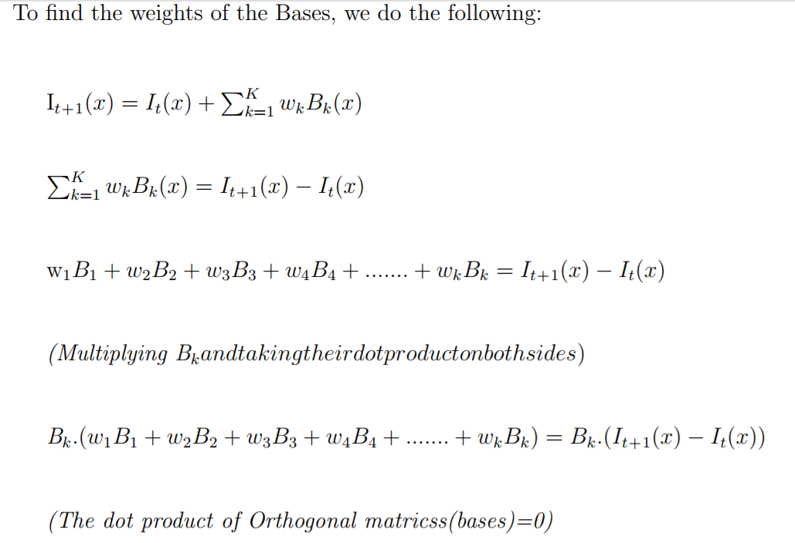

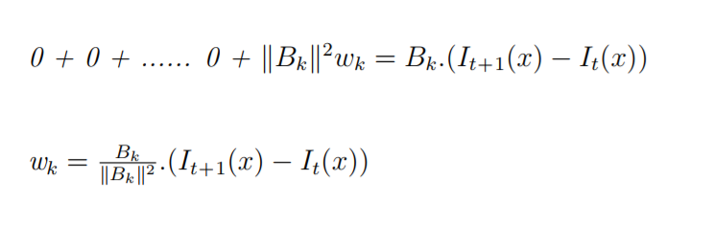

Q2.3 Lukas Kande with Appearance Basis

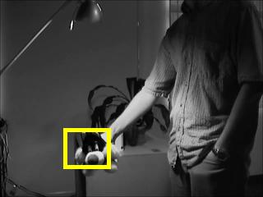 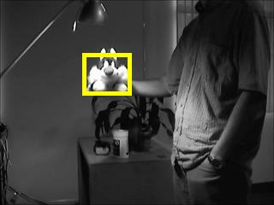 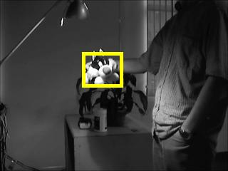

Frame : 1 Frame : 200 Frame: 300

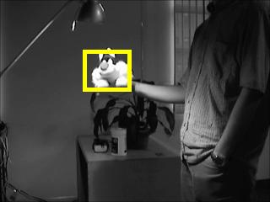 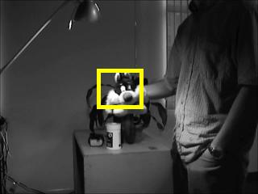

Frame : 350 Frame : 400

Q3.3 Moving Object Detection

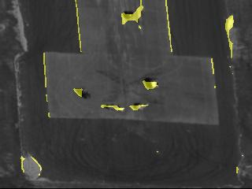 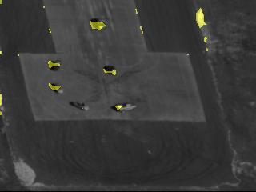

Frame : 30 Frame : 60

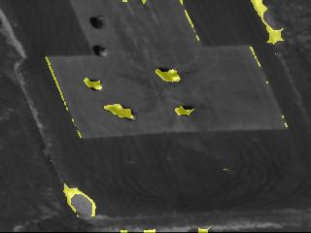 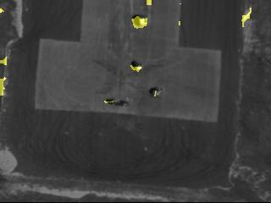

Frame : 90 Frame : 120