TASK 1: IRIS FLOWER CLASSIFICATION
Student Details
Name: Vivek Gujagond
Notebook Link
https://github.com/vivekgujagond-cloud/Iris-Classification/blob/f31e6e696bdcd9cbcd6d758b96c04bc8c33a7546/iris_classification%20(1).ipynb
Model File
iris_model.pkl link: https://github.com/vivekgujagond-cloud/Iris-Classification/blob/f31e6e696bdcd9cbcd6d758b96c04bc8c33a7546/iris_model.pkl
1. Executive Summary
The Iris Flower Classification project is a machine learning classification task that predicts the species of an iris flower based on its physical measurements. The dataset contains information about sepal length, sepal width, petal length, and petal width for three iris species: Setosa, Versicolor, and Virginica.
The project involved data exploration, visualization, preprocessing, model training, and evaluation. A Random Forest Classifier was used to classify the flowers. The trained model achieved high accuracy, demonstrating the effectiveness of machine learning for classification problems.
2. Objective
The objective of this project is to build a machine learning model that can accurately classify iris flowers into different species using flower measurements.
3. Dataset Description
Dataset Name: Iris Dataset
Features:
- Sepal Length
- Sepal Width
- Petal Length
- Petal Width
- Species
Total Records: 150
Total Classes:
- Iris Setosa
- Iris Versicolor
- Iris Virginica
4. Data Exploration
The dataset was loaded using Pandas and explored using:
- df.head()
- df.info()
- df.describe()
- df.isnull().sum()
Observations:
- Dataset contains 150 records.
- No missing values were found.
- All features are numerical except Species.
Insert Screenshot: Dataset Preview
Insert Screenshot: Dataset Information
5. Data Visualization
Several visualizations were created to understand the dataset.
Visualizations Used:
- Pair Plot
- Histogram
- Scatter Plot
- Box Plot
Observations:
- Setosa is clearly separated from the other species.
- Petal dimensions provide strong classification capability.
Insert Screenshot: Pair Plot
Insert Screenshot: Distribution Plot
6. Data Preprocessing
The following preprocessing steps were performed:
- Checked for missing values.
- Encoded the Species column using LabelEncoder.
- Split the dataset into training and testing sets.
Training Data: 80%
Testing Data: 20%
7. Model Training
Machine Learning Algorithm Used:
Random Forest Classifier
Steps:
- Imported Random Forest Classifier.
- Trained the model using training data.
- Generated predictions on test data.
8. Model Evaluation
Evaluation Metric:
- Accuracy Score
Accuracy Obtained:
0.9666666666666667%
Accuracy Output:
Confusion Matrix: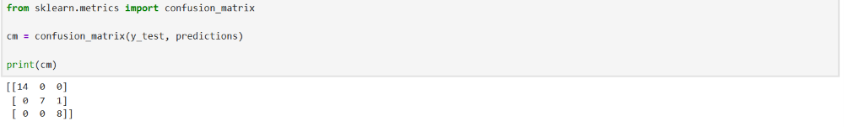
9. Results and Findings
The Random Forest Classifier successfully classified iris flowers with high accuracy.
Key Findings:
- Petal Length and Petal Width are the most important features.
- Setosa species is easily distinguishable.
- The model performed well on unseen test data.
10. Conclusion
This project successfully demonstrated the application of machine learning classification techniques on the Iris dataset. After preprocessing and visualization, a Random Forest model was trained and evaluated. The model achieved excellent performance and accurately classified flower species based on their measurements.
11. Screenshots

- Dataset Preview (df.head()):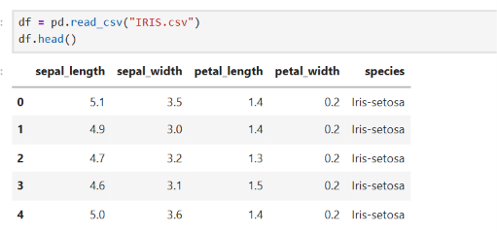
- Dataset Information (df.info()): 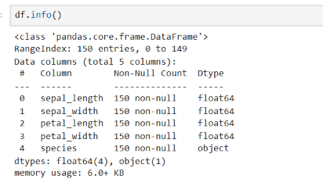
- Missing Values Check: 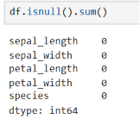
- Pair Plot: 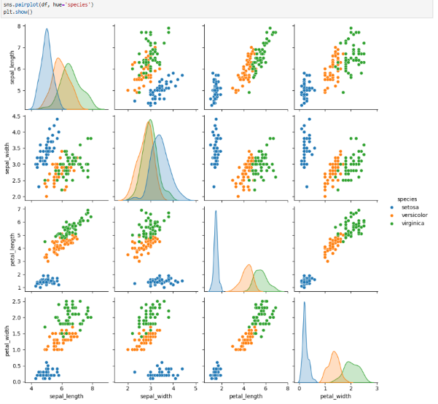
- Histogram or Scatter Plot: 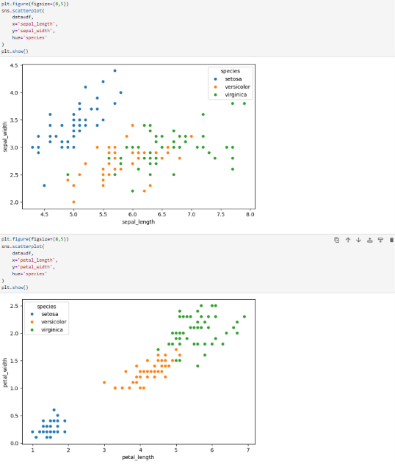
- Accuracy Output:
- Confusion Matrix:

