SHRI.

VEERBHADRESHWAR PRASANNA

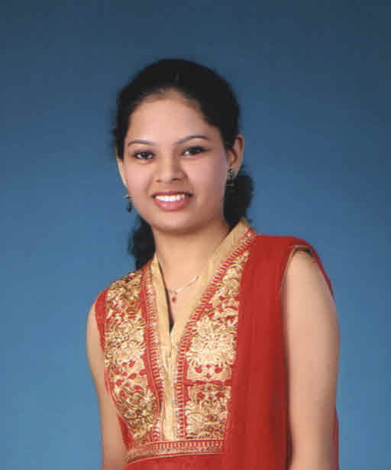

|  |  |
| --- | --- |
| Name | Shreya Balayya Hiremath |
| DATE OF BIRTH | 17TH February-1991 |
| Time of Birth | 5-50 AM |
|  |  |
|  |  |
| Height | 5.2” |
| Place of Birth | Belgaum |
| Caste | Jangam |
| Qualification | B.E (Information Science) GIT, Belgaum  PU- RLS, Belgaum, SSLC- Kendriya Vidhalaya -Belgaum |
| Occupation | Software Engineer, Mindtree Ltd,Bangalore. |
| Language Known | Kannada, English,Hindi, Marathi, Sanskrit |
| Fathers Name | Shri. Balayya Chanabasayya Hiremath |
| Fathers Occupation | Inspector of Customs & Central Excise, Belgaum |
| Mothers Name | Smt. Mahadevi Balayya Hiremath |
| Mothers Occupation | House Wife |
| Sister s Name | Priya (Younger) B.E IN KLE Engineering College, Belgaum. |
| Permanent Address | Plot No. 29 “Sumangal Sadan” Azam Nagar Ist Cross, Vidyagiri, Belgaum |
| Phone Number | 9986833684 |
| E-mail | hiremath.505@rediffmail.com |