**Part3-**

In an era where digital presence is inextricably linked to business success, understanding the dynamics of online customer feedback becomes crucial for businesses, especially in the food industry. Our motivation to dive into this topic was sparked by witnessing firsthand the transformative power of online reviews on local eateries. A single review can catapult a hidden gem into the limelight or significantly tarnish the reputation of an established restaurant. This observation is backed by numerous studies and articles, such as those found in "Harvard Business Review," highlighting the direct correlation between online reviews and business revenue.

The proliferation of platforms like Yelp has democratized the process of critiquing, allowing every customer to share their dining experiences with a broad audience. This shift has not only changed how restaurants operate but also how customers make dining decisions. Inspired by the anecdotal evidence of reviews' impact, I sought to explore this dataset to uncover the nuanced relationship between online reviews, ratings, and the success of businesses within the food industry.

#### **Objectives and Goals**

My primary aim is to dissect the influence of online reviews and ratings on the visibility and perceived quality of restaurants. Specifically, I want to answer the following questions:

* How did the reviews count in different business locations?
* How were categories being distributed according to ratings?
* Can trends be identified that predict the rise or fall of a business's reputation based on review data?

By answering these questions, I hope to offer actionable insights to restaurant owners and managers on leveraging customer feedback for improvement and growth. Additionally, this analysis could provide consumers with a better understanding of the review ecosystem, encouraging more thoughtful and constructive feedback.

#### **Relevance and Benefits**

This project holds significant relevance for multiple stakeholders in the food industry ecosystem:

* For Business Owners: It offers data-driven insights into managing and enhancing their online reputation, which is critical in an increasingly competitive market.
* For Customers: It fosters a deeper understanding of the impact of their reviews, potentially leading to more meaningful interactions between consumers and businesses.
* For Researchers and Marketers: It provides a case study on the power of digital word-of-mouth, enriching strategies for engagement and customer satisfaction.

Ultimately, this exploration seeks to demystify the relationship between online reviews, customer satisfaction, and business success, contributing to a more vibrant, transparent, and responsive food industry landscape.

### **Data Collection and Funding**

* Who Collected the Data: The data was likely collected by Yelp, as part of their Yelp Dataset Challenge or a similar initiative. Yelp regularly provides access to subsets of their extensive data for academic research and educational purposes.
* Who Funded the Project: Yelp Inc. itself supports and funds these initiatives, aiming to foster innovation and research in fields ranging from computer science to business analytics.

### **Dataset Variables Description**

The dataset includes several key variables that are common in Yelp's publicly shared datasets:

* ID: A unique identifier for each business listing.
* Organization: The name of the business.
* Rating: The average rating of the business on a scale of 1 to 5 stars.
* NumberReview: The total number of reviews the business has received.
* Category: The type of service or goods the business provides (e.g., "Pizza", "Delivery").
* Country, State, City, Street: Geographic details of the business location.

### **Dataset Size and Coverage**

* Size and Cases: The dataset size wasn't specified, but Yelp datasets typically contain thousands of business listings, reviews, and user accounts.
* Variables: The variables mentioned above are part of the dataset. Additional variables might include user information or detailed attributes about businesses, depending on the dataset's scope.

### **Locations Included**

* Geographic Coverage: Yelp data usually encompasses multiple countries, primarily focusing on the United States. It includes detailed location information, allowing for analyses at the country, state, and city levels.

### **Achieving Goals and Addressing Questions**

This dataset is instrumental in analyzing the impact of online reviews on businesses within the food industry. Specifically, it can help:

* Correlate Reviews and Ratings: By examining Rating and NumberReview, we can explore the relationship between the volume of feedback and business ratings.
* Understand Geographic Influences: The geographic details enable an investigation of how location affects business performance and customer feedback.

### **Limitations**

* Time Range: Without clear information on the collection period, trend analysis may be limited.
* Subjectivity in Reviews: Reviews are subjective, and the dataset doesn't include review text for sentiment analysis, which could provide deeper insights into customer satisfaction.
* Incomplete Information: Missing values or unreported businesses could skew the analysis, and the lack of detailed user demographics limits understanding of the reviewer base.

**CHART ANALYSIS**

CHART1:

* Dominant States: States that occupy larger segments of the chart are key players in the food industry landscape within your dataset. These states might offer more opportunities but also come with higher competition.
* Market Opportunities: Conversely, states with smaller segments may represent untapped markets or niches with less competition, offering potential opportunities for new entrants or expansion.

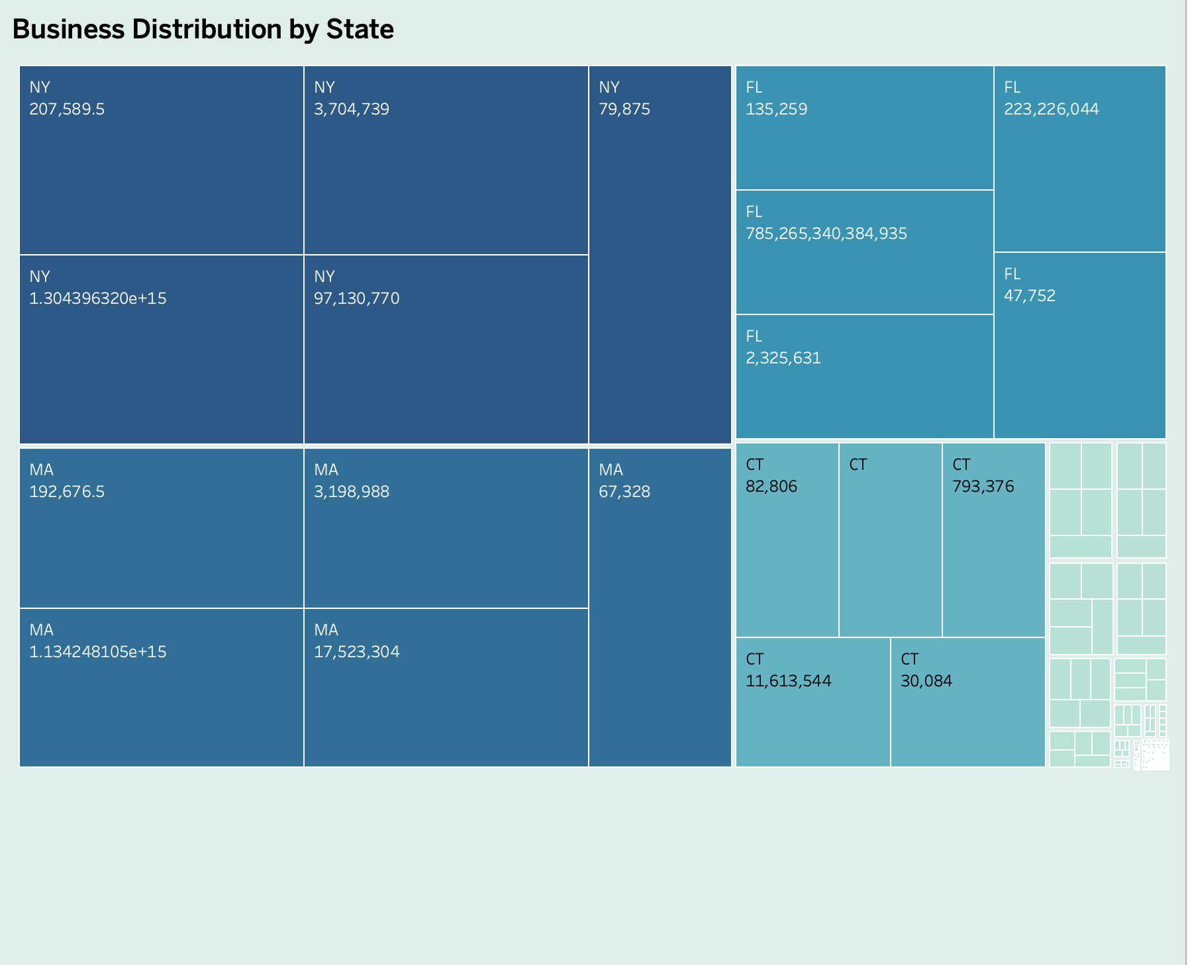

CHART2

Mapping businesses by their location and coloring them by average rating can visually depict where the highest-rated eateries are concentrated. This could reveal regional culinary hotspots or areas with untapped potential for new ventures.

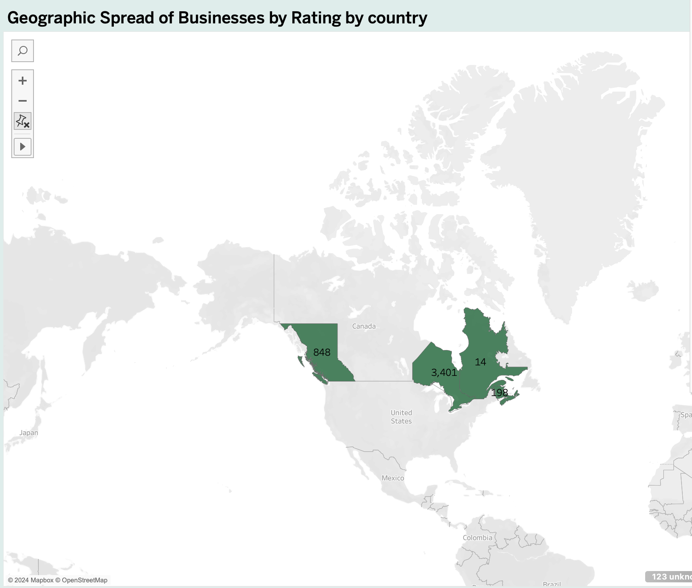

3) Chart3

By comparing average ratings across different food categories, you can identify which types of cuisine receive the highest and lowest average ratings. This plot can highlight consumer preferences or potential areas for improvement within specific sectors of the food industry.

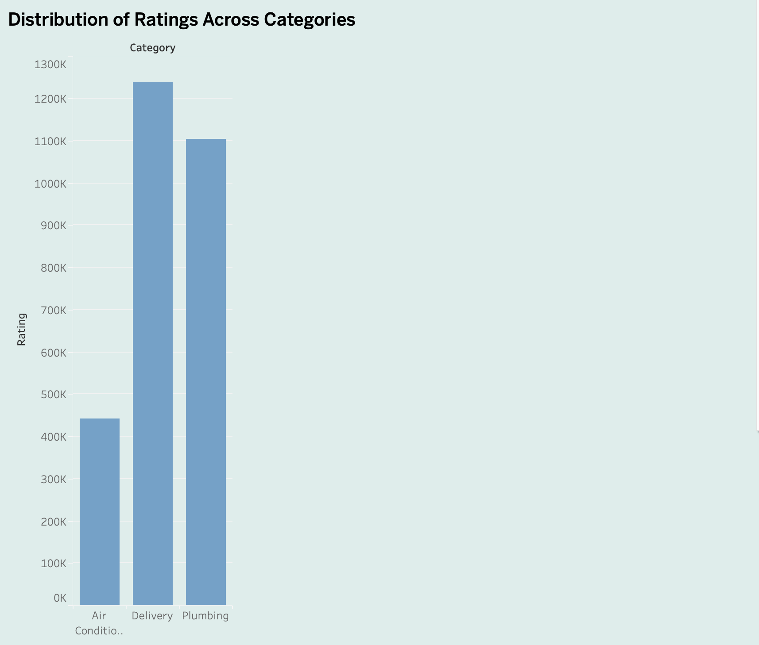

Chart4

Aggregating review counts by location could identify areas with high consumer engagement or areas where businesses might struggle to attract reviews, offering insights into market dynamics or the effectiveness of local marketing strategies.

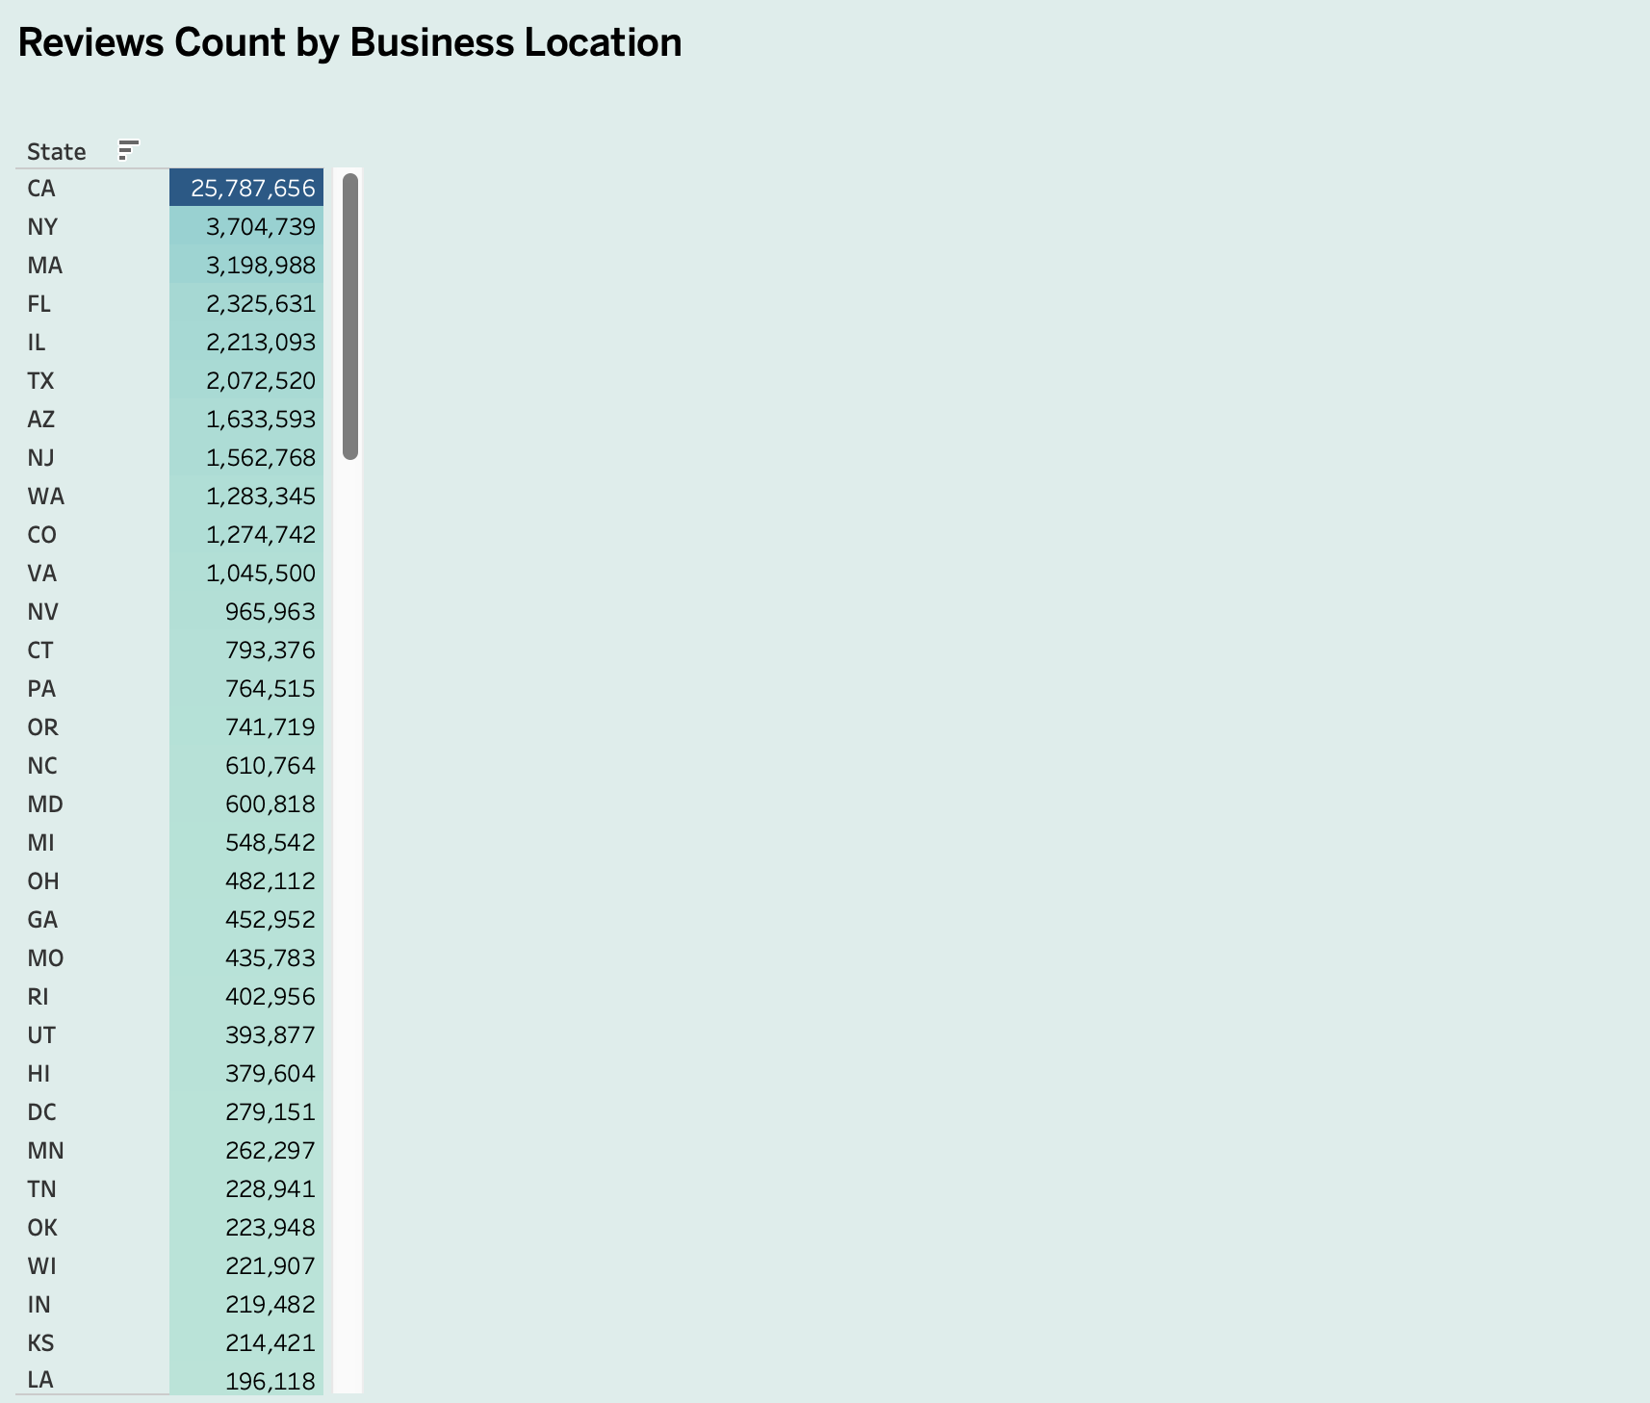

Chart5

Identifies which categories are most engaging to customers, indicated by a higher number of reviews, suggesting popularity or willingness of customers to leave feedback.

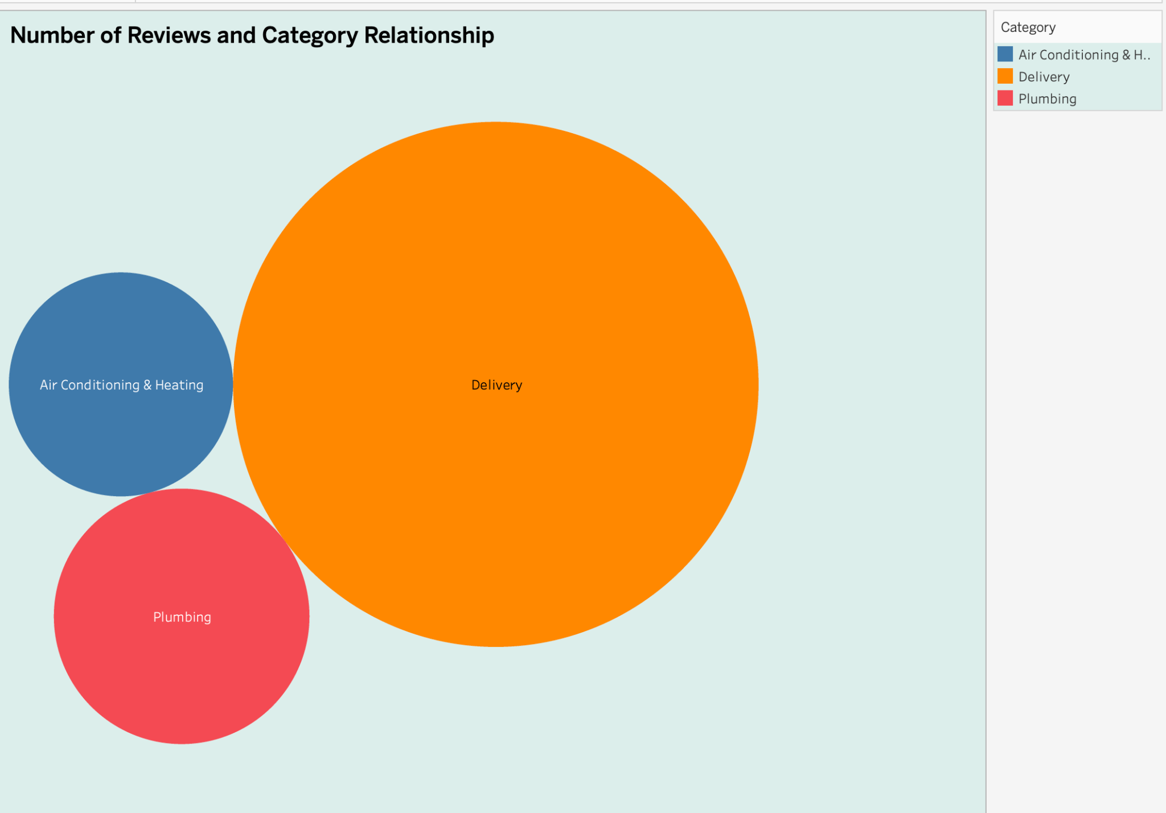

Chart6

Use this to identify which cities are most active on Yelp, suggesting areas with high customer engagement or possibly greater competition among businesses.

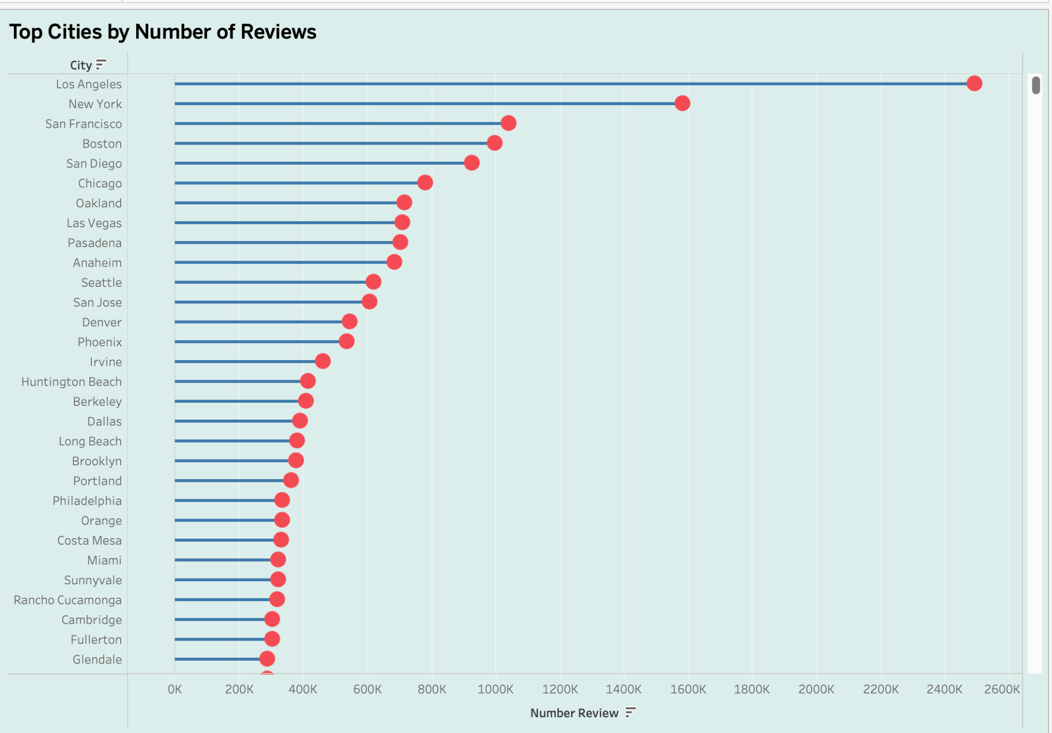

In the digital age, the influence of online reviews on the food industry is profound. Our visual exploration into this realm reveals key insights:

* Geographic Distribution of Businesses: A pie chart illustrates how food businesses are spread across states, pinpointing regions of high competition and potential markets for new ventures. This visualization lays the groundwork for strategic geographical decisions.
* Average Rating by Category Rank: Through a line graph, we delve into customer satisfaction across categories, identifying areas of excellence and those needing improvement. This chart highlights the importance of maintaining high-quality service and product offerings.
* Engagement through Reviews: Another line graph focuses on the average number of reviews per category, demonstrating which types of cuisine engage customers the most. This insight stresses the value of customer interaction in building a business's reputation.

Together these visual narratives provide a succinct yet comprehensive overview of how customer feedback shapes the food industry.

Team Contribution

* Glenn: Spearheaded the data collection and preprocessing stage. He meticulously filtered, cleaned, and organized the dataset, ensuring that it was ready for analysis. Their technical expertise in handling large datasets was crucial in laying the groundwork for our exploration.
* Dharit: Focused on data analysis and insights generation. Their analytical prowess helped transform raw data into meaningful insights.
* Aditi: Led the visualization efforts. Utilizing tools like Tableau, she created compelling and intuitive visual representations of our findings, including the pie chart of business distribution by state and the line graphs highlighting average ratings and engagement.
* Jai: skillfully worked with our findings and visualizations into a coherent and captivating story, highlighting the project's significance and implications for stakeholders in the food industry.