TracktorLive: real-time tracking for automating and standardising behavioural studies

Step-by-step guide

TracktorLive is a python-based program that uses the OpenCV library (https://opencv.org) and Tracktor (see Tracktor for specificities and technical details) to automatically detect objects through image processing. In brief, Tracktor uses adaptive thresholding to isolate the animals of interest from other objects in the background based on their size, separates the individuals from each other using k-means clustering, and maintains the individual identities between frames using the Hungarian algorithm (Kuhn, 1955). TracktorLive includes a GUI (graphical interface) to help the user tune the parameters, includes the option to track one or several individuals in real-time, and use this information to trigger specific actions. This software can be run from a single command line in a terminal (command prompt) using python (see step-by-step manual and examples below). Users with a very basic knowledge of Linux, R-language or command prompt will readily be able use Tracktor-live.

How to use

Here below, we show a step-by-step guide on how to use on a Linux, Mac and Windows device. To use, it just requires a computer with Python 3 installed, and the following packages:

…

Video file

First, to analyse and existing video, we can open a terminal (command prompt) in the folder where we have the three scripts: tracktor.py, params.py, tracktor-live.py. Second, introduce the following command line:

> python -f ~/Desktop/live-tracktor/ExampleFish.mp4 -n TestFish

This will analyse the video “ExampleFish.mp4” (available in Examples folder) and keep all the analysed data in a folder named TestFish. It is important to provide the full path to the file (see below for additional options).

Real-time tracking
To use TracktorLive for real-time tracking and stimuli presentation, we will use a command line similar as above. Thus, we open a terminal in the folder with our three scripts, and introduce the following command line:

> python -c 0 -n TestFish

In this command, we indicate the camera in use (-c). Usually, the camera device would be 0 in Linux or Mac (COM1 in Windows), but could be another number depending on user’s system *. Additional information can be provided to improve the accuracy of the automatic final plots:

> python -c 0 -n TestFish -res 1920x1080 -x 100 -d 10

In this case, we introduced the resolution of the camera (-res), and the distance of the x-axis (in cm) covered by the camera (-x). These parameters help convert units from pixels to centimetres automatically, otherwise the final plots will be plotted in pixels. The parameter -d is direction. If this parameter is introduced, the direction of the animal will be computed in real-time, and the number (10) refers to the minimum number of pixels that the animal needs to move before updating the direction. This number should be according to the animal size, and is used to avoid erroneous changes of direction due to small variations of mass centre position. This direction can be used to trigger a device only when an animal is at a distance X from an object, and the orientation of the body (or moving direction) is at angle Y, for instance. If this parameter is not specified, the direction will not be computed.

The command lines above, if no error, will prompt the following windows:

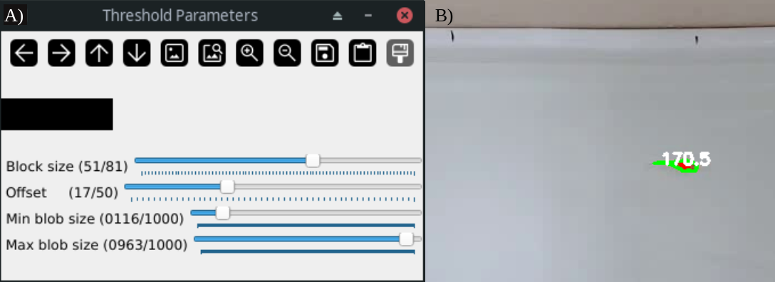
Figure 1: A) Thresholding parameters that can be manually tuned to improve detection. B) Screenshot of the camera, showing the objects and areas detected with the current parameters (green circles), as well as the approximative size of each blob detected (number).

In the window prompted (Fig. 1A), we can tune the parameters until the only object detected (Fig. 1B) is our animal of interest (this may require some trial-error essays). Once done, we click ESC or Q to automatically update the parameter values in params.py, and start tracking the object in real-time. Additional parameters can be updated manually using the params.py file (e.g., number of individuals to track, use of K-means, etc)**. If parameters from the file are updated manually, be sure to avoid adding or removing lines inside the script may cause errors in the software.

We can use this real-time information to trigger a given stimulus by simply connecting an Arduino board to the computer via USB, and uploading the script provided in the file Arduino examples (visit www …… for more information on how to install and use Arduino board). To initiate the triggering code, we just need to add the track option (“-t True”) at our initial command:

> python tracktor-live.py -c 0 -n TestFish -d 10 -t True

This will launch the script tracking.sh (tracking.ps1 in Windows***) to trigger any action programmed via the Arduino board when the individual is inside the desired area, or in a given orientation. This tracking file can be readily modified designing specific areas of our setup (squared or round), or even define whether the animal needs to be in any specific orientation (angle 0 - 360 degrees). We provide example scripts in Examples. Using -t True, will start reading the X and Y coordinates of the animal in real-time, and send a signal to the Arduino board, which will trigger the action, once the coordinates of the animal are within the desired area. We provide two examples in supplementary material, one that turns on a light when the individual is in a given distance from an object and in a specific angle, and a second one where a stepper motor is triggered (e.g., this can trigger a decoy predator, open a door or release an object) when the individual is in an specific area. It should be noticed that performance differences may be observed depending on the computer used, as low resources may read the video feed less often than higher range desktops.

[Add video of how it works? or example of fish experiment?]

*How to detect your camera in Linux: … Mac …. Win…

**The function of each parameter is described in Tracktor (github) or within the file params.py

*** In case of error in Windows, make sure that the verifying execution policy has been activated by Set-ExecutionPolicy RemoteSigned.

