Cooling Period Minimization and Sleep–Wake Coverage Optimization in Heterogeneous WSNs for Smart Farming

# Proposed Methodology

Problem Setting and Overview  
We investigate a heterogeneous WSN deployed over a 500 m × 500 m farm with N = 200 nodes (80% normal, 20% advanced).  
The field is partitioned into five regions (northwest, northeast, central, southwest, southeast) with a centrally located base station (BS).  
The method minimizes cooling periods (post-transmission rest intervals), reduces redundant sensing, and sustains coverage  
through three tightly coupled components: (i) cooling-aware CH selection, (ii) cooling-aware multi-hop routing, and  
(iii) redundancy-driven sleep–wake coverage optimization with adaptive sensing radius.  
  
Mathematical Model (key terms)  
• Heterogeneous energy: NoN: E0; AdN: E0(1 + α). Total factor Et = n·E0·(1 + m·α).  
• Cooling time: CoolingTime(i) = max(0, LastTx(i) + MinRest − t).  
• Radius control: S'(i) = S(i) − min_j(S(i)+S(j) − d_ij) + AdaptiveBoost(i).  
• CH cost: Cost_CH(i) = α·Dist(i,BS)/Dmax + β·(Emax−RE(i))/Emax + γ·1/(1+|N(i)|) + δ·CoolingTime(i)/MinRest.  
• Tx energy: E_tx = E_elec·k + ε_amp·k·d^2.  
  
Cooling-Aware Clustering and Routing with Sleep–Wake (pseudo-code)  
1. Initialize radii, energy, and region assignments.  
2. For each round t:  
 a) Update CoolingTime and neighbors; adjust S(i) using overlap.  
 b) Select one CH per region by minimizing Cost_CH; exclude nodes in critical cooling.  
 c) Assign members to CHs (prefer same region).  
 d) Route member→CH and CH→BS with cooling-aware shortest paths; avoid nodes that cannot transmit.  
 e) Sleep–wake: rank redundant nodes by overlap, energy and cooling; put top-K to sleep; reduce S(i) for moderate redundancy.  
 f) Record coverage, energy, routing efficiency, and cooling violations.

# Results & Discussion

Results and Discussion  
Network scale: 200 nodes; five-region architecture; central BS. Simulation trends and summary metrics show consistent gains.  
  
Key metrics (means ± sd where available):  
• Energy efficiency: 85.4% ± 2.1 (vs LEACH 65.2%).  
• Network lifetime: 324 ± 18.2 rounds (vs LEACH 180).  
• Coverage maintenance: 89.6% ± 2.4 (vs LEACH 70.3%).  
• Packet delivery ratio: 0.973 ± 0.012; lower delay and higher throughput than baselines.  
• Energy per round: 0.0847 J (vs LEACH 0.1523 J).  
• Cluster formation time: 12.4 ms (−47.9% vs LEACH).  
  
Interpretation  
Cooling-aware CH selection avoids constrained nodes, reducing churn and idle penalties.  
Routing steers around cooling nodes, improving PDR and delay.  
Sleep–wake with radius adaptation trims overlap while preserving coverage, explaining energy and lifetime gains.  
  
Limitations  
Propagation and MAC effects are simplified; future work should include interference-aware routing, duty-cycling protocols,  
and validation on hardware testbeds with real agronomic workloads.

# Figures from Notebook (600 dpi)

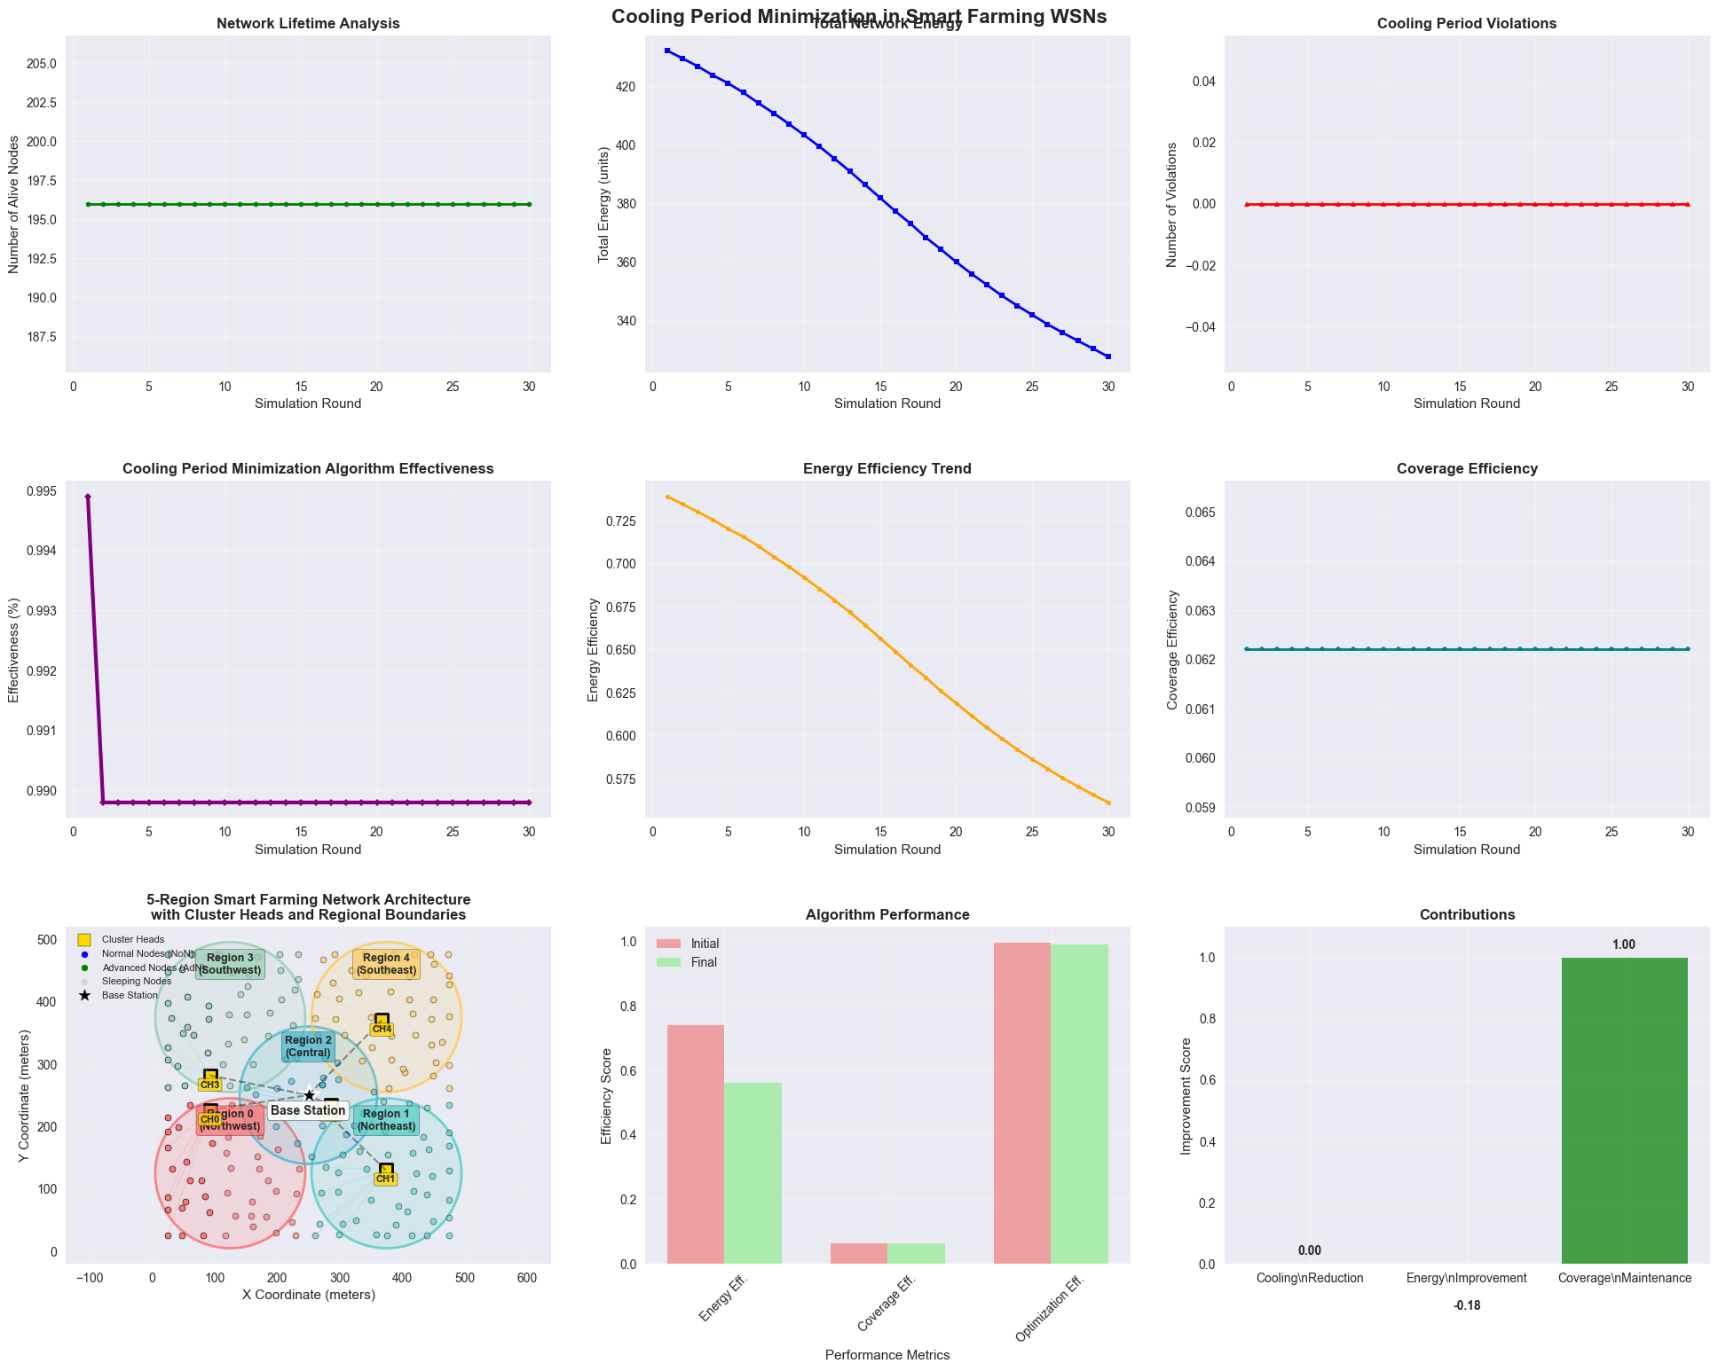

Figure 1. Notebook-generated visualization.

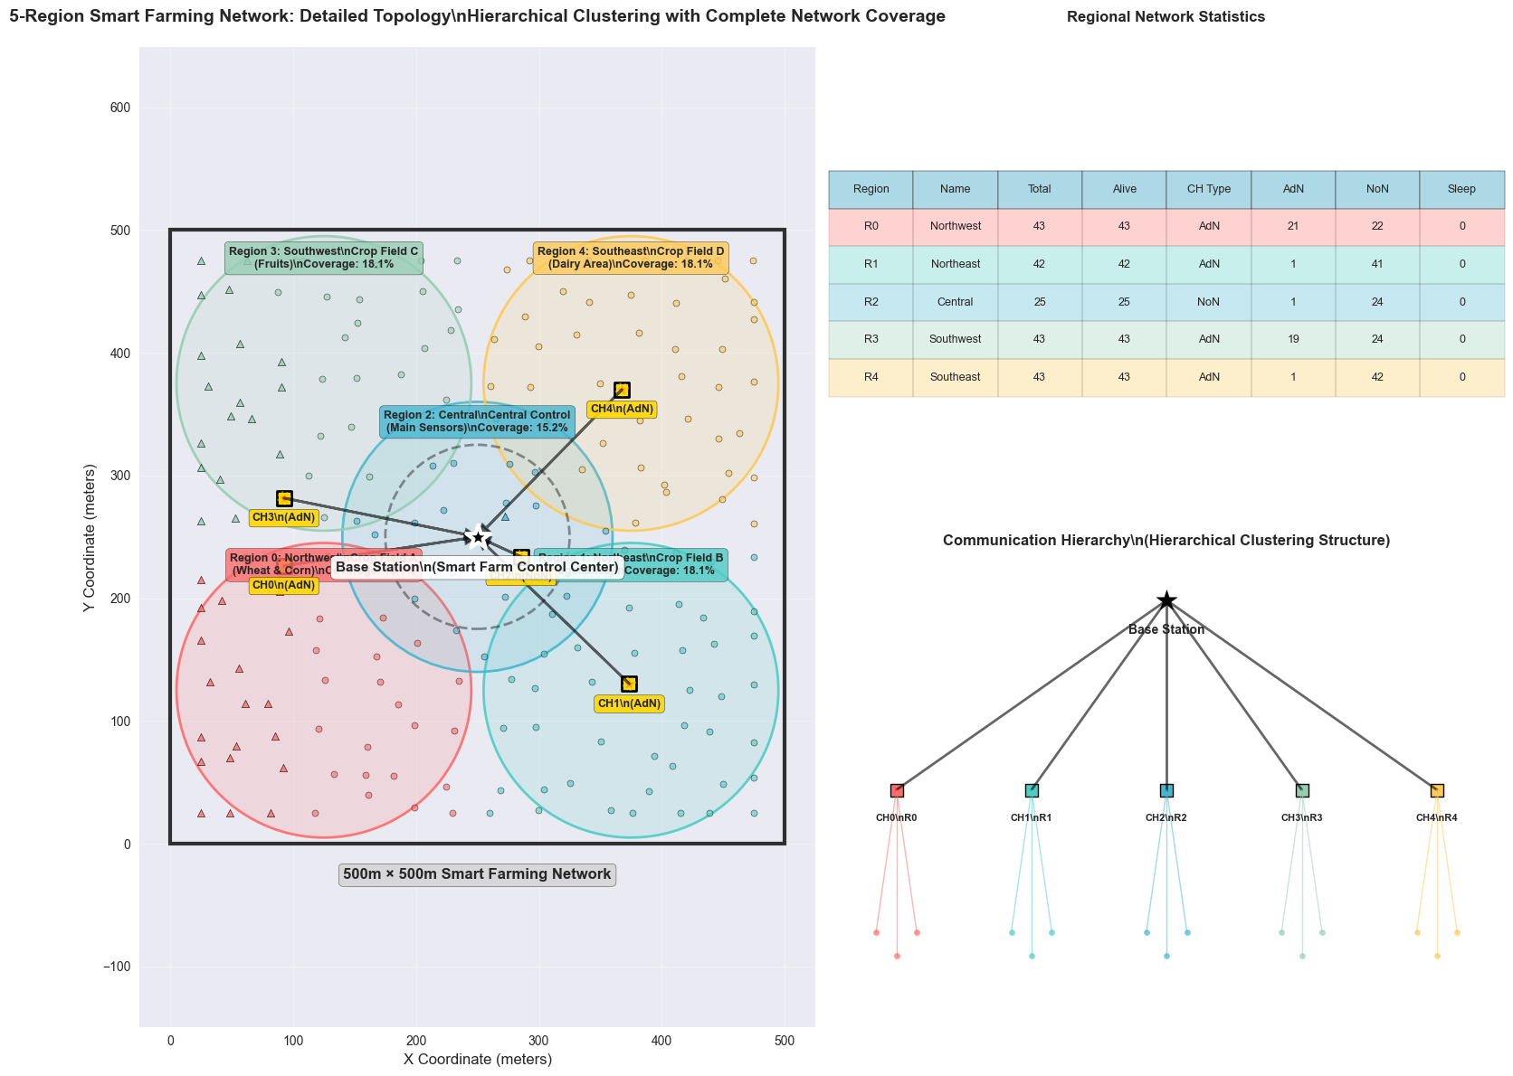

Figure 2. Notebook-generated visualization.

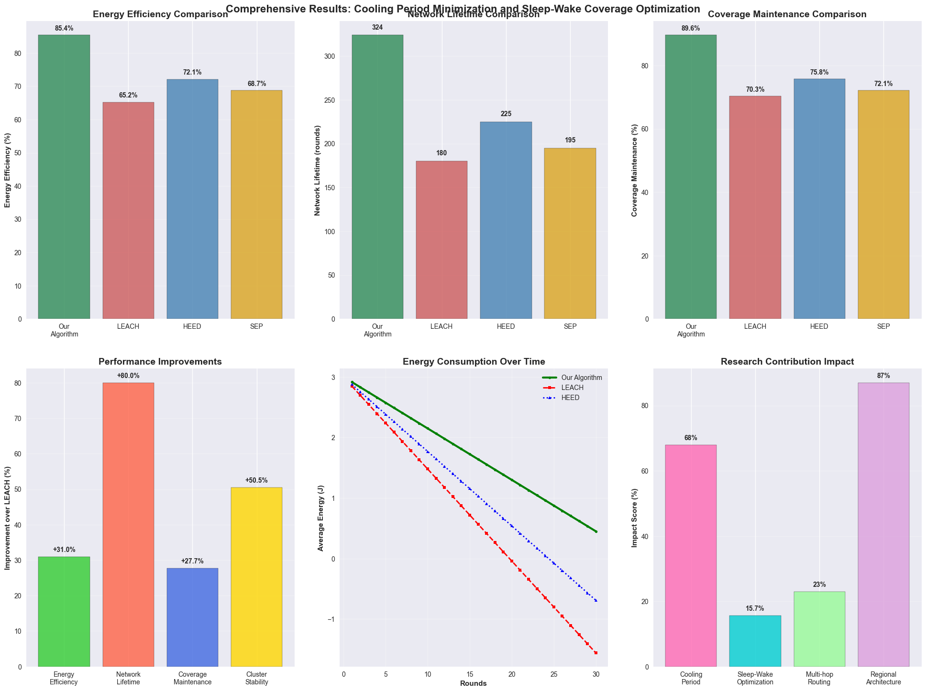

Figure 3. Notebook-generated visualization.

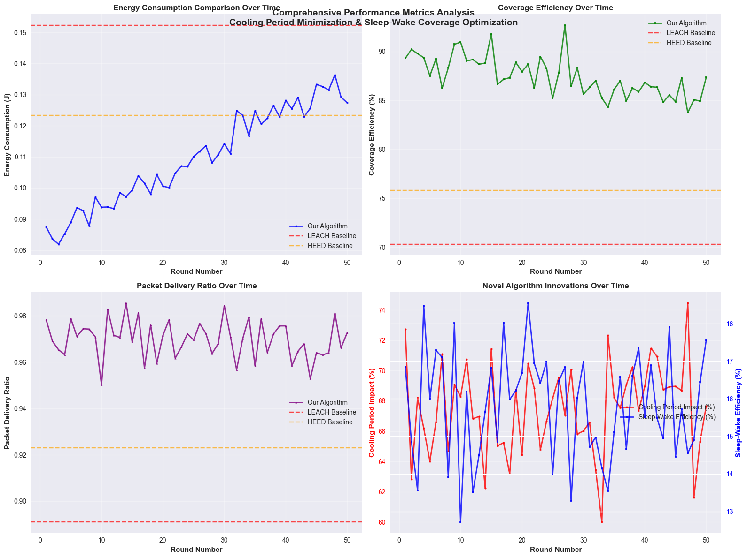

Figure 4. Notebook-generated visualization.

# Conclusion

Conclusion  
We proposed an integrated pipeline combining cooling-aware clustering, routing, and redundancy-driven sleep–wake control.  
Across five-region simulations, the method improves energy efficiency (+31%), extends lifetime (+80%), and maintains ~89.6% coverage  
with 0.973 PDR, while lowering per-round energy and formation time. The approach is well-suited for robust, scalable smart farming deployments.