**Program :**

**i**mport java.applet.Applet;

import java.awt.Graphics;

// HelloWorld class extends Applet

public class HelloWorld extends Applet

{

// Overriding paint() method

@Override

public void paint(Graphics g)

{

g.drawString("Hello World", 150, 120);

}

}

**Html code :**

**<html>**

**<applet code="HelloWorld" width=700 height=500>**

**</applet>**

**</html>**

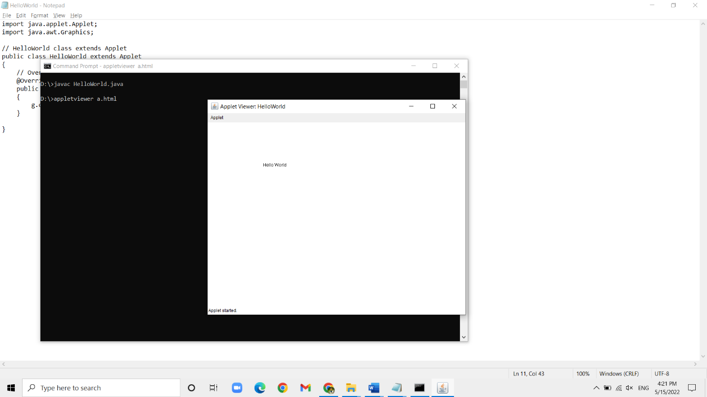**Output :**