Assignment 12
Name : Ritesh Ramchandra Patil
PRN : 22510044
Batch : T3

Problem Statement: Finding Things Close to Other Things.
Application in: location-based services on the web

Task :
1. Use Neo4j graph database installed in previous assignments.
2. Install/configure Neo4jSpatial (https://github.com/neo4jcontrib/spatial) from GitHub. It is the Neo4j plug-in that facilitates geospatial operations on data stored in Neo4j.
3. Write CQL (Cypher Query Language) script to add randomly 10,000 location points as follows. Assume any data.
4. Use the point() , distance() function of Neo4j to answer the queries “which things close/nearest to which other things”.
5. Demonstrate the result by firing different cypher queries (write CQL statement).
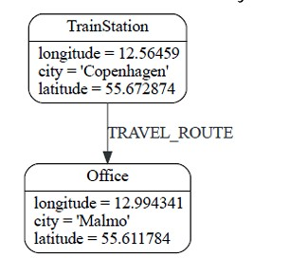

Result:
Creating a project and database in Neo4J
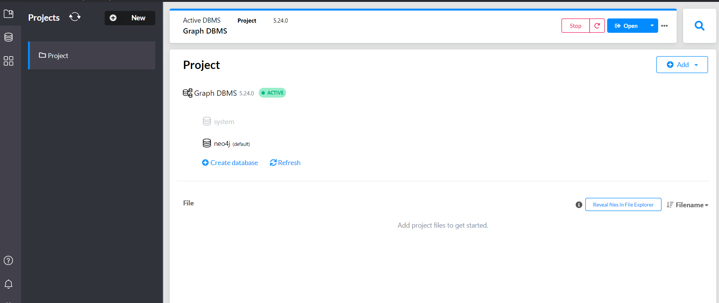
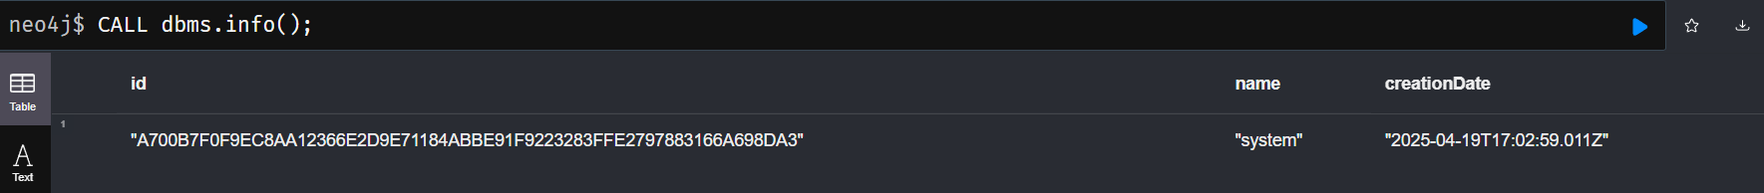

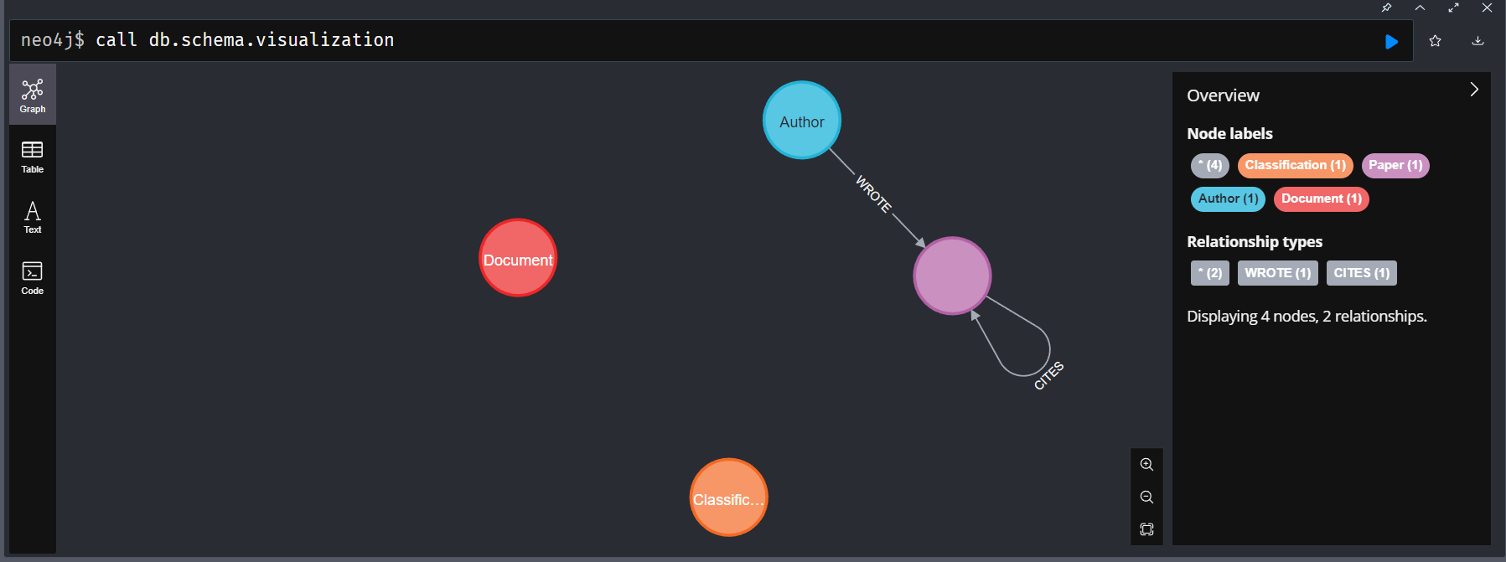

Creating Sample Data (TrainStation → Office)
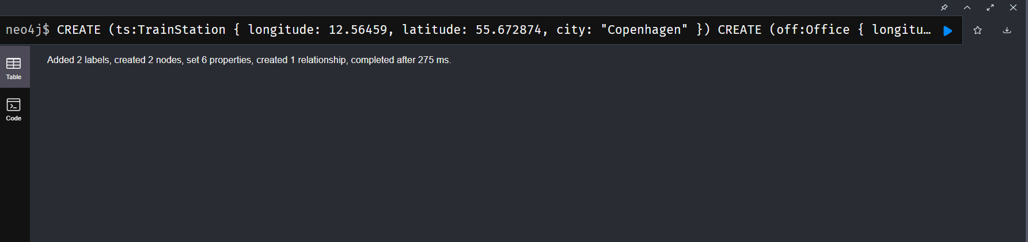
Generate 10,000 Random Location Nodes
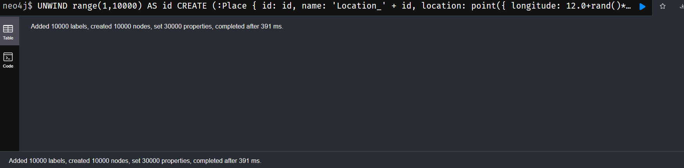
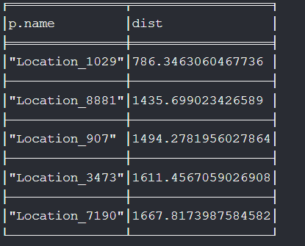
Find Nearest Places Using distance()
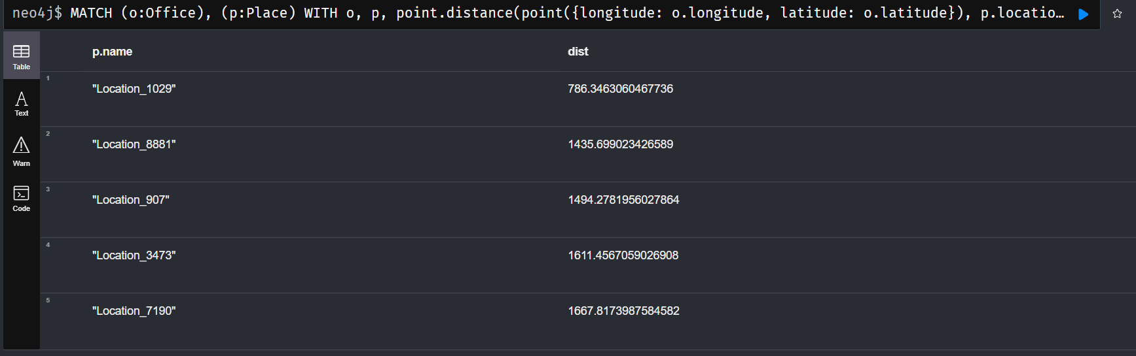
Find all Places within 5km of the TrainStation

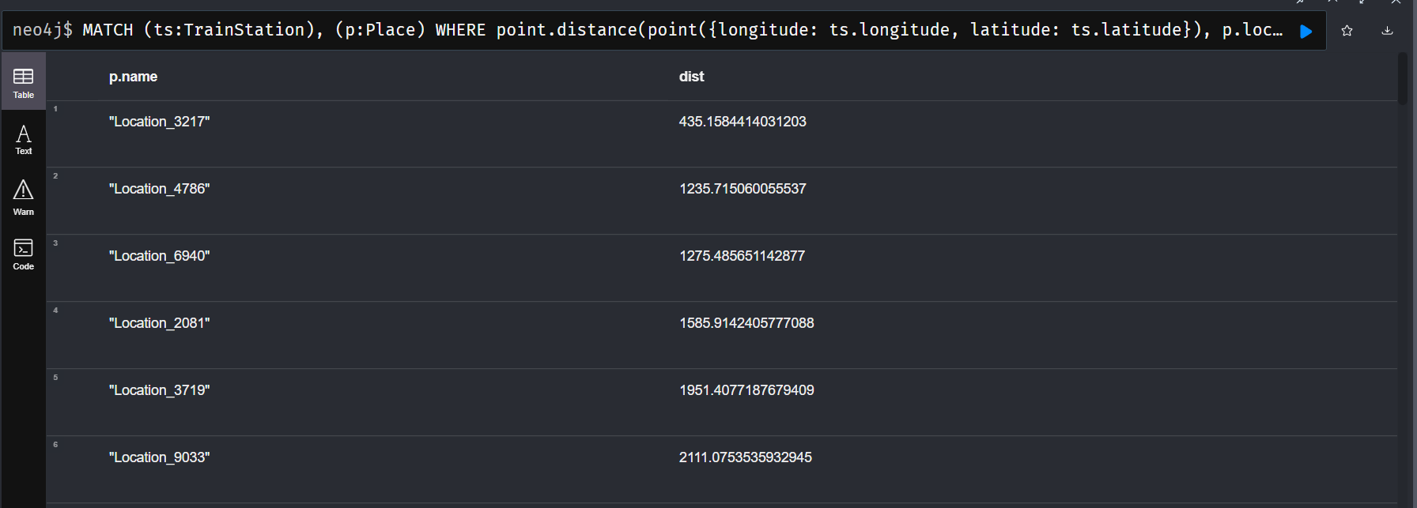
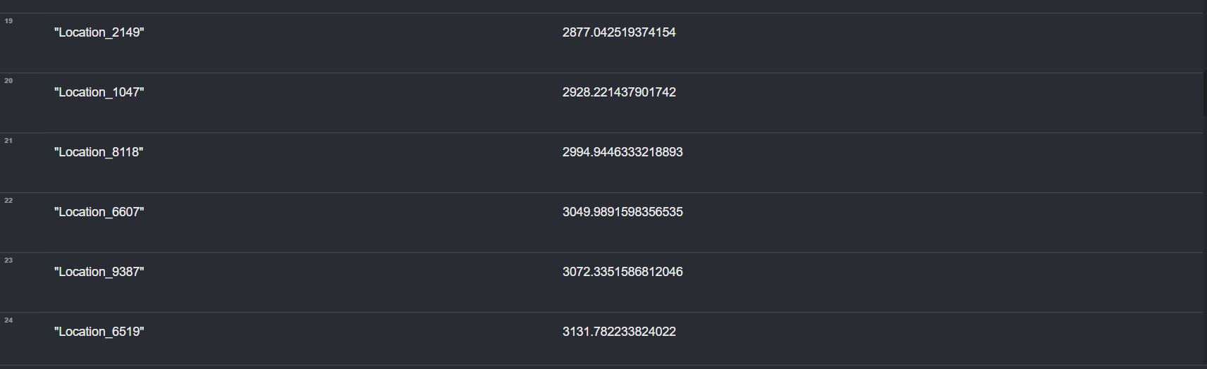
Create new project and Load below data in neo4j browser.

