TY B.Tech. (CSE) – II [ 2024-25 ]
6CS371 : Advanced Database System Lab.

Assignment No. 3
Name : Ritesh Ramchandra Patil
PRN : 22510044
Batch : T3
Design and implement a web-enabled (portal) student MIS (Management Information System) for University schema attached in separate file.

- Student Form :
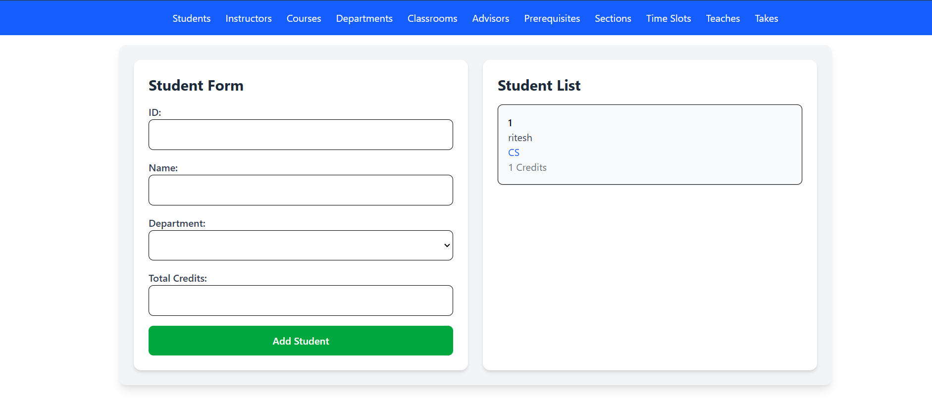

- Instructor Form
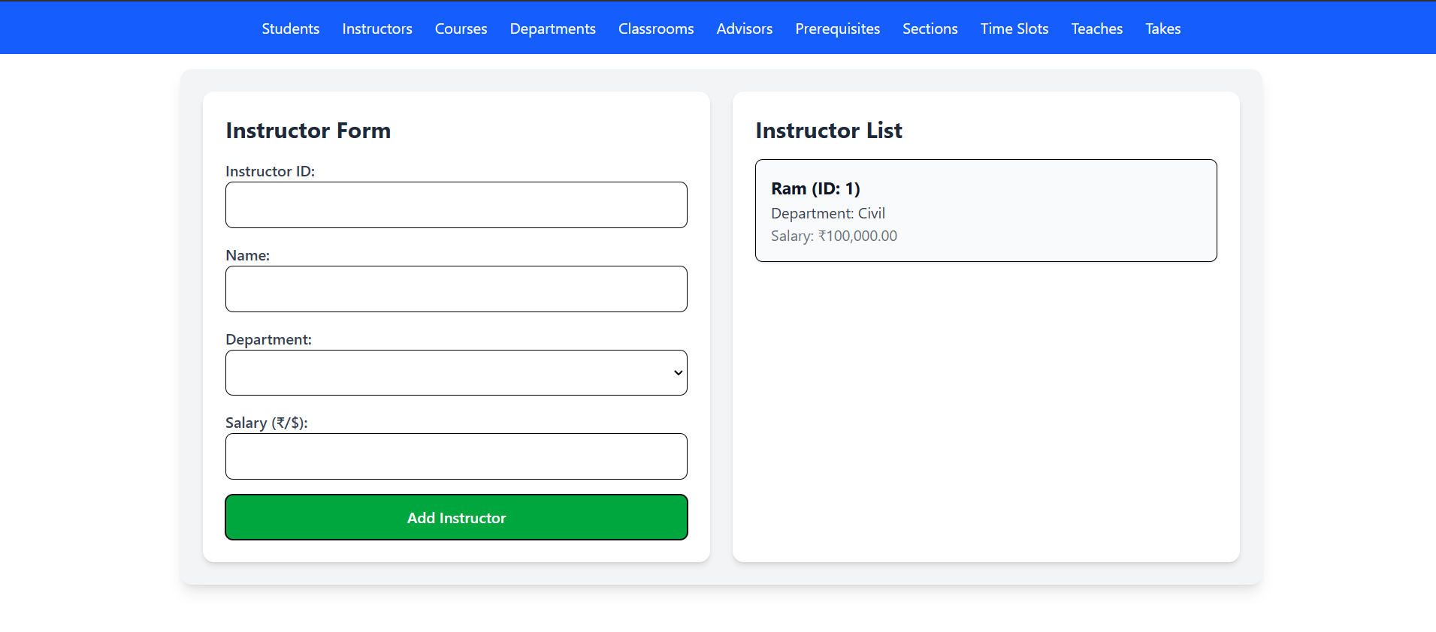

- Course Form

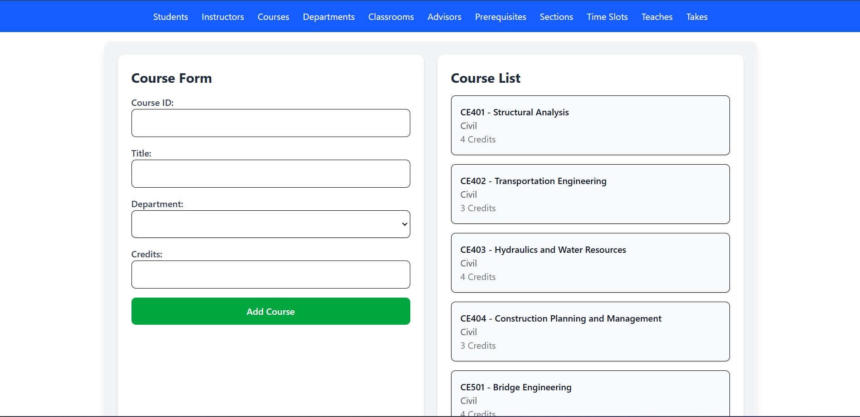

- Department Form
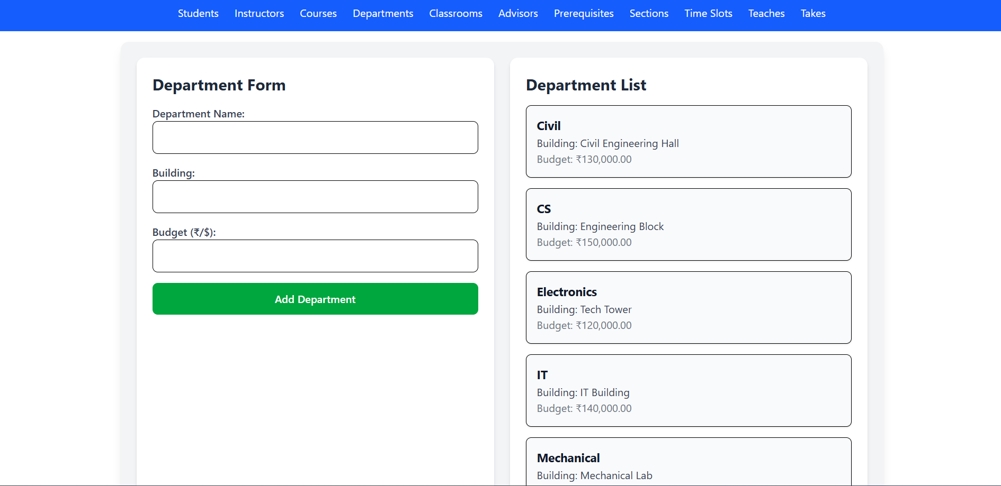

- Classroom Form
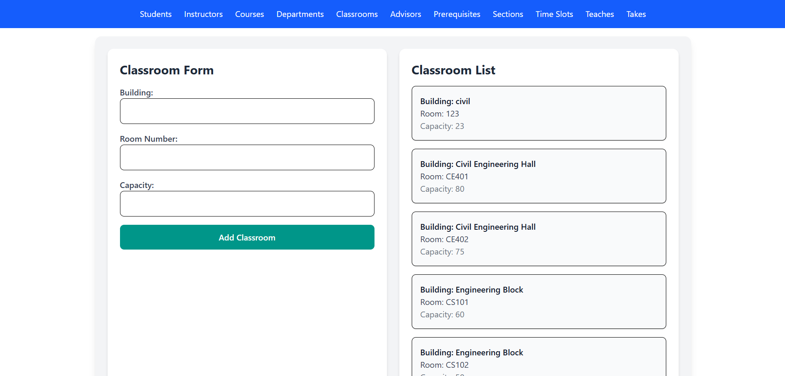

- Advisor Form
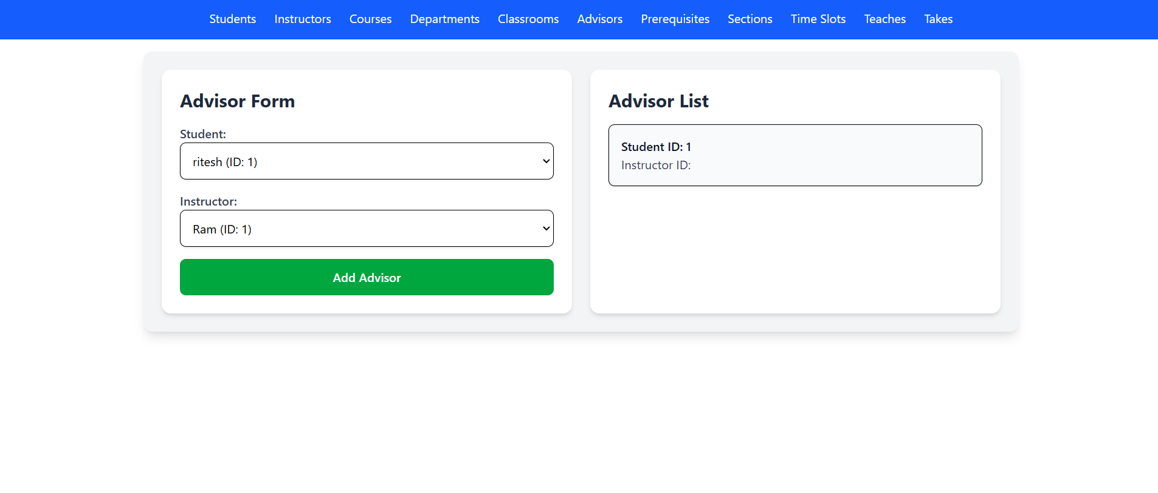

- Prerequisite Form
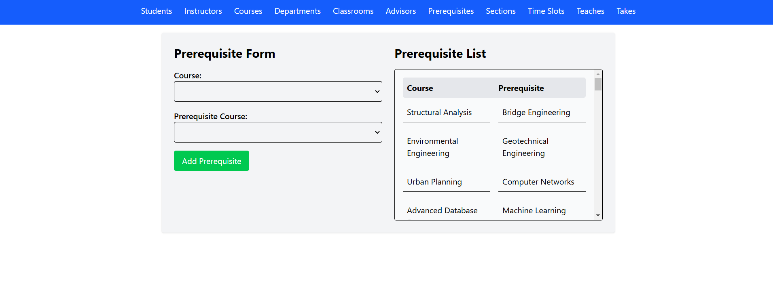

- Section from
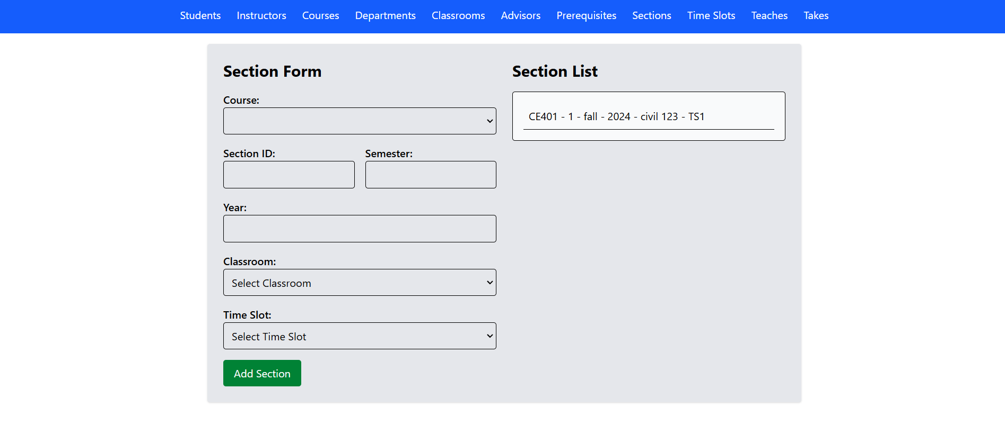
- Time slot Form

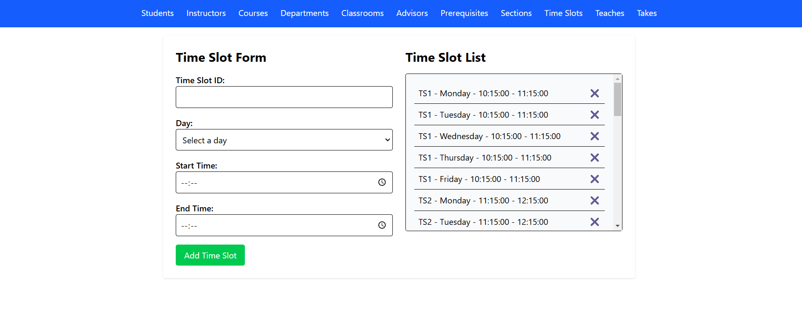
- Teaches Form
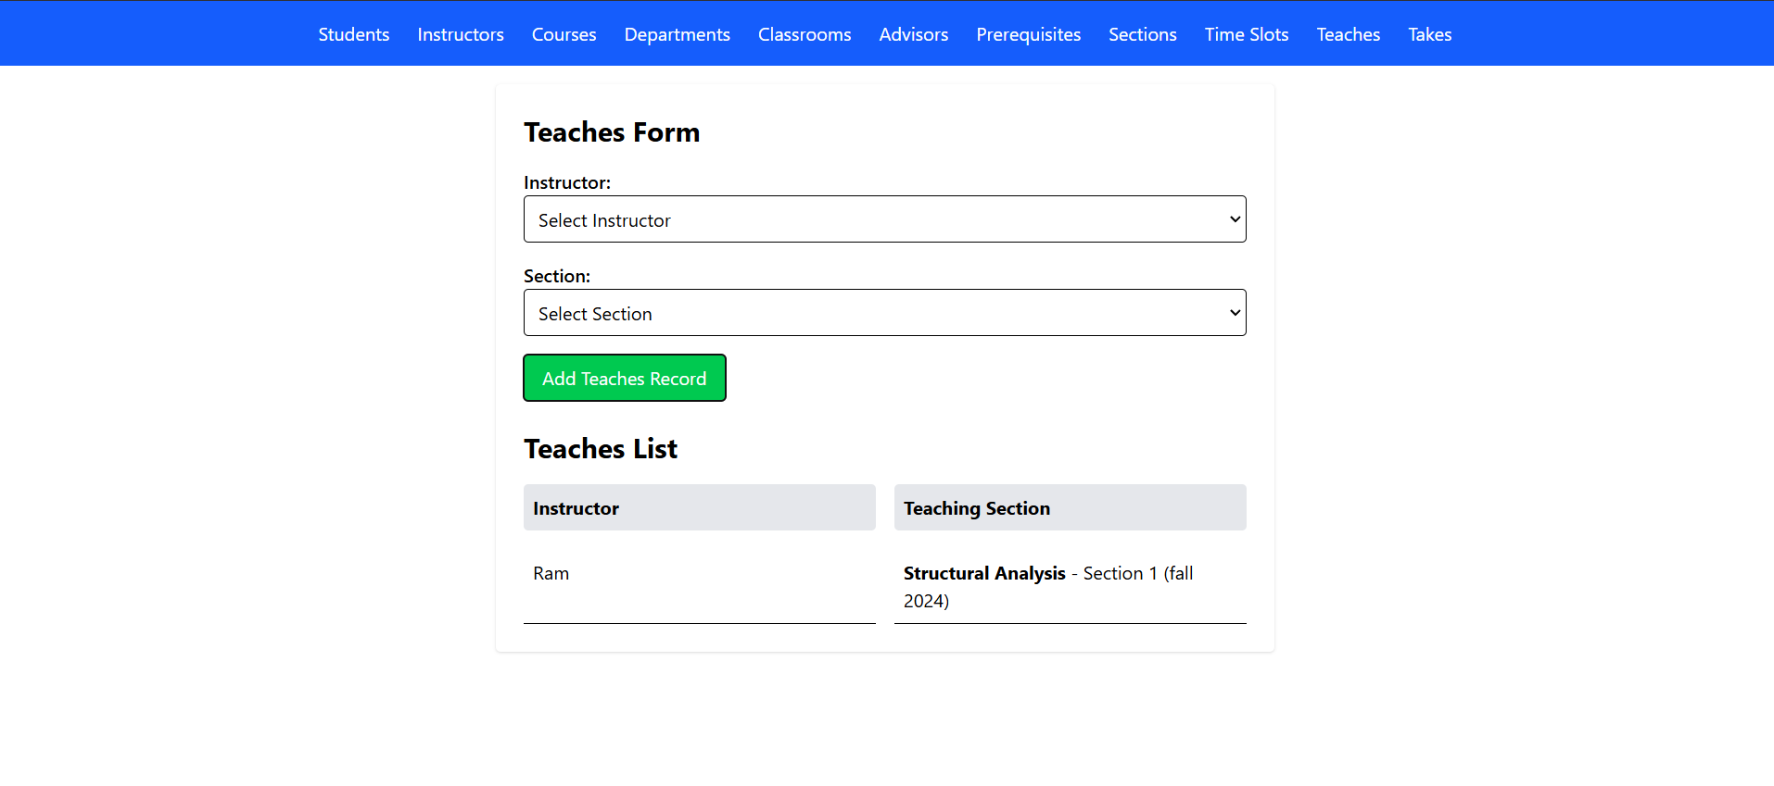
- Enroll student section

