Assignment 5
Name: Ritesh Patil
PRN: 22510044
Batch:T3

Grafana - k6
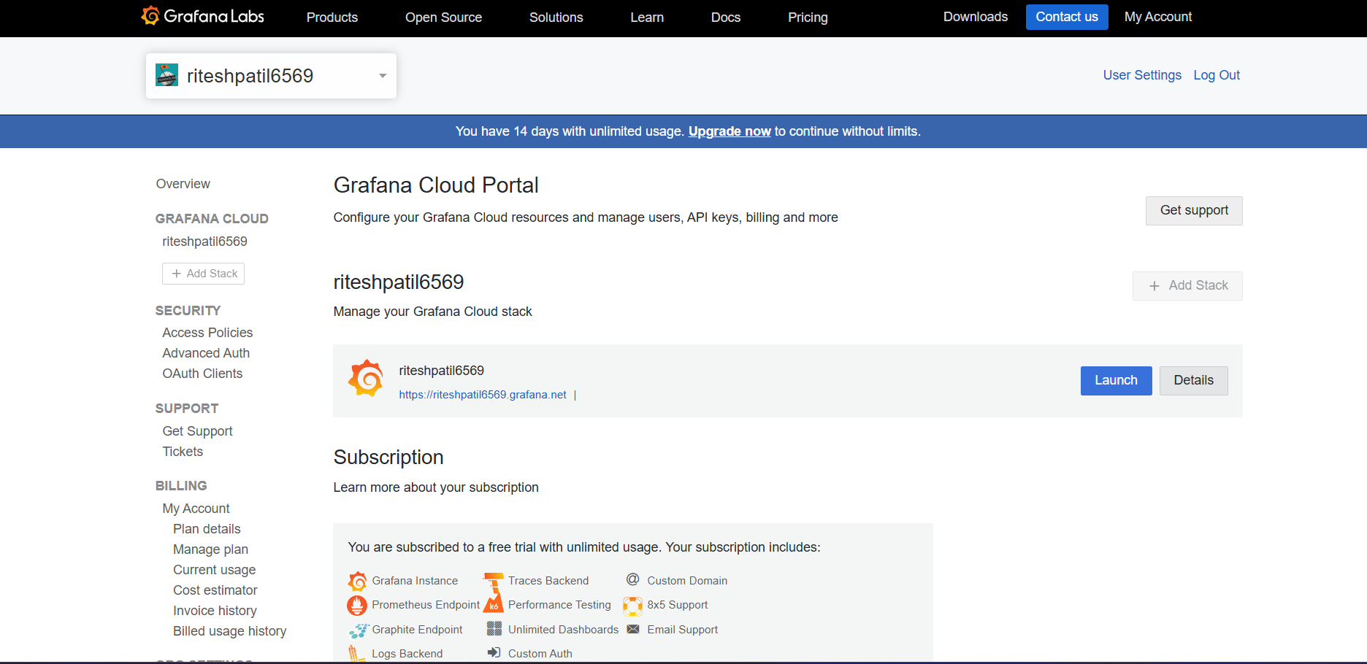

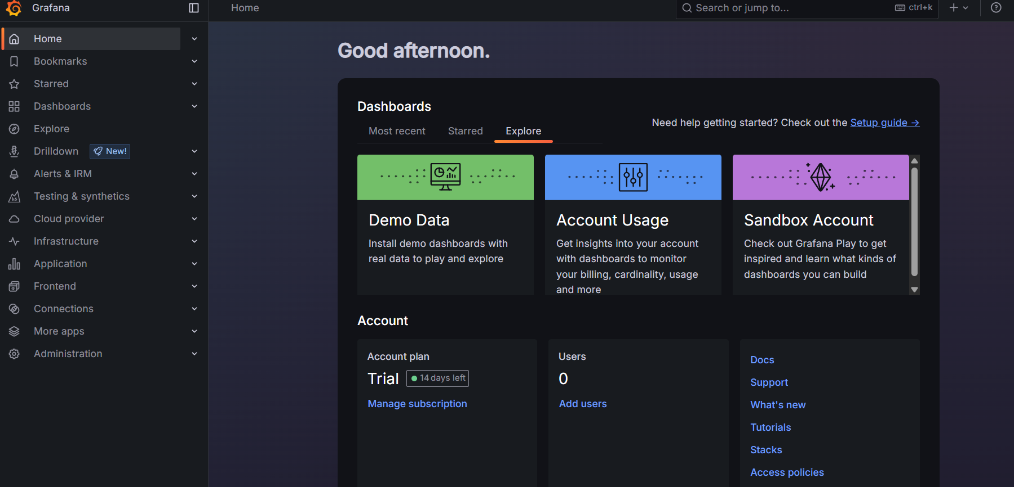
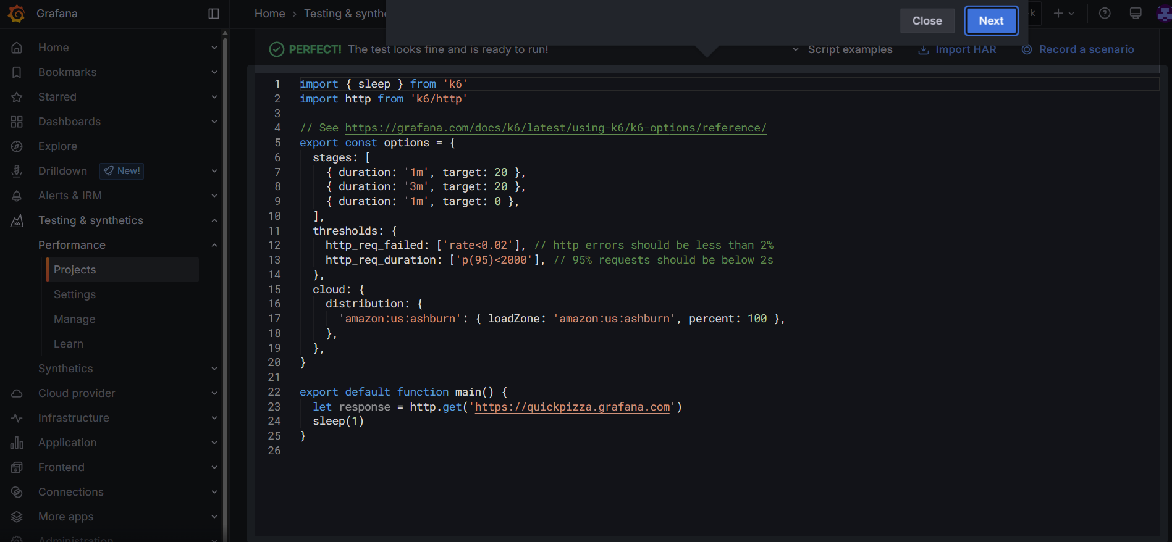

- Testing of 3rd assignment on Grafana - k6

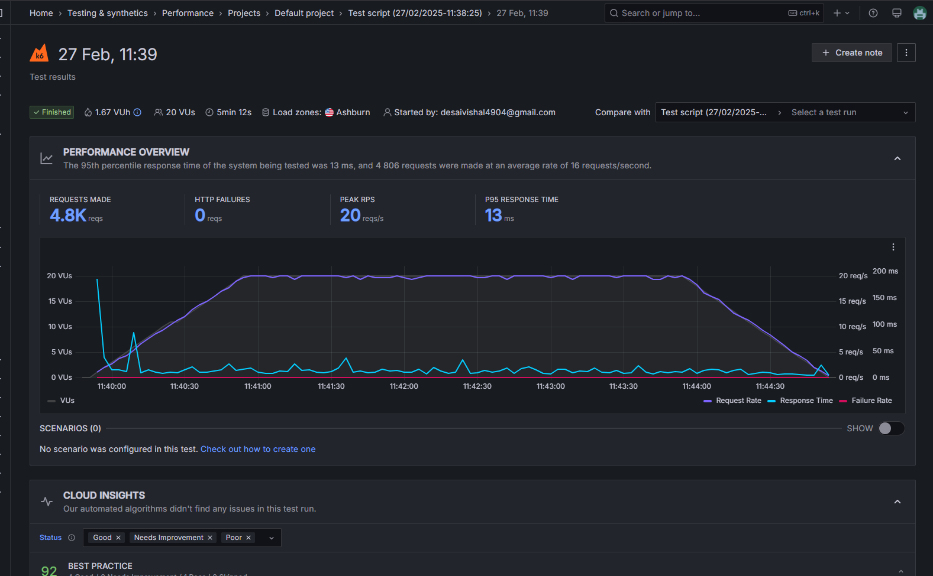

1. Overview of Test Results
- Total Requests Made: 4.8K (4,806 requests)
- HTTP Failures: 0 (No failed requests)
- Peak Requests Per Second (RPS): 20 req/s
- 95th Percentile Response Time: 13 ms (P95 latency)
- Total Virtual Users (VUs): 20
- Test Duration: 5 min 12 sec
- Load Zone: Ashburn (USA)

2. Key Observations
High Stability
- The system handled 4.8K requests without any HTTP failures, indicating high reliability under the tested load.
Low Response Time
- The 95th percentile response time is only 13ms, meaning that 95% of the requests were completed in under 13ms, which is excellent for real-time applications like a quiz app.
Consistent Load Handling
- The request rate (RPS) and response time remain stable throughout the test, suggesting that the backend efficiently manages traffic without significant performance degradation.

- Testing of 4th assignment on Grafana - k6
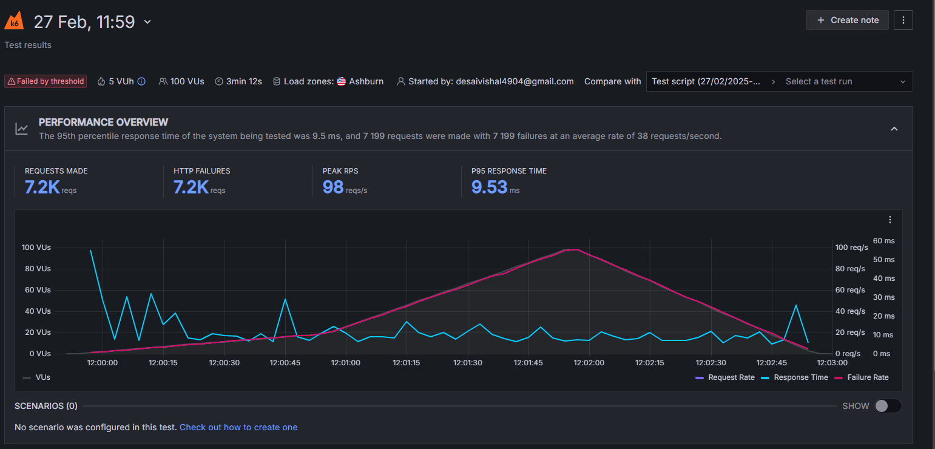Performance Test Analysis & Insights
1. Overview of Test Results
- Total Requests Made: 7.2K (7,200+ requests)
- HTTP Failures: 7.2K (All requests failed)
- Peak Requests Per Second (RPS): 98 req/s
- 95th Percentile Response Time (P95): 9.53 ms
- Total Virtual Users (VUs): 100
- Test Duration: 3 min 12 sec
- Load Zone: Ashburn (USA)
- Test Status: Failed by threshold
2. Key Observations
All Requests Failed (7.2K Failures)
- Every single request resulted in an HTTP failure.
- This suggests a server-side issue, possibly due to overload, misconfiguration, or an authentication failure.
High Load Applied (100 VUs, 98 RPS)
- Compared to the previous test (20 VUs), this test applied significantly more load, increasing the request rate to 98 requests per second.
- The system failed under this increased load, indicating a scalability issue.
Low Response Time (P95 = 9.53 ms)
- Despite failures, response times remain low. This suggests that the server is rejecting requests quickly, rather than handling them and slowing down.
Failure Rate Increased Over Time
- The graph shows a steady increase in failure rate as the number of virtual users (VUs) increased.
- This suggests that the server was initially handling some load but eventually became overwhelmed.

