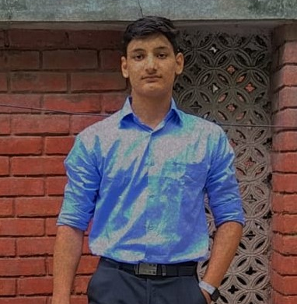

VIVEK KUMAR
BH Block, East Shalimar Bagh
New Delhi – 110088
📞 [8929096311] | ✉️ [kumarvivek66508@gmail.com]

🎯 Career Objective
Motivated and enthusiastic learner with a strong passion for technology and software development. Currently building a solid foundation in coding through hands-on training and self-study. Eager to gain practical experience and contribute to real-world projects in a growth-oriented organization.

🎓 Education
Senior Secondary (12th Grade)
National Institute of Open Schooling (NIOS)
Year of Passing: 2025

💻 Technical Skills
- Languages: Python, HTML, CSS, JavaScript
- Tools & Platforms: VS Code, GitHub
- Core Areas of Interest: Web Development, Problem Solving, Software Logic Building

🧠 Training & Projects
IANT Pitampura, Delhi
Coding Learner (2023 – Present)
- Gaining hands-on experience in programming, debugging, and basic web development.
- Completed mini-projects focused on building interactive web pages and logic-based applications.

📚 Hobbies & Interests
- Coding: Passionate about building and experimenting with code.
- Reading Books: Enjoy exploring new topics, especially in technology, innovation, and self-development.

👤 Personal Details
- Father’s Name: Hariom Arya
- Date of Birth: 12 July 2007
- Address: BH Block, East Shalimar Bagh, New Delhi – 110088
- Languages Known: Hindi, English

✅ Declaration
I hereby declare that the information provided above is true and correct to the best of my knowledge and belief.

