Introduction to Project

This project is about to store informations regarding different countries using data file handling of c++ programming language. The coding of the program leads to output containing main menu giving user the multiple choices like to add, modify or delete a country record.
There is also an option for user to play country quiz. This option leads user to play menu which contains options like add, modify or delete a question .User can also play questions using play option.
This is all about this project.

Software and Hardware
Required

Computer software-

1.) Ram- 512 MB
2.) Hard disk- 500 GB
3.) C++ software
4.) Microsoft Word
5.) Nero start smart

Computer hardware

1.) Keyboard
2.) Monitor
3.) Printer
4.) Pen drive

Introduction to C++

The C++ programming language was developed at AT & T bell laboratories in the early 1980’s by Bjarne Stroustrup. The name c++ was coined by Rick Mascitti were “++”is the C increment operator.C++ evolved to cope with problems encountered by users and through discussions at AT&T. The maturation of the c++ language is attested to by two recent events-
- The formation an ANSI(American National Standard Institute)c++ committee.
- The publication of The Annotated C++ Reference Manual by Ellis and Stroustrup.

STRUCTURE/CLASS RECORD:-
- Class Country
S.no | Data member | DataType/  Size(bytes) | Purpose
1 | name | char / 100 | Country name
2 | cont | char / 100 | Continent
3 | area | char / 30 | Country area
4 | pop | char / 30 | Population
5 | capt | char / 100 | Country Capital
6 | offlan | char / 100 | Official language (s)
7 | cur | char / 100 | Currency
8 | desc | char / 100 | Description
9 | cono | int / 2 | Unique country number

2.Structure Quiz
S.no | Data member | DataType/  Size | Purpose
1 | que | char / 500 | Question
2 | opt | char/4*100 | Options(1,2,3,4)
3 | st | char / 1 | Status(Y/N)
4 | ans | int / 2 | Answer (1/2/3/4)

CODING

#include<iostream.h>
#include<conio.h>
#include<stdio.h>
#include<string.h>
#include<stdlib.h>
#include<fstream.h>
#include<dos.h>

ifstream fin;
ofstream fout;
fstream file;
class country
{
char name[100],cont[100],area[30],pop[30],capt[100],offlan[100];
char cur[100],desc[500];
int cono;
public:
void enter();
void show();
void enter1();
int coun_no()
{
return cono; //FUNCTION TO RETURN COUNTRY NUMBER;
}
} V; //CLASS OBJECT V;

int num(int a) //FUNCTION TO CHECK FOR UNIQUE COUNTRY NUMBER
{
fstream check;
check.open("V.COUNTRY",ios::in|ios::binary);
while(check.read((char*)&V,sizeof(V)))
{
if(a==V.coun_no())
{
check.close();
return(0);
}
}
check.close();
return 1;
}
void country::enter()
{
int g,s;
textcolor(3);
gotoxy(4,3);
cprintf(" ENTER COUNTRY NUMBER:");
cin>>g;
s=num(g);
if(s==1)
{
cono=g;
textcolor(2);
gotoxy(33,3);
cprintf(" ENTER COUNTRY'S NAME:");
gets(name);
textcolor(5);
gotoxy(4,5);
cprintf(" ENTER CONTINENT IN WHICH COUNTRY IS:");
gets(cont);
textcolor(6);
gotoxy(4,7);
cprintf(" ENTER COUNTRY'S AREA(IN Sq.km):");
gets(area);
textcolor(23);
gotoxy(4,9);
cprintf(" ENTER COUNTRY'S POPULATION:");
gets(pop);
textcolor(28);
gotoxy(4,11);
cprintf(" ENTER COUNTRY'S CAPITAL:");
gets(capt);
textcolor(9);
gotoxy(4,13);
cprintf(" ENTER COUNTRY'S OFFICIAL LANGUAGE(S):");
gets(offlan);
textcolor(10);
gotoxy(4,15);
cprintf(" ENTER COUNTRY'S CURRENCY:");
gets(cur);
textcolor(11);
gotoxy(4,17);
cprintf(" ENTER ANY DESCRIPTION ABOUT COUNTRY (MAXIMUM 3 LINES)(PRESS / TO OVER):");
textcolor(4);
for(int i=0,u=17;i<500;++i)
{

desc[i]=getche();
if(desc[i]=='\b')
{
cout<<" \b";
}
else if(desc[i]=='\n'||desc[i]=='\r')
{
u++;
gotoxy(12,u);
}
else if(desc[i]=='/')
{
break;
}
}
desc[i+1]='\0';
}
else
{
gotoxy(18,5);
cout<<" COUNTRY NUMBER ALREADY EXISTS ";
gotoxy(20,7);
cout<<" DON'T PRESS ENTER ";
delay(2500);
gotoxy(20,9);
cout<<" PLEASE ENTER AGAIN";
delay(2000);
void set(int sr,int sc,int er,int ec,int t);
set(2,1,24,80,0);
V.enter();
}
}
void country::show()
{
textcolor(3);
gotoxy(4,3);
cprintf(" COUNTRY NUMBER:");
cout<<cono;
textcolor(2);
gotoxy(33,3);
cprintf(" COUNTRY'S NAME:");
puts(name);
textcolor(5);
gotoxy(4,5);
cprintf(" CONTINENT IN WHICH COUNTRY IS:");
puts(cont);
textcolor(6);
gotoxy(4,7);
cprintf(" COUNTRY'S AREA:");
puts(area);
textcolor(23);
gotoxy(4,9);
cprintf(" COUNTRY'S POPULATION:");
puts(pop);
textcolor(28);
gotoxy(4,11);
cprintf(" COUNTRY'S CAPITAL:");
puts(capt);
textcolor(9);
gotoxy(4,13);
cprintf(" COUNTRY'S OFFICIAL LANGUAGE(S):");
puts(offlan);
textcolor(10);
gotoxy(4,15);
cprintf(" COUNTRY'S CURRENCY:");
puts(cur);
gotoxy(4,17);
textcolor(11);
cprintf(" DESCRIPTION ABOUT COUNTRY :");
textcolor(4);
for(int i=0,u=17;i<500;++i)
{
cprintf("%c",desc[i]);
if(desc[i]=='\n'||desc[i]=='\r')
{
u++;
gotoxy(12,u);
}
else if(desc[i]=='/')
{
break;
}

}
}

void country::enter1()
{
Char nm[100],con[100],ar[30],po[30],cap[100],oflan[100];
char curr[100],des[500];
gotoxy(4,3);
cout<<" [ ENTER '@' IN ANY PART TO RETAIN OLD ONE EXCEPT COUNTRY NUMBER]";
textcolor(3);
gotoxy(4,4);
cprintf(" ENTER COUNTRY NUMBER:");
cout<<cono;
textcolor(2);
gotoxy(33,4);
cprintf(" ENTER COUNTRY'S NAME:");
gets(nm);
textcolor(5);
gotoxy(4,6);
cprintf(" ENTER CONTINENT IN WHICH COUNTRY IS:");
gets(con);
textcolor(6);
gotoxy(4,8);
cprintf(" ENTER COUNTRY'S AREA(IN Sq.km):");
gets(ar);
textcolor(23);
gotoxy(4,10);
cprintf(" ENTER COUNTRY'S POPULATION:");
gets(po);
textcolor(28);
gotoxy(4,12);
cprintf(" ENTER COUNTRY'S CAPITAL:");
gets(cap);
textcolor(9);
gotoxy(4,14);
cprintf(" ENTER COUNTRY'S OFFICIAL LANGUAGE(S):");
gets(oflan);
textcolor(10);
gotoxy(4,16);
cprintf(" ENTER COUNTRY'S CURRENCY:");
gets(curr);
textcolor(11);
gotoxy(4,18);
cprintf(" ENTER ANY DESCRIPTION ABOUT COUNTRY (MAXIMUM 3 LINES)(PRESS / TO OVER):");
textcolor(4);
for(int i=0,u=18;i<500;++i)
{
des[i]=getche();
if(des[i]=='\b')
{
cout<<" \b";
}
else if(des[i]=='\n'||des[i]=='\r')
{
u++;
gotoxy(12,u);
}
else if(des[i]=='/'||des[i]=='@')
{
break;
}
}
des[i+1]='\0';

if(strcmp(nm,"@")!=0)
{
strcpy(name,nm);
}
if(strcmp(con,"@")!=0)
{
strcpy(cont,con);
}
if(strcmp(ar,"@")!=0)
{
strcpy(area,ar);
}
if(strcmp(po,"@")!=0)
{
strcpy(pop,po);
}
if(strcmp(cap,"@")!=0)
{
strcpy(capt,cap);
}
if(strcmp(oflan,"@")!=0)
{
strcpy(offlan,oflan);
}
if(strcmp(curr,"@")!=0)
{
strcpy(cur,curr);
}
if(strcmp(des,"\r@")!=0)
{
strcpy(desc,des);
}
}

struct quiz
{
char que[500],opt[4][100];
char st;
int ans;
}Q; //Q structure variable;

void load()
{
textcolor(3);
gotoxy(40,10);
cprintf("LOADING");
for(int x=20,i=1;x<=100;x++,i++)
{
textcolor(2);
gotoxy(48,10);
delay(20);
cprintf("%d%",x);
textcolor(4);
gotoxy(i,12
);
delay(20);
cprintf("0");
textcolor(9);
gotoxy(81-i,12);
delay(20);
cprintf("0");
}
textcolor(11+128);
gotoxy(40,14);
cprintf("PROJECT LOADING COMPLETED");
gotoxy(40,18);
textcolor(7+128);
cprintf("PRESS ENTER TO CONTINUE");
textcolor(1+128);
gotoxy(58,22);
cprintf("BY VIVEK CREATIONS");
gotoxy(55,10);
printf("\b\b\b ");
}
void load1()
{
int r,c,t;
for(r=1;r<=5;r++)
{ textcolor(4);
gotoxy(2,1+r);
for(t=1;t<=r;++t)
printf(" ");
delay(140);
cprintf("0");
for(t=1;t<=(5-r)*2-1;++t)
printf(" ");
delay(140);
if(r!=5)
cprintf("0");
}
for(r=1;r<=5;r++)
{
textcolor(2);
gotoxy(21,1+r);
delay(140);
if(r==1||r==5)
cprintf("0 0 0 0 0");
else
cprintf(" 0");
}
for(r=1;r<=5;r++)
{
textcolor(3);
gotoxy(31,1+r);
for(t=1;t<=r;++t)
printf(" ");
delay(140);
cprintf("0");
for(t=1;t<=(5-r)*2-1;++t)
printf(" ");
delay(140);
if(r!=5)
cprintf("0");
}
for(r=1;r<=5;r++)
{
textcolor(5);
gotoxy(52,1+r);
if(r==1||r==3||r==5)
{
delay(140);
cprintf("0 0 0 0");
}
else
{
delay(140);
cprintf("0" );
}
}
for(r=1;r<=5;r++)
{
textcolor(6);
gotoxy(62,1+r);
if(r==1)
{
delay(140);
cprintf("0 0");
}
if(r==2)
{
delay(140);
cprintf("0 0");
}
if(r==3)
{
delay(140);
cprintf("00");
}
if(r==4)
{
delay(140);
cprintf( "0 0");
}
if(r==5)
{
delay(140);
cprintf("0 0");
}
}
}

void box(int sr, int sc,int er,int ec,int fg,int bg,int t)
{
int r,c;
textcolor(fg);
textbackground(bg);
gotoxy(sc,sr);
cprintf("É");
for(c=sc+1;c<ec;c++)
cprintf("Í");
cprintf("»");
for(r=sr+1;r<er;r++)
{
gotoxy(ec,r);
cprintf("º");
gotoxy(ec,er);
cprintf("¼");
gotoxy(sc,r);
cprintf("º");
gotoxy(sc,er);
cprintf("È");
}
gotoxy(sc,er-1);
for(c=sc+1;c<ec;c++)
{
gotoxy(c,er);
cprintf("Í");
}
for(r=sr+1;r<er;r++)
{
void bgc(int);
bgc(t);
gotoxy(sc+2,r);
for(c=sc+3;c<ec;c++)
cprintf(" ");
}
}

void set(int sr,int sc,int er,int ec,int t)
{
for(int r=sr+1;r<er;r++)
{
void bgc(int);
bgc(t);
gotoxy(sc+2,r);
for(int c=sc+3;c<ec;c++)
cprintf(" ");
}
}

void bgc(int n)
{
textbackground(n);
}
void fgc(int a)
{
textcolor(a);
}

void screen()
{
box(2,1,24,80,9,2,6);
textcolor(0);
textbackground(2);
gotoxy(4,1);
cprintf("VIVEK'S PROJECT SYSTEM:- [COUNTRIES OF THE WORLD] WELCOMES YOU");
textcolor(12+8+128);
gotoxy(45,25);
cprintf(" VIVEK'S CREATIONS");
textcolor(4);
}

void addc()
{
char ch;
fout.open("V.COUNTRY",ios::app|ios::binary);
if(!fout)
{
gotoxy(30,12);
cout<<" FILE CANNOT OPEN";
getch();
}
else
{
do
{
screen();
set(2,1,24,80,0);
V.enter();
gotoxy(4,22);
textcolor(15);
cprintf(" SAVE IT(Y/N):");
ch=getche();
if(ch=='y'||ch=='Y')
{
fout.write((char*)&V,sizeof(V));
cout<<" [SAVED IN FILE COUNTRY]";
}
gotoxy(40,23);
fgc(15);
cprintf(" ADD MORE (Y/N):");
ch=getche();;
}while(ch=='y'||ch=='Y');
}
getch();
fout.close();
}

void seeall()
{
int n;
fin.open("V.COUNTRY",ios::in|ios::binary);
if(!fin)
{
gotoxy(30,12);
cout<<" FILE CANNOT OPEN";
getch();
}
else
{
screen();
fin.seekg(0,ios::beg);
while(fin.read((char*)&V,sizeof(V)))
{
getch();
set(2,1,24,80,0);
V.show();
}
}
fin.seekg(0,ios::end);
n=fin.tellg();
if(n==0)
{
screen();
box(10,10,14,74,1,4,2);
gotoxy(12,12);
cout<<" SORRY THERE ARE NO RECORDS IN A FILE, ADD RECORDS.";
}
getch();
fin.close();
}

void seesp()
{
int no,m=0,n,k=0;
fin.open("V.COUNTRY",ios::in|ios::binary);
if(!fin)
{
gotoxy(30,12);
cout<<" FILE CANNOT OPEN";
getch();
}
else
{
fin.seekg(0,ios::end);
n=fin.tellg();
if(n==0)
{
screen();
box(10,10,14,74,1,4,2);
gotoxy(12,12);
cout<<" SORRY THERE ARE NO RECORDS IN A FILE, ADD RECORDS.";
k=1;
}
else
{
screen();
box(10,10,16,74,1,4,2);
gotoxy(12,12);
cout<<" ENTER COUNTRY'S SERIAL NUMBER TO SEE ITS RECORD:";
cin>>no;
fin.seekg(0,ios::beg);
while(fin.read((char*)&V,sizeof(V)))
{
if(no==V.coun_no())
{ m=1;
screen();
set(2,1,24,80,0);
V.show();
getch();
break;
}
}
}
}
if(m==0&&k==0)
{
gotoxy(12,14);
cout<<" SORRY,THERE IS NO RECORD IN FILE HAVING COUNTRY NUMBER "<<no;
}
getch();
fin.close();
}

void editc()
{
int nom,m=0,rec=0,found=0,n,k=0;
char ch;
file.open("V.COUNTRY",ios::in|ios::out|ios::binary);
if(!file)
{
gotoxy(30,12);
cout<<" FILE CANNOT OPEN";
getch();
}
else
{
file.seekp(0,ios::end);
n=file.tellp();
if(n==0)
{
k=1;
screen();
box(10,10,14,74,1,4,2);
gotoxy(12,12);
cout<<" SORRY THERE ARE NO RECORDS IN A FILE, ADD RECORDS.";
}
else
{
screen();
box(10,10,16,74,1,4,2);
gotoxy(12,12);
cout<<" ENTER SERIAL NUMBER OF COUNTRY TO BE MODIFIED:";
cin>>nom;
file.seekg(0,ios::beg);
while(file.read((char*)&V,sizeof(V)))
{
if(nom==V.coun_no())
{
found=1;
}
if(found==1)
{
m=1;
screen();
set(2,1,24,80,0);
V.show();
gotoxy(4,22);
cout<<" WANT TO MODIFY IT (Y/N):";
cin>>ch;
if(ch=='y'||ch=='Y')
{
screen();
set(2,1,24,80,0);
V.enter1();
file.seekp((rec)*sizeof(V),ios::beg);
file.write((char*)&V,sizeof(V));
gotoxy(12,23);
cout<<" RECORD MODIFIED";

}
getch();
break;
}
rec++;

}
}
}
if(m==0&&k==0)
{
gotoxy(12,14);
cout<<" SORRY,THERE IS NO RECORD IN FILE HAVING COUNTRY NUMBER "<<nom;
}
getch();
file.close();
}
void delc()
{
int found=0,sno,n,k=0;
char ch;
ofstream fil;
fil.open("temp",ios::app|ios::binary);
fin.open("V.COUNTRY",ios::in|ios::binary);
if(!fin)
{
gotoxy(30,12);
cout<<" FILE CANNOT OPEN";
getch();
}
else
{
fin.seekg(0,ios::end);
n=fin.tellg();
if(n==0)
{
k=1;
screen();
box(10,10,14,74,1,4,2);
gotoxy(12,12);
cout<<" SORRY THERE ARE NO RECORDS IN A FILE, ADD RECORDS.";
}
else
{
screen();
box(10,10,16,74,1,4,2);
gotoxy(12,12);
cout<<" ENTER SERIAL NUMBER OF COUNTRY TO BE DELETED:";
cin>>sno;
fin.seekg(0,ios::beg);
while(fin.read((char*)&V,sizeof(V)))
{
if(sno==V.coun_no())
{
found=1;
screen();
set(2,1,24,80,0);
V.show();
gotoxy(4,22);
cout<<" WANT TO DELETE IT (Y/N):";
cin>>ch;
if(ch=='n'||ch=='N')
{
fil.write((char*)&V,sizeof(V));
}
else
{
gotoxy(50,22);
cout<<" RECORD DELETED";
}
}
else
{
fil.write((char*)&V,sizeof(V));
}
}
}
}
if(found==0&&k==0)
{
gotoxy(12,14);
cout<<" SORRY,THERE IS NO RECORD IN FILE HAVING COUNTRY NUMBER "<<sno;
}
fin.close();
fil.close();
remove("V.COUNTRY");
rename("temp","V.COUNTRY");
getch();
}
void enterq()
{
gotoxy(4,4);
fgc(7);
cprintf(" ENTER QUESTION :-(ENTER ? TO END QUESTION)");
gotoxy(20,5);
fgc(2);
for(int i=0,u=5;i<500;++i)
{
Q.que[i]=getche();
if(Q.que[i]=='\b')
{
cout<<" \b";
}
else if(Q.que[i]=='\n'||Q.que[i]=='\r')
{
u++;
gotoxy(20,u);
}
else if(Q.que[i]=='?')
{
break;
}
}
for(i=0,u+=2;i<4;++i,u+=2)
{
gotoxy(20,u);
cout<<" OPTION "<<i+1<<" :-";
gets(Q.opt[i]);
}
gotoxy(20,u+1);
cout<<"ENTER ANSWER NUMBER:-";
cin>>Q.ans;
Q.st='N';
}

void adq()
{
char ch;
fout.open("CTRY.QUIZ",ios::app|ios::binary);
if(!fout)
{
gotoxy(30,12);
cout<<" FILE CANNOT OPEN";
getch();
}
else
{
do
{
screen();
set(2,1,24,80,0);
enterq();
gotoxy(20,21);
textcolor(6);
cprintf(" SAVE IT(Y/N):");
ch=getche();
if(ch=='y'||ch=='Y')
{
fout.write((char*)&Q,sizeof(Q));
cout<<" [SAVED IN FILE ]";
}
gotoxy(20,23);
fgc(2);
cprintf("WANT TO ADD MORE(Y/N):");
ch=getche();
}while(ch=='y'||ch=='Y');
}
getch();
fout.close();
}
void showqs()
{
gotoxy(20,5);
fgc(2);
for(int i=0,u=5;i<500;++i)
{
cprintf("%c",Q.que[i]);
if(Q.que[i]=='\n'||Q.que[i]=='\r')
{
u++;
gotoxy(20,u);
}
else if(Q.que[i]=='?')
{
break;
}
}
fgc(4);
for(i=0,u+=2;i<4;++i,u+=2)
{
gotoxy(20,u);
cout<<" OPTION "<<i+1<<" :-";
puts(Q.opt[i]);
}
gotoxy(20,u+1);
cout<<"ANSWER NUMBER:-"<<Q.ans;
gotoxy(20,u+3);
cout<<"QUESTION STATUS:-"<<Q.st;
}

void showallq()
{
int n;
fin.open("CTRY.QUIZ",ios::in|ios::binary);
if(!fin)
{
gotoxy(30,12);
cout<<" FILE CANNOT OPEN";
getch();
}
else
{
screen();
fin.seekg(0,ios::beg);
while(fin.read((char*)&Q,sizeof(Q)))
{
getch();
set(2,1,24,80,0);
showqs();
}
}
fin.seekg(0,ios::end);
n=fin.tellg();
if(n==0)
{
screen();
box(10,10,14,74,1,4,2);
gotoxy(12,12);
cout<<" SORRY THERE ARE NO QUESTIONS IN A FILE, ADD QUESTIONS.";
}
getch();
fin.close();
}

void show1q()
{
int no,m=0,n,k=0,r;
fin.open("CTRY.QUIZ",ios::in|ios::binary);
if(!fin)
{
gotoxy(30,12);
cout<<" FILE CANNOT OPEN";
getch();
}
else
{
fin.seekg(0,ios::end);
n=fin.tellg();
r=n/sizeof(Q);
if(n==0)
{
screen();
box(10,10,14,74,1,4,2);
gotoxy(12,12);
cout<<" SORRY THERE ARE NO QUESTIONS IN A FILE, ADD QUESTIONS.";
k=1;
}

else
{
screen();
box(10,10,16,74,1,4,2);
gotoxy(12,12);
cout<<" ENTER QUESTION NUMBER TO SEE QUESTION (1 -"<<r<<" ):";
cin>>no;
if(no<=r&&no>=1)
{
no--;
m=1;
}
if(m==1)
{
screen();
set(2,1,24,80,0);
fin.seekg(no*sizeof(Q),ios::beg);
fin.read((char*)&Q,sizeof(Q));
showqs();
getch();
}
}
}

if(m==0&&k==0)
{
gotoxy(12,14);
cout<<" SORRY,THERE IS NO QUESTION IN FILE WITH NUMBER "<<no;
}
getch();
fin.close();
}

void editq()
{
int nom,m=0,found=0,n,k=0,r;
char ch;
file.open("CTRY.QUIZ",ios::in|ios::out|ios::binary);
if(!file)
{
gotoxy(30,12);
cout<<" FILE CANNOT OPEN";
getch();
}
else
{
file.seekp(0,ios::end);
n=file.tellp();
r=n/sizeof(Q);
if(n==0)
{
k=1;
screen();
box(10,10,14,74,1,4,2);
gotoxy(12,12);
cout<<" SORRY THERE ARE NO QUESTIONS IN A FILE, ADD QUESTIONS.";
}
else
{
screen();
box(10,10,16,74,1,4,2);
gotoxy(12,12);
cout<<" ENTER QUESTION NUMBER TO BE MODIFIED (1 -"<<r<<" ):";
cin>>nom;
if(nom<=r&&nom>=1)
{
nom--;
m=1;
}
file.seekg(0,ios::beg);
if(m==1)
{
found=1;
}
if(found==1)
{
screen();
set(2,1,24,80,0);
file.seekg(nom*sizeof(Q),ios::beg);
file.read((char*)&Q,sizeof(Q));
showqs();
gotoxy(20,21);
cout<<" WANT TO MODIFY IT (Y/N):";
cin>>ch;
if(ch=='y'||ch=='Y')
{
screen();
set(2,1,24,80,0);
enterq();
file.seekp((nom)*sizeof(Q),ios::beg);
file.write((char*)&Q,sizeof(Q));
gotoxy(20,22);
cout<<" RECORD MODIFIED";
}
}
}
}
if(m==0&&k==0)
{
gotoxy(12,14);
cout<<" SORRY,THERE IS NO QUESTION IN FILE HAVING QUESTION NUMBER "<<nom;
}
getch();
file.close();
}

void delq()
{
int found=0,sno,n,k=0,r,y,z=0;
char ch;
ofstream fil;
fil.open("tempq",ios::app|ios::binary);
fin.open("CTRY.QUIZ",ios::in|ios::binary);
if(!fin)
{
gotoxy(30,12);
cout<<" FILE CANNOT OPEN";
getch();
}
else
{
fin.seekg(0,ios::end);
n=fin.tellg();
r=n/sizeof(Q);
if(n==0)
{
k=1;
screen();
box(10,10,14,74,1,4,2);
gotoxy(12,12);
cout<<" SORRY THERE ARE NO QUESTIONS IN A FILE, ADD QUESTIONS.";
}
else
{
screen();
box(10,10,16,74,1,4,2);
gotoxy(12,12);
cout<<" ENTER SERIAL NUMBER OF QUESTION TO BE DELETED (1 -"<<r<<" ):";
cin>>sno;
if(sno<=r&&sno>=1)
{
sno--;
found=1;
}
if(found==1)
{
screen();
set(2,1,24,80,0);
fin.seekg(sno*sizeof(Q),ios::beg);
fin.read((char*)&Q,sizeof(Q));
showqs();
gotoxy(20,21);
cout<<" WANT TO DELETE IT (Y/N):";
cin>>ch;
if(ch=='y'||ch=='Y')
{
z=1;
for(y=0;y<r;++y)
{
if(y!=sno)
{
fin.seekg(y*sizeof(Q),ios::beg);
fin.read((char*)&Q,sizeof(Q));
fil.write((char*)&Q,sizeof(Q));
}
}
}
}
}
}
if(found==0&&k==0)
{
gotoxy(12,14);
cout<<" SORRY,THERE IS NO QUESTION IN FILE HAVING QUESTION NUMBER "<<sno;
}
if(z==1)
{
remove("CTRY.QUIZ");
rename("tempq","CTRY.QUIZ");
gotoxy(60,22);
cout<<" RECORD DELETED";
}
fin.close();
fil.close();
getch();
}

void refresh()
{
file.open("CTRY.QUIZ",ios::in|ios::out|ios::binary);
int m=0;
file.seekg(0,ios::beg);
while( file.read((char*)&Q,sizeof(Q)))
{
Q.st='N';
file.seekp(m*sizeof(Q),ios::beg);
file.write((char*)&Q,sizeof(Q));
m++;
}
file.close();
}
void showplay()
{
gotoxy(20,5);
fgc(2);
for(int i=0,u=5;i<500;++i)
{
cprintf("%c",Q.que[i]);
if(Q.que[i]=='\n'||Q.que[i]=='\r')
{
u++;
gotoxy(20,u);
}
else if(Q.que[i]=='?')
{
break;
}
}
fgc(4);
for(i=0,u+=2;i<4;++i,u+=2)
{
gotoxy(20,u);
cprintf(" OPTION %d :-",i+1);
puts(Q.opt[i]);
}
gotoxy(20,u+1);
}

void playq()
{
int x,n,m,s=0,anns=0,p=0;
file.open("CTRY.QUIZ",ios::in|ios::out|ios::binary);
file.seekg(0,ios::end);
n=file.tellg()/sizeof(Q);
screen();
box(10,10,18,74,1,4,2);
gotoxy(12,14);
cout<<" ANY WRONG ANSWER WILL STOP THE QUIZ!! : ";
gotoxy(12,12);
cout<<" HOW MANY QUESTIONS TO BE ASKED (OUT OF " <<n<<") : ";
cin>>m;
if(m>n||m<1)
{
gotoxy(25,16);
cout<<" WRONG ENTRY";
p=1;
s=1;
}
else
{
screen();
set(2,1,24,80,0);
int g;
for(x=0;x<m&&p==0;x++)
{
g=random(n);
file.seekg(g*sizeof(Q),ios::beg);
file.read((char*)&Q,sizeof(Q));
if(Q.st=='N')
{
set(2,1,24,80,0);
s++;
gotoxy(15,6);
cout<<"Q."<<s;
showplay();
cout<<" ENTER OPTION NO. TO ANSWER(1,2,3,4):";
cin>>anns;
gotoxy(20,22);
if(Q.ans==anns)
{
fgc(6);
cprintf(" CORRECT ANSWER");
getch();
}
else
{
fgc(6);
cprintf(" SORRY WRONG ANSWER");
getch();
p=1;
}
Q.st='Y';
file.seekp(g*sizeof(Q),ios::beg);
file.write((char*)&Q,sizeof(Q));
getch();
}
}
}
int d=0,q;
q=s;
for(x=0;x<n&&q<m&&p==0;x++)
{
file.seekg(x*sizeof(Q),ios::beg);
file.read((char*)&Q,sizeof(Q));
if(Q.st=='N')
{
set(2,1,24,80,0);
d++;
q=s+d;
gotoxy(15,6);
cout<<"Q."<<q;
showplay();
cout<<" ENTER OPTION NO. TO ANSWER(1,2,3,4):";
cin>>anns;
gotoxy(20,22);
if(Q.ans==anns)
{
fgc(6);
cprintf(" CORRECT ANSWER");
getch();
}
else
{
fgc(6);
cprintf(" SORRY WRONG ANSWER");
p=1;
getch();
}
Q.st='Y';
file.seekp(x*sizeof(Q),ios::beg);
file.write((char*)&Q,sizeof(Q));
getch();
}
}
if((s==0||q<m)&&p!=1)
{
screen();
box(12,12,16,70,0,1,2);

gotoxy(20,14);
cout<<" ALL QUESTIONS ARE ASKED ,PLEASE REFRESH";
}
getch();
file.close();
}

void playc()
{
int op,r,c;
do
{
screen();
box(3,20,23,55,4,11,7);
gotoxy(34,3);
cout<<"PLAY MENU";
gotoxy(29,5);
fgc(3);
cprintf("1.ADD QUESTIONS ");
gotoxy(29,7);
cprintf("2.SHOW ALL QUESTIONS ");
gotoxy(29,9);
cprintf("3.SHOW SPECIFIC QUESTION ");
gotoxy(29,11);
cprintf("4.EDIT QUESTION");
gotoxy(29,13);
cprintf("5.DELETE QUESTION ");
gotoxy(29,15);
cprintf("6.REFRESH QUESTIONS ");
gotoxy(29,17);
cprintf("7.PLAY QUIZ ");
gotoxy(29,19);
cprintf("8.EXIT ");
gotoxy(29,21);
fgc(17);
cprintf("ENTER CHOICE:- ");
cscanf("%d",&op);
switch(op)
{
case 1:
screen();
adq();
break;

case 2:
screen();
showallq();
break;

case 3:
screen();
show1q();
getch();
break;

case 4:
screen();
editq();
getch();
break;

case 5:
screen();
delq();
getch();
break;

case 6:
screen();
refresh();
getch();
break;

case 7:
screen();
playq();
getch();
break;
}
}while(op!=8);
}

void menu()
{
int op,r,c;
do
{ screen();
box(8,22,20,61,0,0,0);
box(7,20,19,60,11,4,4);
gotoxy(35,7);
fgc(1);
cout<<"MAIN MENU";
for(r=8;r<19;r++)
{
bgc(4);
gotoxy(21,r);
for(c=20;c<59;c++)
cprintf(" ");
}
fgc(15);
gotoxy(23,9);
cprintf("1.ADD INFRO OF NEW COUNTRY");
gotoxy(23,10);
cprintf("2.SEE ALL COUNTRY'S INFRO");
gotoxy(23,11);
cprintf("3.SEE SPECIFIC COUNTRY'S RECORD");
gotoxy(23,12);
cprintf("4.EDIT RECORD OF ANY COUNTRY");
gotoxy(23,13);
cprintf("5.DELETE RECORD OF ANY COUNTRY");
gotoxy(23,14);
cprintf("6.PLAY COUNTRY QUIZ");
gotoxy(23,15);
cprintf("7.EXIT");
gotoxy(23,17);
fgc(0);
cprintf("ENTER CHOICE [ ]\b\b");
cscanf("%d",&op);
switch(op)
{
case 1:
screen();
addc();
break;
case 2:
screen();
seeall();
getch();
break;
case 3:
screen();
seesp();
getch();
break;
case 4:
screen();
editc();
getch();
break;
case 5:
screen();
delc();
getch();
break;
case 6:
screen();
playc();
getch();
break;
}
}while(op!=7);
}

void main()
{
randomize();
textbackground(0);
clrscr();
load1();
for(int a=1;a<=80;a++)
{
gotoxy(a,12);
textcolor(15);
cprintf("0");
}
load();
getch();
set(-1,-1,27,82,2);
menu();
screen();
box(7,10,17,70,4,1,3);
gotoxy(17,12);
for(int i=1;i<=50;++i)
{
bgc(0);
gotoxy(16+i,12);
delay(50);
cprintf(" ");
}
char ar[]="THANKS FOR VISITING VIVEK'S COMPUTER PROJECT.";
int l=strlen(ar);
gotoxy(17,12);
for(i=0;i<l;++i)
{
fgc(4);
delay(110);
cprintf("%c",ar[i]);
}
delay(2500);
getch();
}

OUTPUTS

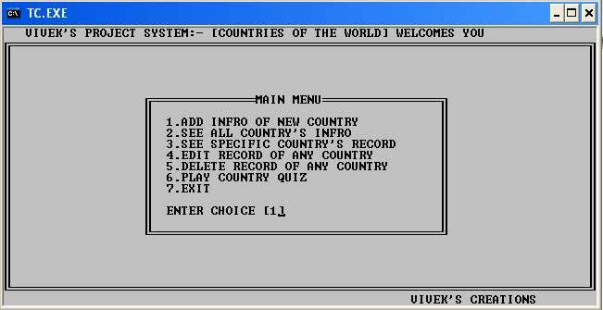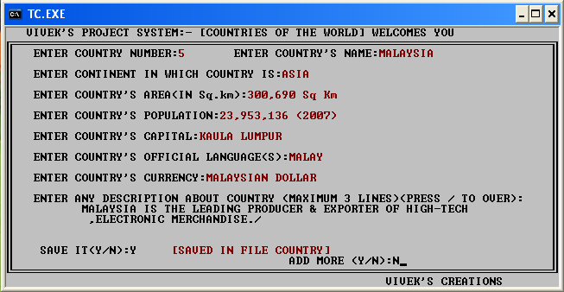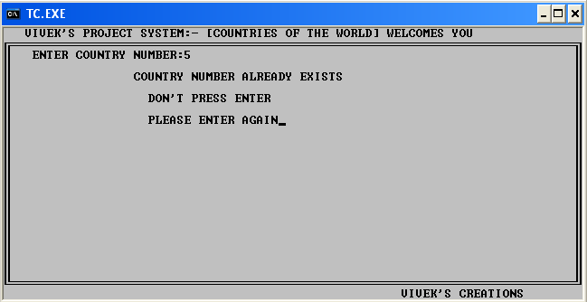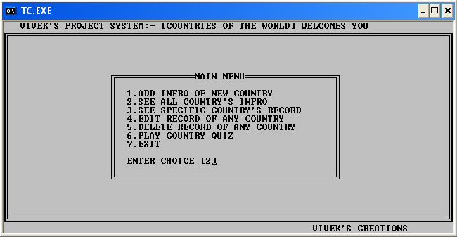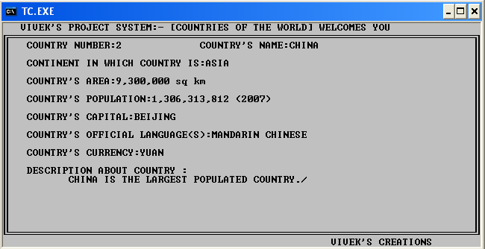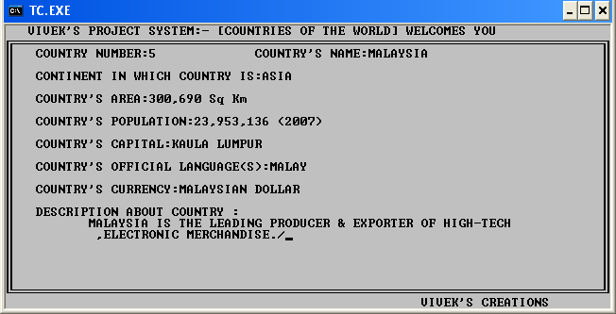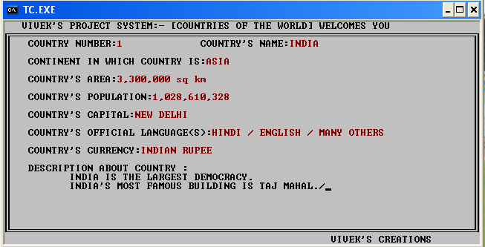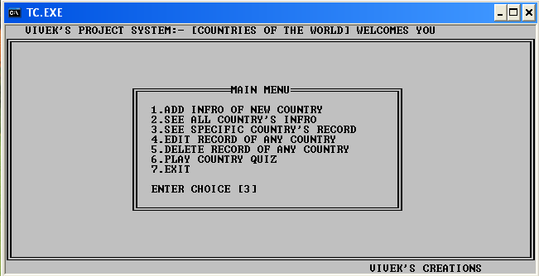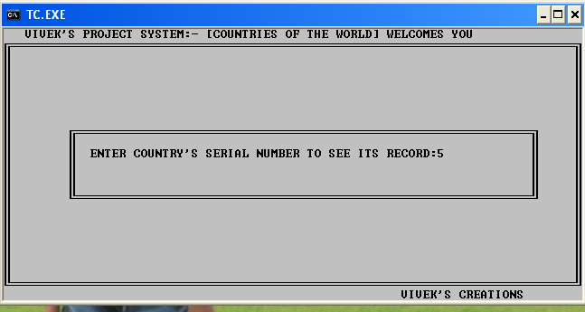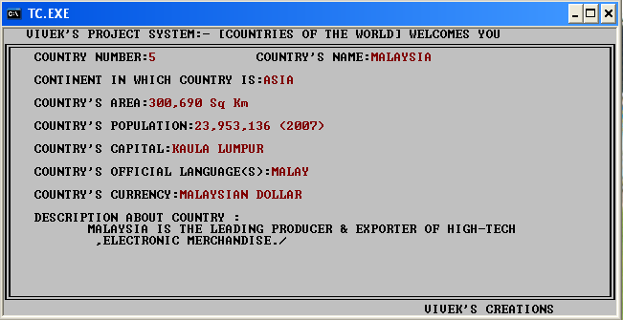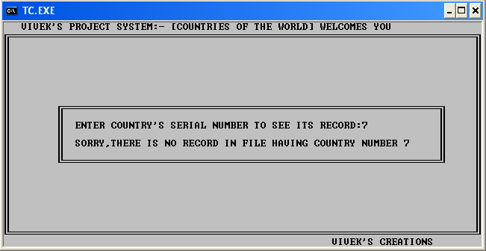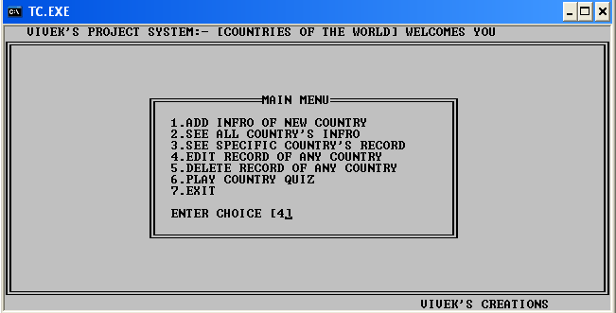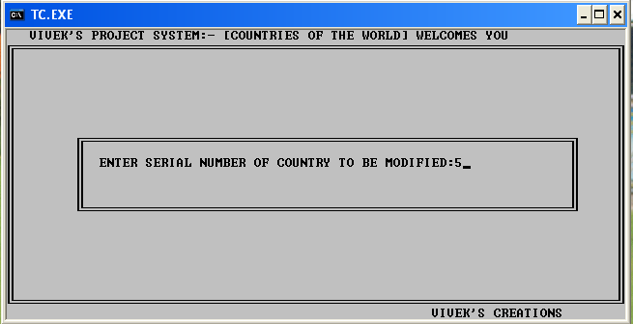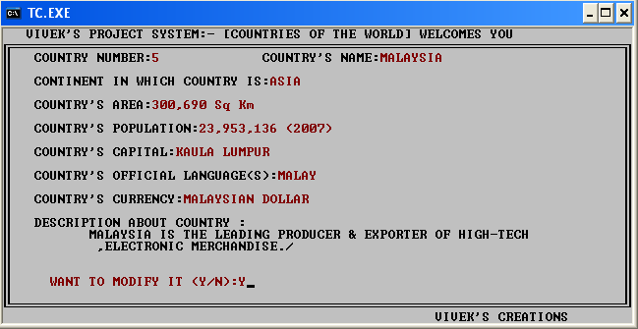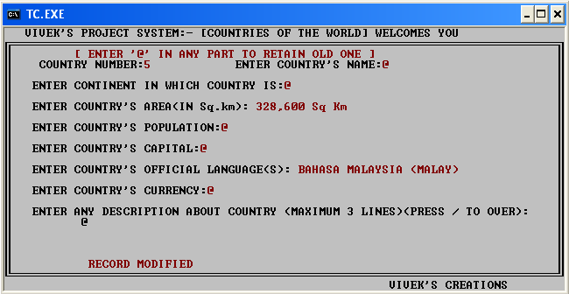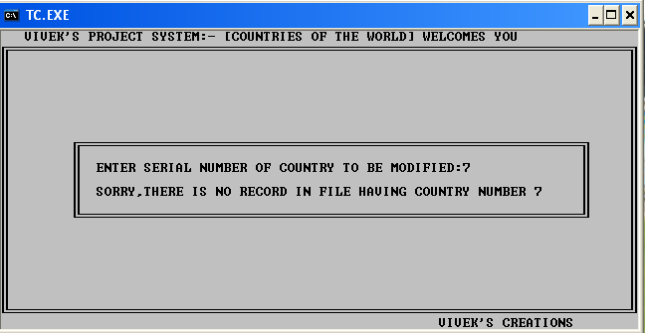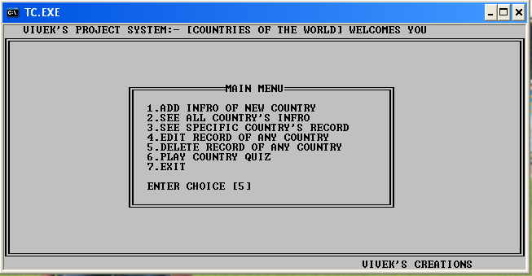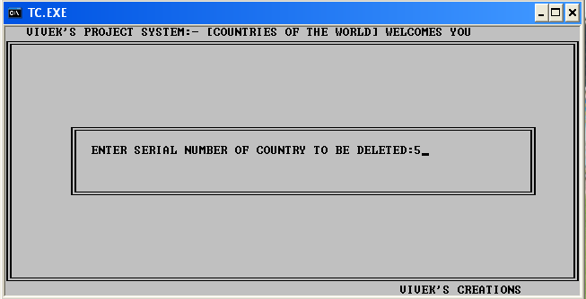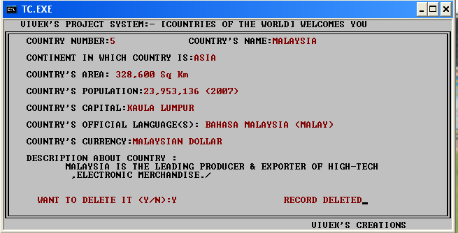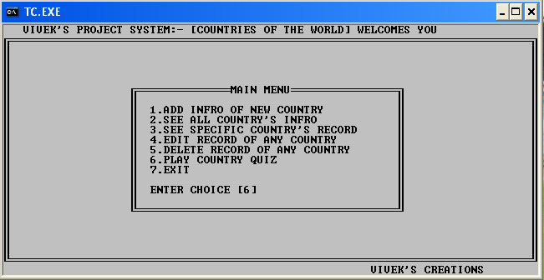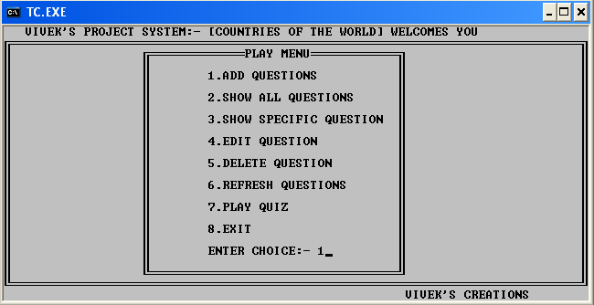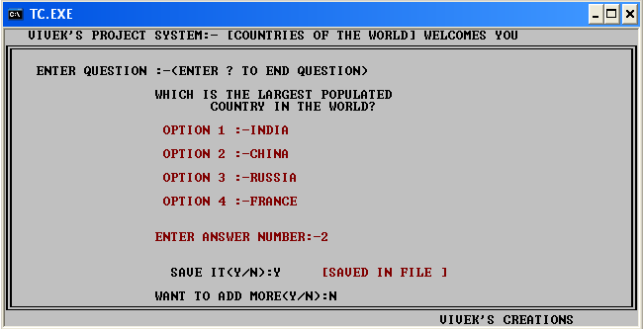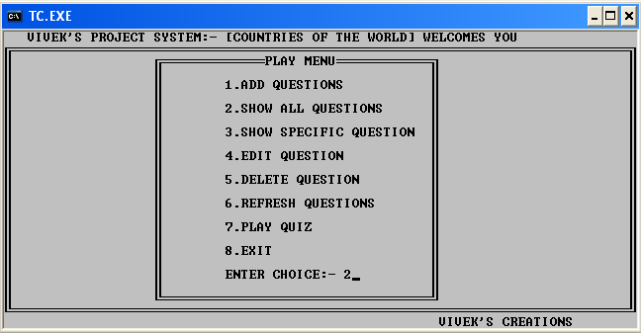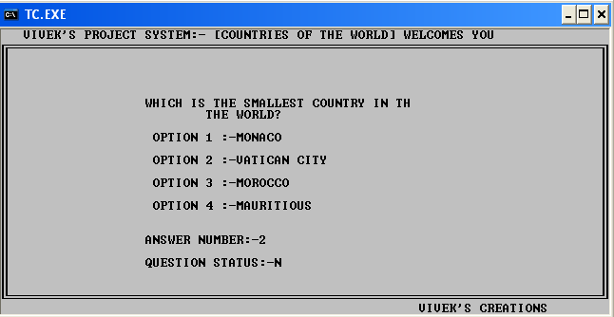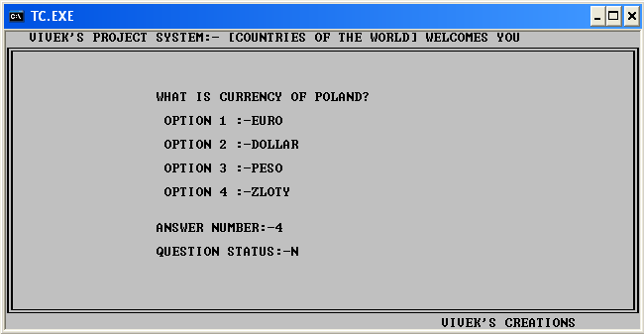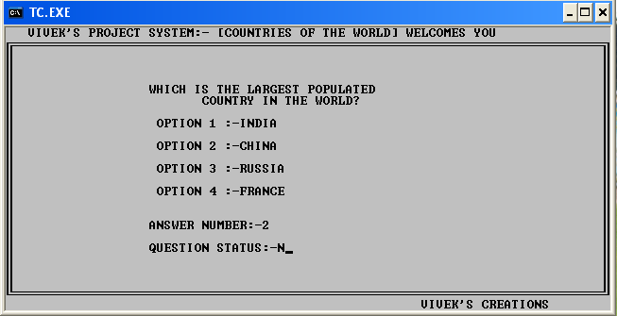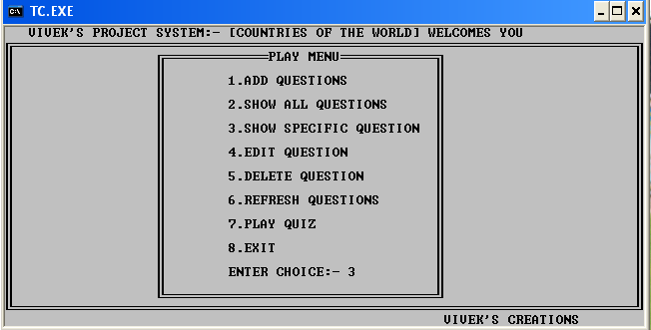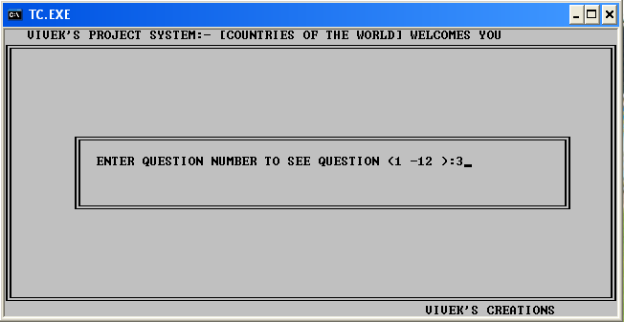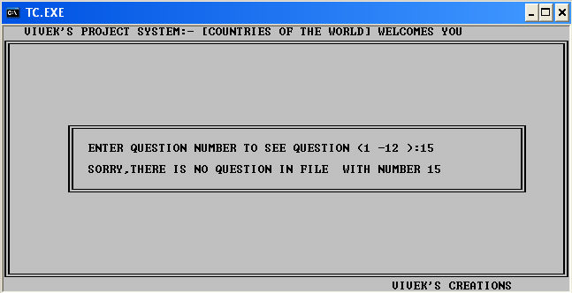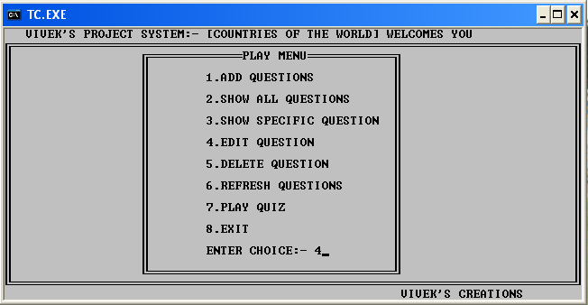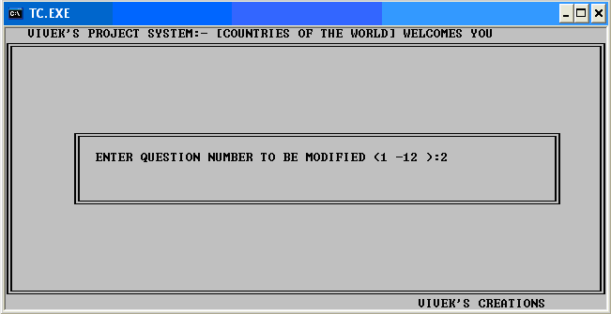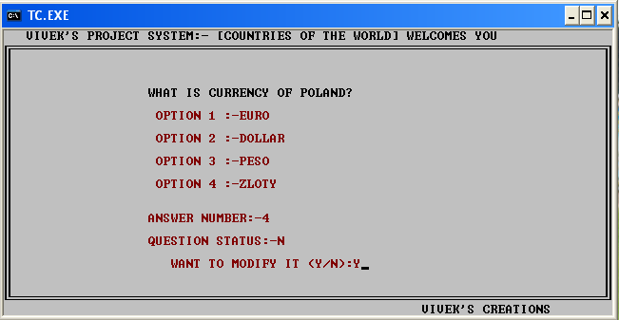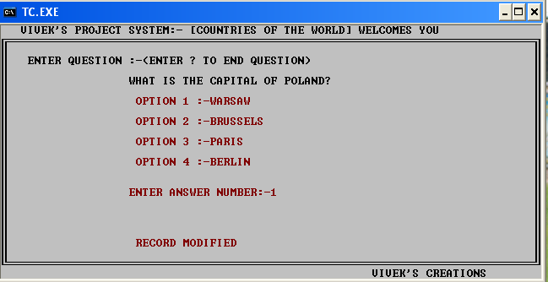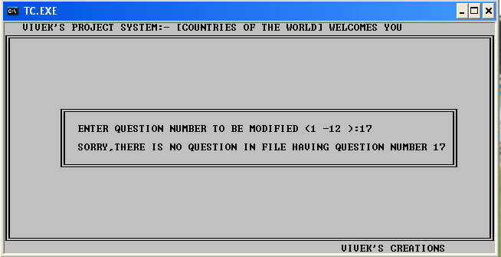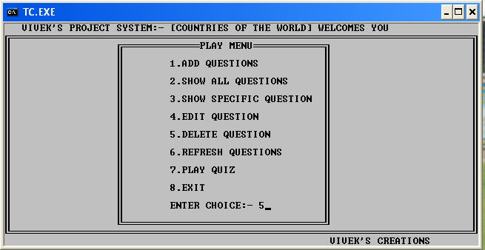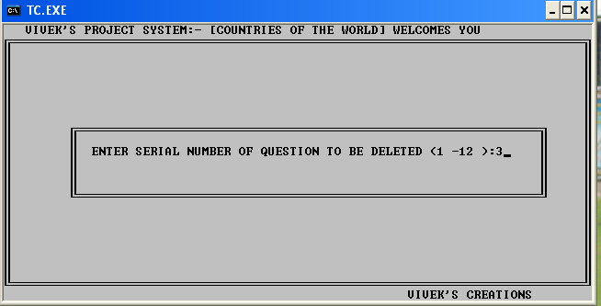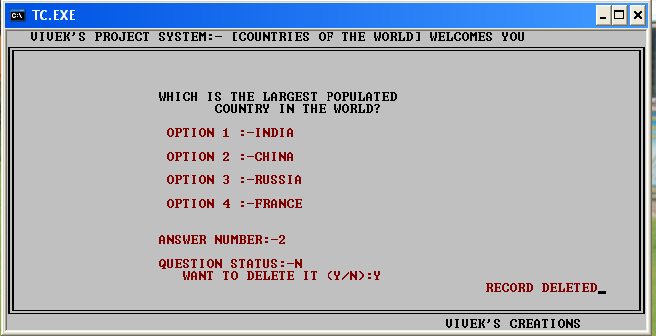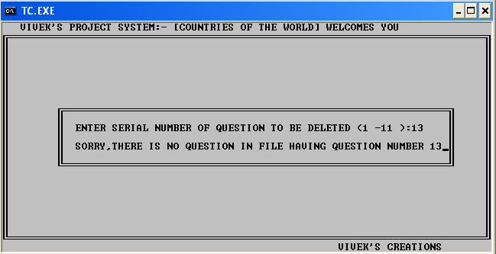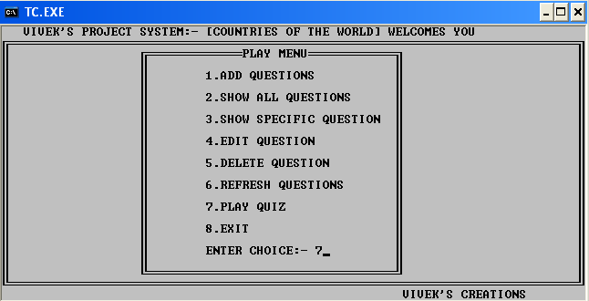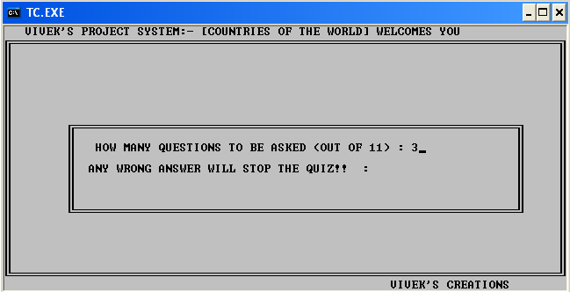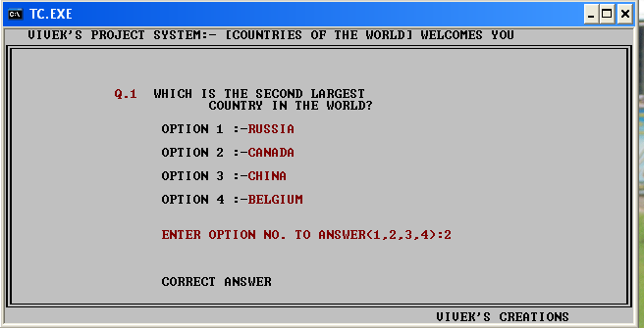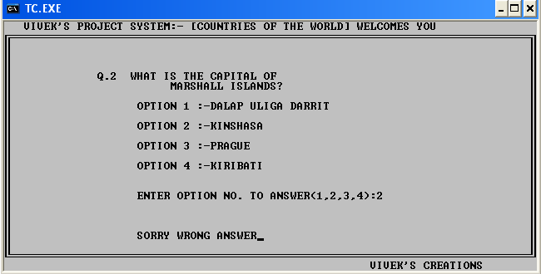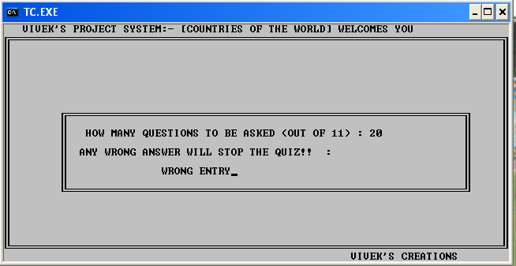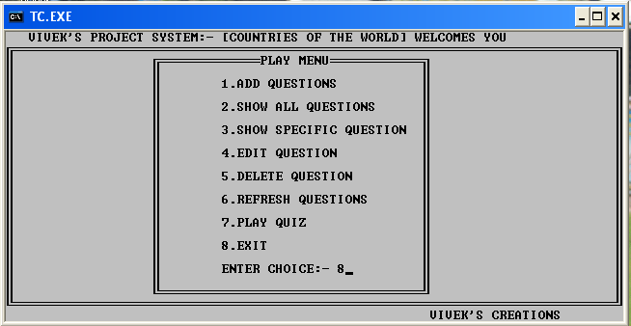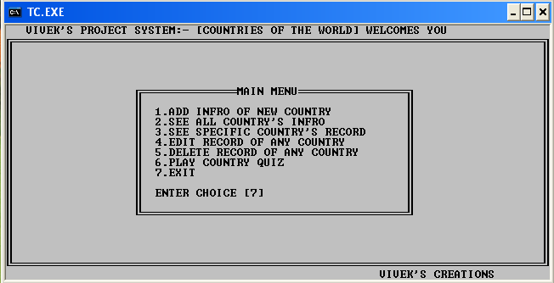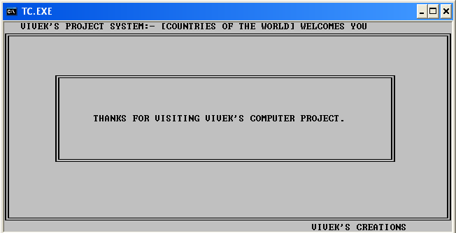
Conclusion

This project file deals with my successful representation of c++ program based on data file handling consisting file containing records of countries.
I think this project would be liked by my teacher and my
Friends.

Bibliography

I collected most of the data of the project from the following sources:-

- From class teacher
- Classmates & friends.
- Computer science text book – class XII.
- Own knowledge.

