For the attached data set, detailed analysis of the data frame can be shown as below:

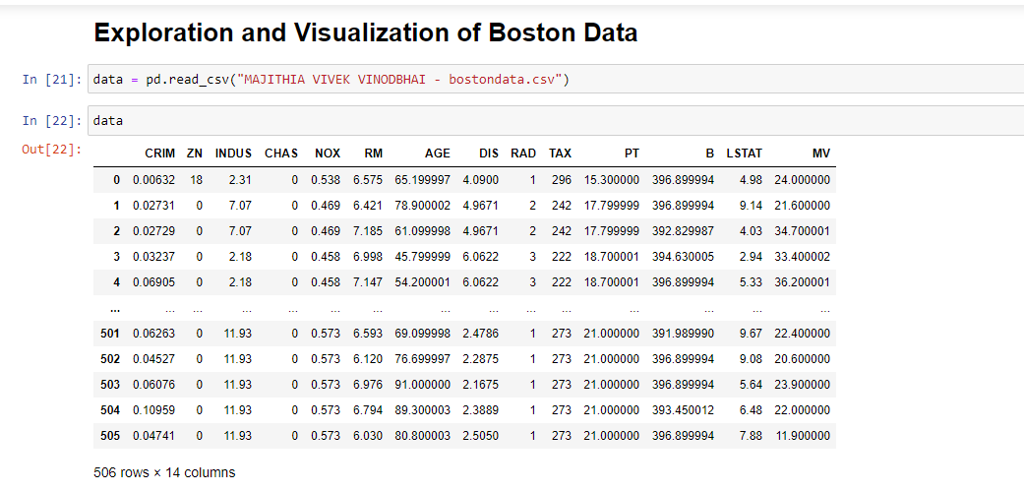

1. Remove unwanted characters and clean it

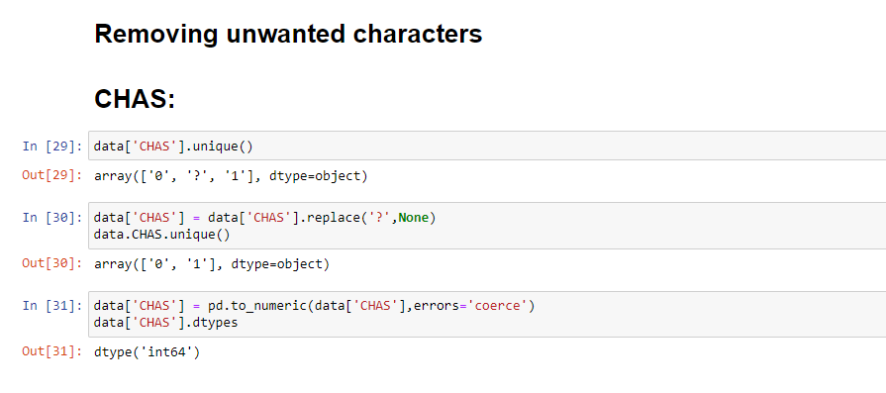

1. Do analysis of the data frame and see different properties of the data frame

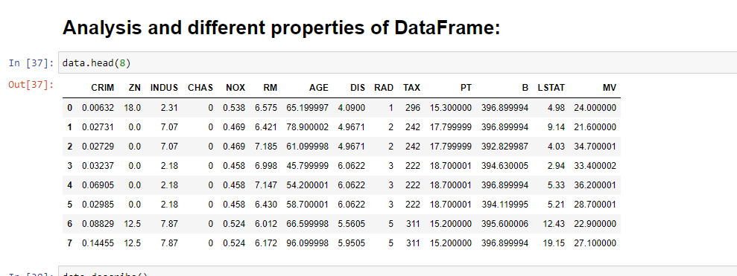

1. Slice the data frame for some rows and some columns

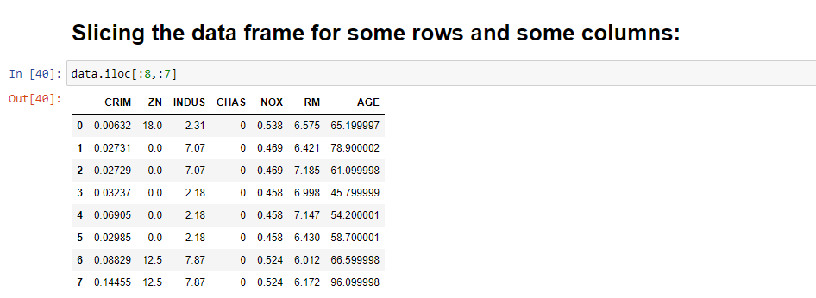

1. Select a few rows and columns based on conditions like in SQL for databases

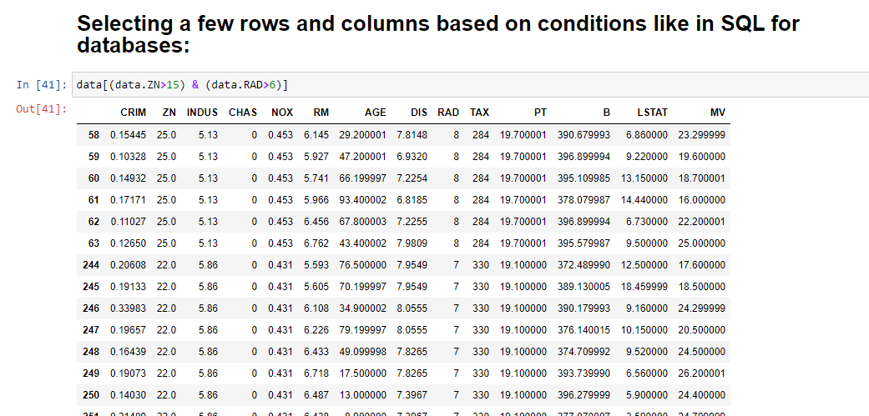

1. Do analysis of discrete variables including mode

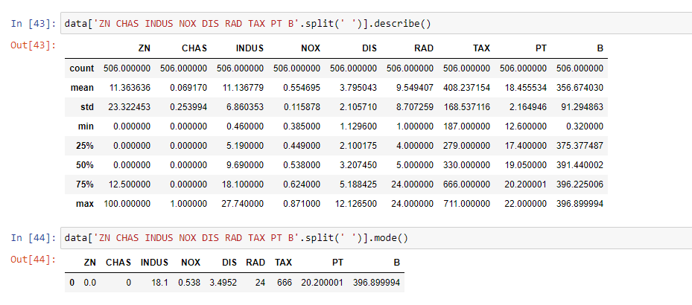

1. Do detailed descriptive analytics of continuous variables including max min variance mean median std and at least five percentiles

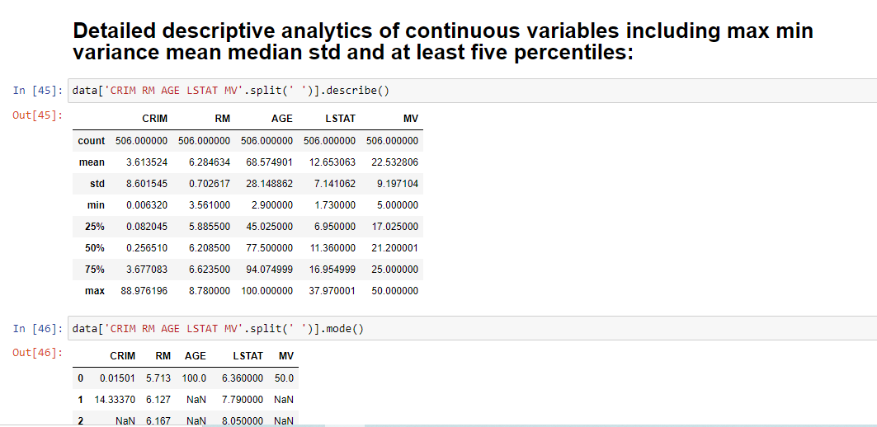

1. Draw univariate plots for discrete columns and continuous columns

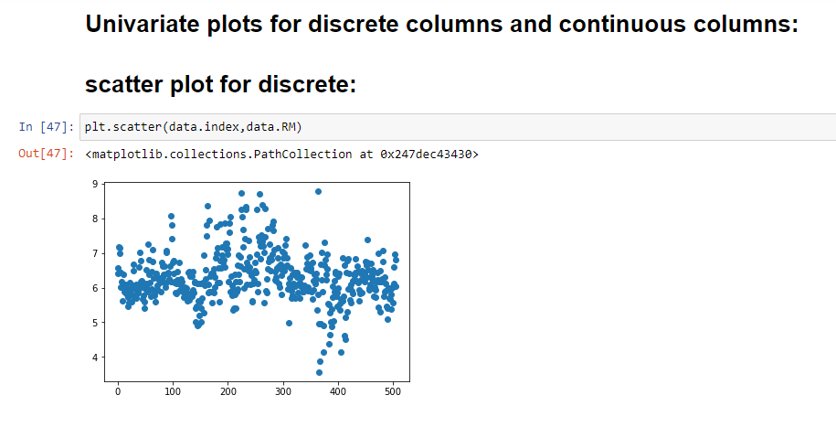

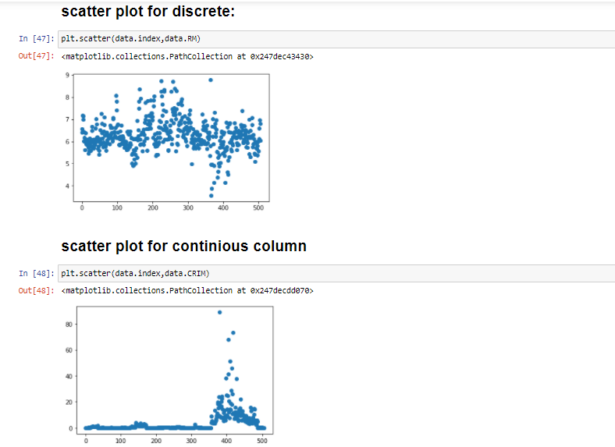

1. Draw a bivariate plot for two continuous columns

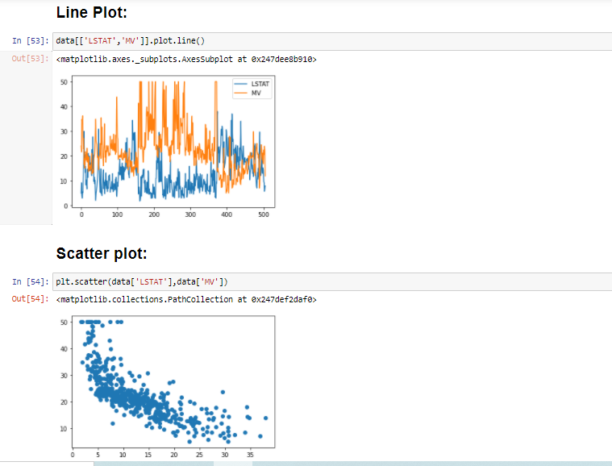

1. Find if the continuous columns have outliers using boxplot

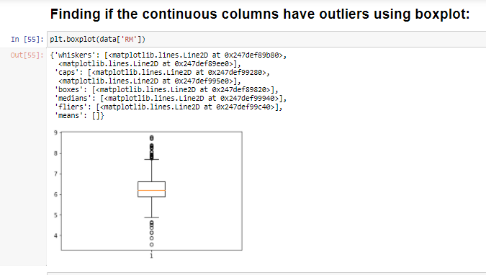

1. Derive a linear regression between MV as output variable and other variables. Print mse and r square. Do with different test sizes.

