# Ridge Regression:

## 5-Fold cross validation (alpha=0.01, solver = Stochastic Gradient Descent):

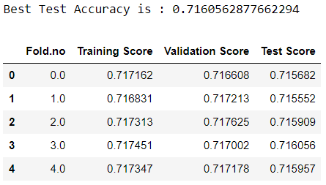

## Confusion Matrix for model in 4th validation:

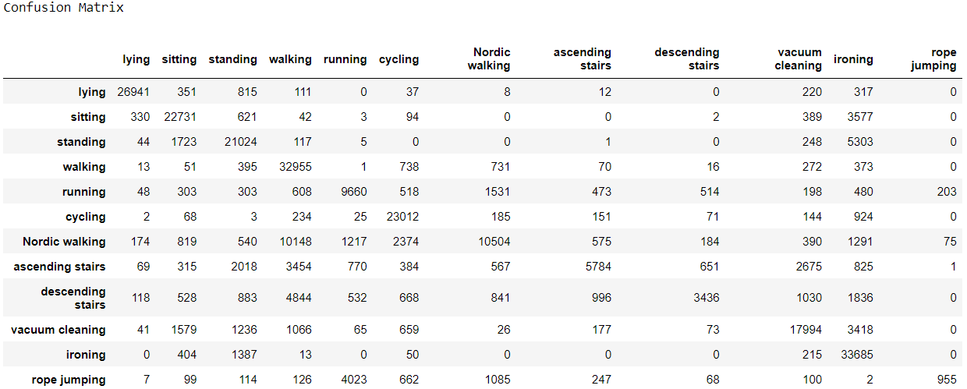

# Logistic Regression:

## 5-Fold cross validation (C=0.01, solver = Stochastic Gradient Descent):

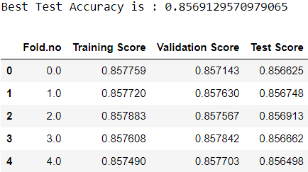

## Confusion Matrix for model in 3rd validation:

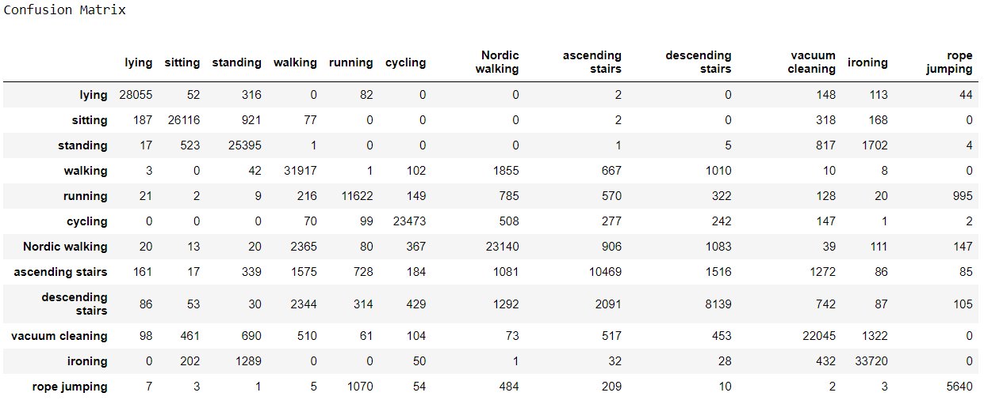

# Decision Tree:

## 5-Fold cross validation (max depth=15):

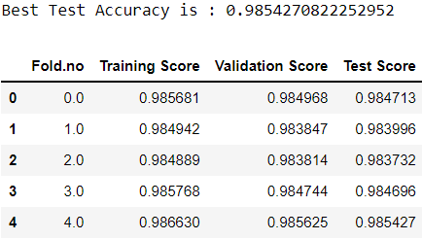

## Confusion Matrix for model in 5th validation:

