HTML -13-07-2024

Webpage poc

Explanation-If a person want to sell his car and want to see the vehicles available to buy the cars can access the webpage gadibecho.com.It consist of interlink of four webpages for different purposes connected in navbar.

Name of website-Gadibecho.com

Html pages-4

1)home.html-base page of website

2)sell.html-gets the details of seller about his car and condition

3)enquiry.html-can see the cars which are ready to buy in a location

4)support.html-get the contact support

Cognine.html

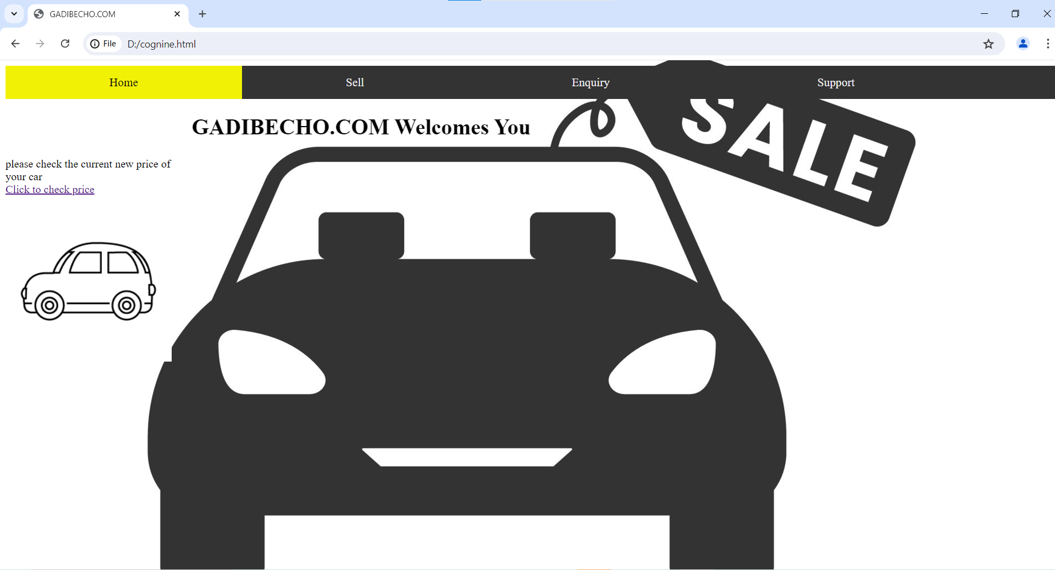

Sell.html

Enquiry.html

Support.html

