RepoMind MCP Assistant
System Design Document
repomind | v1.1 | Python + React
May 26, 2026

Scenario:

Your engineering team manages a GitHub codebase. During development, team members manually navigate repositories, read file contents, identify code quality issues, and push changes — often switching between GitHub, editors, and review tools. This is time-consuming and error-prone.

The RepoMind MCP Assistant integrates GitHub with an AI agent (Claude), enabling developers to ask questions like "Show me the current code for auth.py" or "Review this file and suggest improvements" — and receive real-time, intelligent assistance without leaving a single interface.

Beyond reading, the system supports key write actions such as proposing revised code, editing proposals interactively, and pushing approved changes back to GitHub through a mandatory human-approval gate.

Part 1: Problem Analysis and Architecture

1.1 The Problem — Why Not Call GitHub API Directly?
Every modern development tool that wants GitHub data must build its own integration, handle its own authentication, deal with pagination, base64 decoding, SHA management, and repeat all that work separately. This is called API fragmentation.

MCP solves this by placing one server between the AI and GitHub. The server handles all complexity. Any MCP-compatible host can connect to it without knowing anything about GitHub's REST API internals.

Here is what the MCP approach adds over a direct GitHub API call:
- The AI receives clean, decoded file content instead of raw base64 JSON that wastes context window space.
- GitHub credentials (PAT) are stored once in the server, not in every AI application.
- When the GitHub API changes, only the server needs updating — not every AI tool.
- The server enforces a human approval gate before any write operation executes — something a direct API call cannot do.
- Any MCP-compatible host (Claude Desktop, VS Code, others) can reuse the same server immediately.

1.2 Who Benefits and How
Developer — Backend Engineer
The developer opens a repository, clicks a file, and reads its current content in a Monaco editor without navigating GitHub's web UI. They can ask Claude to review the file against internal coding standards and receive structured feedback. After reviewing the AI's proposed changes, they approve the push — all from one interface.

Team Lead — Engineering Lead
The team lead previously opened GitHub, found the file, copied code into an external review tool, and manually tracked feedback. Now they click Ask Agent To Review. Claude calls the review tool, loads internal policy documents (coding standards, security guidelines, Python best practices), and produces a structured review. The lead approves proposed code changes and pushes — with a double confirmation layer preventing accidental writes.

Security Reviewer
The security reviewer runs the repository security scan tool, which checks root-level Python files for risky patterns such as eval(), os.system(), and hardcoded API key strings. The same scan can be run against the latest commit to catch newly introduced risks before they are merged.

1.3 Architecture — Full Flow
The four-layer architecture below shows how a user action becomes a GitHub API call:

Layer | Component | Role
Layer 1 | React Frontend (Host) | User interface: repository browser, Monaco editor, chat approval panel, code-change modal. Sends messages and approval decisions to the bridge.
 | Communication: HTTP Fetch API
Layer 2 | FastAPI Bridge | HTTP bridge. Manages chat sessions, pending tool lifecycle, approval decisions, and response shaping for the frontend.
 | Communication: MCP stdio (subprocess)
Layer 3 | MCP Server (FastMCP) | Core engineering logic. Implements MCP tools for GitHub browsing, file read/write, code review, and security scanning. Uses Groq for AI reasoning.
 | Communication: HTTPS REST + Groq API
Layer 4 | GitHub REST API + Groq | GitHub Contents API for read/write operations. Groq LLM for review generation and code change proposals.

1.4 Direct API Plugin vs MCP Server Approach
Criteria | Direct GitHub API Plugin | MCP Server Approach
Reusability | Tied to one host app. Every new tool needs a fresh GitHub integration. | One server works with all MCP-compatible hosts — Claude Desktop, VS Code, and others.
Security | GitHub PAT must be stored in every app that calls the API. | Credentials stored once in the server. The host never sees raw tokens.
Maintenance | Any GitHub API change requires updating every integration separately. | Update the server once; all connected hosts benefit immediately.
Human Approval | No built-in way to pause and ask the user before writing data. | Approval-first design: every write tool requires explicit user confirmation before execution.
AI Response Quality | AI receives raw base64 JSON. It must decode and parse file structures itself. | Server decodes, normalises, and returns clean content. The AI gets usable answers.
Testing | No standard test tools. Custom setup needed for each integration. | MCP Inspector provides a ready-made visual testing interface for all tools.
Error Handling | Each app handles GitHub errors (401, 404, 422, rate limits) its own way. | Error handling is centralised in the server and consistent across all clients.

Part 2: Environment Setup

2.1 Project Initialisation
The project is built in Python (backend) and React (frontend) using FastMCP for the MCP server layer. Source files are organised under app/ with sub-packages for agents, tools, resources, server, and utils. The frontend lives under frontend/src/.

2.2 Empty Server (main.py)
An initial MCP server was created with:
- Name: RepoMind MCP Assistant
- Transport: stdio (subprocess spawned by bridge_api.py)

This confirms that the server starts and registers tools before any features are added.

2.3 MCP Inspector — Successful Connection
The MCP Inspector was used to verify server startup and tool registration.

What MCP Inspector provides:
- Connect to any MCP server
- View all registered tools and resources
- Test tool calls manually with custom inputs
- Debug server responses and error output

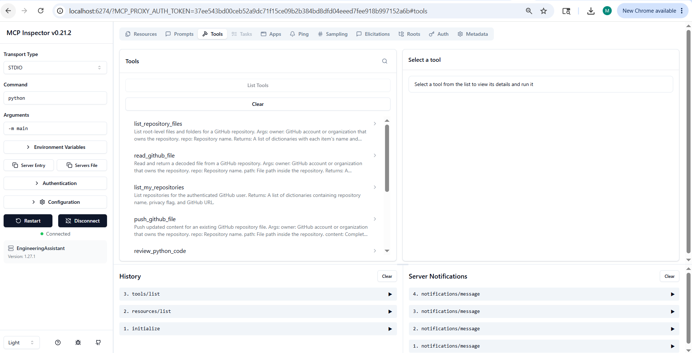

2.4 Claude Desktop Configuration
The MCP server is also compatible with Claude Desktop via claude_desktop_config.json. This allows Claude to interact with the server and call all registered tools directly from the chat interface without the React frontend.

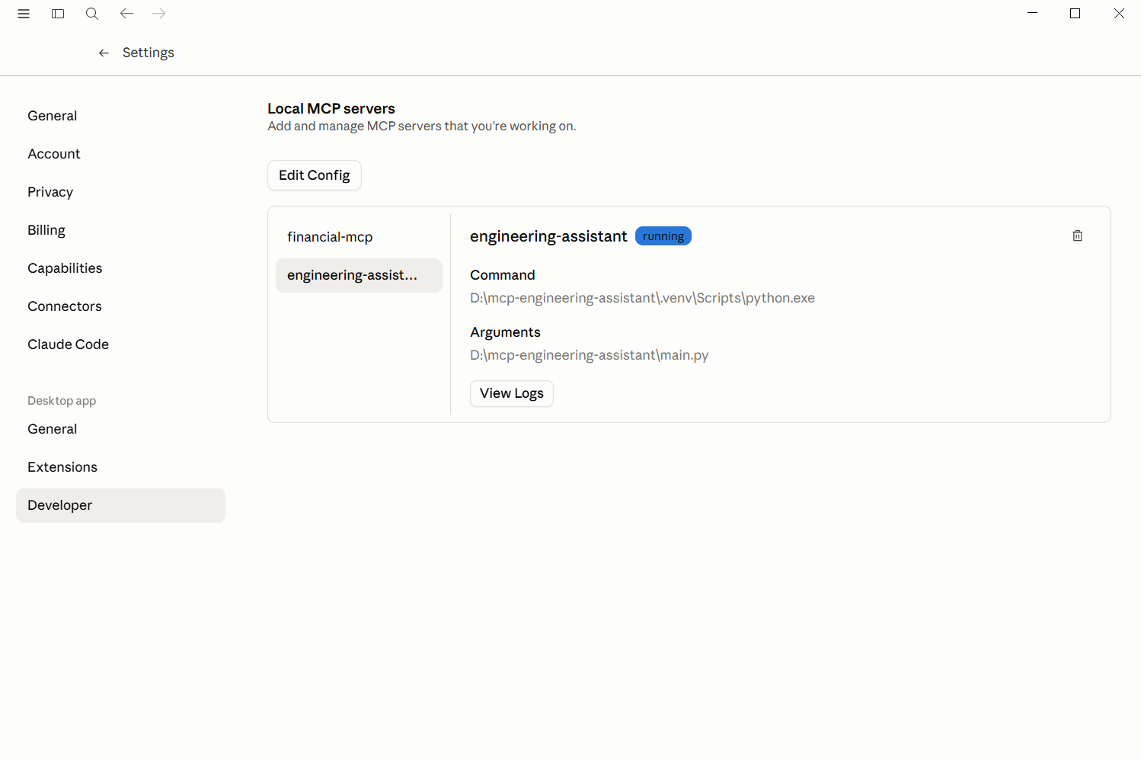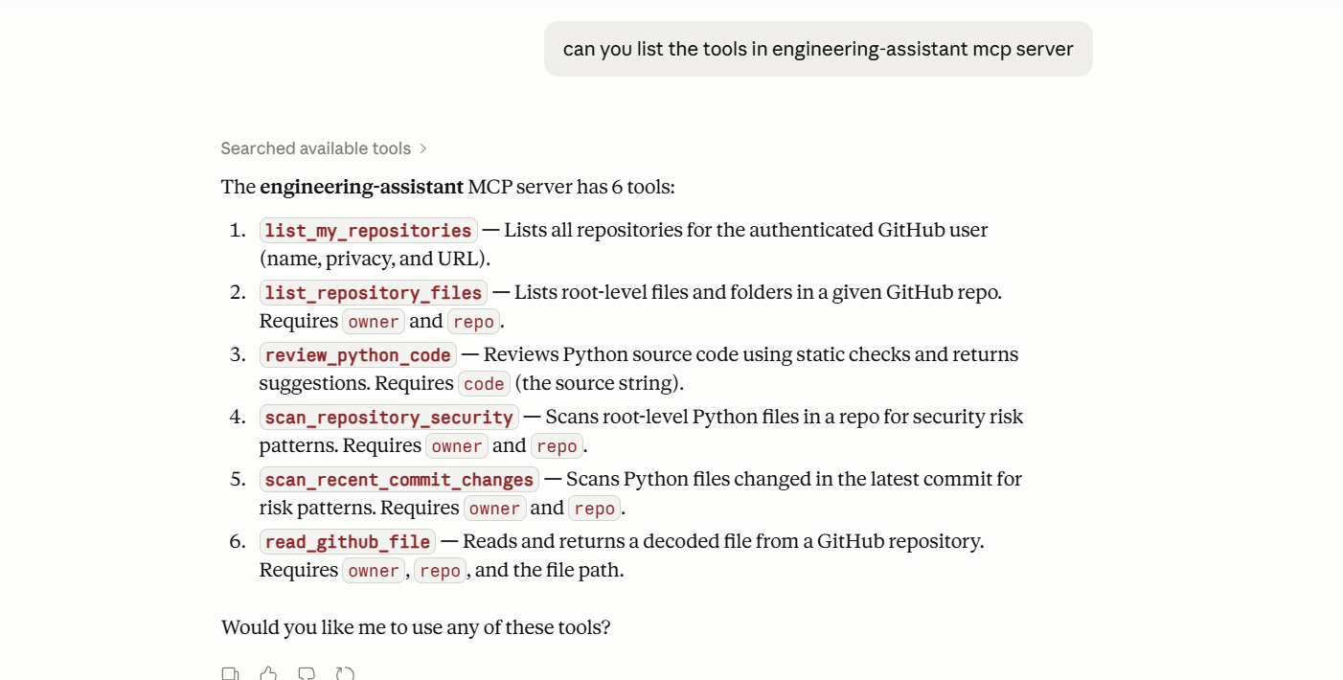

2.5 Setup Issues and Resolutions
# | Issue | Cause | Resolution
1 | FastAPI CORS errors — frontend could not reach the bridge. | Default FastAPI has no CORS headers. | Added CORSMiddleware with allow_origins=["*"] for local development.
2 | MCP tool discovery failed — agent reported no tools available. | bridge_api.py spawned python -m main but the module path was wrong. | Fixed working directory and module path. Used python main.py as the subprocess command.
3 | GitHub API returned 422 on push — SHA mismatch. | update_github_file was computing SHA locally instead of fetching the current file SHA from GitHub first. | Updated github_client.py to always fetch the current file SHA via GET before the PUT commit.
4 | Groq model returned <think> blocks and markdown fences in code output. | Reasoning models emit chain-of-thought blocks that are not valid Python. | Added sanitisation in the agent layer to strip <think>...</think> and markdown code fences before returning changed_code to the frontend.
5 | Monaco editor showed stale code after push. | App.jsx did not update the code state after push_github_file completed. | Agent now returns pushed_file content; frontend sets code state from pushed_file on success.

2.6 How to Run the Project
Backend:
- Create and activate a virtual environment: python -m venv venv && venv\scripts\activate
- Install dependencies: pip install -r requirements.txt
- Create a .env file with GITHUB_TOKEN, GROQ_API_KEY, and optionally GROQ_MODEL
- Start the FastAPI bridge: uvicorn bridge_api:app --reload --port 8000

Frontend:
- Navigate to the frontend directory: cd frontend
- Install dependencies: npm install
- Start the dev server: npm run dev
- Open http://localhost:5173 in a browser

Using MCP Inspector (optional):
- Run: npx @modelcontextprotocol/inspector python main.py
- Open the Inspector UI and connect to verify tool registration
- Test individual tools such as list_repository_files or review_python_code manually

Part 3: Resources Design

Resources are read-only data endpoints the MCP server exposes. They do not run code or change anything — they return structured data. In this project, resources expose the local review policy documents that guide the AI's code review behaviour.

3.1 Resource 1 — coding://standards
Field | Value
URI | coding://standards
MIME Type | text/plain
Description | Returns the full contents of coding_standards.md — the internal coding style rules and structure expectations used by the review tool to evaluate Python code quality.

Response:
{
"contents": [
{
"uri": "standards://coding",
"mimeType": "text/plain",
"text": "# Python Coding Standards\n\n- Follow PEP8\n- Use type hints\n- Prefer async for I/O operations\n- Keep functions small and reusable\n- Avoid deeply nested loops\n- Use meaningful variable names\n- Add docstrings for public functions\n- Use logging instead of print\n- Avoid hardcoded values"
}
]
}

3.2 Resource 2 — security://guidelines
Field | Value
URI | security://guidelines
MIME Type | text/plain
Description | Returns the contents of security_guidelines.md — risk patterns and security rules the review tool checks for, including dangerous function calls, hardcoded credentials, and insecure patterns.

Response:
{
"contents": [
{
"uri": "standards://python",
"mimeType": "text/plain",
"text": "# Python Best Practices\n\n- Use virtual environments\n- Prefer pathlib over os.path\n- Write unit tests\n- Use dependency injection\n- Avoid global mutable state\n- Use async for network operations\n- Keep modules focused\n- Use structured logging"
}
]
}

3.3 Resource 3 — python://best-practices
Field | Value
URI | python://best-practices
MIME Type | text/plain
Description | Returns the contents of python_best_practices.md — Pythonic idiom, type hinting, error handling patterns, and quality standards used to guide both code review and code change proposals.

Example response (excerpt):
{
"contents": [
{
"uri": "standards://python",
"mimeType": "text/plain",
"text": "# Python Best Practices\n\n- Use virtual environments\n- Prefer pathlib over os.path\n- Write unit tests\n- Use dependency injection\n- Avoid global mutable state\n- Use async for network operations\n- Keep modules focused\n- Use structured logging"
}
]
}

3.4 Resource 4 — review://constraints
Field | Value
URI | review://constraints
MIME Type | text/plain
Description | Returns the contents of review_constraints.md — hard constraints the review and code change tools must respect: preserve runtime behaviour, routes, API responses, and config-driven behaviour. Forbids unnecessary rewrites.

Example response (excerpt):
{
"contents": [
{
"uri": "standards://review_constraints",
"mimeType": "text/plain",
"text": "# Review Constraints\n\n- Preserve existing runtime behavior\n- Preserve API response formats\n- Preserve endpoint routes\n- Preserve configuration-driven behavior\n- Avoid breaking changes\n- Do not hardcode configurable values\n- Preserve authentication behavior unless explicitly unsafe\n- Do not remove features unless explicitly requested\n- Prefer minimal safe fixes over architectural rewrites"
}
]
}

3.5 How Resources Restrict Review Behaviour
Resources in this project act as a policy boundary for the AI. Instead of relying on the LLM's general knowledge of "good code", the review tool explicitly loads all four policy resources before calling Groq. This ensures:
- Review feedback is scoped to this project's agreed standards, not generic best practices.
- The LLM cannot hallucinate constraints that are not in the policy files.
- Updating a policy file (e.g., adding a new security rule) immediately changes review behaviour without touching any Python code.
- The review prompt explicitly forbids code examples and revised code blocks in review output — the constraints resource reinforces this.

Part 4: Tools Design

Tools are actions the AI can request. Unlike resources, tools can call external services and write data. Each tool in this project is registered with the FastMCP instance. The frontend's approval workflow ensures no tool executes without explicit user confirmation.

Tool 1 — list_my_repositories
Field | Value
Name | list_my_repositories
Category | GitHub
Description | Lists all repositories accessible to the configured GITHUB_TOKEN. Returns repository names, visibility, and URLs. This is a read-only tool and does not modify any data.
Parameters | None — uses GITHUB_TOKEN from environment

Example response:
{
"repositories": [
{ "name": "repomind", "visibility": "private", "url": "https://github.com/user/repomind" },
{ "name": "api-service", "visibility": "private", "url": "https://github.com/user/api-service" }
]
}

Tool 2 — list_repository_files
Field | Value
Name | list_repository_files
Category | GitHub
Description | Lists root-level files and folders for a given owner/repo. Returns name, path, and type (file or dir) for each entry. This is a read-only tool used to populate the sidebar file tree.
Parameters | owner (string), repo (string)

Example response:
{
"tools": [
{
"name": "list_repository_files",
"description": "List root-level files and folders for a GitHub repository.\n\n Args:\n owner: GitHub account or organization that owns the repository.\n repo: Repository name.\n\n Returns:\n A list of dictionaries with each item's name and GitHub content type.\n ",
"inputSchema": {
"type": "object",
"properties": {
"owner": {
"title": "Owner",
"type": "string"
},
"repo": {
"title": "Repo",
"type": "string"
}
},
"required": [
"owner",
"repo"
],
"title": "list_repository_filesArguments"
}
},
{
"name": "read_github_file",
"description": "Read and return a decoded file from a GitHub repository.\n\n Args:\n owner: GitHub account or organization that owns the repository.\n repo: Repository name.\n path: File path inside the repository.\n\n Returns:\n A dictionary containing the file name, path, and decoded content.\n ",
"inputSchema": {
"type": "object",
"properties": {
"owner": {
"title": "Owner",
"type": "string"
},
"repo": {
"title": "Repo",
"type": "string"
},
"path": {
"title": "Path",
"type": "string"
}
},
"required": [
"owner",
"repo",
"path"
],
"title": "read_github_fileArguments"
}
},
{
"name": "list_my_repositories",
"description": "List repositories for the authenticated GitHub user.\n\n Returns:\n A list of dictionaries containing repository name, privacy flag, and\n GitHub URL.\n ",
"inputSchema": {
"type": "object",
"properties": {},
"title": "list_my_repositoriesArguments"
}
},
{
"name": "push_github_file",
"description": "Push updated content for an existing GitHub repository file.\n\n Args:\n owner: GitHub account or organization that owns the repository.\n repo: Repository name.\n path: File path inside the repository.\n content: Complete updated file content to commit.\n commit_message: Commit message for the GitHub update.\n branch: Optional branch name. When omitted, GitHub uses default branch.\n\n Returns:\n Commit metadata and the pushed file content.\n ",
"inputSchema": {
"type": "object",
"properties": {
"owner": {
"title": "Owner",
"type": "string"
},
"repo": {
"title": "Repo",
"type": "string"
},
"path": {
"title": "Path",
"type": "string"
},
"content": {
"title": "Content",
"type": "string"
},
"commit_message": {
"title": "Commit Message",
"type": "string"
},
"branch": {
"anyOf": [
{
"type": "string"
},
{
"type": "null"
}
],
"default": null,
"title": "Branch"
}
},
"required": [
"owner",
"repo",
"path",
"content",
"commit_message"
],
"title": "push_github_fileArguments"
}
},
{
"name": "review_python_code",
"description": "Review Python code using local standards and AI reasoning.\n\n Args:\n code: Python source code.\n\n Returns:\n AI-generated review response.\n ",
"inputSchema": {
"type": "object",
"properties": {
"code": {
"title": "Code",
"type": "string"
}
},
"required": [
"code"
],
"title": "review_python_codeArguments"
}
},
{
"name": "propose_python_code_changes",
"description": "Generate a revised Python file proposal safely.\n\n Args:\n code: Original Python source code.\n review: AI review feedback.\n\n Returns:\n Revised code proposal.\n ",
"inputSchema": {
"type": "object",
"properties": {
"code": {
"title": "Code",
"type": "string"
},
"review": {
"title": "Review",
"type": "string"
}
},
"required": [
"code",
"review"
],
"title": "propose_python_code_changesArguments"
}
},
{
"name": "scan_repository_security",
"description": "Scan root-level Python files in a repository for simple risk patterns.\n\n Args:\n owner: GitHub account or organization that owns the repository.\n repo: Repository name.\n\n Returns:\n A list of security findings. Each finding contains a file and issue.\n ",
"inputSchema": {
"type": "object",
"properties": {
"owner": {
"title": "Owner",
"type": "string"
},
"repo": {
"title": "Repo",
"type": "string"
}
},
"required": [
"owner",
"repo"
],
"title": "scan_repository_securityArguments"
}
},
{
"name": "scan_recent_commit_changes",
"description": "Scan Python files changed in the latest commit for risk patterns.\n\n Args:\n owner: GitHub account or organization that owns the repository.\n repo: Repository name.\n\n Returns:\n A status dictionary containing the latest commit SHA, scanned files,\n and any findings.\n ",
"inputSchema": {
"type": "object",
"properties": {
"owner": {
"title": "Owner",
"type": "string"
},
"repo": {
"title": "Repo",
"type": "string"
}
},
"required": [
"owner",
"repo"
],
"title": "scan_recent_commit_changesArguments"
}
}
]
}
Note: Current limitation: root-level listing only. Nested folder browsing is not yet implemented.

Tool 3 — read_github_file
Field | Value
Name | read_github_file
Category | GitHub
Description | Reads a specific file from GitHub using the Contents API. Decodes base64 content server-side and returns the raw file text. This is a read-only tool that populates the Monaco editor.
Parameters | owner (string), repo (string), path (string)

Example response:
{
"content": [
{
"type": "text",
"text": "{\n \"name\": \"function_app.py\",\n \"path\": \"function_app.py\",\n \"content\": \"import azure.functions as func\\nimport json\\nimport logging\\nimport datetime\\nimport random\\nimport config\\nimport os\\n\\n# ----------------------------------------\\n# TEMPORARY TEST SECURITY ISSUES\\n# (Only for MCP scanner testing)\\n# ----------------------------------------\\n\\nAPI_KEY = \\\"my-secret-api-key\\\"\\n\\napp = func.FunctionApp()\\n\\n# In-memory OTP store\\n# Format: { \\\"user\\\": (otp, expiry_time) }\\notp_store = {}\\n\\n\\n@app.route(route=\\\"generate-otp\\\", auth_level=func.AuthLevel.ANONYMOUS)\\ndef generate_otp(req: func.HttpRequest) -> func.HttpResponse:\\n \\\"\\\"\\\"\\n HTTP Trigger: Generate OTP for a user.\\n\\n Query Params:\\n user (str): Optional user identifier.\\n\\n Returns:\\n JSON response containing OTP and expiry time.\\n \\\"\\\"\\\"\\n\\n user = req.params.get(\\\"user\\\", \\\"default\\\")\\n\\n # ----------------------------------------\\n # TEMPORARY INSECURE CODE FOR TESTING\\n # ----------------------------------------\\n\\n result = eval(\\\"2 + 2\\\")\\n\\n os.system(\\\"dir\\\")\\n\\n logging.info(\\\"Eval result = %s\\\", result)\\n\\n # ----------------------------------------\\n\\n otp = str(random.randint(1000, 9999))\\n\\n expiry = datetime.datetime.utcnow() + datetime.timedelta(\\n minutes=config.OTP_EXPIRY_MINUTES\\n )\\n\\n otp_store[user] = (otp, expiry)\\n\\n logging.info(\\\"Generated OTP for user=%s\\\", user)\\n\\n return func.HttpResponse(\\n json.dumps(\\n {\\n \\\"user\\\": user,\\n \\\"otp\\\": otp,\\n \\\"expires_at\\\": expiry.isoformat()\\n }\\n ),\\n mimetype=\\\"application/json\\\",\\n status_code=200\\n )\\n\\n\\n@app.route(route=\\\"otps\\\", auth_level=func.AuthLevel.ANONYMOUS)\\ndef view_otps(req: func.HttpRequest) -> func.HttpResponse:\\n \\\"\\\"\\\"\\n HTTP Trigger: Retrieve all active OTPs.\\n\\n Returns:\\n JSON response containing all OTPs with expiry timestamps.\\n \\\"\\\"\\\"\\n\\n data = {\\n user: {\\n \\\"otp\\\": otp,\\n \\\"expires_at\\\": expiry.isoformat()\\n }\\n for user, (otp, expiry) in otp_store.items()\\n }\\n\\n logging.info(\\\"Fetched %d OTP entries\\\", len(data))\\n\\n return func.HttpResponse(\\n json.dumps(data),\\n mimetype=\\\"application/json\\\",\\n status_code=200\\n )\\n\\n\\n@app.timer_trigger(\\n schedule=\\\"%TIMER_SCHEDULE%\\\",\\n arg_name=\\\"timer\\\"\\n)\\ndef cleanup_otps(timer: func.TimerRequest) -> None:\\n \\\"\\\"\\\"\\n Timer Trigger: Cleanup expired OTPs.\\n\\n Runs on configured CRON schedule and removes OTPs\\n whose expiry time has passed.\\n \\\"\\\"\\\"\\n\\n now = datetime.datetime.utcnow()\\n\\n expired_users = []\\n\\n for user, (otp, expiry) in otp_store.items():\\n\\n if expiry < now:\\n\\n expired_users.append(user)\\n\\n for user in expired_users:\\n\\n del otp_store[user]\\n\\n if expired_users:\\n\\n logging.info(\\n \\\"Removed expired OTPs: %s\\\",\\n expired_users\\n )\\n\\n else:\\n\\n logging.info(\\n \\\"No expired OTPs found\\\"\\n )\"\n}"
}
],
"isError": false
}

Tool 4 — push_github_file
Field | Value
Name | push_github_file
Category | GitHub
Description | Pushes edited file content back to GitHub using the Contents API PUT endpoint. Fetches the current file SHA, base64-encodes the updated content, and commits the change. This tool modifies GitHub data and requires user confirmation before it runs.
Parameters | owner (string), repo (string), path (string), content (string), commit_message (string), branch (string, optional)

Example response:
{
"content": [
{
"type": "text",
"text": "{\n \"owner\": \"vivekmantur\",\n \"repo\": \"VivekFunctionApp\",\n \"path\": \"requirements.txt\",\n \"branch\": null,\n \"commit_sha\": \"c2a61a32348d34eca62c20db4865d0bec8db159d\",\n \"commit_url\": \"https://github.com/vivekmantur/VivekFunctionApp/commit/c2a61a32348d34eca62c20db4865d0bec8db159d\",\n \"content\": \"# Uncomment to enable Azure Monitor OpenTelemetry\\n# Ref: aka.ms/functions-azure-monitor-python \\n# azure-monitor-opentelemetry \\n\\nazure-functions\",\n \"message\": \"updated requirements.txt\"\n}"
}
],
"isError": false
}
Note: Push requires two confirmations: browser confirm() dialog and MCP approval card click.

Tool 5 — review_python_code
Field | Value
Name | review_python_code
Category | Review
Description | Reviews Python code using all four local policy resources (coding standards, security guidelines, Python best practices, review constraints) plus Groq LLM reasoning. Returns structured review feedback. The review prompt explicitly forbids code examples and revised code blocks in output.
Parameters | code (string) — full Python file content

Example response:
{
"content": [
{
"type": "text",
"text": "{\n \"resources_used\": [\n \"coding_standards\",\n \"security_guidelines\",\n \"python_best_practices\",\n \"review_constraints\"\n ],\n \"review\": \"1. Summary \\nThe code contains multiple security vulnerabilities and code quality issues. Key problems include unsafe use of `eval()` and `os.system()`, hardcoded secrets, and insecure API endpoint configurations. The code violates security best practices and requires immediate fixes to mitigate risks.\\n\\n2. Findings \\n**Security Issues** \\n- Hardcoded API key (`API_KEY = \\\"my-secret-api-key\\\"`) violates secret management standards \\n- Unsafe use of `eval(\\\"2 + 2\\\")` introduces arbitrary code execution risk \\n- Use of `os.system(\\\"dir\\\")` exposes command injection vulnerability \\n- Anonymous access (`auth_level=func.AuthLevel.ANONYMOUS`) for OTP generation endpoint \\n- Exposes all OTPs in `/otps` endpoint (potential data leakage) \\n\\n**Code Quality Issues** \\n- Missing type hints on function parameters/returns \\n- Global mutable state (`otp_store`) without thread safety \\n- No input validation for `user` parameter \\n- Hardcoded configuration values (e.g., `config.OTP_EXPIRY_MINUTES` should be environment variables) \\n- No structured logging implementation \\n\\n**Best Practice Violations** \\n- Uses `os.system()` instead of `subprocess` module \\n- No async I/O for HTTP operations \\n- No input sanitization for query parameters \\n- Excessive logging of sensitive data (OTP values) \\n\\n3. Recommended Fixes \\n**Security Fixes** \\n- Remove `eval()` usage entirely (insecure by design) \\n- Replace `os.system()` with `subprocess.run()` with proper argument sanitization \\n- Migrate hardcoded `API_KEY` to environment variables with secure loading \\n- Add authentication requirement to `/generate-otp` endpoint \\n- Mask OTP values in logs (e.g., log only user identifiers) \\n\\n**Code Quality Improvements** \\n- Add type hints to all public functions \\n- Convert `otp_store` to a thread-safe data structure \\n- Add input validation for `user` parameter (length, format) \\n- Convert hardcoded configuration values to environment variables \\n- Implement structured logging with sensitive data filtering \\n\\n**Best Practice Updates** \\n- Replace `os.system()` with `subprocess` module for safer command execution \\n- Add async support for HTTP request handling \\n- Add input sanitization for all external parameters \\n- Add rate limiting to prevent OTP generation abuse \\n- Add response validation for JSON outputs \\n\\nAll fixes should be implemented while preserving the existing API behavior and configuration-driven structure.\"\n}"
}
],
"isError": false
}

Tool 6 — propose_python_code_changes
Field | Value
Name | propose_python_code_changes
Category | Review
Description | Generates a complete revised Python file based on the original code and the prior review output. Calls Groq with the review as context. Backend sanitises the model output by stripping <think> blocks, markdown fences, and any non-code preamble before returning the result.
Parameters | code (string) — original file content, review (string) — prior review text

Example response:
{
"changed_code": "from fastapi import FastAPI\nimport subprocess\n\ndef get_data() -> dict:\n try:\n ...\n except Exception as e:\n raise RuntimeError(f'GitHub call failed: {e}') from e\n"
}

Tool 7 — scan_repository_security
Field | Value
Name | scan_repository_security
Category | Security
Description | Scans all root-level Python files in the repository for simple risky patterns: eval( calls, os.system( calls, and hardcoded API-key-like strings. Returns a list of findings per file with line references.
Parameters | owner (string), repo (string)

Example response:
{
"content": [
{
"type": "text",
"text": "{\n \"file\": \"function_app.py\",\n \"issue\": \"Avoid using eval()\"\n}"
},
{
"type": "text",
"text": "{\n \"file\": \"function_app.py\",\n \"issue\": \"Avoid using os.system()\"\n}"
},
{
"type": "text",
"text": "{\n \"file\": \"function_app.py\",\n \"issue\": \"Possible hardcoded API key\"\n}"
}
],
"isError": false
}

Tool 8 — scan_recent_commit_changes
Field | Value
Name | scan_recent_commit_changes
Category | Security
Description | Fetches the latest commit from the GitHub repository and scans only the Python files changed in that commit for the same risky patterns as scan_repository_security. Returns commit SHA, list of scanned files, and any findings.
Parameters | owner (string), repo (string)

Example response:
{
"content": [
{
"type": "text",
"text": "{\n \"status\": \"warning\",\n \"message\": \"No Python files found in latest commit.\",\n \"latest_commit\": \"c2a61a32348d34eca62c20db4865d0bec8db159d\"\n}"
}
],
"isError": false
}

Part 5: Approval Workflow and Frontend

5.1 Approval-Based Execution
The approval-first design is the core safety mechanism. No MCP tool executes until the user explicitly approves it. This is critical for write operations like push_github_file.

Step | Actor | What Happens
1 | User | Clicks a button or sends a message in the frontend
2 | Frontend | Sends a chat message or deterministic shortcut to POST /agent-chat
3 | Bridge | Agent creates a pending MCP tool and returns it without executing
4 | Frontend | Displays the pending tool approval card in the chat panel
5 | User | Clicks Approve or Reject
6 | Bridge | On approval: calls the MCP tool over stdio and receives the result
7 | Bridge | Normalises raw MCP output into UI-friendly fields (files, code, review, changed_code)
8 | Frontend | Updates UI state — editor, sidebar, review panel, or modal
The approval workflow ensures that tools are not executed silently. Every MCP tool call passes through user confirmation before execution
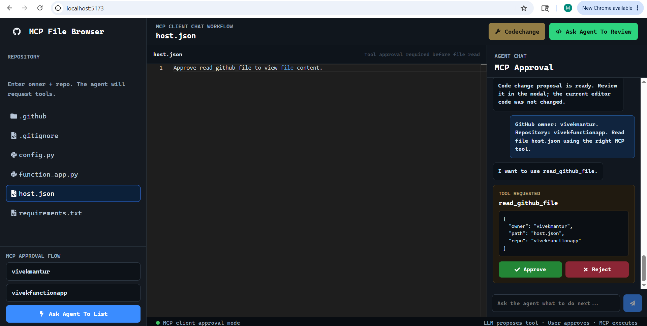

Deterministic shortcuts bypass LLM tool-selection for write operations:
Shortcut | Effect
__MCP_REVIEW_PYTHON_CODE__ | Triggers review_python_code without LLM choosing the tool
__MCP_PROPOSE_PYTHON_CODE_CHANGES__ | Triggers propose_python_code_changes directly
__MCP_PUSH_GITHUB_FILE__ | Triggers push_github_file directly — prevents accidental selection

5.2 Frontend Architecture
The frontend is implemented in React 19 with Vite. The current active UI lives primarily in App.jsx.

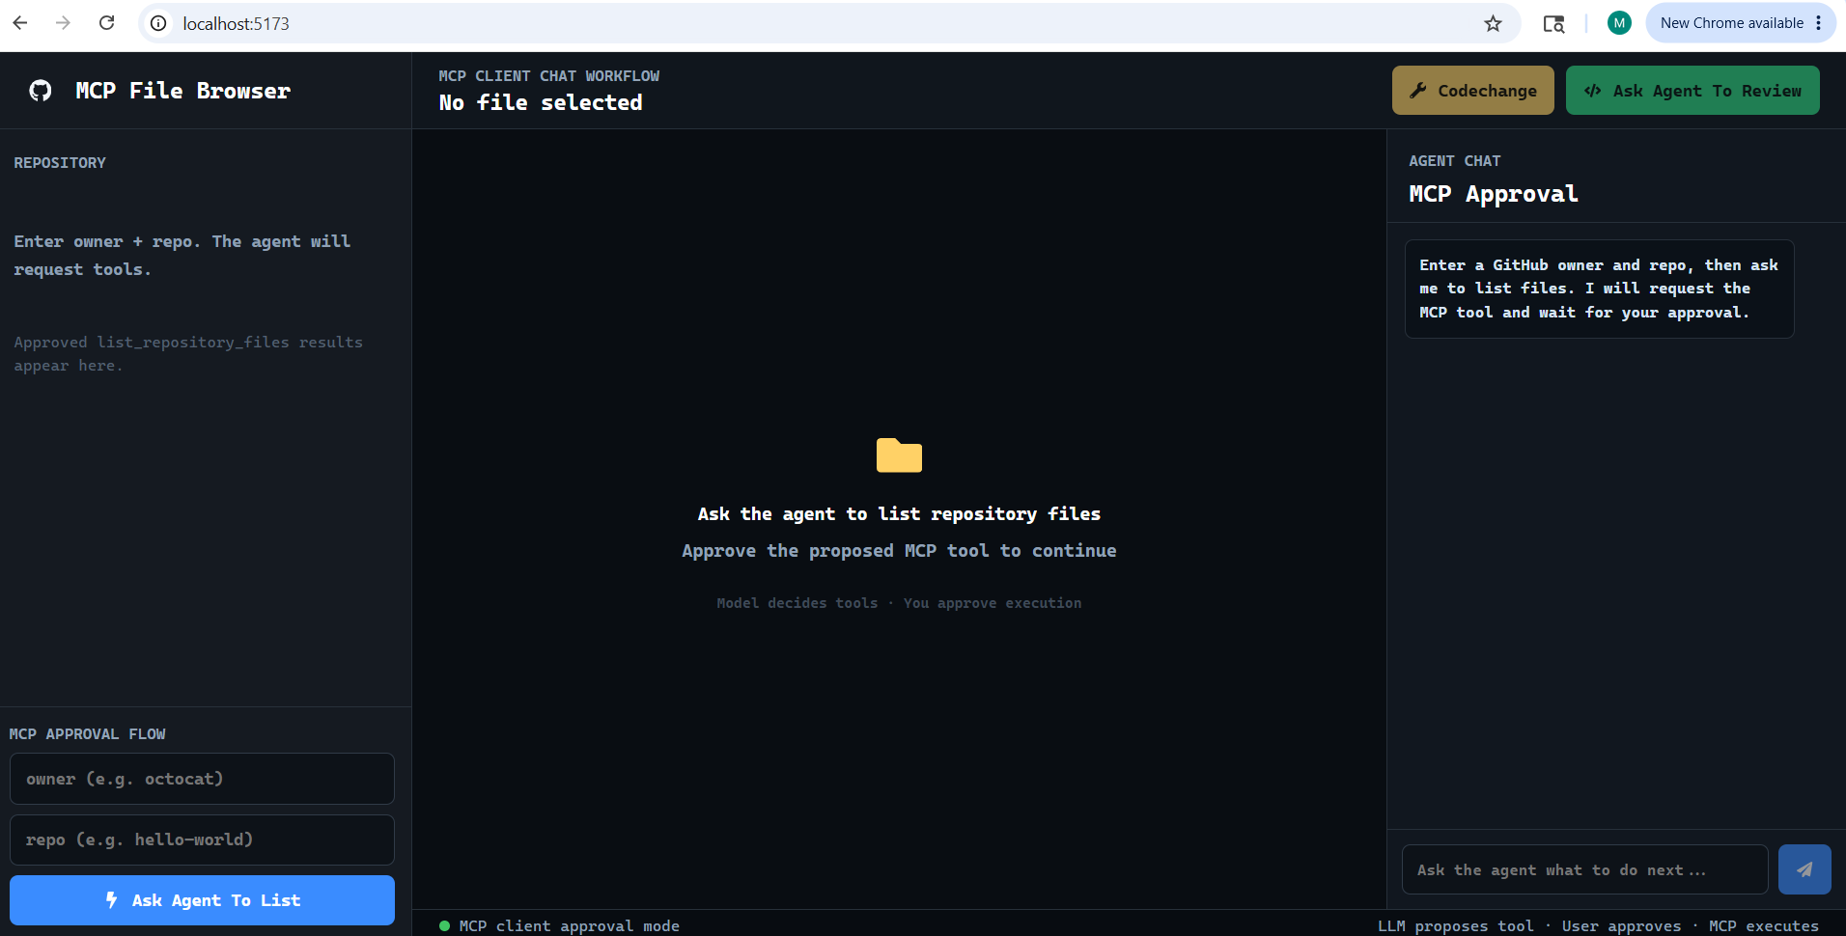

UI Area | Contents
Sidebar | owner/repo form and root-level file tree. Clicking a file triggers the read flow.
Workspace | Topbar, Ask Agent To Review button, Codechange button, Monaco editor displaying current file content.
Chat Panel | Chronological user/assistant/tool/review messages. Pending MCP tool approval card with Approve/Reject buttons.
Code-Change Modal | Side-by-side panes: original code (left) and proposed code (right). Edit/lock toggle and Push button.

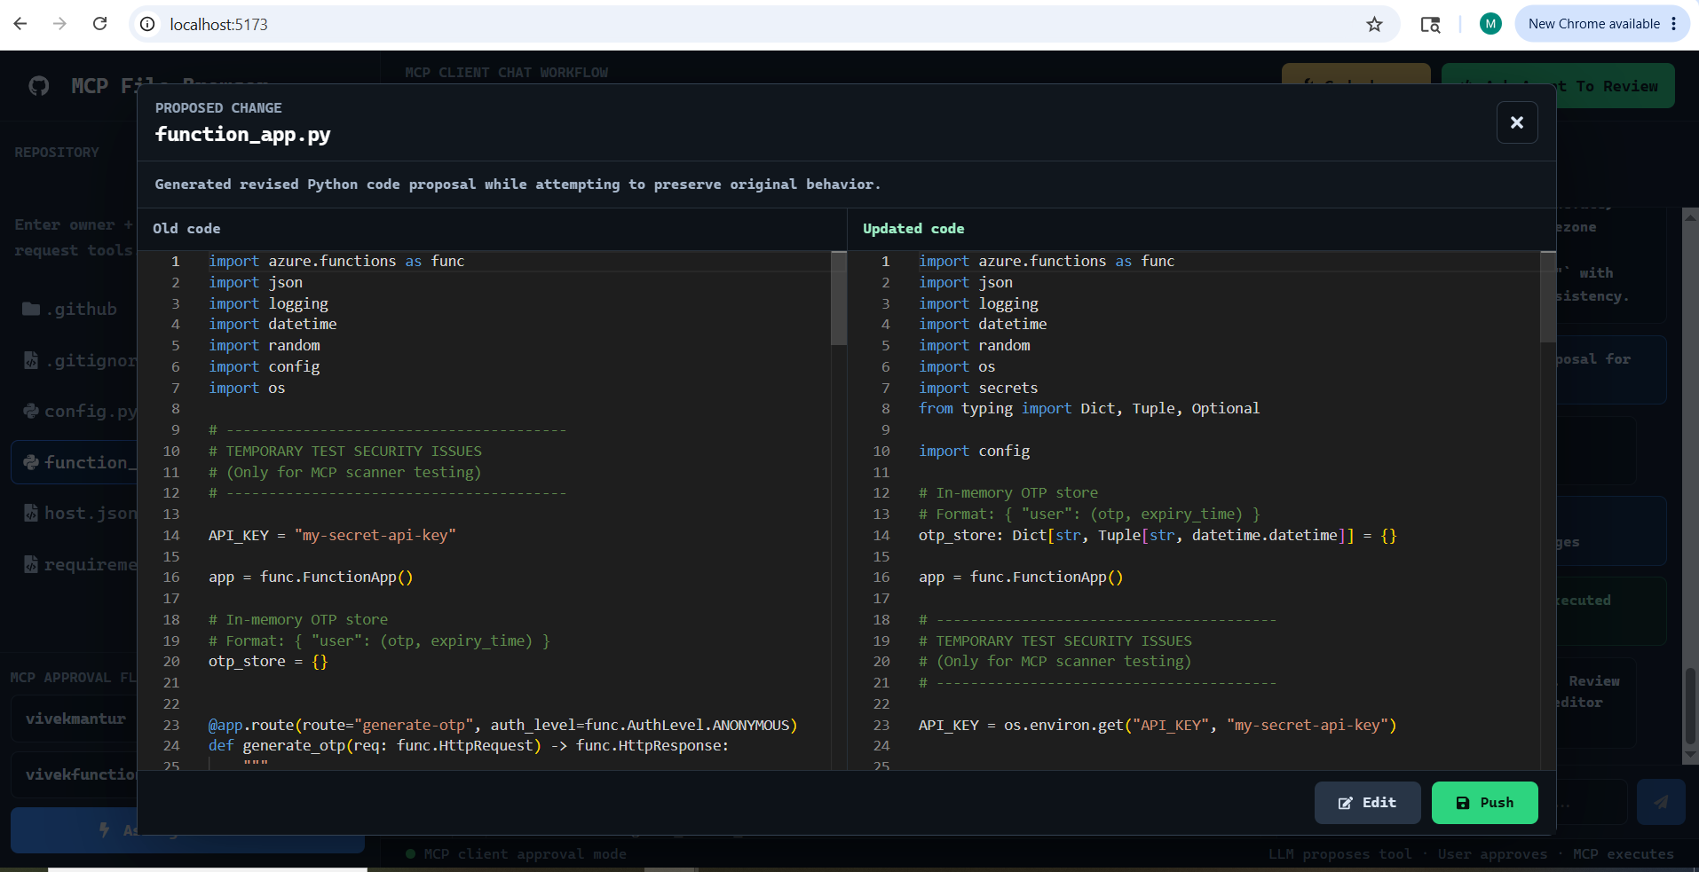

5.3 Key State in App.jsx
State Field | Type | Purpose
owner / repo | string | Current repository identifiers entered by the user
files | array | Root-level file/folder list from list_repository_files
selectedFile | object | Currently selected file metadata (name, path)
code | string | File content loaded in the Monaco editor
review | string | Latest review output from review_python_code
changedCode | string | Proposed revised code from propose_python_code_changes
changeSummary | string | Summary text returned alongside the code change
isCodeChangeModalOpen | boolean | Controls side-by-side comparison modal visibility
isChangedCodeEditable | boolean | Controls whether the proposed code pane allows editing
pendingTool | object | The MCP tool currently awaiting user approval
chatMessages | array | Chronological chat, review, and tool status messages
agentBusy | boolean | Loading/disabled state during backend calls
error | string | Current UI error banner text

Part 6: Integration Map and Reflection

6.1 MCP Primitives Map
Primitive | Implementation in This Project | Why This Primitive
Resources | coding://standards, security://guidelines, python://best-practices, review://constraints | Resources represent static policy data loaded by the review tool. They do not perform actions — they provide context boundaries for AI reasoning.
Tools | list_my_repositories, list_repository_files, read_github_file, push_github_file, review_python_code, propose_python_code_changes, scan_repository_security, scan_recent_commit_changes | Tools represent executable actions: reading from GitHub, generating AI-driven review, proposing code changes, and writing back to GitHub. Tools can have side effects; resources cannot.
Approval Gate | FastAPI bridge enforces one pending tool per session; frontend shows approve/reject card | Ensures no write operation (push_github_file) executes without explicit human confirmation. This is the Human-in-the-Loop layer.
Sampling (future) | Not yet implemented. Planned for stalled PR detection and cross-file analysis. | Would allow the server to send structured file data to an LLM and receive contextual reasoning — for example, identifying related files that need updating when one file changes.

6.2 Known Limitations
# | Limitation | Impact
1 | Repository file listing is root-level only | Nested folders cannot be browsed; user must know file paths for deep files
2 | Chat sessions are in-memory only | Sessions reset on backend restart; no audit log of approvals or pushes
3 | No user authentication | Anyone who can reach the FastAPI bridge can access any repository the PAT can read
4 | CORS is open (allow_origins=["*"]) | Safe only for local development; must be restricted before any network exposure
5 | Security scanners are pattern-based only | eval( and hardcoded-key patterns are heuristic; not a substitute for full SAST
6 | Push updates existing files only | No branch creation, no new file creation, no pull request flow
7 | Native browser confirm() for push | Not styled; cannot be customised or blocked by browser popup settings
8 | Code comparison is plain side-by-side modal | Not a Monaco diff editor; no line-level highlighting of changes
9 | App.jsx owns all UI logic | Components in frontend/src/components/ exist but are not wired into App.jsx

6.3 Future Improvements
Area | Planned Improvement
File Browsing | Add recursive folder browsing beyond root level
Frontend Structure | Decompose App.jsx into Sidebar, CodeViewer, ReviewPanel, and ModalManager components
Sessions | Add persistent session and audit storage (SQLite or file-based log of approvals and pushes)
Authentication | Add user authentication and per-user GitHub token management
Branch Support | Add branch selection and branch creation UI before push
Pull Requests | Replace direct commit with PR creation; allow adding reviewers
Push Confirmation | Replace native confirm() with a styled confirmation modal
Code Diff | Integrate a real Monaco diff editor for line-level change highlighting
Static Analysis | Add deeper static analysis or integrate a lightweight SAST engine (e.g., bandit)
Sampling | Implement MCP sampling for cross-file impact analysis when proposing changes
Testing | Add unit tests for MCP result normalisation, GitHub client, and frontend approval flows

6.4 Reflection — Supporting Both GitHub and GitLab
If the server needed to support both GitHub (for the current codebase) and GitLab (for a client's on-premise repository), the MCP architecture shows its real advantage.

What would stay the same:
- The MCP protocol interface — all hosts connect in exactly the same way.
- The approval gate — the human-in-the-loop pattern for write operations applies equally to GitHub and GitLab commits.
- The review and code-change tools — only the data source changes underneath.
- The React frontend and FastAPI bridge — no frontend changes needed.

What would change:
- Tool implementations — read_github_file would be joined by read_gitlab_file; the agent layer would select the right implementation based on the repository URL.
- Authentication — the server would manage two sets of credentials (GitHub PAT and GitLab PAT) internally; the host never sees either.
- Resource URIs — new URIs such as gitlab://standards could expose GitLab-specific review constraints.

Without MCP, every AI tool would need to build its own GitHub and GitLab integration separately. With MCP, a single server handles both. All AI hosts connect to one server using a standard protocol. When either API changes, only the server needs updating — once.

Core advantages this demonstrates:
- Centralised business logic: all file read/write and review logic is in one place, avoiding duplication across AI clients.
- Secure credential management: authentication tokens are stored only in the server; AI clients never see raw tokens.
- Human-in-the-Loop for write operations: the approval gate ensures no code is pushed without explicit human confirmation, regardless of which Git provider is used.
- Controlled access via Resources: policy documents (coding standards, security guidelines) are loaded as MCP resources, not hardcoded into prompts, making them easy to update without touching Python code.
- Reusability across multiple hosts: the same MCP server works with Claude Desktop, VS Code, and the React frontend without any changes.

repomind | v1.1 | System Design Document | May 26, 2026

