**Question1**-Installation of Linux Distribution: * Install a Linux distribution (e.g., CentOS or REDHAT) on a virtual machine or in Cloud.

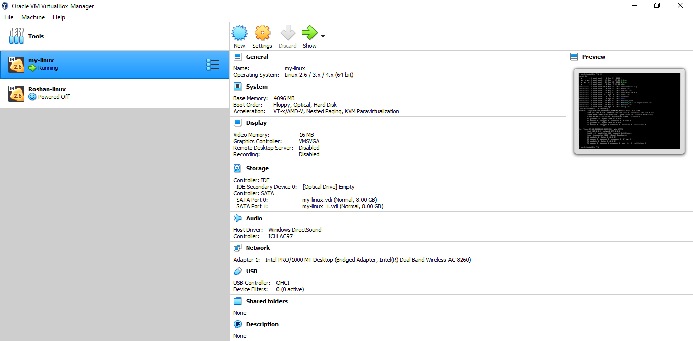

**Question2-**Text Editor: * Demonstrate the use of a text editor with 8 commands (e.g., vi, vim or nano)

Installation of vim editor by using the YUM install vim command.

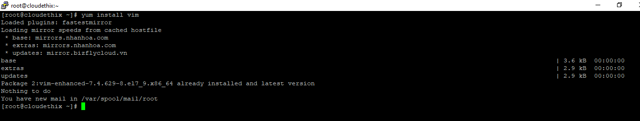

After the installation you have to create one TXT file by using touch command.

**Touch filename.txt**

And after creation of file you have to open the file by using Vi command.

**Vi filename.txt**

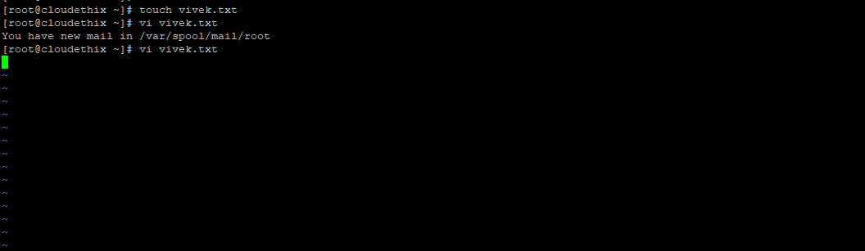

After opening the file you have to write some data in that but before you write a data you have to **press inert mod by press key I**. after write code you save the file using :wq command.

**W is for save and Q is for Quit**.

By using cat command you see the data which is store in your file.

**Cat filename.txt**

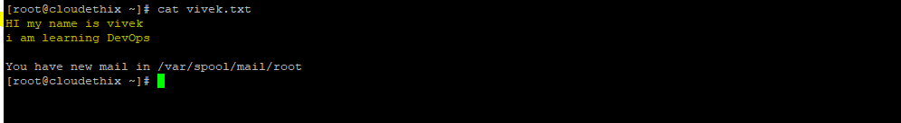

**Question3-**Basic Linux Commands: * Demonstrate basic Linux commands (e.g., ls, cd, pwd, mkdir, rm, rmdir, cp, mv, cat, less, more, head, tail, sort, uniq, wc, diff, sdiff, cmp, echo, date, uptime, hostname, w, hostnamectl, clear, exit, script)

**LS- long listing**

It is used to list the files and directories in a directory.

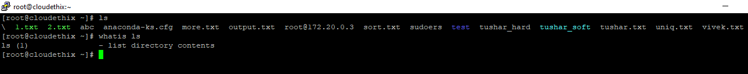

**CD-Change directory**

This command in Linux is used to change the current working directory.

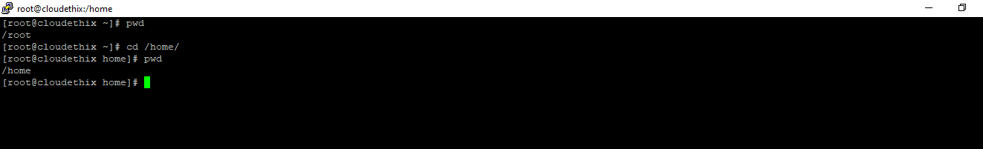

**Pwd-print working directory**

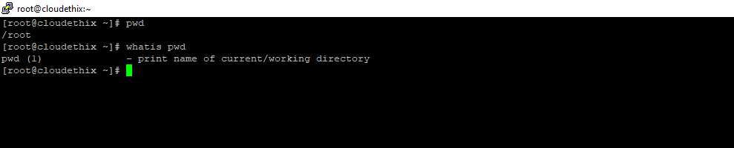

**Mkdir-make a directory**

This command is used for creation of directory.

Syntax: mkdir directory name

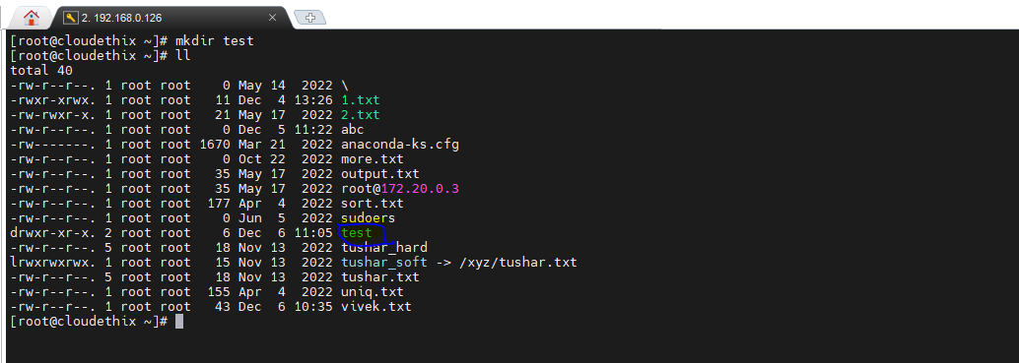

**Cat**- command in Linux is used to concatenate and display the content of files

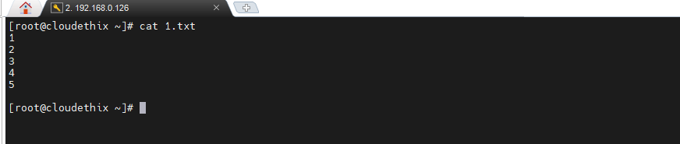

**Date**: this command shows the date.

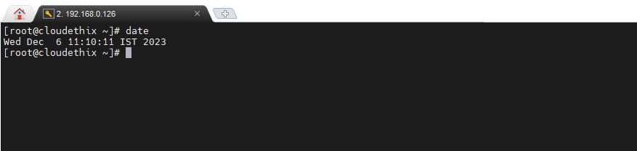

**Rmdir**- remove the directory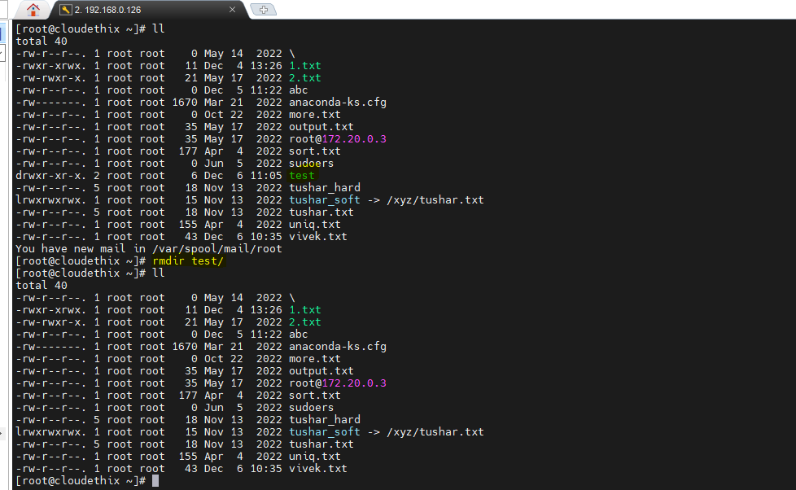

**CP**- command in Linux is used to copy files or directories from one location to another.

Syntax: **cp source file destination**

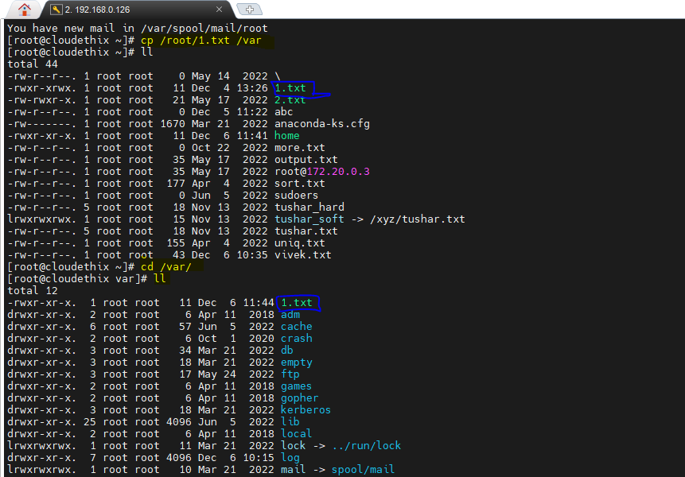

**MV:** command in Linux is used to move or rename files and directories.

Syntax: **mv source file destination**

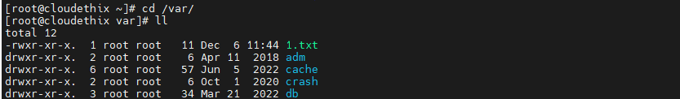



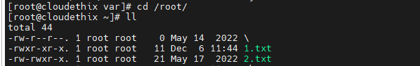

**Clear-** by usingthis command you clear the terminal.

Control+L its shortcut key for clear.

**Less-** command is a pager program used in Linux operating systems to view the contents of text files buffer by buffer.

Syntax: less Filename

Less messages (filename)

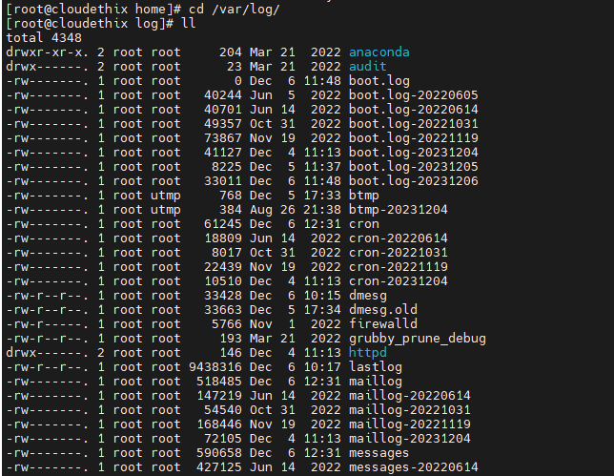



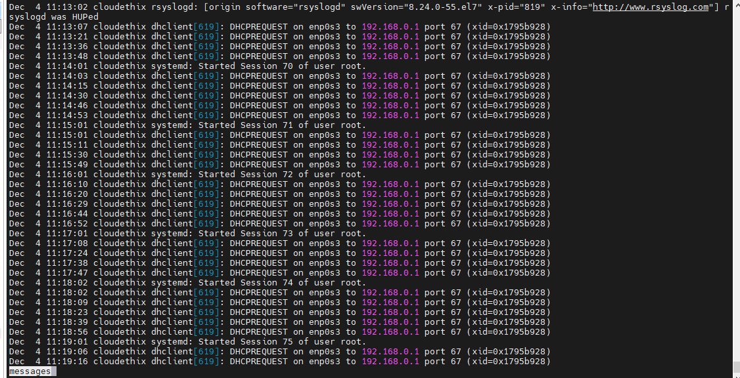

After Press the spacebar to move forward one page.

**More** is just a similar case but whenever you press spacebar the page buffer and showing in the percentage.





**HEAD**- command in Linux is used to display the beginning of a text file or the output of a command in the terminal. By default, it shows the first 10 lines of a file.

Syntax: head filename

Also you can give the number of line which you want.

Head –n 20 filename

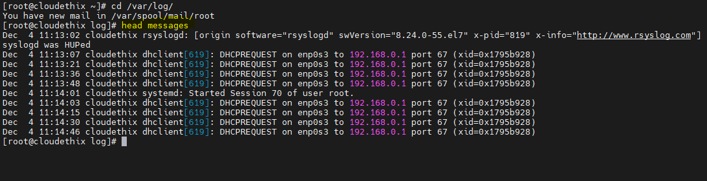

**Tail**- command in Linux is used to display the end of a text file or the last part of the output of a command in the terminal. It is similar with head nut in terms of tail the output shows in the bottom of the file.

Syntax: tail filename

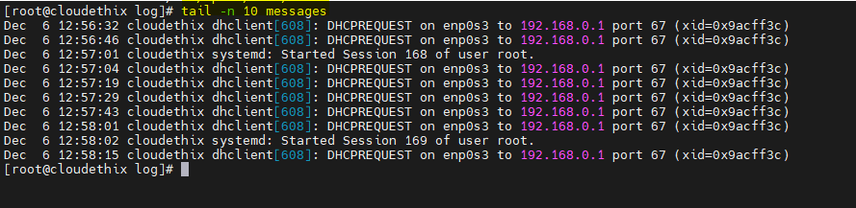

**WC-word count :** command in Linux is used to count the number of lines, words, and characters in a file or the output of a command.

Syntax: wc filename

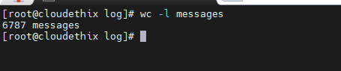

**Diff- Difference**

Command in Linux is used to compare the content of two text files and highlight the differences between them.

Syntax: diff file1 file2

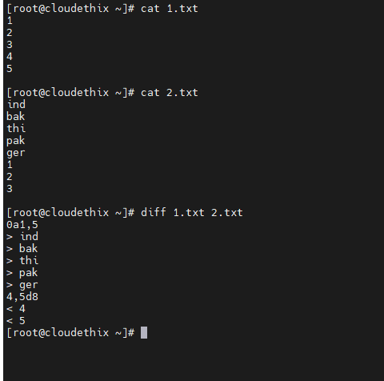

**Sdiff-** its similar with diff command but the o/p is shows in good human understanding manner.

Syntax: sdiff file1 file2

The highlighted part is the difference between 1.txt and 2.txt

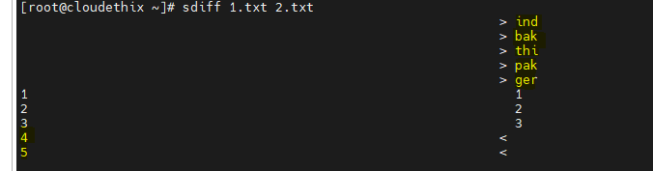

**CMP**- command in Linux is used to compare two files byte by byte. It is typically used to check whether two files are identical or to find the first byte position where they differ.

Syntax: cmp file1 file2

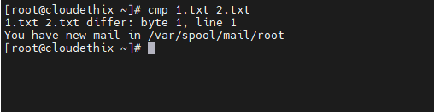

**Echo-** command in Linux is used to display print text or variables on the terminal. It is a simple and commonly used command for outputting information.

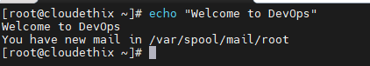

**Hostname-** command in Linux is used to display or set the system's host name.



**W-** This command displays a summary of information about currently logged-in users, including their usernames, terminal, remote host (if applicable), login time, idle time, JCPU (total CPU time used by all processes attached to the terminal), PCPU (CPU time used by the current process), and more.

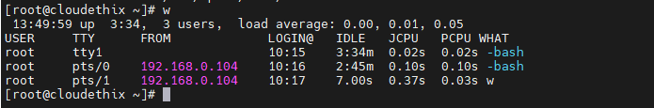

**Hostnamectl-** This command provides detailed information about the system, including the static hostname, the kernel version, the architecture, and more.

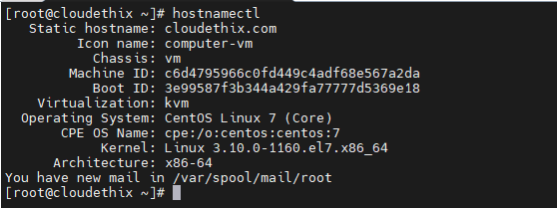

**Script-** This command starts recording a terminal session and saves the output to a file named **typescript** in the current directory.

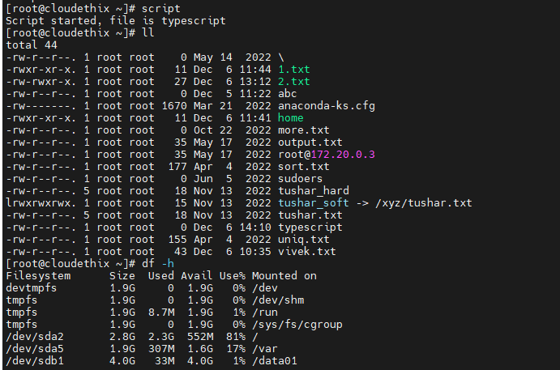

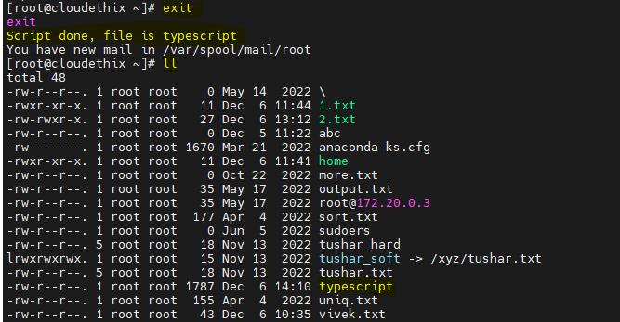

**Question4**- File Permissions and Ownership: * Demonstrate file permissions and ownership to single or all files in all directories (e.g., chmod, chown, and chgrp)?

File permissions are used to control access to files and directories. Permissions are assigned to three categories of users: **the file owner, the group and others.** Each category can have three types of permissions: read R write W and execute X.

**r(read)=4:** Permission to read the file or list the contents of a directory. The value of read 4.

**w(write)=2:**Permission to modify the file or create, delete, and rename files in a directory. The value of write permission 2.

**x(execute)=1:** Permission to execute a file or access a directory. The value of execution 1.

rwx(read, write, execute) becomes (4 + 2 + 1)=7

**Chmod**= chmod 700 1.txt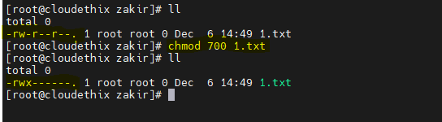

Chmod u-rw,g+rw 1.txt 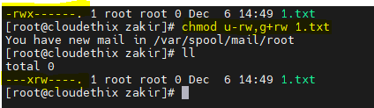

**Chown=** In this example the previous owner is root after using chown command it will change into cloudethix.

Chown cloudethix:root 1.txt

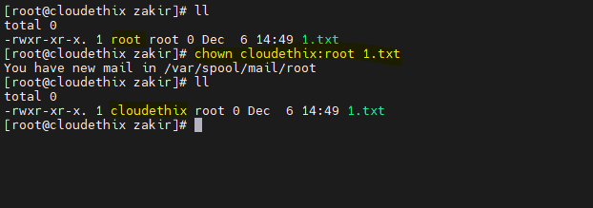

**Chgrp=** In this example the previous group is root after using chgrp command it will change into vivek.

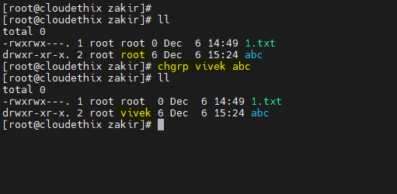

**Question5**- Linux File System Hierarchy: * Explore the Linux file system hierarchy in Linux (e.g., /, /home, /etc, /usr, and /var).

The Linux file system hierarchy defines the organization and structure of the files and directories on a Linux system.

**/= Root Directory**

The root directory is the top-level directory in the file system hierarchy. All other directories and files are organized under the root directory.

**/home** Normal user home

User home directories where user-specific files and settings are stored.

**/etc** configuration related data

Configuration files for system-wide settings and software applications.

**/usr** 3rd party bins

Third party application user data and program files are stored in /usr.

**/var** Variable data/ all system logs will be stored here.

**Question6**-Process management:* Demonstrate process management (eg ps ,top, kill and nice)?

**PS** command in Linux is used to provide information about currently running processes.

It is the type of task manager.

**Ps -ef**

The options provide a full-format listing, including the process UID, PPID, CPU usage, memory usage, etc.

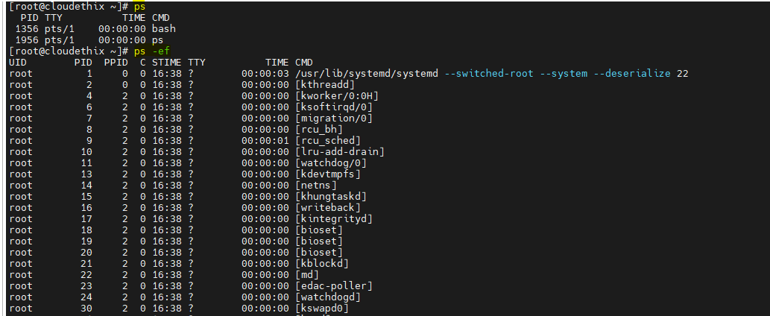

**Top** command in Linux is a real-time system monitoring

It displays information about CPU usage, memory usage, and other system metrics.

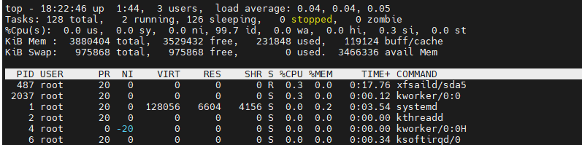

**Kill** command in Linux is used terminate or control the behavior of processes running on a system.

**Kill pid**

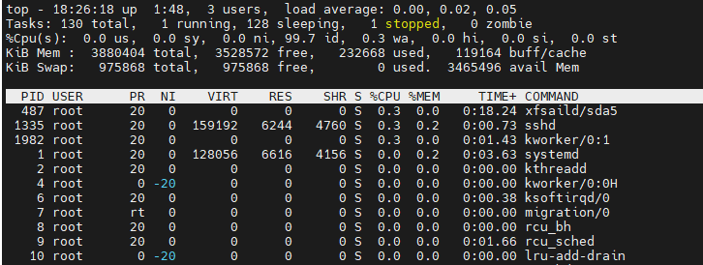 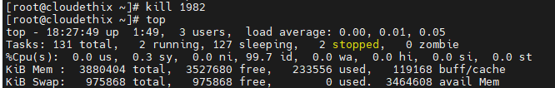

**Nice** command in Linux is used to launch a new process with a specified priority. A lower priority value means a higher priority for the process. The **nice** command is particularly useful when you want to influence the scheduling priority of a process.

**Question7-** Archiving and Compression: * Demonstrate archiving and compression (e.g., zip, tar, gzip, bzip2, zcat , zless , zmore , zgrep , bzcat , bzless, bzmore , bzgrep )?

**Zip** command is used to compress files and create compressed archives.

Syntax: zip newzipfilename.**zip** filename

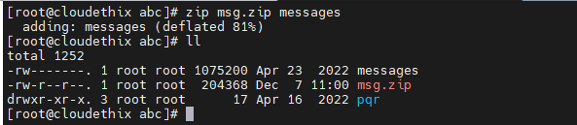

**Unzip** command in Linux is used to extract files from a ZIP archive.

Syntax: unzip filename.zip (e.g unzip msg.zip)

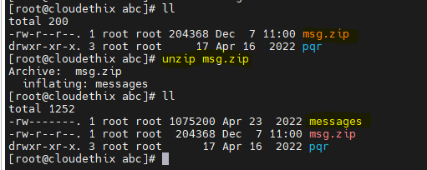

**gzip** command in Linux is used to compress and decompress files using the gzip compression.

Syntax: gzip backup.**gz** filename

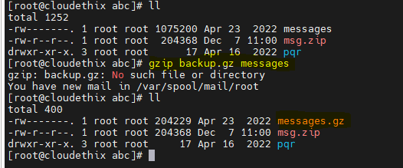

**gunzip** command in Linux is used to decompress files that have been compressed using the gzip compression.

Syntax: gunzip filename.gz

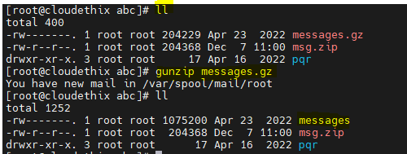

**bzip2** syntax: bzip2 filename

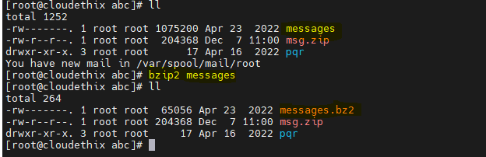

**Bunzip2** Syntax: bunzip2 filename.**bz2**

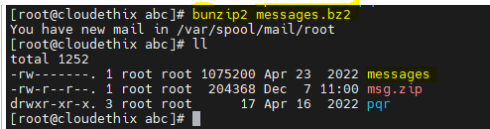

**Tar** command in Linux is used to create, maintain, modify, and extract files from archive files in the tar format. The name "tar" stands for "tape archive," and it's commonly used for creating backups and distributing files.

tar –cvf flag

c-create v-verbose(output of the command which print on terminal) f-file

Synatx: tar –cvf filename.tar inputfile file1 file2

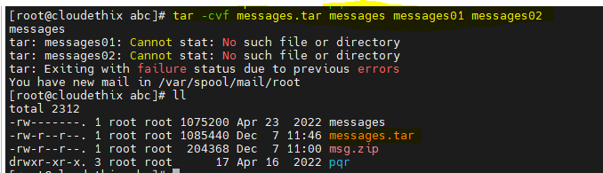

Tar –xvf filename.tar (uncompressed command)

x- extract verbose file

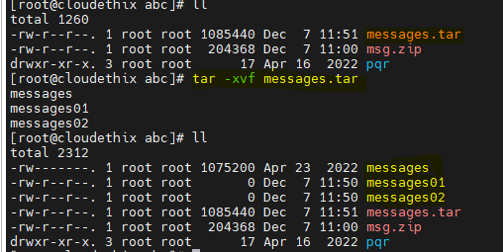

**Zcat** command in Linux is used to display the contents of compressed files in the gzip format. It will show all the present data in zip compressed file.

SYnatx : zcat messages.zip

**Zless/Zmore** command in Linux is used to view the contents of gzip-compressed files shows the data buffer by buffer.

**Bzgrep** This command searches for the specified pattern within the Bzip2-compressed file.

The **bzgrep** command automatically decompresses the data on-the file and showing the output with the specified content.

**Question8-** Input/Output Redirection and Piping: * Demonstrate the use of input/output redirection and piping (e.g., >, >>, <, |, and tee)?

**>** it seems like you're using the greater-than sign. Overwrite symbol.

< less than symbol

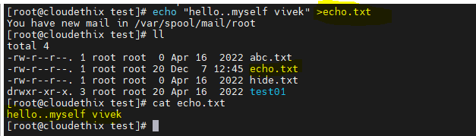

**>> Append**

This command appends the specified text to the file named echo.txt. if doesn't exist, it will be created. If it already exists, the text will be added to the end of the file.

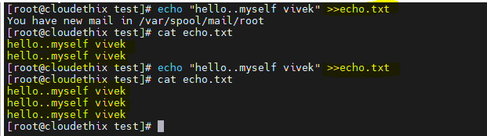

**|** pipe command: in Linux is used to combine commands in a way that the output of one command becomes the input of another.

In this example I have give a o/p of –l with pipe command gives input to grep .txt file.

It will show me all the .txt file present In current directory.

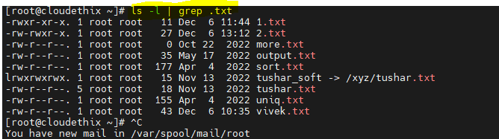

**Tee** command: In Linux is used to read from standard input and write to standard output.

Sometimes the > symbol create file with the input but some outputs not in standard manner

At that time we are use tee command.

Look into the example:



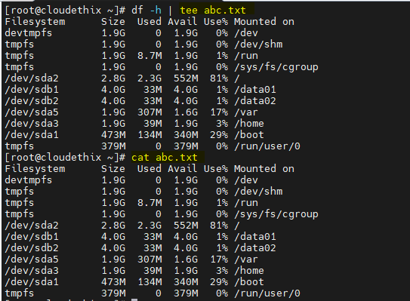

**Question9-** Environment Variables and Aliases: * Explore environment variables and set aliases.

Linux environment variables are dynamic variables used by a shell and it will represent values which is defined in variable.

Use the **env** or **printenv** command to view all environment variables.

The major files of env. Variable is vi .bashrc

In this file you have to export variable value which is permanently stored.



You have to export some variable value in .bashrc file

export TESTVAR=ABC

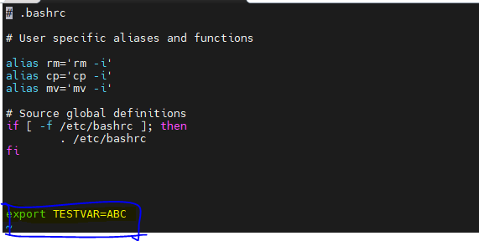

After that you have to source file and call your variable by using echo. You will getting value.

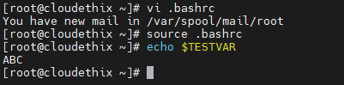

Steps to set environmental variables and alias:

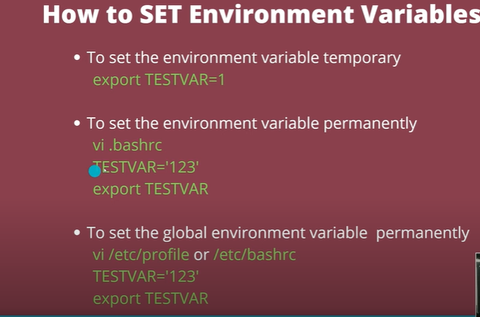

For delete temporary variable in env use command unset $variablename e.g unset $TESTVAR

**Question10-** Package Management: * Familiarize yourself with package management. Download and install rpm packages using rpm command. (e.g., yum, or rpm). * Use Linux box & setup local yum repository & install packages.

First download the rpm package by using wget command.

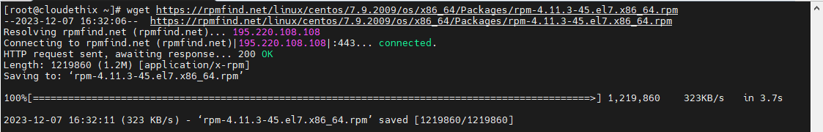

Installation by using RPM



**setup local yum repository & install packages.**

Yum install httpd

Yum install createrepo

Yum install yum-utils

Create one directory in /var/www/html/

Mkdir repos

First you have to add one disk 15GB (add,patition,format,)

Mount disk (/var/www/html)

Download a local copy of the official **CentOS repositories** to your server.(base,centoplus,extras,updates)

reposync -g -l -d -m --repoid=base --newest-only --download-metadata --download_path=/var/www/html/repos/

reposync -g -l -d -m --repoid=centosplus --newest-only --download-metadata --download_path=/var/www/html/repos/

reposync -g -l -d -m --repoid=extras --newest-only --download-metadata --download_path=/var/www/html/repos/

reposync -g -l -d -m --repoid=updates --newest-only --download-metadata --download_path=/var/www/html/repos/

after this createrepo /var/www/html (creating repo in /var/www/html)

Spawning worker 0 with 10072 pkgs

Workers Finished

Saving Primary metadata

Saving file lists metadata

Saving other metadata

Generating sqlite DBs

Sqlite DBs complete

switch to the client system and login as a user with **root** or **sudo** privileges.

Go to cd /etc/yum.repos.d/ then mv /etc/yum.repos.d/*.repo /tmp/

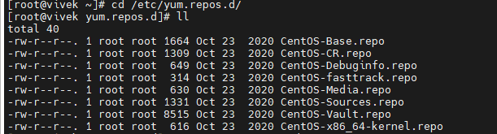

Create one repo file vi vivek.repo

**Insert the below code and change ip address**

[remote]

name=RHEL Apache

baseurl=http://192.168.1.10

enabled=1

gpgcheck=0

after that you save and exit. Install some package on client machine it will run.

