Mushroom Classification

Vivek Pruthi, Rajesh Grandhi and Jyothi Pulimamidi

July 12, 2017

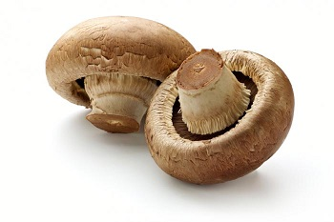

library(ggplot2)  
library(caret)  
library(ggthemes)

## Importing the data

mushrooms_data<-read.csv("C:\\vik\\2017\\personal\\DSLA\\course material\\project 1 files\\mushrooms.csv",header = TRUE,sep = ",")

## Exploring the data

### Dimensions of the mushroom datasets are :

dim(mushrooms_data)

## [1] 8124 23

### Fields in the dataset are:

names(mushrooms_data)

## [1] "class" "cap.shape"   
## [3] "cap.surface" "cap.color"   
## [5] "bruises" "odor"   
## [7] "gill.attachment" "gill.spacing"   
## [9] "gill.size" "gill.color"   
## [11] "stalk.shape" "stalk.root"   
## [13] "stalk.surface.above.ring" "stalk.surface.below.ring"  
## [15] "stalk.color.above.ring" "stalk.color.below.ring"   
## [17] "veil.type" "veil.color"   
## [19] "ring.number" "ring.type"   
## [21] "spore.print.color" "population"   
## [23] "habitat"

### Following are the definitions of these fields:

* Fields/Attributes/features of the dataframe are
  + classes: edible=e, poisonous=p
  + cap-shape: bell=b,conical=c,convex=x,flat=f, knobbed=k,sunken=s
  + cap-surface: fibrous=f,grooves=g,scaly=y,smooth=s
  + cap-color: brown=n,buff=b,cinnamon=c,gray=g,green=r,pink=p,purple=u,red=e,white=w,yellow=y
  + bruises: bruises=t,no=f
  + odor: almond=a,anise=l,creosote=c,fishy=y,foul=f,musty=m,none=n,pungent=p,spicy=s
  + gill-attachment: attached=a,descending=d,free=f,notched=n
  + gill-spacing: close=c,crowded=w,distant=d
  + gill-size: broad=b,narrow=n
  + gill-color: black=k,brown=n,buff=b,chocolate=h,gray=g,green=r,orange=o,pink=p,purple=u,red=e,white=w ,yellow=y
  + stalk-shape: enlarging=e,tapering=t
  + stalk-root: bulbous=b,club=c,cup=u,equal=e,rhizomorphs=z,rooted=r,missing=?
  + stalk-surface-above-ring: fibrous=f,scaly=y,silky=k,smooth=s
  + stalk-surface-below-ring: fibrous=f,scaly=y,silky=k,smooth=s
  + stalk-color-above-ring: brown=n,buff=b,cinnamon=c,gray=g,orange=o,pink=p,red=e,white=w,yellow=y
  + stalk-color-below-ring: brown=n,buff=b,cinnamon=c,gray=g,orange=o,pink=p,red=e,white=w,yellow=y
  + veil-type: partial=p,universal=u
  + veil-color: brown=n,orange=o,white=w,yellow=y
  + ring-number: none=n,one=o,two=t
  + ring-type: cobwebby=c,evanescent=e,flaring=f,large=l,none=n,pendant=p,sheathing=s,zone=z
  + spore-print-color: black=k,brown=n,buff=b,chocolate=h,green=r,orange=o,purple=u,white=w,yellow=y
  + population: abundant=a,clustered=c,numerous=n,scattered=s,several=v,solitary=y
  + habitat: grasses=g,leaves=l,meadows=m,paths=p,urban=u,waste=w,woods=d

### Let's have a look at the structure of the dataset :

str(mushrooms_data)

## 'data.frame': 8124 obs. of 23 variables:  
## $ class : Factor w/ 2 levels "e","p": 2 1 1 2 1 1 1 1 2 1 ...  
## $ cap.shape : Factor w/ 6 levels "b","c","f","k",..: 6 6 1 6 6 6 1 1 6 1 ...  
## $ cap.surface : Factor w/ 4 levels "f","g","s","y": 3 3 3 4 3 4 3 4 4 3 ...  
## $ cap.color : Factor w/ 10 levels "b","c","e","g",..: 5 10 9 9 4 10 9 9 9 10 ...  
## $ bruises : Factor w/ 2 levels "f","t": 2 2 2 2 1 2 2 2 2 2 ...  
## $ odor : Factor w/ 9 levels "a","c","f","l",..: 7 1 4 7 6 1 1 4 7 1 ...  
## $ gill.attachment : Factor w/ 2 levels "a","f": 2 2 2 2 2 2 2 2 2 2 ...  
## $ gill.spacing : Factor w/ 2 levels "c","w": 1 1 1 1 2 1 1 1 1 1 ...  
## $ gill.size : Factor w/ 2 levels "b","n": 2 1 1 2 1 1 1 1 2 1 ...  
## $ gill.color : Factor w/ 12 levels "b","e","g","h",..: 5 5 6 6 5 6 3 6 8 3 ...  
## $ stalk.shape : Factor w/ 2 levels "e","t": 1 1 1 1 2 1 1 1 1 1 ...  
## $ stalk.root : Factor w/ 5 levels "?","b","c","e",..: 4 3 3 4 4 3 3 3 4 3 ...  
## $ stalk.surface.above.ring: Factor w/ 4 levels "f","k","s","y": 3 3 3 3 3 3 3 3 3 3 ...  
## $ stalk.surface.below.ring: Factor w/ 4 levels "f","k","s","y": 3 3 3 3 3 3 3 3 3 3 ...  
## $ stalk.color.above.ring : Factor w/ 9 levels "b","c","e","g",..: 8 8 8 8 8 8 8 8 8 8 ...  
## $ stalk.color.below.ring : Factor w/ 9 levels "b","c","e","g",..: 8 8 8 8 8 8 8 8 8 8 ...  
## $ veil.type : Factor w/ 1 level "p": 1 1 1 1 1 1 1 1 1 1 ...  
## $ veil.color : Factor w/ 4 levels "n","o","w","y": 3 3 3 3 3 3 3 3 3 3 ...  
## $ ring.number : Factor w/ 3 levels "n","o","t": 2 2 2 2 2 2 2 2 2 2 ...  
## $ ring.type : Factor w/ 5 levels "e","f","l","n",..: 5 5 5 5 1 5 5 5 5 5 ...  
## $ spore.print.color : Factor w/ 9 levels "b","h","k","n",..: 3 4 4 3 4 3 3 4 3 3 ...  
## $ population : Factor w/ 6 levels "a","c","n","s",..: 4 3 3 4 1 3 3 4 5 4 ...  
## $ habitat : Factor w/ 7 levels "d","g","l","m",..: 6 2 4 6 2 2 4 4 2 4 ...

It is good to have a little peek at a slice of data.

head(mushrooms_data)

## class cap.shape cap.surface cap.color bruises odor gill.attachment  
## 1 p x s n t p f  
## 2 e x s y t a f  
## 3 e b s w t l f  
## 4 p x y w t p f  
## 5 e x s g f n f  
## 6 e x y y t a f  
## gill.spacing gill.size gill.color stalk.shape stalk.root  
## 1 c n k e e  
## 2 c b k e c  
## 3 c b n e c  
## 4 c n n e e  
## 5 w b k t e  
## 6 c b n e c  
## stalk.surface.above.ring stalk.surface.below.ring stalk.color.above.ring  
## 1 s s w  
## 2 s s w  
## 3 s s w  
## 4 s s w  
## 5 s s w  
## 6 s s w  
## stalk.color.below.ring veil.type veil.color ring.number ring.type  
## 1 w p w o p  
## 2 w p w o p  
## 3 w p w o p  
## 4 w p w o p  
## 5 w p w o e  
## 6 w p w o p  
## spore.print.color population habitat  
## 1 k s u  
## 2 n n g  
## 3 n n m  
## 4 k s u  
## 5 n a g  
## 6 k n g

tail(mushrooms_data)

## class cap.shape cap.surface cap.color bruises odor gill.attachment  
## 8119 p k y n f f f  
## 8120 e k s n f n a  
## 8121 e x s n f n a  
## 8122 e f s n f n a  
## 8123 p k y n f y f  
## 8124 e x s n f n a  
## gill.spacing gill.size gill.color stalk.shape stalk.root  
## 8119 c n b t ?  
## 8120 c b y e ?  
## 8121 c b y e ?  
## 8122 c b n e ?  
## 8123 c n b t ?  
## 8124 c b y e ?  
## stalk.surface.above.ring stalk.surface.below.ring  
## 8119 k s  
## 8120 s s  
## 8121 s s  
## 8122 s s  
## 8123 s k  
## 8124 s s  
## stalk.color.above.ring stalk.color.below.ring veil.type veil.color  
## 8119 p w p w  
## 8120 o o p o  
## 8121 o o p n  
## 8122 o o p o  
## 8123 w w p w  
## 8124 o o p o  
## ring.number ring.type spore.print.color population habitat  
## 8119 o e w v d  
## 8120 o p b c l  
## 8121 o p b v l  
## 8122 o p b c l  
## 8123 o e w v l  
## 8124 o p o c l

It is pertinent from the data that the fields in the dataset are of type factor i.e. these are catgorical variables with different levels. it is better to visualize this data . We will first check the summary and then explore the data visually :

summary(mushrooms_data)

## class cap.shape cap.surface cap.color bruises odor   
## e:4208 b: 452 f:2320 n :2284 f:4748 n :3528   
## p:3916 c: 4 g: 4 g :1840 t:3376 f :2160   
## f:3152 s:2556 e :1500 s : 576   
## k: 828 y:3244 y :1072 y : 576   
## s: 32 w :1040 a : 400   
## x:3656 b : 168 l : 400   
## (Other): 220 (Other): 484   
## gill.attachment gill.spacing gill.size gill.color stalk.shape  
## a: 210 c:6812 b:5612 b :1728 e:3516   
## f:7914 w:1312 n:2512 p :1492 t:4608   
## w :1202   
## n :1048   
## g : 752   
## h : 732   
## (Other):1170   
## stalk.root stalk.surface.above.ring stalk.surface.below.ring  
## ?:2480 f: 552 f: 600   
## b:3776 k:2372 k:2304   
## c: 556 s:5176 s:4936   
## e:1120 y: 24 y: 284   
## r: 192   
##   
##   
## stalk.color.above.ring stalk.color.below.ring veil.type veil.color  
## w :4464 w :4384 p:8124 n: 96   
## p :1872 p :1872 o: 96   
## g : 576 g : 576 w:7924   
## n : 448 n : 512 y: 8   
## b : 432 b : 432   
## o : 192 o : 192   
## (Other): 140 (Other): 156   
## ring.number ring.type spore.print.color population habitat   
## n: 36 e:2776 w :2388 a: 384 d:3148   
## o:7488 f: 48 n :1968 c: 340 g:2148   
## t: 600 l:1296 k :1872 n: 400 l: 832   
## n: 36 h :1632 s:1248 m: 292   
## p:3968 r : 72 v:4040 p:1144   
## b : 48 y:1712 u: 368   
## (Other): 144 w: 192

As few of the levels are shown in summary as (others), let's check what the complete levels are of all the categorical variables in this dataset :

for(i in 1:23){  
 print(names(mushrooms_data[i]))  
 print(levels(mushrooms_data[,i]))  
}

## [1] "class"  
## [1] "e" "p"  
## [1] "cap.shape"  
## [1] "b" "c" "f" "k" "s" "x"  
## [1] "cap.surface"  
## [1] "f" "g" "s" "y"  
## [1] "cap.color"  
## [1] "b" "c" "e" "g" "n" "p" "r" "u" "w" "y"  
## [1] "bruises"  
## [1] "f" "t"  
## [1] "odor"  
## [1] "a" "c" "f" "l" "m" "n" "p" "s" "y"  
## [1] "gill.attachment"  
## [1] "a" "f"  
## [1] "gill.spacing"  
## [1] "c" "w"  
## [1] "gill.size"  
## [1] "b" "n"  
## [1] "gill.color"  
## [1] "b" "e" "g" "h" "k" "n" "o" "p" "r" "u" "w" "y"  
## [1] "stalk.shape"  
## [1] "e" "t"  
## [1] "stalk.root"  
## [1] "?" "b" "c" "e" "r"  
## [1] "stalk.surface.above.ring"  
## [1] "f" "k" "s" "y"  
## [1] "stalk.surface.below.ring"  
## [1] "f" "k" "s" "y"  
## [1] "stalk.color.above.ring"  
## [1] "b" "c" "e" "g" "n" "o" "p" "w" "y"  
## [1] "stalk.color.below.ring"  
## [1] "b" "c" "e" "g" "n" "o" "p" "w" "y"  
## [1] "veil.type"  
## [1] "p"  
## [1] "veil.color"  
## [1] "n" "o" "w" "y"  
## [1] "ring.number"  
## [1] "n" "o" "t"  
## [1] "ring.type"  
## [1] "e" "f" "l" "n" "p"  
## [1] "spore.print.color"  
## [1] "b" "h" "k" "n" "o" "r" "u" "w" "y"  
## [1] "population"  
## [1] "a" "c" "n" "s" "v" "y"  
## [1] "habitat"  
## [1] "d" "g" "l" "m" "p" "u" "w"

We can check their proportionate distribution too:

for(i in 1:23){  
 print(names(mushrooms_data[i]))  
 print(prop.table((table(mushrooms_data[,i])))*100)  
}

## [1] "class"  
##   
## e p   
## 51.79714 48.20286   
## [1] "cap.shape"  
##   
## b c f k s x   
## 5.56376169 0.04923683 38.79862137 10.19202363 0.39389463 45.00246184   
## [1] "cap.surface"  
##   
## f g s y   
## 28.55736091 0.04923683 31.46233383 39.93106844   
## [1] "cap.color"  
##   
## b c e g n p   
## 2.0679468 0.5416051 18.4638109 22.6489414 28.1142294 1.7725258   
## r u w y   
## 0.1969473 0.1969473 12.8015756 13.1954702   
## [1] "bruises"  
##   
## f t   
## 58.44412 41.55588   
## [1] "odor"  
##   
## a c f l m n   
## 4.9236829 2.3633678 26.5878877 4.9236829 0.4431315 43.4268833   
## p s y   
## 3.1511571 7.0901034 7.0901034   
## [1] "gill.attachment"  
##   
## a f   
## 2.584934 97.415066   
## [1] "gill.spacing"  
##   
## c w   
## 83.85032 16.14968   
## [1] "gill.size"  
##   
## b n   
## 69.07927 30.92073   
## [1] "gill.color"  
##   
## b e g h k n   
## 21.2703102 1.1816839 9.2565239 9.0103397 5.0221566 12.9000492   
## o p r u w y   
## 0.7877893 18.3653373 0.2954210 6.0561300 14.7956672 1.0585918   
## [1] "stalk.shape"  
##   
## e t   
## 43.27917 56.72083   
## [1] "stalk.root"  
##   
## ? b c e r   
## 30.526834 46.479567 6.843919 13.786312 2.363368   
## [1] "stalk.surface.above.ring"  
##   
## f k s y   
## 6.794682 29.197440 63.712457 0.295421   
## [1] "stalk.surface.below.ring"  
##   
## f k s y   
## 7.385524 28.360414 60.758247 3.495815   
## [1] "stalk.color.above.ring"  
##   
## b c e g n o   
## 5.31757755 0.44313146 1.18168390 7.09010340 5.51452486 2.36336780   
## p w y   
## 23.04283604 54.94830133 0.09847366   
## [1] "stalk.color.below.ring"  
##   
## b c e g n o   
## 5.3175775 0.4431315 1.1816839 7.0901034 6.3023141 2.3633678   
## p w y   
## 23.0428360 53.9635647 0.2954210   
## [1] "veil.type"  
##   
## p   
## 100   
## [1] "veil.color"  
##   
## n o w y   
## 1.18168390 1.18168390 97.53815854 0.09847366   
## [1] "ring.number"  
##   
## n o t   
## 0.4431315 92.1713442 7.3855244   
## [1] "ring.type"  
##   
## e f l n p   
## 34.1703594 0.5908419 15.9527326 0.4431315 48.8429345   
## [1] "spore.print.color"  
##   
## b h k n o r   
## 0.5908419 20.0886263 23.0428360 24.2245199 0.5908419 0.8862629   
## u w y   
## 0.5908419 29.3943870 0.5908419   
## [1] "population"  
##   
## a c n s v y   
## 4.726736 4.185130 4.923683 15.361891 49.729197 21.073363   
## [1] "habitat"  
##   
## d g l m p u w   
## 38.749385 26.440177 10.241260 3.594289 14.081733 4.529788 2.363368

library(ggplot2)  
library(gridExtra)  
 p1<-ggplot(mushrooms_data,aes(x=class))+geom_histogram(stat="count",fill="blue")+ggtitle(label="Poisonous or Edible")  
 p2<-ggplot(mushrooms_data,aes(x=cap.shape))+geom_histogram(stat="count",aes(fill=class))+ggtitle(label="cap shape")  
 p3<-ggplot(mushrooms_data,aes(x=cap.surface))+geom_histogram(stat="count",aes(fill=class))+ggtitle(label="cap surface")  
 p4<-ggplot(mushrooms_data,aes(x=cap.color))+geom_histogram(stat="count",aes(fill=class))+ggtitle(label="cap.color")  
 p5<-ggplot(mushrooms_data,aes(x=bruises))+geom_histogram(stat="count",aes(fill=class))+ggtitle(label="bruises")  
 p6<-ggplot(mushrooms_data,aes(x=odor))+geom_histogram(stat="count",aes(fill=class))+ggtitle(label="odor")  
 p7<-ggplot(mushrooms_data,aes(x=gill.attachment))+geom_histogram(stat="count",aes(fill=class))+ggtitle(label="gill.attachment")  
 p8<-ggplot(mushrooms_data,aes(x=gill.spacing))+geom_histogram(stat="count",aes(fill=class))+ggtitle(label="gill.spacing")  
 p9<-ggplot(mushrooms_data,aes(x=gill.size))+geom_histogram(stat="count",aes(fill=class))+ggtitle(label="gill.size")  
 p10<-ggplot(mushrooms_data,aes(x=gill.color))+geom_histogram(stat="count",aes(fill=class))+ggtitle(label="gill.color")  
 p11<-ggplot(mushrooms_data,aes(x=stalk.shape))+geom_histogram(stat="count",aes(fill=class))+ggtitle(label="stalk.shape")  
 p12<-ggplot(mushrooms_data,aes(x=stalk.root))+geom_histogram(stat="count",aes(fill=class))+ggtitle(label="stalk.root")  
 p13<-ggplot(mushrooms_data,aes(x=stalk.surface.above.ring))+geom_histogram(stat="count",aes(fill=class))+ggtitle(label="stalk.surface.above.ring")  
 p14<-ggplot(mushrooms_data,aes(x=stalk.surface.below.ring))+geom_histogram(stat="count",aes(fill=class))+ggtitle(label="stalk.surface.below.ring")  
 p15<-ggplot(mushrooms_data,aes(x=stalk.color.above.ring))+geom_histogram(stat="count",aes(fill=class))+ggtitle(label="stalk.color.above.ring")  
 p16<-ggplot(mushrooms_data,aes(x=stalk.color.below.ring))+geom_histogram(stat="count",aes(fill=class))+ggtitle(label="stalk.color.below.ring")  
 p17<-ggplot(mushrooms_data,aes(x=veil.type))+geom_histogram(stat="count",aes(fill=class))+ggtitle(label="veil.type")  
 p18<-ggplot(mushrooms_data,aes(x=veil.color))+geom_histogram(stat="count",aes(fill=class))+ggtitle(label="veil.color")  
 p19<-ggplot(mushrooms_data,aes(x=ring.number))+geom_histogram(stat="count",aes(fill=class))+ggtitle(label="ring.number")  
 p20<-ggplot(mushrooms_data,aes(x=ring.type))+geom_histogram(stat="count",aes(fill=class))+ggtitle(label="ring.type")  
 p21<-ggplot(mushrooms_data,aes(x=spore.print.color))+geom_histogram(stat="count",aes(fill=class))+ggtitle(label="spore.print.color")  
 p22<-ggplot(mushrooms_data,aes(x=population))+geom_histogram(stat="count",aes(fill=class))+ggtitle(label="population")  
 p23<-ggplot(mushrooms_data,aes(x=habitat))+geom_histogram(stat="count",aes(fill=class))+ggtitle(label="habitat")  
 grid.arrange(p1,p2,p3,p4,p5,p6,p7,p8,p9,p10,p11,p12,p13,p14,p15,p16,p17,p18,p19,p20,p21,p22,p23,ncol=2)

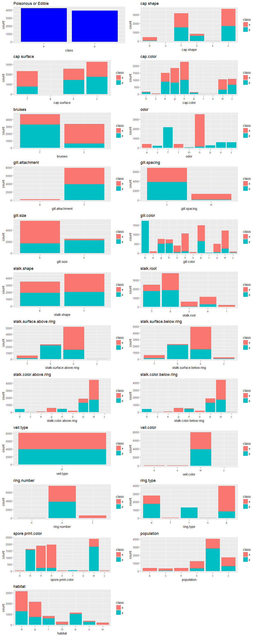

#### We can make the hunches based on the exploratory analysis , but will confirm the huncheas based on the model that we select for machine learning.

## Machine Learning

We will follow following steps to decide about the classification model:

1. split the data in train set and test set
2. train the model on the train set
3. check the efficiency of the model on the train set
4. predict the classification of the test set data
5. check the efficiency of the model on the test set

We will iterate these steps for different models and then compare the efficiencies of different models to choose the best model.

### Defining split factor

First of all we will define a splitting factor which will be used to split data between train and test set . As it is better to train the model on bigger data set and test on small dataset, we will use a variable to accomodate that thought. Thought behind defining the split factor is to check the effect of the size of training set on the efficiency of the model.

mushroom_split_factor<-0.8

We will now define the train and test sets:

set.seed(1)  
mushrooms_split_index<-createDataPartition(mushrooms_data$class,p = mushroom_split_factor,list = FALSE)  
mushrooms_trainset<-mushrooms_data[mushrooms_split_index,]  
mushrooms_testset<-mushrooms_data[-mushrooms_split_index,]

We will now check the dimensions of mashromm dataset, mushroom_trainset and mushroom_testset to make sure that split is fine.

dim(mushrooms_data)

## [1] 8124 23

dim(mushrooms_testset)

## [1] 1624 23

dim(mushrooms_trainset)

## [1] 6500 23

As this is a classification problem. I intend to use rpart,Classification decision trees, bagging , Random Forest and boosting models and then compare the results.We will load the requisite packages here:

library(rpart)  
library(rpart.plot)  
library(caret)

### 1. Model I : rpart

We will use the same trainset and testset defined earlier for different models . we will train the model on trainset,plot the model, predict for trainset ,calculate the efficiency of model on trainset ,predict for testset , calculate the efficiency for testset and then compare the change in efficiency from train to testset , which will give us an idea about underfitting or overfitting .

mushrooms_mdl_rpart<-rpart(class~.,mushrooms_trainset,method = "class")

We will plot this model to get an insight now:

plot(mushrooms_mdl_rpart)  
text(mushrooms_mdl_rpart,pretty = 0)

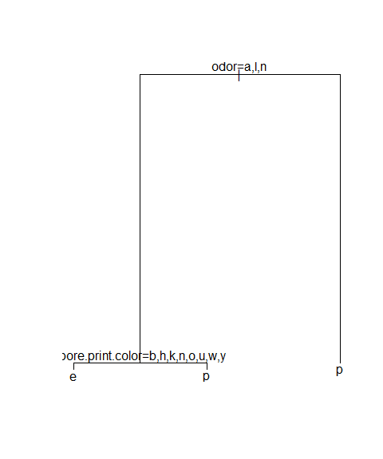

Let's look into a little better version of it :

rpart.plot(mushrooms_mdl_rpart,shadow.col = "blue")

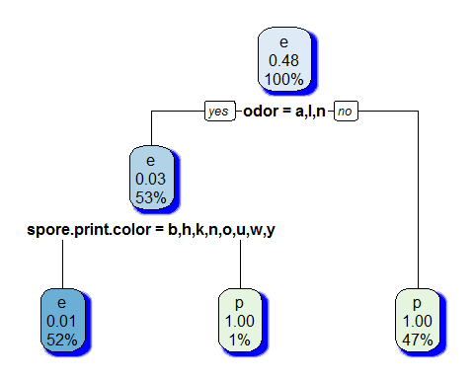

Predictions for trainset :

mushroom_pred_rpart_train<-predict(mushrooms_mdl_rpart,mushrooms_trainset,type = "class")

let's look at the consolidated predictions:

table(mushroom_pred_rpart_train)

## mushroom_pred_rpart_train  
## e p   
## 3407 3093

To check for the accuracy for trainset :

confusionMatrix(mushroom_pred_rpart_train,mushrooms_trainset$class)

## Confusion Matrix and Statistics  
##   
## Reference  
## Prediction e p  
## e 3367 40  
## p 0 3093  
##   
## Accuracy : 0.9938   
## 95% CI : (0.9916, 0.9956)  
## No Information Rate : 0.518   
## P-Value [Acc > NIR] : < 2.2e-16   
##   
## Kappa : 0.9877   
## Mcnemar's Test P-Value : 6.984e-10   
##   
## Sensitivity : 1.0000   
## Specificity : 0.9872   
## Pos Pred Value : 0.9883   
## Neg Pred Value : 1.0000   
## Prevalence : 0.5180   
## Detection Rate : 0.5180   
## Detection Prevalence : 0.5242   
## Balanced Accuracy : 0.9936   
##   
## 'Positive' Class : e   
##

Let's look at the predictions on the test set and check the accuracy there :

mushroom_pred_rpart_test<-predict(mushrooms_mdl_rpart,mushrooms_testset,type="class")  
table(mushroom_pred_rpart_test)

## mushroom_pred_rpart_test  
## e p   
## 849 775

confusionMatrix(mushroom_pred_rpart_test,mushrooms_testset$class)

## Confusion Matrix and Statistics  
##   
## Reference  
## Prediction e p  
## e 841 8  
## p 0 775  
##   
## Accuracy : 0.9951   
## 95% CI : (0.9903, 0.9979)  
## No Information Rate : 0.5179   
## P-Value [Acc > NIR] : < 2e-16   
##   
## Kappa : 0.9901   
## Mcnemar's Test P-Value : 0.01333   
##   
## Sensitivity : 1.0000   
## Specificity : 0.9898   
## Pos Pred Value : 0.9906   
## Neg Pred Value : 1.0000   
## Prevalence : 0.5179   
## Detection Rate : 0.5179   
## Detection Prevalence : 0.5228   
## Balanced Accuracy : 0.9949   
##   
## 'Positive' Class : e   
##

As we see that the accuracy has increased from 99.38% to 99.51% from trainset to testset, which means our model has performed better for unseen data , but still the acceptance of the model depends upon what is the threshold above which, you will accept.

### 2. Model II : Decision Trees and Pruning :

library(tree)

Model:

mushroom_mdl_tree<-tree(class~.,mushrooms_testset)

summary of the model :

summary(mushroom_mdl_tree)

##   
## Classification tree:  
## tree(formula = class ~ ., data = mushrooms_testset)  
## Variables actually used in tree construction:  
## [1] "odor" "spore.print.color"   
## [3] "gill.size" "stalk.surface.above.ring"  
## Number of terminal nodes: 5   
## Residual mean deviance: 0.01037 = 16.79 / 1619   
## Misclassification error rate: 0.001232 = 2 / 1624

Plotting the decision Tree:

plot(mushroom_mdl_tree)  
text(mushroom_mdl_tree,pretty=0)

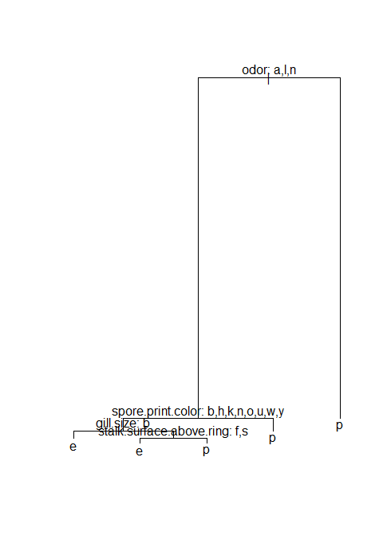

A look at the tree in text :

mushroom_mdl_tree

## node), split, n, deviance, yval, (yprob)  
## * denotes terminal node  
##   
## 1) root 1624 2249.00 e ( 0.517857 0.482143 )   
## 2) odor: a,l,n 858 167.00 e ( 0.980186 0.019814 )   
## 4) spore.print.color: b,h,k,n,o,u,w,y 849 90.56 e ( 0.990577 0.009423 )   
## 8) gill.size: b 793 0.00 e ( 1.000000 0.000000 ) *  
## 9) gill.size: n 56 45.93 e ( 0.857143 0.142857 )   
## 18) stalk.surface.above.ring: f,s 50 16.79 e ( 0.960000 0.040000 ) *  
## 19) stalk.surface.above.ring: k 6 0.00 p ( 0.000000 1.000000 ) *  
## 5) spore.print.color: r 9 0.00 p ( 0.000000 1.000000 ) *  
## 3) odor: c,f,m,p,s,y 766 0.00 p ( 0.000000 1.000000 ) *

Prediction for training set and the evaluation of efficiency of model on training set :

mushroom_pred_tree_train<-predict(mushroom_mdl_tree,mushrooms_trainset,type="class")  
mushroom_tree_train_perf<-table(mushroom_pred_tree_train,mushrooms_trainset$class)  
mushroom_tree_train_perf

##   
## mushroom_pred_tree_train e p  
## e 3367 14  
## p 0 3119

sum(diag(mushroom_tree_train_perf))/sum(mushroom_tree_train_perf)

## [1] 0.9978462

Prediction for test set and the evaluation of efficiency of model on test set :

mushroom_pred_tree_test<-predict(mushroom_mdl_tree,mushrooms_testset,type="class")  
mushroom_tree_test_perf<-table(mushroom_pred_tree_test,mushrooms_testset$class)  
mushroom_tree_test_perf

##   
## mushroom_pred_tree_test e p  
## e 841 2  
## p 0 781

sum(diag(mushroom_tree_test_perf))/sum(mushroom_tree_test_perf)

## [1] 0.9987685

In this model also , model performed better with test data than the training data.To find the optimal level of tree complexity, we can use cost complexity pruning in order to select sequence of trees. We do this by using cross validation. It will help us identify the size of tree that will have minimum residual mean davience.

set.seed(1)  
mushroom_mdl_tree_cv<-cv.tree(mushroom_mdl_tree,FUN = prune.misclass)  
mushroom_mdl_tree_cv

## $size  
## [1] 5 3 2 1  
##   
## $dev  
## [1] 6 10 17 783  
##   
## $k  
## [1] -Inf 3 9 766  
##   
## $method  
## [1] "misclass"  
##   
## attr(,"class")  
## [1] "prune" "tree.sequence"

plot(mushroom_mdl_tree_cv$size,mushroom_mdl_tree_cv$dev,type = "l",xlab = "Size",ylab="Residual Mean Deviance")

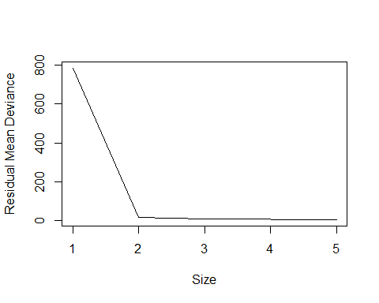

we can create a pruned tree for the optimum size 5 as:

mushroom_mdl_tree_prune<-prune.misclass(mushroom_mdl_tree,best=5)  
plot(mushroom_mdl_tree_prune)  
text(mushroom_mdl_tree_prune,pretty=0)

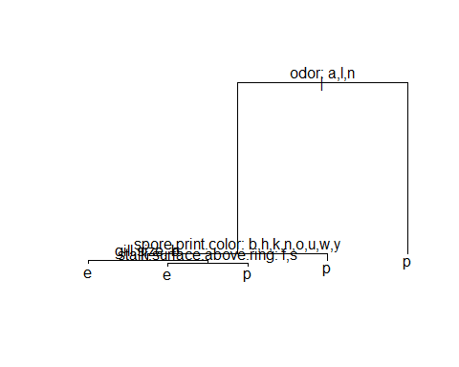

mushroom_pred_tree_train_prune<-predict(mushroom_mdl_tree_prune,mushrooms_trainset,type="class")  
mushroom_pred_tree_test_prune<- predict(mushroom_mdl_tree_prune,mushrooms_testset,type="class")  
mush_prn_train_perftab<-table(mushroom_pred_tree_train_prune,mushrooms_trainset$class)  
mush_prn_test_perftab<-table(mushroom_pred_tree_test_prune,mushrooms_testset$class)

Performance of the pruned tree on trainset :

sum(diag(mush_prn_train_perftab))/sum(mush_prn_train_perftab)

## [1] 0.9978462

Performance of the pruned tree on testset :

sum(diag(mush_prn_test_perftab))/sum(mush_prn_test_perftab)

## [1] 0.9987685

In fact the tree that we created before pruning was optimum already as it had the 5 terminal nodes as were concluded from cross validation.

### 3. Model III : Bagging

Next Model that we will consider .Here we would try to create trees taking all variables into account while creating multiple trees and then using their average as the final result.first we will load the requisite package :

we will now create the model bagging the trees taking into account all the variables i.e. all the predictors should be considered for each split of the tree(minus the dependent variable):

set.seed(1)  
mushroom_mdl_bagging<-randomForest(class~.,data=mushrooms_trainset,mtry=22,importance=TRUE)

Let's take a look at the bagged tree model:

mushroom_mdl_bagging

##   
## Call:  
## randomForest(formula = class ~ ., data = mushrooms_trainset, mtry = 22, importance = TRUE)   
## Type of random forest: classification  
## Number of trees: 500  
## No. of variables tried at each split: 22  
##   
## OOB estimate of error rate: 0.02%  
## Confusion matrix:  
## e p class.error  
## e 3367 0 0.0000000000  
## p 1 3132 0.0003191829

We would do the predictions for train and test dataset now and check the performance accuracy of the model.We could have used MSE , if the data would have been numeric to test the accuracy of model , but in this case we will use the confusionMatrix to check the efficiency of the model:

mushroom_pred_bag_train<-predict(mushroom_mdl_bagging,mushrooms_trainset)  
mushroom_pred_bag_train_tbl<-table(mushroom_pred_bag_train,mushrooms_trainset$class)  
mushroom_pred_bag_train_tbl

##   
## mushroom_pred_bag_train e p  
## e 3367 0  
## p 0 3133

so the accuracy of the model for the training set is :

(sum(diag(mushroom_pred_bag_train_tbl))/sum(mushroom_pred_bag_train_tbl))*100

## [1] 100

As the model on the trainset may be overfitted to give 100% accuract, let's try this on testset:

mushroom_pred_bag_test<-predict(mushroom_mdl_bagging,mushrooms_testset)  
mushroom_pred_bag_test_tbl<-table(mushroom_pred_bag_test,mushrooms_testset$class)  
mushroom_pred_bag_test_tbl

##   
## mushroom_pred_bag_test e p  
## e 841 0  
## p 0 783

so the accuracy of the model for the test set is :

(sum(diag(mushroom_pred_bag_test_tbl))/sum(mushroom_pred_bag_test_tbl))*100

## [1] 100

so , we can clearly see that bagging has improved the accuracy of the model.

Let us check at the importance of these variables in this model

mushroom_imp_bagging<-importance(mushroom_mdl_bagging)  
mushroom_imp_bagging

## e p MeanDecreaseAccuracy  
## cap.shape 4.896537 -0.5887669 4.909002  
## cap.surface 6.664476 7.9949604 6.901242  
## cap.color 5.906325 3.1514921 5.904314  
## bruises 6.468706 3.6529900 6.475842  
## odor 817.423374 164.0282639 366.850539  
## gill.attachment 5.919623 0.0000000 5.917669  
## gill.spacing 5.578414 3.7414657 5.636164  
## gill.size 7.171052 4.9527073 7.209767  
## gill.color 5.907561 2.0077569 5.908320  
## stalk.shape 0.000000 0.0000000 0.000000  
## stalk.root 11.655025 18.9036291 13.857407  
## stalk.surface.above.ring 19.566633 19.5185920 21.089021  
## stalk.surface.below.ring 0.000000 0.0000000 0.000000  
## stalk.color.above.ring 6.106820 1.4169494 6.105548  
## stalk.color.below.ring 118.554154 77.5745890 129.701302  
## veil.type 0.000000 0.0000000 0.000000  
## veil.color 5.521455 0.0000000 5.519290  
## ring.number 0.000000 0.0000000 0.000000  
## ring.type 0.000000 0.0000000 0.000000  
## spore.print.color 51.222850 140.7635297 101.475489  
## population 1.001002 1.0010015 1.001002  
## habitat 29.438197 19.0325768 29.593294  
## MeanDecreaseGini  
## cap.shape 2.677097e+00  
## cap.surface 5.811078e+00  
## cap.color 3.103987e-01  
## bruises 3.691480e-01  
## odor 3.044693e+03  
## gill.attachment 3.061402e-01  
## gill.spacing 2.600468e-01  
## gill.size 3.597446e-01  
## gill.color 2.943350e-01  
## stalk.shape 0.000000e+00  
## stalk.root 1.158332e+01  
## stalk.surface.above.ring 1.085451e+01  
## stalk.surface.below.ring 0.000000e+00  
## stalk.color.above.ring 2.758827e-01  
## stalk.color.below.ring 4.505889e+01  
## veil.type 0.000000e+00  
## veil.color 2.593538e-01  
## ring.number 0.000000e+00  
## ring.type 0.000000e+00  
## spore.print.color 1.220579e+02  
## population 1.566138e-02  
## habitat 1.116141e-01

mushroom_imp_baggingdf<-as.data.frame(unlist(mushroom_imp_bagging))  
ggplot(mushroom_imp_baggingdf,aes(x=row.names(mushroom_imp_baggingdf),y=MeanDecreaseAccuracy))+geom_bar(stat="identity")+theme(axis.text.x = element_text(angle = 60, hjust = 1))+xlab("Variables")

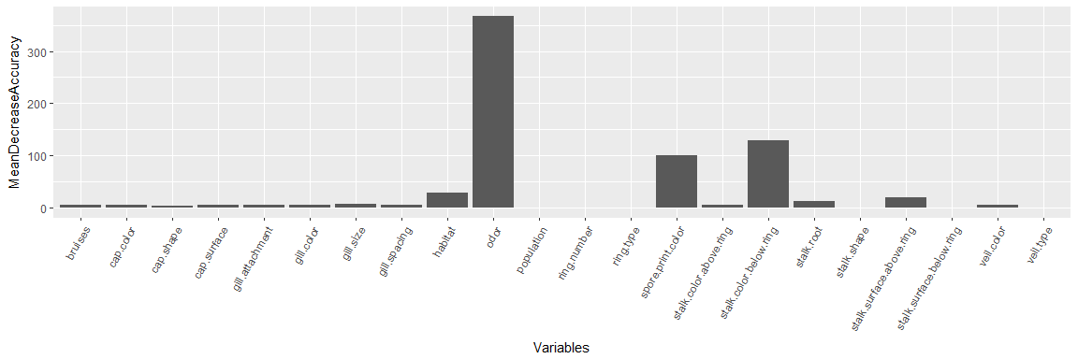

We can clearly see that the odor,stalk.colorbelow.ring and sport.printcolor are the top 3 variables in the bagged model.

### 4. Model IV : randomForest

This model allows random number of variables to be considered at each split unlike the bagging. By default in classification , number of variables considered are sqrt(total no. of variables) i.e for us , it is roundup(sqrt(23))=5

mushroom_mdl_ranforest<-randomForest(class~.,data=mushrooms_trainset,mtry=5,importance=TRUE,ntree=500)  
  
mushroom_mdl_ranforest

##   
## Call:  
## randomForest(formula = class ~ ., data = mushrooms_trainset, mtry = 5, importance = TRUE, ntree = 500)   
## Type of random forest: classification  
## Number of trees: 500  
## No. of variables tried at each split: 5  
##   
## OOB estimate of error rate: 0%  
## Confusion matrix:  
## e p class.error  
## e 3367 0 0  
## p 0 3133 0

let's check the predictions and accuracy on testset:

mushroom_pred_ranforest_train<-predict(mushroom_mdl_ranforest,mushrooms_trainset)  
mushroom_pred_ranforest_traintbl<-table(mushroom_pred_ranforest_train,mushrooms_trainset$class)

Accuracy of the model is :

(sum(diag(mushroom_pred_ranforest_traintbl))/sum(mushroom_pred_ranforest_traintbl))*100

## [1] 100

Let's do the predictions for the testset and find the accuracy:

mushroom_pred_ranforest_test<-predict(mushroom_mdl_ranforest,mushrooms_testset)  
mushroom_pred_ranforest_testtbl<-table(mushroom_pred_ranforest_test,mushrooms_testset$class)  
mushroom_pred_ranforest_testtbl

##   
## mushroom_pred_ranforest_test e p  
## e 841 0  
## p 0 783

Accuracy of the testset is :

(sum(diag(mushroom_pred_ranforest_testtbl))/sum(mushroom_pred_ranforest_testtbl))*100

## [1] 100

Let's check this model give what importance to which variable:

importance(mushroom_mdl_ranforest)

## e p MeanDecreaseAccuracy  
## cap.shape 5.080529 6.619204 7.929082  
## cap.surface 5.642044 6.372138 7.126618  
## cap.color 12.275185 8.072518 12.139288  
## bruises 6.828824 6.736306 7.809696  
## odor 33.943566 30.613914 37.829428  
## gill.attachment 1.951394 1.430975 1.900784  
## gill.spacing 8.597167 9.644807 10.742491  
## gill.size 14.472528 10.666829 13.408822  
## gill.color 16.767960 10.086676 17.156519  
## stalk.shape 7.604760 10.540555 10.481279  
## stalk.root 12.480795 9.880242 13.304965  
## stalk.surface.above.ring 12.699791 8.347161 13.223349  
## stalk.surface.below.ring 9.468360 8.260831 10.531920  
## stalk.color.above.ring 9.277861 6.081152 9.102598  
## stalk.color.below.ring 14.895532 6.342392 14.545454  
## veil.type 0.000000 0.000000 0.000000  
## veil.color 2.785361 3.733575 3.371209  
## ring.number 11.137914 10.555566 12.054208  
## ring.type 8.686938 9.563414 11.015712  
## spore.print.color 18.569862 15.223876 19.336402  
## population 12.455042 12.080278 14.955008  
## habitat 13.178816 9.052500 13.770274  
## MeanDecreaseGini  
## cap.shape 6.8611205  
## cap.surface 14.7355960  
## cap.color 39.5676751  
## bruises 56.3030363  
## odor 1290.9265078  
## gill.attachment 0.9371213  
## gill.spacing 55.8342115  
## gill.size 151.9342793  
## gill.color 267.9314166  
## stalk.shape 34.0853235  
## stalk.root 68.3581452  
## stalk.surface.above.ring 152.1710823  
## stalk.surface.below.ring 143.6505514  
## stalk.color.above.ring 27.9892543  
## stalk.color.below.ring 40.6361788  
## veil.type 0.0000000  
## veil.color 2.1918414  
## ring.number 54.9147640  
## ring.type 124.2530803  
## spore.print.color 542.6689806  
## population 94.9234245  
## habitat 70.9116371

Graphically we can see the importance as:

varImpPlot(mushroom_mdl_ranforest)

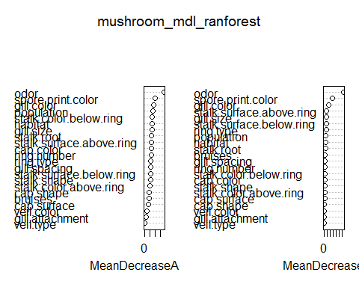

We see that odor, spore.print.color and gill.color are top three variables to affect the accuracy of this model.

### 5. Model V : Boosting

In boosting, trees are grown sequentially. each tree is grown using the information from previously grown trees.  
We first load the requisite package-gbm:

library(gbm)

## Loading required package: survival

##   
## Attaching package: 'survival'

## The following object is masked from 'package:caret':  
##   
## cluster

## Loading required package: splines

## Loading required package: parallel

## Loaded gbm 2.1.3

As this is a classification problem, we will use distribution="bernoulli" as one of the options of gbm() to cretae model. we have kept no. of trees as 500 just to keep it same with the bagging model to facilitate easy comparison. In this model the expectation from dependent variable is be in the form of 0 or 1 , so we change the data for class=p as 0 and class=e as 1. we will call these newsets as testset1 and trainset1

set.seed(1)  
mushrooms_trainset1<-mushrooms_trainset  
mushrooms_testset1<-mushrooms_testset  
mushrooms_trainset1$class<-ifelse(mushrooms_trainset1$class=="e",1,0)  
mushrooms_testset1$class<-ifelse(mushrooms_testset1$class=="e",1,0)  
mushroom_mdl_boost<-gbm(class~.-class,mushrooms_trainset1,distribution="bernoulli",n.trees = 500,interaction.depth = 4)

## Warning in gbm.fit(x, y, offset = offset, distribution = distribution, w =  
## w, : variable 16: veil.type has no variation.

here is the summary of Model:

summary(mushroom_mdl_boost)

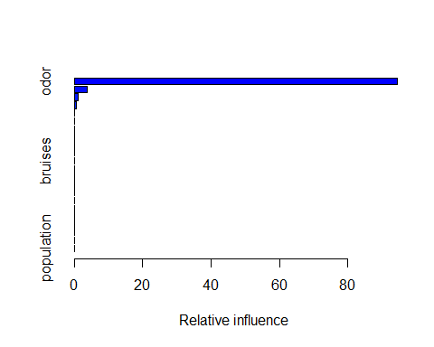

## var rel.inf  
## odor odor 9.445683e+01  
## spore.print.color spore.print.color 3.775892e+00  
## stalk.color.below.ring stalk.color.below.ring 1.214827e+00  
## stalk.root stalk.root 5.396358e-01  
## gill.size gill.size 6.078012e-03  
## stalk.surface.above.ring stalk.surface.above.ring 4.532729e-03  
## cap.color cap.color 2.173386e-03  
## habitat habitat 3.154492e-05  
## cap.shape cap.shape 0.000000e+00  
## cap.surface cap.surface 0.000000e+00  
## bruises bruises 0.000000e+00  
## gill.attachment gill.attachment 0.000000e+00  
## gill.spacing gill.spacing 0.000000e+00  
## gill.color gill.color 0.000000e+00  
## stalk.shape stalk.shape 0.000000e+00  
## stalk.surface.below.ring stalk.surface.below.ring 0.000000e+00  
## stalk.color.above.ring stalk.color.above.ring 0.000000e+00  
## veil.type veil.type 0.000000e+00  
## veil.color veil.color 0.000000e+00  
## ring.number ring.number 0.000000e+00  
## ring.type ring.type 0.000000e+00  
## population population 0.000000e+00

let's check the partial dependence plots of top 6 variables:

par(mfrow=c(2,3))  
plot(mushroom_mdl_boost,i="odor")  
plot(mushroom_mdl_boost,i="spore.print.color")  
plot(mushroom_mdl_boost,i="stalk.color.below.ring")  
plot(mushroom_mdl_boost,i="stalk.root")  
plot(mushroom_mdl_boost,i="gill.size")  
plot(mushroom_mdl_boost,i="cap.color")

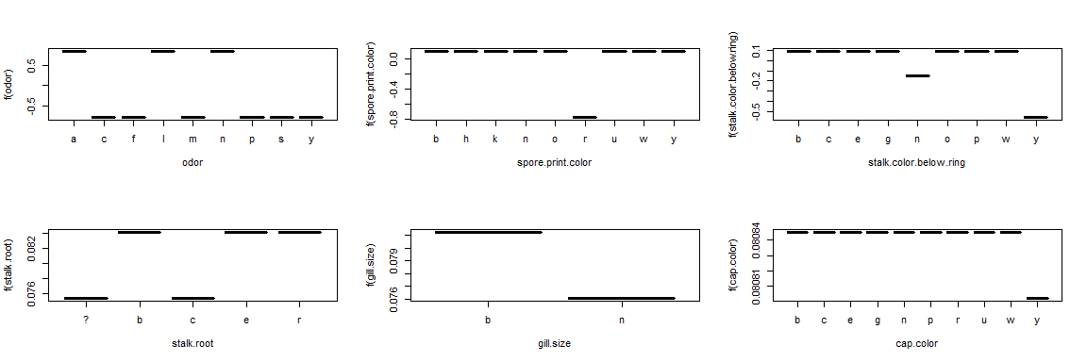

we will now use this model to do the prediction for testset:

mushroom_pred_boost_test<-predict(mushroom_mdl_boost,mushrooms_testset1,n.trees=500)  
head(mushroom_pred_boost_test)

## [1] -0.7808930 0.8812237 0.8812237 0.8812237 0.8812237 0.8712815

we can use the confusionmatrix for accuracy after using ifelse as the predictions don't come in 0 or 1 format.

## Summary of Models used:

Based on the analysis and checking the accuracy of the above models with test data, we will go for Bagging or Random Tree as they have already reached perfect accuracy. Increasing the complexity further with boosting and decreasing the explainabilty would not be appropriate.