CARDIAC ARRHYTHMIA DETECTION USING ECG SIGNALS

**Aadithya Naresh**  
*Computer Science*College of Engineering,Guindy2018103501

**Sibi Akash M**  
 *Computer Science*College of Engineering,Guindy2018103594

**Vivek Ramkumar***Computer Science*College of Engineering,Guindy2018103082

***Abstract*—A large part of the biomedical research spectrum is dedicated to develop electrocardiogram (ECG) signal processing techniques to contribute to early diagnosis. However, it is common to find that ECG analysis methods reported are confined to off-line PC host operation. The author here present an arrhythmia classification method implemented on a Digital Signal Processing (DSP) using MATLAB to classify seven heartbeat conditions: normal sinus rhythm (N), atrial fibrillation (AFIB), left bundle branch block (LBBB), right bundle branch block (RBBB), Atrial Flutter (AF), Ventricular Flutter (VF) and supraventricular tachycardia (SVT). The algorithm uses a discrete wavelet transform process to remove the baseline wandering present in the obtained ECG signals. Classification is conducted by means of a Neural Network and various other machine learning algorithms. The algorithm is tested with 17 ECG records obtained from the MIT_BIH dataset from the PhysioNet repository. The data obtained from the above dataset was pre processed through MATLAB from which multiple important features were extracted. The features were then passed to various different machine learning algorithms and a shallow neural network for classification into the aforementioned seven arrhythmias. The results suggest that the method and prototype presented may be suitable for being implemented on wearable sensing applications auxiliary for on-line, real-time diagnosis**

# Introduction (*Heading 1*)

Cardiac arrhythmia may be a group of conditions during which the heartbeat is irregular, too fast, or too slow. Arrhythmias occur due to problems with the electrical conduction system of the heart. Cardiac arrhythmia occurs intermittently at early stages of heart disease which is difficult early diagnosis. Undiagnosed cardiac arrhythmias often evolve undetected [1], reducing the effectiveness of treatment in advanced stages. In addition, tachyarrhythmia events are associated with sudden death [2], occurring less than an hour after symptoms onset [3]. Thus, an outsized part of the biomedical research spectrum is directed towards developing electrocardiogram (ECG) diagnostic equipment and signal processing techniques [4] to contribute to early diagnosis so as to improve the effectiveness of heart condition treatment beginning at the first stages. On the other hand, current trends in ambulatory diagnostic equipment involve the use of remote implantable monitoring [5] and wearable sensing technologies [6] that may facilitate obtaining online real-time data for immediate, remote diagnosis. The advances in electronics technology during the last decade have contributed to the development of commercial, powerful mixed-signal data acquisition and processing devices, suitable for wearable sensor applications. Therefore methods for on-line cardiac arrhythmia detection for ambulatory data acquisition devices are continuously reported that may result in enhanced on-line detection of intermittent events that may otherwise be undetected.

# Problem statement

The task we have on hand is to do an on-line cardiac arrhythmia detection. However, many ECG analysis results reported are confined to traditional, off-line, PC-based operation. Here, the authors address the importance of arrhythmia classification procedures intended for on-line. Therefore we identify if the person has cardiac arrhythmia and if so, classify into a type of arrhythmia. The inherent difficulty of identifying the ECG waves corresponding to AF may also lead to automated classification errors . Supraventricular tachycardia is another example of an abnormal cardiac rhythm where there's a rise in heartbeat rate and therefore the P-wave overlapping the narrow QRS complex . Thus, in automated ECG analysis, there are a variety of preprocessing and signal component identification analysis procedures that require to be administered before classification. Moreover, given the vast amount of data which will be derived from the ECG records, several methodologies are , and still be proposed to undertake to correlate successfully, ECG signal deviations from the standard pattern to specific arrhythmia conditions.Therefore, In this work, we are concerned with two problems. First, we want to classify a record into binary classes (normal or abnormal). Second, we want to classify a record into multiple classes, depending on the specific case of arrhythmia present (multi-class classification). We construct a neural network topology using significant hyperparameter tuning to achieve the desired results.

# proposed system

The proposed system goes to debate and explain the prediction of abnormal beats during a patient which are represented using an ECG graph. Then after detecting the abnormal beats the values of different features are extracted which are given to multiple machine learning algorithms and a shallow neural network. The performances of various different algorithms we have used is finally measured using multiple different parameters.

# literature survey

Albert Haque [7] proposes the following system,

Identifying patterns in arrhythmia has been studied for several years and many statistical approaches have been attempted. These approaches can be grouped into two categories: (i) statistical learning based on explicit feature extraction and (ii) recognizing patterns from the raw time series data. Most attempts fall into the first category of extracting features using human intuition. Many studies use classical machine learning algorithms such as support vector machines. The second category of approaches

are centered around time series analysis. Time series approaches use wavelet transforms and attempt to minimize

the noise present in the data . Some models note the periodic interval between the QRS complex and PR/QT intervals. Autoregressive neural networks have also been proposed for forecasting time series data.

The results obtained by the model proposed by him are as follows,

In the multi-class case, the neural network still outperforms SVMs and logistic regression with a test accuracy of 75.7%.

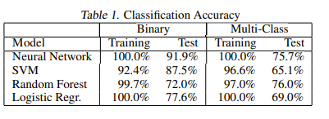

The results obtained by him are given in the table above.

Pranav Rajpurkar,Awni Y. Hannun,Masoumeh Haghpanahi,Codie Bourn,Andrew Y. Ng [8] proposes a different model architecture as shown below.

We use a convolutional neural network for the sequence-to-sequence learning task. The high-level architecture of the network is shown in Figure 2. The network takes as input a time-series of raw ECG signal, and outputs a sequence of label predictions. The 30 second long ECG signal is sampled at 200Hz, and the model outputs a new prediction once every second. We arrive at an architecture which is 33 layers of convolution followed by a fully connected layer and a softmax.

The results obtained by them are satisfactory and on par with human level analysis.

# features selected

There are multiple distinct points present in an ECG wave, all of which varies on the type of the wave. In order for the model to be efficient and produce the best possible output, we use the following features. These features make the neural network model as well the other models we choose to perform well and produce the desired outputs with higher accuracy.

The features selected and hence extracted are,

* 3 RR intervals for the time interval that the arrhythmia occurs.
* 3 PR intervals for the time interval that the arrhythmia occurs
* 3 QRS intervals for the time interval that the arrhythmia occurs.
* Heart rate of the person in that interval.

## RR intervals

RR interval, the time elapsed between two successive R-waves of the QRS signal on the electrocardiogram (and its reciprocal, the HR) is a function of intrinsic properties of the sinus node as well as autonomic influences.

## PR intervals

PR (PQ) interval starts from the beginning of the P wave and ends at the beginning of the QRS complex. When measuring the PR interval, the lead with the longest PR interval should be chosen (in some leads, the initial part of the PR interval may be isoelectronic; this may be misinterpreted as short PR interval). Normal PR interval is between 0.12 s and 0.2 s. PR interval = P wave + PR segment. PR segment is the isoelectric line which is from the end of P wave to the beginning of QRS

## QRS intervals

The beginning of a QRS complex is the first local maximum before an R peak and the end is the first local minimum after an R-peak.In the case where there is not an S wave component detectable,the search is extended until the extreme on R peak is reached.

# models

We compare our neural network model to three commonly used approaches: (i) support vector machines, (ii) logistic regression, (iii) random forests,(iv) Naive Bayes,(v) Decision Tree.

## Neural Network

We employ a multi-layer neural network for multi-class classification of cardiac arrhythmia. We give an input of the features above, all of which are extracted using MATLAB and stored in a .csv file. The input is then passed through the custom neural network that we have built which in turn makes predictions. We train the network using back propagation and stochastic gradient descent to minimize the cost function.

The structure of the neural network is as follows. The neural network takes as input the features extracted and it is passed to the first hidden layer with 300 hidden units. The tanh activation function which is,

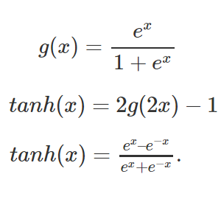

The second hidden layer has 100 hidden units. The output of the tanh function is passed to the second hidden layer as an input. The output of this layer is done using a relu activation function which is,

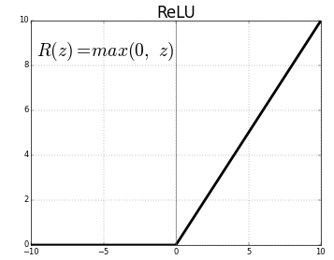

The third hidden layer has 50 hidden units. The output from the relu activation function is passed as an input to this layer. The activation function used here is a relu activation function similar to the previous hidden unit.

The final hidden layer has 6 output units, which are generated by our softmax activation function. These 6 units represent the six different classes that we considered in the start. The desired output is generated and the record is assigned that particular class.

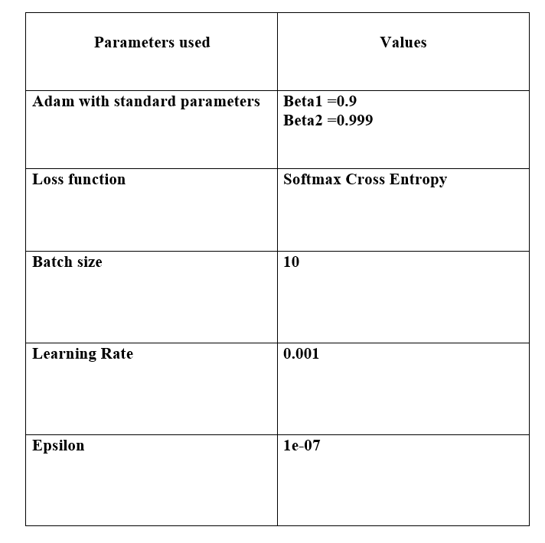

## Logistic regression

Closely related to our neural network, logistic regression aims to minimize the cost function:

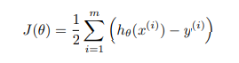

where h(x) = θ T x and θ is defined in (1). To learn the parameters θ, we minimize J(θ) using stochastic gradient descent.

## Support Vector Machines (SVM)

Due to its popularity in practice, we evaluate the performance of SVMs on our dataset. The SVM attempts to find the maximum-margin hyperplane that separates the dataset in a higher dimensional feature space. Finding this optimal margin reduces to solving the following convex optimization problem:

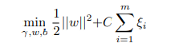

Subject to the constraints:



Where the ξi above allows for “slack” in the event the dataset is not linearly separable.

## Naive Bayes

Naive Bayes methods are a set of supervised learning algorithms based on applying Bayes’ theorem with the “naive” assumption of conditional independence between every pair of features given the value of the class variable.



## Decision Tree

Decision Trees (DTs) are a non-parametric supervised learning method used for classification and regression. The goal is to create a model that predicts the value of a target variable by learning simple decision rules inferred from the data features. The algorithm uses various metrics like ID3,Gene Index for a particular feature to be selected as the root node.A tree can be seen as a piecewise constant approximation.

## Random Forest

A random forest is a meta estimator that fits a number of decision tree classifiers on various sub-samples of the dataset and uses averaging to improve the predictive accuracy and control over-fitting.

# Experiments

The authors separate the input dataset containing 199 records to a train and test split. 132 records are used for training and the rest of the records are used for testing. There are more records that can be generated from the MIT-BIH dataset but this would not produce the desired results as we need the arrhythmia to occur at least for a appreciable time interval. Only then we can make sure that the data we chose belongs to a certain type of arrhythmia and use that for our proceedings.

## Initial extraction

With the help of the multiresolution Teager energy operator (MTEO) algorithm, the authors have used an open source implementation of the same algorithm. The algorithm extracts various different points on the input ECG wave and the authors choose the points we require between a time interval in which a particular arrhythmia occurs which the authors get from the PhysioNet annotations. The intervals which we need and the heart rate is then calculated. The calculated values are then written into a csv file for future use.

## Classification

The dataset generated is loaded in a python file. Before giving input into the neural network, the data from the input dataset is preprocessed. The RR intervals,PR intervals and QRS intervals are sorted so that the order of these values do not matter, but their values only do. This preprocessed data is now given as an input to the various different machine learning and the neural network, the accuracy for all the algorithms are calculated.

# Results

The neural network designed outperforms all other machine learning algorithms used. The multi-class classification done using the neural network, after running for almost 10,000 epochs produces 98.5% accuracy on the test dataset.

accuracy values

|  |  |  |
| --- | --- | --- |
| **Model** | **Accuracy(in %)** | |
| ***Training set*** | ***Test set*** |
| SVM | 52.27 | 50 |
| Random Forest | 79.54 | 68.18 |
| Logistic Regression | 52.57 | 80.30 |
| Naive Bayes | 79.54 | 93.93 |
| Decision Tree | 100 | 95.45 |
| Neural Network | 100 | 98.48 |

1. Sample of a Table footnote. (*Table footnote*)

.

# IX. CONCLUSION

In the clinical routine, computer aided diagnosis of heart arrhythmias can reduce the workload of cardiologists. as machine learning has evolved dramatically in recent years, it has reduced the workload of many things with the help of its algorithms.In this project, a proper understanding of different abnormal beats in an ecg recording is simplified and those beats are graphically represented using a graph.The proposed system talks about different machine and deep learning algorithms which are used to measure the performance in terms of accuracy.From the developed project we get an understanding that a shallow Neural Network provides a better performance (accuracy) as compared to the other machine learning algorithms represented . With the recent state-of-the-art performances of deep learning, biomedical scientists are coming one step closer to effective utilization of deep learning techniques to be carried out to assist clinicians and patients alike in the near future.

##### X.ACKNOWLEDGEMENT

Foremost, we would like to express our sincere gratitude to our project guide, Mrs. Lalitha Devi K, Teaching Fellow, Department of Computer Science and Engineering, College of Engineering Guindy, Chennai for her constant source of inspiration. We thank her for the continuous support and guidance which was instrumental in taking the project tosuccessful completion. We are grateful to Dr.S.Valli , Professorand Head, Department of Computer Science and Engineering, College of Engineering Guindy, Chennai for her support and for providing necessary facilities to carry out for our the project.We would also like to thank our friends and family for their encouragement and continued support. We would also like to thank the Almighty for giving us the moral strength to accomplish our task.

XI.References

### [1] A.S. Adabag, G. Peterson, F.S. Apple, J. Titus, R. King, R.V. Luepker, Etiology ofsudden death in the community: results of anatomic, metabolic, and geneticevaluation, Am. Heart. J. 159 (January (1)) (2010) 33–39.

### [2] J.J. Goldberger, A.E. Buxton, M. Cain, O. Costantini, D.V. Exner, B.P. Knight, D.Lloyd-Jones, A.H. Kadish, B. Lee, A. Moss, R. Myerburg, J. Olgin, R. Passman, D.Rosenbaum, W. Stevenson, W. Zareba, D.P. Zipes, Risk stratification forarrhythmic sudden cardiac death: identifying the roadblocks, Circulation 123(2011) 2423–2430.

### [3] E. Asensio, R. Narváez, J. Dorantes, J. Oseguera, T.A. Orea, R.P. Hernández, G.V.Rebollar, L. Mont, J. Brugada, Conceptos actuales sobre la muerte súbita, Gac.Med. Mex. 141 (March–April (2)) (2005) 89–98.

### [4] M. Velic, I. Padavic, S. Car, Computer aided ECG Analysis – State of the Art andUpcoming Challenges, 2013, arXiv:1306.5096v1 [cs.CV] 21 June.

### [5] M.E. Guevara-Valdivia, Monitoreo a distancia de los dispositivos automáticosimplantables cardiovasculares (marcapasos, desfibriladores automáticosimplantables y resincronizadores cardiacos), Arch. Cardiol. Mex. 79(July–September (3)) (2009) 221–225.

### [6] L. Gatzoulis, I. Iakovidis, Wearable and Portable eHealth Systems:Technological Issues and Opportunities for personalized care, IEEE Eng. Med.Biol. Mag. 26 (September-October (5)) (2007) 51–56

### [7]Albert Haque, Cardiac Dysrhythmia Detection with GPU-Accelerated Neural Networks.

### [8]Pranav Rajpurkar, Awni Y. Hannun,Masoumeh Haghpanahi, Codie Bourn, Andrew Y. Ng,Cardiologist-Level Arrhythmia Detection with Convolutional Neural Networks.

IEEE conference templates contain guidance text for composing and formatting conference papers. Please ensure that all tejkkmplate text is removed from your conference paper prior to submission to the conference. Failure to remove template text from your paper may result in your paper not being publish