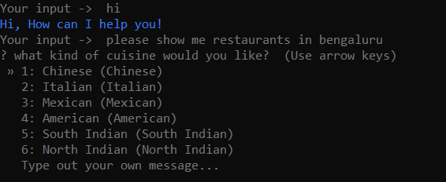

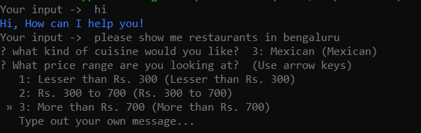

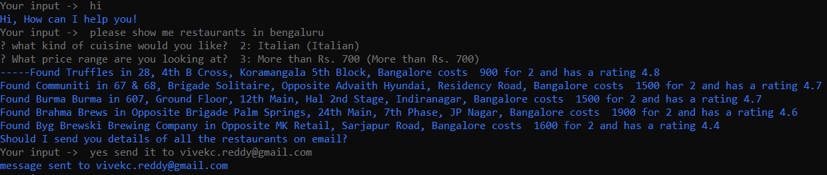

Tier 1 mail

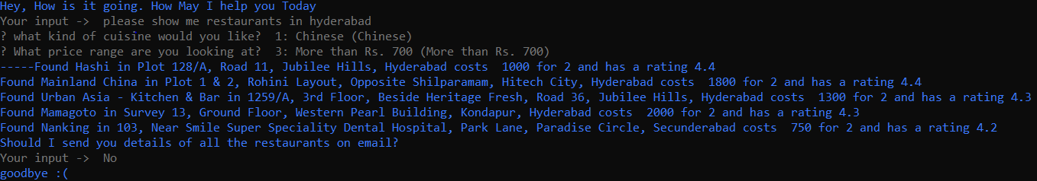

Tier 1 location ,No mail

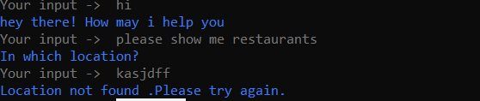

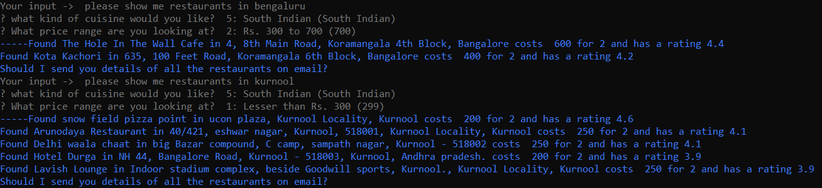

Less than 300 and from 300 to 700 in Kurnool

