**EKS Task**

Aws EKS , K8s , eksctl , kubectl

OwnCloud Running On Amazon Eks Using Efs For Storage

**WhaT is Eks :-**

Amazon Elastic Kubernetes Service (Amazon EKS) is a fully managed [Kubernetes](https://aws.amazon.com/kubernetes/) service. Customers such as Intel, Snap, Intuit, GoDaddy, and Autodesk trust EKS to run their most sensitive and mission critical applications because of its security, reliability, and scalability.

EKS is the best place to run Kubernetes for several reasons. First, you can choose to run your EKS clusters using [AWS Fargate](https://aws.amazon.com/fargate/), which is serverless compute for containers. Fargate removes the need to provision and manage servers, lets you specify and pay for resources per application, and improves security through application isolation by design. Second, EKS is deeply integrated with services such as Amazon CloudWatch, Auto Scaling Groups, AWS Identity and Access Management (IAM), and Amazon Virtual Private Cloud (VPC), providing you a seamless experience to monitor, scale, and load-balance your applications. Third, EKS integrates with [AWS App Mesh](https://aws.amazon.com/app-mesh/) and provides a Kubernetes native experience to consume service mesh features and bring rich observability, traffic controls and security features to applications. Additionally, EKS provides a scalable and highly-available control plane that runs across multiple availability zones to eliminate a single point of failure.

EKS runs upstream Kubernetes and is certified Kubernetes conformant so you can leverage all benefits of open source tooling from the community. You can also easily migrate any standard Kubernetes application to EKS without needing to refactor your code.

## Benefits :-

### High Availability

EKS runs the Kubernetes management infrastructure across multiple AWS Availability Zones, automatically detects and replaces unhealthy control plane nodes, and provides on-demand, zero downtime upgrades and patching.

### Secure

EKS automatically applies the latest security patches to your cluster control plane. AWS also works closely with the community to ensure critical security issues are addressed before new releases and patches are deployed to existing clusters.

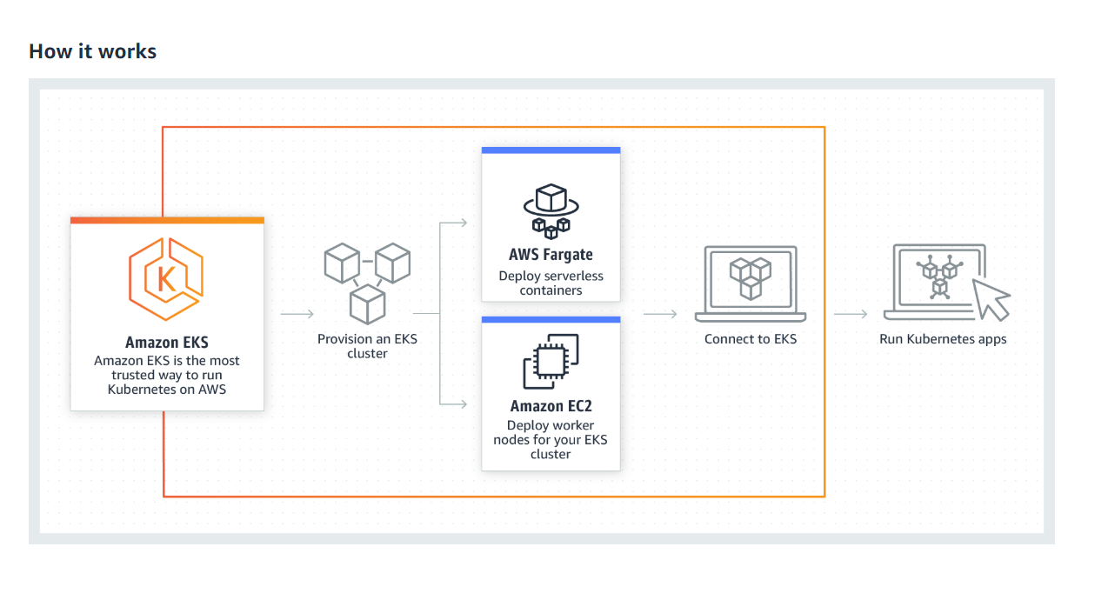

**A Safe Home For Data-**