(If you see gas instead of GAs, it was the autocorrect)

1. Each genome would be a structure of several polygons (in our case 50 triangles) that have co-ordinate values on a XY plane with RGBA (red, blue, green, and alpha transparency values). The polygon could be of any shape, but the result would depend on the positioning, size, colour, and transparency.
2. The target image can be any PNG or jpg image. In this case a 256x256 Mona Lisa image. The idea is to generate and mutate images with polygons that increasingly look like the target image by evolution. My fitness function idea was inspired by the function used by Roger Johansson, sqrt of sum of squares of the difference in pixel values of the target and genotype. (Trying to learn comparatively efficient implement it as the for loops are slowing it down significantly)
3. My initial idea of optimization was very primitive and more along the lines of patchwork on a single entity. In contrast the Darwinian principle used in GAs, survival of the fittest logic, is very interesting. One way to look at it would be that GAs sacrifice to optimize.
4. Premature convergence is when the population for an optimization problem converged too early, resulting in a suboptimal solution. I am seeing premature convergence in images that are more complex and have more colours.
5. Good: Interesting concept for optimization. Robust w.r.t local minima & maxima.  
   Bad: Computationally expensive. (I am assuming, since I tried 2 different fitness functions) Fitness function dictates how long it is going to take.

Gen 0:

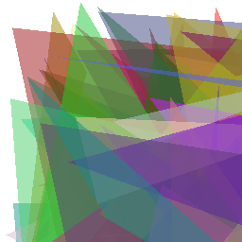

Gen 500:

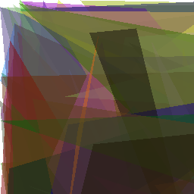

Gen 30000:

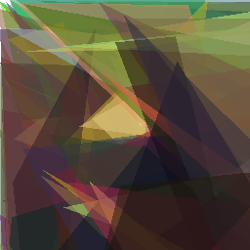

Gen 100,000:

