BUSINESS UNDERSTANDING
UNITED INDIA INSURANCE COMPANY LTD. is an insurance company with headquarters in CHENNAI(INDIA) . It is a Public Sector Undertaking(PSU) dealing with 6 type of insurances namely
Motor Insurance,Health Insurance,Fire,Marine,Rural,Personal Accident Insurance.Currently UIIC is serving approximately 10million policy holders.

The company provides various insurances to its customers and use that capital investing in various other sectors/companies known as insurance float.

They also use cross-selling methodology to recommend new products to current customers based on their recent purchases to increase their revenue.

DATA UNDERSTANDING
Data set contain 15 variables with information about age,gender,marital status,family members,educational qualifications,income etc.
Data set contains information about the response of a customer to new policies and whether he/she opts for it.
Imported data in R Studio to further explore and train ML model.

DATA EXPLORATION
1 data set with 15 variables.

AGE

Imputed missing values in Age variable using average age of the variable.

Number of people in various age groups
18-23 | 24-29 | 30-35 | 36-41 | 42-47 | 48-53 | 54-59 | 60
12859 | 14465 | 14279 | 14270 | 14325 | 14361 | 14252 | 1189

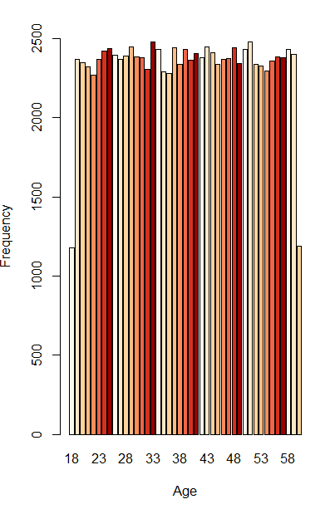

GENDER

Numbers

MALE | FEMALE
60107 | 39893
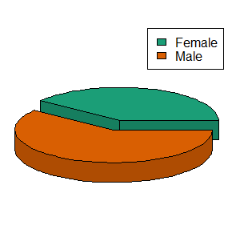
Policy Holders

TOTAL | MALE | FEMALE
57138 | 34414 | 22724

MARITAL STATUS

SINGLE | MARRIED | DIVORCED
22848 | 53992 | 23160

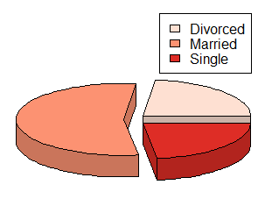

Policy Holders
SINGLE | MARRIED | DIVORCED
9258 | 32441 | 15439

CURRENT PRODUCT

Total Number of Policy Holders
YES | NO
57138 | 42862

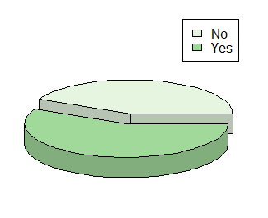
FAMILY MEMBERS

No. of Memb-ers | 1 | 2 | 3 | 4 | 5 | 6 | 7 | 8 | 9 | 10
Freque-ncy | 8654 | 19011 | 11795 | 13322 | 11734 | 10376 | 7414 | 5850 | 7487 | 4357

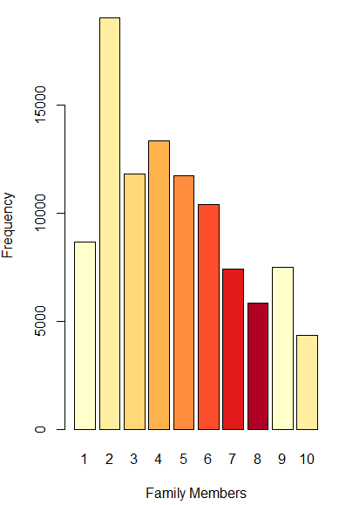

EDUCATION

BD | LHS | MD | NE | PD | UHS
29632 | 13399 | 22543 | 7232 | 14746 | 12448

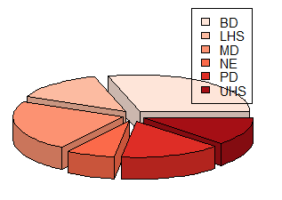

OCCUPATION

SE | SFT | SPT
39443 | 8522 | 52035

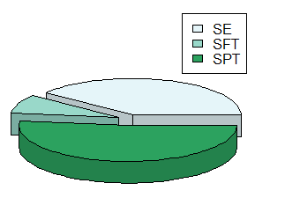

CURRENT PRODUCT TYPE

ANS | END | INV | NA | PMT | TLE
18461 | 5487 | 10346 | 42888 | 8477 | 14341

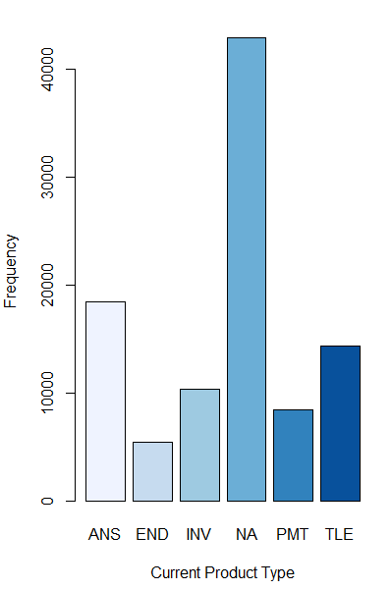

NEW PRODUCT TYPE

ANS | END | INV | PMT | TLE
29198 | 12718 | 20429 | 12588 | 25067

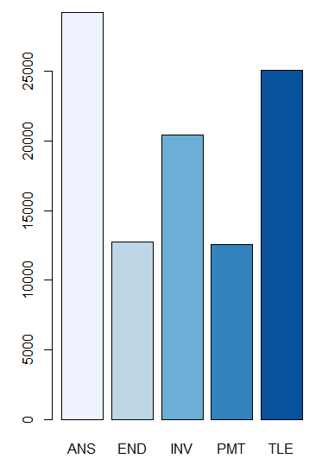

RATING

COLD | WARM | HOT
47595 | 29417 | 22988

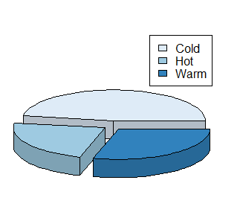

DATA MODELLING

LOGISTIC REGRESSION
LOGISTIC REGRESSION algorithm predicts Categorical Variable.Predicting whether the customer was converted into a policy holder or not.
Partitioned the data in proportions of 75% for training the model and 25% for testing the model.

Carried out Logistic regression to get the following outputs.

CONFUSION MATRIX

NOT CONVERTED | NOT CONVERTED | CONVERTED | 15245
NOT CONVERTED | 13675 | 1570 | 15245
CONVERTED | 1305 | 8450 | 9755
CONVERTED | 14980 | 10020 | 9755

ACCURACY=0.885
ERROR RATE=0.115
SENSITIVITY=0.866
SPECIFICITY0.89

Area Under the Curve

Plotted the curve taking TRUE POSITIVE RATE on Y-axis and FALSE POSITIVE RATE on X-axis.
The ROC curve is a distribution of probabilities.

AUC measure is 0.921.

DECISION TREE

