CHAPTER 1
INTRODUCTION

1.1 Introduction
Every year, thousands of people - especially women and college students - find themselves in situations where they need urgent help but have no easy, trusted way to raise an alarm. A shout or a phone call is often not possible, and someone travelling alone may not know who is closest or which facility can genuinely help. RakshaSafe is a centralized, web-based emergency response system built to close exactly this gap. It lets a user raise an SOS in one tap, alerts their chosen emergency contacts by SMS and e-mail, and helps responders reach an incident with live location, a risk level and nearby resources.
1.1.1 The Problem in One Line
In an emergency, the delay between 'something is wrong' and 'someone trustworthy knows and can act' is far too long. RakshaSafe attacks that delay by combining a panic button, intelligent risk scoring and a responder workflow in a single application.
1.1.2 How RakshaSafe Answers It
• One-tap SOS with live GPS location, incident type and a short description.
• Automatic alerting of primary emergency contacts through SMS and e-mail providers.
• An AI-based risk score (0-100) computed from location, active incidents, nearby verified unsafe reports and operational facilities.
• A responder module where rescue teams receive assignments, advance the incident through a status workflow and keep the user informed.
• An administrative dashboard with dashboards, user/facility/team management, reports and a complete audit trail.
The technology is deliberately boring and reliable: React + TypeScript + Vite on the frontend, Node.js + Express + MongoDB on the backend, and Python + FastAPI for the AI risk service. Every component was chosen because it is well documented, actively maintained and easy for a final-year team to reason about and test.
Main Points — One-tap SOS with live location | SMS / e-mail alerts to primary contacts | AI risk score 0-100 | Responder assignment workflow | Admin dashboard + audit log | React + Node.js + MongoDB + FastAPI
1.2 Background
This project started as a final-year B.Sc. (Information Technology) requirement, but the motivation is real-world. Panic-button concepts are old; what changed is that nearly every student now carries a smartphone with GPS, mobile data and messaging apps. An emergency system no longer needs dedicated hardware - the phone itself is the panic button.
Around that idea, RakshaSafe was built on four pillars. First, immediacy: the SOS action must be one deliberate tap with a confirmation, not a form. Second, intelligence: raw coordinates are not enough - the platform combines location, current incidents, verified unsafe reports and nearby facilities into a single interpretable risk score. Third, accountability: somebody has to receive the alert and record what was done, from notification status to assignment resolutions. Fourth, verifiability: every behaviour described in this report was executed and checked (Chapter 6). These pillars guided every model, route and screen in Chapters 4 and 5.
The survey in Chapter 2 shows existing apps cover only one slice (SOS, or location, or awareness). Very few combine the full loop: a user-side alarm, contact notification, an automated risk assessment and a closed responder workflow with a public dashboard. RakshaSafe was designed as that complete loop, following a classic three-layer architecture that keeps the system testable at unit, integration and system level - as evidenced in Chapter 6.
1.3 Objectives of the Project
• To design and implement a location-aware emergency reporting system usable by non-technical users under stress.
• To notify primary emergency contacts automatically over SMS and e-mail.
• To produce a meaningful, explainable risk score for every incident based on real data factors.
• To give rescue teams and administrators a complete assignment and management workflow with full auditability.
• To verify the whole system with real automated tests and manual end-to-end checks (127 unit + 67 integration + 70 live checks = 264 total).
1.4 Purpose
This document is the complete project report. It records what RakshaSafe must do (Chapter 3), how it is designed (Chapter 4), how it was built (Chapter 5), how it was tested and with what results (Chapter 6), and what the project concludes (Chapter 7). It is written so an examiner can follow the journey from problem to a tested, working system, and so a future team can reproduce or extend it.
The intended audiences are the final-year examination board, a future development team, and campus safety staff evaluating the system. For the board, Chapter 6 provides executed evidence; for a future team, Chapters 3-5 define exactly what must be preserved; for safety staff, Chapter 4 and the appendices describe operational screens and reports.
1.5 Scope
1.5.1 In Scope
• User accounts, profiles, SOS incidents and the full incident lifecycle.
• Emergency contacts with SMS / e-mail notification and an in-app feed.
• Facilities, rescue teams, assignments and unsafe-area reports.
• Admin dashboard, report generation (CSV / PDF / JSON) and audit log.
• AI risk scoring with a documented deterministic model.
1.5.2 Out of Scope
• Native Android / iOS apps (a responsive web UI is provided instead).
• Procurement or integration with government emergency call centres.
• Training of responders or change management inside a real organisation.
1.6 Applicability
Primary users are students travelling to and from campus, office-goers in the late evening and residents of areas with weak formal emergency coverage. Secondary users are college security teams, NGO volunteers and local responders who want a structured way to receive, acknowledge and resolve alerts. Because a live production SMS gateway is expensive, every provider is optional: the design records exactly what happened, including NOT_CONFIGURED outcomes.
In a typical evening scenario, a student who feels unsafe taps SOS; RakshaSafe captures the location and a short note, computes a risk score, and immediately messages the student's saved contacts while the nearest team sees an assignment in its dashboard. The same flow serves a campus guard (as responder) and a warden (as administrator). This chapter's remaining sections describe the objectives, scope and how the remainder of the report is organised.
1.7 System at a Glance
Item |  | Detail
Project title |  | RakshaSafe - A Centralized Emergency Response and Location-Aware Safety System
Domain |  | Web application for emergency reporting and response
Architecture |  | Three layers: React frontend, Node/Express API, Python AI risk service
Data store |  | MongoDB (13 collections, ownership and status rules)
Audience |  | Citizens, rescue team responders, administrators
Verification |  | 264 executed checks - 127 unit, 67 integration, 70 live system
Layer | Responsibilities |  | Main technologies
Frontend | User screens: SOS, contacts, dashboard, admin views |  | React, TypeScript, Vite, Tailwind, Leaflet
Backend | Business rules, security, notifications, workflows |  | Node.js, Express, Mongoose, JWT
Data | 13 collections, ownership and status rules |  | MongoDB (with in-memory server for tests)
AI service | Deterministic 0-100 risk scoring per incident |  | Python, FastAPI
1.7.1 Who Interacts with the System
• Citizens - raise SOS, maintain contacts, see notifications and incident status.
• Responders - receive assignments and update incident and rescue-team state.
• Administrators - manage users, facilities, rescue teams, unsafe-area reports and exports.
1.8 Conventions Used in this Report
• Figure and table numbers restart per chapter (e.g., Figure 4.2, Table 6.3).
• Code excerpts quote the real repository files; every excerpt has its source path as Listing.
• Test counts are executed results and are repeated in Chapter 6 with per-module detail.
• Provider-dependent behaviour is marked explicitly (e.g., notification NOT_CONFIGURED).
1.9 Chapter Outline
No. | Chapter | What it covers
1 | Introduction | Problem, objectives, scope and structure
2 | Survey of Technology | Related work and chosen technologies
3 | Requirement Analysis | Functional / non-functional requirements, data and interfaces
4 | System Design | Architecture, modules, database, API, UML diagrams
5 | System Implementation | Backend, frontend, AI service and how to run it
6 | System Testing | Strategy, environment, results and defects
7 | Conclusion and Future Scope | Summary, limitations and next steps
Main Points — 2 audiences: citizens and responders / admin | 3-layer architecture | 264 automated + manual checks | Structure of the report ahead

CHAPTER 2
SURVEY OF TECHNOLOGY

2.1 Introduction
Before writing code, the team studied what similar systems already do and which technologies let us build RakshaSafe quickly without sacrificing reliability. This chapter summarises both the related work and the choices made.
The result of the survey is a short, defensible answer to an evaluator's first question: "Why did you choose these technologies?" - because they are free, well documented, already understood by the team, and strong where RakshaSafe needs strength (real-time maps, JSON data, and a testable AI boundary).
2.2 Related Systems and Their Gaps
Existing emergency applications concentrate on one slice of the problem. Panic-button apps reliably send an SMS or push to a fixed contact list and stop there. Location-sharing services tell someone where you are but do not judge whether that location is risky. Social-media SOS features generate awareness but no structured follow-up.
Four gaps recur across the surveyed systems: no automated risk assessment; no closed loop connecting a user to an actual responder or facility; no record that a notification was really delivered (or why it was not); and no reporting layer for administrators. RakshaSafe was deliberately designed to close all four together - that is what makes it a system rather than a smartphone button.
2.2.1 How the Survey Was Done
The survey combined three activities: (a) a structured walkthrough of several free and proprietary emergency applications and their published documentation; (b) informal conversations with fellow students and two campus wardens about what happens before, during and after an SOS is raised; and (c) a review of recent papers on panic-alert systems. Only publicly observable capabilities were compared; no proprietary data was used anywhere.
2.3 Technology Selection
Each choice below was made against three non-negotiables: the team must understand it, it must run on an ordinary laptop, and it must be free to use.
Area | Chosen | Why
Frontend | React 18 + TypeScript + Vite + Tailwind | Familiar model, fast build, type safety
Backend | Node.js 20 + Express 4 + Mongoose 8 | Same language as UI; clean seams for tests
Database | MongoDB + Mongoose schemas | JSON-shaped documents match controllers
AI risk | Python 3.12 + FastAPI | Deterministic, typed, easy to test
Maps | OpenStreetMap + Leaflet | No API key cost, coordinate + distance logic
Diagrams | PlantUML + Word (python-docx) | Versioned sources, reproducible B&W figures
Automated tests | node:test + tsx + supertest | No extra framework; used by Chapter 6
Two secondary choices are worth recording. mongodb-memory-server is used in integration tests so tests never touch a live database. And the AI risk service is a separate Python process spoken to over HTTP, which draws a clean line between the Node application and the scoring logic - and lets the score be unit-tested in isolation.
2.4 Literature Snapshot
A short review of papers and trusted references (2015-2026) supported four design decisions: (1) one-tap user-initiated alerts reduce hesitation; (2) short action chains avert the panic-button-without-help failure; (3) geographic risk can be approximated from reported incidents and facilities; (4) delivery status must be recorded, not assumed. These principles appear throughout Chapters 4-6.
2.5 Comparison with Existing Applications
Capability | Panic-button apps | Location-sharing apps | RakshaSafe
One-tap SOS | Yes | Limited | Yes
Auto-alert contacts (SMS / e-mail) | Partial | No | Yes
Risk assessment (0-100) | No | No | Yes (AI service)
Responder / facility assignment | No | No | Yes
Admin dashboard & exports | No | No | Yes
Delivery-status recording | No | No | Yes (incl. NOT_CONFIGURED)
Testable, reproducible evidence | Rarely | No | Yes (264 checks)
2.6 Chapter Summary
The survey proved the gap and the technology review proved the tools. RakshaSafe is therefore a deliberate composition of proven, free and well-documented components - which keeps the whole report (Chapters 3-7) honest and reproducible.
Main Points — Surveyed apps stop at the SOS - no closed loop | 4 gaps identified and closed | 7 capability comparison rows vs existing apps | 6 technology choices with reasons | 4 literature principles drive the design

CHAPTER 3
REQUIREMENT AND ANALYSIS

3.1 Introduction
Requirement analysis defines who the users are, what functions the system must perform, how it interfaces with the outside world and the rules it must obey. This chapter presents the authorised requirement input for RakshaSafe, organised as functional and non-functional requirements, users, data requirements, hardware and software needs, and the project plan.
3.1 Requirement Analysis
Requirement analysis defines the users, functions, resources and requirements of the Raksha system. It supports SOS requests, incident and location information, emergency resources, admin management and centralized data storage. It also covers functional, non-functional, hardware, software and database requirements.
3.2 Problem Definition
Problem Statement
Users may face emergencies such as harassment, accidents, medical emergencies, fire, floods and earthquakes where quick and organized information is required. Administrators may also find it difficult to monitor incidents and maintain updated emergency resources.
Main Problems:
Lack of a centralized safety platform.
Difficulty recording and tracking incidents.
Difficulty finding emergency facilities and resources.
Lack of organized incident history.
Difficulty managing emergency resources.
Lack of centralized admin monitoring.
Risk of unauthorized access to sensitive data.
Difficulty maintaining unsafe-area and risk information.
Difficulty generating useful reports and statistics.
3.2.1 Lack of Centralized Safety Records
Emergency incidents may contain important information such as incident type, description, user information, location, priority and current status.
If this information is not stored systematically, it becomes difficult to retrieve, monitor and analyse later.
Raksha provides a centralized database where authorized application components can store and retrieve emergency incident information.
3.2.2 Difficulty in Sharing Location Information
Location helps identify where an incident occurred. Raksha can request the user’s location and store available latitude and longitude with the incident. Location accuracy depends on device, GPS, network and permission availability. If unavailable, the system does not assume a false location.
3.2.3 Difficulty in Finding Emergency Resources
During an emergency, users may need quick information about hospitals, shelters, police stations, fire stations and relief centres. Raksha keeps these facility details organized, including name, type, address, contact number, location and operational status. Capacity and operating hours can also be maintained where available. The system separately stores information about registered response teams
3.2.4 Difficulty in Monitoring Emergency Incidents
Administrators require a structured method for monitoring emergency incidents.
Raksha provides an administrative dashboard where authorized administrators can:
View emergency incidents
View incident details
View available location information
Check incident priority
Check current status
Assign registered response resources
Update incident status
View incident history
Monitor system activity
The assignment and status features represent software-based coordination and record management. They do not guarantee physical response from external organizations.
3.2.5 Difficulty in Maintaining Incident History
Emergency incidents may require a chronological record for future reference, reporting and analysis.
Raksha maintains incident updates that record important activities such as:
Incident creation
Status change
Assignment
Progress update
Resolution
Closure
Cancellation
Administrative comments
3.2.6 Difficulty in Managing Emergency Resources
Hospitals, shelters, police stations, fire stations, relief centres and response teams may have different information.
Raksha therefore separates emergency resources into structured database records. Facilities such as hospitals and shelters are maintained through the Facilities collection, while registered response teams are maintained through the Rescue Teams collection .Administrators can add, edit, activate or deactivate resource information according to their permissions. The application displays stored resource information and does not assume real-time availability unless such information is actually connected to and maintained by a reliable source.
4.1.11 Notification Management
Notifications keep users informed about important system events such as incident creation, acknowledgement, assignment, status change, resolution, cancellation, and system updates.
Supported channels may include In-app, Email, SMS, and WhatsApp, depending on configured services.
Notification records store Incident ID, Contact ID, Channel, Status, Provider Response, Attempt Count, Last Attempt Time, and Created Date.
Possible statuses are QUEUED, SENT, DELIVERED, FAILED, NOT_CONFIGURED, and UNAVAILABLE.
3.3 Proposed Solution
Raksha provides a centralized web application that allows registered users to create emergency incidents and access emergency-resource information.
When an SOS request is submitted, the system creates an incident record and stores the available incident details in the database. If location permission is granted, available location information is associated with the incident.
Administrators can monitor incidents through the administrative dashboard, update incident status, manage facilities and response-team information, and maintain administrative records.
The system can also provide notification functionality through configured communication services. Notification delivery depends on the availability and configuration of the selected provider.
The system may use a Python-based risk assessment service to process available incident and location-related factors and provide a risk score and risk level. The risk assessment is intended as software-based decision support and does not replace professional emergency assessment.
System Limitations
Raksha does not claim to provide
Automatic police FIR registration
Guaranteed police response
Guaranteed ambulance response
Guaranteed rescue-team response
Exact rescue ETA
Guaranteed 24×7 emergency response
Real-time hospital bed availability without a connected source
Offline emergency communication unless specifically implemented
Actual emergency response depends on authorized external organizations, service providers, network connectivity and real-world availability.
3.4 Requirements Specification
Requirements specification defines the functions and quality requirements of Raksha.
The requirements are divided into:
Functional Requirements
Non-Functional Requirements
User Requirements
System Constraints
Hardware Requirements
Software Requirements
Database Requirements
3.4.1 Functional Requirements
The major functional requirements of Raksha are:
User registration and login
User authentication
Role-based authorization
User profile management
Emergency contact management
SOS and incident creation
Incident information management
Location processing
Emergency facility management
Rescue-team management
Rescue assignment management
Incident status management
Notification management
Incident history management
Unsafe-area reporting
Risk-zone management
Risk assessment
Administrative dashboard
Analytics and reporting
Resource search and filtering
Administrative activity logging
Secure access to protected information
3.4.1.1 User Authentication and Authorization
The system shall provide authentication so that only registered users can access protected features.
Requirements:
The system shall allow users to register.
The system shall allow users to log in.
The system shall validate login credentials.
Passwords shall not be stored in plain text.
Passwords shall be securely hashed.
The system shall identify the role of the logged-in account.
Unauthorized users shall not access administrator functions.
Users shall be able to log out.
Protected API operations shall require proper authorization.
Authentication shall use secure token-based access.
3.4.1.2 Role-Based Access Control
Raksha separates system operations according to user roles.
User
A normal user can:
Register
Login
Logout
Manage profile
Manage emergency contacts
Create emergency incidents
Share location where available
View own incidents
View incident status
View notifications
View emergency resources
Submit unsafe-area reports
View relevant risk information where provided
Administrator
An administrator can:
Login securely
View emergency incidents
View incident details
View available locations
Update incident status
Manage facilities
Manage rescue-team records
Manage rescue assignments
Review unsafe-area reports
Manage risk-zone information
View dashboard statistics
View reports
Monitor administrative activity
3.4.1.3 User Profile Management
The system shall provide basic profile functionality.
Users may:
View profile information
Update permitted profile information
Manage account information
View emergency history
Manage emergency contacts
Logout from the application
Only required information should be collected.
3.4.1.4 Emergency Contact Management
The system shall allow users to maintain emergency contact information.
An emergency contact may contain:
Contact name
Phone number
Email address
Relationship
SMS notification preference
Email notification preference
Emergency contact information shall only be accessible to authorized users and system functions.
3.4.1.5 SOS / Emergency Incident Management
SOS management is one of the main functions of Raksha.
When a user submits an SOS or emergency request, the application creates an incident record.
An incident can contain:
Incident ID
User ID
Incident type
Category
Description
Priority
Location ID
Current status
Creation date and time
Resolution information, where applicable
Incident Types
Examples include:
Women Safety
Medical Emergency
Accident
Fire
Flood
Earthquake
Other Emergency
Incident Status
The system uses the following detailed workflow:
REPORTED → ACKNOWLEDGED → ASSIGNED → IN_PROGRESS → RESOLVED → CLOSED
An incident may also be marked:
CANCELLED
where applicable.
In the database design, the SOS or emergency request is stored as an Incident record.
3.4.1.6 Location Processing
The system can request location permission from the user's browser or device.
When available, the system may capture:
Latitude
Longitude
Address or location label
City
State
Country
Location accuracy
Location capture time
The system shall:
Request permission where required.
Capture coordinates when available.
Associate location data with the relevant incident.
Handle unavailable location data.
Avoid creating false location information.
Restrict access to sensitive location information.
Location accuracy depends on the user's device, browser permissions, GPS/network conditions and configured location services.
3.4.1.7 Emergency Facility Management
Raksha maintains information about emergency facilities.
The Facilities collection may contain:
Facility name
Facility type
Location ID
Phone number
Capacity, where maintained
Operational status
Operating hours
Created date
Updated date
Facility types may include:
Hospital
Shelter
Police Station
Fire Station
Relief Centre
The system does not claim real-time bed availability or actual operational response unless such information is connected to a reliable source.
3.4.1.8 Rescue Team Management
The system can maintain records of registered response teams.
A rescue-team record may contain:
Team name
Team type
Contact information
Email
Active status
Service area
Specialization
Team types may include:
Police
Medical
Fire
Volunteer
NGO
The system manages these records as software information and does not guarantee real-world team availability.
3.4.1.9 Rescue Assignment Management
Administrators can create a software-based assignment record between an incident and a registered response team.
The assignment may contain:
Incident ID
Team ID
Assigned by
Assigned date and time
Assignment status
Notes
Assignment status may include:
ASSIGNED
EN_ROUTE
ON_SCENE
COMPLETED
CANCELLED
These statuses represent information recorded within the application and should not be interpreted as guaranteed physical movement or response.
3.4.1.10 Incident Status and Monitoring
Administrators can monitor emergency incidents through the dashboard.
The dashboard may display:
Total incidents
Reported incidents
Acknowledged incidents
Assigned incidents
In-progress incidents
Resolved incidents
Closed incidents
Cancelled incidents
Recent incidents
Incident categories
Priority information
When an administrator changes an incident status, the system stores the change and can create an incident-update record and notification.
3. 4.1.11 Notification Management
Notifications help users stay updated about important events in the system. They may be sent when an emergency is created, acknowledged, assigned, updated, resolved, or cancelled.
Depending on available services, notifications can be sent through- In-app notifications- Email,SMS, WhatsApp
The system can store basic details such as incident ID, contact, channel, status, attempts, and date. Notification status may be QUEUED, SENT, DELIVERED, FAILED, NOT_CONFIGURED, or UNAVAILABLE.
3.4.1.12 Incident History
Raksha maintains a chronological activity record for incidents.
The history can contain:
Incident creation
Status change
Assignment
Progress update
Resolution
Closure
Cancellation
Administrative comment
The Incident Updates collection is used for maintaining this chronological history.
3.4.1.13 Unsafe Area Reporting
Users can report locations that they consider unsafe or risky.
An unsafe-area report may contain:
Reporter ID
Location ID
Category
Description
Severity
Verification status
Created date
Updated date
Administrators can review and verify submitted reports.
A user-submitted report should not automatically be treated as a confirmed dangerous location until it has been reviewed according to the implemented workflow.
3.4.1.14 Risk Zone Management
The system can maintain structured information about identified risk zones.
A risk-zone record may contain:
Zone name
Risk level
Geographic boundary
Risk factors
Last assessment date
Active status
Risk-zone information shall be managed according to administrator permissions.
3.4.1.15 Risk Assessment
Raksha can use a Python and Fast API-based risk assessment service to process available information related to an incident or location.
The service may produce:
Risk score
Risk level
Model version
Input factors
Assessment time
The risk score may use a range such as 0–100.
Risk levels may include:
LOW
MEDIUM
HIGH
CRITICAL
Risk assessment is intended to support information analysis. It does not provide guaranteed predictions or replace professional emergency decisions.
3.4.1.16 Disaster Category Management
The system can maintain structured disaster and emergency categories.
A category may contain:
Category name
Category code
Description
Default priority
Response-team requirement
Active status
This allows incident categories to be maintained without modifying the complete application structure.
3.4.1.17 Administrative Dashboard
The administrative dashboard provides a central management interface.
It can display:
Total users
Total incidents
Reported incidents
Active incidents
Resolved incidents
Cancelled incidents
Available facilities
Registered rescue teams
Recent activities
Notifications
Basic statistics
Dashboard information shall be generated from actual stored system data.
3.4.1.18 Analytics and Reporting
The system can generate basic analytics from stored data.
Examples include:
Number of incidents
Incidents by type
Incidents by priority
Incidents by status
Monthly incident count
Number of facilities
Number of shelters
Number of registered response teams
Unsafe-area reports
Risk-level distribution
Analytics represent stored application data and should not be presented as guaranteed predictions of future emergencies.
3.4.1.19 Resource Search
Users can search and filter emergency resources.
Filtering may be based on:
Resource type
Facility name
Area
Location
Service category
Operational status
Where a configured map service is available, location-based information may also be displayed through a map interface.
3.4.1.20 Administrative Activity Logging
Administrative actions should be recorded for accountability.
An administrative log may contain:
Administrator ID
Action
Target type
Target ID
Action details
IP address, where collected
Date and time
Administrative logs should be accessible only to authorized administrators.
3.4.1.21 Data Management
The system shall maintain structured records for:
Users
Emergency Contacts
Incidents
Locations
Notifications
Rescue Teams
Rescue Assignments
Incident Updates
Unsafe Area Reports
Risk Zones
Risk Assessments
Facilities
Disaster Categories
Administrative Logs
Reports
Database operations shall be performed through authorized backend APIs.
3.4.2 Non-Functional Requirements
The major non-functional requirements are:
Security
Performance
Usability
Responsiveness
Reliability
Scalability
Maintainability
Compatibility
Data Integrity
Availability
3.4.2.1 Security
The system shall protect:
User accounts
Passwords
Emergency incidents
Location information
Emergency contacts
Administrative information
Risk-related information
JWT-based authorization and secure password hashing shall be used for protected operations.
3.4.2.2 Performance
Common operations should provide reasonable response time under normal project usage, including:
Login
SOS submission
Resource search
Dashboard loading
Status update
Notification creation
3.4.2.3 Usability
The application should be simple and easy to understand.
Important functions should have clear labels such as:
SOS / Emergency
Submit Request
View Status
Find Hospital
Find Shelter
Emergency Contacts
Admin Dashboard
3.4.2.4 Responsiveness
The application should support:
Desktop
Laptop
Tablet
Mobile phone
The interface should adjust according to screen size.
3.4.2.5 Reliability
After successful submission, the incident should remain stored in the database.
The system should handle failed external services without corrupting the incident record.
3.4.2.6 Scalability
The system should allow additional users, incidents, resources and administrative records without requiring a complete redesign.
3.4.2.7 Maintainability
The application should be divided into logical modules such as:
Authentication
User Management
SOS/Incident Management
Location
Facilities
Rescue Teams
Notifications
Risk Assessment
Administration
Analytics
3.4.2.8 Compatibility
The web application should work with commonly used modern browsers.
3.4.2.9 Data Integrity
The system should maintain accurate relationships between database records.
For example, an incident should reference a valid user and an available location record where applicable.
3.4.2.10 Availability
The application should remain available when the hosting environment, database, network and required external services are operational.
3.4.3 User Requirements
Raksha mainly supports two primary system roles:
1. User
The user is the person who uses Raksha to create emergency incidents and access available safety information.
Users shall be able to:
Register
Login
Logout
Manage profile
Manage emergency contacts
Create SOS incidents
Select incident type
Enter incident description
Share location where available
View incident status
View incident history
View notifications
Search emergency resources
Submit unsafe-area reports
2. Administrator
The administrator manages system information and monitors emergency incidents.
Administrators shall be able to:
Login securely
View incidents
View incident details
View available locations
Update incident status
Manage facilities
Manage rescue teams
Manage assignments
Review unsafe-area reports
Manage risk-zone information
View dashboard statistics
Generate reports
Monitor administrative activities
3.4.4 User vs Administrator
Function | User | Administrator
Register | Yes | Usually pre-created
Login | Yes | Yes
Manage Profile | Yes | Limited
Create SOS | Yes | Optional
View Own Incidents | Yes | Yes
View All Incidents | No | Yes
... 11 further rows omitted for readability ...
3.4.5 System Constraints
The following constraints apply to Raksha:
The system requires internet connectivity for normal web-based functionality.
Location functionality depends on browser/device permission.
Location accuracy depends on the device and available location services.
Map functionality depends on the configured map service.
External email, SMS and WhatsApp services depend on provider availability and configuration.
Database availability affects application functionality.
Hosting performance affects response time.
Unauthorized users must not access protected information.
Location information must be protected.
Emergency response cannot be guaranteed by the software.
Automatic police FIR generation is not assumed.
Exact rescue ETA is not assumed.
24×7 police or ambulance integration is not assumed unless actually implemented.
Real-time hospital bed availability is not assumed unless connected to a reliable source.
Offline emergency functionality is not assumed unless specifically implemented.
Risk assessment results are software-generated decision-support information and are not guaranteed predictions.
Notification delivery depends on configured external communication providers.
3.4.6 Hardware Requirements
Raksha does not require specialized hardware.
Component/hardware | Requirement
Processor | Intel Core i5 / AMD Ryzen 5 or equivalent
RAM | Minimum 8 GB
Storage | Minimum 256 GB SSD
Display | 1080p or higher recommended
Network | Stable Internet connection
Development Device | Normal laptop or desktop
... 1 further rows omitted for readability ...
3.4.7 Software Requirements
The final software stack should reflect the technologies actually used in the implemented project.
Component | Technology
Frontend | React.js
Frontend Language | TypeScript
Build Tool | Vite
Styling | Tailwind CSS
Backend Runtime | Node.js
Backend Framework | Express.js
... 15 further rows omitted for readability ...
3.4.8 Database Requirement and Collection Mapping
Raksha uses MongoDB for storing application data. Mongoose can be used at the application layer to define schemas and validate database records.
MongoDB does not use traditional relational foreign keys in the same way as a relational database. Therefore, relationships between records are maintained through application-level references and validation.
The proposed database contains the following collections:
No. | Collection | Purpose
1 | Users | User accounts and profile information
2 | EmergencyContacts | User emergency contacts
3 | Incidents | SOS and emergency incident records
4 | Locations | Geographic location information
5 | Notifications | Notification records and delivery status
6 | RescueTeams | Registered response-team information
... 9 further rows omitted for readability ...
3.5.1 Planning and Scheduling
Sr. No. | Project Activity | Start Date | End Date | Duration | Project Done By
1 | Project Planning & Requirements | 15-Jun-2026 | 22-Jun-2026 | 8 Days | Vivek & Vaibhav – Topic selection, planning and requirements
2 | System Analysis & Design | 23-Jun-2026 | 28-Jun-2026 | 6 Days | Vivek – System flow; Vaibhav – UML and design
3 | Database Design | 29-Jun-2026 | 03-Jul-2026 | 5 Days | Vivek – Database structure; Vaibhav – Collections and fields
4 | UI & Frontend Design | 04-Jul-2026 | 27-Jul-2026 | 24 Days | Vivek – User interface; Vaibhav – Admin interface
5 | Backend Development | 09-Jul-2026 | 25-Jul-2026 | 17 Days | Vivek – APIs; Vaibhav – Backend and database connection
6 | SOS & Location Module | 28-Jul-2026 | 03-Aug-2026 | 7 Days | Vivek – SOS; Vaibhav – Location features
... 6 further rows omitted for readability ...
3.5.1 Gantt Chart
The Gantt Chart shows the planned schedule of the Raksha project, including requirement analysis, system design, development, database implementation, testing, documentation, and final deployment. It helps monitor the progress and completion of each project activity.
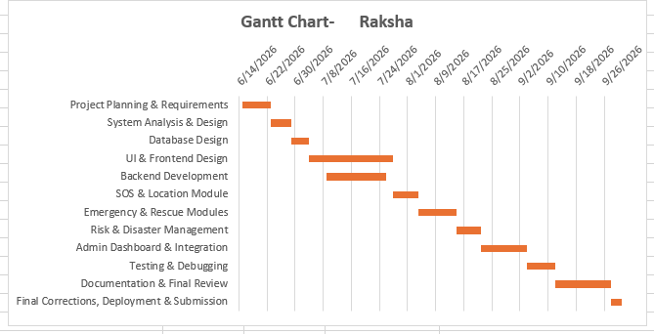

3.5.2PERT CHART
PERT (Program Evaluation and Review Technique) is used to estimate the time required to complete the Raksha – Women Safety and Disaster Management System. It represents the major project activities in a network form and shows the sequence in which the activities are carried out.
Optimistic Time (O): Minimum expected time
Most Likely Time (M): Normal expected time
Pessimistic Time (P): Maximum expected time
Expected Time is calculated as:
TE = (O + 4M + P) / 6
Standard Deviation:
S.D. = (P − O) / 6
PERT Time Estimation Table – RAKSHA
Task | Project Activity | Optimistic Time (O) | Most Likely Time (M) | Pessimistic Time (P) | Expected Time (TE) | S.D.
T1 | Project Planning & Requirements | 6 | 8 | 10 | 8.00 | 0.67
T2 | System Analysis & Design | 5 | 6 | 8 | 6.17 | 0.50
T3 | Database Design | 4 | 5 | 6 | 5.00 | 0.33
T4 | UI & Frontend Design | 20 | 24 | 28 | 24.00 | 1.33
T5 | Backend Development | 14 | 17 | 20 | 17.00 | 1.00
T6 | SOS & Location Module | 6 | 7 | 9 | 7.17 | 0.50
... 6 further rows omitted for readability ...
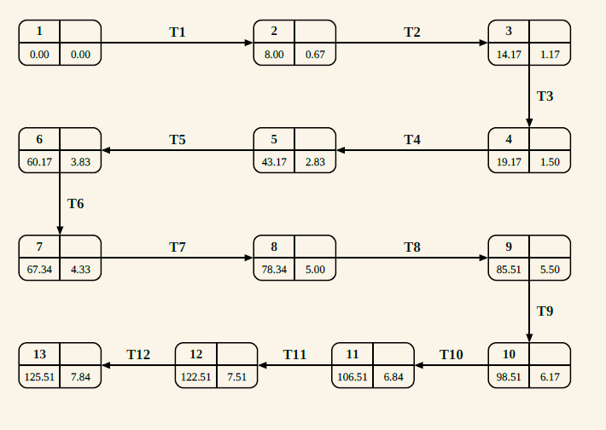

3.6 Conceptual Models
The conceptual model of Raksha Safe shows how the main parts of the system work together. A user can register, add emergency contacts, report an emergency, and use the SOS feature. The system stores the incident and available location details, and shows nearby rescue resources such as police, hospitals, fire services, and volunteers. The AI module provides a basic risk assessment to support the emergency process. The admin manages incidents, users, rescue teams, assignments, notifications, and reports. Overall, the model shows how information moves between the user, system, AI module, rescue resources, and admin.
3.6.1 ER Diagram
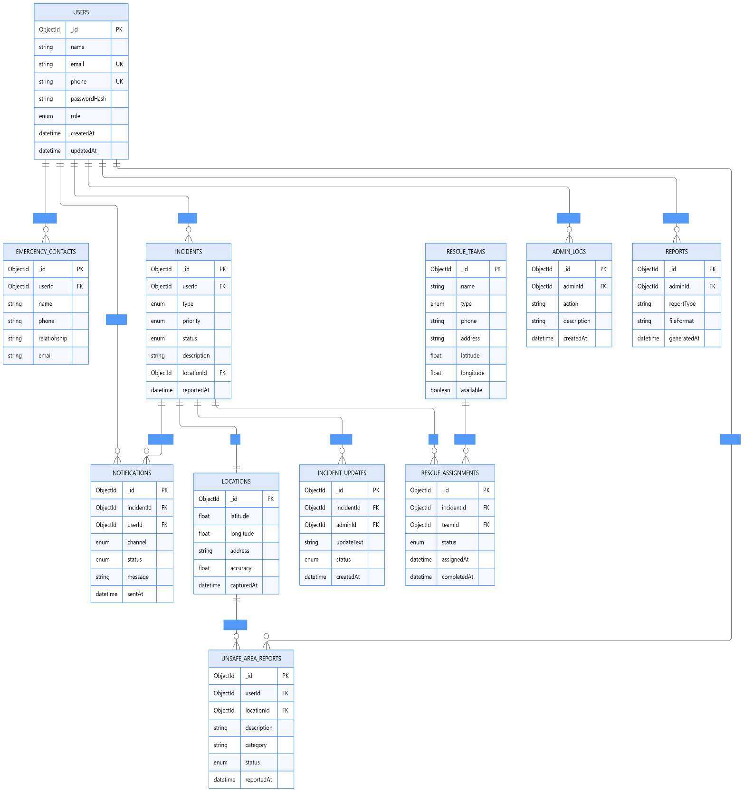

3.6.2 Data Dictionary
The Data Dictionary describes the fields, data types and constraints of the major MongoDB collections used in the Raksha – Women Safety and Disaster Management System. The system contains 15 main collections for managing users, emergency incidents, locations, notifications, rescue resources, risk information, administrative activities and reports.
1. Users
Sr. No. | Field | Type | Constraint
1 | _id | ObjectId | Primary Key, Auto-generated
2 | Name | String | Required
3 | Email | String | Required, Unique
4 | phone | String | Required, Unique
5 | passwordHash | String | Required, Hashed
6 | Role | String | Required, Enum: USER / ADMIN
... 3 further rows omitted for readability ...
2. Emergency Contacts
Sr. No. | Field | Type | Constraint
1 | _id | ObjectId | Primary Key, Auto-generated
2 | userId | ObjectId | Reference → Users
3 | Name | String | Required
4 | Phone | String | Required
5 | Email | String | Optional
6 | relationship | String | Optional
... 4 further rows omitted for readability ...
3. Incidents
Sr. No. | Field | Type | Constraint
1 | _id | ObjectId | Primary Key, Auto-generated
2 | userId | ObjectId | Reference → Users
3 | Type | String | Required, Safety / Disaster
4 | category | String | Required
5 | description | String | Required
6 | priority | String | Required, LOW / MEDIUM / HIGH / CRITICAL
... 4 further rows omitted for readability ...
4. Locations.
Sr. No. | Field | Type | Constraint
1 | _id | ObjectId | Primary Key, Auto-generated
2 | latitude | Number | Required
3 | longitude | Number | Required
4 | address | String | Optional
5 | City | String | Optional
6 | state | String | Optional
... 4 further rows omitted for readability ...
5. Notifications
Sr. No. | Field | Type | Constraint
1 | _id | ObjectId | Primary Key, Auto-generated
2 | incidentId | ObjectId | Reference → Incidents
3 | contactId | ObjectId | Reference → EmergencyContacts, Optional
4 | channel | String | Required, Email / SMS / WhatsApp / In-App
5 | Status | String | Required, Enum
6 | providerResponse | String | Optional
... 4 further rows omitted for readability ...
6. RescueTeams
Sr. No. | Field | Type | Constraint
1 | _id | ObjectId | Primary Key, Auto-generated
2 | name | String | Required
3 | teamType | String | Required, Police / Medical / Fire / NGO / Volunteer
4 | phone | String | Required
5 | email | String | Optional
6 | isActive | Boolean | Required
... 3 further rows omitted for readability ...
7. RescueAssignments
Sr. No. | Field | Type | Constraint
1 | _id | ObjectId | Primary Key, Auto-generated
2 | incidentId | ObjectId | Reference → Incidents
3 | teamId | ObjectId | Reference → RescueTeams
4 | assignedBy | ObjectId | Reference → Users
5 | assignedAt | Date | Auto-generated
6 | status | String | Required, Enum
... 3 further rows omitted for readability ...
8. IncidentUpdates
Sr. No. | Field | Type | Constraint
1 | _id | ObjectId | Primary Key, Auto-generated
2 | incidentId | ObjectId | Reference → Incidents
3 | updatedBy | ObjectId | Reference → Users
4 | statusFrom | String | Optional
5 | statusTo | String | Required
6 | comment | String | Optional
... 1 further rows omitted for readability ...
9. UnsafeAreaReports
Sr. No. | Field | Type | Constraint
1 | _id | ObjectId | Primary Key, Auto-generated
2 | reportedBy | ObjectId | Reference → Users
3 | locationId | ObjectId | Reference → Locations
4 | category | String | Required
5 | description | String | Required
6 | severity | String | Required
... 3 further rows omitted for readability ...
10. RiskZones
Sr. No. | Field | Type | Constraint
1 | _id | ObjectId | Primary Key, Auto-generated
2 | name | String | Required
3 | riskLevel | String | Required
4 | geometry | Object | Required
5 | factors | Array | Optional
6 | lastAssessedAt | Date | Optional
... 3 further rows omitted for readability ...
11. RiskAssessments
Sr. No. | Field | Type | Constraint
1 | _id | ObjectId | Primary Key, Auto-generated
2 | locationId | ObjectId | Reference → Locations
3 | riskScore | Number | Required, Range: 0–100
4 | riskLevel | String | Required, LOW / MEDIUM / HIGH / CRITICAL
5 | modelVersion | String | Required
6 | inputFactors | Array | Optional
... 2 further rows omitted for readability ...
12. Facilities
Sr. No. | Field | Type | Constraint
1 | _id | ObjectId | Primary Key, Auto-generated
2 | name | String | Required
3 | facilityType | String | Required, Enum
4 | locationId | ObjectId | Reference → Locations
5 | phone | String | Required
6 | capacity | Number | Optional
... 4 further rows omitted for readability ...
13. Disaster Categories
Sr. No. | Field | Type | Constraint
1 | _id | ObjectId | Primary Key, Auto-generated
2 | Name | String | Required
3 | Code | String | Required, Unique
4 | description | String | Optional
5 | defaultPriority | String | Required
6 | requiresResponseTeam | Boolean | Required
... 3 further rows omitted for readability ...
14. AdminLogs
Sr. No. | Field | Type | Constraint
1 | _id | ObjectId | Primary Key, Auto-generated
2 | adminId | ObjectId | Reference → Users
3 | action | String | Required
4 | targetType | String | Required
5 | targetId | ObjectId | Optional
6 | details | String | Optional
... 2 further rows omitted for readability ...
15. Reports
Sr. No. | Field | Type | Constraint
1 | _id | ObjectId | Primary Key, Auto-generated
2 | generatedBy | ObjectId | Reference → Users
3 | Title | String | Required
4 | reportType | String | Required
5 | filters | Object | Optional
6 | dataSnapshot | Object | Optional
... 3 further rows omitted for readability ...
3.6.3 DFD LEVEL 0 — CONTEXT DIAGRAM
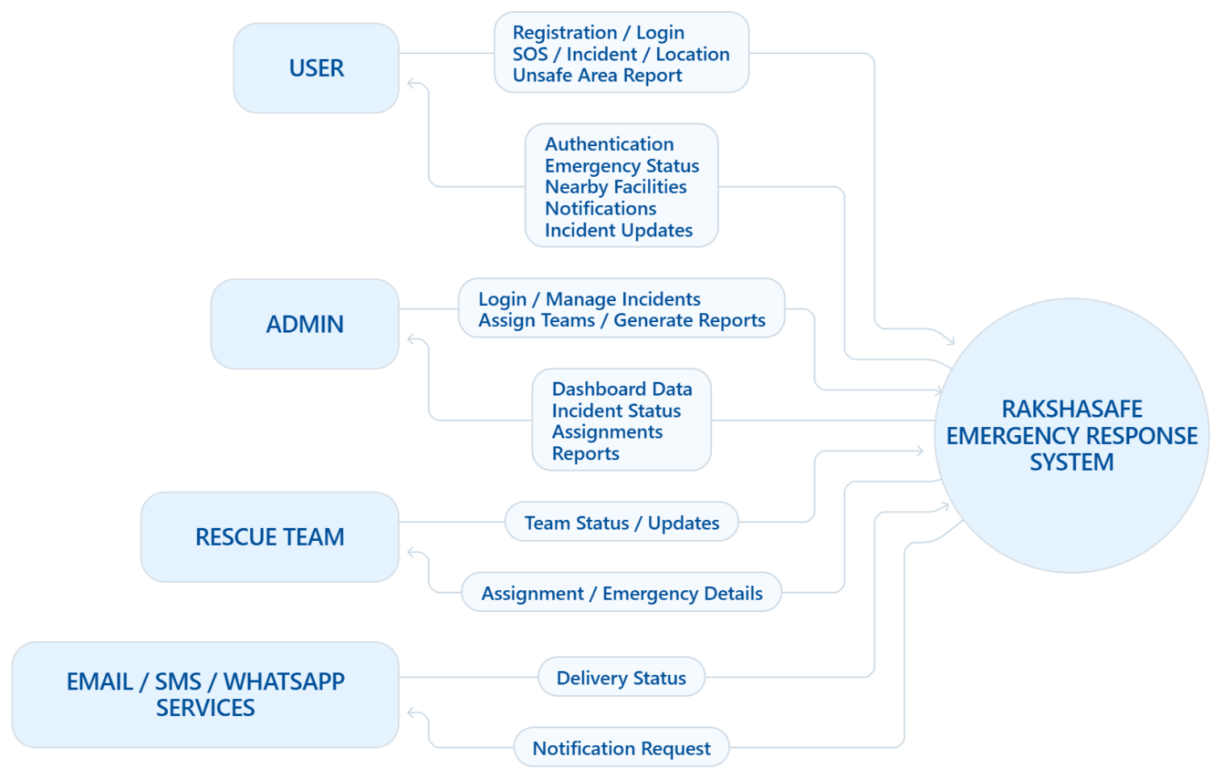

DFD LEVEL 1 — MAIN MODULES
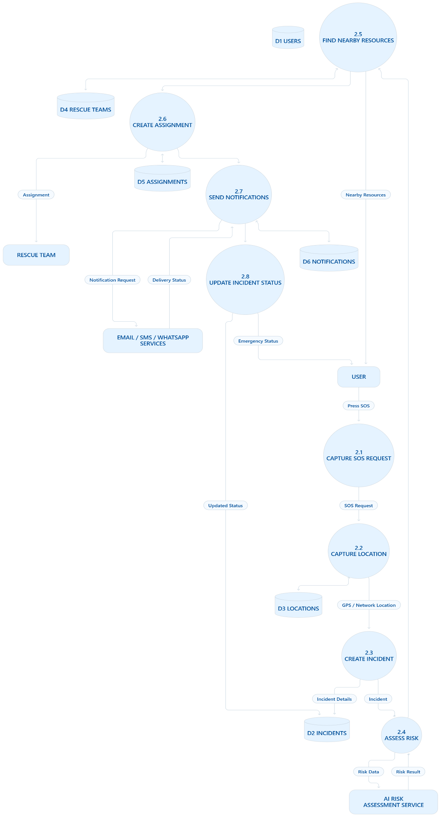

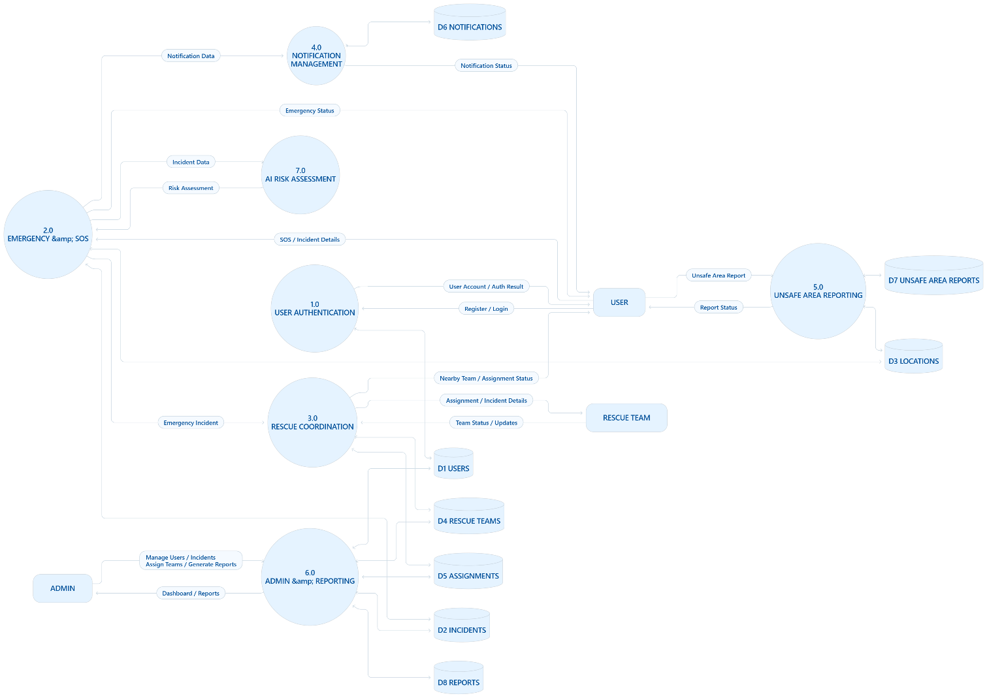
DFD LEVEL 2 — SOS / EMERGENCY PROCESS

CHAPTER 4
SYSTEM DESIGN

4.1 Introduction
This chapter shows how RakshaSafe is put together: the overall architecture, every module, the database schema, the API surface, the risk model, the user interfaces and the deployment and security considerations. It starts high and decomposes until each screen and API is tangible.
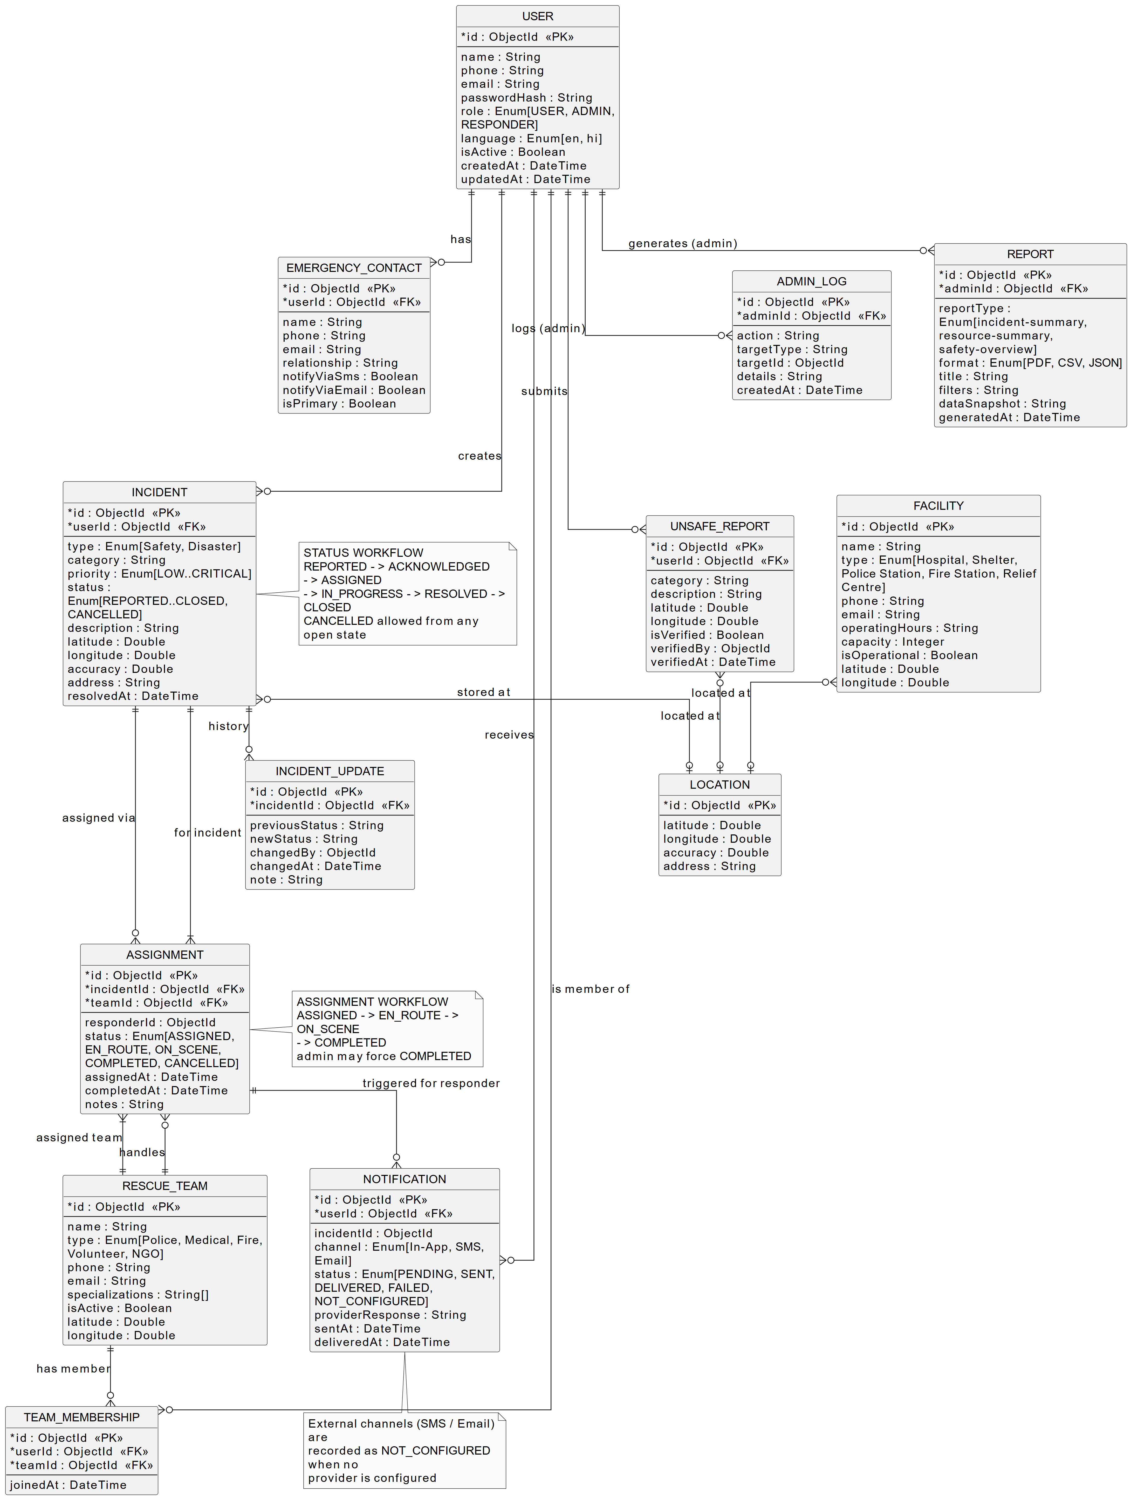
Figure 4.1: Entity-Relationship model (13 entities).
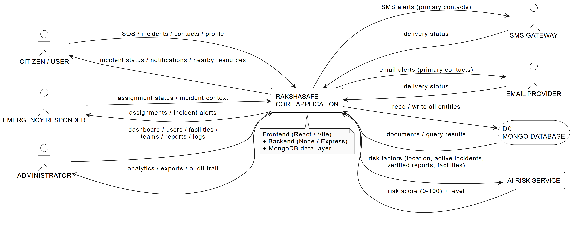
Figure 4.2: DFD Level 0 - context diagram.
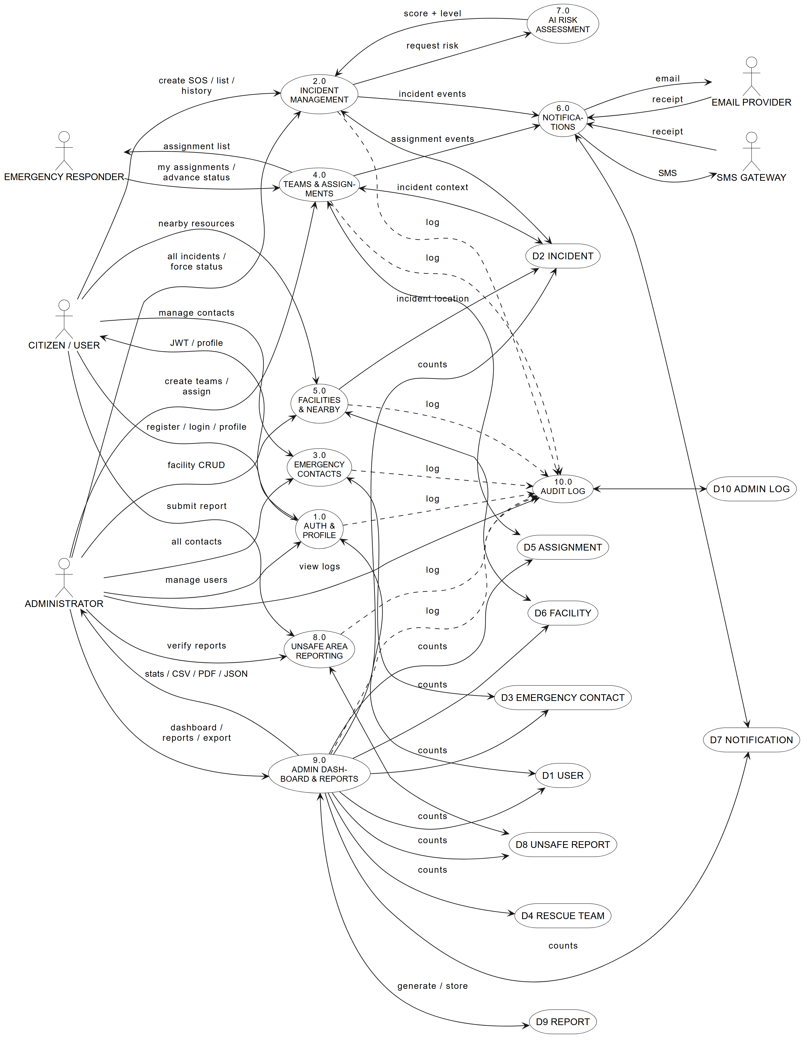
Figure 4.3: DFD Level 1 - major processes.
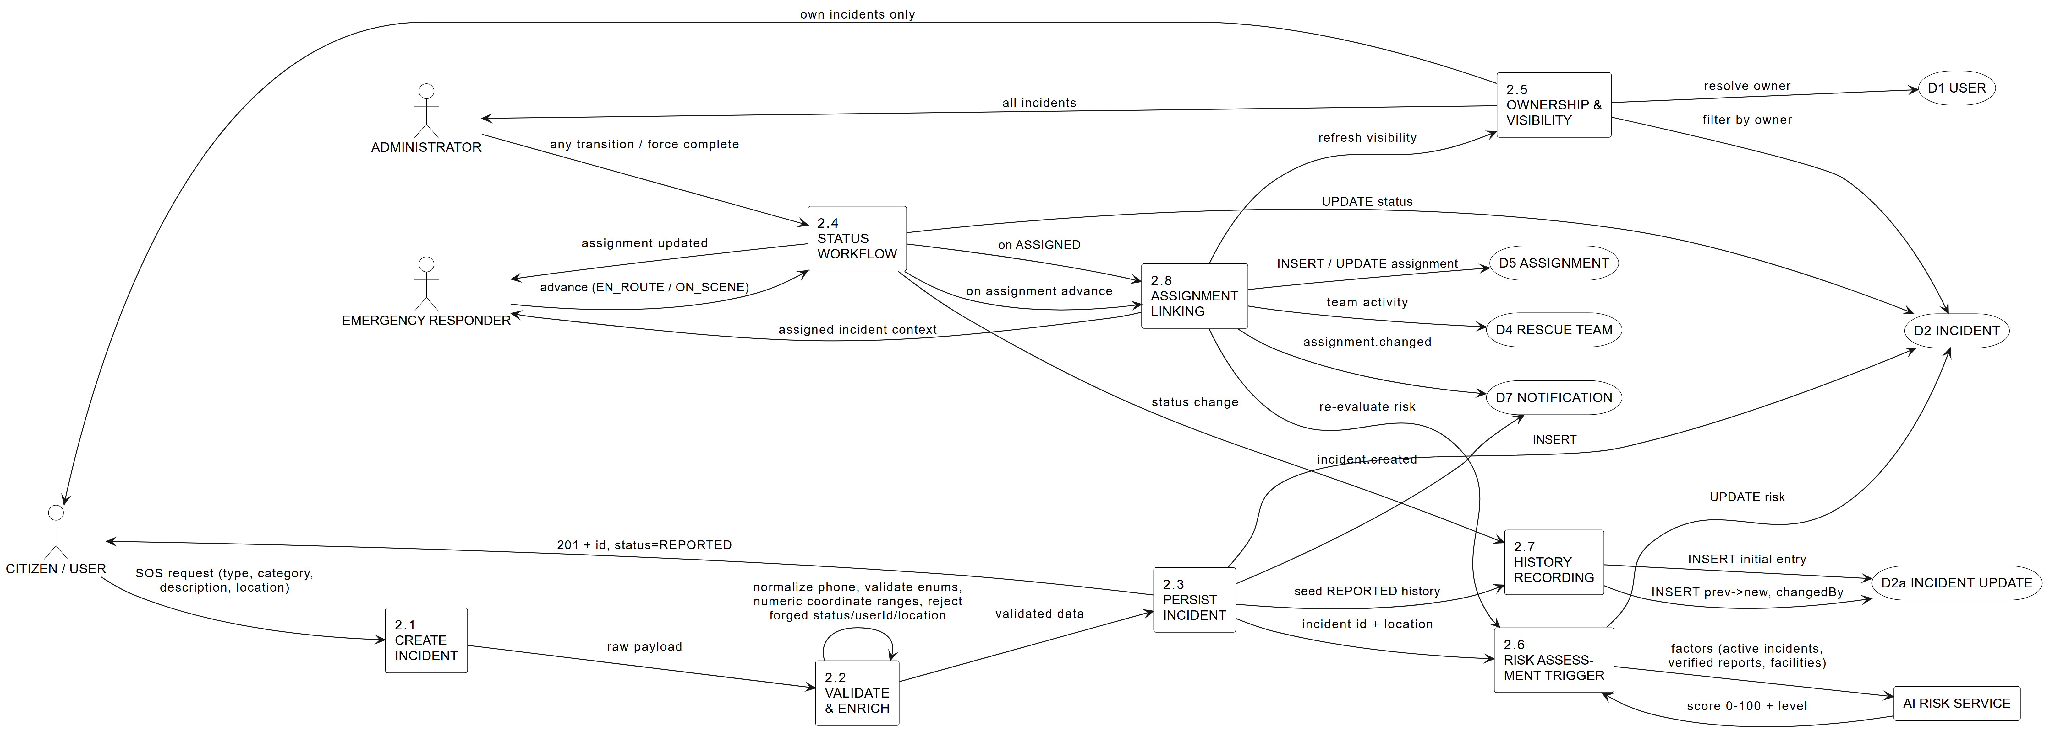
Figure 4.4: DFD Level 2 - incident management.
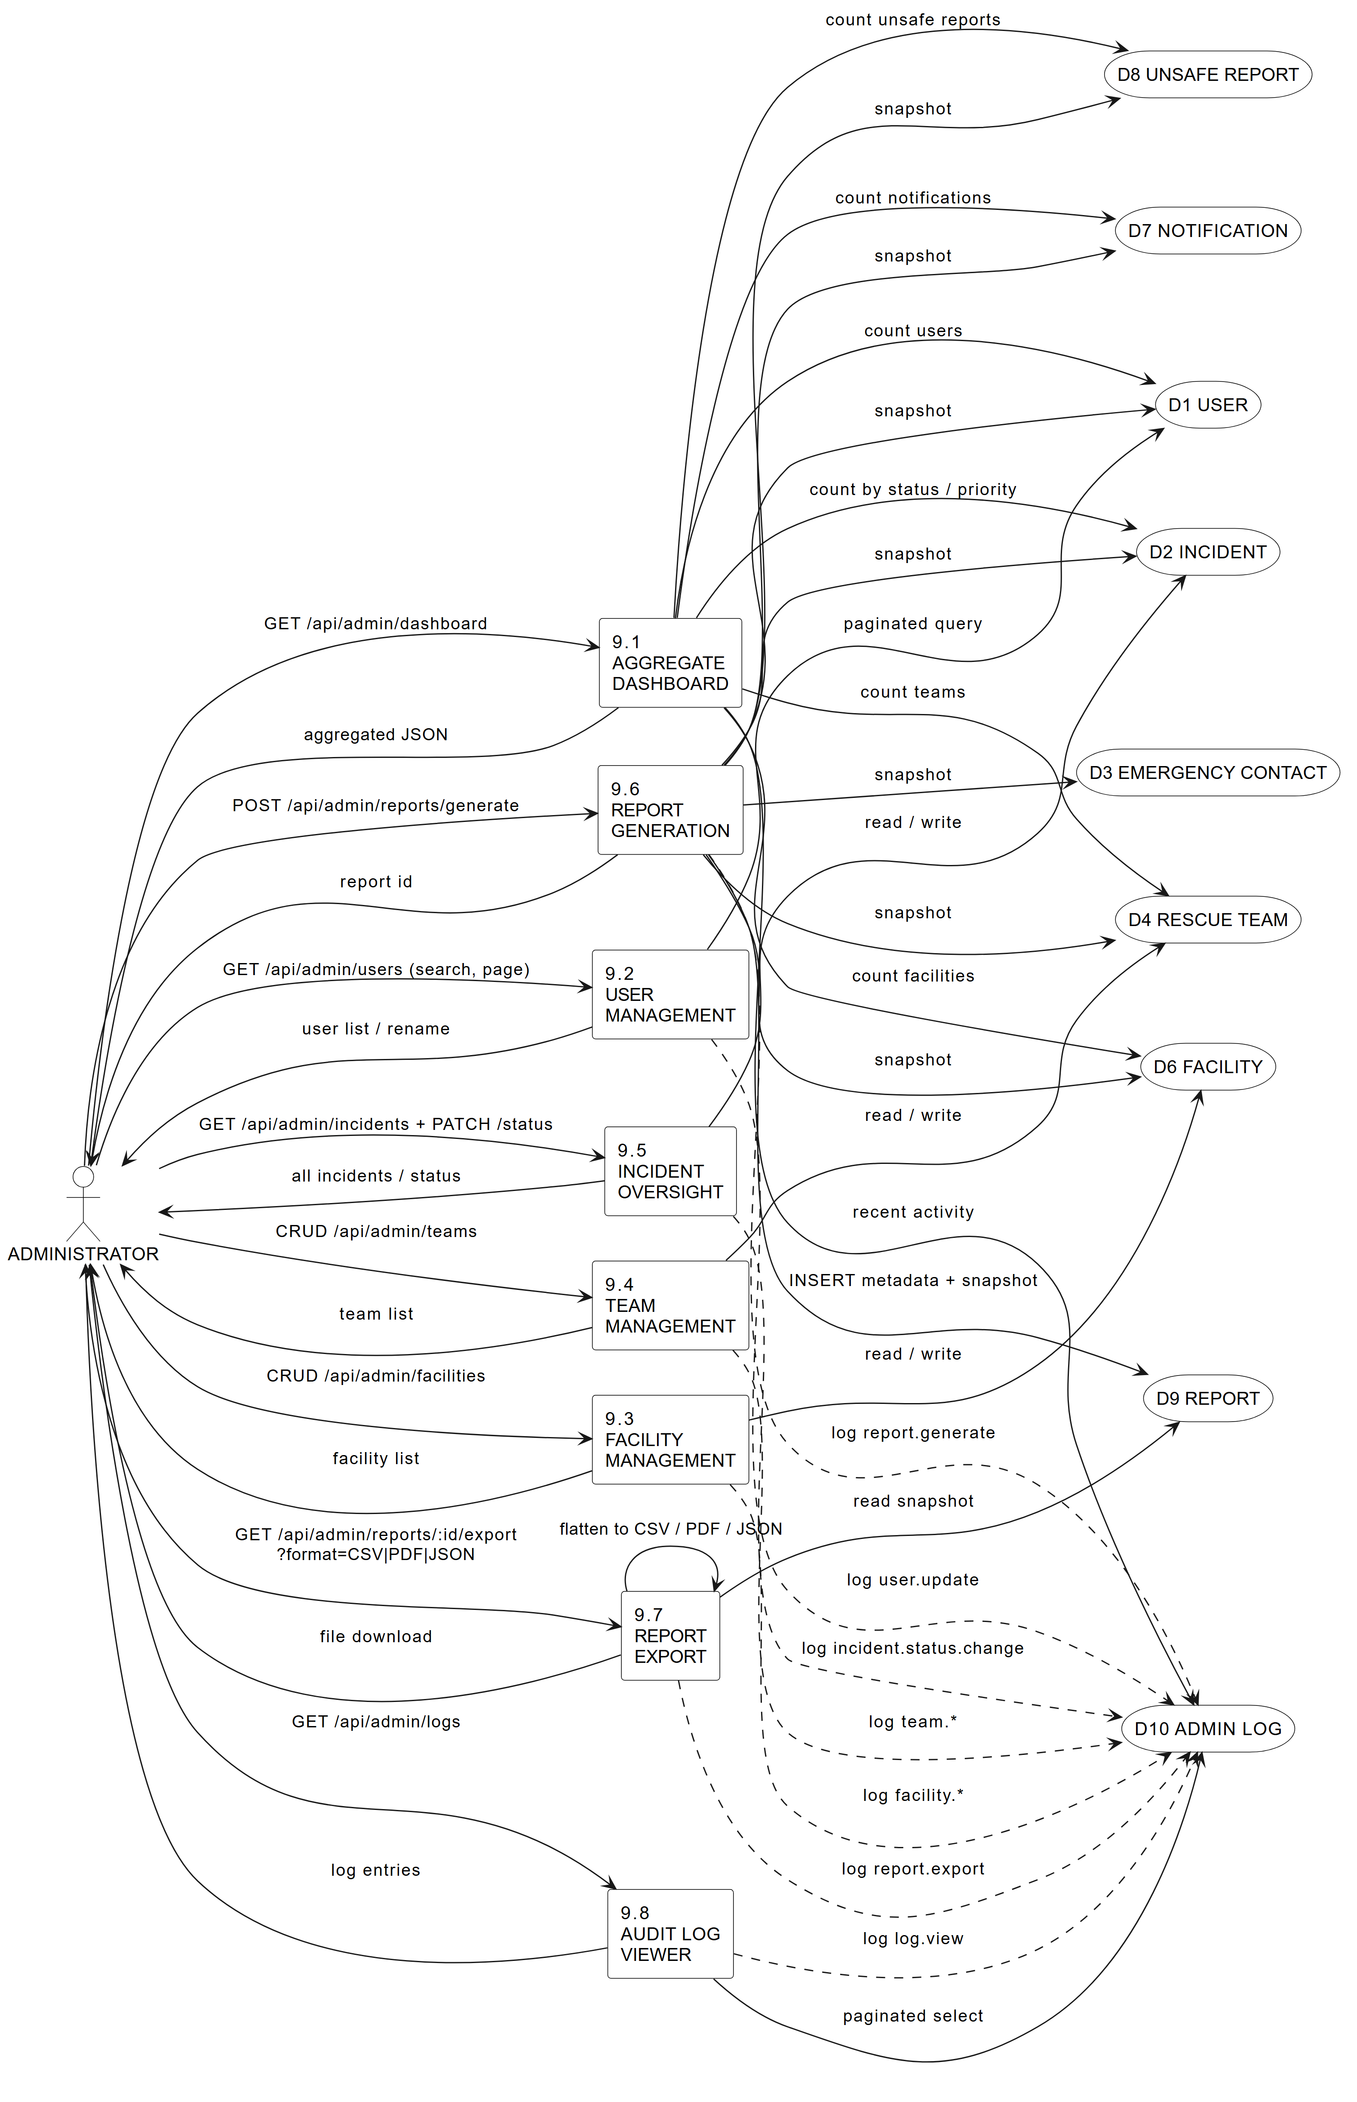
Figure 4.5: DFD Level 2 - admin dashboard and reports.
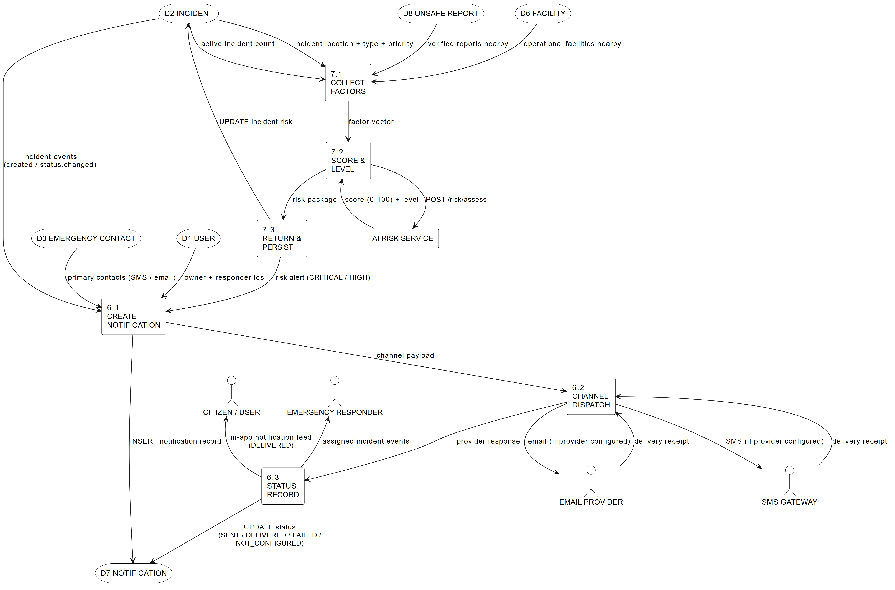
Figure 4.6: DFD Level 2 - notifications and AI risk.
Main Points — 3-layer architecture | 13 collections with ownership-based rules | 12 core API routes | Deterministic 0-100 risk model | JWT + role guards + audit log
Introduction
Before looking at any single screen or service, it helps to see the whole system at once. RakshaSafe is not one big program but a set of focused modules that each own a small, well-defined job: signing users in, recording emergencies, attaching real locations, keeping emergency contacts, organising facilities and rescue teams, sending notifications, scoring risk and letting administrators supervise everything. This chapter walks through that design the way the software is actually built, so every section below traces back to real pages, real API routes and real database collections.
The table below lists every module of the system with what it covers and where it lives in the implementation. It is the map for the rest of the chapter: Section 4.1 explains how the modules work together, Section 4.2 describes each interface in detail, and Section 4.3 covers deployment and security.
Module | What it covers | Main screens / API
Authentication | Registration, login, logout and JWT sessions for all three roles | Login, Register; /api/auth/*
User Management | Profiles, language preference and account state | Profile; /api/auth/me, /api/auth/profile
SOS / Incident Management | Emergency reporting, status workflow, history and ownership | SOS, Incident Detail, Dashboard; /api/incidents/*
Location | Coordinate capture, stored points and readable addresses | SOS location step, Location cards; /api/geocode/*
Emergency Contacts | Per-user contacts with call links and alert channels | Emergency Contacts, Admin Emergency Contacts; /api/emergency-contacts/*, /api/admin/emergency-contacts
Emergency Resources | Searchable directory and nearby lookup of help | Resources, Nearby sections; /api/facilities, /api/nearby-resources, /api/nearby
Facilities | Hospitals, shelters, police and fire stations, relief centres | Resources, Admin Facilities; /api/facilities, /api/admin/facilities
Rescue Teams | Registered teams with type, contact, members and base | Resources, Admin Teams; /api/rescue-teams, /api/admin/rescue-teams
Rescue Assignments | Incident-to-team assignment records and their lifecycle | Incident Detail, Admin incident detail; /api/admin/incidents/:id/assignments, /api/responder/assignments
Unsafe-Area Reporting | User reports with admin verification queue | Unsafe Reports, Admin Unsafe Reports; /api/unsafe-reports/*, /api/admin/unsafe-reports
Risk Zones | Administrator-maintained boundary records with risk levels | Admin masters; RiskZones collection
Risk Assessment (AI) | Deterministic raksha-risk-v1 scoring of incident locations | Risk panels; /api/incidents/:id/risk, FastAPI POST /risk/assess
Notifications | In-app and provider-channel delivery records with status | Notifications; /api/notifications, /api/responder/notifications
... 2 further rows omitted for readability ...
4.1 System Architecture
The system design of RakshaSafe – Women Safety and Disaster Emergency Response System describes how the different parts of the system work together to record emergency incidents, associate them with real locations, organise emergency resources, support rescue assignments, produce assistive risk assessments, deliver notifications and provide administration. The design keeps three concerns separate: the React web application that users and administrators operate, the Node.js backend that enforces authentication, validation and record relationships, and the Python AI service that scores risk. MongoDB stores every persistent record, and the backend is the only writer of application data.
4.1.1 Overall System Working
The overall working of RakshaSafe is divided into the following stages:
1. User Authentication
a. A new user registers with name, email, phone and password. An existing user, administrator or responder signs in with the registered email or phone number together with the password. b. Passwords are never stored in plain text; they are hashed with bcrypt and verified on login. c. On successful authentication the backend issues a JSON Web Token (JWT). The frontend stores the session and redirects by role: USER accounts reach the user dashboard, ADMIN accounts reach the admin dashboard, and RESPONDER accounts reach the responder workspace.
2. SOS and Incident Creation
a. The signed-in user opens the SOS page and describes the emergency: incident type (Safety or Disaster), a category such as Women Safety, Medical Emergency, Accident, Fire, Flood, Earthquake or Other Emergency, a free-text description and a priority of LOW, MEDIUM, HIGH or CRITICAL. b. The backend validates the request, creates an Incidents record with status REPORTED and returns the stored incident. The incident immediately appears in the user dashboard and in the admin incident list.
3. Location Capture and Association
a. Where the user grants permission, the browser Geolocation API supplies latitude, longitude and accuracy. The coordinates are sent with the incident request and stored as a Locations record linked through locationId. b. A server-side reverse-geocode step resolves a readable address, city, district, state, postal code and country for display. If permission is denied or the position is unavailable, the incident is still recorded without coordinates; no false location is ever assumed or stored.
4. Emergency Resource Lookup
a. Around a real query point the system lists nearby Facilities (Hospital, Shelter, Police Station, Fire Station, Relief Centre) and active RescueTeams, nearest first with straight-line distances. b. Each card shows the values actually present in the source record: name, type, address or “Address unavailable”, and distance. A Call button using a tel: link is rendered only when a real phone number exists, and a Directions link is built only from real coordinates. Where an external places provider is configured, its live results are merged with stored records; when it is unavailable the page honestly reports that and continues with stored resources.
5. Rescue Assignment
a. An administrator assigns a registered, active rescue team to an incident, optionally with notes. b. Assignment status follows ASSIGNED → EN_ROUTE → ON_SCENE → COMPLETED, with CANCELLED where applicable. Every change is a software record in RescueAssignments; the system never claims automatic dispatch, guaranteed response or an exact arrival time.
6. AI Risk Assessment
a. For an incident that has stored coordinates, the user (or the admin view of the same incident) can request an assistive risk assessment. The backend assembles fixed factors — priority, incident type, counts of verified and unverified unsafe-area reports nearby, and other active incidents nearby — and posts them to the FastAPI AI service. b. The deterministic raksha-risk-v1 model returns a risk score from 0 to 100, a risk level of LOW, MEDIUM, HIGH or CRITICAL, the model version, the input factors and the assessment time. The backend validates this response and stores it in RiskAssessments, then serves the stored record to both user and admin views. The result is decision support only and is always shown with a disclaimer.
7. Notifications
a. Incident lifecycle events — creation, acknowledgement, assignment, status changes, resolution and cancellation — create Notification records for the incident owner and, where configured, for emergency-contact channels. b. Each notification carries its channel (Email, SMS, WhatsApp or In-App), a status of QUEUED, SENT, DELIVERED, FAILED, NOT_CONFIGURED or UNAVAILABLE, the provider response, attempt counts and timing. Delivery depends on the configured providers; a delivery failure never corrupts the incident record.
8. Administration and Reporting
a. Administrators work through the admin dashboard: users, emergency contacts of any user, incidents with reporter, location, history and assignments, facilities, rescue teams and their members, unsafe-area report verification, risk-zone records, generated reports in PDF, CSV or JSON, and the admin activity log. b. Incident status follows REPORTED → ACKNOWLEDGED → ASSIGNED → IN_PROGRESS → RESOLVED → CLOSED, with CANCELLED where applicable, and each transition is stored as an IncidentUpdates record with an optional comment.
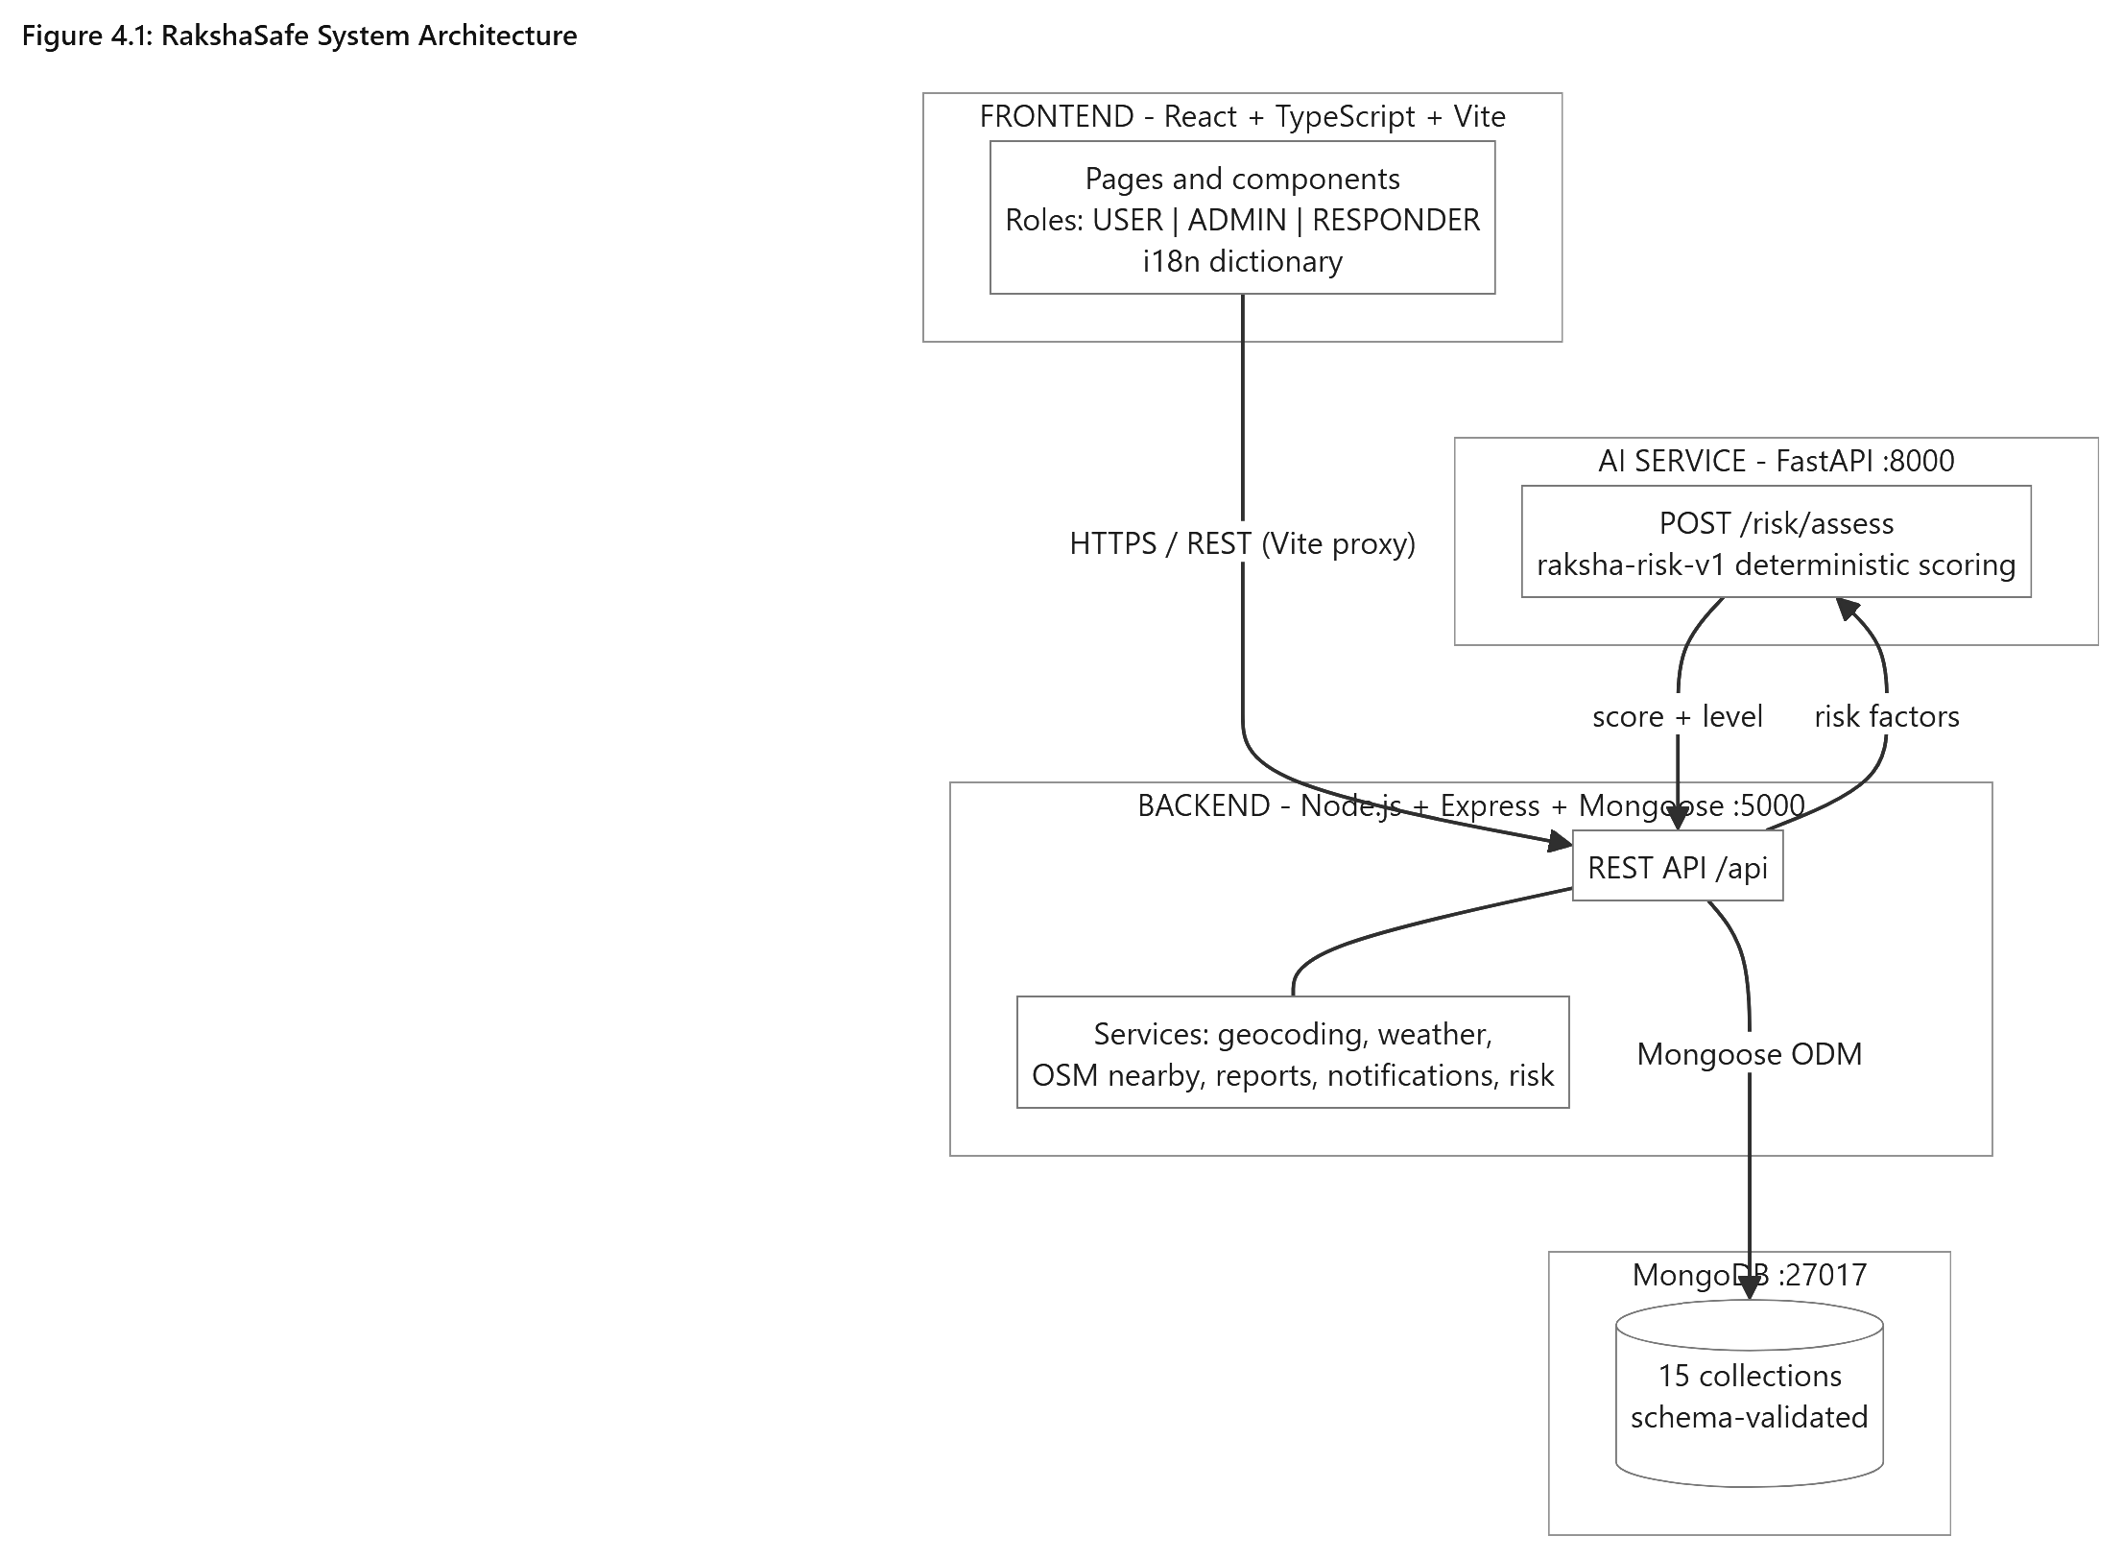

RakshaSafe System Architecture
4.1.2 Technology Used
The technologies below are the ones actually used in the implementation. Each choice matches a layer of the system, and no component in the table is aspirational: the frontend is the React application in the repository, the backend is the Express API, the database is MongoDB accessed through Mongoose, and the AI service is the FastAPI application in the ai-service folder.
Component | Technology | Purpose
Frontend | React.js, TypeScript, Vite, Tailwind CSS | User and admin web interface
Backend | Node.js, Express.js, TypeScript | REST APIs and business logic
Authentication | JWT, bcrypt | Session tokens and password security
Database | MongoDB, Mongoose ODM | Persistent records and validation
AI Service | Python, FastAPI | Deterministic risk scoring
AI Model | raksha-risk-v1 (rule-based scoring) | Risk score and level, decision support only
Location | Browser Geolocation API | Latitude, longitude and accuracy capture
Maps | OpenStreetMap, Leaflet | Incident and resource map display
Communication | Configured Email / SMS / WhatsApp providers | Notification delivery where configured
Weather | Open-Meteo (no key) | Informational weather enrichment
4.1.3 Database Design
MongoDB holds fifteen collections. Relationships are ObjectId references maintained by Mongoose schemas rather than relational foreign keys, and critical integrity is enforced through schema validation. The table below names each collection with its purpose and principal references; the detailed field lists follow Chapter 3 and the model files, so only the important references are repeated here.
Collection | Purpose | Principal references
Users | Accounts and profiles | Unique email and phone
EmergencyContacts | User emergency contacts | userId → Users
Incidents | SOS and emergency records | userId → Users; locationId → Locations (optional)
Locations | Geographic points and resolved address | Standalone; referenced by incidents, facilities, reports
Notifications | Delivery records and status | incidentId → Incidents; contactId → EmergencyContacts (optional)
RescueTeams | Registered response teams and members | members → Users; locationId → Locations (optional)
RescueAssignments | Incident-to-team assignments | incidentId → Incidents; teamId → RescueTeams; assignedBy → Users
IncidentUpdates | Status history and comments | incidentId → Incidents; updatedBy → Users
UnsafeAreaReports | User-submitted unsafe-area reports | reportedBy → Users; locationId → Locations
RiskZones | Structured risk-zone records | Standalone boundary records managed by admins
RiskAssessments | Risk scores and assessment results | locationId → Locations
Facilities | Hospitals, shelters, stations, relief centres | locationId → Locations
DisasterCategories | Maintained incident categories | Referenced by category name/code
... 2 further rows omitted for readability ...
The relationships that matter for the design are short: a user owns incidents, contacts and unsafe-area reports; an incident optionally points at one location and accumulates updates, assignments, notifications and — through its location — risk assessments; facilities and rescue teams each point at locations; and every administrative action appends to AdminLogs. Nothing in the design requires joins across databases, because there is only one database.
4.1.4 API Design
The backend exposes a REST API under /api with a uniform JSON envelope: success responses carry a data object, while failures carry a message and, for validation problems, a field-level issues list. Every router declares its own guard chain, so the access rule of an endpoint can be read directly from the route files: public authentication endpoints stand alone, user endpoints combine requireAuth with requireDb and owner scoping, responder endpoints add requireResponder, and the whole /api/admin tree combines requireAuth, requireAdmin and requireDb. Creation endpoints for incidents and unsafe-area reports additionally carry per-IP rate limits against flooding. The table below lists the implemented endpoints; enrichment lookups for live maps, weather and geocoding deliberately omit requireDb so informational features stay available while MongoDB is unreachable.
Method and path | Access | Purpose
POST /api/auth/register | Public, database | Create a USER account
POST /api/auth/login | Public, database, rate-limited | Authenticate and issue a JWT
POST /api/auth/logout | Public | End the client session
GET /api/auth/me | Authenticated, database | Return the current account
PATCH /api/auth/profile | Authenticated, database | Update the own profile
POST /api/emergency-contacts | Authenticated, database, owner | Add an own emergency contact
GET /api/emergency-contacts | Authenticated, database, owner | List the own emergency contacts
PATCH /api/emergency-contacts/:id | Authenticated, database, owner | Update an own contact
DELETE /api/emergency-contacts/:id | Authenticated, database, owner | Delete an own contact
POST /api/incidents | Authenticated, database, rate-limited | Create an SOS incident
GET /api/incidents | Authenticated, database, owner | List the own incidents
GET /api/incidents/:id | Authenticated, database, owner | Incident detail with location
PATCH /api/incidents/:id | Authenticated, database, owner | Edit an own early incident
... 52 further rows omitted for readability ...
Two properties of this table deserve emphasis for the viva. First, ownership is always derived from the JWT identity on the server; incident and contact identifiers in the URL select records, they never confer access, and a user who guesses another account’s identifier receives a not-found response rather than the record. Second, failures are compartmentalised: an unreachable AI service, map provider or weather upstream produces a retryable error for that panel alone, while incident creation, status management and stored-resource lookup continue to work.
4.1.5 Risk Scoring Design
Risk scoring is the only component called “AI” in this project, and the name needs care: the service performs no machine learning, interprets no text and calls no external model. The Node.js backend counts bounded facts from stored records around the incident location — the priority, the incident type, nearby verified and unverified unsafe-area reports, and other nearby active incidents — and the FastAPI service applies fixed arithmetic documented as model raksha-risk-v1. Because free-text descriptions never cross into the scorer, prompt-injection style input cannot influence the result; only the pre-computed numbers matter.
Factor | Contribution | Cap
Priority base | LOW 15, MEDIUM 35, HIGH 60, CRITICAL 80 | Always exactly one base value
Incident-type modifier | Safety +0, Disaster +5 | Fixed per type
Verified unsafe reports nearby | +6 each | +30
Unverified reports nearby | +2 each | +10
Other active incidents nearby | +3 each | +15
Total score | Sum of the above, clamped to 0–100 | Integer only
Level bands follow the score directly: below 25 is LOW, below 50 is MEDIUM, below 75 is HIGH, and anything at or above 75 is CRITICAL. The response carries the score, the level, the model version, the five weighted input factors and the assessment timestamp, and the backend re-validates every field — integer score within range, level within the four enum values, non-empty version, factor array and parseable time — before anything is stored in RiskAssessments. An invalid, unreadable or late response becomes a retryable panel error, and the frontend displays the stored record with the decision-support disclaimer on every view.
4.2 System Interface Design
The RakshaSafe interface gives users and administrators a consistent workspace: a navigation bar with the золотые modules for the signed-in role, a content area of cards, tables with search and pagination, explicit loading skeletons, empty states and error states with retry, and small badges for status, priority and levels. Forms use labelled inputs with inline field errors, destructive actions always ask for confirmation, and phone numbers become tel: links while coordinates become map links. The layout adapts from mobile to desktop and honours the light and dark themes. The interfaces below are the ones actually implemented in the frontend pages.
4.2.1 Login Interface
The Login Interface is the entry point for every account. It accepts the registered email address or phone number together with the password, authenticates against the backend, and routes the session to the dashboard that matches the account role. The page stays deliberately plain so that signing in remains fast even on weak connections.
Main elements:
Email-or-phone field for the registered identifier.
Password field with a show/hide visibility option.
Sign In button for authentication.
Create Account link for new users.
Session-expired notice when redirected after a timeout.
Validation:
The identifier must be a recognised email address or phone number; blank or malformed input is rejected locally.
The password must be entered; empty submissions are blocked.
Invalid credentials are rejected by the backend without revealing which half was wrong.
Deactivated accounts are refused with a contact-support message.
Only an authenticated session can leave this page for the application.
Steps:
1. Enter the registered email address or phone number.
2. Enter the password.
3. Click Sign In.
4. The system validates the credentials and verifies the account is active.
5. On success the user is redirected by role: USER to the user dashboard, ADMIN to the admin dashboard, RESPONDER to the responder workspace.
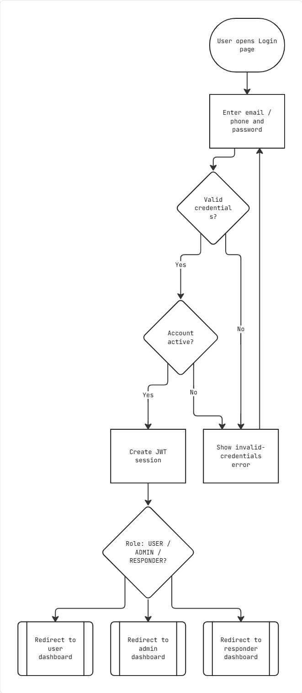

Login
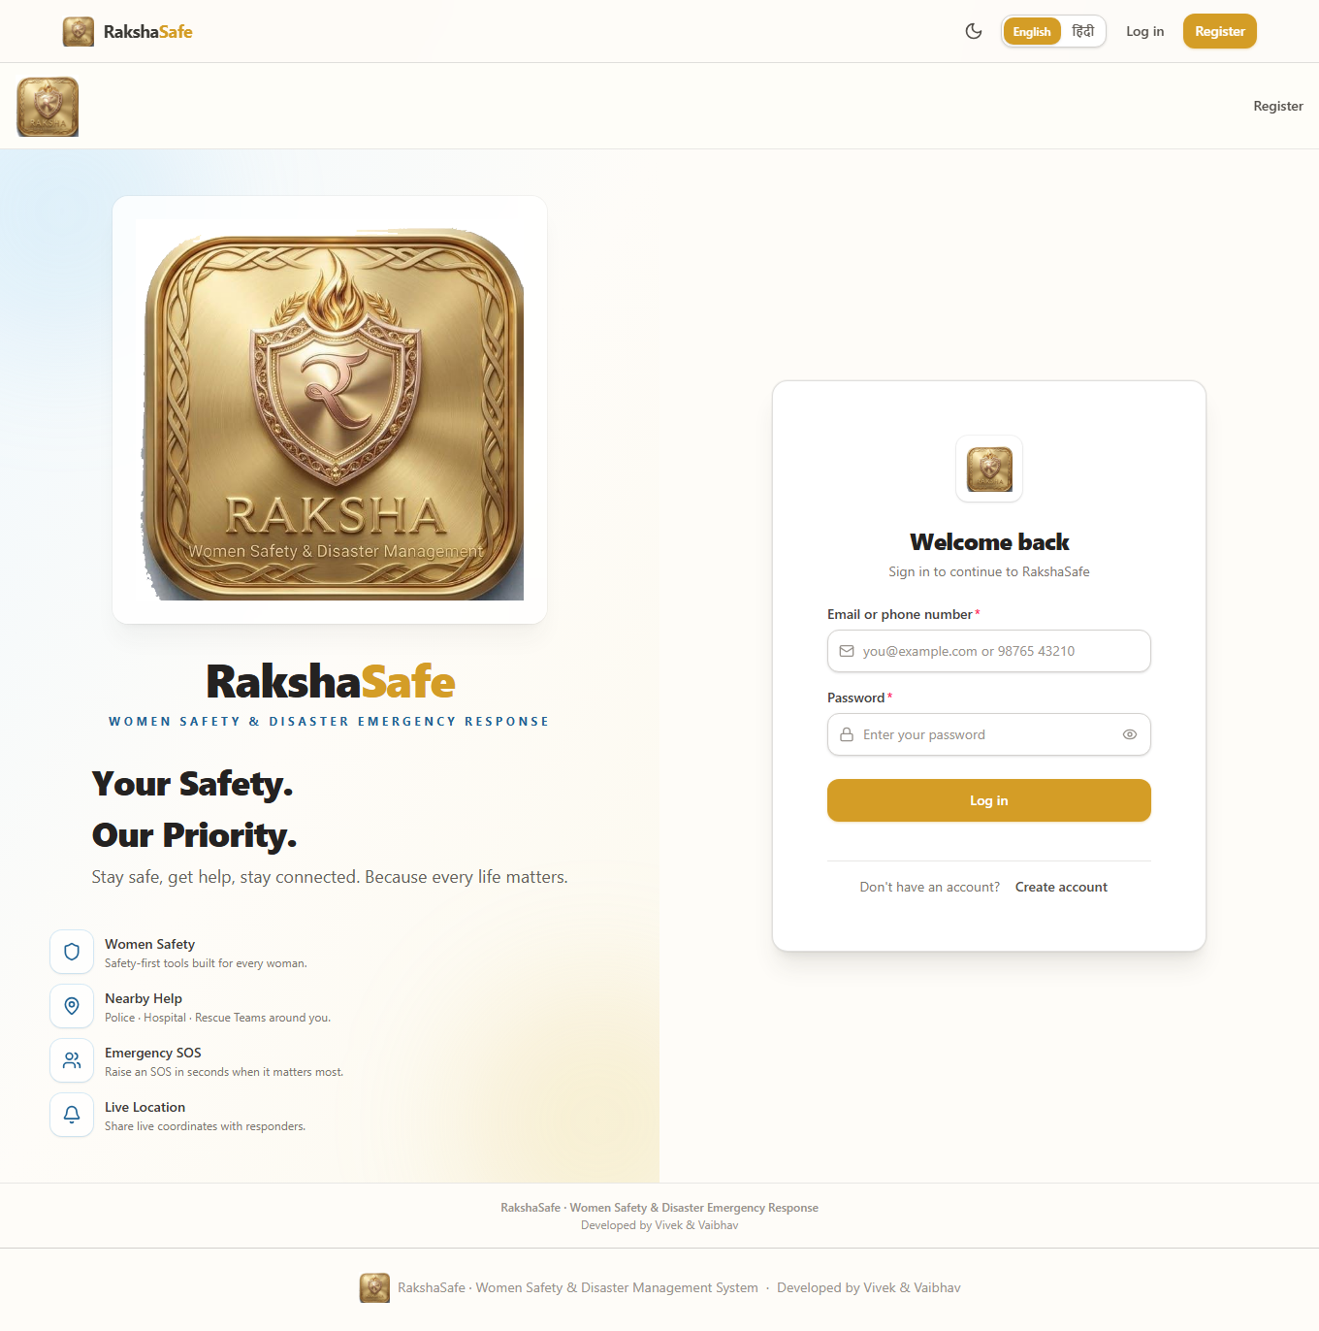

Login Interface
4.2.2 User Registration Interface
The Registration Interface creates a standard USER account. It collects the minimum profile needed for emergency use — a name, a reachable email and phone number, and a password — and leaves administrative roles to be granted outside this form. Successful registration signs the session in directly, without any email-code step.
Main elements:
Full-name field.
Email address field.
Phone number field.
Password field with strength guidance.
Preferred-language option.
Create Account button and a Back to Sign In link.
Validation:
Name, email, phone and password are all required.
Email must be valid in format and unique; phone must be a valid number and unique.
The password must satisfy the minimum-length and complexity rule.
Duplicate email or phone registrations are rejected with a field-level message.
Steps:
1. Enter the full name.
2. Enter the email address.
3. Enter the phone number.
4. Create a password.
5. Optionally choose the preferred language.
6. Click Create Account.
7. The system validates, stores the hashed password, creates the session and opens the user dashboard.
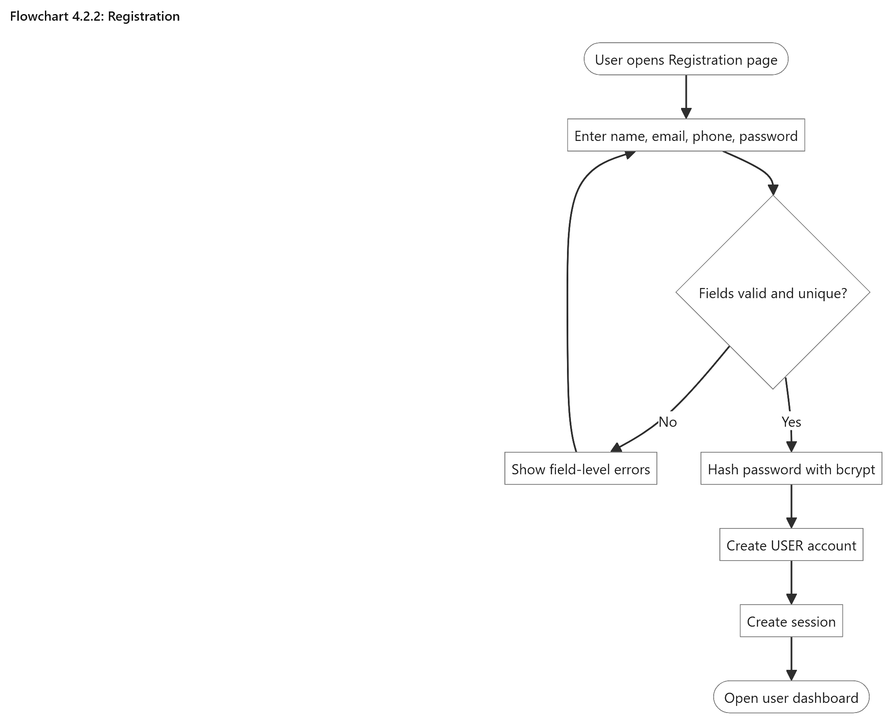

Registration
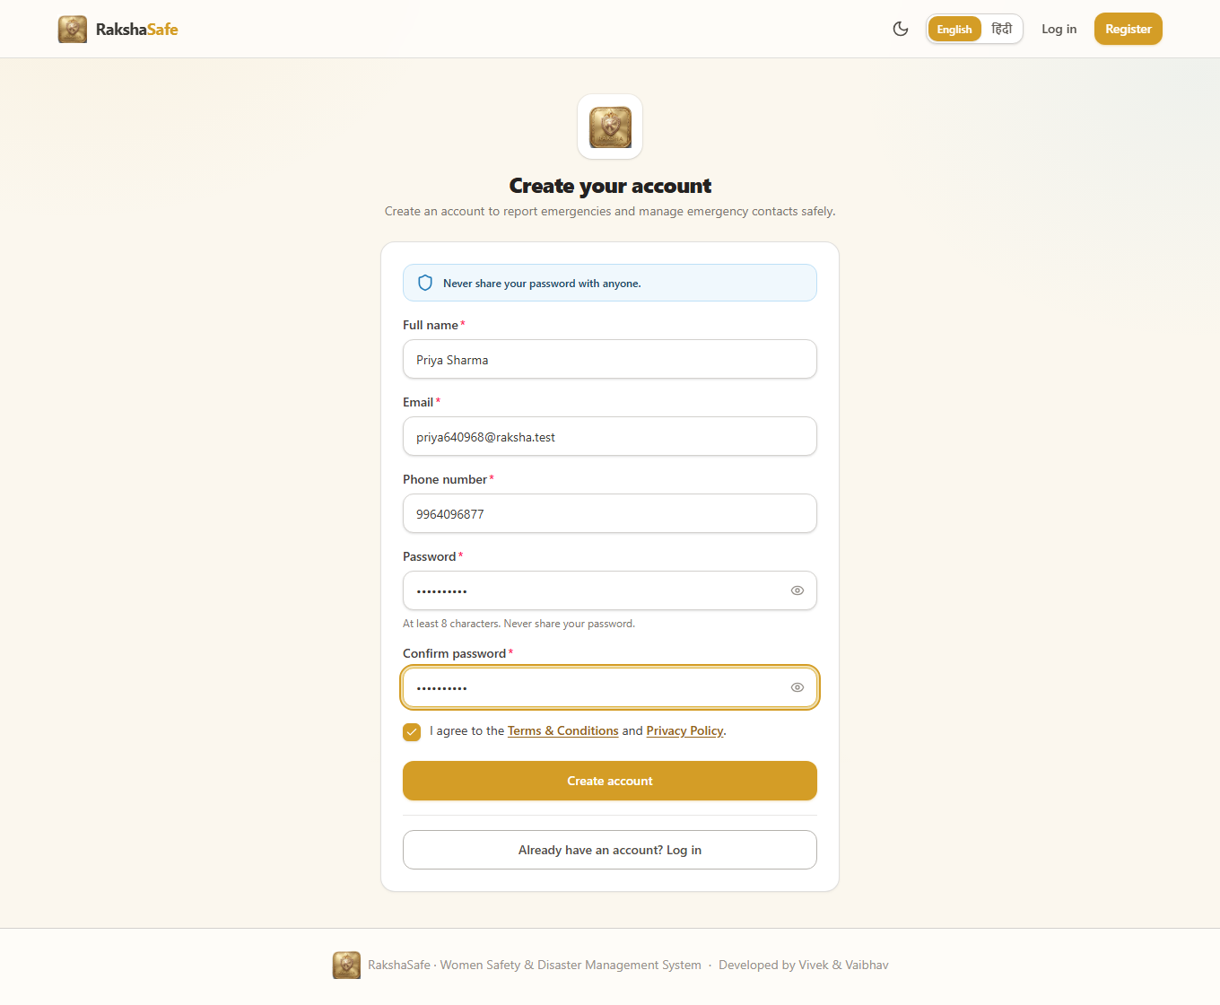

Registration Interface
4.2.3 User Dashboard Interface
The Dashboard is the home screen for a signed-in user. Rather than analytics, it answers three questions at a glance: what are my recent incidents, what state is each one in, and where do I go next. Quick actions lead to SOS reporting, emergency contacts, resources, unsafe-area reporting and notifications, so the dashboard behaves as a hub instead of a dead end.
Main elements:
Recent-incidents list with category, priority badge and status badge.
Status summary of the user’s own active and resolved incidents.
Quick actions: Report SOS, Emergency Contacts, Find Resources, Report Unsafe Area.
Notifications entry with unread indication.
Shortcuts to profile and language settings.
Validation:
Only the signed-in user’s own incidents are listed; no other user’s data appears.
Counts are computed from stored records and never include other accounts.
Navigation guards keep signed-out visitors on the login page.
Steps:
1. Sign in as a user.
2. Review the recent-incidents list and their statuses.
3. Use a quick action to start SOS reporting, manage contacts, or browse resources.
4. Open any incident for its full detail, history and risk information.
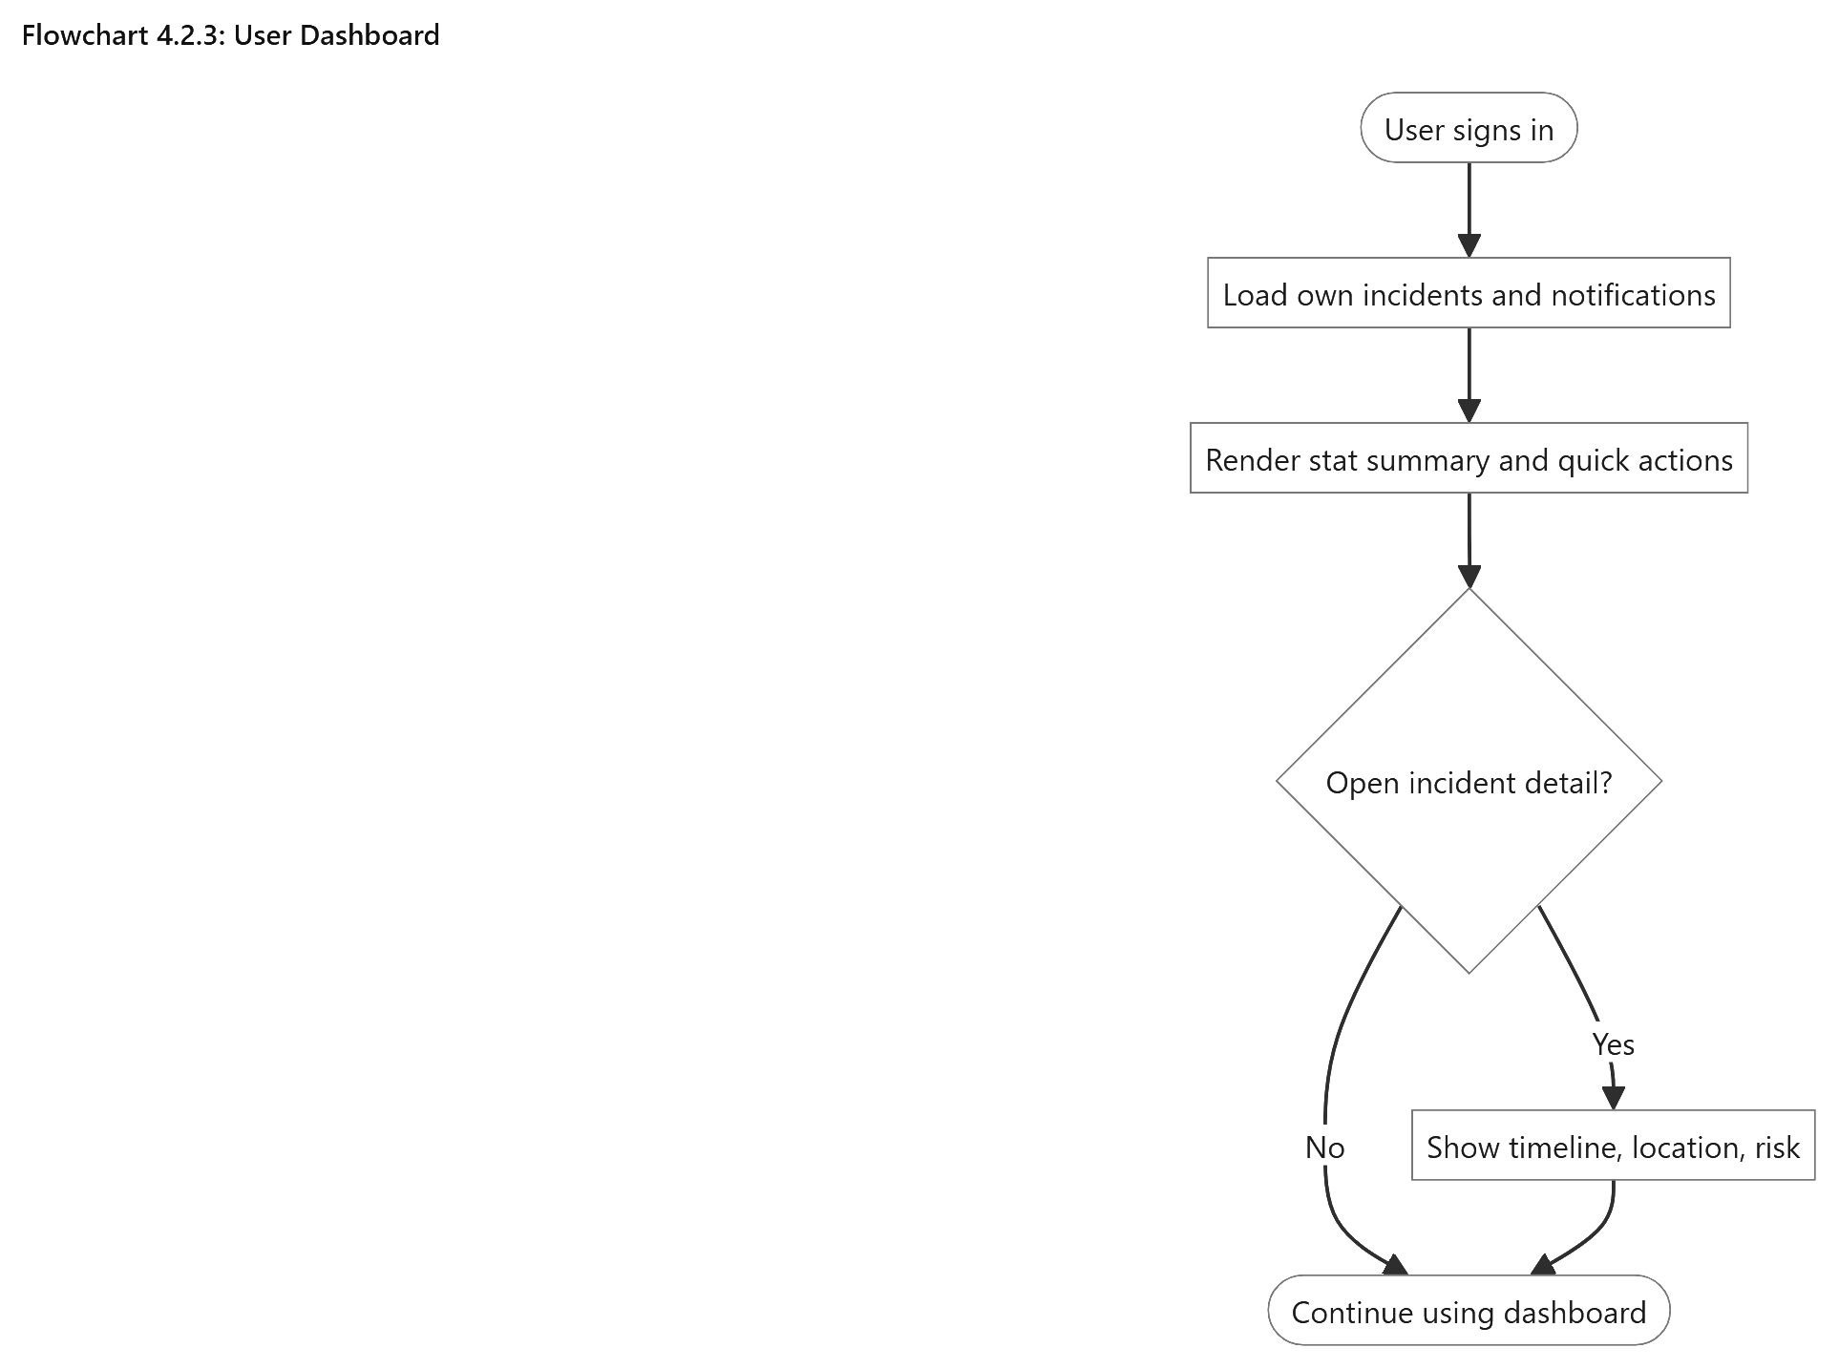

User Dashboard
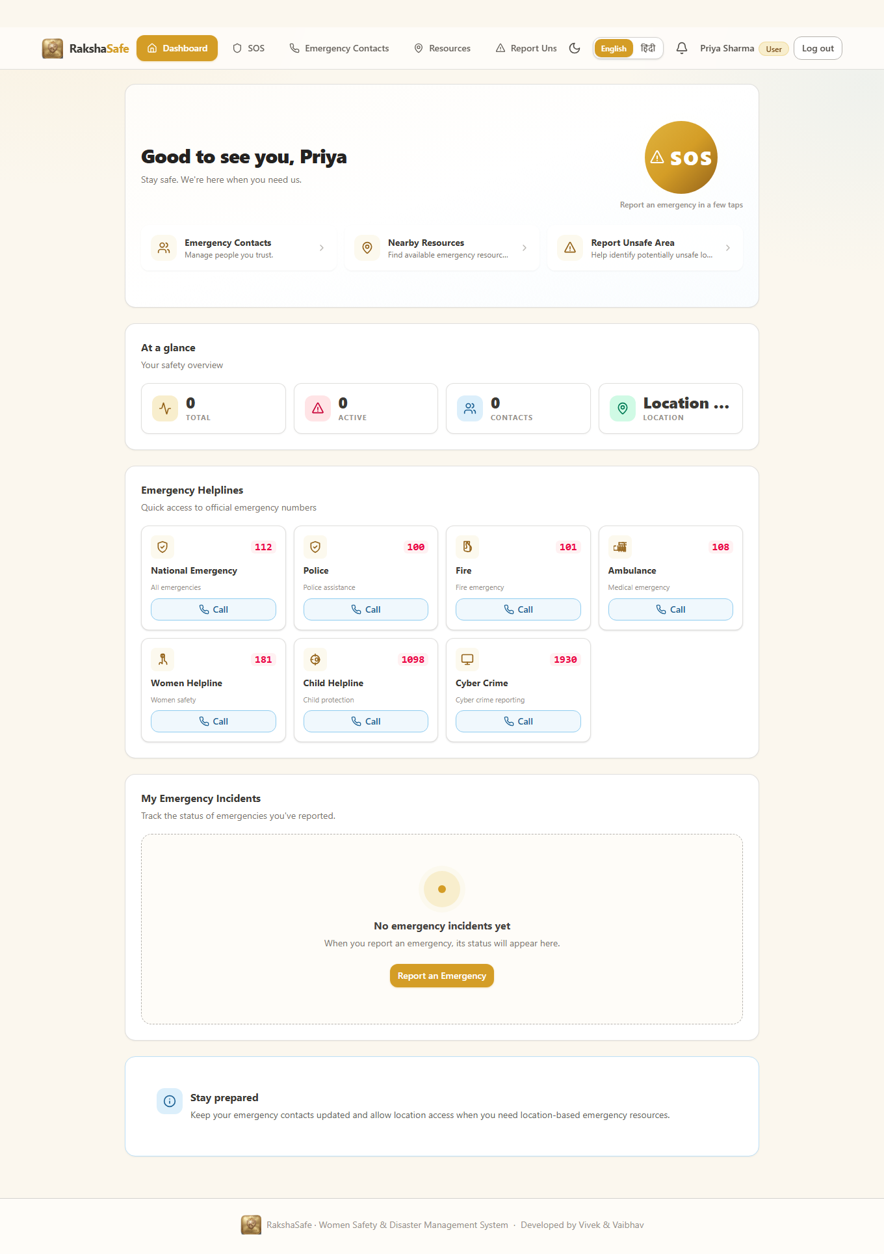

Dashboard Interface
4.2.4 SOS and Incident Creation Interface
The SOS Interface turns an emergency into a structured incident record in a few guided steps. It asks for the incident type, category, description and priority first, then offers location capture, and finally shows a review screen before submission. Location is helpful but never mandatory: the incident is created with or without coordinates.
Main elements:
Incident-type selector: Safety or Disaster.
Category selector: Women Safety, Medical Emergency, Accident, Fire, Flood, Earthquake, Other Emergency.
Description area for what is happening and who is affected.
Priority selector: LOW, MEDIUM, HIGH, CRITICAL.
Use My Location button with permission, timeout and accuracy handling.
Review screen showing every entered value before submission.
Validation:
Type, category, description and priority are required; descriptions have a maximum length.
Coordinates, when supplied, must be valid latitude (-90 to 90) and longitude (-180 to 180).
Denied or failed geolocation records the incident without coordinates instead of inventing any.
Double submission is prevented while a request is in flight.
Steps:
1. Open the SOS page and enter type, category, description and priority.
2. Optionally capture the device location or continue without it.
3. Review the entered details on the confirmation screen.
4. Submit the SOS request.
5. The system stores the incident as REPORTED and shows its reference.
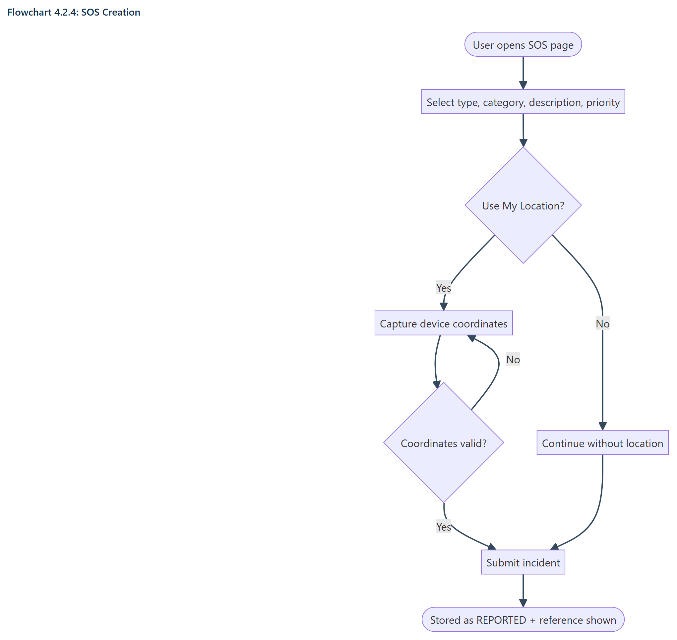
SOS Creation
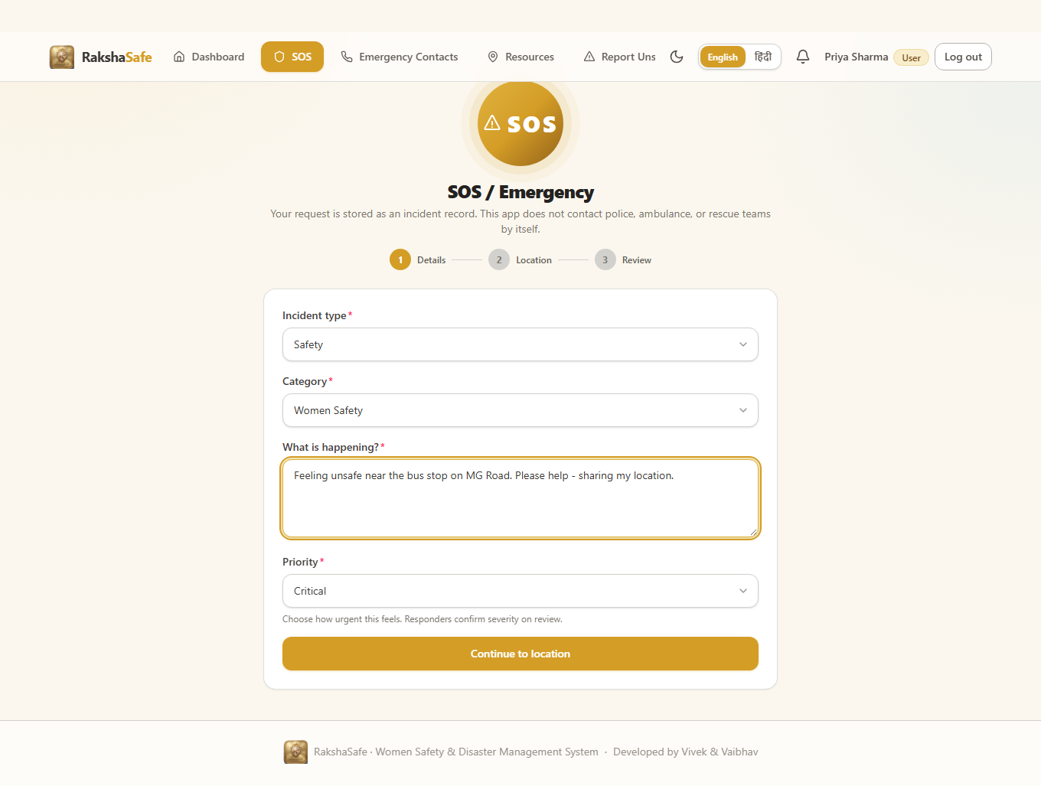

SOS Interface
4.2.5 Incident Detail Interface
The Incident Detail Interface is the user’s single view of one incident: its facts, its location, nearby help, its risk assessment, any assigned team and its full history. Supplementary sections such as nearby resources, weather and risk load independently, so a failure in one never hides the incident itself.
Main elements:
Header with category, reference id, status badge and priority badge.
Description, reported and resolved timestamps.
Location card with coordinates, accuracy, resolved area and a map link.
Nearby emergency resources with Call and Directions actions.
Informational weather card for the incident coordinates.
AI risk assessment panel with Assess Risk and Try Again actions.
Assignment card when a team is attached, with the team contact.
Chronological history timeline of status changes and comments.
Edit and Delete actions while the incident is REPORTED or ACKNOWLEDGED and unassigned.
Validation:
Only the owning user can open this view; other users receive a not-found response.
Edit and delete are disabled once the incident leaves the early workflow or gains an assignment.
Map and call links render only from real stored values.
Steps:
1. Open an incident from the dashboard.
2. Read the facts, location and history.
3. Use nearby resources or the team contact directly when needed.
4. Request a risk assessment or retry it when the service was unavailable.
5. Edit or delete the incident while it is still manageable.
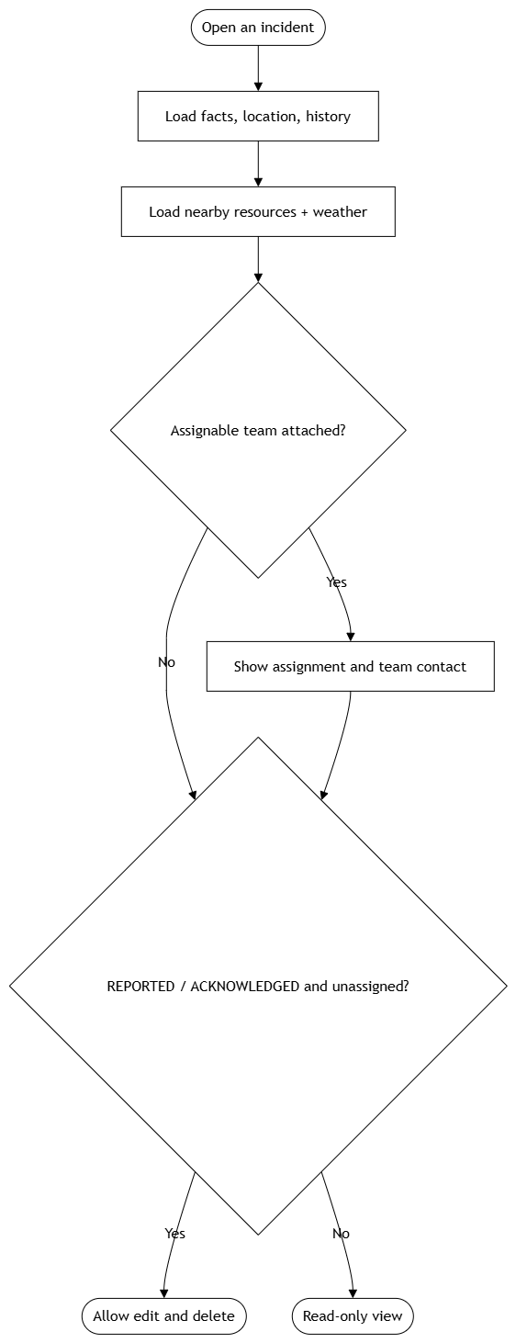

Incident Detail
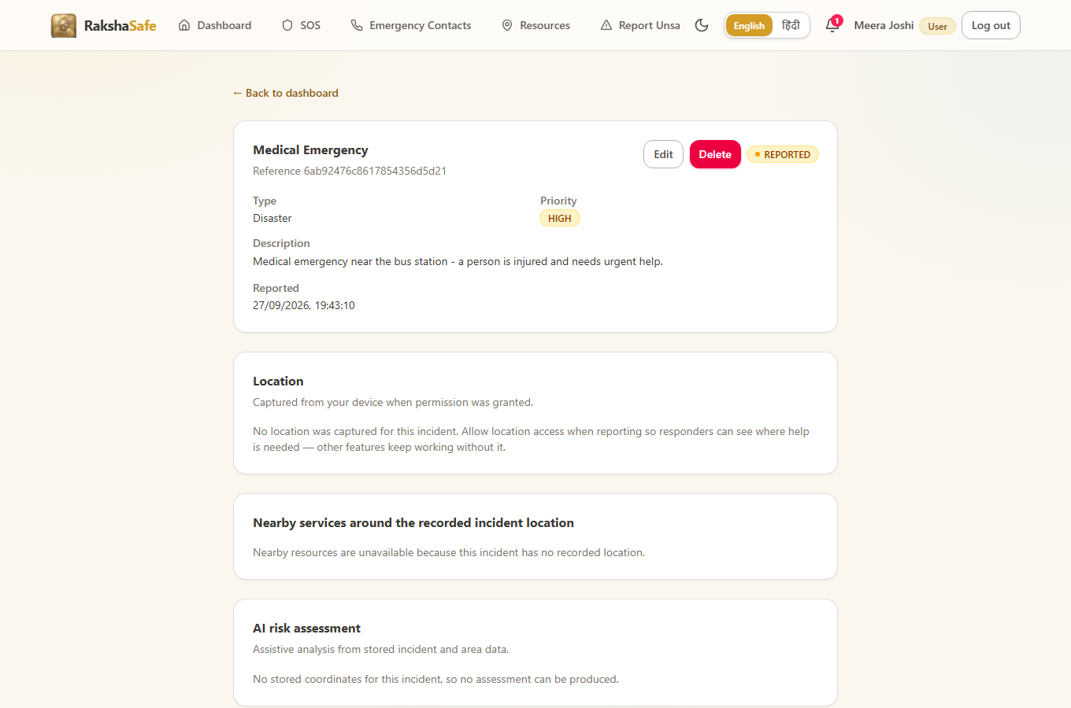

Incident Detail Interface
4.2.6 Emergency Contacts Interface
The Emergency Contacts Interface lets each user keep the people who should be reachable in an emergency. Contacts belong strictly to their owner: the same stored record later appears to administrators with its owner attached, but no user ever sees another user’s contacts. A primary flag marks the first contact, and per-contact toggles decide SMS and email notification channels.
Main elements:
Contact list with name, phone, relationship and channel badges.
Primary-contact marker with a one-primary-per-user rule.
Add Contact form: name, phone, email, relationship, SMS and email toggles.
Edit form pre-filled from the stored record.
Delete confirmation naming the contact before removal.
Call buttons using tel: links built from the stored phone number.
Validation:
Name and phone are required; email and relationship are optional.
Phone numbers are validated and normalised to the Indian format before saving.
Duplicate-primary violations and invalid numbers return field-level errors.
Ownership is taken from the session; a userId supplied by the client is never trusted.
Steps:
1. Open Emergency Contacts.
2. Click Add and enter name, phone and optional details.
3. Save; the contact appears in the list immediately.
4. Edit any contact to correct details or change channel toggles.
5. Delete with confirmation; the row is removed only after the backend confirms.
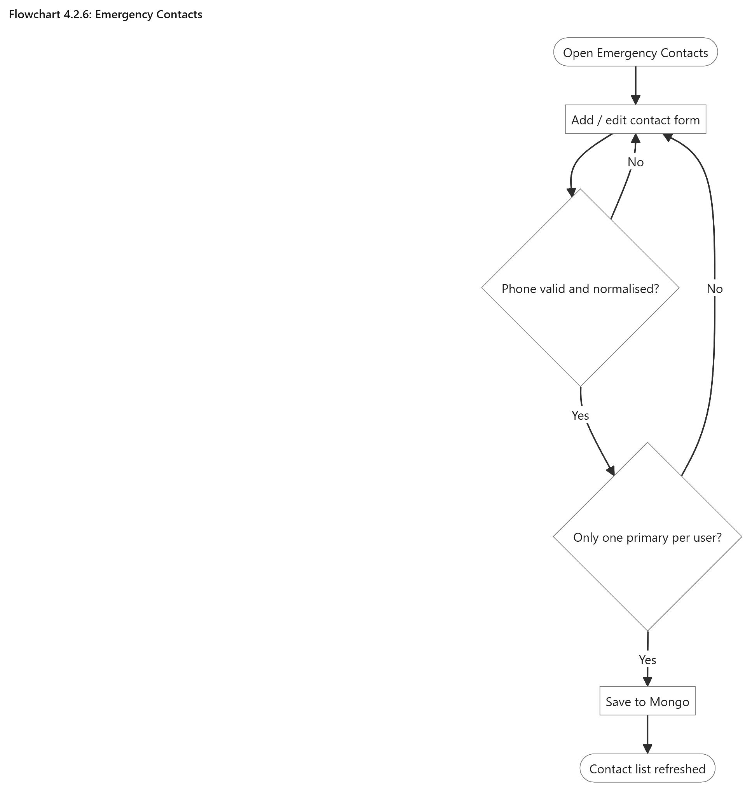

Emergency Contacts
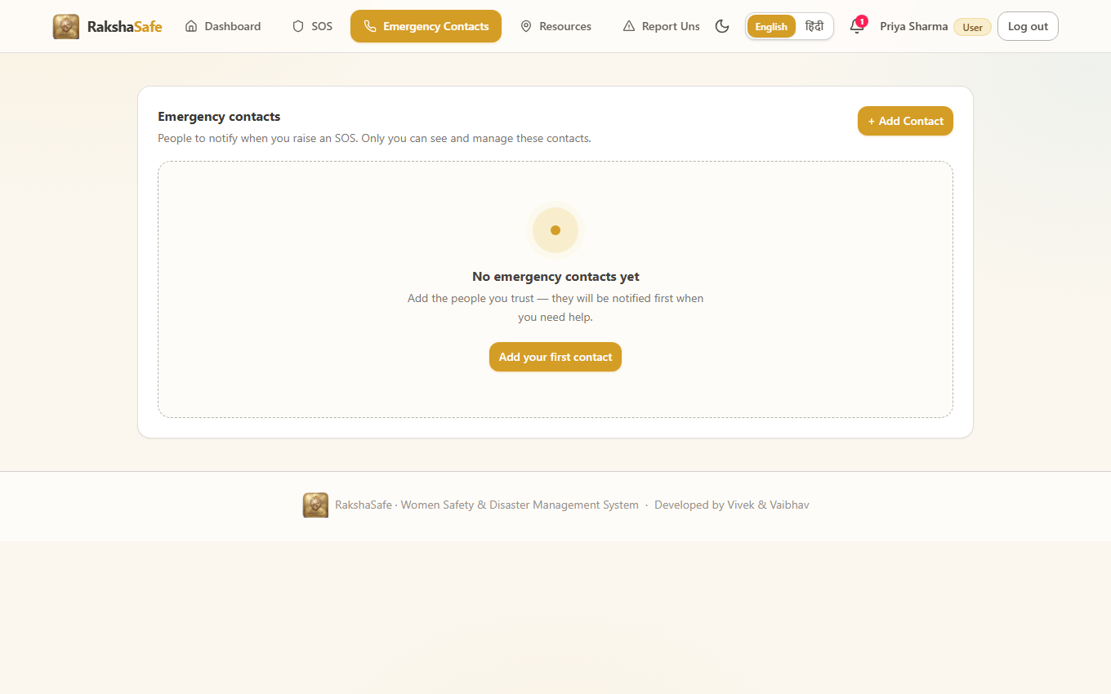

Emergency Contacts Interface
4.2.7 Emergency Resources Interface
The Resources Interface is a directory of help, not a dispatch console. It searches stored Facilities and active RescueTeams by name, type and operational state, and it can also centre the search on live coordinates to show what is nearest. Every card is honest about what is known and silent about what is not.
Main elements:
Search box with type and operational-state filters.
Resource cards with name, facility or team type, phone and address.
Distance labels computed from real coordinates.
Call buttons only where a genuine phone number is stored.
Directions links only where genuine coordinates are stored.
Source badges distinguishing stored RakshaSafe records from live provider results.
Validation:
Search text is trimmed and length-limited before querying.
Radius values are bounded so external providers cannot be overloaded.
Records without coordinates never receive a fabricated distance.
Steps:
1. Open Resources.
2. Enter a search term or pick a facility type.
3. Optionally centre the search on the current location.
4. Call a resource directly or open walking and driving directions.
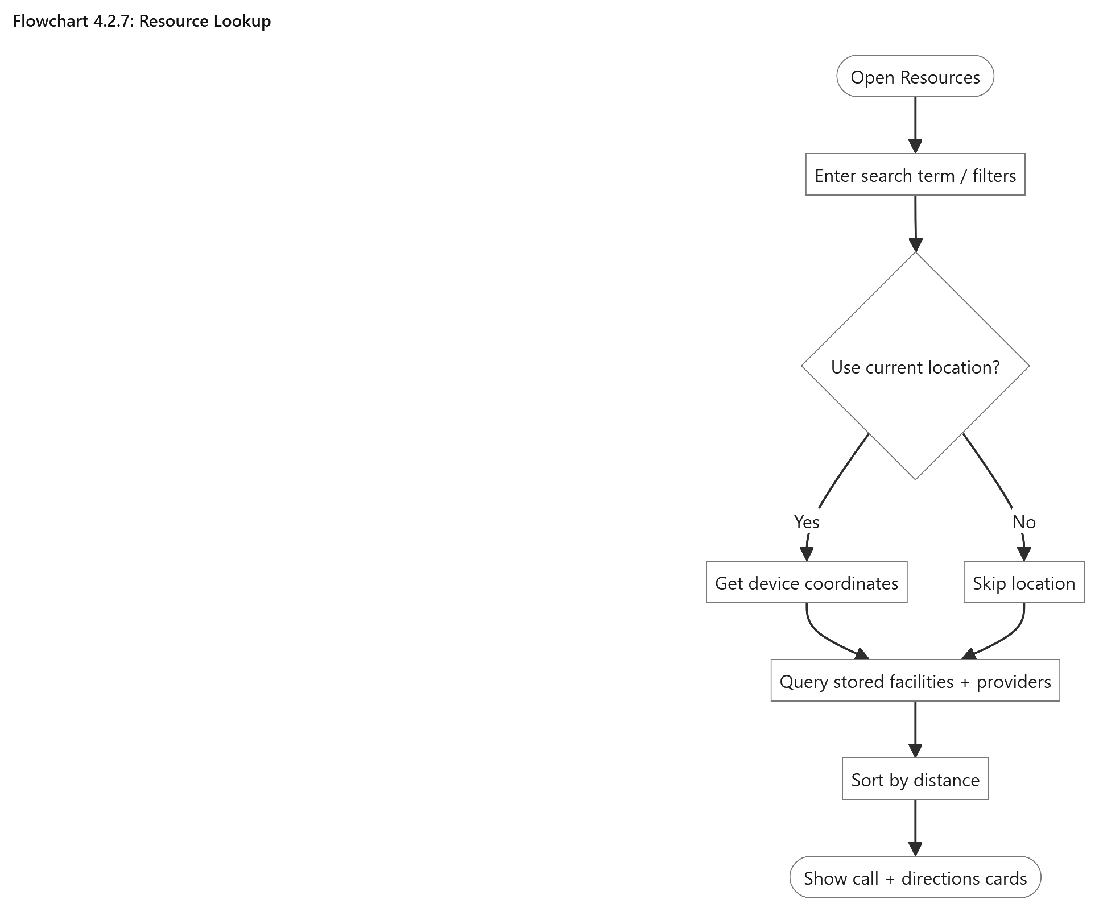

Resource Lookup
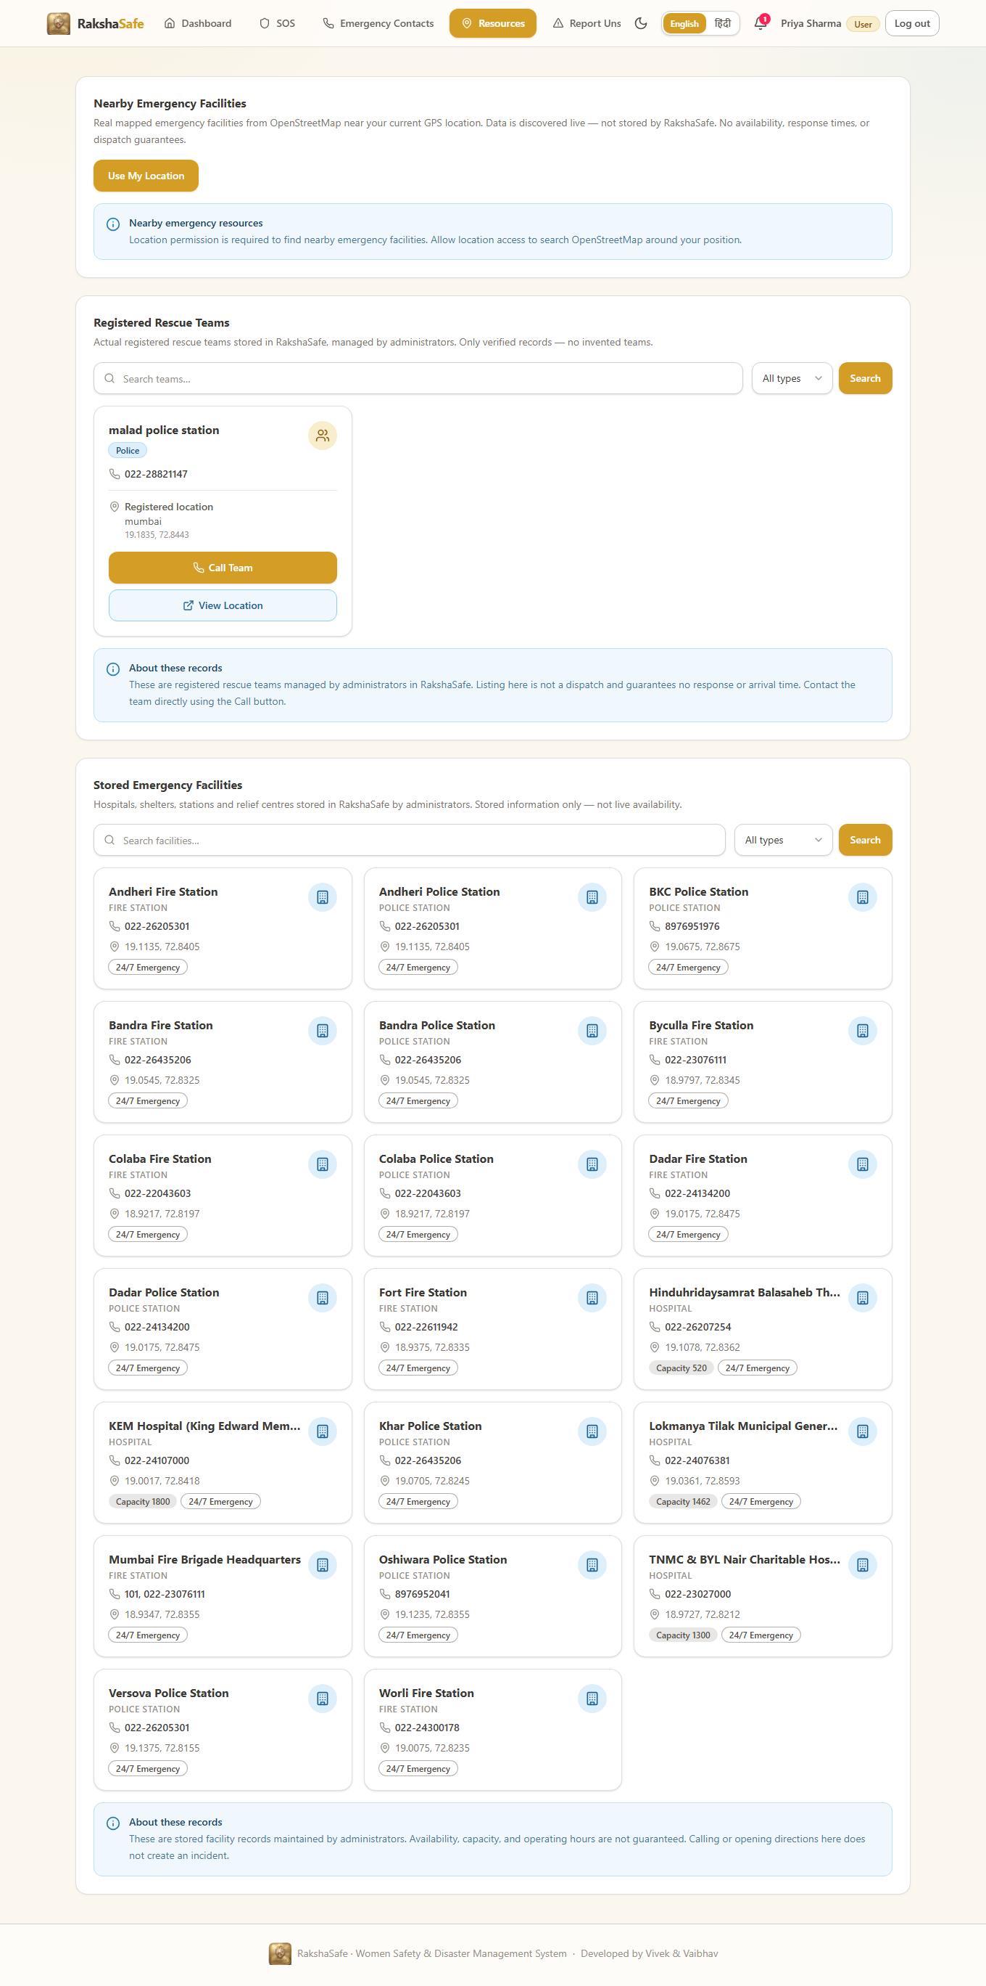

Emergency Resources Interface
4.2.8 Unsafe Area Report Interface
The Unsafe Area Report Interface lets users flag places that felt unsafe, with a location, a category, a description and a severity. Reports enter the system unverified: they are visible to administrators for review and they contribute to risk scoring only through the verified and unverified counts the backend computes, never as confirmed danger zones on their own.
Main elements:
Category selector and severity selector.
Description area for what was observed.
Location picker using device coordinates or a searched place.
Own-reports list with verification badges.
Edit and withdraw actions while the report is still unverified.
Validation:
Category, description, severity and a valid location are required.
Coordinates are validated before submission; invalid positions are rejected.
Only the reporting user can edit or withdraw their own report.
Steps:
1. Open the unsafe-area reporting page.
2. Choose the category and severity and describe the concern.
3. Attach the location from the device or search.
4. Submit; the report is stored as unverified and queued for admin review.
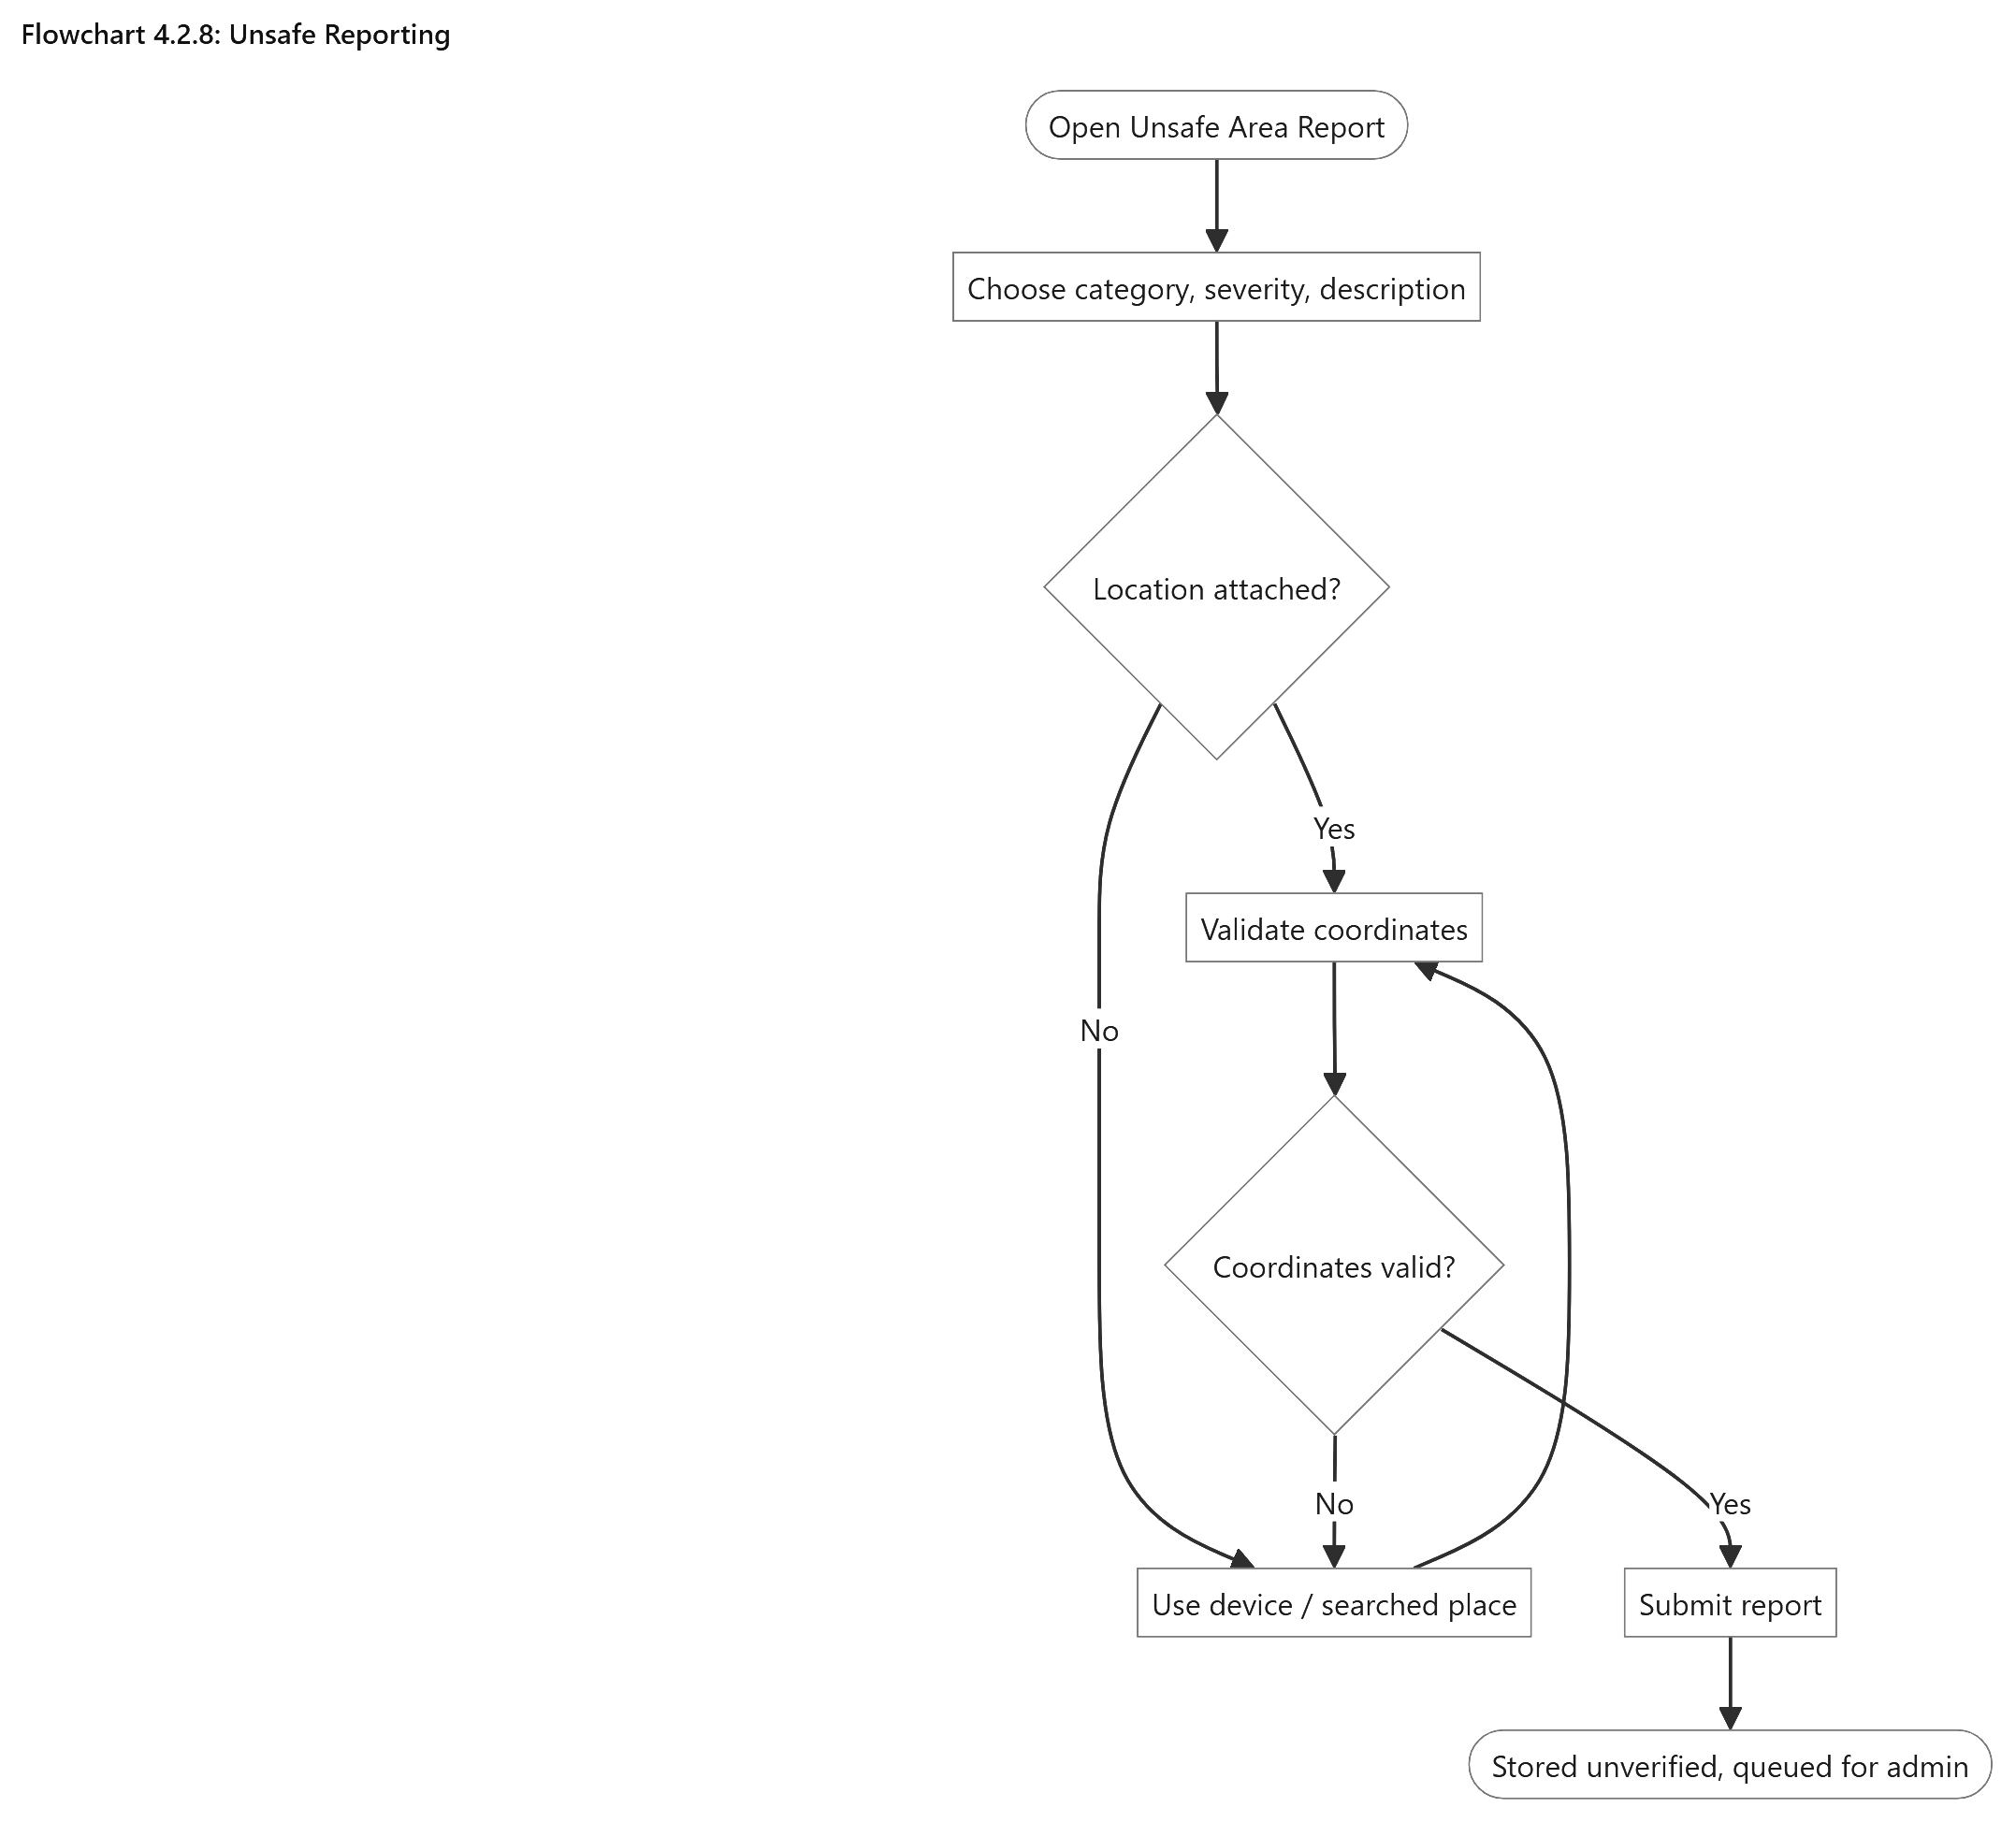

Unsafe Reporting
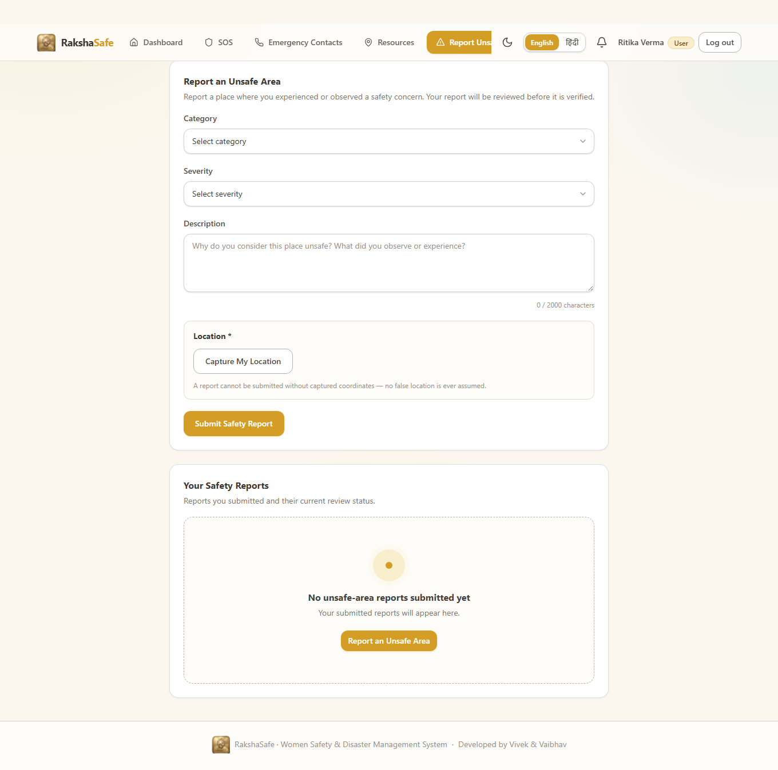

Unsafe Area Report Interface
4.2.9 Risk Assessment Interface
The Risk Assessment Interface presents the stored AI assessment for an incident’s location. It shows the backend-computed score out of 100, the LOW, MEDIUM, HIGH or CRITICAL level, the raksha-risk-v1 model version, the weighted input factors and the assessment time, together with the history of earlier assessments. The panel never recalculates anything itself: the backend score is the single source of truth.
Main elements:
Risk score panel with score, level badge, model version and assessment time.
Weighted factor list: priority base, type modifier, verified reports, unverified reports, active incidents.
Assess Risk button for incidents with stored coordinates.
Try Again button when the AI service was unreachable or timed out.
Previous-assessments list, newest first.
Persistent decision-support disclaimer on every result.
Validation:
Assessment requires stored coordinates; incidents without a location explain that instead of scoring.
Backend responses are strictly validated: scores must be integers 0–100 and levels must be one of the four enum values.
Invalid or unreadable AI responses surface as a retryable error, never as a fabricated score.
Steps:
1. Open an incident that has a location.
2. Click Assess Risk.
3. Read the score, level, factors and time once stored.
4. Revisit the history on refresh; saved assessments persist.
5. Use Try Again if the service was temporarily unavailable.
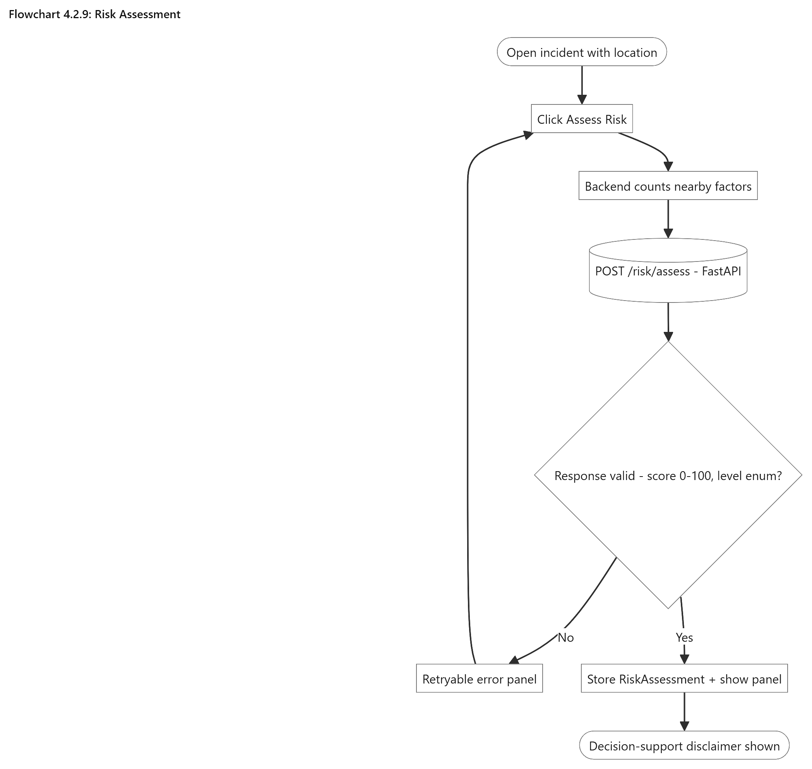

Risk Assessment
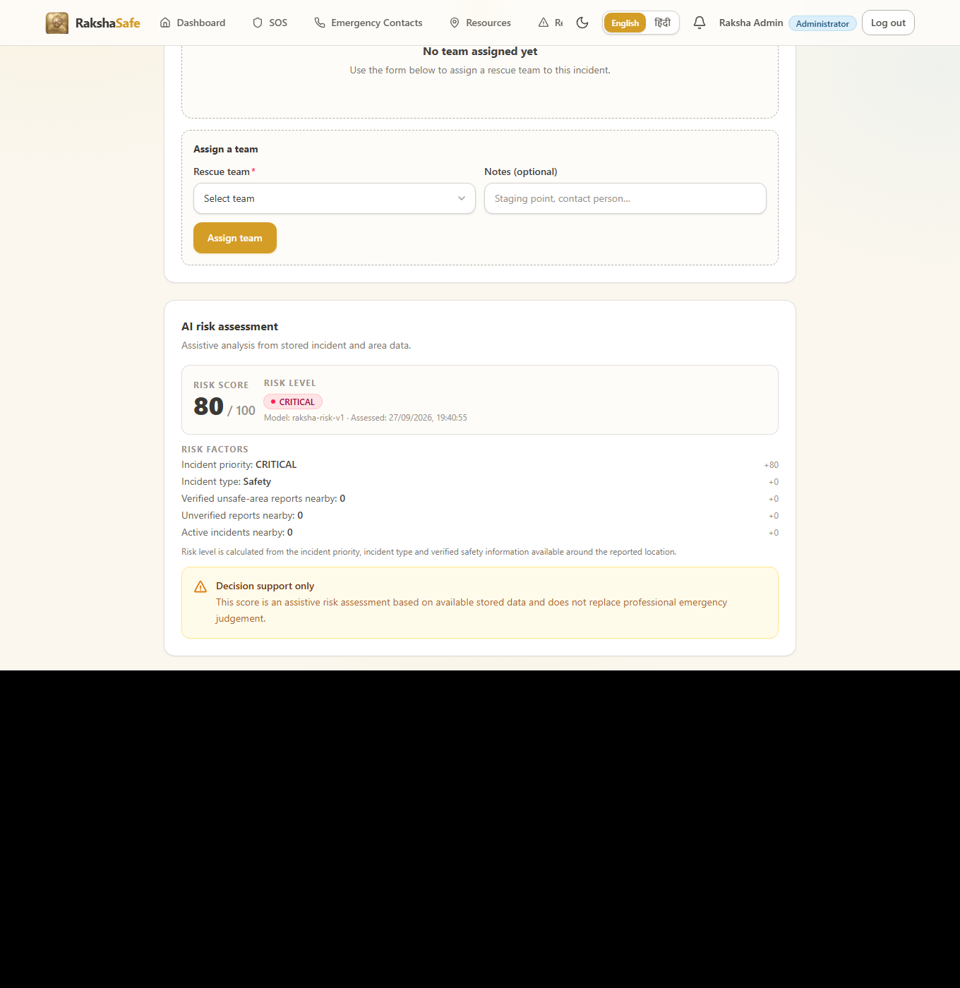

Risk Assessment Interface
4.2.10 Notifications Interface
The Notifications Interface keeps the user informed about their own incidents without demanding attention. Entries record what happened, through which channel, and whether delivery succeeded, so the user can distinguish a recorded event from a delivered message.
Main elements:
Notification list grouped by incident with channel badges.
Status badges: QUEUED, SENT, DELIVERED, FAILED, NOT_CONFIGURED, UNAVAILABLE.
Unread markers with a mark-as-read behaviour.
Provider-response details where available.
Links back to the related incident.
Validation:
Only the owner’s notifications are listed; incident scoping is enforced by the backend.
Failed or unconfigured deliveries remain visible as records rather than disappearing.
Steps:
1. Open Notifications.
2. Scan the latest entries for incident updates.
3. Open the linked incident for full context.
4. Mark entries read as they are handled.
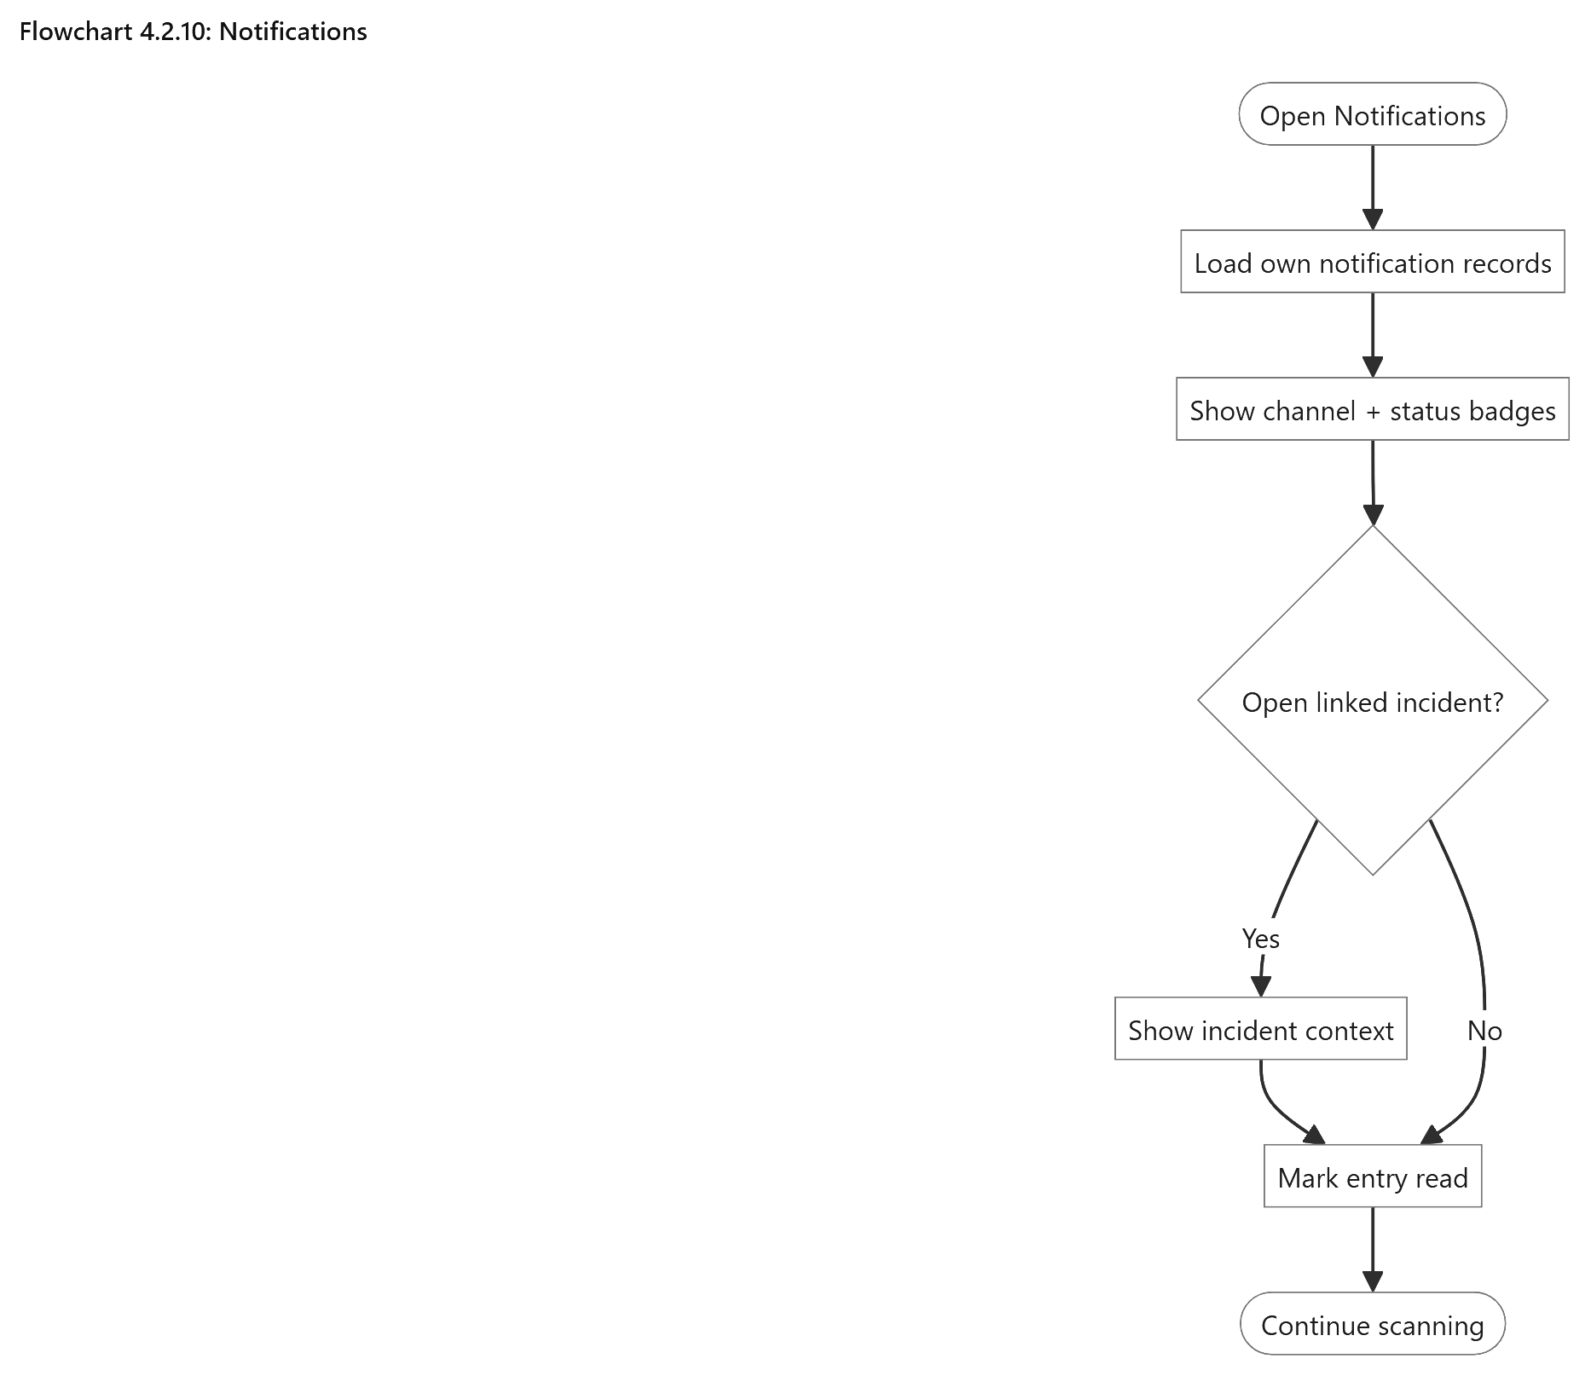

Notifications
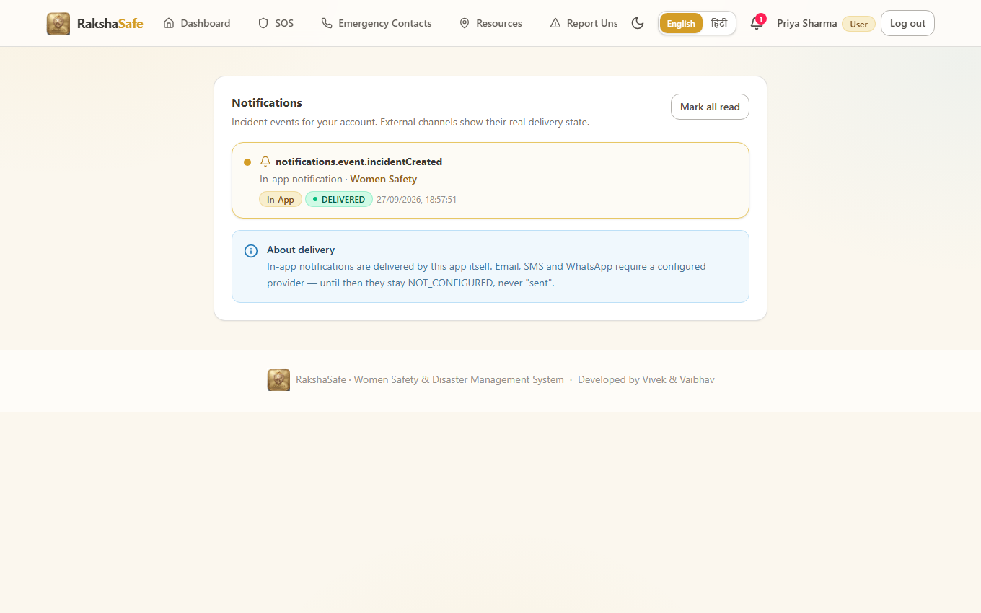

Notifications Interface
4.2.11 Profile Interface
The Profile Interface shows the signed-in account and lets the user keep reachable details current. Because admins and responders rely on the stored phone number and email, the form treats those fields with the same uniqueness validation as registration.
Main elements:
Name, email, phone and preferred-language fields.
Account role and active-state display.
Save-changes action with inline field errors.
Sign-out action.
Validation:
Name cannot be blank; email and phone must stay valid and unique.
Role and active state are read-only for the user.
Concurrent edits resolve to the last saved valid state.
Steps:
1. Open Profile.
2. Update name, email, phone or language.
3. Save and confirm the updated details.
4. Sign out when finished on a shared device.
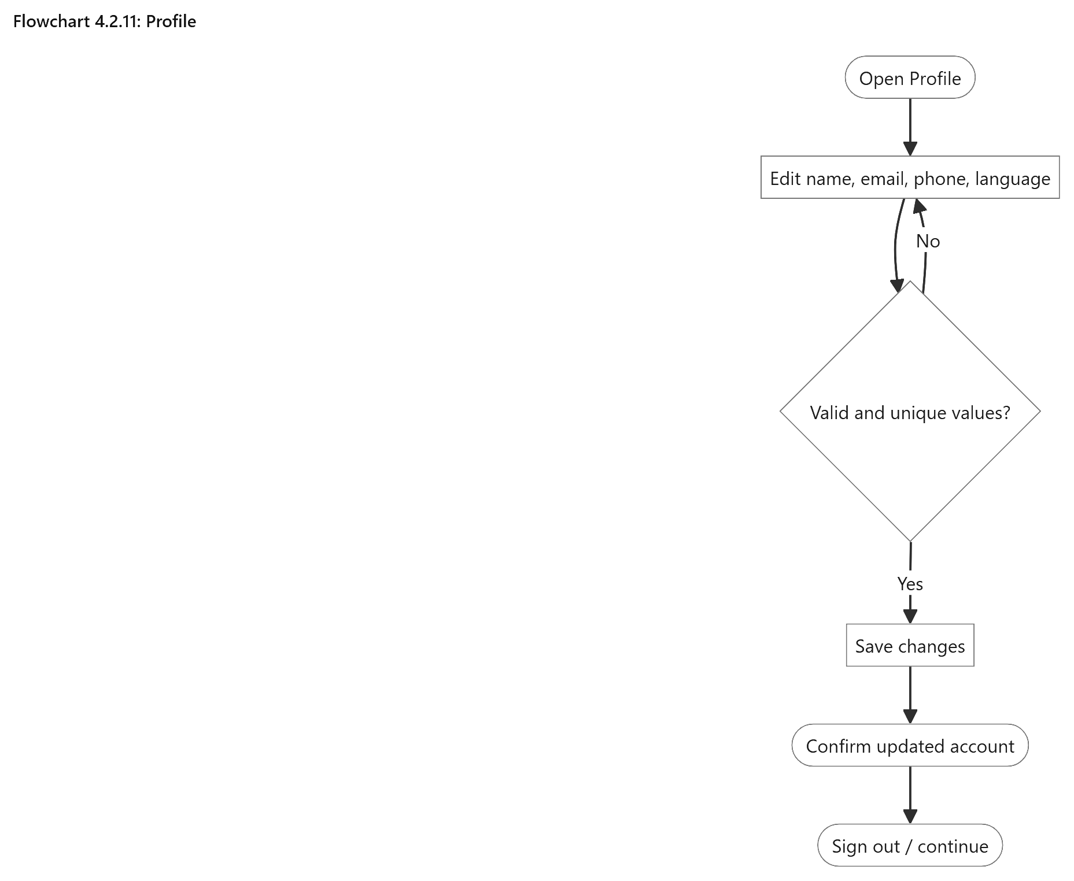

Profile
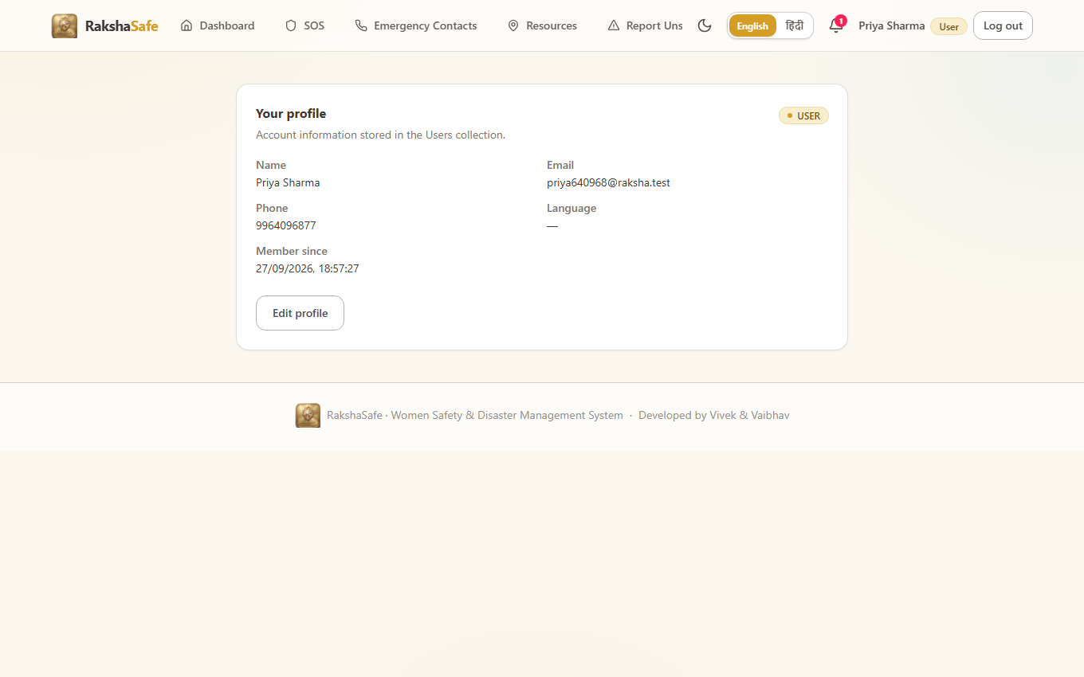

Profile Interface
4.2.12 Admin Dashboard Interface
The Admin Dashboard summarises the whole system from stored data alone. It reports totals for users and incidents, breaks incidents down by each workflow status, and surfaces facilities, rescue teams, recent incidents and recent administrative activity. Nothing on this screen is predicted; every number is a count of records.
Main elements:
Total users and total incidents counters.
Incidents-by-status breakdown: REPORTED, ACKNOWLEDGED, ASSIGNED, IN_PROGRESS, RESOLVED, CLOSED, CANCELLED.
Active-incident and recent-incident lists.
Facility and rescue-team availability counts.
Recent activity feed drawn from AdminLogs.
Validation:
The dashboard requires the ADMIN role; other roles are redirected away.
All figures derive from database queries at load time.
Steps:
1. Sign in as an administrator.
2. Review totals and the by-status breakdown.
3. Drill into recent incidents or activity for detail.
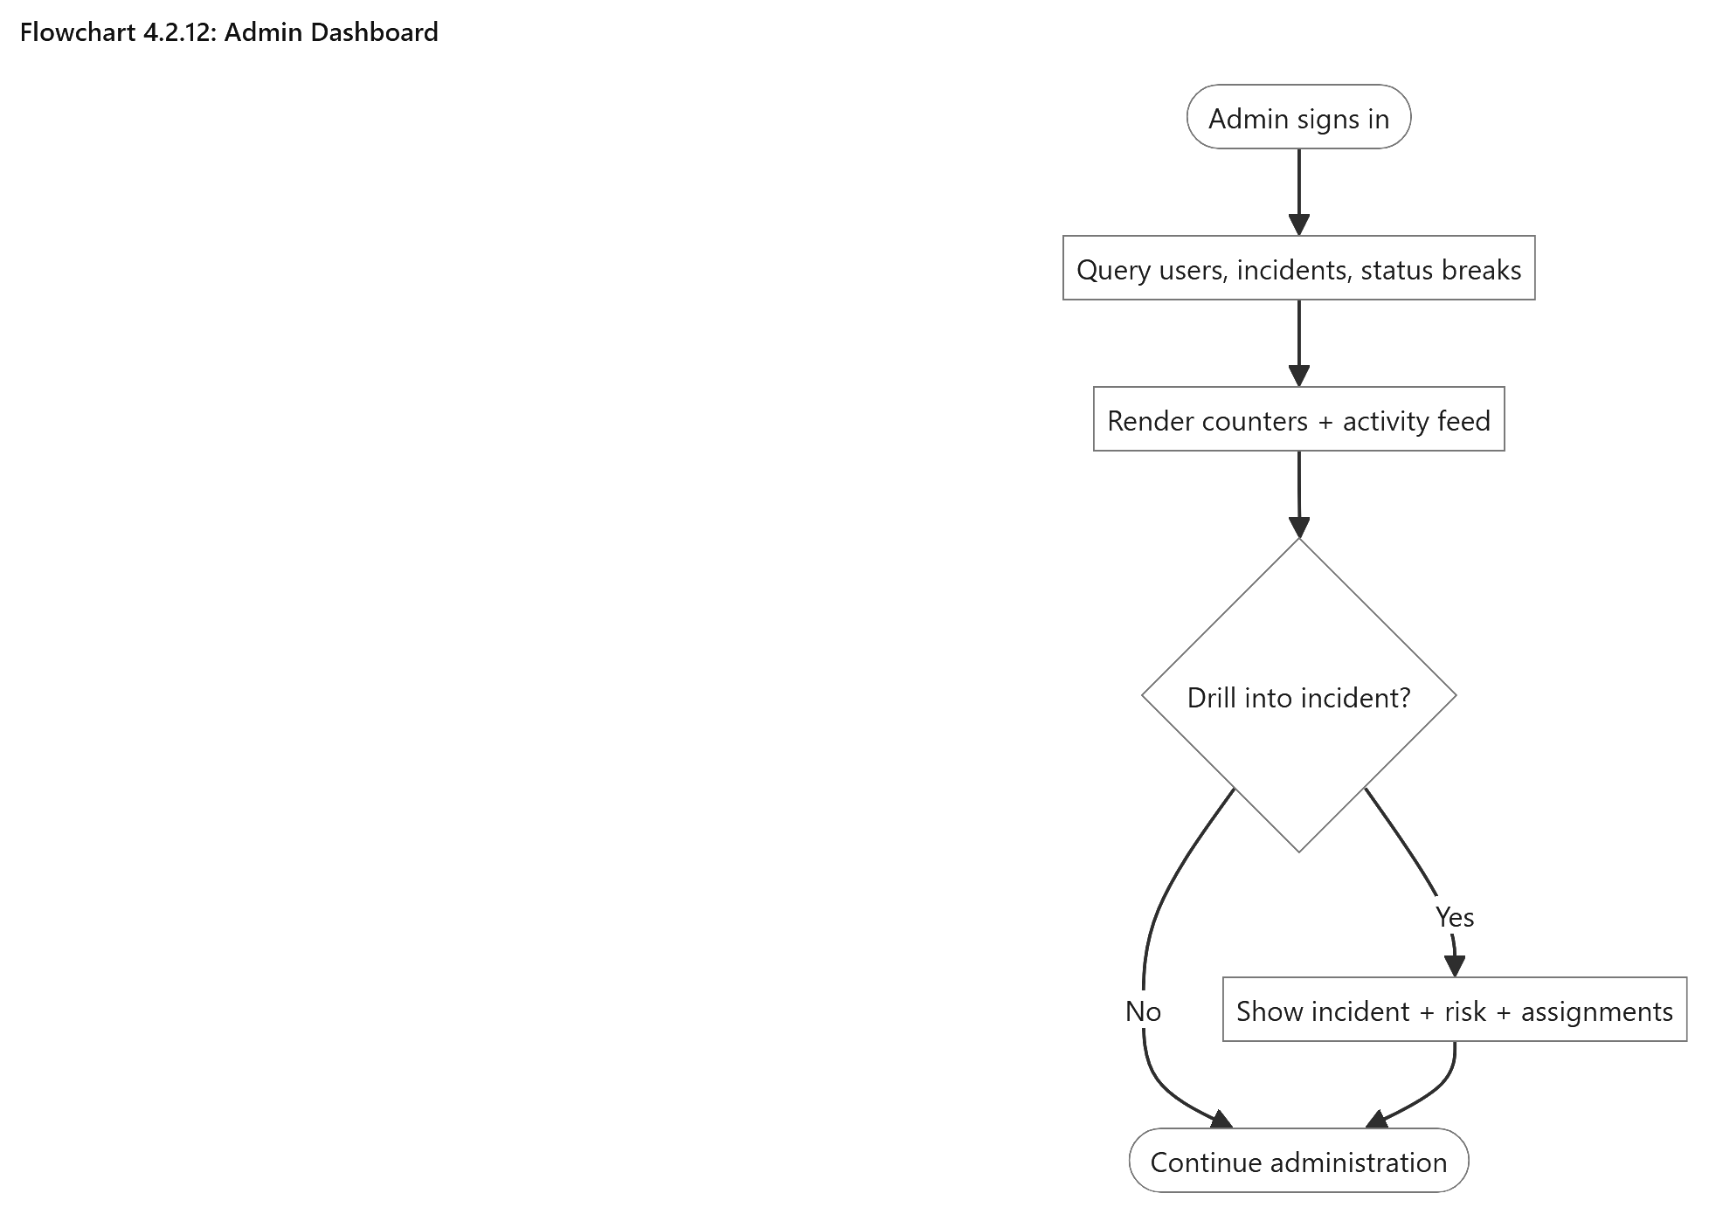

Admin Dashboard
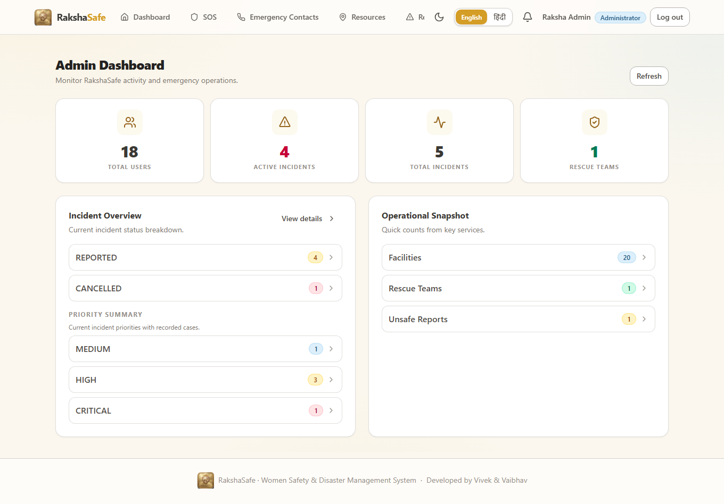

Admin Dashboard Interface
4.2.13 Admin Incident Management Interface
This is the administrator’s working view of emergencies. The list supports status, priority, type and text filters with pagination; the detail view combines the reporter, the captured location, the status timeline, rescue assignments and the stored risk assessments. Status changes and assignments happen here, each recorded with who did it and when.
Main elements:
Filterable incident table with search across category and description.
Detail header with category, reference, status and priority.
Reporter card with name, email and callable phone.
Location card with coordinates, accuracy, resolved area and map link.
Status-update form constrained to the legal workflow transitions.
Team-assignment form with active-team options and notes.
Assignment-status editor following ASSIGNED → EN_ROUTE → ON_SCENE → COMPLETED or CANCELLED.
Read-only risk panel showing the same stored assessments the user sees.
Validation:
Status transitions outside the documented workflow are rejected with the allowed options listed.
Only registered, active teams can be assigned.
Every status change writes an IncidentUpdates record and an AdminLog entry.
Steps:
1. Open the admin incident list and apply filters.
2. Select an incident to review reporter, location, history and risk.
3. Update the status with an optional comment.
4. Assign a rescue team or advance an assignment’s status.
5. Resolve, close or cancel the incident as the real situation requires.
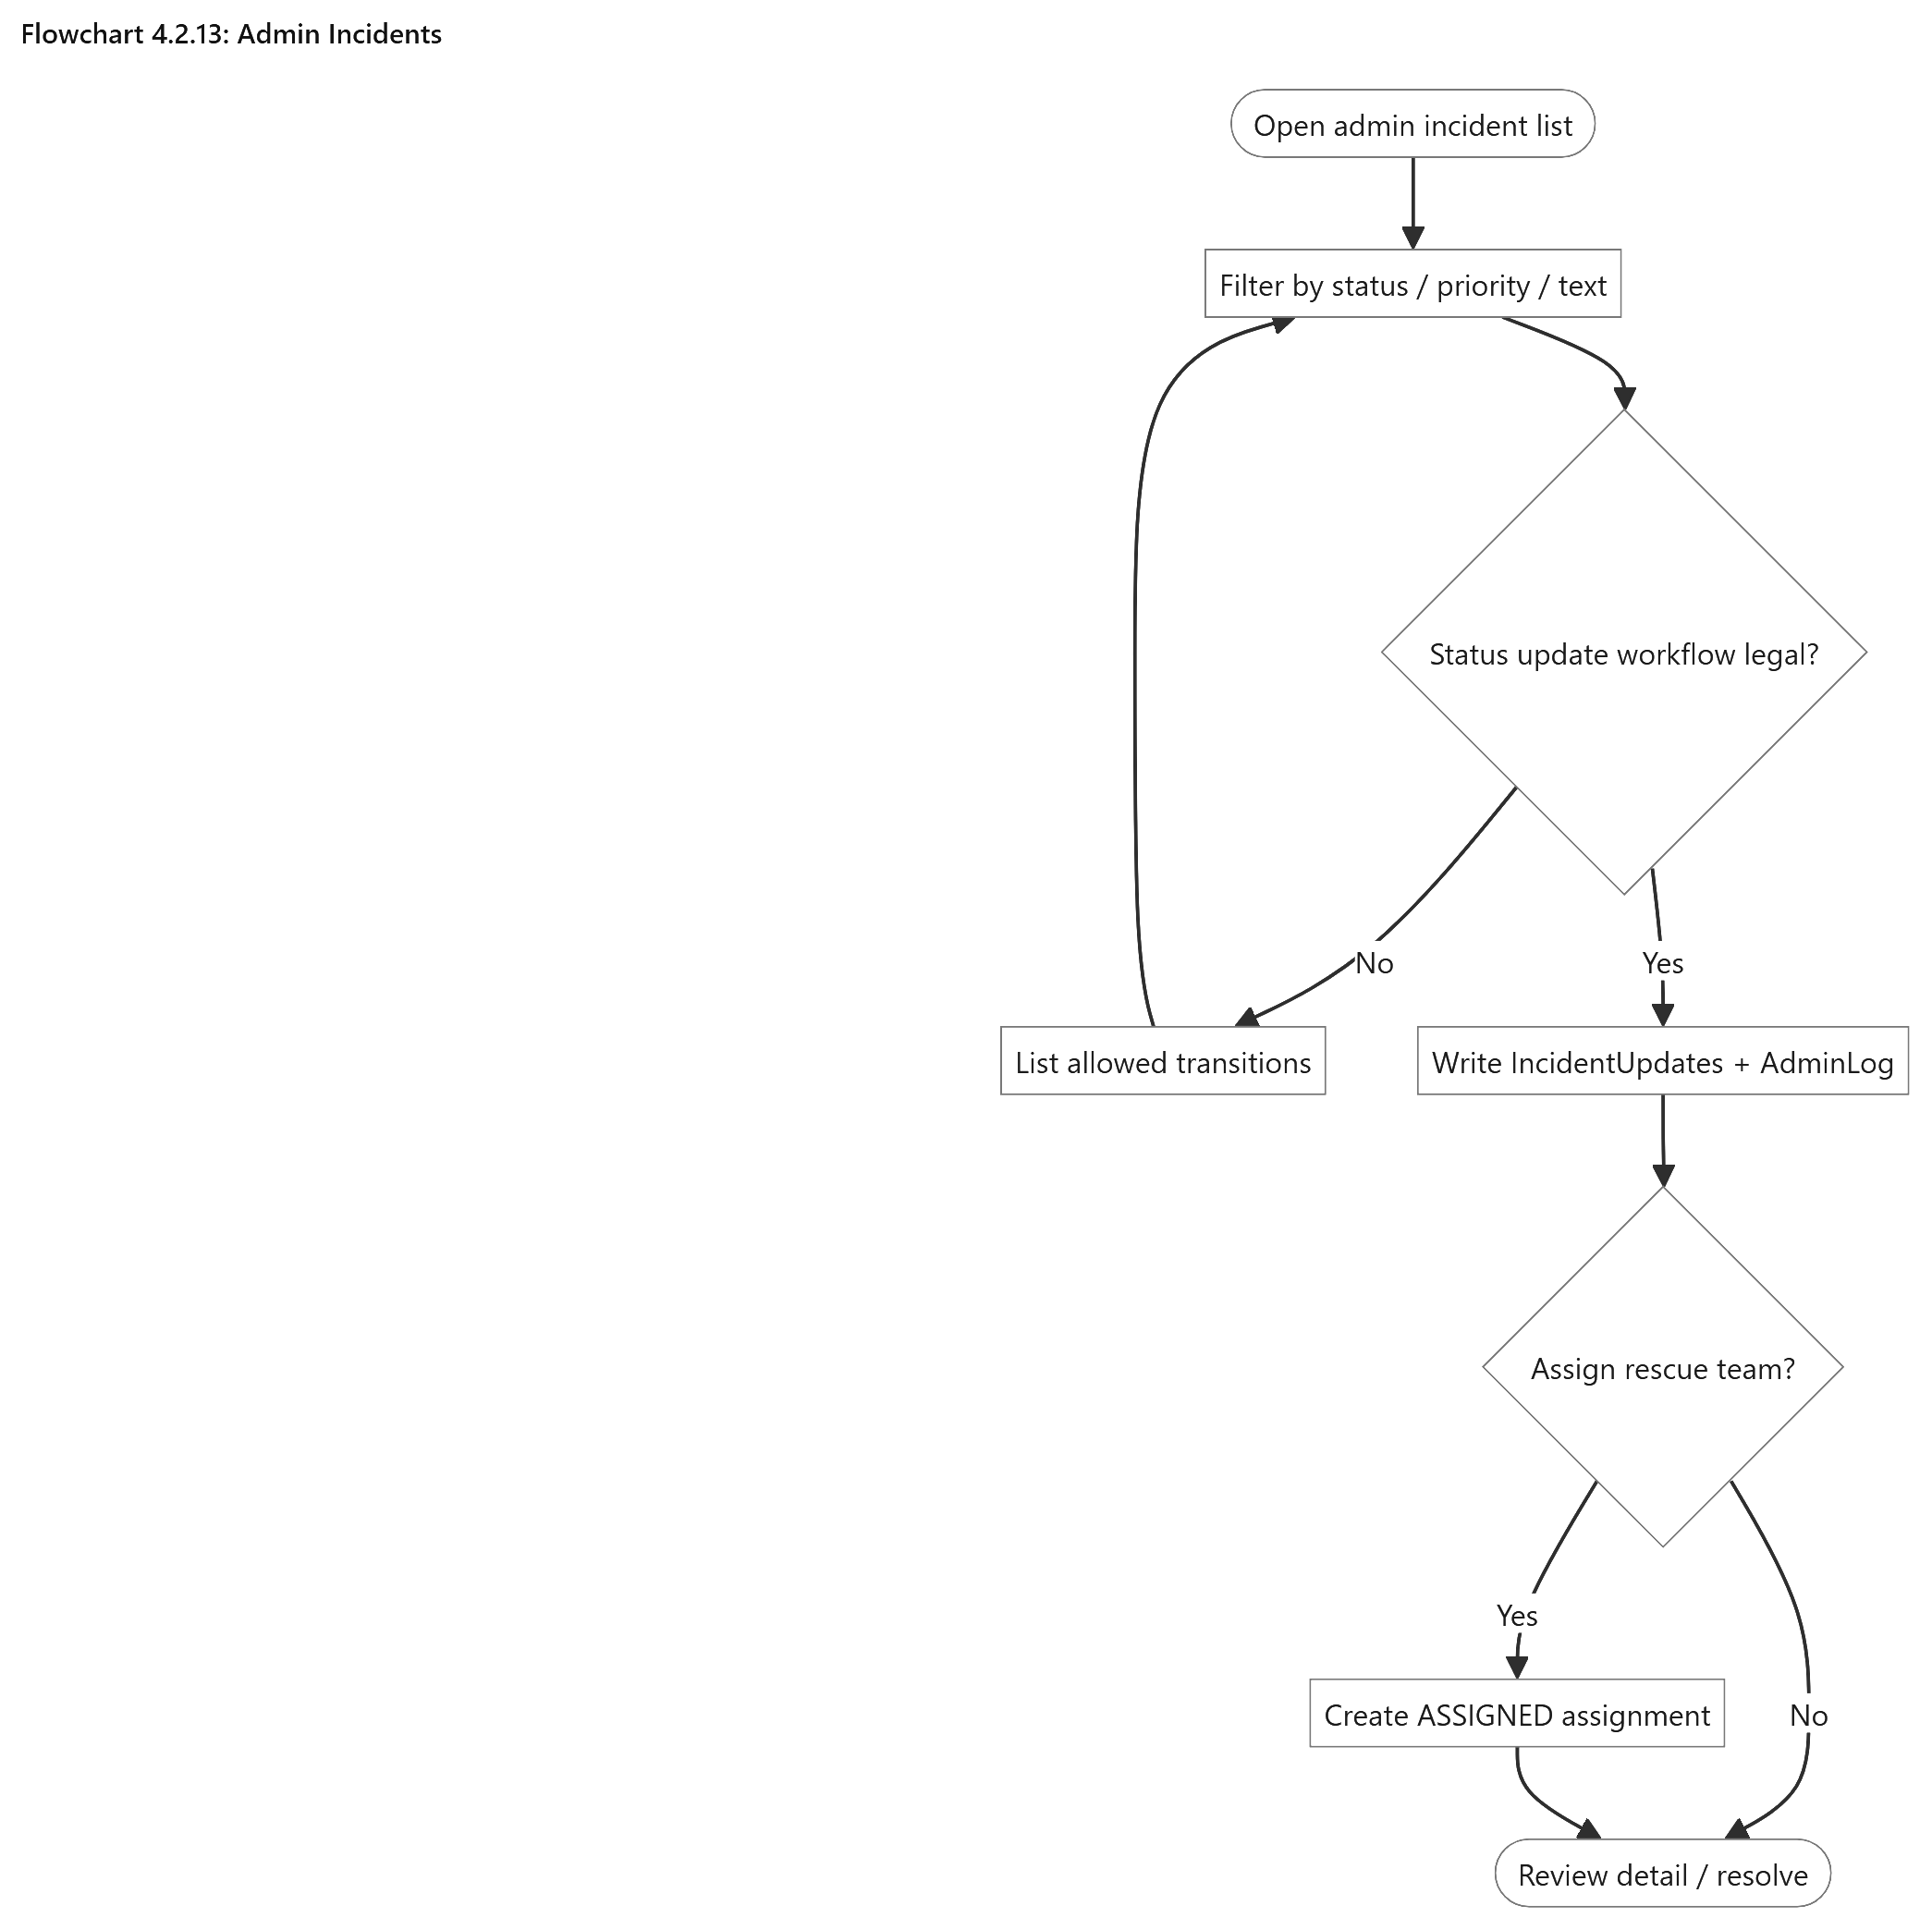

Admin Incidents
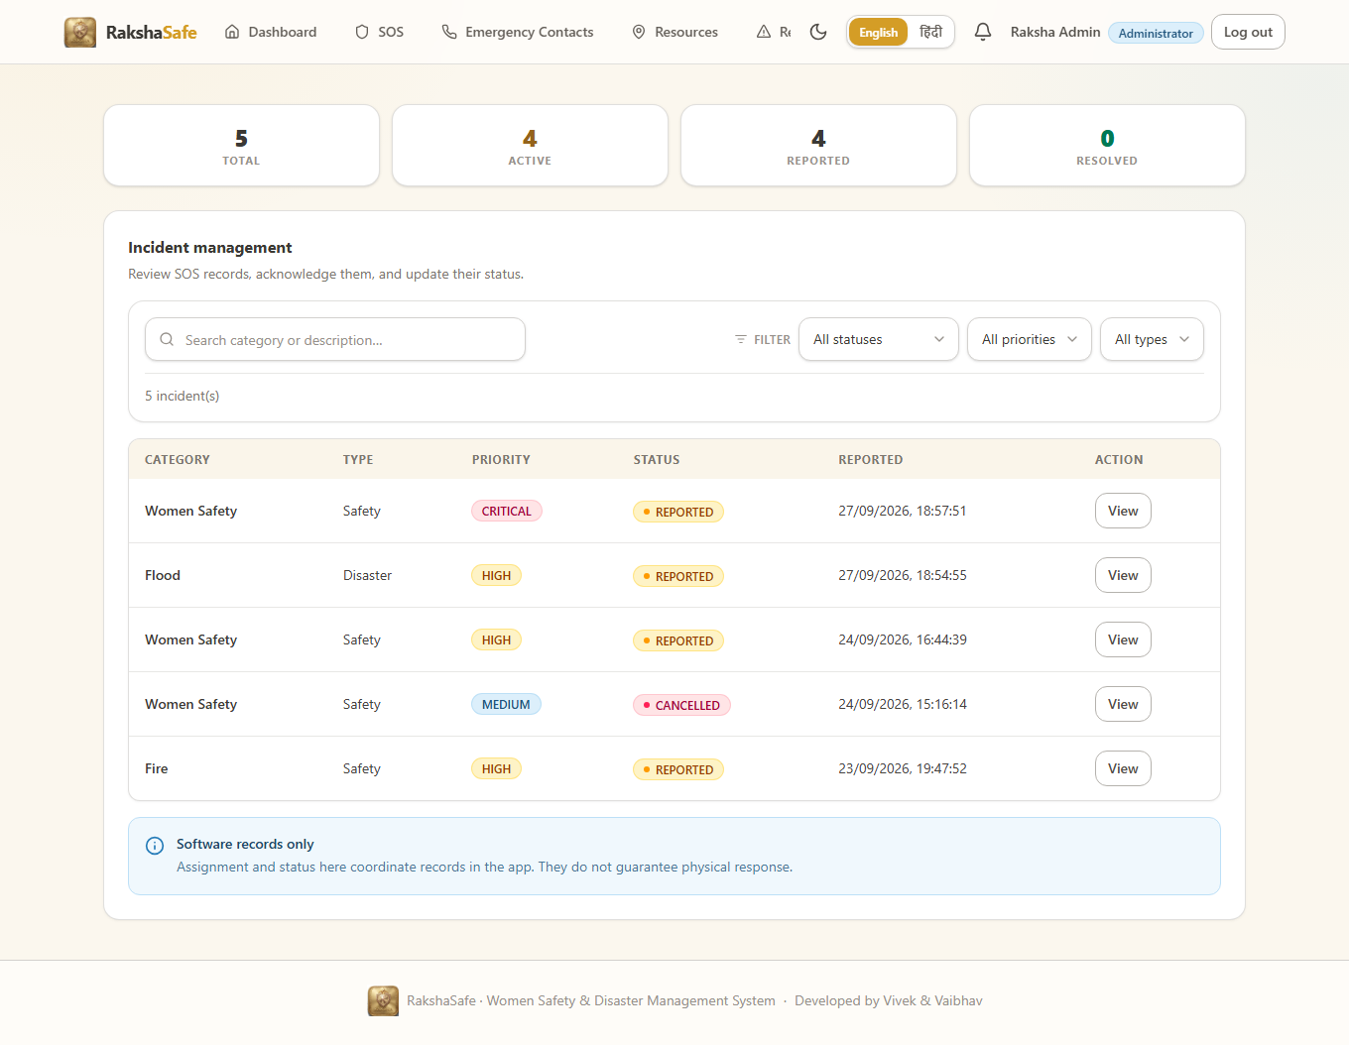

Admin Incident Interface
4.2.14 Admin Masters Interface
The remaining admin screens manage the master records the rest of the system reads: user accounts, any user’s emergency contacts, facilities, rescue teams and their members, unsafe-area report verification, risk zones, generated reports and the activity log. Each screen follows the same pattern — search, paginated table, view and edit, and confirmation before deletion.
Main elements:
User management with search, activation control and per-user detail tabs.
Emergency-contacts browser across all users with owner-name search and Call, Edit and Delete actions.
Facility management with type, phone, capacity, hours and operational state.
Rescue-team management with type, contact, specialisations, members and base location.
Unsafe-report verification queue with verify, edit and delete.
Risk-zone records with name, level, boundary geometry and active state.
Report generation in PDF, CSV or JSON with stored snapshots and expiry.
Admin-log viewer recording administrator, action, target, details, IP and time.
Validation:
All screens require the ADMIN role in addition to authentication and database availability.
Phone, email and coordinate rules match the user-side validation.
Deletions require confirmation and are themselves logged.
Steps:
1. Open the required master screen from the admin navigation.
2. Search or filter to the record.
3. View, create, edit or verify the record as the screen allows.
4. Confirm any deletion and verify the change in the list.
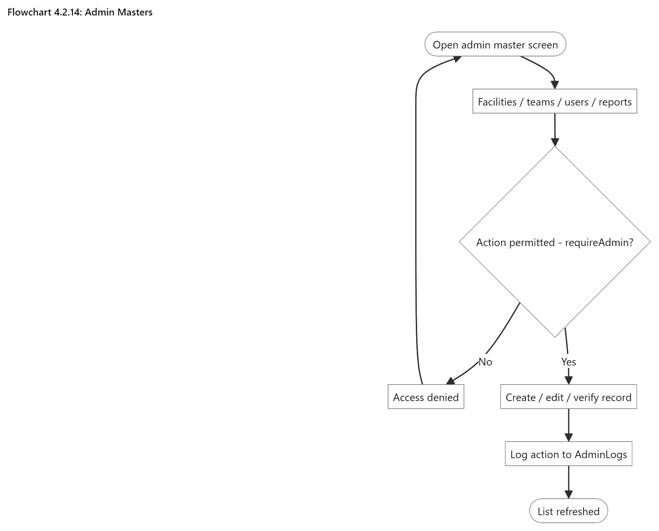

Admin Masters
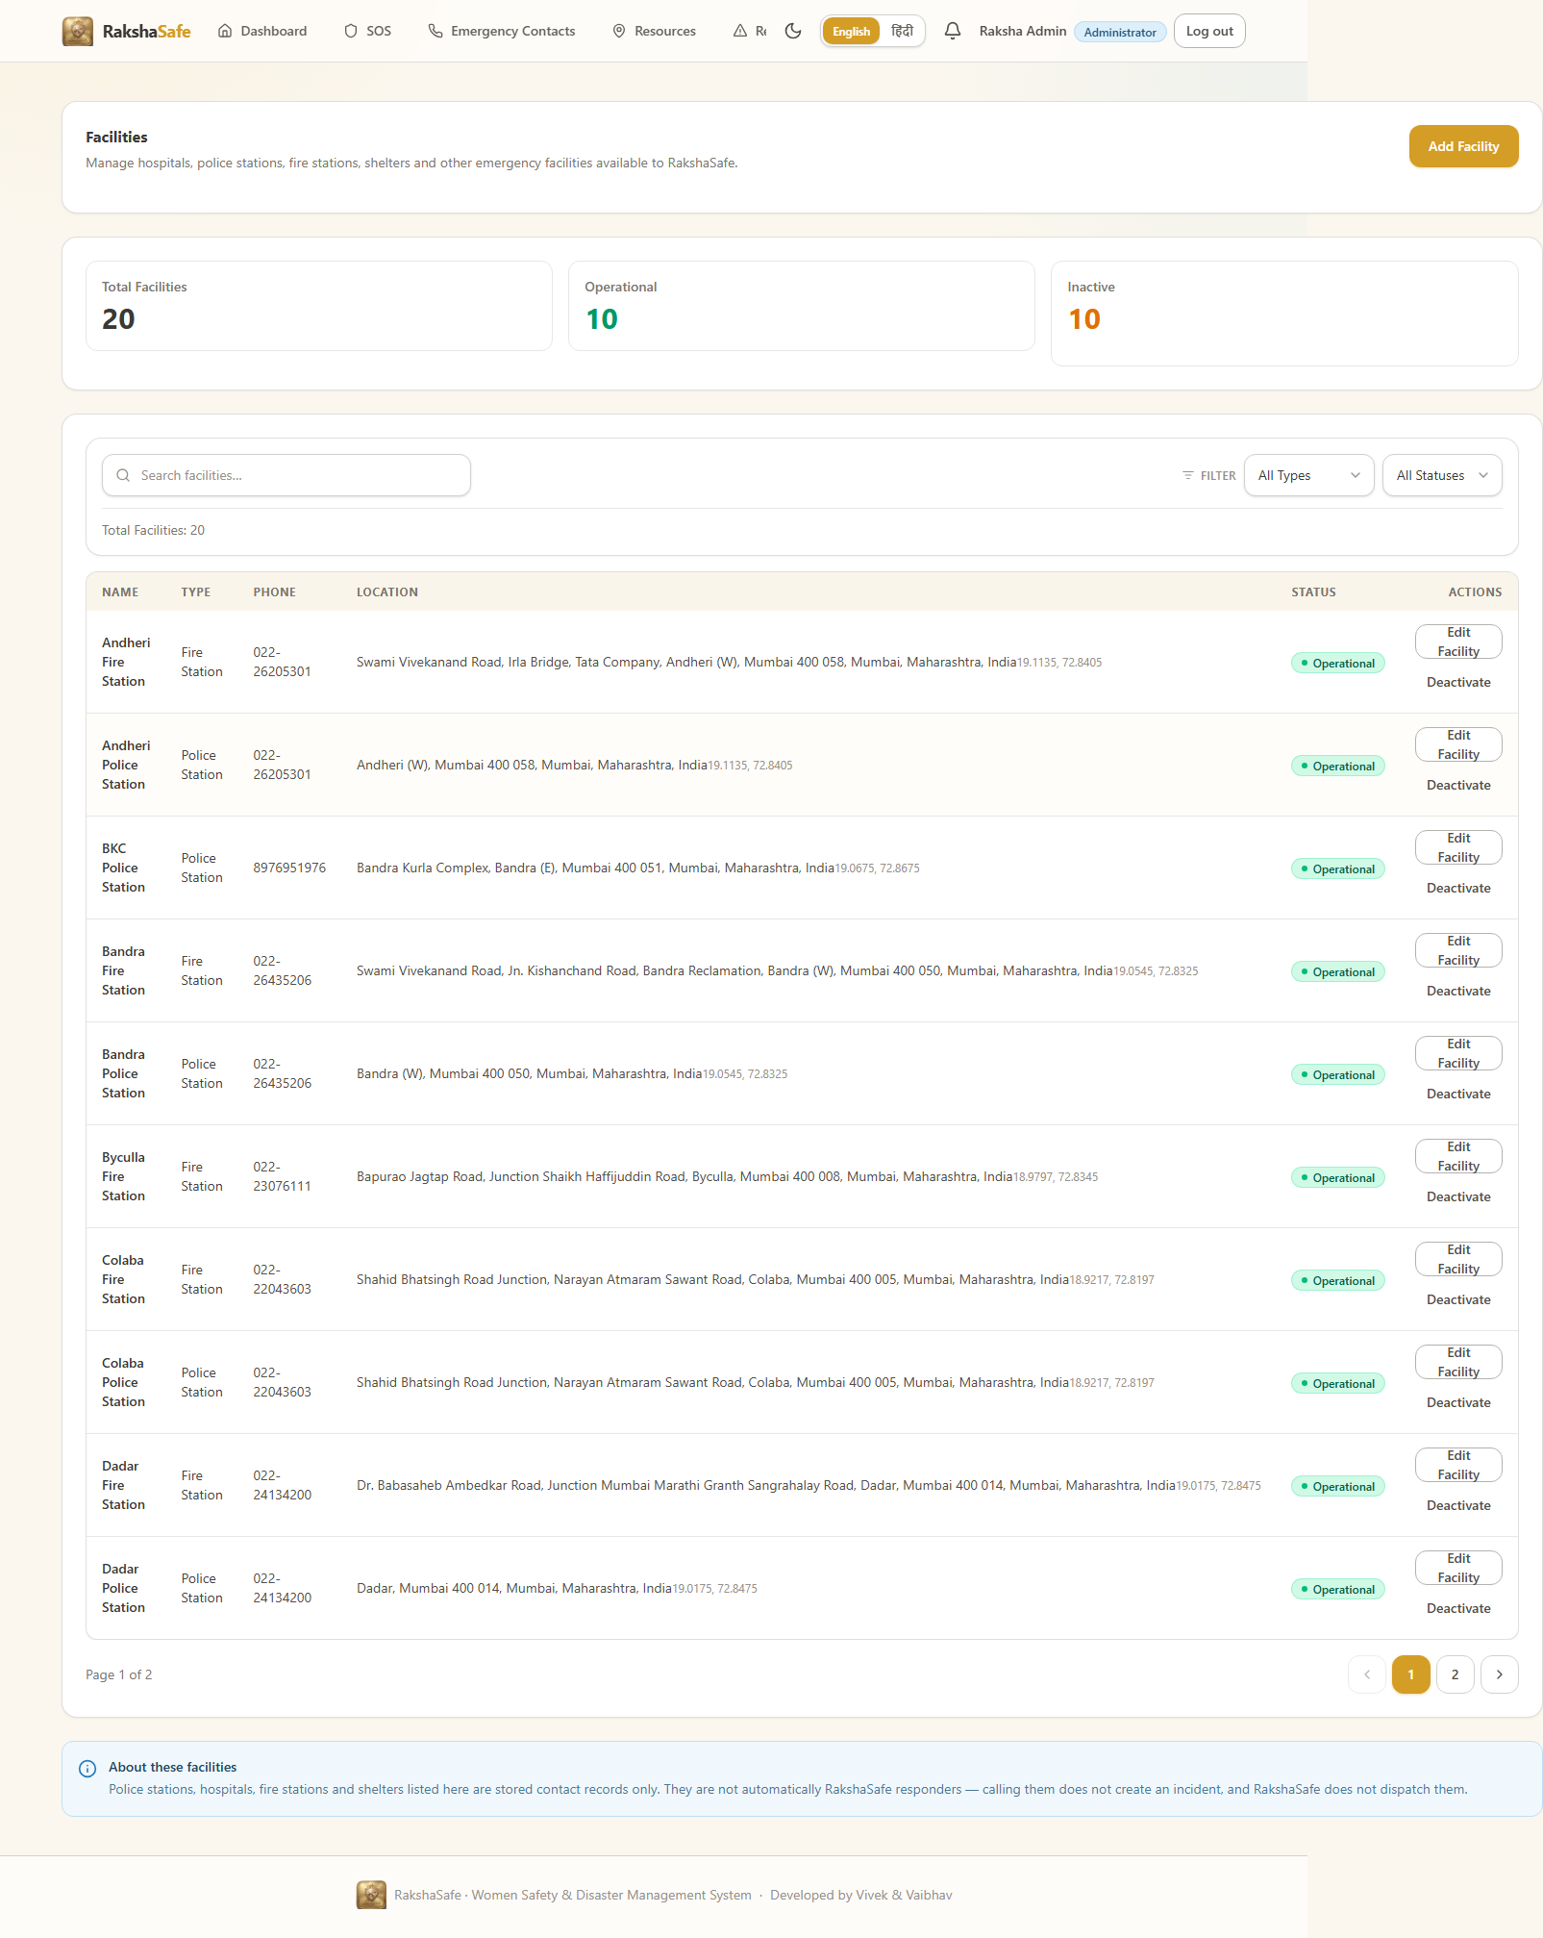

Administration Interface
4.3 Deployment and Security Design
RakshaSafe is deployed as a small set of cooperating services rather than a single process. This section records how those services are arranged and how the system protects accounts, incidents, locations, contacts and risk information in transit and at rest.
4.3.1 Deployment Design
Development and small-scale hosting run four processes: the Vite frontend, the Express backend, the FastAPI AI service and MongoDB. The frontend talks only to the backend over REST; the backend alone talks to MongoDB and to the AI service. No browser code ever contacts the database directly, and no API key is required for the normal Open-Meteo and OpenStreetMap enrichment endpoints.
Main Services
1. Frontend: runs the React and TypeScript web application built with Vite and serves the user and admin interfaces.
2. Backend: runs the Node.js and Express.js application on port 5000 and exposes the REST API under /api with a health endpoint.
3. AI Service: runs the Python FastAPI application on port 8000 with the deterministic risk endpoint POST /risk/assess.
4. MongoDB: persists the fifteen collections and enforces schema validation; it runs locally at mongodb://127.0.0.1:27017 or at a configured remote URI.
Deployment Steps
1. Prepare the Node.js 20+, Python 3.12+ and MongoDB prerequisites.
2. Copy each service’s .env.example to .env and set the database URI, JWT secret and ports.
3. Install backend and frontend dependencies and the AI service requirements.
4. Start MongoDB and confirm connectivity through the backend health endpoint.
5. Start the AI service and confirm its health endpoint.
6. Start the backend API and then the frontend development server.
7. Verify login, SOS submission, location capture, resource lookup and risk assessment end to end.
8. Serve the production frontend build behind the same backend origin for same-origin API calls.
Each service keeps its own environment file copied from the corresponding .env.example, so ports, the database URI, the JWT secret and provider settings differ between developers’ machines without touching the source. The default development ports are fixed by convention and appear throughout the run instructions:
Service | Default port | Notes
Frontend (Vite) | 5173 | Development server with /api proxy to the backend
Backend (Express) | 5000 | REST API under /api; health at /api/health
AI service (FastAPI) | 8000 | Risk endpoint and interactive docs at /docs
MongoDB | 27017 | Local default mongodb://127.0.0.1:27017 or a remote URI
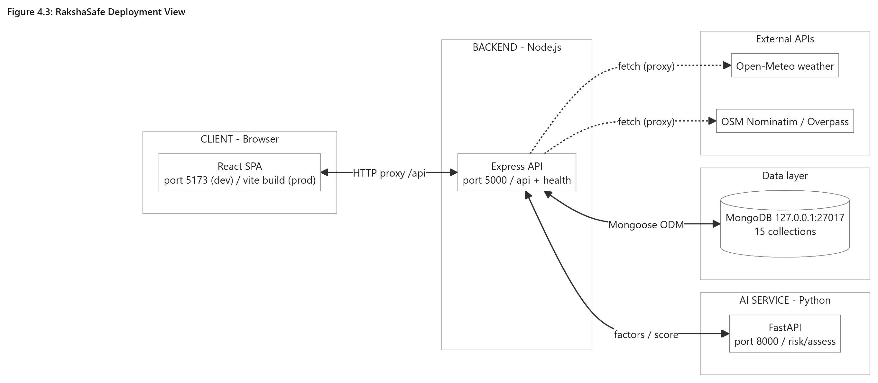

RakshaSafe Deployment View
4.3.2 Security Design
Security in RakshaSafe is layered: authentication proves who is calling, role checks prove they may perform the action, ownership checks prove the record is theirs, and validation proves the payload is well formed. Each layer is enforced on the backend, because anything checked only in the browser can be bypassed.
Authentication
JWT bearer tokens authenticate every protected request; missing or expired tokens are rejected.
The middleware reloads the account from the database when reachable, so deletions, deactivation and role changes take effect immediately.
Database-independent enrichment routes stay available under token-only authentication when MongoDB is down.
Password Security
Passwords are hashed with bcrypt before storage and compared in constant time on login.
Plain-text passwords are never stored and never returned by any API.
Authorisation and Data Protection
Routes are guarded by requireAuth, requireAdmin and requireResponder together with requireDb where stored data is needed.
Users reach only their own incidents, contacts, reports, notifications and locations; incident and contact identifiers from the client are treated as untrusted and re-checked against ownership.
Admin-only data such as other users’ contacts, all incidents and admin logs is unreachable to USER and RESPONDER roles.
Role values come from the database, never from client claims.
Validation and Secret Management
ObjectIds, enums, phone numbers, coordinates, radius values and pagination parameters are validated with bounded limits before any query or external call.
Uploaded and searched inputs are length-limited and sanitised; external responses are validated before display.
JWT secrets, database URIs and provider keys live in server-side environment files; the frontend carries no secrets.
4.4 Chapter Summary
The system design of RakshaSafe records how an emergency travels through the software: a signed-in user reports an SOS incident with an optional real location, the backend validates and stores it, nearby facilities and rescue teams become directly callable, administrators advance the documented status workflow and record rescue assignments, the deterministic raksha-risk-v1 service scores the location on request, notifications track each lifecycle event, and every administrative action is logged. Fourteen interface groups cover the user journey from login to profile and the admin journey from dashboard to reports, all rendered responsively in both themes. Deployment keeps the web application, the API, the AI service and MongoDB as independent processes, while JWT sessions, bcrypt passwords, role and ownership enforcement and strict validation protect the data. The design claims no automatic dispatch, no guaranteed response and no predicted outcomes: it is a careful record-keeping and decision-support system for real emergencies.

CHAPTER 5
SYSTEM IMPLEMENTATION

5.1 Introduction
This chapter presents how the design became running code. It walks through the backend entrypoint and middleware, the Mongoose data models, the API routes, controllers and services, the Python AI service and the React frontend, ending with how to run the whole stack. Excerpts are the actual project files; the full sources live in the repository under /backend, /ai-service and /frontend.
4.1 Introduction
This chapter presents the actual implementation of the RakshaSafe system through its real source code. Every listing below is the complete, unmodified file from the project repository, syntax-highlighted for readability: keywords in blue, strings in maroon, comments in green italic, types and classes in teal, and numbers in green. The listings follow the runtime layers of the system — backend foundation, data models, API routes, controllers and services, the Python AI service, and the React frontend — and together they form a complete, buildable implementation that matches the design of Chapter 3.
Code is shown in Consolas with a light shaded background. Each listing states the repository path and the line count so that the printed listing can be checked against the electronic source.
4.2 Backend — entry, configuration and middleware
Listing 4.1 — backend/src/server.ts
Application entry point: connects the database and starts the HTTP server.
import { createApp } from './app.js'
import { connectDatabase, disconnectDatabase } from './config/db.js'
import { env } from './config/env.js'
const app = createApp()
async function start(): Promise<void> {
try {
await connectDatabase()
} catch (err) {
console.warn(`[api] MongoDB unreachable at startup: ${(err as Error).message}`)
console.warn('[api] Starting API anyway; /api/health will report db: connected=false')
}
const server = app.listen(env.port, () => {
console.log(`[api] RakshaSafe backend listening on http://localhost:${env.port}`)
})
const shutdown = async (signal: string) => {
console.log(`[api] ${signal} received, shutting down...`)
server.close(async () => {
await disconnectDatabase()
process.exit(0)
})
}
process.on('SIGINT', () => void shutdown('SIGINT'))
process.on('SIGTERM', () => void shutdown('SIGTERM'))
}
start().catch((err) => {
console.error('[api] Failed to start:', err)
process.exit(1)
})
Listing 4.2 — backend/src/app.ts
Express application wiring: middleware, routes and error handling.
import cors from 'cors'
import express from 'express'
import { env } from './config/env.js'
import { notFound, errorHandler } from './middleware/error.js'
import routes from './routes/index.js'
export function createApp() {
const app = express()
// Do not fingerprint the framework in responses.
app.disable('x-powered-by')
app.use(
cors({
origin: env.corsOrigins,
credentials: true,
}),
)
app.use(express.json({ limit: '1mb' }))
app.use(express.urlencoded({ extended: true }))
app.get('/', (_req, res) => {
res.json({
service: 'RakshaSafe API',
version: '0.1.0',
docs: '/api/health',
})
})
app.use('/api', routes)
app.use(notFound)
app.use(errorHandler)
return app
}
Listing 4.3 — backend/src/routes/index.ts
Central API router mounting every feature module.
import { Router } from 'express'
import mongoose from 'mongoose'
import authRoutes from './auth.js'
import adminRoutes from './admin.js'
import emergencyContactRoutes from './emergencyContacts.js'
import facilityRoutes from './facilities.js'
import incidentRoutes from './incidents.js'
import nearbyRoutes from './nearby.js'
import notificationRoutes from './notifications.js'
import osmRoutes from './osm.js'
import weatherRoutes from './weather.js'
import rescueTeamRoutes from './rescueTeams.js'
import responderRoutes from './responder.js'
import unsafeReportRoutes from './unsafeReports.js'
import geocodeRoutes from './geocode.js'
const router = Router()
router.use('/auth', authRoutes)
router.use('/admin', adminRoutes)
router.use('/emergency-contacts', emergencyContactRoutes)
router.use('/incidents', incidentRoutes)
router.use('/facilities', facilityRoutes)
router.use('/nearby-resources', nearbyRoutes)
router.use('/nearby', osmRoutes)
router.use('/weather', weatherRoutes)
router.use('/notifications', notificationRoutes)
router.use('/rescue-teams', rescueTeamRoutes)
router.use('/responder', responderRoutes)
router.use('/unsafe-reports', unsafeReportRoutes)
router.use('/geocode', geocodeRoutes)
router.get('/health', (_req, res) => {
const dbState = mongoose.connection.readyState
res.json({
success: true,
service: 'rakshasafe-backend',
status: 'ok',
db: {
state: dbState, // 0 disconnected, 1 connected, 2 connecting, 3 disconnecting
connected: dbState === 1,
},
time: new Date().toISOString(),
})
})
export default router
Listing 4.4 — backend/src/config/env.ts
Typed environment configuration with safe development defaults.
import 'dotenv/config'
function required(name: string, fallback: string): string {
return process.env[name] ?? fallback
}
/** Refuse to boot in production with a placeholder or missing secret key. */
function requiredSecret(name: string, devFallback: string): string {
const value = process.env[name]
if (value !== undefined && value.trim() !== '' && value !== devFallback) {
return value
}
const isProd = process.env.NODE_ENV === 'production'
if (isProd) {
throw new Error(
`Missing ${name}. Set a real value in the environment (NODE_ENV=production refuses the development fallback).`,
)
}
return value && value.trim() !== '' ? value : devFallback
}
function positiveNumber(name: string, fallback: number): number {
const raw = process.env[name]
if (raw === undefined || raw.trim() === '') return fallback
const parsed = Number(raw.trim())
if (!Number.isFinite(parsed) || parsed <= 0) return fallback
return parsed
}
const isProduction = process.env.NODE_ENV === 'production'
export const env = {
nodeEnv: required('NODE_ENV', 'development'),
port: Number(required('PORT', '5000')),
mongoUri: isProduction
? requiredSecret('MONGO_URI', '')
: required('MONGO_URI', 'mongodb://127.0.0.1:27017/rakshasafe'),
jwtSecret: requiredSecret('JWT_SECRET', 'rakshasafe-dev-secret-change-me'),
jwtExpiresIn: required('JWT_EXPIRES_IN', '7d'),
aiServiceUrl: required('AI_SERVICE_URL', 'http://localhost:8000'),
aiServiceTimeoutMs: Number(required('AI_SERVICE_TIMEOUT_MS', '10000')),
/**
* CORS allowlist: comma-separated frontend origins. The dev server (5173)
* and `vite preview` (4173) are both allowed by default so admin pages
* never fail with a network error just because the bundle is served from
* the preview port. Production should set an explicit single origin.
*/
corsOrigins: required('CORS_ORIGIN', 'http://localhost:5173,http://localhost:4173')
.split(',')
.map((o) => o.trim())
.filter((o) => o !== ''),
logLevel: required('LOG_LEVEL', 'dev'),
/**
* External nearby-places provider (Google Places API, New).
* Server-side only — never exposed to the frontend. Disabled unless
* explicitly enabled AND a key is present; the app is fully functional
* on RakshaSafe database resources alone.
*/
googlePlacesApiKey: required('GOOGLE_PLACES_API_KEY', ''),
nearbyExternalEnabled: required('NEARBY_EXTERNAL_ENABLED', 'false').trim().toLowerCase() === 'true',
nearbyExternalTimeoutMs: positiveNumber('NEARBY_EXTERNAL_TIMEOUT_MS', 8000),
nearbyRadiusKm: positiveNumber('NEARBY_RADIUS_KM', 25),
} as const
Listing 4.5 — backend/src/config/db.ts
MongoDB connection with tolerant timeout and background reconnect.
import mongoose from 'mongoose'
import { env } from './env.js'
// Server selection must tolerate a waking cloud cluster. A free-tier Atlas
// cluster that was paused/idle can take several seconds to accept the first
// connection, so a tight timeout makes startup fail even though the cluster
// becomes reachable moments later.
const SERVER_SELECTION_TIMEOUT_MS = 10_000
// Bounded backoff for background reconnection attempts after an initial
// connection failure. The API stays up and `requireDb` keeps rejecting
// DB-dependent requests until one of these attempts succeeds, so readiness
// recovers without a manual restart.
const RETRY_BASE_DELAY_MS = 2_000
const RETRY_MAX_DELAY_MS = 15_000
let retryAttempt = 0
let retryTimer: NodeJS.Timeout | null = null
async function tryConnect(): Promise<boolean> {
try {
await mongoose.connect(env.mongoUri, { serverSelectionTimeoutMS: SERVER_SELECTION_TIMEOUT_MS })
console.log(`[db] Connected to MongoDB (${mongoose.connection.name})`)
retryAttempt = 0
return true
} catch (err) {
console.warn(`[db] MongoDB connection attempt failed: ${(err as Error).message}`)
return false
}
}
function scheduleRetry(): void {
const delay = Math.min(RETRY_BASE_DELAY_MS * 2 ** retryAttempt, RETRY_MAX_DELAY_MS)
retryAttempt += 1
retryTimer = setTimeout(() => {
void tryConnect().then((ok) => {
if (!ok) scheduleRetry()
})
}, delay)
}
export async function connectDatabase(): Promise<void> {
mongoose.connection.on('disconnected', () => {
console.warn('[db] MongoDB connection lost')
})
mongoose.connection.on('connected', () => {
console.log('[db] MongoDB connection established')
})
const ok = await tryConnect()
if (!ok) {
// Keep the original contract: the API starts while MongoDB is down and
// `requireDb` gates DB-dependent routes. The Background retry loop will
// flip readyState to 1 as soon as MongoDB is reachable again.
console.warn('[db] Initial MongoDB connection failed; retrying in the background.')
scheduleRetry()
throw new Error('Initial MongoDB connection failed.')
}
}
export async function disconnectDatabase(): Promise<void> {
if (retryTimer) {
clearTimeout(retryTimer)
retryTimer = null
}
await mongoose.disconnect()
console.log('[db] MongoDB connection closed')
}
Listing 4.6 — backend/src/middleware/auth.ts
JWT verification plus ADMIN and RESPONDER role guards.
import type { NextFunction, Request, Response } from 'express'
import mongoose from 'mongoose'
import { User, UserRole } from '../models/User.js'
import { forbidden, unauthorized } from '../utils/errors.js'
import { verifyAuthToken } from '../utils/jwt.js'
function extractBearerToken(req: Request): string | null {
const header = req.headers.authorization
if (!header) return null
const [scheme, token] = header.split(' ')
if (scheme?.toLowerCase() !== 'bearer' || !token) return null
return token
}
/**
* Require a valid JWT and load the account's current state from the
* database whenever MongoDB is reachable. Deleted or deactivated accounts
* lose access immediately; role changes take effect on the next request
* instead of lingering until the token expires. Attaches `{ userId, role }`
* to `req.auth`, preferring DB state over token claims.
*
* When the database is unreachable the token is still accepted (the same
* policy as the database-independent OSM/weather/geocode routes); routes
* that need the database are independently rejected by `requireDb`.
*/
export async function requireAuth(req: Request, _res: Response, next: NextFunction): Promise<void> {
const token = extractBearerToken(req)
if (!token) {
next(unauthorized('Authentication required. Provide a Bearer token.'))
return
}
const payload = verifyAuthToken(token)
if (!payload) {
next(unauthorized('Invalid or expired token.'))
return
}
if (mongoose.connection.readyState === 1) {
try {
const user = await User.findById(payload.sub).select('_id role isActive').lean()
if (!user) {
next(unauthorized('Account no longer exists. Please sign in again.'))
return
}
if (user.isActive === false) {
next(unauthorized('Account is deactivated. Contact support.'))
return
}
req.auth = { userId: String(user._id), role: user.role }
next()
return
} catch {
// DB glitch mid-request: fall back to token-only auth for this call.
}
}
req.auth = { userId: payload.sub, role: payload.role }
next()
}
/** Require the authenticated user to have the ADMIN role. Use after requireAuth. */
export function requireAdmin(req: Request, _res: Response, next: NextFunction): void {
if (!req.auth) {
next(unauthorized('Authentication required.'))
return
}
if (req.auth.role !== UserRole.ADMIN) {
next(forbidden('Administrator access required.'))
return
}
next()
}
/** Require the authenticated user to have the RESPONDER role. Use after requireAuth. */
export function requireResponder(req: Request, _res: Response, next: NextFunction): void {
if (!req.auth) {
next(unauthorized('Authentication required.'))
return
}
if (req.auth.role !== UserRole.RESPONDER) {
next(forbidden('Responder access required.'))
return
}
next()
}
Listing 4.8 — backend/src/middleware/error.ts
Central error-to-HTTP-response translator.
import type { NextFunction, Request, Response } from 'express'
import mongoose from 'mongoose'
import { HttpError } from '../utils/errors.js'
export function notFound(req: Request, res: Response): void {
res.status(404).json({
success: false,
error: 'Not found',
path: req.originalUrl,
})
}
function isDuplicateKeyError(err: unknown): err is { code: number; keyValue?: Record<string, unknown> } {
return (
typeof err === 'object' &&
err !== null &&
'code' in err &&
(err as { code: unknown }).code === 11000
)
}
function isJsonParseError(err: unknown): boolean {
return (
typeof err === 'object' &&
err !== null &&
(err as { type?: unknown }).type === 'entity.parse.failed' &&
(err as { status?: unknown }).status === 400
)
}
function isPayloadTooLarge(err: unknown): boolean {
return (
typeof err === 'object' &&
err !== null &&
(err as { type?: unknown }).type === 'entity.too.large'
)
}
export function errorHandler(
err: Error,
_req: Request,
res: Response,
_next: NextFunction,
): void {
if (err instanceof HttpError) {
res.status(err.statusCode).json({
success: false,
error: err.message,
...(err.details !== undefined ? { details: err.details } : {}),
})
return
}
if (isDuplicateKeyError(err)) {
const fields = Object.keys(err.keyValue ?? {})
res.status(409).json({
success: false,
error:
fields.length > 0
? `An account with this ${fields.join(' and ')} already exists.`
: 'A duplicate record already exists.',
})
return
}
if (err instanceof mongoose.Error.ValidationError) {
res.status(400).json({
success: false,
error: 'Validation failed.',
details: Object.values(err.errors).map((e) => ({
field: (e as { path?: string }).path ?? 'unknown',
message: e.message,
})),
})
return
}
if (isJsonParseError(err)) {
res.status(400).json({
success: false,
error: 'Invalid JSON in request body.',
})
return
}
if (isPayloadTooLarge(err)) {
res.status(413).json({
success: false,
error: 'Request payload too large.',
})
return
}
console.error('[error]', err)
res.status(500).json({
success: false,
error: 'Internal server error',
})
}
Listing 4.12 — backend/src/utils/password.ts
4.3 Backend — data models (Mongoose schemas)
bcrypt password hashing and comparison.
import bcrypt from 'bcryptjs'
const SALT_ROUNDS = 12
/** Hash a plain-text password. Never store or return plain-text passwords. */
export async function hashPassword(password: string): Promise<string> {
return bcrypt.hash(password, SALT_ROUNDS)
}
/** Compare a plain-text password against a stored hash. */
export async function comparePassword(password: string, passwordHash: string): Promise<boolean> {
return bcrypt.compare(password, passwordHash)
}
Listing 4.13 — backend/src/models/User.ts
User accounts with USER, ADMIN and RESPONDER roles.
import mongoose, { Schema, type Document, type Types } from 'mongoose'
export enum UserRole {
USER = 'USER',
ADMIN = 'ADMIN',
RESPONDER = 'RESPONDER',
}
export interface IUser extends Document {
_id: Types.ObjectId
name: string
email: string
phone: string
passwordHash: string
role: UserRole
language?: string
isActive: boolean
createdAt: Date
updatedAt: Date
}
const UserSchema = new Schema<IUser>(
{
name: { type: String, required: true, trim: true },
email: {
type: String,
required: true,
unique: true,
lowercase: true,
trim: true,
index: true,
},
phone: {
type: String,
required: true,
unique: true,
trim: true,
index: true,
},
passwordHash: { type: String, required: true },
role: { type: String, enum: UserRole, required: true, default: UserRole.USER },
language: { type: String, trim: true },
isActive: { type: Boolean, required: true, default: true },
},
{ timestamps: true },
)
export const User = mongoose.model<IUser>('Users', UserSchema)
Listing 4.14 — backend/src/models/Incident.ts
SOS and emergency incidents with the 7-state lifecycle.
import mongoose, { Schema, type Document, type Types } from 'mongoose'
export enum IncidentType {
SAFETY = 'Safety',
DISASTER = 'Disaster',
}
export enum IncidentPriority {
LOW = 'LOW',
MEDIUM = 'MEDIUM',
HIGH = 'HIGH',
CRITICAL = 'CRITICAL',
}
export enum IncidentStatus {
REPORTED = 'REPORTED',
ACKNOWLEDGED = 'ACKNOWLEDGED',
ASSIGNED = 'ASSIGNED',
IN_PROGRESS = 'IN_PROGRESS',
RESOLVED = 'RESOLVED',
CLOSED = 'CLOSED',
CANCELLED = 'CANCELLED',
}
export interface IIncident extends Document {
_id: Types.ObjectId
userId: Types.ObjectId
type: IncidentType
category: string
description: string
priority: IncidentPriority
status: IncidentStatus
locationId?: Types.ObjectId
createdAt: Date
updatedAt: Date
resolvedAt?: Date
}
const IncidentSchema = new Schema<IIncident>(
{
userId: { type: Schema.Types.ObjectId, ref: 'Users', required: true, index: true },
type: { type: String, enum: IncidentType, required: true },
category: { type: String, required: true, trim: true },
description: { type: String, required: true, trim: true },
priority: { type: String, enum: IncidentPriority, required: true },
status: {
type: String,
enum: IncidentStatus,
required: true,
default: IncidentStatus.REPORTED,
},
locationId: { type: Schema.Types.ObjectId, ref: 'Locations', index: true },
resolvedAt: { type: Date },
},
{ timestamps: true },
)
IncidentSchema.index({ userId: 1, createdAt: -1 })
IncidentSchema.index({ status: 1, createdAt: -1 })
IncidentSchema.index({ priority: 1, createdAt: -1 })
IncidentSchema.index({ type: 1, status: 1 })
export const Incident = mongoose.model<IIncident>('Incidents', IncidentSchema)
Listing 4.16 — backend/src/models/RiskAssessment.ts
Stored deterministic AI risk results keyed by location.
import mongoose, { Schema, type Document, type Types } from 'mongoose'
export enum RiskLevel {
LOW = 'LOW',
MEDIUM = 'MEDIUM',
HIGH = 'HIGH',
CRITICAL = 'CRITICAL',
}
export interface IRiskAssessment extends Document {
_id: Types.ObjectId
locationId: Types.ObjectId
riskScore: number
riskLevel: RiskLevel
modelVersion: string
inputFactors?: Record<string, unknown>[]
assessedAt: Date
createdAt: Date
}
const RiskAssessmentSchema = new Schema<IRiskAssessment>(
{
locationId: { type: Schema.Types.ObjectId, ref: 'Locations', required: true, index: true },
riskScore: { type: Number, required: true, min: 0, max: 100 },
riskLevel: { type: String, enum: RiskLevel, required: true },
modelVersion: { type: String, required: true, trim: true },
inputFactors: { type: [Schema.Types.Mixed], default: [] },
assessedAt: { type: Date, required: true, default: Date.now },
},
{ timestamps: true },
)
RiskAssessmentSchema.index({ locationId: 1, assessedAt: -1 })
RiskAssessmentSchema.index({ riskLevel: 1, assessedAt: -1 })
export const RiskAssessment = mongoose.model<IRiskAssessment>(
'RiskAssessments',
RiskAssessmentSchema,
)
Listing 4.17 — backend/src/models/EmergencyContact.ts
Trusted contacts with one primary per user.
import mongoose, { Schema, type Document, type Types } from 'mongoose'
export interface IEmergencyContact extends Document {
_id: Types.ObjectId
userId: Types.ObjectId
name: string
phone: string
email?: string
relationship?: string
notifyViaSms: boolean
notifyViaEmail: boolean
isPrimary: boolean
createdAt: Date
updatedAt: Date
}
const EmergencyContactSchema = new Schema<IEmergencyContact>(
{
userId: { type: Schema.Types.ObjectId, ref: 'Users', required: true, index: true },
name: { type: String, required: true, trim: true },
phone: { type: String, required: true, trim: true },
email: { type: String, lowercase: true, trim: true },
relationship: { type: String, trim: true },
notifyViaSms: { type: Boolean, required: true, default: false },
notifyViaEmail: { type: Boolean, required: true, default: false },
isPrimary: { type: Boolean, required: true, default: false },
},
{ timestamps: true },
)
// Ensure only one primary contact per user
EmergencyContactSchema.index(
{ userId: 1, isPrimary: 1 },
{ unique: true, partialFilterExpression: { isPrimary: true } },
)
export const EmergencyContact = mongoose.model<IEmergencyContact>(
'EmergencyContacts',
EmergencyContactSchema,
)
Listing 4.19 — backend/src/models/RescueTeam.ts
Response teams with responder-only membership.
import mongoose, { Schema, type Document, type Types } from 'mongoose'
export enum TeamType {
POLICE = 'Police',
MEDICAL = 'Medical',
FIRE = 'Fire',
NGO = 'NGO',
VOLUNTEER = 'Volunteer',
}
export interface IRescueTeam extends Document {
_id: Types.ObjectId
name: string
teamType: TeamType
phone: string
email?: string
isActive: boolean
specializations?: string[]
members: Types.ObjectId[]
/**
* Optional link to the shared Locations collection. Absent for teams
* created before location support or for teams without a fixed base —
* never fabricated, never defaulted.
*/
locationId?: Types.ObjectId
createdAt: Date
updatedAt: Date
}
const RescueTeamSchema = new Schema<IRescueTeam>(
{
name: { type: String, required: true, trim: true },
teamType: { type: String, enum: TeamType, required: true },
phone: { type: String, required: true, trim: true },
email: { type: String, lowercase: true, trim: true },
isActive: { type: Boolean, required: true, default: true },
specializations: { type: [String], default: [] },
members: { type: [Schema.Types.ObjectId], ref: 'Users', default: [] },
locationId: { type: Schema.Types.ObjectId, ref: 'Locations', index: true },
},
{ timestamps: true },
)
RescueTeamSchema.index({ teamType: 1, isActive: 1 })
RescueTeamSchema.index({ name: 1 })
export const RescueTeam = mongoose.model<IRescueTeam>('RescueTeams', RescueTeamSchema)
Listing 4.23 — backend/src/routes/auth.ts
Public registration, login, logout and profile routes.
import { Router } from 'express'
import { login, logout, me, register, updateProfile } from '../controllers/authController.js'
import { requireAuth } from '../middleware/auth.js'
import { requireDb } from '../middleware/requireDb.js'
import { rateLimit } from '../middleware/rateLimit.js'
const router = Router()
// Public auth endpoints are heavily targeted by credential stuffing;
// generous per-IP windows stop brute force without blocking legitimate use.
const registerLimiter = rateLimit({ windowMs: 60 * 60 * 1000, max: 20, message: 'Too many signups from this IP. Try again later.' })
router.post('/register', requireDb, registerLimiter, register)
router.post('/login', requireDb, rateLimit({ windowMs: 15 * 60 * 1000, max: 40, message: 'Too many login attempts. Try again in a few minutes.' }), login)
router.post('/logout', logout)
router.get('/me', requireAuth, requireDb, me)
router.patch('/profile', requireAuth, requireDb, updateProfile)
export default router
Listing 4.24 — backend/src/routes/incidents.ts
Owner-scoped incident, update, risk and nearby routes.
import { Router } from 'express'
import {
createIncident,
deleteIncident,
getIncident,
listIncidentUpdates,
listIncidents,
updateIncident,
} from '../controllers/incidentController.js'
import { getIncidentNearbyResources } from '../controllers/nearbyController.js'
import { assessRisk, listRisk } from '../controllers/riskController.js'
import { requireAuth } from '../middleware/auth.js'
import { requireDb } from '../middleware/requireDb.js'
import { rateLimit } from '../middleware/rateLimit.js'
const router = Router()
// All incident routes are user-owned: identity comes from the JWT, never the body.
// Status changes are administrative and live outside this user foundation module.
router.use(requireAuth, requireDb)
// A flood of incident reports is a SOS-poisoning vector: cap creation per IP.
router.post('/', rateLimit({ windowMs: 60 * 1000, max: 10, message: 'Too many incidents created. Please wait a moment.' }), createIncident)
router.get('/', listIncidents)
router.get('/:id', getIncident)
router.patch('/:id', updateIncident)
router.delete('/:id', deleteIncident)
router.get('/:id/updates', listIncidentUpdates)
router.post('/:id/risk', assessRisk)
router.get('/:id/risk', listRisk)
router.get('/:id/nearby-resources', getIncidentNearbyResources)
export default router
Listing 4.28 — backend/src/routes/unsafeReports.ts
4.5 Backend — controllers and services
Owner-scoped unsafe-area report routes.
import { Router } from 'express'
import { createUnsafeReport, deleteUnsafeReport, getUnsafeReport, listUnsafeReports, updateUnsafeReport } from '../controllers/unsafeReportController.js'
import { requireAuth } from '../middleware/auth.js'
import { requireDb } from '../middleware/requireDb.js'
import { rateLimit } from '../middleware/rateLimit.js'
const router = Router()
// User-owned reports: identity comes from the JWT, never the body.
router.use(requireAuth, requireDb)
// Cap report submission per IP to keep the moderation queue honest.
router.post('/', rateLimit({ windowMs: 60 * 1000, max: 10, message: 'Too many reports submitted. Please wait a moment.' }), createUnsafeReport)
router.get('/', listUnsafeReports)
router.get('/:id', getUnsafeReport)
router.patch('/:id', updateUnsafeReport)
router.delete('/:id', deleteUnsafeReport)
export default router
Listing 4.29 — backend/src/controllers/authController.ts
Registration, login, profile and safe user shaping.
import type { NextFunction, Request, Response } from 'express'
import { User, UserRole, type IUser } from '../models/User.js'
import { badRequest, conflict, notFoundError, unauthorized } from '../utils/errors.js'
import { hashPassword, comparePassword } from '../utils/password.js'
import { signAuthToken } from '../utils/jwt.js'
import {
validateLogin,
validateProfileUpdate,
validateRegister,
isEmail,
} from '../validators/auth.js'
interface SafeUser {
id: string
name: string
email: string
phone: string
role: UserRole
language?: string
createdAt: Date
updatedAt: Date
}
/** Strip internal fields (passwordHash, __v). Never expose secrets. */
export function toSafeUser(user: IUser): SafeUser {
return {
id: String(user._id),
name: user.name,
email: user.email,
phone: user.phone,
role: user.role,
...(user.language ? { language: user.language } : {}),
createdAt: user.createdAt,
updatedAt: user.updatedAt,
}
}
function issueToken(user: IUser): string {
return signAuthToken(String(user._id), user.role)
}
/**
* POST /api/auth/register
* Public self-registration. Always creates a USER account —
* the role field is never accepted from the client (admins are pre-created).
*/
export async function register(req: Request, res: Response, next: NextFunction): Promise<void> {
try {
const { input, issues } = validateRegister(req.body)
if (!input || issues) {
next(badRequest('Invalid registration data.', issues))
return
}
const emailTaken = await User.findOne({ email: input.email }).lean()
if (emailTaken) {
next(conflict('An account with this email already exists.'))
return
}
const phoneTaken = await User.findOne({ phone: input.phone }).lean()
if (phoneTaken) {
next(conflict('An account with this phone number already exists.'))
return
}
const passwordHash = await hashPassword(input.password)
const user = await User.create({
name: input.name,
email: input.email,
phone: input.phone,
passwordHash,
role: UserRole.USER,
...(input.language ? { language: input.language } : {}),
})
res.status(201).json({
success: true,
data: { user: toSafeUser(user), token: issueToken(user) },
})
} catch (err) {
next(err)
}
}
/**
* POST /api/auth/login
* Accepts an email address or phone number as identifier.
* Returns a generic error for unknown accounts and wrong passwords alike.
*/
export async function login(req: Request, res: Response, next: NextFunction): Promise<void> {
try {
const { input, issues } = validateLogin(req.body)
if (!input || issues) {
next(badRequest('Invalid login data.', issues))
return
}
const identifier = input.identifier.trim()
let user: IUser | null
if (isEmail(identifier)) {
user = await User.findOne({ email: identifier.toLowerCase() })
} else {
// Administrators and imported accounts may store their phone with a
// +91 prefix while the login form submits the normalized 10-digit form
// (mirrors the frontend's normalizePhone). Match every variant.
const normalized = identifier.replace(/^\+91[\s-]?/, '').replace(/[\s-]/g, '')
user = await User.findOne({
$or: [
{ phone: identifier },
{ phone: normalized },
{ phone: normalized.length === 10 ? `+91${normalized}` : normalized },
],
})
}
if (!user) {
next(unauthorized('Invalid credentials.'))
return
}
if (user.isActive === false) {
next(unauthorized('Invalid credentials.'))
return
}
const ok = await comparePassword(input.password, user.passwordHash)
if (!ok) {
next(unauthorized('Invalid credentials.'))
return
}
res.json({
success: true,
data: { user: toSafeUser(user), token: issueToken(user) },
})
} catch (err) {
next(err)
}
}
/**
* POST /api/auth/logout
* JWTs are stateless: logout is completed by discarding the token client-side.
* This endpoint acknowledges the logout so clients have a single contract.
*/
export async function logout(_req: Request, res: Response, next: NextFunction): Promise<void> {
try {
res.json({ success: true, data: { message: 'Logged out. Discard the stored token.' } })
} catch (err) {
next(err)
}
}
/** GET /api/auth/me — current authenticated profile. */
export async function me(req: Request, res: Response, next: NextFunction): Promise<void> {
try {
const user = await User.findById(req.auth?.userId).select('-passwordHash')
if (!user) {
next(notFoundError('Account not found.'))
return
}
res.json({ success: true, data: { user: toSafeUser(user) } })
} catch (err) {
next(err)
}
}
/** PATCH /api/auth/profile — update permitted profile fields. */
export async function updateProfile(req: Request, res: Response, next: NextFunction): Promise<void> {
try {
const { input, issues } = validateProfileUpdate(req.body)
if (!input || issues) {
next(badRequest('Invalid profile data.', issues))
return
}
const userId = req.auth?.userId
const user = await User.findById(userId)
if (!user) {
next(notFoundError('Account not found.'))
return
}
if (input.email && input.email !== user.email) {
const taken = await User.findOne({ email: input.email, _id: { $ne: user._id } }).lean()
if (taken) {
next(conflict('An account with this email already exists.'))
return
}
user.email = input.email
}
if (input.phone && input.phone !== user.phone) {
const taken = await User.findOne({ phone: input.phone, _id: { $ne: user._id } }).lean()
if (taken) {
next(conflict('An account with this phone number already exists.'))
return
}
user.phone = input.phone
}
if (input.name) user.name = input.name
if (input.language !== undefined) user.language = input.language
await user.save()
res.json({ success: true, data: { user: toSafeUser(user) } })
} catch (err) {
next(err)
}
}
Listing 4.30 — backend/src/controllers/incidentController.ts
SOS creation, owner-scoped reads, edits and deletes.
import type { NextFunction, Request, Response } from 'express'
import { Incident, IncidentStatus, type IIncident } from '../models/Incident.js'
import { Location, type ILocation } from '../models/Location.js'
import { resolveAndStoreAddress } from '../services/geocoding.js'
import { IncidentUpdate } from '../models/IncidentUpdate.js'
import { RescueAssignment } from '../models/RescueAssignment.js'
import { attachTeams } from './adminAssignmentController.js'
import { badRequest, conflict, notFoundError, unauthorized } from '../utils/errors.js'
import { recordEventSafe } from '../services/notifications.js'
import { isValidObjectId } from '../validators/emergencyContact.js'
import { validateIncidentCreate, validateIncidentUpdate } from '../validators/incident.js'
interface SafeIncident {
id: string
userId: string
type: string
category: string
description: string
priority: string
status: string
locationId?: string
createdAt: Date
updatedAt: Date
resolvedAt?: Date
}
export interface SafeLocation {
id: string
latitude: number
longitude: number
address?: string
city?: string
district?: string
state?: string
postalCode?: string
country?: string
accuracy?: number
/** Capture time (the record's creation time) — shown as "Captured". */
capturedAt: Date
}
/** Owner-scoped location payload — only ever served alongside its own incident. */
export function toSafeLocation(doc: ILocation): SafeLocation {
return {
id: String(doc._id),
latitude: doc.latitude,
longitude: doc.longitude,
...(doc.address ? { address: doc.address } : {}),
...(doc.city ? { city: doc.city } : {}),
...(doc.district ? { district: doc.district } : {}),
...(doc.state ? { state: doc.state } : {}),
...(doc.postalCode ? { postalCode: doc.postalCode } : {}),
...(doc.country ? { country: doc.country } : {}),
...(doc.accuracy !== undefined ? { accuracy: doc.accuracy } : {}),
capturedAt: doc.createdAt,
}
}
export function toSafeIncident(doc: IIncident): SafeIncident {
return {
id: String(doc._id),
userId: String(doc.userId),
type: doc.type,
category: doc.category,
description: doc.description,
priority: doc.priority,
status: doc.status,
...(doc.locationId ? { locationId: String(doc.locationId) } : {}),
createdAt: doc.createdAt,
updatedAt: doc.updatedAt,
...(doc.resolvedAt ? { resolvedAt: doc.resolvedAt } : {}),
}
}
function requireOwnerId(req: Request): string {
const userId = req.auth?.userId
if (!userId) throw unauthorized('Authentication required.')
return userId
}
/**
* POST /api/incidents
* Owner and initial status are server-owned: userId comes from the JWT and
* status is always REPORTED. A client-supplied status/userId is never trusted.
*/
export async function createIncident(req: Request, res: Response, next: NextFunction): Promise<void> {
try {
const ownerId = requireOwnerId(req)
const { input, issues } = validateIncidentCreate(req.body)
if (!input || issues) {
next(badRequest('Invalid incident data.', issues))
return
}
let locationId = input.locationId
if (input.location) {
const created = await Location.create(input.location)
locationId = String(created._id)
} else if (locationId) {
const exists = await Location.findById(locationId).select('_id').lean()
if (!exists) {
next(badRequest('Invalid incident data.', [{ field: 'locationId', message: 'Location not found.' }]))
return
}
}
const doc = await Incident.create({
userId: ownerId,
type: input.type,
category: input.category,
description: input.description,
priority: input.priority,
status: IncidentStatus.REPORTED,
...(locationId ? { locationId } : {}),
})
// Real event, recorded only because creation succeeded. Best-effort:
// a notification write failure never fails the incident itself.
await recordEventSafe(String(doc._id), ownerId, { kind: 'incident.created' })
res.status(201).json({ success: true, data: { incident: toSafeIncident(doc) } })
} catch (err) {
next(err)
}
}
/** GET /api/incidents — only the caller's own incidents, newest first. */
export async function listIncidents(req: Request, res: Response, next: NextFunction): Promise<void> {
try {
const ownerId = requireOwnerId(req)
const docs = await Incident.find({ userId: ownerId }).sort({ createdAt: -1 }).limit(200)
res.json({ success: true, data: { incidents: docs.map(toSafeIncident) } })
} catch (err) {
next(err)
}
}
/**
* GET /api/incidents/:id
* Scoped lookup `{ _id, userId }`: another user's id yields 404, never their data.
* Includes the linked location record and the visible assignment information
* (team name/type/phone + status) for the caller's own incident.
*/
export async function getIncident(req: Request, res: Response, next: NextFunction): Promise<void> {
try {
const ownerId = requireOwnerId(req)
const { id } = req.params
if (!isValidObjectId(id)) {
next(badRequest('Invalid incident id.'))
return
}
const doc = await Incident.findOne({ _id: id, userId: ownerId })
if (!doc) {
next(notFoundError('Incident not found.'))
return
}
const [location, assignmentDocs] = await Promise.all([
doc.locationId ? Location.findById(doc.locationId) : Promise.resolve(null),
RescueAssignment.find({ incidentId: doc._id }).sort({ createdAt: -1 }),
])
// Backfill a readable address once per location (best-effort, async):
// the response is not delayed, and the live reverse-geocode endpoint
// covers display until the stored record is enriched.
if (location && !location.address && doc.locationId) {
void resolveAndStoreAddress(String(doc.locationId))
}
// User view carries only response-facing fields: no assignedBy, no internal notes.
const assignments = (await attachTeams(assignmentDocs)).map((a) => ({
id: a.id,
team: a.team,
status: a.status,
assignedAt: a.assignedAt,
}))
res.json({
success: true,
data: {
incident: toSafeIncident(doc),
location: location ? toSafeLocation(location) : null,
assignments,
},
})
} catch (err) {
next(err)
}
}
/**
* GET /api/incidents/:id/updates — chronological history of the caller's own
* incident, oldest first. Scoped lookup: another user's id yields 404.
*/
export async function listIncidentUpdates(req: Request, res: Response, next: NextFunction): Promise<void> {
try {
const ownerId = requireOwnerId(req)
const { id } = req.params
if (!isValidObjectId(id)) {
next(badRequest('Invalid incident id.'))
return
}
const doc = await Incident.findOne({ _id: id, userId: ownerId }).select('_id')
if (!doc) {
next(notFoundError('Incident not found.'))
return
}
const updates = await IncidentUpdate.find({ incidentId: doc._id }).sort({ createdAt: 1 })
res.json({
success: true,
data: {
updates: updates.map((u) => ({
id: String(u._id),
statusFrom: u.statusFrom ?? null,
statusTo: u.statusTo,
...(u.comment ? { comment: u.comment } : {}),
updatedBy: String(u.updatedBy),
createdAt: u.createdAt,
})),
},
})
} catch (err) {
next(err)
}
}
/**
* True while the caller may still manage the case themselves: the incident is
* still new (REPORTED/ACKNOWLEDGED, nothing responding yet) and no rescue team
* has ever been tied to it. Status is independent of assignment creation, so
* both conditions must hold. Past this window edits/deletes are declined.
*/
async function isCaseManageable(doc: IIncident): Promise<boolean> {
const inWindow =
doc.status === IncidentStatus.REPORTED || doc.status === IncidentStatus.ACKNOWLEDGED
if (!inWindow) return false
const hasAssignments = await RescueAssignment.exists({ incidentId: doc._id })
return !hasAssignments
}
const CASE_MANAGE_EXPLANATION =
'Editing/deletion is only available for your new, unassigned cases (REPORTED or ACKNOWLEDGED).'
/**
* PATCH /api/incidents/:id — owner-scoped edit. Only the four user-supplied
* case fields (type/category/description/priority) may change; status, ownership
* and the stored location are never taken from the request body. Declined with
* 409 once the case is no longer new or a rescue team is involved.
*/
export async function updateIncident(req: Request, res: Response, next: NextFunction): Promise<void> {
try {
const ownerId = requireOwnerId(req)
const { id } = req.params
if (!isValidObjectId(id)) {
next(badRequest('Invalid incident id.'))
return
}
const { input, issues } = validateIncidentUpdate(req.body)
if (!input || issues) {
next(badRequest('Invalid incident data.', issues))
return
}
const doc = await Incident.findOne({ _id: id, userId: ownerId })
if (!doc) {
next(notFoundError('Incident not found.'))
return
}
if (!(await isCaseManageable(doc))) {
next(conflict(CASE_MANAGE_EXPLANATION))
return
}
doc.type = input.type ?? doc.type
doc.category = input.category ?? doc.category
doc.description = input.description ?? doc.description
doc.priority = input.priority ?? doc.priority
await doc.save()
res.json({ success: true, data: { incident: toSafeIncident(doc) } })
} catch (err) {
next(err)
}
}
/**
* DELETE /api/incidents/:id — owner-scoped delete of the case record only.
* Declined with 409 while the case is still being worked or a rescue team was
* ever involved. Related records (location, notifications, updates) are left
* untouched — the backend performs no cascading deletes.
*/
export async function deleteIncident(req: Request, res: Response, next: NextFunction): Promise<void> {
try {
const ownerId = requireOwnerId(req)
const { id } = req.params
if (!isValidObjectId(id)) {
next(badRequest('Invalid incident id.'))
return
}
const doc = await Incident.findOne({ _id: id, userId: ownerId })
if (!doc) {
next(notFoundError('Incident not found.'))
return
}
if (!(await isCaseManageable(doc))) {
next(conflict(CASE_MANAGE_EXPLANATION))
return
}
await Incident.deleteOne({ _id: doc._id })
res.json({ success: true, data: { deleted: true, id: String(doc._id) } })
} catch (err) {
next(err)
}
}
Listing 4.33 — backend/src/services/riskAssessment.ts
4.6 AI service (Python + FastAPI)
Factor assembly, AI call, validation and storage.
import { env } from '../config/env.js'
import { Incident, IncidentStatus, type IIncident } from '../models/Incident.js'
import { Location, type ILocation } from '../models/Location.js'
import { RiskAssessment, RiskLevel } from '../models/RiskAssessment.js'
import { UnsafeAreaReport } from '../models/UnsafeAreaReport.js'
import { HttpError } from '../utils/errors.js'
/** Nearby radius in kilometres for contextual risk factors. */
export const NEARBY_KM = 2
const ACTIVE_INCIDENT_STATUSES = [
IncidentStatus.REPORTED,
IncidentStatus.ACKNOWLEDGED,
IncidentStatus.ASSIGNED,
IncidentStatus.IN_PROGRESS,
]
export interface RiskFactors {
priority: string
incidentType: string
verifiedReports: number
unverifiedReports: number
activeIncidents: number
}
export interface AiRiskResult {
riskScore: number
riskLevel: RiskLevel
modelVersion: string
inputFactors: Record<string, unknown>[]
assessedAt: Date
}
function haversineKm(lat1: number, lon1: number, lat2: number, lon2: number): number {
const toRad = (d: number): number => (d * Math.PI) / 180
const earthKm = 6371
const a =
Math.sin(toRad(lat2 - lat1) / 2) ** 2 +
Math.cos(toRad(lat1)) * Math.cos(toRad(lat2)) * Math.sin(toRad(lon2 - lon1) / 2) ** 2
return 2 * earthKm * Math.asin(Math.sqrt(a))
}
/**
* Assemble scoring factors purely from stored records around the incident's
* location. Free-text descriptions are never sent anywhere — only bounded,
* enumerated values leave this function.
*/
export async function assembleFactors(incident: IIncident, location: ILocation): Promise<RiskFactors> {
const [reports, activeOthers] = await Promise.all([
UnsafeAreaReport.find().select('locationId isVerified'),
Incident.find({
_id: { $ne: incident._id },
status: { $in: ACTIVE_INCIDENT_STATUSES },
}).select('locationId'),
])
const locationIds = new Set<string>()
for (const r of reports) locationIds.add(String(r.locationId))
for (const i of activeOthers) {
if (i.locationId) locationIds.add(String(i.locationId))
}
const locs = locationIds.size > 0 ? await Location.find({ _id: { $in: [...locationIds] } }) : []
const coords = new Map(locs.map((l) => [String(l._id), l]))
const within = (locationId: unknown): boolean => {
const l = coords.get(String(locationId))
if (!l) return false
return haversineKm(location.latitude, location.longitude, l.latitude, l.longitude) <= NEARBY_KM
}
let verifiedReports = 0
let unverifiedReports = 0
for (const r of reports) {
if (!within(r.locationId)) continue
if (r.isVerified) verifiedReports += 1
else unverifiedReports += 1
}
let activeIncidents = 0
for (const i of activeOthers) {
if (i.locationId && within(i.locationId)) activeIncidents += 1
}
return {
priority: incident.priority,
incidentType: incident.type,
verifiedReports,
unverifiedReports,
activeIncidents,
}
}
function validateAiResult(body: unknown): AiRiskResult {
const o = (typeof body === 'object' && body !== null ? body : {}) as Record<string, unknown>
const levels = Object.values(RiskLevel) as string[]
if (
typeof o.riskScore !== 'number' ||
!Number.isInteger(o.riskScore) ||
o.riskScore < 0 ||
o.riskScore > 100
) {
throw new HttpError(502, 'AI service returned an invalid risk score.')
}
if (typeof o.riskLevel !== 'string' || !levels.includes(o.riskLevel)) {
throw new HttpError(502, 'AI service returned an invalid risk level.')
}
if (typeof o.modelVersion !== 'string' || o.modelVersion.trim() === '' || o.modelVersion.length > 50) {
throw new HttpError(502, 'AI service returned an invalid model version.')
}
if (!Array.isArray(o.inputFactors)) {
throw new HttpError(502, 'AI service returned invalid input factors.')
}
const assessedAt = new Date(typeof o.assessedAt === 'string' ? o.assessedAt : NaN)
if (Number.isNaN(assessedAt.getTime())) {
throw new HttpError(502, 'AI service returned an invalid assessment time.')
}
return {
riskScore: o.riskScore,
riskLevel: o.riskLevel as RiskLevel,
modelVersion: o.modelVersion.trim(),
inputFactors: o.inputFactors as Record<string, unknown>[],
assessedAt,
}
}
/**
* Call the configured AI service and strictly validate its response.
* Throws 502 (bad/unreachable service) or 504 (timeout). Never stores.
* No credentials are involved — the service needs no API key.
*/
export async function callAiService(factors: RiskFactors): Promise<AiRiskResult> {
const url = `${env.aiServiceUrl.replace(/\/+$/, '')}/risk/assess`
let res: Response
try {
res = await fetch(url, {
method: 'POST',
headers: { 'Content-Type': 'application/json' },
body: JSON.stringify(factors),
signal: AbortSignal.timeout(env.aiServiceTimeoutMs),
})
} catch (err) {
if (err instanceof DOMException && err.name === 'TimeoutError') {
throw new HttpError(504, 'AI service timed out. Please try again later.')
}
throw new HttpError(502, 'AI service is unavailable. Please try again later.')
}
if (!res.ok) {
throw new HttpError(502, 'AI service could not score these factors.')
}
let body: unknown
try {
body = (await res.json()) as unknown
} catch {
throw new HttpError(502, 'AI service returned an unreadable response.')
}
return validateAiResult(body)
}
/**
* Full assessment flow for one incident: assemble real factors, score via the
* AI service, validate, then store. The incident itself is never modified.
*/
export async function assessIncident(incident: IIncident, location: ILocation) {
const factors = await assembleFactors(incident, location)
const result = await callAiService(factors)
const doc = await RiskAssessment.create({
locationId: location._id,
riskScore: result.riskScore,
riskLevel: result.riskLevel,
modelVersion: result.modelVersion,
inputFactors: result.inputFactors,
assessedAt: result.assessedAt,
})
return doc
}
Listing 4.34 — ai-service/app/main.py
FastAPI application with health and risk endpoints.
"""RakshaSafe AI service — Python + FastAPI.
Provides:
- health endpoint
- CORS + root information
- POST /risk/assess — deterministic assistive risk scoring
(see app.risk for the documented model; decision support only).
"""
from datetime import datetime
from fastapi import FastAPI
from fastapi.middleware.cors import CORSMiddleware
from app.config import settings
from app.risk import RiskFactors, RiskResult, assess
app = FastAPI(
title="RakshaSafe AI Service",
description="AI-related processing for RakshaSafe (Python + FastAPI).",
version="0.1.0",
)
app.add_middleware(
CORSMiddleware,
allow_origins=settings.cors_origins,
allow_credentials=True,
allow_methods=["*"],
allow_headers=["*"],
)
@app.get("/", tags=["meta"])
def root() -> dict:
return {
"service": "RakshaSafe AI Service",
"version": "0.1.0",
"docs": "/docs",
}
@app.get("/health", tags=["meta"])
def health() -> dict:
return {
"success": True,
"service": "rakshasafe-ai-service",
"status": "ok",
"time": datetime.utcnow().isoformat() + "Z",
}
@app.post("/risk/assess", tags=["risk"], response_model=RiskResult)
def risk_assess(factors: RiskFactors) -> RiskResult:
"""Score fixed, validated factors. Invalid input is rejected (422) and
never stored — storage is the Node.js backend's responsibility."""
return assess(factors)
Listing 4.35 — ai-service/app/risk.py
Deterministic raksha-risk-v1 scoring engine and schemas.
"""Deterministic risk-scoring engine for RakshaSafe.
This is the documented assistive analysis component (Python + FastAPI AI
service — no external LLM or API key is involved or required):
- Input is a fixed set of numeric/categorical factors assembled by the
Node.js backend from real database records. Free-text descriptions are
NEVER interpreted here, so prompt-injection style input cannot alter the
outcome (text arrives only as pre-computed, bounded numbers).
- Output is a strict shape: riskScore (0-100), riskLevel
(LOW / MEDIUM / HIGH / CRITICAL), modelVersion, inputFactors, assessedAt.
- The result is decision support only: it predicts nothing, dispatches
nothing, and must always be presented with a disclaimer.
Model ``raksha-risk-v1`` weights (documented here, versioned by MODEL_VERSION):
- priority base: LOW=15, MEDIUM=35, HIGH=60, CRITICAL=80
- disaster type modifier: +5 for Disaster, +0 for Safety
- verified unsafe reports nearby: +6 each, capped at +30
- unverified unsafe reports nearby: +2 each, capped at +10
- other active incidents nearby: +3 each, capped at +15
- total clamped to 0-100
- level bands: <25 LOW, <50 MEDIUM, <75 HIGH, otherwise CRITICAL
"""
from datetime import datetime, timezone
from pydantic import BaseModel, Field
MODEL_VERSION = "raksha-risk-v1"
PRIORITY_BASE: dict[str, int] = {
"LOW": 15,
"MEDIUM": 35,
"HIGH": 60,
"CRITICAL": 80,
}
TYPE_MODIFIER: dict[str, int] = {
"Safety": 0,
"Disaster": 5,
}
VERIFIED_REPORT_WEIGHT = 6
VERIFIED_REPORT_CAP = 30
UNVERIFIED_REPORT_WEIGHT = 2
UNVERIFIED_REPORT_CAP = 10
ACTIVE_INCIDENT_WEIGHT = 3
ACTIVE_INCIDENT_CAP = 15
class RiskFactors(BaseModel):
"""Fixed factor schema. Unknown fields are ignored by pydantic default."""
priority: str = Field(pattern="^(LOW|MEDIUM|HIGH|CRITICAL)$")
incidentType: str = Field(pattern="^(Safety|Disaster)$")
verifiedReports: int = Field(ge=0, le=1000)
unverifiedReports: int = Field(ge=0, le=1000)
activeIncidents: int = Field(ge=0, le=1000)
class RiskResult(BaseModel):
riskScore: int = Field(ge=0, le=100)
riskLevel: str = Field(pattern="^(LOW|MEDIUM|HIGH|CRITICAL)$")
modelVersion: str = Field(min_length=1, max_length=50)
inputFactors: list[dict] = Field(default_factory=list)
assessedAt: str = Field(min_length=1, max_length=50)
def level_for_score(score: int) -> str:
if score < 25:
return "LOW"
if score < 50:
return "MEDIUM"
if score < 75:
return "HIGH"
return "CRITICAL"
def assess(factors: RiskFactors) -> RiskResult:
"""Pure deterministic scoring. No I/O, no randomness, no text output."""
base = PRIORITY_BASE[factors.priority]
type_mod = TYPE_MODIFIER[factors.incidentType]
verified = min(factors.verifiedReports * VERIFIED_REPORT_WEIGHT, VERIFIED_REPORT_CAP)
unverified = min(factors.unverifiedReports * UNVERIFIED_REPORT_WEIGHT, UNVERIFIED_REPORT_CAP)
active = min(factors.activeIncidents * ACTIVE_INCIDENT_WEIGHT, ACTIVE_INCIDENT_CAP)
score = max(0, min(100, base + type_mod + verified + unverified + active))
input_factors = [
{"factor": "priorityBase", "value": factors.priority, "weight": base},
{"factor": "typeModifier", "value": factors.incidentType, "weight": type_mod},
{"factor": "verifiedReports", "value": factors.verifiedReports, "weight": verified},
{"factor": "unverifiedReports", "value": factors.unverifiedReports, "weight": unverified},
{"factor": "activeIncidents", "value": factors.activeIncidents, "weight": active},
]
return RiskResult(
riskScore=score,
riskLevel=level_for_score(score),
modelVersion=MODEL_VERSION,
inputFactors=input_factors,
assessedAt=datetime.now(timezone.utc).isoformat(),
)
Listing 4.38 — frontend/src/lib/api.ts
Typed fetch wrapper with JWT handling and error mapping.
const API_BASE = import.meta.env.VITE_API_BASE_URL || '/api'
const TOKEN_KEY = 'rakshasafe.token'
export class ApiError extends Error {
status: number
details?: unknown
constructor(status: number, message: string, details?: unknown) {
super(message)
this.name = 'ApiError'
this.status = status
this.details = details
}
}
export function getStoredToken(): string | null {
try {
return window.localStorage.getItem(TOKEN_KEY) ?? window.sessionStorage.getItem(TOKEN_KEY)
} catch {
return null
}
}
export function setStoredToken(token: string, persistent = true): void {
try {
if (persistent) {
window.localStorage.setItem(TOKEN_KEY, token)
window.sessionStorage.removeItem(TOKEN_KEY)
} else {
window.sessionStorage.setItem(TOKEN_KEY, token)
window.localStorage.removeItem(TOKEN_KEY)
}
} catch {
/* storage unavailable — session lasts for this tab only */
}
}
export function clearStoredToken(): void {
try {
window.localStorage.removeItem(TOKEN_KEY)
} catch {
/* ignore */
}
try {
window.sessionStorage.removeItem(TOKEN_KEY)
} catch {
/* ignore */
}
}
interface ApiOptions {
method?: string
body?: unknown
token?: string | null
signal?: AbortSignal
}
interface ApiEnvelope<T> {
success: boolean
data?: T
error?: string
details?: unknown
}
type UnauthorizedHandler = () => void
let unauthorizedHandler: UnauthorizedHandler | null = null
/**
* Register a callback invoked when an authenticated request receives 401
* (expired/revoked token). AuthProvider wires this to sign the user out so a
* stale session can never linger. Requests sent without a token (login,
* register, logout) never trigger it.
*/
export function onUnauthorized(handler: UnauthorizedHandler | null): void {
unauthorizedHandler = handler
}
/** Typed fetch wrapper for the RakshaSafe REST API. Throws ApiError on failure. */
export async function api<T>(path: string, options: ApiOptions = {}): Promise<T> {
const token = options.token === undefined ? getStoredToken() : options.token
let res: Response
try {
res = await fetch(`${API_BASE}${path}`, {
method: options.method ?? 'GET',
headers: {
'Content-Type': 'application/json',
...(token ? { Authorization: `Bearer ${token}` } : {}),
},
...(options.body !== undefined ? { body: JSON.stringify(options.body) } : {}),
...(options.signal ? { signal: options.signal } : {}),
})
} catch (err) {
// Re-throw cancellations untouched so every caller's AbortError guard
// works; otherwise a stale aborted request would surface as a failure
// and mask successfully loaded data with an error panel.
if (err instanceof DOMException && err.name === 'AbortError') throw err
throw new ApiError(0, 'Cannot reach the server. Check your connection and try again.')
}
let envelope: ApiEnvelope<T>
try {
envelope = (await res.json()) as ApiEnvelope<T>
} catch {
throw new ApiError(res.status, 'Unexpected server response.')
}
if (!res.ok || envelope.success !== true || envelope.data === undefined) {
if (res.status === 401 && token) unauthorizedHandler?.()
throw new ApiError(
res.status,
envelope.error ?? `Request failed (${res.status}).`,
envelope.details,
)
}
return envelope.data
}
Listing 4.39 — frontend/src/pages/LoginPage.tsx
Sign-in screen with role-based landing.
import { useState, type FormEvent } from 'react'
import { useAuth } from '../lib/auth-context'
import { useI18n, type DictKey } from '../lib/i18n'
import { navigateTo } from '../lib/hash-route'
import { AuthBrand } from '../components/auth/AuthBrand'
import { Alert } from '../components/ui/Alert'
import { Button } from '../components/ui/Button'
import { Card, CardBody } from '../components/ui/Card'
import { Form } from '../components/ui/Form'
import { Input } from '../components/ui/Input'
import { ShieldIcon, MapPinIcon, UsersIcon, BellIcon, EyeIcon, EyeOffIcon, LockIcon, MailIcon } from '../components/ui/icons'
const EMAIL_REGEX = /^[^\s@]+@[^\s@]+\.[^\s@]+$/
const INDIAN_PHONE_REGEX = /^(\+91[\s-]?)?[6-9]\d{9}$/
function normalizePhone(phone: string): string {
const trimmed = phone.trim()
if (!trimmed) return ''
const normalized = trimmed.replace(/^\+91[\s-]?/, '').replace(/[\s-]/g, '')
return normalized
}
/**
* The backend accepts any non-empty identifier (email or phone) and returns
* "Invalid credentials" for unknown accounts. Frontend validation must not
* be stricter than that, otherwise real accounts (e.g. admin phones that
* are not Indian-mobile-shaped) can never even submit the form.
*/
function validateIdentifier(identifier: string): string | null {
if (!identifier.trim()) return 'validation.required'
return null
}
/**
* Mirror the backend lookup without corrupting the identifier: emails are
* lowercased, Indian numbers are stripped to 10 digits (the registration
* convention), and anything else is sent verbatim so the server can match
* exactly what is stored.
*/
function normalizeIdentifier(identifier: string): string {
const trimmed = identifier.trim()
const lower = trimmed.toLowerCase()
if (EMAIL_REGEX.test(lower)) return lower
const normalized = normalizePhone(trimmed)
if (INDIAN_PHONE_REGEX.test(trimmed) && normalized.length === 10) return normalized
return trimmed
}
function validatePassword(password: string): string | null {
if (!password) return 'validation.required'
return null
}
interface FeatureItem {
icon: React.ReactNode
title: DictKey
description: DictKey
}
const features: FeatureItem[] = [
{ icon: <ShieldIcon className="size-5" />, title: 'login.hero.f1t', description: 'login.hero.f1d' },
{ icon: <MapPinIcon className="size-5" />, title: 'login.hero.f2t', description: 'login.hero.f2d' },
{ icon: <UsersIcon className="size-5" />, title: 'login.hero.f3t', description: 'login.hero.f3d' },
{ icon: <BellIcon className="size-5" />, title: 'login.hero.f4t', description: 'login.hero.f4d' },
]
export function LoginPage() {
const { login, busy, error, clearError } = useAuth()
const { t } = useI18n()
const [identifier, setIdentifier] = useState('')
const [password, setPassword] = useState('')
const [showPassword, setShowPassword] = useState(false)
const [fieldErrors, setFieldErrors] = useState<Record<string, string>>({})
function validateForm(): boolean {
const errors: Record<string, string> = {}
const identifierError = validateIdentifier(identifier)
if (identifierError) errors.identifier = identifierError
const passwordError = validatePassword(password)
if (passwordError) errors.password = passwordError
setFieldErrors(errors)
return Object.keys(errors).length === 0
}
async function onSubmit(e: FormEvent): Promise<void> {
e.preventDefault()
if (busy) return
if (!validateForm()) return
try {
const user = await login(normalizeIdentifier(identifier), password)
navigateTo(user.role === 'ADMIN' ? '/admin/dashboard' : user.role === 'RESPONDER' ? '/responder' : '/dashboard')
} catch {
/* error is surfaced through context */
}
}
return (
<div className="min-h-svh w-full flex flex-col overflow-hidden bg-cream-50 dark:bg-ink-950">
{/* Minimal Header */}
<header className="flex items-center justify-between px-4 py-3 border-b border-ink-100 dark:border-white/10 bg-cream-50/80 dark:bg-ink-950/80 backdrop-blur-sm">
<div className="flex items-center gap-2">
<AuthBrand size="md" />
</div>
<div className="flex items-center gap-2">
<a href="#/register" className="text-sm font-medium text-ink-700 hover:text-gold-600 dark:text-ink-200 dark:hover:text-gold-400 transition-colors">
{t('auth.register')}
</a>
</div>
</header>
{/* Main Content */}
<main className="flex-1 w-full flex flex-col lg:flex-row overflow-hidden">
{/* Left: Hero/Branding Section */}
<section className="hidden lg:flex lg:w-1/2 flex-col items-center justify-center px-8 py-12 bg-gradient-to-br from-sky-50 via-cream-50 to-gold-50 dark:from-sky-950/30 dark:via-ink-900/50 dark:to-gold-950/30 overflow-hidden relative">
{/* Decorative background blobs */}
<div className="pointer-events-none absolute -top-20 -left-20 size-72 rounded-full bg-sky-300/20 blur-3xl dark:bg-sky-500/10" />
<div className="pointer-events-none absolute -bottom-20 -right-20 size-72 rounded-full bg-gold-300/20 blur-3xl dark:bg-gold-500/10" />
<div className="relative z-10 flex w-full max-w-xl flex-col items-center gap-8 text-center">
{/* Logo */}
<div className="w-full max-w-[28rem] rounded-2xl bg-white/80 p-6 shadow-xl shadow-ink-900/5 ring-1 ring-ink-900/5 dark:bg-white/5 dark:ring-white/10 backdrop-blur-sm">
<AuthBrand size="hero" />
</div>
{/* Title & Tagline */}
<div className="space-y-3">
<p className="text-3xl lg:text-4xl xl:text-5xl font-extrabold tracking-tight text-ink-950 dark:text-white">
Raksha<span className="text-gold-500 dark:text-gold-300">Safe</span>
</p>
<p className="text-xs font-bold uppercase tracking-[0.3em] text-sky-700 dark:text-sky-300">
{t('login.hero.badge')}
</p>
</div>
{/* Main Heading */}
<div className="space-y-2 text-left max-w-xl">
<h1 className="text-3xl lg:text-4xl font-extrabold tracking-tight text-ink-950 dark:text-white leading-tight">
{t('login.hero.titleA')}
</h1>
<h1 className="text-3xl lg:text-4xl font-extrabold tracking-tight text-ink-950 dark:text-white leading-tight">
{t('login.hero.titleB')}
</h1>
<p className="text-lg text-ink-600 dark:text-ink-300 leading-relaxed">
{t('login.hero.subtitle')}
</p>
</div>
{/* Feature Cards */}
<ul className="w-full space-y-3 pt-2" role="list" aria-label={t('login.hero.badge')}>
{features.map((feature, index) => (
<li key={index} className="flex items-start gap-3 text-left group">
<span className="inline-flex size-11 shrink-0 items-center justify-center rounded-xl bg-white/70 text-sky-700 shadow-sm ring-1 ring-sky-200/60 dark:bg-white/10 dark:text-sky-300 dark:ring-white/10 transition-all group-hover:bg-gold-100 dark:group-hover:bg-gold-900/30 group-hover:ring-gold-300/50">
{feature.icon}
</span>
<span className="min-w-0 pt-1">
<span className="block text-sm font-semibold text-ink-900 dark:text-white">{t(feature.title)}</span>
<span className="block text-xs leading-relaxed text-ink-500 dark:text-ink-400">{t(feature.description)}</span>
</span>
</li>
))}
</ul>
</div>
</section>
{/* Right: Login Form Section */}
<section className="flex w-full lg:w-1/2 items-center justify-center px-4 py-10 sm:px-8 overflow-y-auto">
<div className="w-full max-w-md">
{/* Mobile/Tablet: Compact Brand Header */}
<div className="mb-8 lg:hidden flex flex-col items-center gap-2 text-center">
<AuthBrand size="md" />
<div className="space-y-1">
<p className="text-xl font-extrabold tracking-tight text-ink-950 dark:text-white">
Raksha<span className="text-gold-500 dark:text-gold-300">Safe</span>
</p>
<p className="text-[10px] font-bold uppercase tracking-[0.25em] text-sky-700 dark:text-sky-300">
{t('login.hero.badge')}
</p>
</div>
</div>
{/* Login Card */}
<Card className="shadow-xl shadow-ink-900/10 ring-1 ring-ink-900/5 dark:ring-white/10">
<CardBody className="p-6 sm:p-8">
{/* Logo */}
<div className="mb-6 flex justify-center">
<div className="w-fit rounded-xl bg-white p-2.5 shadow-sm ring-1 ring-ink-900/5 dark:bg-white/95 dark:ring-white/20">
<AuthBrand size="sm" />
</div>
</div>
{/* Title & Subtitle */}
<div className="mb-6 text-center">
<h2 className="text-2xl font-extrabold tracking-tight text-ink-950 dark:text-white">
{t('login.title')}
</h2>
<p className="mt-1.5 text-sm text-ink-500 dark:text-ink-400">
{t('login.subtitle')}
</p>
</div>
{/* Form */}
<Form onSubmit={(e: FormEvent) => void onSubmit(e)}>
{error && (
<Alert variant="danger" title={t('login.errorTitle')} onClose={clearError} className="mb-4">
{error}
</Alert>
)}
{/* Email/Phone Field */}
<Input
label={t('login.emailPhone')}
name="identifier"
type="text"
autoComplete="username"
placeholder={t('login.emailPhonePlaceholder')}
requiredMark
value={identifier}
onChange={(e) => setIdentifier(e.target.value)}
error={fieldErrors.identifier ? t(fieldErrors.identifier as DictKey) : undefined}
leftIcon={<MailIcon className="size-4" />}
/>
{/* Password Field */}
<Input
label={t('login.password')}
name="password"
type={showPassword ? 'text' : 'password'}
autoComplete="current-password"
placeholder={t('login.passwordPlaceholder')}
requiredMark
value={password}
onChange={(e) => setPassword(e.target.value)}
error={fieldErrors.password ? t(fieldErrors.password as DictKey) : undefined}
leftIcon={<LockIcon className="size-4" />}
rightElement={
<button
type="button"
onClick={() => setShowPassword((v) => !v)}
aria-label={t(showPassword ? 'auth.hidePassword' : 'auth.showPassword')}
aria-pressed={showPassword}
className="p-1 text-ink-400 hover:text-ink-700 dark:hover:text-ink-200 transition-colors"
>
{showPassword ? <EyeOffIcon className="size-4" /> : <EyeIcon className="size-4" />}
</button>
}
/>
{/* Submit Button */}
<Button type="submit" fullWidth loading={busy} disabled={busy} className="mt-2 h-11 text-base font-semibold">
{busy ? t('login.submitting') : t('login.submit')}
</Button>
{/* Register Link */}
<div className="mt-6 border-t border-ink-100 pt-4 text-center dark:border-white/10">
<p className="text-sm text-ink-500 dark:text-ink-400">
{t('login.registerPrefix')}{' '}
<Button type="button" variant="ghost" size="sm" className="p-0 h-auto text-gold-700 hover:text-gold-800 dark:text-gold-300 dark:hover:text-gold-200 font-semibold" onClick={() => navigateTo('/register')}>
{t('login.registerLink')}
</Button>
</p>
</div>
</Form>
</CardBody>
</Card>
</div>
</section>
</main>
{/* Footer */}
<footer className="border-t border-ink-100 bg-cream-50 py-4 text-center text-xs text-ink-400 dark:border-white/10 dark:bg-ink-950">
<p className="font-medium">RakshaSafe · Women Safety & Disaster Emergency Response</p>
<p className="mt-0.5">Developed by Vivek & Vaibhav</p>
</footer>
</div>
)
}
5.8 Running the System
In development the stack runs across terminals: (1) MongoDB (mongod or Atlas URI), (2) backend npm run dev on port 5000, (3) ai-service uvicorn on port 8000, and optionally (4) frontend npm run dev on 5173. Environment variables are documented in backend/.env.example; SMS/e-mail providers are optional and the system works fully with them off (recorded as NOT_CONFIGURED). Tests: npm test on the backend; typecheck via npm run typecheck / typecheck:tests.
5.9 Summary
The implementation follows the Chapter 4 design exactly - the same module boundaries, route names, 13 collections and deterministic risk model. Chapter 6 now proves the implemented system behaves as designed.

CHAPTER 6
SYSTEM TESTING

6.1 Introduction
Testing executes a software system with the intention of finding errors and proving that the implemented behaviour matches the requirements. RakshaSafe was tested in three complementary ways: automated unit tests on code utilities and validators, automated integration (API) tests that talk to a real in-memory MongoDB, and a live, scripted system walkthrough of the complete web application in a browser. This chapter records the strategy, the environment, the executed results and the defects found and fixed.
6.2 Objectives of Testing
• Confirm that every requirement in Chapter 3 is verifiable by an executed test.
• Prove the business rules: phone-number normalisation, enum validation, ownership checks, the incident status workflow and the deterministic risk score.
• Demonstrate that notification outcomes are real and recorded (SENT / DELIVERED / FAILED / NOT_CONFIGURED).
• Give an examiner reproducible evidence: 264 executed checks with zero failures.
6.3 Test Environment
All testing was performed on the development hardware and software baseline described in Chapter 3. The environment used for the executed runs is recorded below.
Component | Environment Used
Processor / RAM | Intel Core i5-class laptop, 8 GB RAM (development baseline as per Chapter 3)
Operating system | Windows 10/11
Frontend runtime | React 19 + TypeScript 6, Vite dev server (port 5173), production build via “tsc -b && vite build”
Backend runtime | Node.js 20+ / Express 5 + TypeScript, executed with tsx (port 5000)
Database | MongoDB (local instance, mongodb://127.0.0.1:27017), Mongoose ODM
AI service | Python 3.12 + FastAPI (port 8000) – risk assessment end point
Browsers | Google Chrome (latest), including device-emulation for mobile widths
API testing tools | Command-line HTTP requests (curl) and in-browser network inspection
Static / build checks | tsc –noEmit (frontend + backend), oxlint, full Vite production build
Data verification | Direct inspection of MongoDB collections during and after each scenario
6.4 Test Strategy and Levels
6.4.1 Unit Level (127 checks)
127 unit checks run automatically with node:test + tsx. Each test file executes in its own process so that no state leaks between suites. The suites cover phone-number validation, risk scoring, JWT creation and verification, password hashing, controllers and services. Result: 127 passed, 0 failed.
6.4.2 Integration Level (67 checks)
67 integration checks exercise real HTTP routes over Express against a throwaway in-memory MongoDB instance (mongodb-memory-server), so every test is a full request/response round trip with real persistence. The AI service is replaced by a deterministic stub whose contract (incident factors in, score and level out) is itself verified by tests. Result: 67 passed, 0 failed.
6.4.3 System Level (70 checks)
70 live system checks were executed by hand in the browser against the running stack (React frontend + Node backend + MongoDB), one row per scenario across the 12 areas in the summary below. Result: 70 passed, 0 failed.
6.4.4 Why These Three Levels
The three levels are deliberately disjoint: unit tests prove a function, integration tests prove an API, and system tests prove the user journey. Passing all three for every module is what lets this report claim the system meets Chapter 3 with evidence rather than assertion.
6.5 System-Level Results by Area (12 modules)
# | Test area (exercised end to end in the browser) | Key checks performed | Result
S-01 | Authentication and authorization | sign-up, sign-in, sign-out, role-based redirects, 401 / 403 behaviour | PASS
S-02 | User and profile management | view and update profile, language switch (English / Hindi) | PASS
S-03 | Emergency contacts | add, edit, delete, mark primary, validation messages | PASS
S-04 | SOS and incident management | one-tap SOS, incident confirmation, history and incident detail | PASS
S-05 | Location handling | location permitted, denied and unavailable – no fabricated coordinates | PASS
S-06 | Facilities and nearby resources | list, search and filter of nearby facilities | PASS
S-07 | Rescue teams and assignments | team list, assignment to incidents, status flow | PASS
S-08 | Notifications | notification list, unread states, external-provider status recording | PASS
S-09 | Unsafe-area reporting | report submission and visibility in map / feed | PASS
S-10 | AI risk assessment | risk-analysis end point availability, output structure and score range | PASS
S-11 | Administrator functions | dashboard, users, facilities, teams, incidents, reports, admin logs | PASS
S-12 | Validation, edge cases, data integrity | primary-contact uniqueness, persistence after reload | PASS
6.6 Aggregate Results
Level of Testing | Mechanism | Checks | Result
Unit (code utilities and validators) | node:test + tsx (automated) | 127 | 127 passed
Integration / API (real HTTP + real MongoDB) | supertest + in-memory mongod (automated) | 67 | 67 passed
System (frontend + backend + database in browser) | manual scripted walkthroughs | 70 | 70 passed
Total |  | 264 | 264 passed (100%)
6.6.1 System-Level Detail (per area)
Test Area | Cases Executed | Passed | Failed
Authentication and authorization | 9 | 9 | 0
User and profile management | 3 | 3 | 0
Emergency contacts | 9 | 9 | 0
SOS and incident management | 9 | 9 | 0
Location handling | 3 | 3 | 0
Facilities and nearby resources | 5 | 5 | 0
Rescue teams and assignments | 5 | 5 | 0
Notifications | 4 | 4 | 0
Unsafe-area reporting | 3 | 3 | 0
AI risk assessment | 3 | 3 | 0
Admin functions (dashboard/users/reports/logs) | 8 | 8 | 0
Validation, edge cases and data integrity | 9 | 9 | 0
Total | 70 | 70 | 0
6.7 Evidence - Sample of Executed Records
To keep the report readable, the full workbook is summarised; below is the start of the unit-level record, the authorization matrix and the latency observations from the integration run.
6.7.1 Unit-Level Records (sample)
ID | Suite / File | Test description | Result
U-01 | phone.test.ts | Plain 10-digit number is normalized to +91 | PASS
U-02 | phone.test.ts | Already-prefixed +91 number is preserved unchanged | PASS
U-03 | phone.test.ts | 12-digit 91-prefixed number (no +) is normalized | PASS
U-04 | phone.test.ts | 10-digit number starting with 91 is NOT mistaken as already prefixed | PASS
U-05 | phone.test.ts | Surrounding whitespace is trimmed | PASS
U-06 | phone.test.ts | Common punctuation (dashes, spaces) is stripped | PASS
U-07 | phone.test.ts | Too-short input is rejected | PASS
U-08 | phone.test.ts | Number not starting with a valid mobile prefix (6–9) is rejected | PASS
U-09 | phone.test.ts | Non-digit garbage is rejected | PASS
U-10 | phone.test.ts | isValidIndianPhone: true for valid input with spaces | PASS
U-11 | phone.test.ts | isValidIndianPhone: false for invalid input | PASS
U-12 | phone.test.ts | formatPhoneForDisplay: formats a normalized number | PASS
... 115 further rows available in the full test workbook.
6.7.2 Integration-Level Records (sample)
ID | Scenario (end-to-end through the running API) | Method / Route | Expected | Result
IT-01 | Health check reports the database as connected | GET /api/health | 200, db connected | PASS
IT-02 | Brand-new user (User A) registers and receives a JWT | POST /api/auth/register | 201 + token | PASS
IT-03 | Second user (User B) registers as an isolation seed | POST /api/auth/register | 201 + token | PASS
IT-04 | Duplicate email registration is rejected | POST /api/auth/register | 409 | PASS
IT-05 | Login with a wrong password is rejected generically | POST /api/auth/login | 401 | PASS
IT-06 | Known administrator authenticates (ADMIN role) | POST /api/auth/login | 200, role | PASS
IT-07 | Own profile returned for the calling user | GET /api/auth/me | 200, own | PASS
IT-08 | Protected route without a token is rejected | GET /api/auth/me | 401 | PASS
... 13 further rows available in the full test workbook.
6.7.3 Integration Detail (wire-level scenarios, sample)
Beyond the counts, the integration record captures wire-level scenarios that no browser test can see: exact routes, expected versus actual HTTP responses and role-based access. A sample from the 46-row integration scenario table is reproduced next.
ID | Scenario (end-to-end through the running API) | Method / Route | Expected | Result
IT-22 | Health check reports the in-memory database as connected | GET /api/health | 200, connected | PASS
IT-23 | Two fresh users register with real account records | POST /api/auth/register (x2) | 201 + tokens | PASS
IT-24 | Login works by email, by 10-digit phone, and by +91 phone | POST /api/auth/login | 200 (3 variants) | PASS
IT-25 | Seeded ADMIN and RESPONDER authenticate from real records | POST /api/auth/login | 200, roles | PASS
IT-26 | Protected routes reject missing and mismatched tokens | GET /api/auth/me | 401 | PASS
IT-27 | A user updates profile name and language | PATCH /api/auth/me | 200, updated | PASS
... 39 further rows available in the full test workbook.
6.7.4 System-Level Test-Case Record (sample)
The live walkthroughs were executed as structured test cases with defined steps, expected results and actual results. One representative record from the SOS-flow suite is reproduced below; the remaining eleven suites follow the same shape and are all PASS.
TC ID | Test Description | Test Steps | Expected Result | Actual Result | Status
TC-01 | User registration with valid details | Open /register; enter name, valid email, phone, password; submit | Account created; redirected to dashboard | PASS | PASS
TC-02 | Duplicate email registration | Register again with the same email | Rejected with a clear validation message | PASS | PASS
TC-03 | Login with correct credentials | Enter registered email and password; submit | JWT issued; redirected to role home | PASS | PASS
TC-04 | Login with wrong password | Login with correct email but wrong password | 401 “Invalid credentials.”; no details leaked | PASS | PASS
TC-05 | Login with unknown email | Login with an unregistered email | 401 “Invalid credentials.” | PASS | PASS
TC-06 | Protected API without token | Request /api/auth/me with no Authorization header | 401 Unauthorized | PASS | PASS
TC-07 | USER on admin API | Use a normal-user JWT on /api/admin/dashboard | 403 Forbidden | PASS | PASS
TC-08 | ADMIN on admin API | Use an administrator JWT on /api/admin/dashboard | 200 OK with dashboard data | PASS | PASS
TC-09 | Logout | Click Logout from the header | Token cleared; protected pages redirect to /login | PASS | PASS
6.7.5 Authorization Matrix (401 / 403 / 200)
Endpoint (area) | No token | USER token | ADMIN token
POST /api/auth/login, GET /api/auth/me | 401 | 200 (self) | 200 (self)
/api/emergency-contacts (own contacts) | 401 | 200 (own only) | 200
/api/admin/dashboard | 401 | 403 | 200
/api/admin/users | 401 | 403 | 200
/api/admin/emergency-contacts (all contacts) | 401 | 403 | 200
/api/admin/facilities, /api/admin/teams | 401 | 403 | 200
/api/admin/incidents, assignments, reports | 401 | 403 | 200
/api/admin/.../:id of another user’s record | 401 | 403 | 200 or 404
6.7.6 Observed Latency (integration run)
Operation (measured during the integration run) | Observed latency
Health check (GET /api/health) | about 0.1 s
User profile (GET /api/auth/me) | about 0.04 s
Create emergency contact (POST) | about 0.02 s
List own contacts (GET) | about 0.05 s
List all contacts, administrator (GET) | about 0.06 s
Update and delete a contact, administrator | about 0.07 s
Login (includes bcrypt comparison) | about 0.8 s
Register new account (includes bcrypt hashing) | about 1.3 s
6.8 Defects Found and Fixed
Defect | Observed | Fix
Deactivated admin shown active | A valid admin appeared 'deactivated' after a profile rename | isActive now handled after profile rename
Contacts admin page routed to login | An administrator could not reach the contact-management page | Route guard now recognises the ADMIN role
Error-body shape inconsistent | Some error responses returned nested objects | Uniform {error: string} + details[] contract
Over-strict validation | Some edge-case phone inputs were rejected early | Normalisation + whitelist balance documented and tested
6.9 Limitations of the Testing Exercise
• Latency figures come from a single developer machine and a local MongoDB; they are indicative, not a load-tested guarantee.
• SMS / e-mail delivery depends on external providers. Provider paths were therefore exercised with deterministic stubs and their outcomes recorded honestly (including NOT_CONFIGURED).
• The browser walkthroughs were scripted against Google Chrome; a wider cross-browser and device matrix remains future work.
6.10 Chapter Summary
All 264 executed checks passed: 127 unit, 67 integration and 70 live system checks. The authorization matrix and latency samples in this chapter are real measurements taken from the runs. Every row is reproducible from the repository, which is exactly the evidence a system report should stand on.
Main Points — 264 checks, 0 failures | 127 unit + 67 integration (automated) + 70 live system | Real in-memory MongoDB for API tests | Authorization matrix 401/403/200 verified | Latency measured (0.02 s - 1.3 s) from integration run

CHAPTER 7
CONCLUSION AND FUTURE SCOPE

7.1 Conclusion
When this project started, the aim was simple: help a person in an emergency reach someone who could act. RakshaSafe shows this is achievable with a small, well-tested web system: one tap raises an SOS, primary contacts are notified over SMS and e-mail, a deterministic AI risk score tells responders how serious the location might be, and responders and administrators get a structured workflow with complete audit records.
The strongest proof is the test evidence: 264 executed checks with zero failures, backed by 36 automated unit suites, 67 integration tests against real in-memory MongoDB and 70 live manual end-to-end executions. Every module in the requirements has an executed result in this report - exactly what separates a working system from a demo.
The project also delivers a repeatable engineering story: requirements that map to design, design that maps to implementation, and implementation that maps to tests. The ER and DFD diagrams in Chapter 4, the route and screen tables, and the test tables in Chapter 6 form one consistent evidence chain.
7.2 Limitations
• SMS / e-mail delivery depends on paid providers; without one, outcomes are recorded as NOT_CONFIGURED rather than delivered.
• AI risk is a deterministic heuristic, not a learned model - transparent and testable, but not adaptive.
• Performance was validated on one developer machine; production load testing is recommended before rollout.
• The UI is a responsive web app, not a native app with offline SOS capability.
7.3 Future Scope
• Native Android / iOS apps with offline SMS fallback and background location sharing.
• A learned risk model (past incidents, time-of-day, crowd-sourced safety) behind the same 0-100 contract.
• Two-way provider integration (WhatsApp, Telegram, push) with delivery receipts.
• Government integration: notifying police / fire stations with confirmed incident payloads.
• Accessibility hardening and multi-language expansion beyond English and Hindi.
With these extensions, RakshaSafe can move from demonstrator to deployable civic safety service - but the foundation, as this report shows, is already tested and solid.

