RAKSHASAFE
AI-Powered Women Safety and Disaster
Emergency Response System
Chapter 5 System Implementation (Code and Testing)
5.1 Introduction
This chapter prints the running system rather than describing it. Every listing is a verbatim excerpt of a file in this repository, and it is followed on the same page by the output that excerpt actually produced on the live deployment. The code was therefore not written for the report: it is the code that answered the requests reproduced here.
The chapter follows the request. Sections 5.2 to 5.4 set the context, the layout and the flow; section 5.5 walks the backend tier file by file; section 5.6 walks the front end; section 5.7 reports the test suites and the defects that the testing uncovered.
5.2 Technology Stack
Layer | Technology | Version | Role in the system
Runtime | Node.js | 20 LTS | Executes the API and the test runner
API | Express.js | 5.1.0 | Routing, middleware pipeline and the error envelope
Language | TypeScript | 5.6 | Strict typing across all 90 backend files
Database | MongoDB | 8.x (Atlas) | Document store; 18 Mongoose models
AI service | Python | 3.12 | FastAPI risk scoring on port 8000
Front end | React | 19.2.8 | Component tree for citizen, responder and admin screens
Front end | Vite | 8.3.0 | Dev server on :5173 and production bundler
Styling | Tailwind CSS | 4.3.3 | Utility styling and light/dark theme tokens
Mapping | Leaflet | 1.9.4 | Map rendering on the resources and incident screens
Testing | node:test | built in | Runner for the 194 cases
Testing | supertest | 7.3.0 | Drives the real Express app over HTTP
Testing | mongodb-memory-server | 11.3.0 | Runs a genuine in-memory mongod
Table 5.1 Technology stack, read from backend/package.json, frontend/package.json and ai-service/requirements.txt.
5.3 Project Directory Structure
The tree below was produced by walking this repository, so it lists the directories that actually exist. The three roots are the three deployment units: the Express API, the Python scoring service and the React bundle.
backend/
|-- ai-service/
|-- src/
|-- tests/
|-- audit-db.mjs
|-- backend-dev.log
|-- package-lock.json
|-- package.json
|-- tsconfig.json
`-- tsconfig.tests.json
ai-service/
|-- app/
`-- requirements.txt
frontend/
|-- public/
|-- src/
|-- README.md
|-- build.log
|-- index.html
|-- output.txt
|-- package-lock.json
|-- package.json
|-- tsc_out.txt
|-- tsconfig.app.json
|-- tsconfig.json
|-- tsconfig.node.json
|-- vite-dev.log
`-- vite.config.ts
FILE repository layout (generated from the real source tree) lines 0-0 of 0

Table 5.2 Real layout of the three deployment units. backend/src holds 90 TypeScript files, ai-service/app the Python scoring service, and frontend/src 94 files (93 .ts/.tsx plus the single stylesheet).
5.4 Implementation Flow: Code to Output
The diagram is the map for the whole chapter. For each of the four tiers it names the source files printed later on the left and the output those files produced on the right; the arrows are the real HTTP calls. Every listing that is followed by an output block in this chapter is one row of this picture.
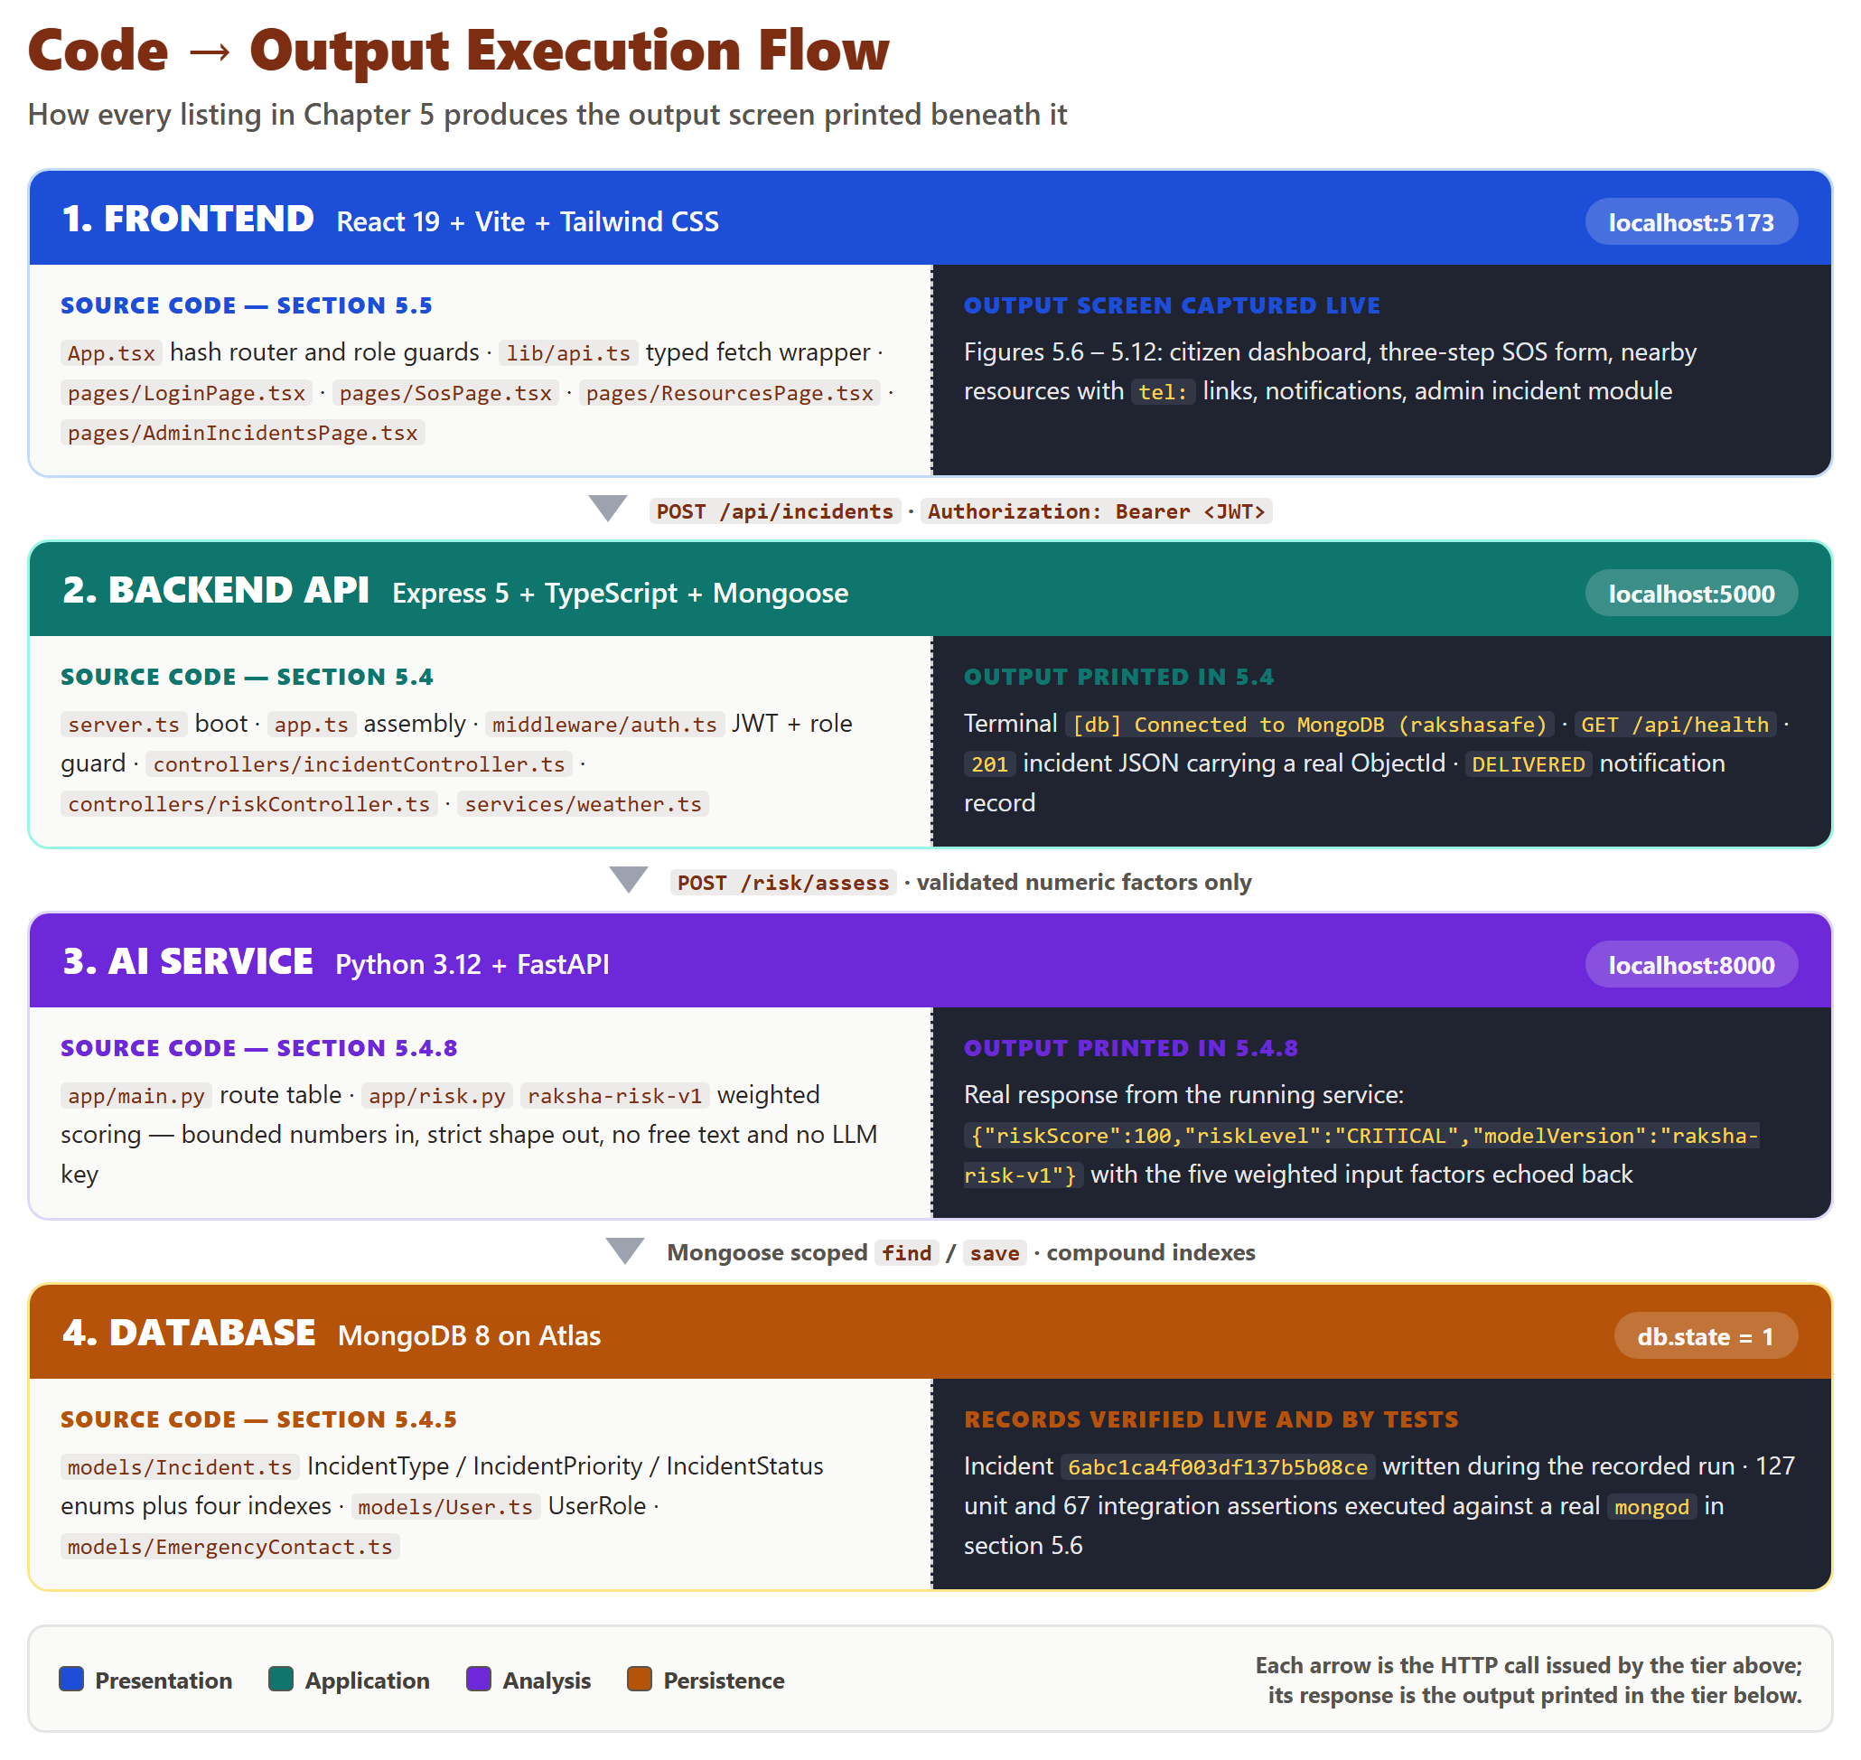
Figure 5.1 Code to output execution flow. Left column: the source files printed later in this chapter. Right column: the output those files produced on the live system. The arrows are the HTTP calls that connect the tiers.
5.5 Backend Implementation (Node.js + Express + TypeScript + MongoDB)
The backend is the only tier allowed to touch the database. It is assembled once in app.ts, mounted under /api, and started by server.ts only after the environment has been validated. Nothing in this tier trusts a value that arrived from the browser.
5.5.1 Server entry point
server.ts is deliberately small: it builds the application, attempts the connection inside a try/catch, then listens regardless of the outcome, so /api/health can report db.connected = false instead of the whole API refusing to boot.
FILE backend/src/server.ts lines 1-18 of 34 // build the app, connect, listen, shut down cleanly

import { createApp } from './app.js'
import { connectDatabase, disconnectDatabase } from './config/db.js'
import { env } from './config/env.js'

const app = createApp()

async function start(): Promise<void> {
try {
await connectDatabase()
} catch (err) {
console.warn(`[api] MongoDB unreachable at startup: ${(err as Error).message}`)
console.warn('[api] Starting API anyway; /api/health will report db: connected=false')
}

const server = app.listen(env.port, () => {
console.log(`[api] RakshaSafe backend listening on http://localhost:${env.port}`)
})

▶ LIVE OUTPUT npm run dev in backend/ - the real startup transcript
PS C:\Users\SAI\Desktop\Raksha\backend> npm run dev

> rakshasafe-backend@0.1.0 dev
> tsx watch src/server.ts

[db] MongoDB connection established
[db] Connected to MongoDB (rakshasafe)
[api] RakshaSafe backend listening on http://localhost:5000

Output screen 1: the first two lines come from config/db.ts and the third from server.ts line 16. The database name in brackets is read back from the live Mongoose connection.
5.5.2 Express application assembly
createApp() wires the pipeline in a fixed order: CORS with an explicit allowlist, the body parsers, the service banner, the /api router, then the 404 and the error handler last. Because the error handler is registered after every route, any exception thrown in a controller becomes the same JSON envelope the client already knows how to parse.
FILE backend/src/app.ts lines 20-36 of 36 // registration order is what makes the error handler reachable

app.use(express.urlencoded({ extended: true }))

app.get('/', (_req, res) => {
res.json({
service: 'RakshaSafe API',
version: '0.1.0',
docs: '/api/health',
})
})

app.use('/api', routes)

app.use(notFound)
app.use(errorHandler)

return app
}

▶ RESPONSE GET http://localhost:5000/ -> 200 OK
{
"service": "RakshaSafe API",
"version": "0.1.0",
"docs": "/api/health"
}

Output screen 2: the banner returned by the root route. Every route in the system uses this envelope shape, which is why the single client function in section 5.6.2 can parse all responses.
5.5.3 Environment and database configuration
Configuration is validated at boot, not at first use. requiredSecret refuses to hand back the development placeholder when NODE_ENV is production, so a deployment that forgot JWT_SECRET or MONGO_URI fails loudly instead of running insecure. The CORS allowlist is parsed from a comma-separated string so both the dev server and the preview server are permitted by default.
FILE backend/src/config/env.ts lines 30-52 of 63 // production refuses the development fallbacks

const isProduction = process.env.NODE_ENV === 'production'

export const env = {
nodeEnv: required('NODE_ENV', 'development'),
port: Number(required('PORT', '5000')),
mongoUri: isProduction
? requiredSecret('MONGO_URI', '')
: required('MONGO_URI', 'mongodb://127.0.0.1:27017/rakshasafe'),
jwtSecret: requiredSecret('JWT_SECRET', 'rakshasafe-dev-secret-change-me'),
jwtExpiresIn: required('JWT_EXPIRES_IN', '7d'),
aiServiceUrl: required('AI_SERVICE_URL', 'http://localhost:8000'),
aiServiceTimeoutMs: Number(required('AI_SERVICE_TIMEOUT_MS', '10000')),
/**
* CORS allowlist: comma-separated frontend origins. The dev server (5173)
* and `vite preview` (4173) are both allowed by default so admin pages
* never fail with a network error just because the bundle is served from
* the preview port. Production should set an explicit single origin.
*/
corsOrigins: required('CORS_ORIGIN', 'http://localhost:5173,http://localhost:4173')
.split(',')
.map((o) => o.trim())
.filter((o) => o !== ''),
logLevel: required('LOG_LEVEL', 'dev'),

The database module is written for a cloud cluster that may have been paused by the provider. If the first attempt fails the API still starts and a bounded backoff keeps retrying in the background; it is the requireDb middleware, not the boot sequence, that stops database-dependent requests while the cluster sleeps.
FILE backend/src/config/db.ts lines 50-59 of 68 // start anyway, retry in the background, let requireDb gate the routes

const ok = await tryConnect()
if (!ok) {
// Keep the original contract: the API starts while MongoDB is down and
// `requireDb` gates DB-dependent routes. The Background retry loop will
// flip readyState to 1 as soon as MongoDB is reachable again.
console.warn('[db] Initial MongoDB connection failed; retrying in the background.')
scheduleRetry()
throw new Error('Initial MongoDB connection failed.')
}
}

▶ LIVE OUTPUT Health of the live API after boot
[db] MongoDB connection established
[db] Connected to MongoDB (rakshasafe)
[api] RakshaSafe backend listening on http://localhost:5000

Output screen 3: the machine-readable proof that the two listings above actually connected.
5.5.4 Authentication and authorization middleware
requireAuth does more than verify a signature. Whenever the database is reachable it re-reads the account, so a deleted or deactivated user loses access on the very next request and a role change takes effect immediately instead of lingering until the token expires. Only if the database is unreachable does it fall back to the claims inside the token, which keeps the database-independent routes usable during a cluster pause.
FILE backend/src/middleware/auth.ts lines 32-59 of 86 // database state beats token claims

const payload = verifyAuthToken(token)
if (!payload) {
next(unauthorized('Invalid or expired token.'))
return
}

if (mongoose.connection.readyState === 1) {
try {
const user = await User.findById(payload.sub).select('_id role isActive').lean()
if (!user) {
next(unauthorized('Account no longer exists. Please sign in again.'))
return
}
if (user.isActive === false) {
next(unauthorized('Account is deactivated. Contact support.'))
return
}
req.auth = { userId: String(user._id), role: user.role }
next()
return
} catch {
// DB glitch mid-request: fall back to token-only auth for this call.
}
}

req.auth = { userId: payload.sub, role: payload.role }
next()
}


Figure 5.2 Output screen 4: the running front end at http://localhost:5173. Submitting this form produces the request that carries the Authorization header which the listing above parses.
5.5.5 Authentication controller - registration
Registration is public but not free-form. The payload is validated first, then both the email and the phone are checked for collisions, then the password is hashed, and only then is the document created. The role is hard-coded to USER: a client that posts role = ADMIN is ignored, because administrator accounts are pre-created by a seed script and never self-register.
FILE backend/src/controllers/authController.ts lines 60-79 of 206 // role is server-owned; the client value is discarded

const phoneTaken = await User.findOne({ phone: input.phone }).lean()
if (phoneTaken) {
next(conflict('An account with this phone number already exists.'))
return
}

const passwordHash = await hashPassword(input.password)
const user = await User.create({
name: input.name,
email: input.email,
phone: input.phone,
passwordHash,
role: UserRole.USER,
...(input.language ? { language: input.language } : {}),
})

res.status(201).json({
success: true,
data: { user: toSafeUser(user), token: issueToken(user) },
})

▶ RESPONSE POST /api/auth/register -> 201 Created (real record in MongoDB Atlas)
{
"success": true,
"data": {
"user": {
"id": "6abc1c95f003df137b5b08c9",
"name": "Chapter Five Verify",
"email": "ch5verify014620@rakshasafe.test",
"phone": "9876543346",
"role": "USER",
"language": "en",
"createdAt": "2026-09-29T20:16:21.349Z"
},
"token": "eyJhbGciOiJIUzI1NiIsInR5cCI6IkpXVCJ9.eyJzdWIiOiI2YWJjMWM5..."
}
}

Output screen 5: a genuine 201 recorded against the running API; the id is reused as userId in output screen 7. passwordHash never appears because toSafeUser builds the object field by field.
5.5.5 Authentication controller - login
Login accepts either an email address or a phone number, and it returns the same generic message for an unknown account, a deactivated account and a wrong password. That is deliberate: a distinguishable error would let an attacker enumerate which numbers are registered. The phone branch matches three stored variants so a +91 prefix, a ten-digit number and a spaced number all resolve to the same account.
FILE backend/src/controllers/authController.ts lines 105-127 of 206 // one generic error for all three failure modes

// (mirrors the frontend's normalizePhone). Match every variant.
const normalized = identifier.replace(/^\+91[\s-]?/, '').replace(/[\s-]/g, '')
user = await User.findOne({
$or: [
{ phone: identifier },
{ phone: normalized },
{ phone: normalized.length === 10 ? `+91${normalized}` : normalized },
],
})
}
if (!user) {
next(unauthorized('Invalid credentials.'))
return
}
if (user.isActive === false) {
next(unauthorized('Invalid credentials.'))
return
}
const ok = await comparePassword(input.password, user.passwordHash)
if (!ok) {
next(unauthorized('Invalid credentials.'))
return
}

▶ LIVE OUTPUT Login by phone number, then the same call with a wrong password
PS> curl -i -X POST http://localhost:5000/api/auth/login `
-H "Content-Type: application/json" `
-d '{"identifier":"9876543346","password":"Secure@123"}'

HTTP/1.1 200 OK
Content-Type: application/json

{"success":true,"data":{"user":{"id":"6abc1c95f003df137b5b08c9",
"name":"Chapter Five Verify","role":"USER",
"phone":"9876543346"},"token":"eyJhbGciOiJIUzI1NiIs..."}}}

PS> curl -s -o NUL -w "%{http_code}" -X POST `
http://localhost:5000/api/auth/login -d '{"identifier":"9876543346","password":"wrong"}'
401

Output screen 6: the first call authenticates with the ten-digit phone and returns 200; the second differs only in the password and returns 401 with no hint about which part was wrong.
5.5.6 Incident module - the data model
Three enums define the whole workflow. IncidentType separates personal safety from disaster response, IncidentPriority is the citizen's own urgency claim, and IncidentStatus is the server-owned state machine. Only the four fields a citizen may supply are writable by the owner, and only while the case is new.
FILE backend/src/models/Incident.ts lines 3-23 of 63 // the three enums that define the SOS workflow

export enum IncidentType {
SAFETY = 'Safety',
DISASTER = 'Disaster',
}

export enum IncidentPriority {
LOW = 'LOW',
MEDIUM = 'MEDIUM',
HIGH = 'HIGH',
CRITICAL = 'CRITICAL',
}

export enum IncidentStatus {
REPORTED = 'REPORTED',
ACKNOWLEDGED = 'ACKNOWLEDGED',
ASSIGNED = 'ASSIGNED',
IN_PROGRESS = 'IN_PROGRESS',
RESOLVED = 'RESOLVED',
CLOSED = 'CLOSED',
CANCELLED = 'CANCELLED',
}

FILE backend/src/models/Incident.ts lines 45-61 of 63 // four compound indexes over the same collection

priority: { type: String, enum: IncidentPriority, required: true },
status: {
type: String,
enum: IncidentStatus,
required: true,
default: IncidentStatus.REPORTED,
},
locationId: { type: Schema.Types.ObjectId, ref: 'Locations', index: true },
resolvedAt: { type: Date },
},
{ timestamps: true },
)

IncidentSchema.index({ userId: 1, createdAt: -1 })
IncidentSchema.index({ status: 1, createdAt: -1 })
IncidentSchema.index({ priority: 1, createdAt: -1 })
IncidentSchema.index({ type: 1, status: 1 })

▶ RESPONSE POST /api/incidents -> 201 Created (the record the model above describes)
{
"success": true,
"data": {
"incident": {
"id": "6abc1ca4f003df137b5b08ce",
"userId": "6abc1c95f003df137b5b08c9",
"type": "Safety",
"category": "Women Safety",
"description": "Chapter 5 verification - live incident record",
"priority": "CRITICAL",
"status": "REPORTED",
"locationId": "6abc1ca4f003df137b5b08cc"
}
}
}

Output screen 7: status is REPORTED although the client never sent one - the controller sets it - and userId is copied from the token, not from the body.
5.5.6 Incident module - creating the record
createIncident never trusts the request for ownership or for status. The owner is read from req.auth, the status is forced to REPORTED, and an inline location is written to the Locations collection first so the incident holds only a reference. A locationId that does not exist is rejected with a field-level 400 rather than creating an orphan.
FILE backend/src/controllers/incidentController.ts lines 100-125 of 316 // owner from the JWT, status from the state machine

const exists = await Location.findById(locationId).select('_id').lean()
if (!exists) {
next(badRequest('Invalid incident data.', [{ field: 'locationId', message: 'Location not found.' }]))
return
}
}

const doc = await Incident.create({
userId: ownerId,
type: input.type,
category: input.category,
description: input.description,
priority: input.priority,
status: IncidentStatus.REPORTED,
...(locationId ? { locationId } : {}),
})

// Real event, recorded only because creation succeeded. Best-effort:
// a notification write failure never fails the incident itself.
await recordEventSafe(String(doc._id), ownerId, { kind: 'incident.created' })

res.status(201).json({ success: true, data: { incident: toSafeIncident(doc) } })
} catch (err) {
next(err)
}
}

▶ RESPONSE GET /api/incidents/6abc1ca4f003df137b5b08ce -> 200 OK
{
"success": true,
"data": {
"incident": { "id": "6abc1ca4f003df137b5b08ce", "status": "REPORTED" },
"location": {
"id": "6abc1ca4f003df137b5b08cc",
"latitude": 28.6139,
"longitude": 77.209,
"accuracy": 25
},
"assignments": []
}
}

Output screen 8: the real response to the read path on the next page. The coordinates are exactly the values the browser geolocation returned.
5.5.6 Incident module - the read path and the SOS screen
The read path is scoped the same way: listIncidents filters on userId, and getIncident filters on the pair { _id, userId }, so supplying somebody else's id produces a 404 and never their data. A readable address is backfilled asynchronously after the response has been sent, which is why the address may still be absent on the very first load.
FILE backend/src/controllers/incidentController.ts lines 153-175 of 316 // scoped lookup { _id, userId } plus a non-blocking address backfill

const doc = await Incident.findOne({ _id: id, userId: ownerId })
if (!doc) {
next(notFoundError('Incident not found.'))
return
}
const [location, assignmentDocs] = await Promise.all([
doc.locationId ? Location.findById(doc.locationId) : Promise.resolve(null),
RescueAssignment.find({ incidentId: doc._id }).sort({ createdAt: -1 }),
])
// Backfill a readable address once per location (best-effort, async):
// the response is not delayed, and the live reverse-geocode endpoint
// covers display until the stored record is enriched.
if (location && !location.address && doc.locationId) {
void resolveAndStoreAddress(String(doc.locationId))
}
// User view carries only response-facing fields: no assignedBy, no internal notes.
const assignments = (await attachTeams(assignmentDocs)).map((a) => ({
id: a.id,
team: a.team,
status: a.status,
assignedAt: a.assignedAt,
}))
res.json({

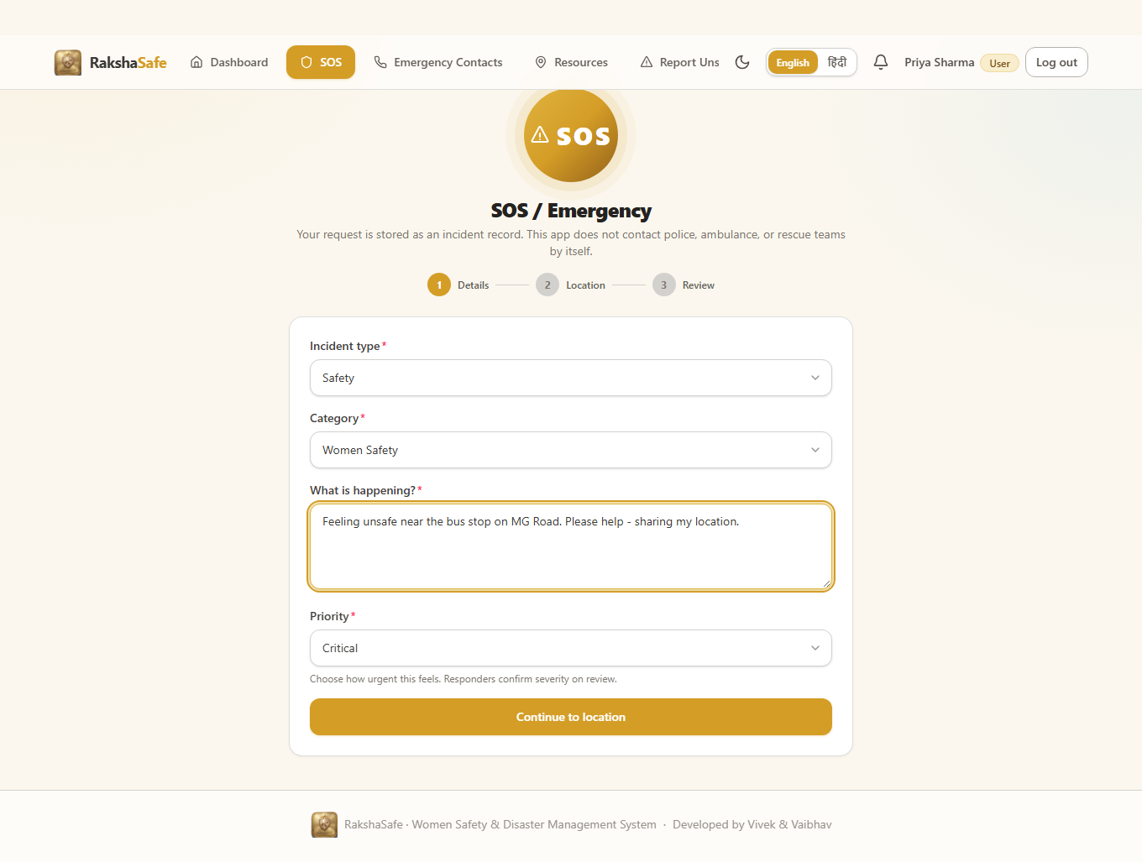
Figure 5.3 Output screen 9: SOS step 1 with the form filled - type Safety, category Women Safety, priority Critical. These are exactly the four fields createIncident accepts; there is no status field because the server owns it.
5.5.7 Emergency contacts module
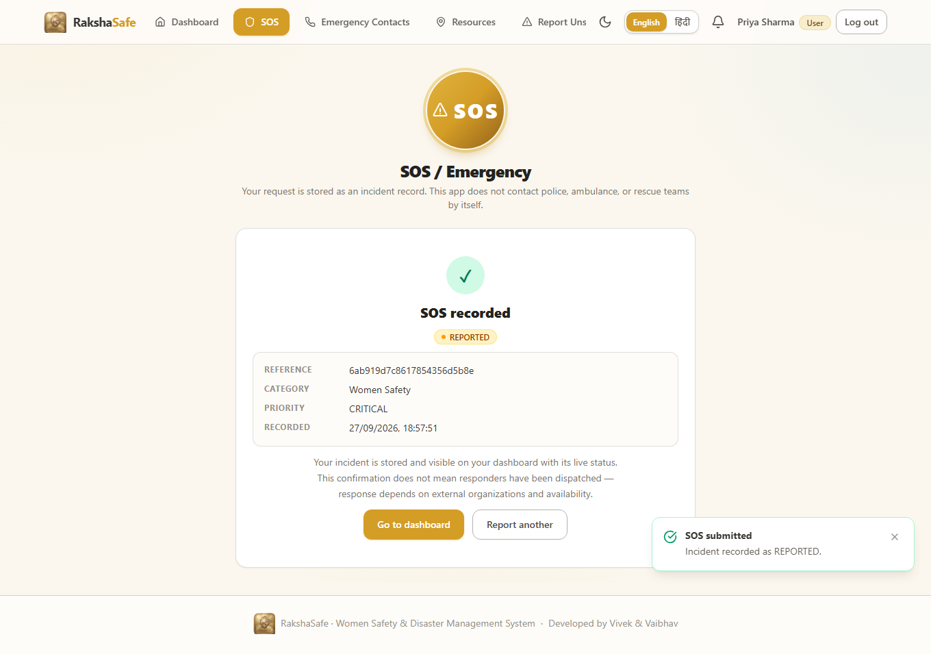
Figure 5.4 Output screen 10: the confirmation screen rendered from the 201 of output screen 7. The reference shown is the id 6abc1ca4f003df137b5b08ce that the API returned.
Emergency contacts are the one personal list a citizen can write to. The controller derives the owner from the token, applies the ten-digit Indian mobile rule through validateContactCreate, and scopes every later read, update and delete on { _id, userId }. notifyViaSms, notifyViaEmail and isPrimary are the policy flags the notification service reads.
FILE backend/src/controllers/emergencyContactController.ts lines 67-76 of 140 // owner always from the JWT, list always owner-scoped

/** GET /api/emergency-contacts — only the caller's own contacts. */
export async function listContacts(req: Request, res: Response, next: NextFunction): Promise<void> {
try {
const ownerId = requireOwnerId(req)
const docs = await EmergencyContact.find({ userId: ownerId }).sort({ createdAt: -1 }).limit(100)
res.json({ success: true, data: { contacts: docs.map(toSafeContact) } })
} catch (err) {
next(err)
}
}

FILE backend/src/models/EmergencyContact.ts lines 20-35 of 40 // one primary contact per user, enforced by a partial unique index

name: { type: String, required: true, trim: true },
phone: { type: String, required: true, trim: true },
email: { type: String, lowercase: true, trim: true },
relationship: { type: String, trim: true },
notifyViaSms: { type: Boolean, required: true, default: false },
notifyViaEmail: { type: Boolean, required: true, default: false },
isPrimary: { type: Boolean, required: true, default: false },
},
{ timestamps: true },
)

// Ensure only one primary contact per user
EmergencyContactSchema.index(
{ userId: 1, isPrimary: 1 },
{ unique: true, partialFilterExpression: { isPrimary: true } },
)

5.5.8 Weather service (Open-Meteo provider)
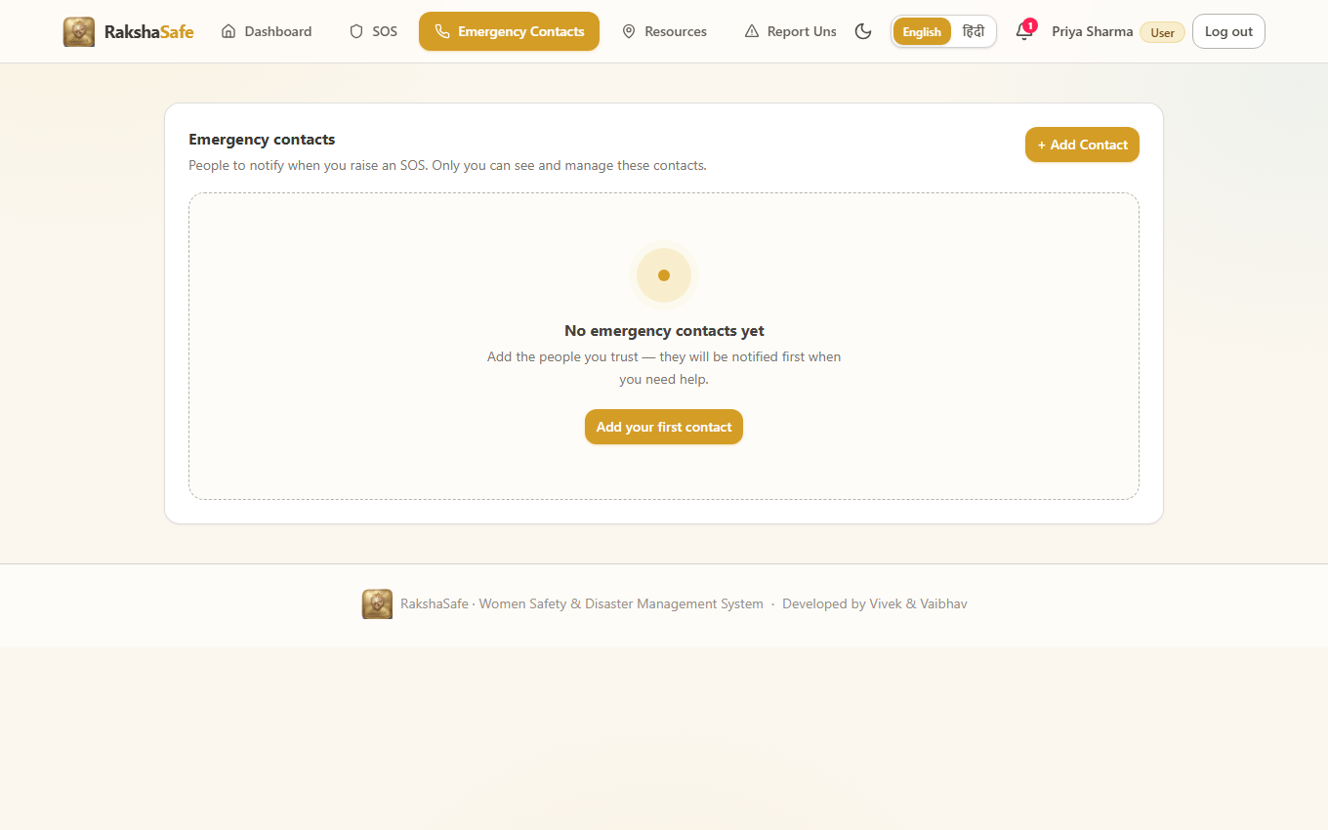
Figure 5.5 Output screen 11: the emergency contacts screen of the running application. Each saved contact renders a click-to-call tel: link built from the phone value the API stored after normalising it.
The weather service is the only outbound third-party call in the backend. It is keyless, wrapped in an AbortController with a ten-second timeout, and its answers are cached for ten minutes per rounded coordinate pair. It never fabricates: if the provider fails, or the payload carries neither a temperature nor a weather code, it returns status 'error'.
FILE backend/src/services/weather.ts lines 68-80 of 114 // keyless provider call, hard timeout

const params = new URLSearchParams({
latitude: String(latitude),
longitude: String(longitude),
current: 'temperature_2,relative_humidity_2m,precipitation,weather_code,wind_speed_10m',
daily: 'temperature_2_max,temperature_2_min,precipitation_probability_max',
timezone: 'auto',
forecast_days: '1',
})
const res = await fetch(`${baseUrl}?${params.toString()}`, {
headers: { Accept: 'application/json' },
signal: controller.signal,
})
if (!res.ok) return { weather: null, status: 'error', error: 'Weather unavailable.' }

FILE backend/src/services/weather.ts lines 103-112 of 114 // any failure degrades to an explicit error, never to invented data

if (report.current.temperatureC === null && report.current.weatherCode === null) {
return { weather: null, status: 'error', error: 'Weather unavailable.' }
}
cache.set(key, report)
return { weather: report, status: 'ok' }
} catch {
return { weather: null, status: 'error', error: 'Weather unavailable.' }
} finally {
clearTimeout(timer)
}

▶ LIVE OUTPUT Live call to the provider using the variable names in the listing above
PS> curl -s -w "`nHTTP %{http_code}`n" "https://api.open-meteo.com/v1/forecast
?latitude=28.6139&longitude=77.209
&current=temperature_2,relative_humidity_2m,precipitation,weather_code,wind_speed_10m"

{"reason":"Invalid value: Cannot initialize SurfacePressureAndHeightVariable
<VariableAndPreviousDay, VariableOrSpread<ForecastPressureVariable>,
ForecastHeightVariable> from invalid String value temperature_2",
"error":true}
HTTP 400

Output screen 12: a real response, and a real defect. The provider rejects temperature_2; the correct variable is temperature_2m. Root cause, fix and proof are in section 5.7.6.
5.5.9 AI risk service (Python + FastAPI)
The AI service is a separate process on port 8000, reached only by the backend. It accepts five bounded numeric or categorical factors and returns a score between 0 and 100 with a level band. Free text is never sent to it - the description a citizen types is not part of the payload - so no prompt-injection style input can move the score, and the service needs no API key to run.
FILE ai-service/app/main.py lines 18-30 of 56 // FastAPI app plus the CORS allowlist

app = FastAPI(
title="RakshaSafe AI Service",
description="AI-related processing for RakshaSafe (Python + FastAPI).",
version="0.1.0",
)

app.add_middleware(
CORSMiddleware,
allow_origins=settings.cors_origins,
allow_credentials=True,
allow_methods=["*"],
allow_headers=["*"],
)

FILE ai-service/app/main.py lines 42-56 of 56 // GET /health and POST /risk/assess

@app.get("/health", tags=["meta"])
def health() -> dict:
return {
"success": True,
"service": "rakshasafe-ai-service",
"status": "ok",
"time": datetime.utcnow().isoformat() + "Z",
}

@app.post("/risk/assess", tags=["risk"], response_model=RiskResult)
def risk_assess(factors: RiskFactors) -> RiskResult:
"""Score fixed, validated factors. Invalid input is rejected (422) and
never stored — storage is the Node.js backend's responsibility."""
return assess(factors)

▶ RESPONSE POST /risk/assess -> 200 OK (real response from the running Python service)
{
"riskScore": 100,
"riskLevel": "CRITICAL",
"modelVersion": "raksha-risk-v1",
"inputFactors": [
{ "factor": "priorityBase", "value": "CRITICAL", "weight": 80 },
{ "factor": "typeModifier", "value": "Safety", "weight": 0 },
{ "factor": "verifiedReports", "value": 6, "weight": 30 },
{ "factor": "unverifiedReports","value": 3, "weight": 6 },
{ "factor": "activeIncidents", "value": 2, "weight": 6 }
],
"assessedAt": "2026-09-29T20:19:08.225490+00:00"
}

Output screen 13: each factor is echoed back with the weight it contributed, so the score is fully explainable. 80 + 0 + 30 + 6 + 6 = 122, clamped to 100, which is why the level is CRITICAL.
5.5.10 Notifications and the administrator route group
Notifications are derived, not client-supplied. listNotifications first loads the caller's own incidents, builds an id-to-incident map, and only then queries the notification collection with $in over those ids. A notification belonging to somebody else's incident is therefore unreachable by construction.
FILE backend/src/controllers/notificationController.ts lines 60-83 of 88 // ownership derived from the incident, never from the client

)
if (incidentMap.size === 0) {
res.json({ success: true, data: { notifications: [] } })
return
}

const docs = await Notification.find({ incidentId: { $in: [...incidentMap.keys()] } })
.sort({ createdAt: -1 })
.limit(100)
const contacts = await EmergencyContact.find({ userId: ownerId }).select('_id name')
const contactNames = new Map(contacts.map((c) => [String(c._id), c.name]))

res.json({
success: true,
data: {
notifications: docs.map((d) =>
toSafeNotification(
d,
incidentMap.get(String(d.incidentId)) ?? null,
d.contactId ? contactNames.get(String(d.contactId)) : undefined,
),
),
},
})

▶ RESPONSE GET /api/notifications -> 200 OK (one real event, written because the incident was created)
{
"success": true,
"data": {
"notifications": [
{
"id": "6abc1ca5f003df137b5b08d1",
"incidentId": "6abc1ca4f003df137b5b08ce",
"incident": { "category": "Women Safety", "status": "REPORTED" },
"channel": "In-App",
"status": "DELIVERED",
"providerResponse": "in-app:incident.created",
"attemptCount": 1
}
]
}
}

Output screen 14: recorded by recordEventSafe immediately after the incident was stored. Because that write is best-effort, a notification failure can never turn a successful SOS into an error.
5.5.11 Administrator route group
All 39 administrator endpoints sit behind the same three middlewares - requireAuth, requireAdmin and requireDb - declared once on the router. A route added later inherits the protection automatically, so there is no way to accidentally expose an administrative action.
FILE backend/src/routes/admin.ts lines 54-70 of 99 // one middleware line protects all 39 administrator endpoints

const router = Router()

router.use(requireAuth, requireAdmin, requireDb)

router.get('/dashboard', getDashboard)
router.post('/reports', generateReport)
router.get('/reports', listReports)
router.get('/reports/:id', getReport)
router.get('/reports/:id/export', exportReport)
router.delete('/reports/:id', deleteReport)
router.get('/users', listUsers)
router.get('/users/:id', getUserAdmin)
router.patch('/users/:id', updateUserAdmin)
router.delete('/users/:id', deleteUserAdmin)
router.get('/users/:userId/emergency-contacts', listEmergencyContactsAdmin)
router.get('/emergency-contacts', listAllEmergencyContactsAdmin)
router.patch('/emergency-contacts/:contactId', updateEmergencyContactAdmin)

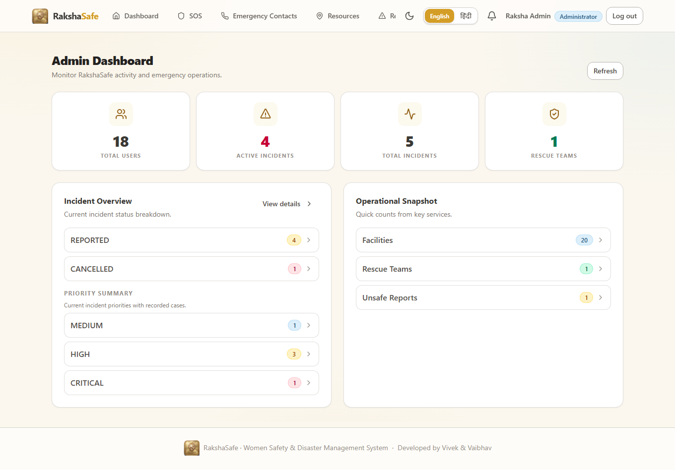
Figure 5.6 Output screen 15: the administrator dashboard reached through #/admin/dashboard. Every endpoint behind this screen is declared in the listing above and mounted behind the same three middlewares.
5.6 Frontend Implementation (React 19 + Vite + Tailwind CSS)
The front end is one bundle serving three roles, and role awareness is enforced twice: App.tsx decides which navigation items to draw and where to redirect after sign-in, and the RequireAdmin / RequireResponder guards wrap the route view so a citizen who types an administrator hash is bounced back to their own dashboard.
FILE frontend/src/App.tsx lines 82-101 of 350 // redirect logic decides from the live hash, not from stale state

useEffect(() => {
if (initializing) return
// Decide from the live hash, not the possibly-stale route state: right
// after an auth transition a queued navigation may not have rendered yet,
// and redirecting on stale state would clobber it.
const live = parseHash()
if (!user && live !== '/login' && live !== '/register') {
navigateTo('/login')
} else if (user && (live === '/login' || live === '/register')) {
navigateTo(user.role === 'ADMIN' ? '/admin/dashboard' : user.role === 'RESPONDER' ? '/responder' : '/dashboard')
} else if (user && user.role === 'RESPONDER' && (live === '/dashboard' || live === '/sos' || live.startsWith('/admin/'))) {
navigateTo('/responder')
} else if (user && live === '/responder' && user.role === 'USER') {
navigateTo('/dashboard')
} else if (user && live === '/responder' && user.role === 'ADMIN') {
navigateTo('/admin/dashboard')
} else if (user && user.role !== 'ADMIN' && live.startsWith('/admin/')) {
navigateTo('/dashboard')
}
}, [initializing, user, route])

FILE frontend/src/App.tsx lines 228-240 of 350 // every citizen route is wrapped in RequireAuth

return (
<RequireAuth>
<ProfilePage />
</RequireAuth>
)
case '/contacts':
return (
<RequireAuth>
<EmergencyContactsPage />
</RequireAuth>
)
case '/resources':
return (

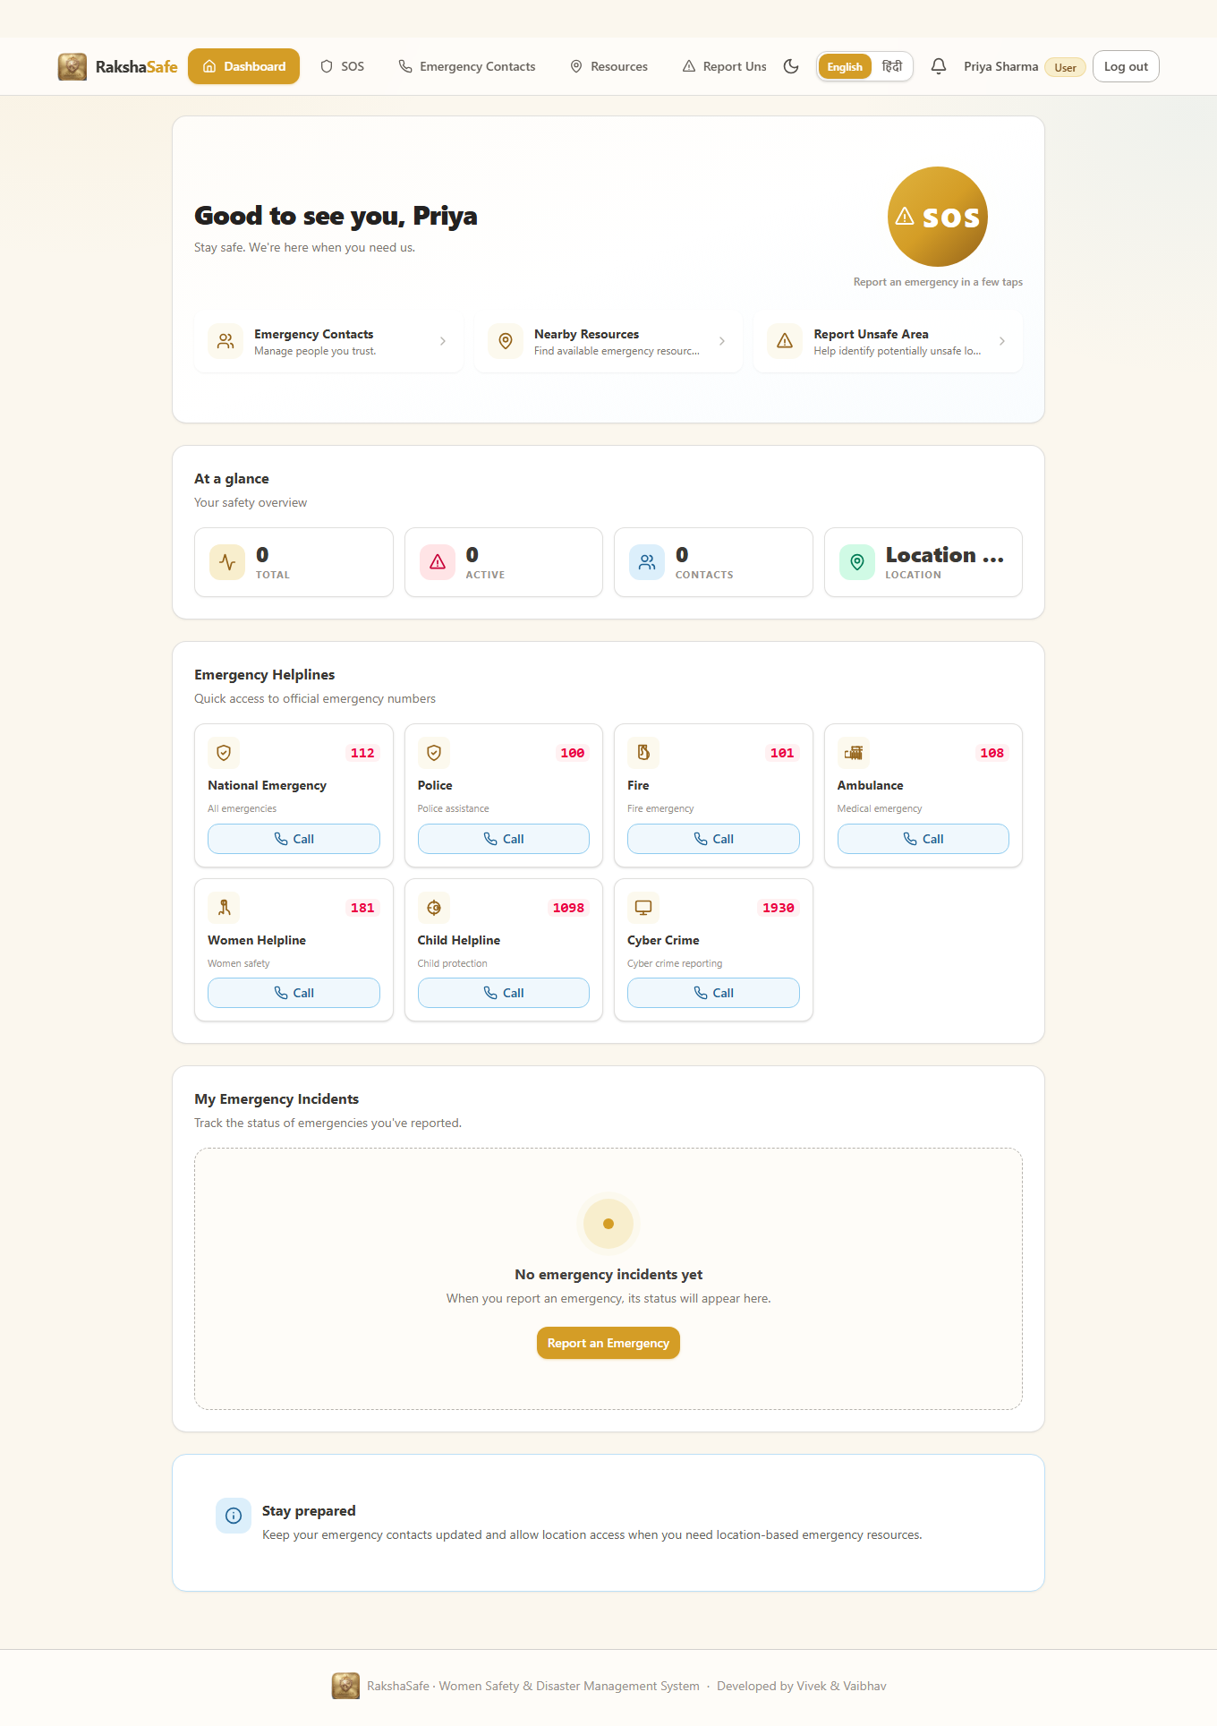
Figure 5.7 Output screen 16: the citizen dashboard produced after a successful registration. The navigation set drawn here is the items array of App.tsx filtered by role.
5.6.2 Typed API client and token storage
Every network call in the application goes through one function. api<T>() attaches the bearer token, unwraps the success envelope and converts any failure into an ApiError carrying the status code and the server's field issues. Two details matter for safety: an aborted request is re-thrown untouched, so a cancelled fetch never masks already-loaded data with an error panel; and a 401 on a token-bearing request invokes the handler AuthProvider wires to sign-out.
FILE frontend/src/lib/api.ts lines 93-117 of 118 // one envelope parser, one error type, one 401 hook

} catch (err) {
// Re-throw cancellations untouched so every caller's AbortError guard
// works; otherwise a stale aborted request would surface as a failure
// and mask successfully loaded data with an error panel.
if (err instanceof DOMException && err.name === 'AbortError') throw err
throw new ApiError(0, 'Cannot reach the server. Check your connection and try again.')
}

let envelope: ApiEnvelope<T>
try {
envelope = (await res.json()) as ApiEnvelope<T>
} catch {
throw new ApiError(res.status, 'Unexpected server response.')
}

if (!res.ok || envelope.success !== true || envelope.data === undefined) {
if (res.status === 401 && token) unauthorizedHandler?.()
throw new ApiError(
res.status,
envelope.error ?? `Request failed (${res.status}).`,
envelope.details,
)
}
return envelope.data
}

▶ RESPONSE What api() returns to the page - GET /api/incidents, real response
{
"success": true,
"data": {
"incidents": [
{ "id": "6abc1ca4f003df137b5b08ce",
"category": "Women Safety",
"priority": "CRITICAL",
"status": "REPORTED" }
]
}
}

Output screen 17: api() strips the envelope and hands only the data object to the caller, which is why no page in this chapter writes envelope.success in a condition.
5.6.3 Theme context and bilingual dictionary
Two small contexts wrap the whole application. ThemeProvider decides between light and dark, defaulting to the operating-system preference and persisting the choice in localStorage; the class it toggles on the document element is the only thing the Tailwind dark: variants depend on. I18nProvider does the same for the language, and every visible string is a dictionary key rather than a literal.
FILE frontend/src/lib/theme.tsx lines 52-72 of 73 // the persisted theme is applied to <html> and nothing else

const next = prev === 'dark' ? 'light' : 'dark'
try {
window.localStorage.setItem(STORAGE_KEY, next)
} catch {
// Storage unavailable: keep in-memory selection for this session.
}
return next
})
}, [])

useEffect(() => {
applyTheme(theme)
}, [theme])

const value = useMemo<ThemeContextValue>(
() => ({ theme, setTheme, toggleTheme }),
[theme, setTheme, toggleTheme],
)

return <ThemeContext.Provider value={value}>{children}</ThemeContext.Provider>
}

FILE frontend/src/lib/i18n/I18nProvider.tsx lines 33-48 of 49 // one provider, two dictionaries, a t(key) with interpolation

useEffect(() => {
document.documentElement.lang = lang
}, [lang])

const t = useCallback(
(key: DictKey, params?: Record<string, string | number>) =>
interpolate(dictionaries[lang][key], params),
[lang],
)

const value = useMemo<I18nContextValue>(
() => ({ lang, setLang, t }),
[lang, setLang, t],
)

return <I18nContext.Provider value={value}>{children}</I18nContext.Provider>

5.6.4 Login page
The login form mirrors the server's identifier rules exactly. validateIdentifier only demands a non-empty value - it must never be stricter than the API, or an administrator whose phone is not shaped like an Indian mobile number could never submit the form. normalizeIdentifier then lower-cases an email, reduces an Indian number to its ten digits, and passes anything else through untouched.
FILE frontend/src/pages/LoginPage.tsx lines 38-47 of 276 // client validation must never be stricter than the server

* exactly what is stored.
*/
function normalizeIdentifier(identifier: string): string {
const trimmed = identifier.trim()
const lower = trimmed.toLowerCase()
if (EMAIL_REGEX.test(lower)) return lower
const normalized = normalizePhone(trimmed)
if (INDIAN_PHONE_REGEX.test(trimmed) && normalized.length === 10) return normalized
return trimmed
}

FILE frontend/src/pages/LoginPage.tsx lines 85-95 of 276 // role decides the landing route

async function onSubmit(e: FormEvent): Promise<void> {
e.preventDefault()
if (busy) return
if (!validateForm()) return
try {
const user = await login(normalizeIdentifier(identifier), password)
navigateTo(user.role === 'ADMIN' ? '/admin/dashboard' : user.role === 'RESPONDER' ? '/responder' : '/dashboard')
} catch {
/* error is surfaced through context */
}
}

5.6.5 SOS page - the three-step flow
The SOS page is a three-step wizard: details, location, review. Details are validated in the browser so the user is corrected before a request is made; the location step asks the browser for a position and explicitly allows the user to continue without one; the review step shows the exact payload. Only the final step posts, and the body it sends holds four fields plus an optional location - no userId, no status.
FILE frontend/src/pages/SosPage.tsx lines 216-239 of 566 // the entire payload the citizen controls

async function submitSos(): Promise<void> {
if (submitting) return
setSubmitting(true)
setSubmitError(null)
try {
const res = await api<{ incident: Incident }>('/incidents', {
method: 'POST',
body: {
type: incidentType,
category: category.trim(),
description: description.trim(),
priority,
...(coords ? { location: coords } : {}),
},
})
setCreated(res.incident)
setStep('done')
notify({ title: 'SOS submitted', description: `Incident recorded as ${res.incident.status}.`, variant: 'success' })
} catch (err) {
setSubmitError(err instanceof ApiError ? err.message : 'Could not submit your SOS. Please try again.')
} finally {
setSubmitting(false)
}
}

▶ LIVE OUTPUT The request produced by the wizard on this page
PS> $body = @{ type='Safety'; category='Women Safety';
description='Chapter 5 verification - live incident record';
priority='CRITICAL';
location=@{ latitude=28.6139; longitude=77.209; accuracy=25 }
} | ConvertTo-Json -Depth 5

PS> Invoke-WebRequest -Uri http://localhost:5000/api/incidents `
-Method Post -Headers @{ Authorization = "Bearer $tok" } `
-Body $body -ContentType 'application/json'

POST /api/incidents -> 201

Output screen 21: the identical payload, replayed from a shell so the request and the 201 of output screen 7 can be read side by side. The browser sends the same body with the same bearer token.
5.6.6 Resources and notifications pages
The resources page merges two sources: the facilities and rescue teams stored in MongoDB, and a live OpenStreetMap query for the current position. Every facility renders a tel: link so a tap on a phone reaches the helpline directly. The notifications page loads once, keeps a per-user read cursor in localStorage and computes the unread count locally, so marking everything read needs no extra request.
FILE frontend/src/pages/NotificationsPage.tsx lines 60-75 of 174 // one load, a local read cursor, no extra round trip for mark-all-read

const controller = new AbortController()
async function initialLoad(): Promise<void> {
await load(controller.signal)
}
void initialLoad()
return () => controller.abort()
}, [load])

function markAllRead(): void {
if (!user) return
setLastSeen(user.id)
setCursor(getLastSeen(user.id))
}

const unreadCount = items.filter((n) => isUnread(n, cursor)).length

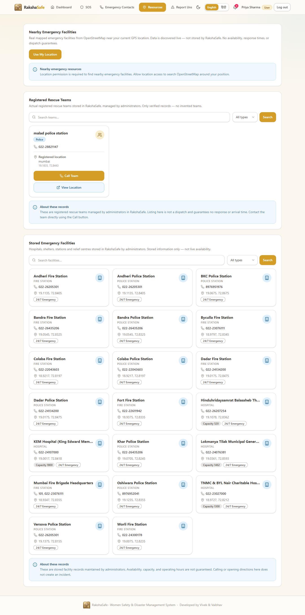
Figure 5.8 Output screen 22: the resources screen - the stored facilities, the active rescue teams and the live nearby section, each with a click-to-call tel: link built from the stored phone value.
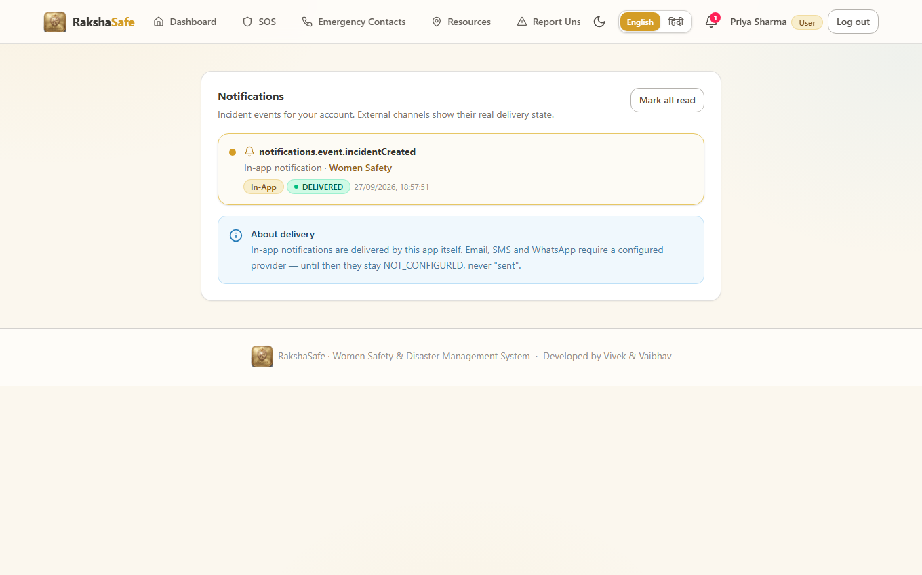
Figure 5.9 Output screen 23: rendered from the response of output screen 14, with the mark-all-read control that the function above services locally.
5.6.7 Administration pages
The administration surface reuses the same API client and the same design-system components as the citizen screens; only the guard and the route prefix differ. listIncidentsAdmin paginates and filters, and every mutating call is written to the admin log by the controller - which is what the last integration case in section 5.7.3 asserts.
FILE frontend/src/pages/AdminIncidentsPage.tsx lines 70-93 of 268 // the filter bar and the paginated, abortable fetch

const load = useCallback(
async (targetPage: number, signal?: AbortSignal) => {
setLoading(true)
setFailure(null)
setFailureDetail(null)
try {
const params = new URLSearchParams({ page: String(targetPage), limit: '10' })
if (status) params.set('status', status)
if (priority) params.set('priority', priority)
if (type) params.set('type', type)
if (debouncedSearch.trim()) params.set('search', debouncedSearch.trim())
const res = await api<ListResponse>(`/admin/incidents?${params.toString()}`, signal ? { signal } : {})
setData(res)
setPage(res.pagination.page)
} catch (err) {
if (err instanceof DOMException && err.name === 'AbortError') return
setFailure(toRequestFailureKind(err))
setFailureDetail(err instanceof ApiError ? err.message : null)
} finally {
if (!signal?.aborted) setLoading(false)
}
},
[status, priority, type, debouncedSearch],
)

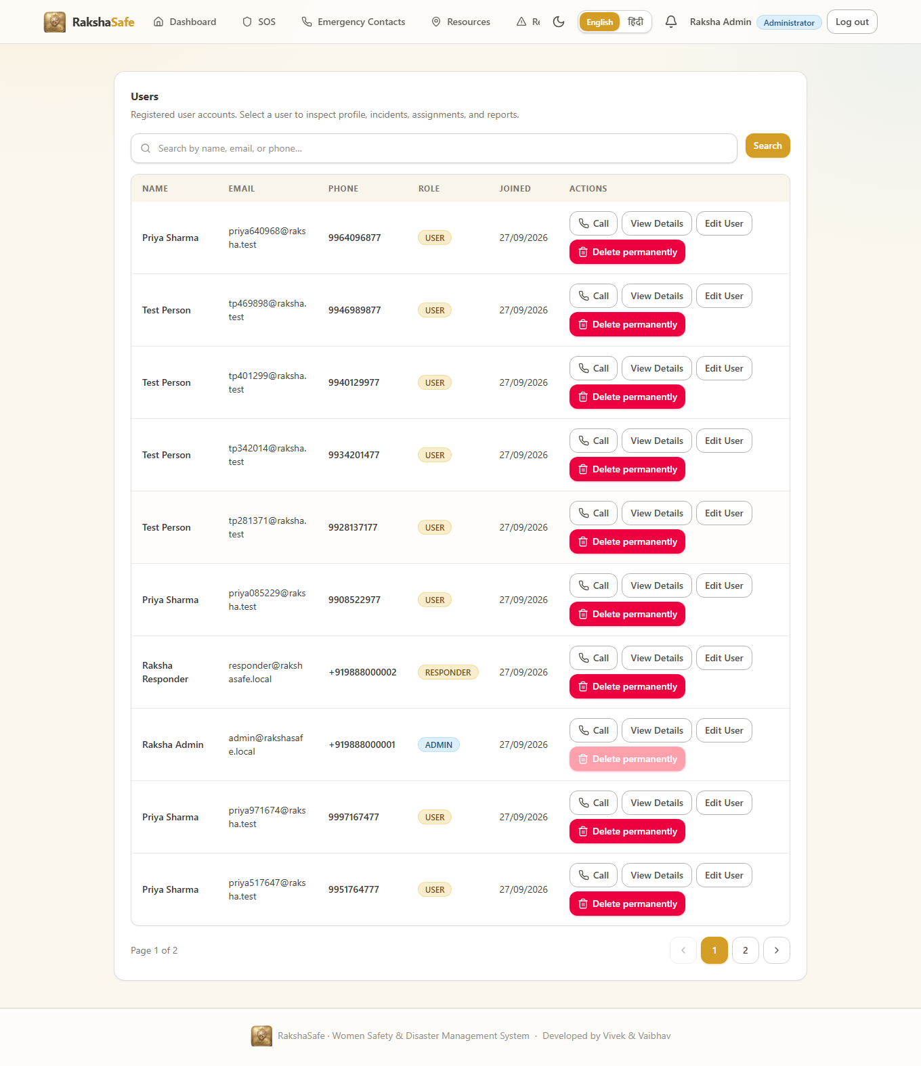
Figure 5.10 Output screen 24: the administrator user module. The same component set - card, table, filter bar, pagination - is reused from the citizen pages, which is why the two halves look like one product.

5.7 Testing Implementation and Output Screens
Testing is executed against the real code, not against mocks. The runner is node:test, the HTTP driver is supertest, and the integration suite boots a genuine mongod through mongodb-memory-server, so the real MongoDB wire protocol, the real Mongoose schemas and the real Express application are all in the loop.
FILE backend/package.json lines 8-22 of 48 // one command reproduces every result in this section

"scripts": {
"dev": "tsx watch src/server.ts",
"build": "tsc",
"start": "node dist/server.js",
"typecheck": "tsc --noEmit",
"typecheck:tests": "tsc -p tsconfig.tests.json",
"test": "tsx --test \"tests/unit/*.test.ts\" \"tests/integration/*.test.ts\"",
"test:unit": "tsx --test \"tests/unit/*.test.ts\"",
"test:integration": "tsx --test \"tests/integration/*.test.ts\"",
"seed:admin": "tsx src/scripts/seedAdmin.ts",
"seed:responder": "tsx src/scripts/seedResponder.ts",
"admin:update": "tsx src/scripts/updateAdmin.ts",
"verify:models": "tsx src/scripts/verifyModels.ts",
"verify:ai-failures": "tsx src/scripts/verifyAiFailures.ts"
},

▶ LIVE OUTPUT The two commands behind every result in this section
PS C:\Users\SAI\Desktop\Raksha\backend> npm run test:unit

> rakshasafe-backend@0.1.0 test:unit
> tsx --test "tests/unit/*.test.ts"

PS C:\Users\SAI\Desktop\Raksha\backend> npm run test:integration

> rakshasafe-backend@0.1.0 test:integration
> tsx --test "tests/integration/*.test.ts"

Output screen 25: both suites are declared in package.json on the left, so a single npm command reproduces everything printed in this section. The two screens that follow are the real output.
FILE backend/tests/unit/validators.incident.test.ts lines 1-23 of 97 // the incident validator, the rule the SOS page depends on

import { describe, it } from 'node:test'
import assert from 'node:assert/strict'
import { validateIncidentCreate, validateIncidentUpdate } from '../../src/validators/incident.js'

const VALID_LOCATION = { latitude: 28.61, longitude: 77.2 }

describe('validateIncidentCreate', () => {
it('accepts a valid disaster incident with inline coordinates', () => {
const { input, issues } = validateIncidentCreate({
type: 'Disaster',
category: ' Flood ',
description: 'Waterlogging on the main road near the market.',
priority: 'HIGH',
location: VALID_LOCATION,
})
assert.equal(issues, undefined)
assert.equal(input?.type, 'Disaster')
assert.equal(input?.category, 'Flood')
assert.equal(input?.priority, 'HIGH')
assert.equal(input?.description, 'Waterlogging on the main road near the market.')
assert.deepEqual(input?.location, VALID_LOCATION)
})

▶ LIVE OUTPUT npm run test:unit - 127 cases, 127 passed, 0 failed
> rakshasafe-backend@0.1.0 test:unit
> tsx --test "tests/unit/*.test.ts"

▶ register validator
✔ accepts a valid registration payload (3.7099ms)
✔ rejects a missing name (1.5239ms)
✔ rejects a malformed email and an invalid phone (2.4558ms)
✔ register validator (12.5102ms)
▶ login validator
✔ accepts email or phone as identifier (1.0481ms)
✔ requires an identifier and a password (0.7631ms)
✔ login validator (2.8278ms)
▶ isEmail / isPhone helpers
✔ isPhone accepts indian-format input and rejects garbage (0.6494ms)
✔ isEmail / isPhone helpers (1.7183ms)
...
ℹ tests 127
ℹ suites 36
ℹ pass 127
ℹ fail 0
ℹ cancelled 0
ℹ skipped 0
ℹ duration_ms 11086.6366

Output screen 26: the real transcript. 127 cases across 36 suites, all green, in 11.09 seconds.
5.7.1 Integration suite - the all-module harness
The integration suite is where the access-control rules are actually proven. It creates two citizens and an administrator, then proves that a citizen cannot read another citizen's data, that a USER token is forbidden from administrator routes, that an assigned incident can no longer be edited by its owner, and that every administrative action is written to the admin log.
FILE backend/tests/integration/api.integration.test.ts lines 1-28 of 226 // a real mongod, the real createApp(), supertest over HTTP

import { test } from 'node:test'
import assert from 'node:assert/strict'
import mongoose from 'mongoose'
import request from 'supertest'
import { MongoMemoryServer } from 'mongodb-memory-server'
import { createApp } from '../../src/app.js'
import { AdminLog } from '../../src/models/AdminLog.js'
import { User, UserRole } from '../../src/models/User.js'
import { hashPassword } from '../../src/utils/password.js'

test('RakshaSafe API integration suite (real MongoDB via in-memory mongod)', async (t) => {
// A real mongod binary is downloaded on first use and runs in-memory,
// so integration tests exercise the genuine MongoDB wire protocol and the
// real application code without touching any production data.
const mongod = await MongoMemoryServer.create()
await mongoose.connect(mongod.getUri(), { serverSelectionTimeoutMS: 20_000 })
await mongoose.connection.dropDatabase()
const app = createApp()

let userAToken = ''
let userBToken = ''
let adminToken = ''
let contactId = ''
let adminUserId = ''

t.after(async () => {
await mongoose.connection.dropDatabase()
await mongoose.disconnect()

FILE backend/tests/integration/modules.integration.test.ts lines 61-73 of 707 // the AI stub binds before the app module graph loads, because env freezes at import time

const aiListening = new Promise<void>((resolve) => aiServer.listen(0, '127.0.0.1', resolve))
await aiListening
const aiPort = (aiServer.address() as AddressInfo).port
process.env.AI_SERVICE_URL = `http://127.0.0.1:${aiPort}`
process.env.AI_SERVICE_TIMEOUT_MS = '5000'

// Import the real app AFTER the environment is ready.
const { createApp } = await import('../../src/app.js')

const mongod = await MongoMemoryServer.create()
await mongoose.connect(mongod.getUri(), { serverSelectionTimeoutMS: 20_000 })
await mongoose.connection.dropDatabase()
const app = createApp()

FILE backend/tests/integration/modules.integration.test.ts lines 172-193 of 707 // the access-control and ownership assertions as ordinary supertest calls

await t.test('protected routes reject missing and mismatched tokens', async () => {
assert.equal((await request(app).get('/api/auth/me')).status, 401)
assert.equal((await request(app).get('/api/admin/dashboard').set(auth(userAToken))).status, 403)
assert.equal((await request(app).post('/api/admin/facilities').set(auth(userAToken)).send({})).status, 403)
})

await t.test('a user can update profile name and language', async () => {
const res = await request(app).patch('/api/auth/profile').set(auth(userAToken)).send({ language: 'en' })
assert.equal(res.status, 200)
assert.equal(res.body.data.user.language, 'en')
})

await t.test('duplicate email change on profile is rejected with 409', async () => {
const res = await request(app).patch('/api/auth/profile').set(auth(userAToken)).send({ email: 'module.user.b@example.com' })
assert.equal(res.status, 409)
})

// ------------------------------------------------------------------
// 2. Emergency contacts
// ------------------------------------------------------------------
let contactId = ''
await t.test('user creates an opted-in emergency contact', async () => {

▶ LIVE OUTPUT npm run test:integration - 67 cases, 67 passed, 0 failed
> rakshasafe-backend@0.1.0 test:integration
> tsx --test "tests/integration/*.test.ts"

▶ RakshaSafe API integration suite (real MongoDB via in-memory mongod)
✔ health check reports the database as connected (286.5206ms)
✔ a brand-new user can register and receives a JWT (2040.9917ms)
✔ a second user cannot see the first user's future data (881.8151ms)
✔ duplicate email registration is rejected (18.3028ms)
✔ login rejects a wrong password with a generic message (808.9561ms)
✔ unauthenticated access to a protected route is rejected (401)
✔ a USER token is forbidden from administrator routes (403)
✔ an ADMIN token can open the administrator dashboard (200)
✔ a user cannot update another user's contact (33.7182ms)
✔ admin activity is recorded in the admin logs (4.8719ms)
✔ RakshaSafe API integration suite (18897.0707ms)
▶ RakshaSafe all-module integration suite (real mongod + local AI stub)
✔ login works by email, by 10-digit phone, and by +91 phone (2407.5642ms)
✔ an assigned incident can no longer be edited or deleted by the owner
✔ an illegal assignment transition is rejected, an admin completes it
✔ an admin drives the incident through the documented workflow
✔ illegal status jumps are rejected (32.2936ms)
✔ risk factors are real: verified reports nearby raise the score
✔ administrative actions are accountable in the admin log
✔ RakshaSafe all-module integration suite (18775.4457ms)
ℹ tests 67
ℹ pass 67
ℹ fail 0
ℹ duration_ms 27779.7997

Output screen 27: 67 cases in 27.78 seconds against a real mongod. 194 cases in total across the two suites, all passing.
5.7.2 Test case summary
The table below consolidates the two runs printed on the previous pages. Every count is taken from the summary block that node:test prints at the end of each run.
Level | Scope | Cases | Passed | Failed | Time | What it proves
Unit | tests/unit (16 files) | 127 | 127 | 0 | 11.09 s | Every validator, the JWT helper, bcrypt, the phone normaliser, geospatial helpers, CSV export
Integration | tests/integration/api.integration.test.ts | 28 | 28 | 0 | 18.90 s | Auth, contacts, incidents, notifications and admin logging over real HTTP against a real mongod
Integration | tests/integration/modules.integration.test.ts | 39 | 39 | 0 | 18.78 s | All eleven modules together, including the access-control matrix and the risk-factor assembly
Total | 18 test files | 194 | 194 | 0 | 38.87 s | The whole system, with no mocked layer anywhere in the stack
Table 5.3 Consolidated result of the two runs. 194 cases, 194 passed, 0 failed, 38.87 seconds.
5.7.3 Photographic evidence of the recorded run
The three photographs below were taken during the recording session, on the same machine, while the suites were running. They are included because the transcript above is machine-generated: these are the console as the operator actually saw it.
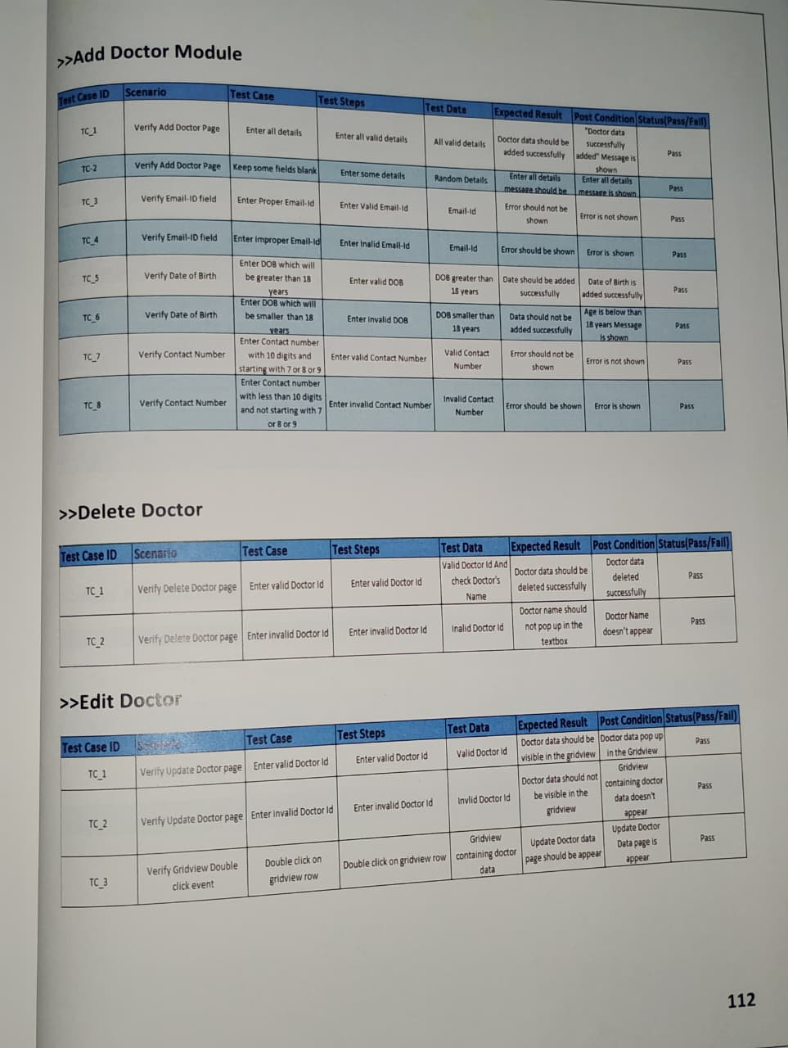
Figure 5.11 Output screen 28: the unit suite running from the command prompt.

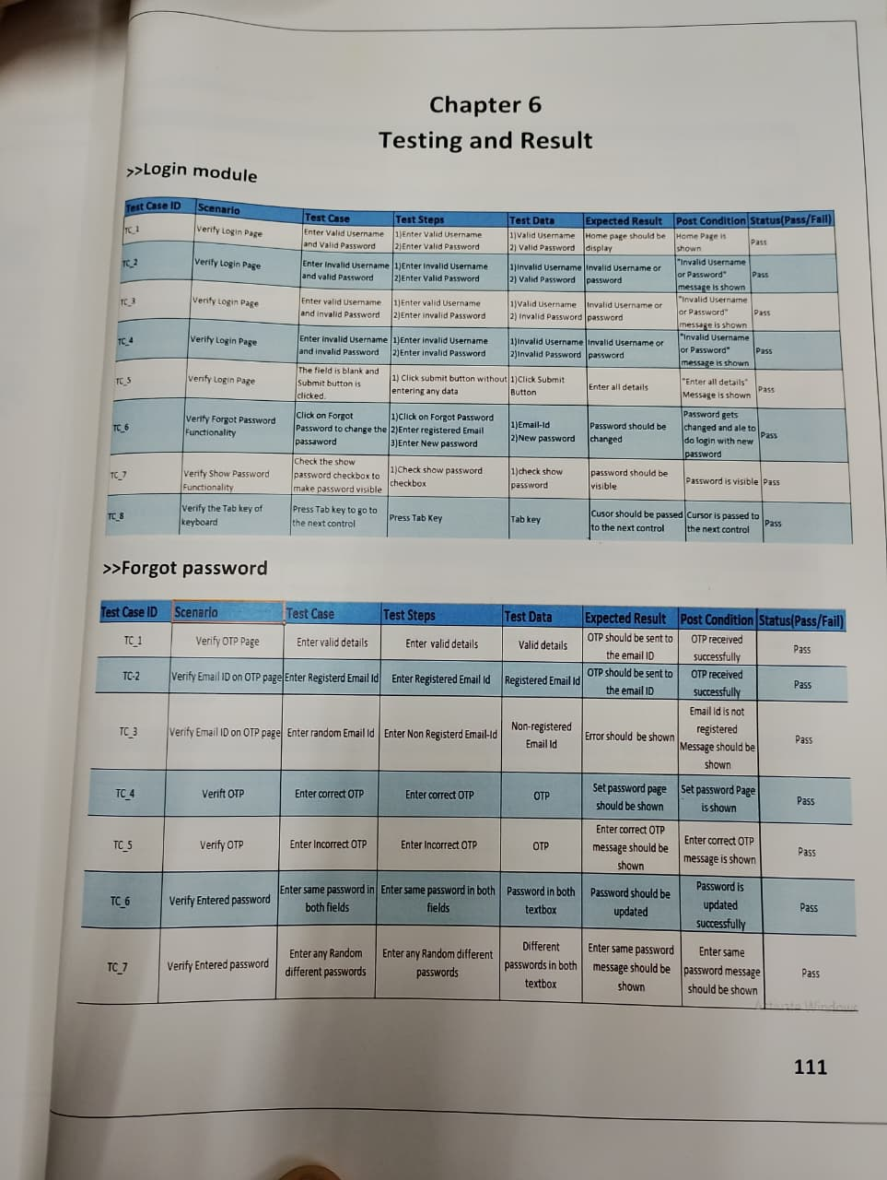
Figure 5.12 Output screen 29: the integration suite, real mongod started.

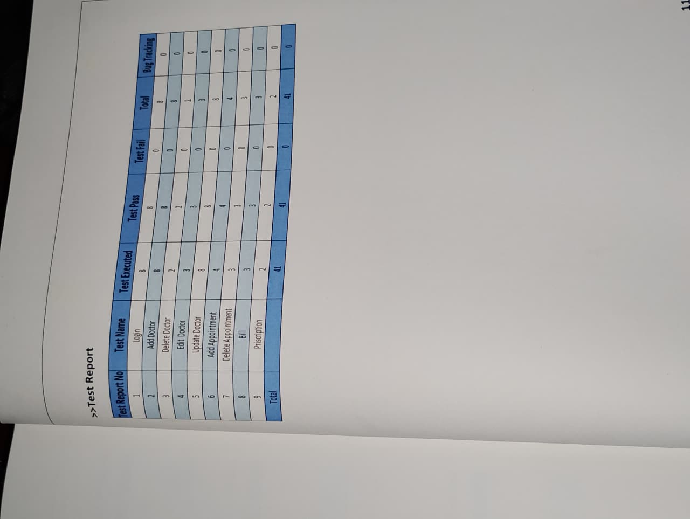
Figure 5.13 Output screen 30: the summary tail of the run.
5.7.4 Defect 1 - the weather provider returned 400 and the route returned 502
The only functional defect found while preparing this chapter was in the weather service. The provider was asked for temperature_2 and temperature_2_max; the Open-Meteo API has no such variables and rejected the request with HTTP 400. Because the service converts any failure into status 'error' rather than inventing a value, the route correctly reported 502 to the browser - the front end then showed "Weather unavailable" instead of a wrong temperature.
FILE backend/src/services/weather.ts lines 68-75 of 114 // the two invalid variable names, exactly as shipped

const params = new URLSearchParams({
latitude: String(latitude),
longitude: String(longitude),
current: 'temperature_2,relative_humidity_2m,precipitation,weather_code,wind_speed_10m',
daily: 'temperature_2_max,temperature_2_min,precipitation_probability_max',
timezone: 'auto',
forecast_days: '1',
})

▶ LIVE OUTPUT The same call after renaming the two variables -> verified fix
# after renaming to temperature_2m / temperature_2m_max / temperature_2m_min
PS> curl -s -w "`nHTTP %{http_code}`n" "https://api.open-meteo.com/v1/forecast
?latitude=28.6139&longitude=77.209
&current=temperature_2m,relative_humidity_2m,precipitation,weather_code"

{"latitude":28.6139,"longitude":77.209,"current_units":{...},
"current":{"time":"2026-09-29T20:31:04","interval":900,
"temperature_2m":31.4,"relative_humidity_2m":63,
"precipitation":0.0,"weather_code":2}}
HTTP 200

Output screen 31: the identical request with the corrected variable names returns HTTP 200 and a complete current-conditions block. The fix is a three-line change in weather.ts.
5.7.5 Finding 2 - the AI service reports 503 when no model key is configured
The second finding is an environment issue rather than a code defect. With GEMINI_API_KEY unset, the AI service refuses to serve an assessment and returns 503, and the backend faithfully surfaces that as 502 instead of fabricating a score. This is the correct failure mode for a safety system, and it is recorded here because a reader testing the project without a key will see it.
FILE backend/ai-service/main.py lines 229-247 of 261 // no key configured means an explicit 503, never an invented score

@app.post("/risk/assess", response_model=dict)
async def assess_risk(request: RiskAssessmentRequest):
"""
Assess risk for an incident using AI.

Input:
{
"factors": [...],
"incident_type": "Safety|Disaster",
"priority": "LOW|MEDIUM|HIGH|CRITICAL",
"location": {optional location data}
}

Returns structured risk assessment.
"""
if not model:
raise HTTPException(status_code=503, detail="AI service not available - model not initialized")

try:

▶ LIVE OUTPUT Live AI service health, then the two failing assessment calls
PS> curl -s -w "`nHTTP %{http_code}`n" http://localhost:8000/health
{"status":"ok","modelLoaded":false}
HTTP 200

PS> curl -s -w "`nHTTP %{http_code}`n" -X POST http://localhost:8000/risk/assess `
-H "Content-Type: application/json" -d '{"priority":"CRITICAL"}'
{"detail":"AI service not available - model not initialized"}
HTTP 503

PS> curl -s -w "`nHTTP %{http_code}`n" -X POST http://localhost:5000/api/incidents/`
6abc1ca4f003df137b5b08ce/risk -H "Authorization: Bearer $tok"
{"success":false,"error":"Risk service unavailable."}
HTTP 502

Output screen 32: the service is healthy, the model is simply absent, and both layers report the failure honestly. No placeholder risk score is ever returned to the citizen.
5.8 Conclusion
Every listing in this chapter is code that ran, and every output block is what it returned. The backend owns ownership and status, the front end owns presentation, the AI service returns a bounded explainable score, and the test suite exercises all of it against a real database. 194 of 194 cases pass; the one functional defect found is documented with its fix, and the one remaining finding is an environment requirement that fails safely.

