CHAPTER 3 REQUIREMENT AND ANALYSIS
3.1 Requirement Analysis
Requirement analysis defines the users, functions, resources and requirements of the Raksha system. It supports SOS requests, incident and location information, emergency resources, admin management and centralized data storage. It also covers functional, non-functional, hardware, software and database requirements.
3.2 Problem Definition
Problem Statement
Users may face emergencies such as harassment, accidents, medical emergencies, fire, floods and earthquakes where quick and organized information is required. Administrators may also find it difficult to monitor incidents and maintain updated emergency resources.
Main Problems:
- Lack of a centralized safety platform.
- Difficulty recording and tracking incidents.
- Difficulty finding emergency facilities and resources.
- Lack of organized incident history.
- Difficulty managing emergency resources.
- Lack of centralized admin monitoring.
- Risk of unauthorized access to sensitive data.
- Difficulty maintaining unsafe-area and risk information.
- Difficulty generating useful reports and statistics.
3.2.1 Lack of Centralized Safety Records
Emergency incidents may contain important information such as incident type, description, user information, location, priority and current status.
If this information is not stored systematically, it becomes difficult to retrieve, monitor and analyse later.
Raksha provides a centralized database where authorized application components can store and retrieve emergency incident information.

3.2.2 Difficulty in Sharing Location Information
Location helps identify where an incident occurred. Raksha can request the user’s location and store available latitude and longitude with the incident. Location accuracy depends on device, GPS, network and permission availability. If unavailable, the system does not assume a false location.

3.2.3 Difficulty in Finding Emergency Resources
During an emergency, users may need quick information about hospitals, shelters, police stations, fire stations and relief centres. Raksha keeps these facility details organized, including name, type, address, contact number, location and operational status. Capacity and operating hours can also be maintained where available. The system separately stores information about registered response teams
3.2.4 Difficulty in Monitoring Emergency Incidents
Administrators require a structured method for monitoring emergency incidents.
Raksha provides an administrative dashboard where authorized administrators can:
- View emergency incidents
- View incident details
- View available location information
- Check incident priority
- Check current status
- Assign registered response resources
- Update incident status
- View incident history
- Monitor system activity
The assignment and status features represent software-based coordination and record management. They do not guarantee physical response from external organizations.

3.2.5 Difficulty in Maintaining Incident History
Emergency incidents may require a chronological record for future reference, reporting and analysis.
Raksha maintains incident updates that record important activities such as:
- Incident creation
- Status change
- Assignment
- Progress update
- Resolution
- Closure
- Cancellation
- Administrative comments
3.2.6 Difficulty in Managing Emergency Resources
Hospitals, shelters, police stations, fire stations, relief centres and response teams may have different information.
Raksha therefore separates emergency resources into structured database records. Facilities such as hospitals and shelters are maintained through the Facilities collection, while registered response teams are maintained through the Rescue Teams collection .Administrators can add, edit, activate or deactivate resource information according to their permissions. The application displays stored resource information and does not assume real-time availability unless such information is actually connected to and maintained by a reliable source.

4.1.11 Notification Management

Notifications keep users informed about important system events such as incident creation, acknowledgement, assignment, status change, resolution, cancellation, and system updates.

Supported channels may include In-app, Email, SMS, and WhatsApp, depending on configured services.

Notification records store Incident ID, Contact ID, Channel, Status, Provider Response, Attempt Count, Last Attempt Time, and Created Date.

Possible statuses are QUEUED, SENT, DELIVERED, FAILED, NOT_CONFIGURED, and UNAVAILABLE.
3.3 Proposed Solution
Raksha provides a centralized web application that allows registered users to create emergency incidents and access emergency-resource information.
When an SOS request is submitted, the system creates an incident record and stores the available incident details in the database. If location permission is granted, available location information is associated with the incident.
Administrators can monitor incidents through the administrative dashboard, update incident status, manage facilities and response-team information, and maintain administrative records.
The system can also provide notification functionality through configured communication services. Notification delivery depends on the availability and configuration of the selected provider.
The system may use a Python-based risk assessment service to process available incident and location-related factors and provide a risk score and risk level. The risk assessment is intended as software-based decision support and does not replace professional emergency assessment.
System Limitations
Raksha does not claim to provide
- Automatic police FIR registration
- Guaranteed police response
- Guaranteed ambulance response
- Guaranteed rescue-team response
- Exact rescue ETA
- Guaranteed 24×7 emergency response
- Real-time hospital bed availability without a connected source
- Offline emergency communication unless specifically implemented
Actual emergency response depends on authorized external organizations, service providers, network connectivity and real-world availability.

3.4 Requirements Specification
Requirements specification defines the functions and quality requirements of Raksha.
- The requirements are divided into:
- Functional Requirements
- Non-Functional Requirements
- User Requirements
- System Constraints
- Hardware Requirements
- Software Requirements
- Database Requirements

3.4.1 Functional Requirements
The major functional requirements of Raksha are:
- User registration and login
- User authentication
- Role-based authorization
- User profile management
- Emergency contact management
- SOS and incident creation
- Incident information management
- Location processing
- Emergency facility management
- Rescue-team management
- Rescue assignment management
- Incident status management
- Notification management
- Incident history management
- Unsafe-area reporting
- Risk-zone management
- Risk assessment
- Administrative dashboard
- Analytics and reporting
- Resource search and filtering
- Administrative activity logging
- Secure access to protected information

3.4.1.1 User Authentication and Authorization
The system shall provide authentication so that only registered users can access protected features.
Requirements:
- The system shall allow users to register.
- The system shall allow users to log in.
- The system shall validate login credentials.
- Passwords shall not be stored in plain text.
- Passwords shall be securely hashed.
- The system shall identify the role of the logged-in account.
- Unauthorized users shall not access administrator functions.
- Users shall be able to log out.
- Protected API operations shall require proper authorization.
- Authentication shall use secure token-based access.

3.4.1.2 Role-Based Access Control
Raksha separates system operations according to user roles.
User
- A normal user can:
- Register
- Login
- Logout
- Manage profile
- Manage emergency contacts
- Create emergency incidents
- Share location where available
- View own incidents
- View incident status
- View notifications
- View emergency resources
- Submit unsafe-area reports
- View relevant risk information where provided
Administrator
An administrator can:
- Login securely
- View emergency incidents
- View incident details
- View available locations
- Update incident status
- Manage facilities
- Manage rescue-team records
- Manage rescue assignments
- Review unsafe-area reports
- Manage risk-zone information
- View dashboard statistics
- View reports
- Monitor administrative activity

3.4.1.3 User Profile Management
The system shall provide basic profile functionality.
Users may:
- View profile information
- Update permitted profile information
- Manage account information
- View emergency history
- Manage emergency contacts
- Logout from the application
Only required information should be collected.

3.4.1.4 Emergency Contact Management
The system shall allow users to maintain emergency contact information.
An emergency contact may contain:
- Contact name
- Phone number
- Email address
- Relationship
- SMS notification preference
- Email notification preference
Emergency contact information shall only be accessible to authorized users and system functions.

3.4.1.5 SOS / Emergency Incident Management
SOS management is one of the main functions of Raksha.
When a user submits an SOS or emergency request, the application creates an incident record.
An incident can contain:
- Incident ID
- User ID
- Incident type
- Category
- Description
- Priority
- Location ID
- Current status
- Creation date and time
- Resolution information, where applicable
Incident Types
Examples include:
- Women Safety
- Medical Emergency
- Accident
- Fire
- Flood
- Earthquake
- Other Emergency
Incident Status
The system uses the following detailed workflow:
REPORTED → ACKNOWLEDGED → ASSIGNED → IN_PROGRESS → RESOLVED → CLOSED
An incident may also be marked:
CANCELLED
where applicable.
In the database design, the SOS or emergency request is stored as an Incident record.

3.4.1.6 Location Processing
The system can request location permission from the user's browser or device.
When available, the system may capture:
- Latitude
- Longitude
- Address or location label
- City
- State
- Country
- Location accuracy
- Location capture time
The system shall:
- Request permission where required.
- Capture coordinates when available.
- Associate location data with the relevant incident.
- Handle unavailable location data.
- Avoid creating false location information.
- Restrict access to sensitive location information.
Location accuracy depends on the user's device, browser permissions, GPS/network conditions and configured location services.

3.4.1.7 Emergency Facility Management
Raksha maintains information about emergency facilities.
The Facilities collection may contain:
- Facility name
- Facility type
- Location ID
- Phone number
- Capacity, where maintained
- Operational status
- Operating hours
- Created date
- Updated date

Facility types may include:
- Hospital
- Shelter
- Police Station
- Fire Station
- Relief Centre
The system does not claim real-time bed availability or actual operational response unless such information is connected to a reliable source.

3.4.1.8 Rescue Team Management
The system can maintain records of registered response teams.
A rescue-team record may contain:
- Team name
- Team type
- Contact information
- Email
- Active status
- Service area
- Specialization
Team types may include:
- Police
- Medical
- Fire
- Volunteer
- NGO
The system manages these records as software information and does not guarantee real-world team availability.
3.4.1.9 Rescue Assignment Management
Administrators can create a software-based assignment record between an incident and a registered response team.
The assignment may contain:
- Incident ID
- Team ID
- Assigned by
- Assigned date and time
- Assignment status
- Notes
Assignment status may include:
- ASSIGNED
- EN_ROUTE
- ON_SCENE
- COMPLETED
- CANCELLED
These statuses represent information recorded within the application and should not be interpreted as guaranteed physical movement or response.

3.4.1.10 Incident Status and Monitoring
Administrators can monitor emergency incidents through the dashboard.
The dashboard may display:
- Total incidents
- Reported incidents
- Acknowledged incidents
- Assigned incidents
- In-progress incidents
- Resolved incidents
- Closed incidents
- Cancelled incidents
- Recent incidents
- Incident categories
- Priority information
When an administrator changes an incident status, the system stores the change and can create an incident-update record and notification.

3. 4.1.11 Notification Management

Notifications help users stay updated about important events in the system. They may be sent when an emergency is created, acknowledged, assigned, updated, resolved, or cancelled.
Depending on available services, notifications can be sent through- In-app notifications- Email,SMS, WhatsApp
The system can store basic details such as incident ID, contact, channel, status, attempts, and date. Notification status may be QUEUED, SENT, DELIVERED, FAILED, NOT_CONFIGURED, or UNAVAILABLE.
3.4.1.12 Incident History
Raksha maintains a chronological activity record for incidents.
The history can contain:
- Incident creation
- Status change
- Assignment
- Progress update
- Resolution
- Closure
- Cancellation
- Administrative comment
The Incident Updates collection is used for maintaining this chronological history.

3.4.1.13 Unsafe Area Reporting
Users can report locations that they consider unsafe or risky.
An unsafe-area report may contain:
- Reporter ID
- Location ID
- Category
- Description
- Severity
- Verification status
- Created date
- Updated date
Administrators can review and verify submitted reports.
A user-submitted report should not automatically be treated as a confirmed dangerous location until it has been reviewed according to the implemented workflow.

3.4.1.14 Risk Zone Management
The system can maintain structured information about identified risk zones.
A risk-zone record may contain:
- Zone name
- Risk level
- Geographic boundary
- Risk factors
- Last assessment date
- Active status
Risk-zone information shall be managed according to administrator permissions.

3.4.1.15 Risk Assessment
Raksha can use a Python and Fast API-based risk assessment service to process available information related to an incident or location.
The service may produce:
- Risk score
- Risk level
- Model version
- Input factors
- Assessment time
The risk score may use a range such as 0–100.
Risk levels may include:
- LOW
- MEDIUM
- HIGH
- CRITICAL
Risk assessment is intended to support information analysis. It does not provide guaranteed predictions or replace professional emergency decisions.

3.4.1.16 Disaster Category Management
The system can maintain structured disaster and emergency categories.
A category may contain:
- Category name
- Category code
- Description
- Default priority
- Response-team requirement
- Active status
This allows incident categories to be maintained without modifying the complete application structure.

3.4.1.17 Administrative Dashboard
The administrative dashboard provides a central management interface.
It can display:
- Total users
- Total incidents
- Reported incidents
- Active incidents
- Resolved incidents
- Cancelled incidents
- Available facilities
- Registered rescue teams
- Recent activities
- Notifications
- Basic statistics
Dashboard information shall be generated from actual stored system data.

3.4.1.18 Analytics and Reporting
The system can generate basic analytics from stored data.
Examples include:
- Number of incidents
- Incidents by type
- Incidents by priority
- Incidents by status
- Monthly incident count
- Number of facilities
- Number of shelters
- Number of registered response teams
- Unsafe-area reports
- Risk-level distribution
Analytics represent stored application data and should not be presented as guaranteed predictions of future emergencies.

3.4.1.19 Resource Search
Users can search and filter emergency resources.
Filtering may be based on:
- Resource type
- Facility name
- Area
- Location
- Service category
- Operational status
Where a configured map service is available, location-based information may also be displayed through a map interface.

3.4.1.20 Administrative Activity Logging
Administrative actions should be recorded for accountability.
An administrative log may contain:
- Administrator ID
- Action
- Target type
- Target ID
- Action details
- IP address, where collected
- Date and time
Administrative logs should be accessible only to authorized administrators.
3.4.1.21 Data Management
The system shall maintain structured records for:
- Users
- Emergency Contacts
- Incidents
- Locations
- Notifications
- Rescue Teams
- Rescue Assignments
- Incident Updates
- Unsafe Area Reports
- Risk Zones
- Risk Assessments
- Facilities
- Disaster Categories
- Administrative Logs
- Reports
Database operations shall be performed through authorized backend APIs.
3.4.2 Non-Functional Requirements
The major non-functional requirements are:
- Security
- Performance
- Usability
- Responsiveness
- Reliability
- Scalability
- Maintainability
- Compatibility
- Data Integrity
- Availability
3.4.2.1 Security
The system shall protect:
- User accounts
- Passwords
- Emergency incidents
- Location information
- Emergency contacts
- Administrative information
- Risk-related information

JWT-based authorization and secure password hashing shall be used for protected operations.
3.4.2.2 Performance
Common operations should provide reasonable response time under normal project usage, including:
- Login
- SOS submission
- Resource search
- Dashboard loading
- Status update
- Notification creation
3.4.2.3 Usability
The application should be simple and easy to understand.
Important functions should have clear labels such as:
  - SOS / Emergency
  - Submit Request
  - View Status
  - Find Hospital
  - Find Shelter
  - Emergency Contacts
  - Admin Dashboard
3.4.2.4 Responsiveness
The application should support:
- Desktop
- Laptop
- Tablet
- Mobile phone
The interface should adjust according to screen size.
3.4.2.5 Reliability
After successful submission, the incident should remain stored in the database.
The system should handle failed external services without corrupting the incident record.
3.4.2.6 Scalability
The system should allow additional users, incidents, resources and administrative records without requiring a complete redesign.
3.4.2.7 Maintainability
The application should be divided into logical modules such as:
- Authentication
- User Management
- SOS/Incident Management
- Location
- Facilities
- Rescue Teams
- Notifications
- Risk Assessment
- Administration
- Analytics
3.4.2.8 Compatibility
The web application should work with commonly used modern browsers.
3.4.2.9 Data Integrity
The system should maintain accurate relationships between database records.
For example, an incident should reference a valid user and an available location record where applicable.
3.4.2.10 Availability
The application should remain available when the hosting environment, database, network and required external services are operational.
3.4.3 User Requirements
Raksha mainly supports two primary system roles:
1. User
The user is the person who uses Raksha to create emergency incidents and access available safety information.
Users shall be able to:
- Register
- Login
- Logout
- Manage profile
- Manage emergency contacts
- Create SOS incidents
- Select incident type
- Enter incident description
- Share location where available
- View incident status
- View incident history
- View notifications
- Search emergency resources
- Submit unsafe-area reports
2. Administrator
The administrator manages system information and monitors emergency incidents.
Administrators shall be able to:
- Login securely
- View incidents
- View incident details
- View available locations
- Update incident status
- Manage facilities
- Manage rescue teams
- Manage assignments
- Review unsafe-area reports
- Manage risk-zone information
- View dashboard statistics
- Generate reports
- Monitor administrative activities
3.4.4 User vs Administrator
Function | User | Administrator
Register | Yes | Usually pre-created
Login | Yes | Yes
Manage Profile | Yes | Limited
Create SOS | Yes | Optional
View Own Incidents | Yes | Yes
View All Incidents | No | Yes
Update Incident Status | No | Yes
Manage Facilities | No | Yes
Manage Rescue Teams | No | Yes
Create Assignments | No | Yes
View Notifications | Yes | Yes
Submit Unsafe Area Report | Yes | Yes
Verify Reports | No | Yes
Manage Risk Zones | No | Yes
View Dashboard | Limited | Yes
Analytics | Limited | Yes
Generate Reports | No/Limited | Yes
3.4.5 System Constraints
The following constraints apply to Raksha:
- The system requires internet connectivity for normal web-based functionality.
- Location functionality depends on browser/device permission.
- Location accuracy depends on the device and available location services.
- Map functionality depends on the configured map service.
- External email, SMS and WhatsApp services depend on provider availability and configuration.
- Database availability affects application functionality.
- Hosting performance affects response time.
- Unauthorized users must not access protected information.
- Location information must be protected.
- Emergency response cannot be guaranteed by the software.
- Automatic police FIR generation is not assumed.
- Exact rescue ETA is not assumed.
- 24×7 police or ambulance integration is not assumed unless actually implemented.
- Real-time hospital bed availability is not assumed unless connected to a reliable source.
- Offline emergency functionality is not assumed unless specifically implemented.
- Risk assessment results are software-generated decision-support information and are not guaranteed predictions.
- Notification delivery depends on configured external communication providers.
3.4.6 Hardware Requirements
Raksha does not require specialized hardware.
Component/hardware | Requirement
Processor | Intel Core i5 / AMD Ryzen 5 or equivalent
RAM | Minimum 8 GB
Storage | Minimum 256 GB SSD
Display | 1080p or higher recommended
Network | Stable Internet connection
Development Device | Normal laptop or desktop
Mobile Device | Smartphone with location capability recommended
3.4.7 Software Requirements
The final software stack should reflect the technologies actually used in the implemented project.
Component | Technology
Frontend | React.js
Frontend Language | TypeScript
Build Tool | Vite
Styling | Tailwind CSS
Backend Runtime | Node.js
Backend Framework | Express.js
API Architecture | REST API
AI Backend | Python
AI Framework | FastAPI
AI Integration | Configured AI Service API
Database | MongoDB/superbase
ODM | Mongoose
Authentication | JSON Web Token (JWT)
Password Security | bcrypt
Location | Browser/Device Geolocation API
Maps | Configured Map Service
Communication | Configured Email/SMS/WhatsApp Providers
Development Environment | Visual Studio Code, Bolt
Version Control | Git, GitHub
Testing | Jest / Supertest, where implemented
Deployment | Configured Cloud Hosting Environment
3.4.8 Database Requirement and Collection Mapping
Raksha uses MongoDB for storing application data. Mongoose can be used at the application layer to define schemas and validate database records.
MongoDB does not use traditional relational foreign keys in the same way as a relational database. Therefore, relationships between records are maintained through application-level references and validation.
The proposed database contains the following collections:
No. | Collection | Purpose
1 | Users | User accounts and profile information
2 | EmergencyContacts | User emergency contacts
3 | Incidents | SOS and emergency incident records
4 | Locations | Geographic location information
5 | Notifications | Notification records and delivery status
6 | RescueTeams | Registered response-team information
7 | RescueAssignments | Incident-to-team assignment records
8 | IncidentUpdates | Incident history and status updates
9 | UnsafeAreaReports | User-submitted unsafe-area reports
10 | RiskZones | Structured risk-zone information
11 | RiskAssessments | Risk scores and assessment results
12 | Facilities | Hospitals, shelters, police/fire stations and relief centres
13 | DisasterCategories | Emergency/disaster categories
14 | AdminLogs | Administrative activity records
15 | Reports | Generated reports and analytics records

3.5.1 Planning and Scheduling
Sr. No. | Project Activity | Start Date | End Date | Duration | Project Done By
1 | Project Planning & Requirements | 15-Jun-2026 | 22-Jun-2026 | 8 Days | Vivek & Vaibhav – Topic selection, planning and requirements
2 | System Analysis & Design | 23-Jun-2026 | 28-Jun-2026 | 6 Days | Vivek – System flow; Vaibhav – UML and design
3 | Database Design | 29-Jun-2026 | 03-Jul-2026 | 5 Days | Vivek – Database structure; Vaibhav – Collections and fields
4 | UI & Frontend Design | 04-Jul-2026 | 27-Jul-2026 | 24 Days | Vivek – User interface; Vaibhav – Admin interface
5 | Backend Development | 09-Jul-2026 | 25-Jul-2026 | 17 Days | Vivek – APIs; Vaibhav – Backend and database connection
6 | SOS & Location Module | 28-Jul-2026 | 03-Aug-2026 | 7 Days | Vivek – SOS; Vaibhav – Location features
7 | Emergency & Rescue Modules | 04-Aug-2026 | 14-Aug-2026 | 11 Days | Vivek – Resource search; Vaibhav – Rescue team and assignments
8 | Risk & Disaster Management | 15-Aug-2026 | 21-Aug-2026 | 7 Days | Vivek & Vaibhav – Risk zones, assessment and disaster features
9 | Admin Dashboard & Integration | 22-Aug-2026 | 03-Sep-2026 | 13 Days | Vivek – System support; Vaibhav – Dashboard; Both – Integration
10 | Testing & Debugging | 04-Sep-2026 | 11-Sep-2026 | 8 Days | Vivek & Vaibhav – Testing and error fixing
11 | Documentation & Final Review | 12-Sep-2026 | 27-Sep-2026 | 16 Days | Vivek – Requirements; Vaibhav – Design; Both – Final review
12 | Final Corrections, Deployment & Submission | 28-Sep-2026 | 30-Sep-2026 | 3 Days | Vivek & Vaibhav – Final corrections, deployment and submission

3.5.1 Gantt Chart
The Gantt Chart shows the planned schedule of the Raksha project, including requirement analysis, system design, development, database implementation, testing, documentation, and final deployment. It helps monitor the progress and completion of each project activity.
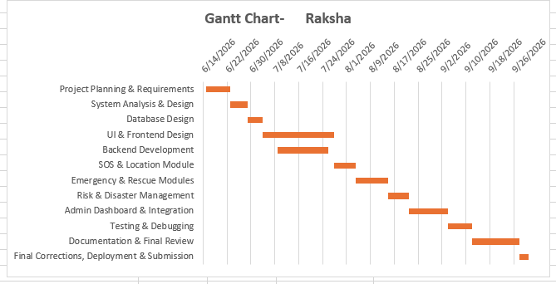

3.5.2PERT CHART
PERT (Program Evaluation and Review Technique) is used to estimate the time required to complete the Raksha – Women Safety and Disaster Management System. It represents the major project activities in a network form and shows the sequence in which the activities are carried out.
Optimistic Time (O): Minimum expected time
Most Likely Time (M): Normal expected time
Pessimistic Time (P): Maximum expected time
Expected Time is calculated as:
TE = (O + 4M + P) / 6
Standard Deviation:
S.D. = (P − O) / 6
PERT Time Estimation Table – RAKSHA

Task | Project Activity | Optimistic Time (O) | Most Likely Time (M) | Pessimistic Time (P) | Expected Time (TE) | S.D.
T1 | Project Planning & Requirements | 6 | 8 | 10 | 8.00 | 0.67
T2 | System Analysis & Design | 5 | 6 | 8 | 6.17 | 0.50
T3 | Database Design | 4 | 5 | 6 | 5.00 | 0.33
T4 | UI & Frontend Design | 20 | 24 | 28 | 24.00 | 1.33
T5 | Backend Development | 14 | 17 | 20 | 17.00 | 1.00
T6 | SOS & Location Module | 6 | 7 | 9 | 7.17 | 0.50
T7 | Emergency & Rescue Modules | 9 | 11 | 13 | 11.00 | 0.67
T8 | Risk & Disaster Management | 6 | 7 | 9 | 7.17 | 0.50
T9 | Admin Dashboard & Integration | 11 | 13 | 15 | 13.00 | 0.67
T10 | Testing & Debugging | 6 | 8 | 10 | 8.00 | 0.67
T11 | Documentation & Final Review | 14 | 16 | 18 | 16.00 | 0.67
T12 | Final Corrections, Deployment & Submission | 2 | 3 | 4 | 3.00 | 0.33

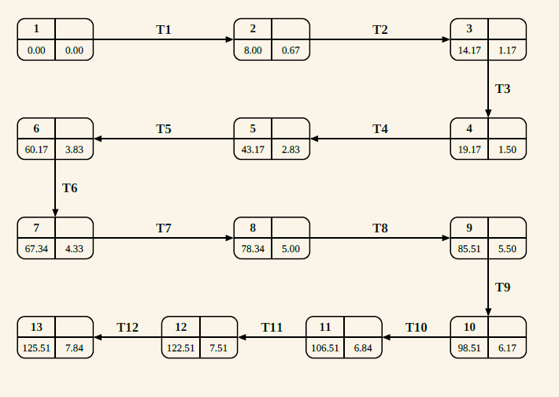

3.6 Conceptual Models
The conceptual model of Raksha Safe shows how the main parts of the system work together. A user can register, add emergency contacts, report an emergency, and use the SOS feature. The system stores the incident and available location details, and shows nearby rescue resources such as police, hospitals, fire services, and volunteers. The AI module provides a basic risk assessment to support the emergency process. The admin manages incidents, users, rescue teams, assignments, notifications, and reports. Overall, the model shows how information moves between the user, system, AI module, rescue resources, and admin.
3.6.1 ER Diagram

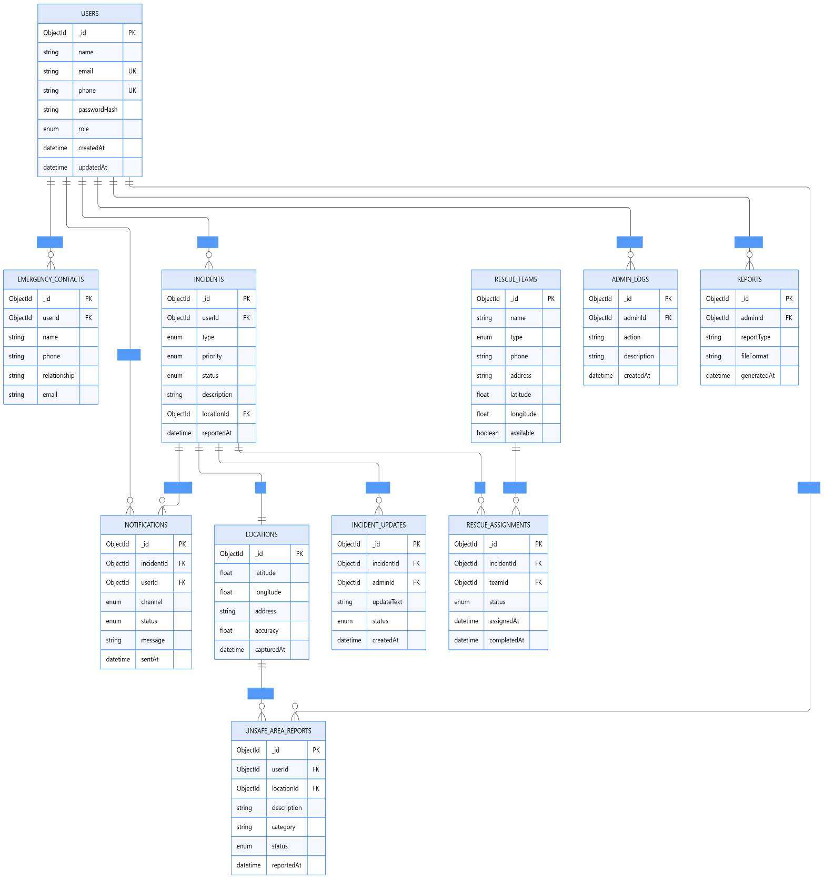
3.6.2 Data Dictionary
The Data Dictionary describes the fields, data types and constraints of the major MongoDB collections used in the Raksha – Women Safety and Disaster Management System. The system contains 15 main collections for managing users, emergency incidents, locations, notifications, rescue resources, risk information, administrative activities and reports.
1. Users
Sr. No. | Field | Type | Constraint
1 | _id | ObjectId | Primary Key, Auto-generated
2 | Name | String | Required
3 | Email | String | Required, Unique
4 | phone | String | Required, Unique
5 | passwordHash | String | Required, Hashed
6 | Role | String | Required, Enum: USER / ADMIN
7 | language | String | Optional
8 | createdAt | Date | Auto-generated
9 | updatedAt | Date | Auto-generated
2. Emergency Contacts
Sr. No. | Field | Type | Constraint
1 | _id | ObjectId | Primary Key, Auto-generated
2 | userId | ObjectId | Reference → Users
3 | Name | String | Required
4 | Phone | String | Required
5 | Email | String | Optional
6 | relationship | String | Optional
7 | notifyViaSms | Boolean | Required
8 | notifyViaEmail | Boolean | Required
9 | createdAt | Date | Auto-generated
10 | updatedAt | Date | Auto-generated
3. Incidents

Sr. No. | Field | Type | Constraint
1 | _id | ObjectId | Primary Key, Auto-generated
2 | userId | ObjectId | Reference → Users
3 | Type | String | Required, Safety / Disaster
4 | category | String | Required
5 | description | String | Required
6 | priority | String | Required, LOW / MEDIUM / HIGH / CRITICAL
7 | status | String | Required, Enum
8 | locationId | ObjectId | Reference → Locations, Optional
9 | createdAt | Date | Auto-generated
10 | resolvedAt | Date | Optional

4. Locations.
Sr. No. | Field | Type | Constraint
1 | _id | ObjectId | Primary Key, Auto-generated
2 | latitude | Number | Required
3 | longitude | Number | Required
4 | address | String | Optional
5 | City | String | Optional
6 | state | String | Optional
7 | country | String | Optional
8 | accuracy | Number | Optional
9 | createdAt | Date | Auto-generated
10 | updatedAt | Date | Auto-generated

5. Notifications
Sr. No. | Field | Type | Constraint
1 | _id | ObjectId | Primary Key, Auto-generated
2 | incidentId | ObjectId | Reference → Incidents
3 | contactId | ObjectId | Reference → EmergencyContacts, Optional
4 | channel | String | Required, Email / SMS / WhatsApp / In-App
5 | Status | String | Required, Enum
6 | providerResponse | String | Optional
7 | attemptCount | Number | Required
8 | lastAttemptAt | Date | Optional
9 | createdAt | Date | Auto-generated
10 | updatedAt | Date | Auto-generated
6. RescueTeams

Sr. No. | Field | Type | Constraint
1 | _id | ObjectId | Primary Key, Auto-generated
2 | name | String | Required
3 | teamType | String | Required, Police / Medical / Fire / NGO / Volunteer
4 | phone | String | Required
5 | email | String | Optional
6 | isActive | Boolean | Required
7 | specializations | Array | Optional
8 | createdAt | Date | Auto-generated
9 | updatedAt | Date | Auto-generated
7. RescueAssignments

Sr. No. | Field | Type | Constraint
1 | _id | ObjectId | Primary Key, Auto-generated
2 | incidentId | ObjectId | Reference → Incidents
3 | teamId | ObjectId | Reference → RescueTeams
4 | assignedBy | ObjectId | Reference → Users
5 | assignedAt | Date | Auto-generated
6 | status | String | Required, Enum
7 | notes | String | Optional
8 | createdAt | Date | Auto-generated
9 | updatedAt | Date | Auto-generated
8. IncidentUpdates

Sr. No. | Field | Type | Constraint
1 | _id | ObjectId | Primary Key, Auto-generated
2 | incidentId | ObjectId | Reference → Incidents
3 | updatedBy | ObjectId | Reference → Users
4 | statusFrom | String | Optional
5 | statusTo | String | Required
6 | comment | String | Optional
7 | createdAt | Date | Auto-generated

9. UnsafeAreaReports
Sr. No. | Field | Type | Constraint
1 | _id | ObjectId | Primary Key, Auto-generated
2 | reportedBy | ObjectId | Reference → Users
3 | locationId | ObjectId | Reference → Locations
4 | category | String | Required
5 | description | String | Required
6 | severity | String | Required
7 | isVerified | Boolean | Required
8 | createdAt | Date | Auto-generated
9 | updatedAt | Date | Auto-generated

10. RiskZones
Sr. No. | Field | Type | Constraint
1 | _id | ObjectId | Primary Key, Auto-generated
2 | name | String | Required
3 | riskLevel | String | Required
4 | geometry | Object | Required
5 | factors | Array | Optional
6 | lastAssessedAt | Date | Optional
7 | isActive | Boolean | Required
8 | createdAt | Date | Auto-generated
9 | updatedAt | Date | Auto-generated
11. RiskAssessments
Sr. No. | Field | Type | Constraint
1 | _id | ObjectId | Primary Key, Auto-generated
2 | locationId | ObjectId | Reference → Locations
3 | riskScore | Number | Required, Range: 0–100
4 | riskLevel | String | Required, LOW / MEDIUM / HIGH / CRITICAL
5 | modelVersion | String | Required
6 | inputFactors | Array | Optional
7 | assessedAt | Date | Auto-generated
8 | createdAt | Date | Auto-generated

12. Facilities
Sr. No. | Field | Type | Constraint
1 | _id | ObjectId | Primary Key, Auto-generated
2 | name | String | Required
3 | facilityType | String | Required, Enum
4 | locationId | ObjectId | Reference → Locations
5 | phone | String | Required
6 | capacity | Number | Optional
7 | isOperational | Boolean | Required
8 | operatingHours | String | Optional
9 | createdAt | Date | Auto-generated
10 | updatedAt | Date | Auto-generated

13. Disaster Categories
Sr. No. | Field | Type | Constraint
1 | _id | ObjectId | Primary Key, Auto-generated
2 | Name | String | Required
3 | Code | String | Required, Unique
4 | description | String | Optional
5 | defaultPriority | String | Required
6 | requiresResponseTeam | Boolean | Required
7 | isActive | Boolean | Required
8 | createdAt | Date | Auto-generated
9 | updatedAt | Date | Auto-generated
14. AdminLogs
Sr. No. | Field | Type | Constraint
1 | _id | ObjectId | Primary Key, Auto-generated
2 | adminId | ObjectId | Reference → Users
3 | action | String | Required
4 | targetType | String | Required
5 | targetId | ObjectId | Optional
6 | details | String | Optional
7 | ipAddress | String | Optional
8 | createdAt | Date | Auto-generated
15. Reports
Sr. No. | Field | Type | Constraint
1 | _id | ObjectId | Primary Key, Auto-generated
2 | generatedBy | ObjectId | Reference → Users
3 | Title | String | Required
4 | reportType | String | Required
5 | filters | Object | Optional
6 | dataSnapshot | Object | Optional
7 | format | String | Required, PDF / CSV / JSON
8 | createdAt | Date | Auto-generated
9 | expiresAt | Date | Optional

3.6.3 DFD LEVEL 0 — CONTEXT DIAGRAM
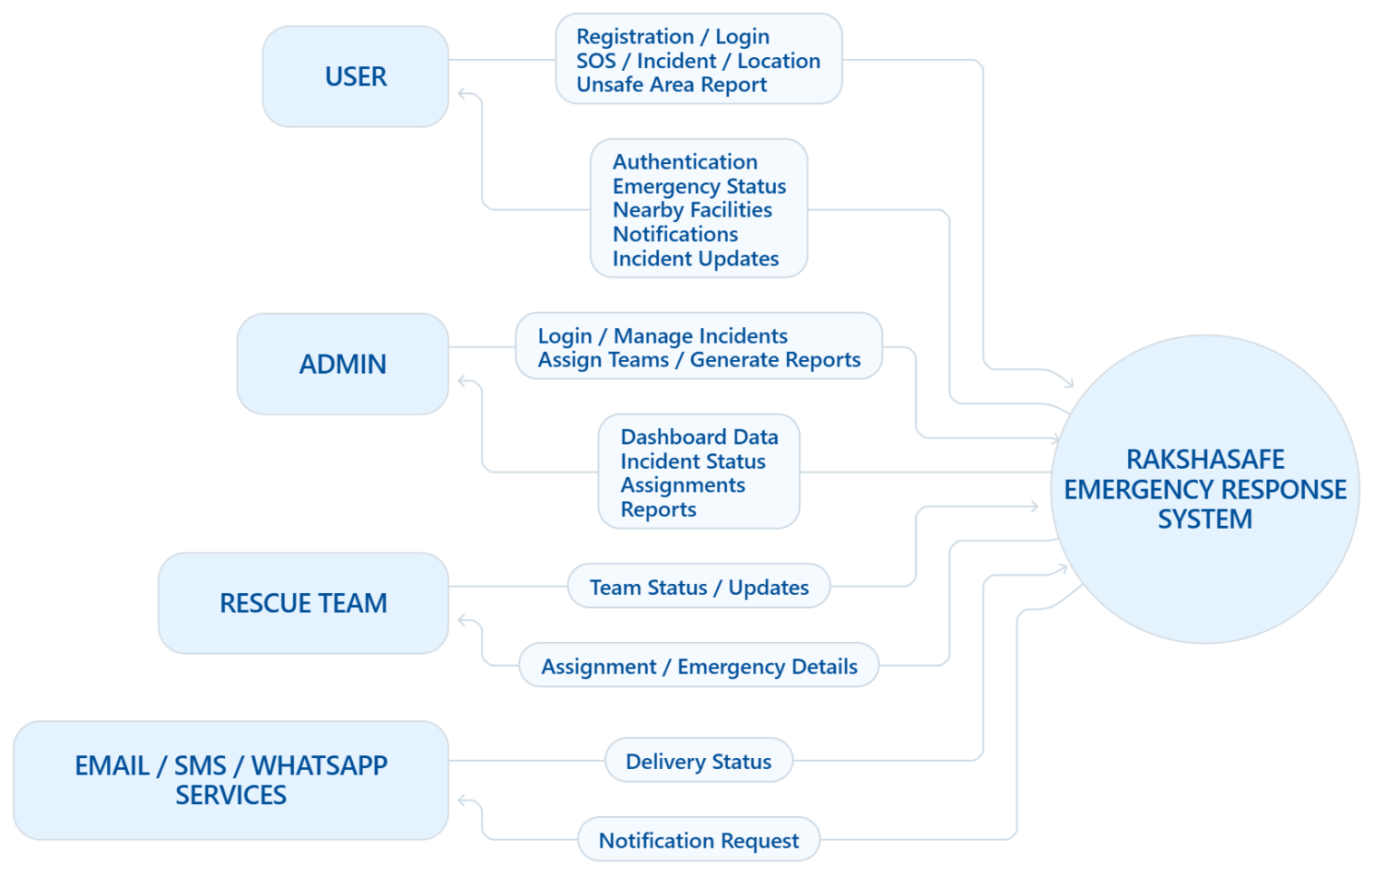

DFD LEVEL 1 — MAIN MODULES
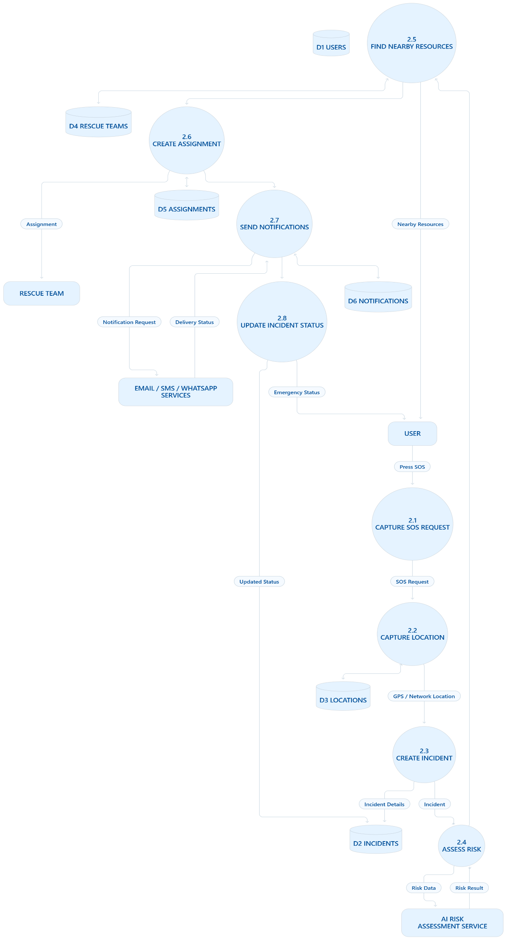

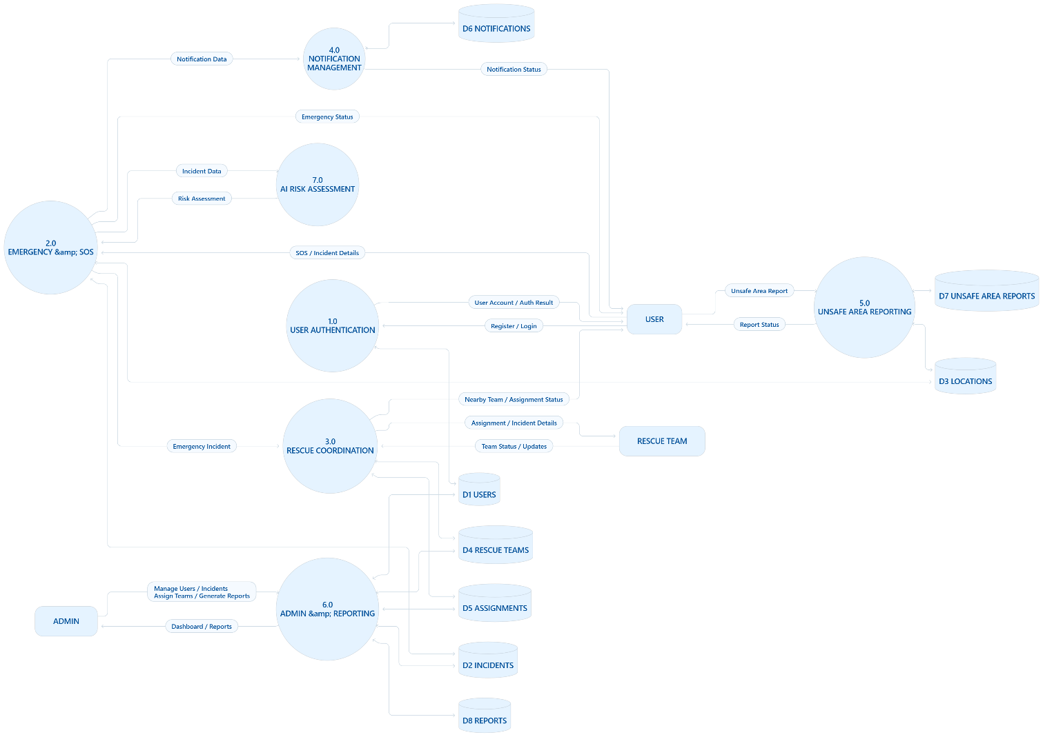
DFD LEVEL 2 — SOS / EMERGENCY PROCESS

