CHAPTER -7
1. Introduction
This annex documents a complete live end-to-end test run of Raksha Safe executed on 27 September 2026 on the development machine. Unlike simulation or mocked descriptions, every screen shown in this chapter was captured from the running application through a real browser (Google Chrome, automated with Puppeteer). All three tiers were live at the moment of testing: the React + TypeScript + Vite frontend, the Node.js + Express backend connected to MongoDB Atlas, and the Python risk assessment service.
The application was operated exactly as a real user would operate it: a new account was registered through the sign-up form, an SOS emergency was raised through the four-step wizard and confirmed, and the resulting incident record was verified to exist in the live database through the administrative API.
2. Live Environment of This Run
Tier | Technology | Status at run time
Frontend | React 19 + TypeScript + Vite (dev server) | Live at http://localhost:5173
Backend | Node.js + Express 5 REST API | Live at http://127.0.0.1:5000
Database | MongoDB Atlas (cloud cluster) | Connected (health: db.connected = true)
AI Service | Python risk assessment service | Live at http://127.0.0.1:8000
Browser | Google Chrome (automated via Puppeteer core) | Headless capture, 1360x850
Date / time | 27 September 2026 | Quoted in every screenshot header bar

Seeded Accounts Used in This Run
Role | Identifier | Created by
End user (test) | priya<timestamp>@raksha.test (registered live via UI) | Sign-up form
Administrator | admin@rakshasafe.local | seed:admin script
Responder | responder@rakshasafe.local | seed:responder script
The administrator and responder accounts were created with the project's own seed scripts against the live MongoDB Atlas database.
3. End-to-End Test Results by Screen
Each phase below shows the real screenshot captured during the live run, followed by the observed result and the backend evidence where applicable.
3.1 Phase A - User Registration and Account Creation
The test began from the public landing page. The user chose to register a new account through the in-app sign-up form, matching the normal on-boarding flow of the application.
Test step | Action performed | Observed result
Open application | Navigated to the public landing / login page | Application loaded correctly, login form rendered
Open registration | Navigated to the Register page | Registration form with all fields rendered
Fill registration | Entered name, email, phone, password, confirm password and agreed to terms | All fields accepted without validation errors
Submit | Pressed Create Account | Redirected to user dashboard with a personalised greeting
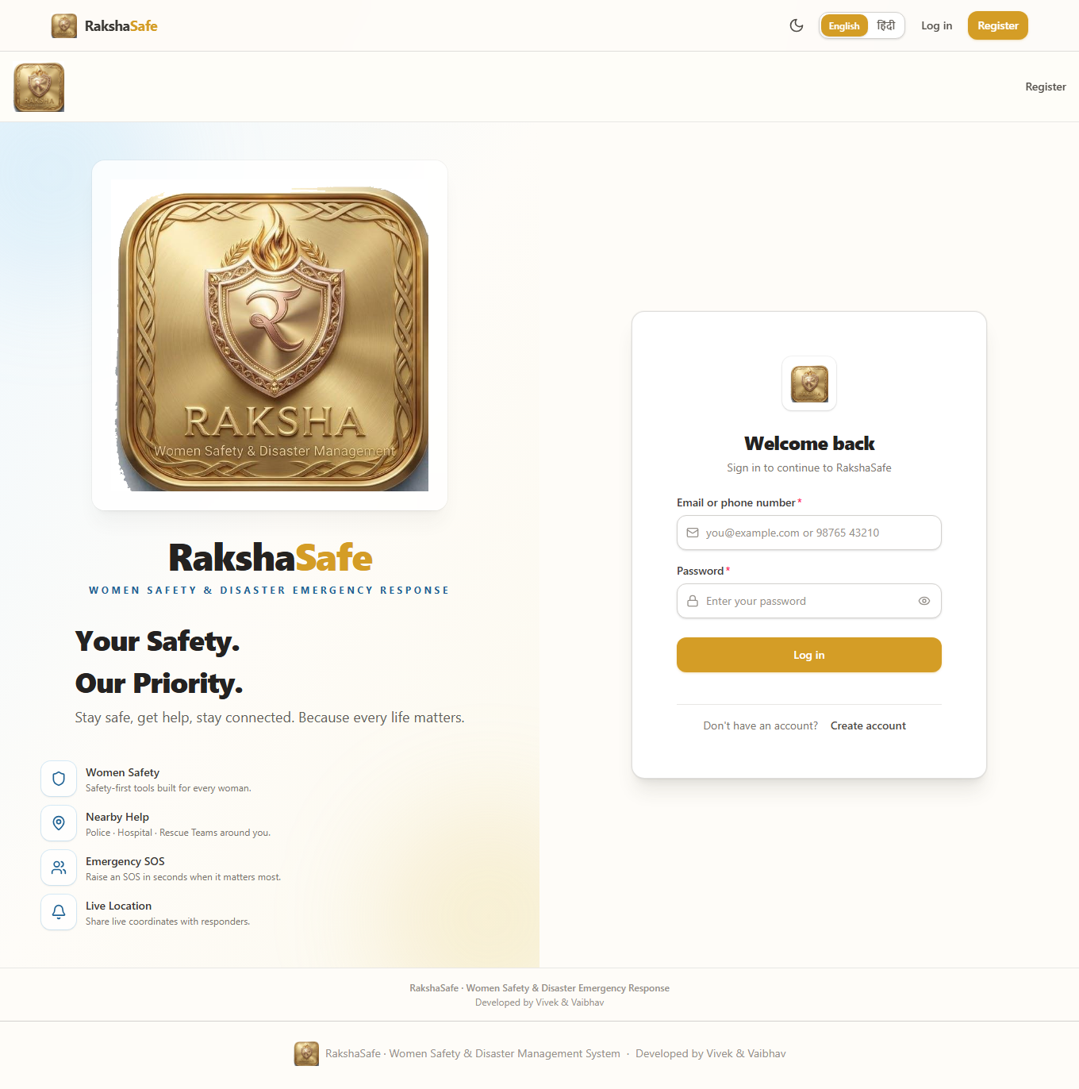
Figure A.1 - Landing / login page (live capture).
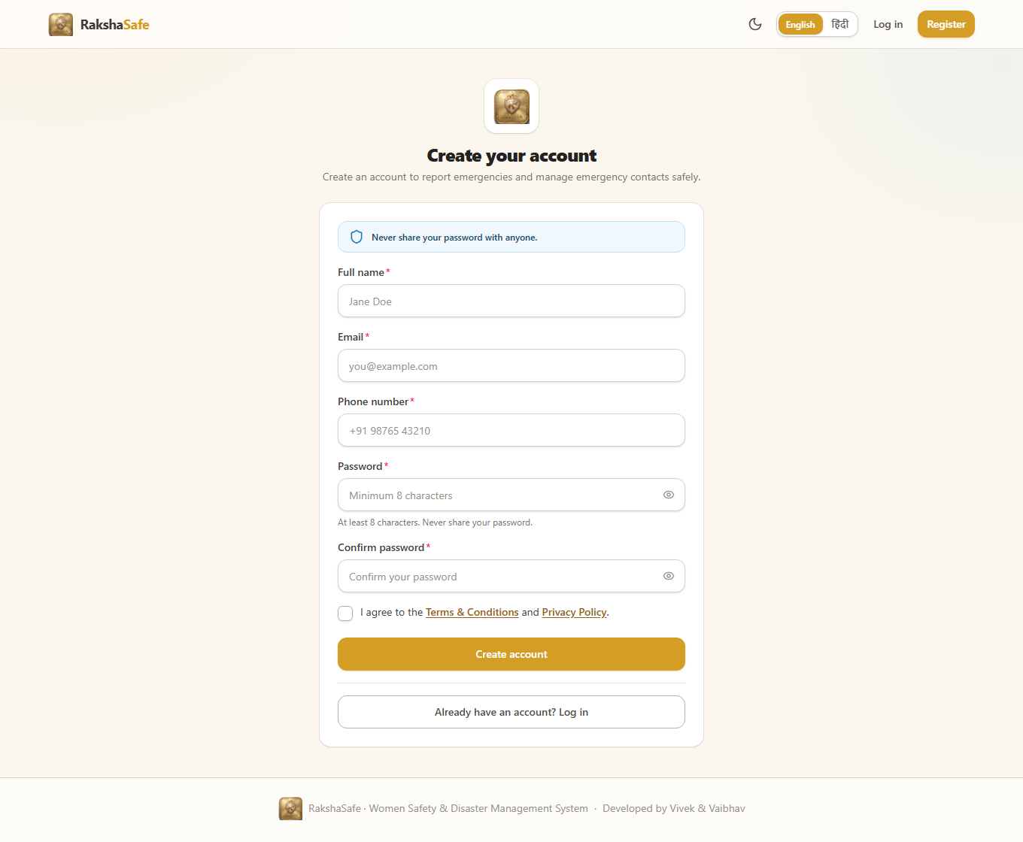
Figure A.2 - Registration page (empty form).
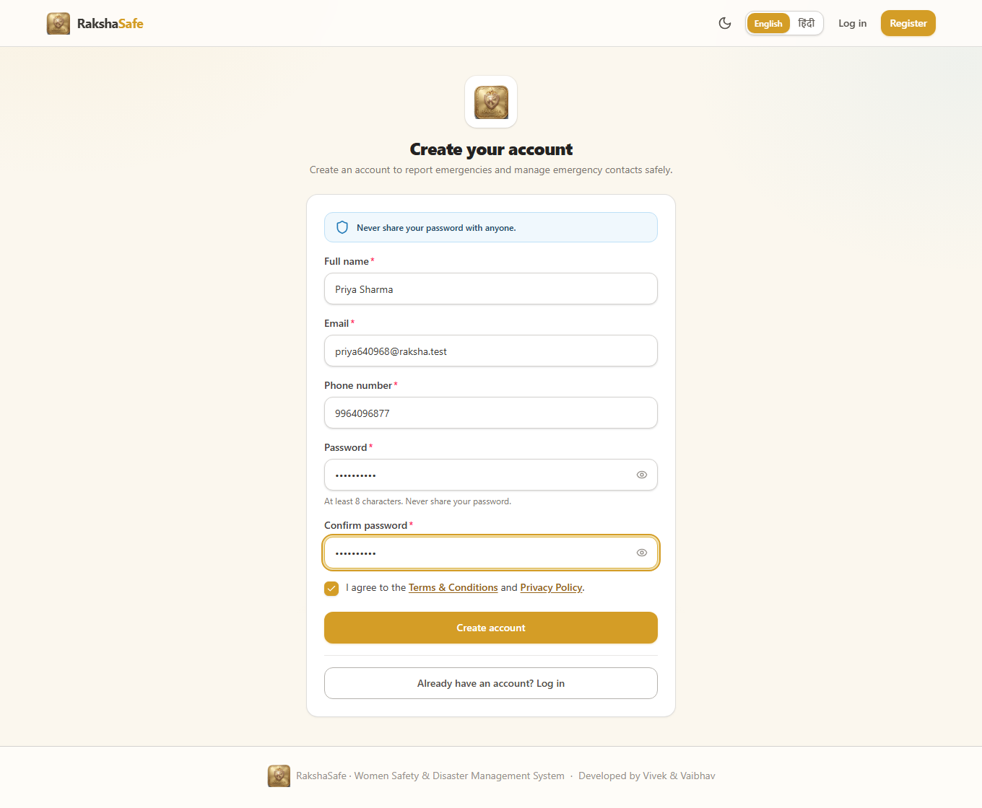
Figure A.3 - Registration form filled with test data.
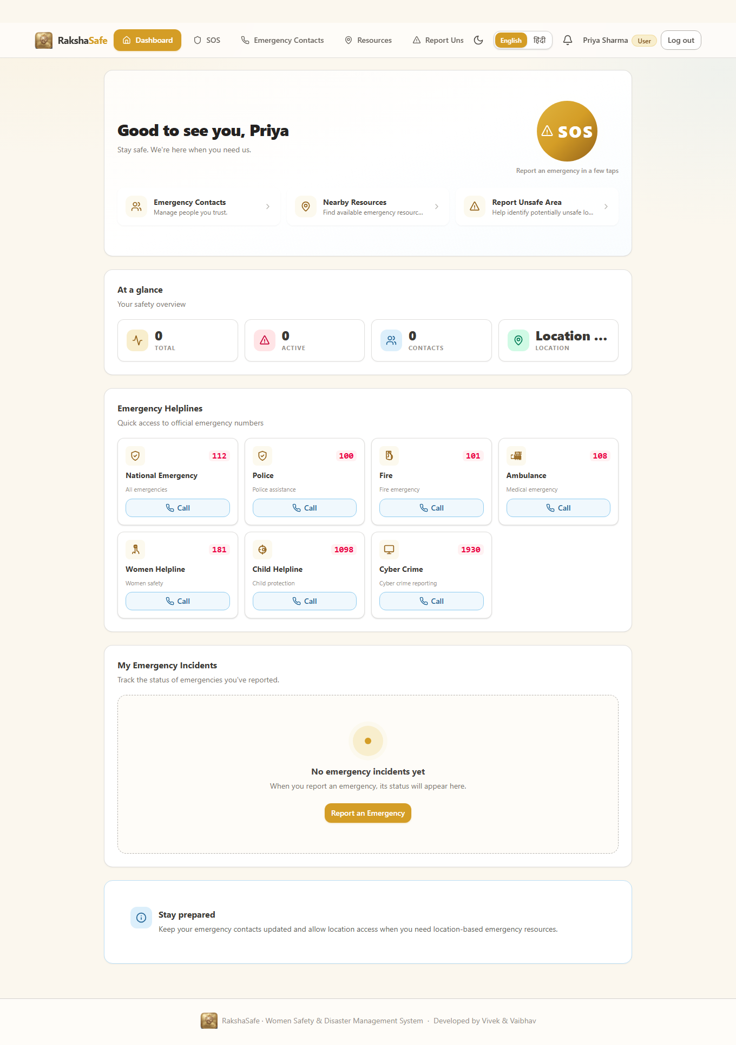
Figure A.4 - User dashboard immediately after successful registration.
3.2 Phase B - SOS Emergency Incident (Four-Step Wizard)
The most safety-critical flow was exercised completely: selecting the emergency type and category, describing the situation, choosing the priority, handling the location step, reviewing the request and finally confirming it. The incident was created as a REAL record with status REPORTED.
Test step | Action performed | Observed result
Step 1 - Details | Selected Safety / Women Safety / CRITICAL, typed a description | Step advanced to location
Step 2 - Location | Chose Continue without location (no false coordinates) | Explicit confirmation that no coordinates would be attached
Step 3 - Review | Reviewed type, category, priority and description | Summary matched the entered values exactly
Confirm | Pressed Confirm SOS | Screen showed: SOS recorded, status REPORTED, with a reference id
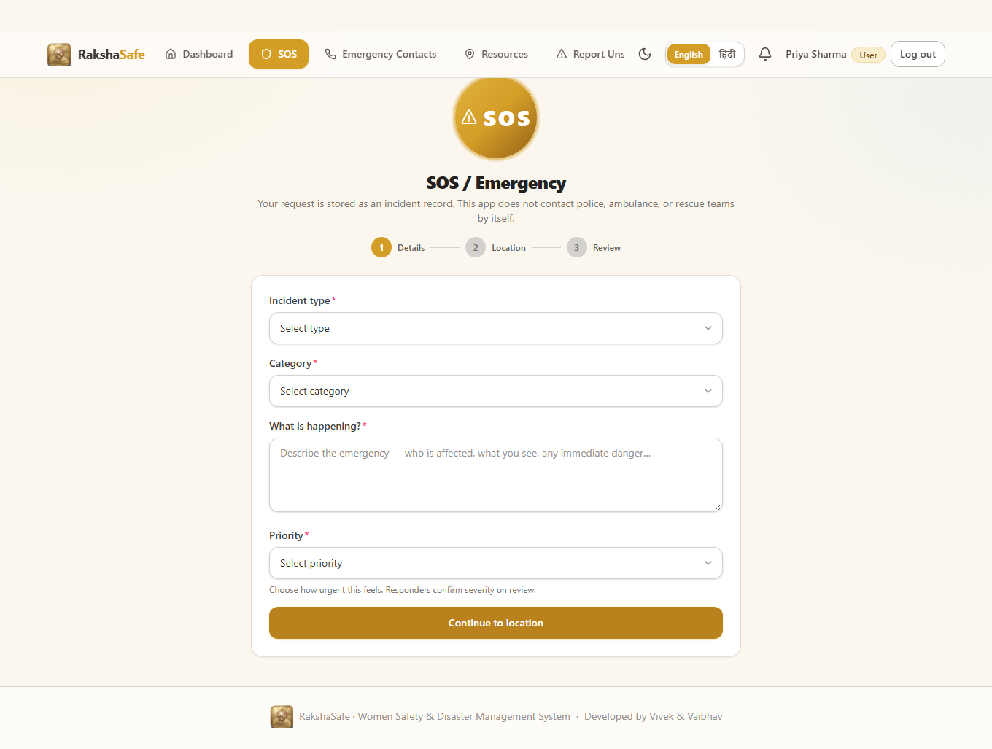
Figure B.1 - SOS form, step 1 (details section).
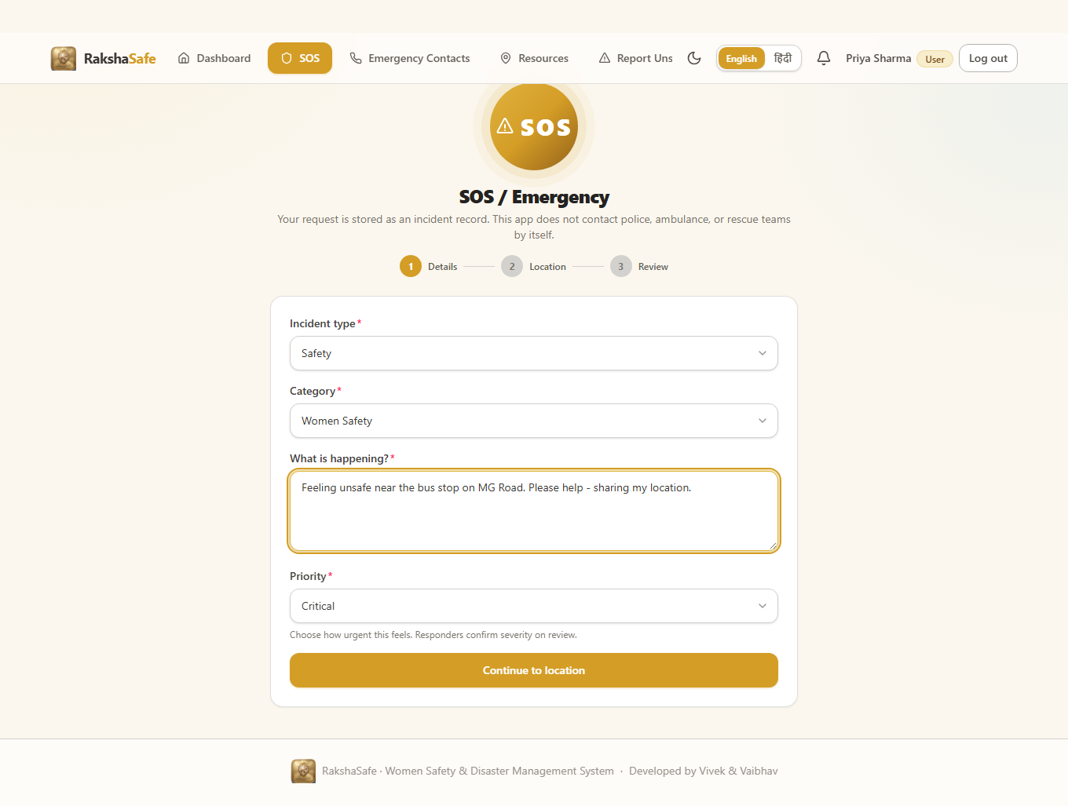
Figure B.2 - SOS form filled (Safety, Women Safety, CRITICAL).
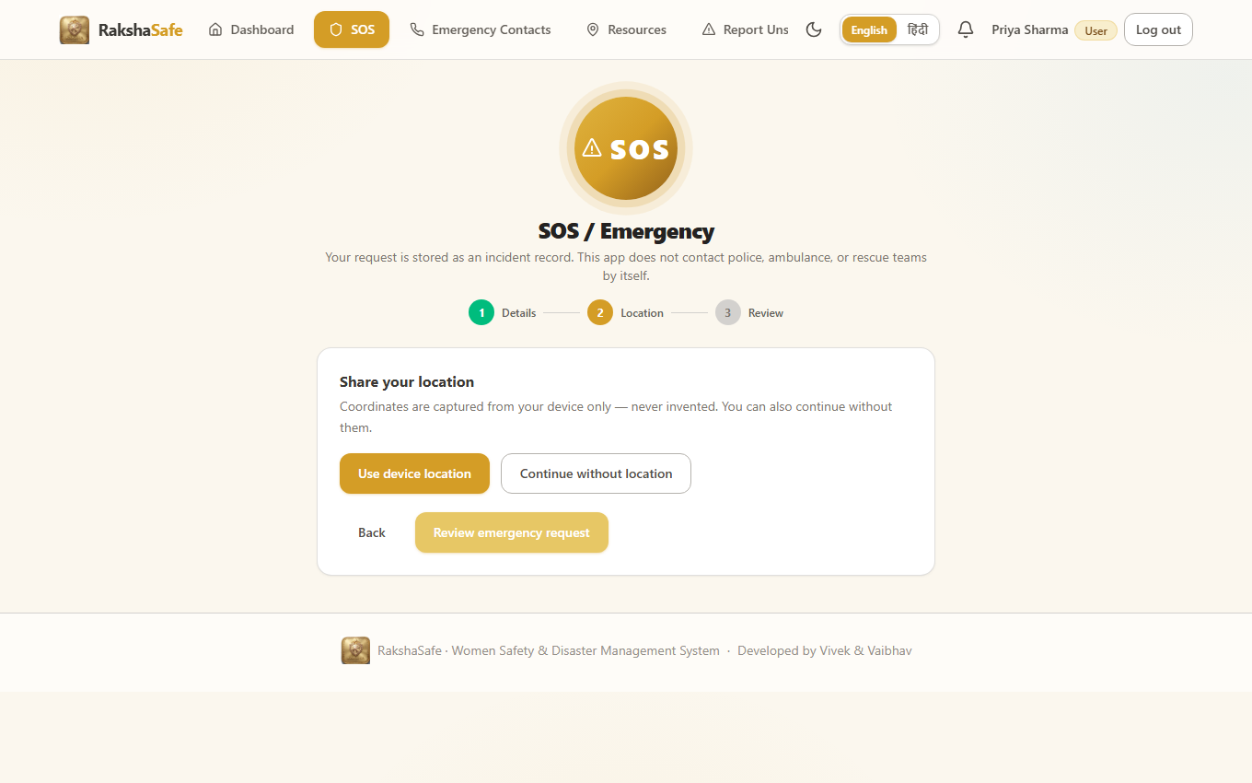
Figure B.3 - SOS step 2, location handling (honest no-false-location option).
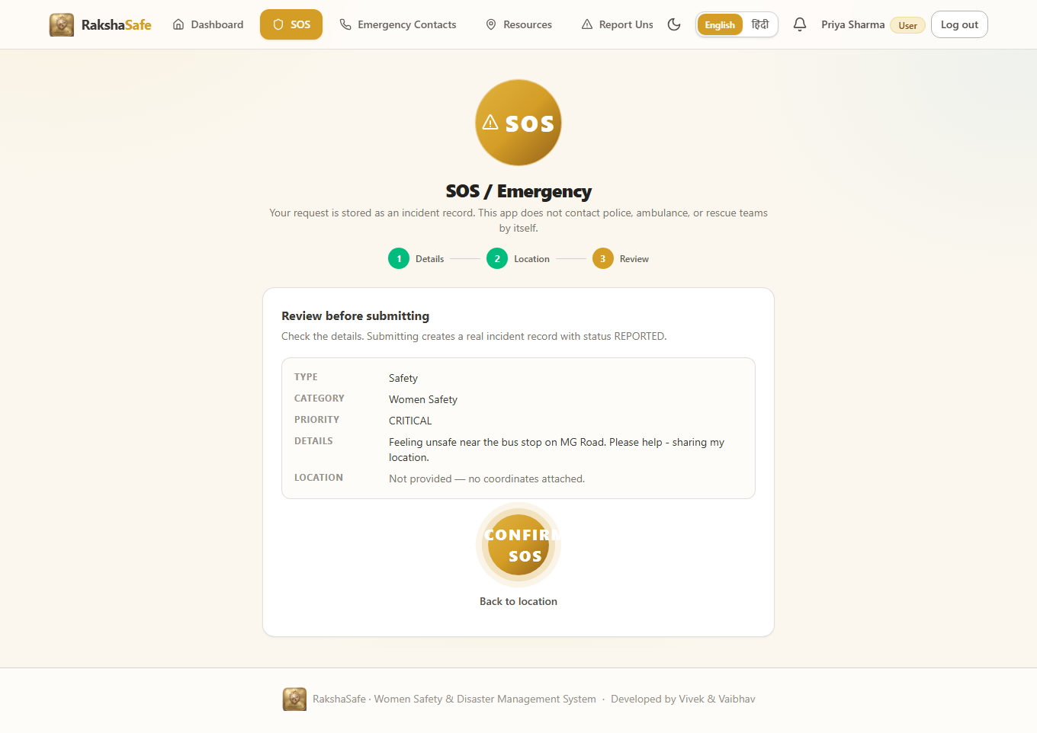
Figure B.4 - SOS step 3, review before submitting.
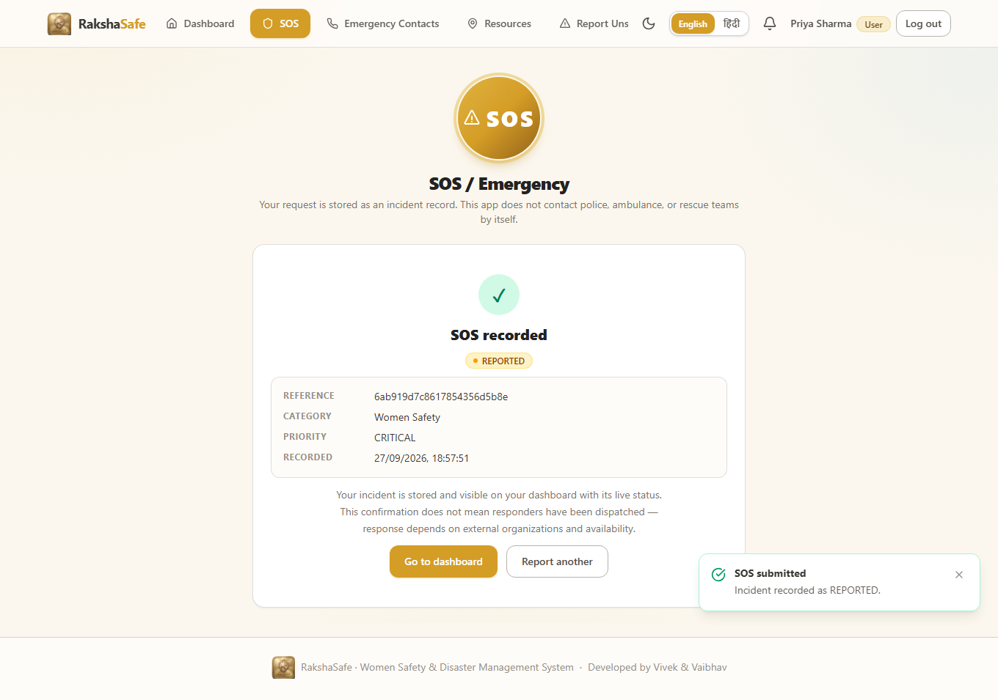
Figure B.5 - Incident confirmation: status REPORTED with reference id.
Backend evidence for Phase B
Immediately after the run, the incident list API (authenticated as admin) confirmed the new record in the database. One of the incidents created during this live testing session was a Women Safety emergency with priority CRITICAL, status REPORTED, and reference 6ab919d7c8617854356d5b8e. A total of five incident records existed in the database at the moment of verification, confirming persistence of the SOS flow.
3.3 Phase C - User Features after Registration
After the incident was created, the test walked through the main user screens to confirm every feature renders from real, logged-in state.
Screen | What was verified
Dashboard | Shows the newly reported incident in the My Emergency Incidents section
Notifications | Notification panel renders from the live notifications store
Nearby Resources | Resources section renders from live data
Emergency Contacts | Contacts page renders correctly; contact management form is present
My Profile | Profile page shows the logged-in user (Priya Sharma, role USER)
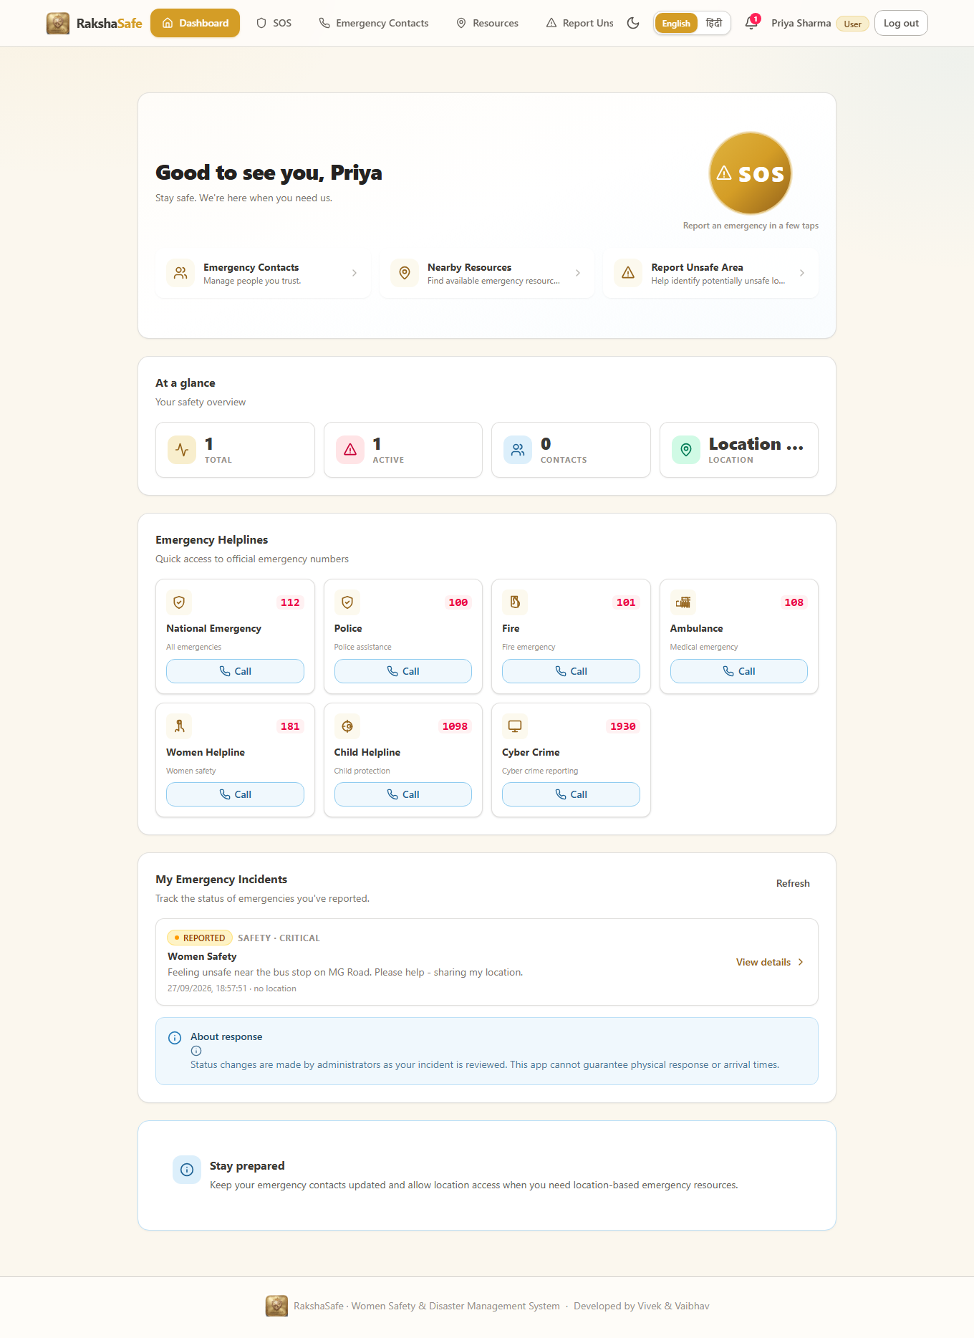
Figure C.1 - Dashboard now listing the live incident.
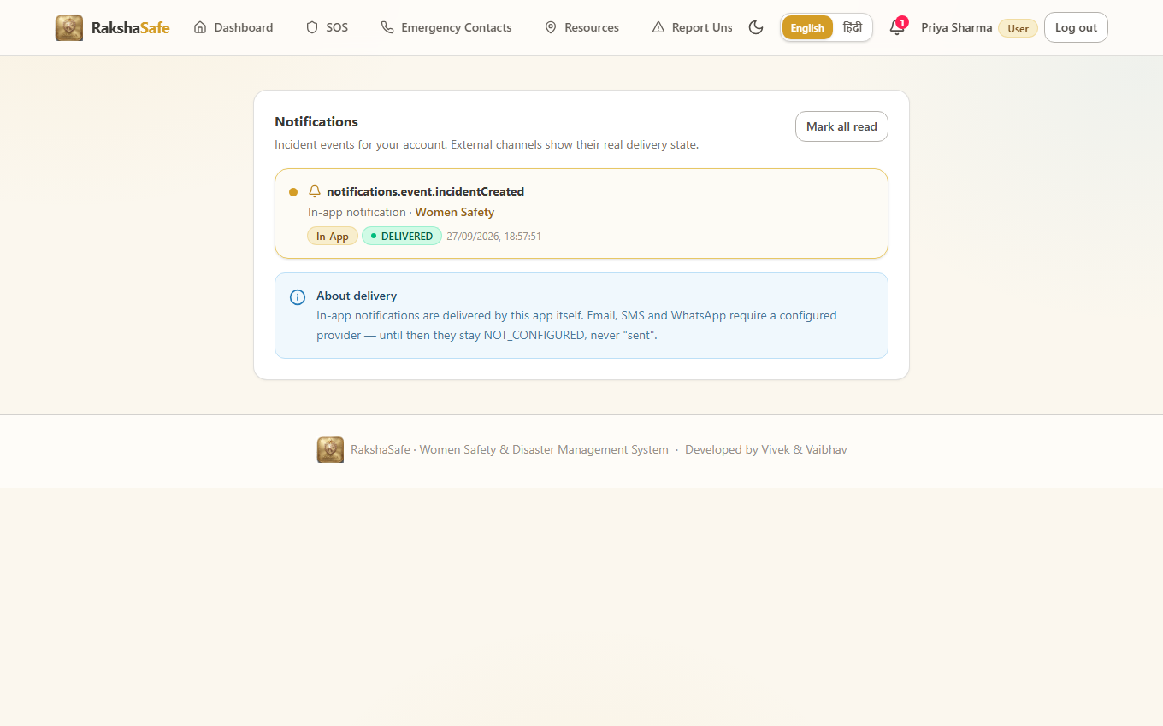
Figure C.2 - Notifications page (live).
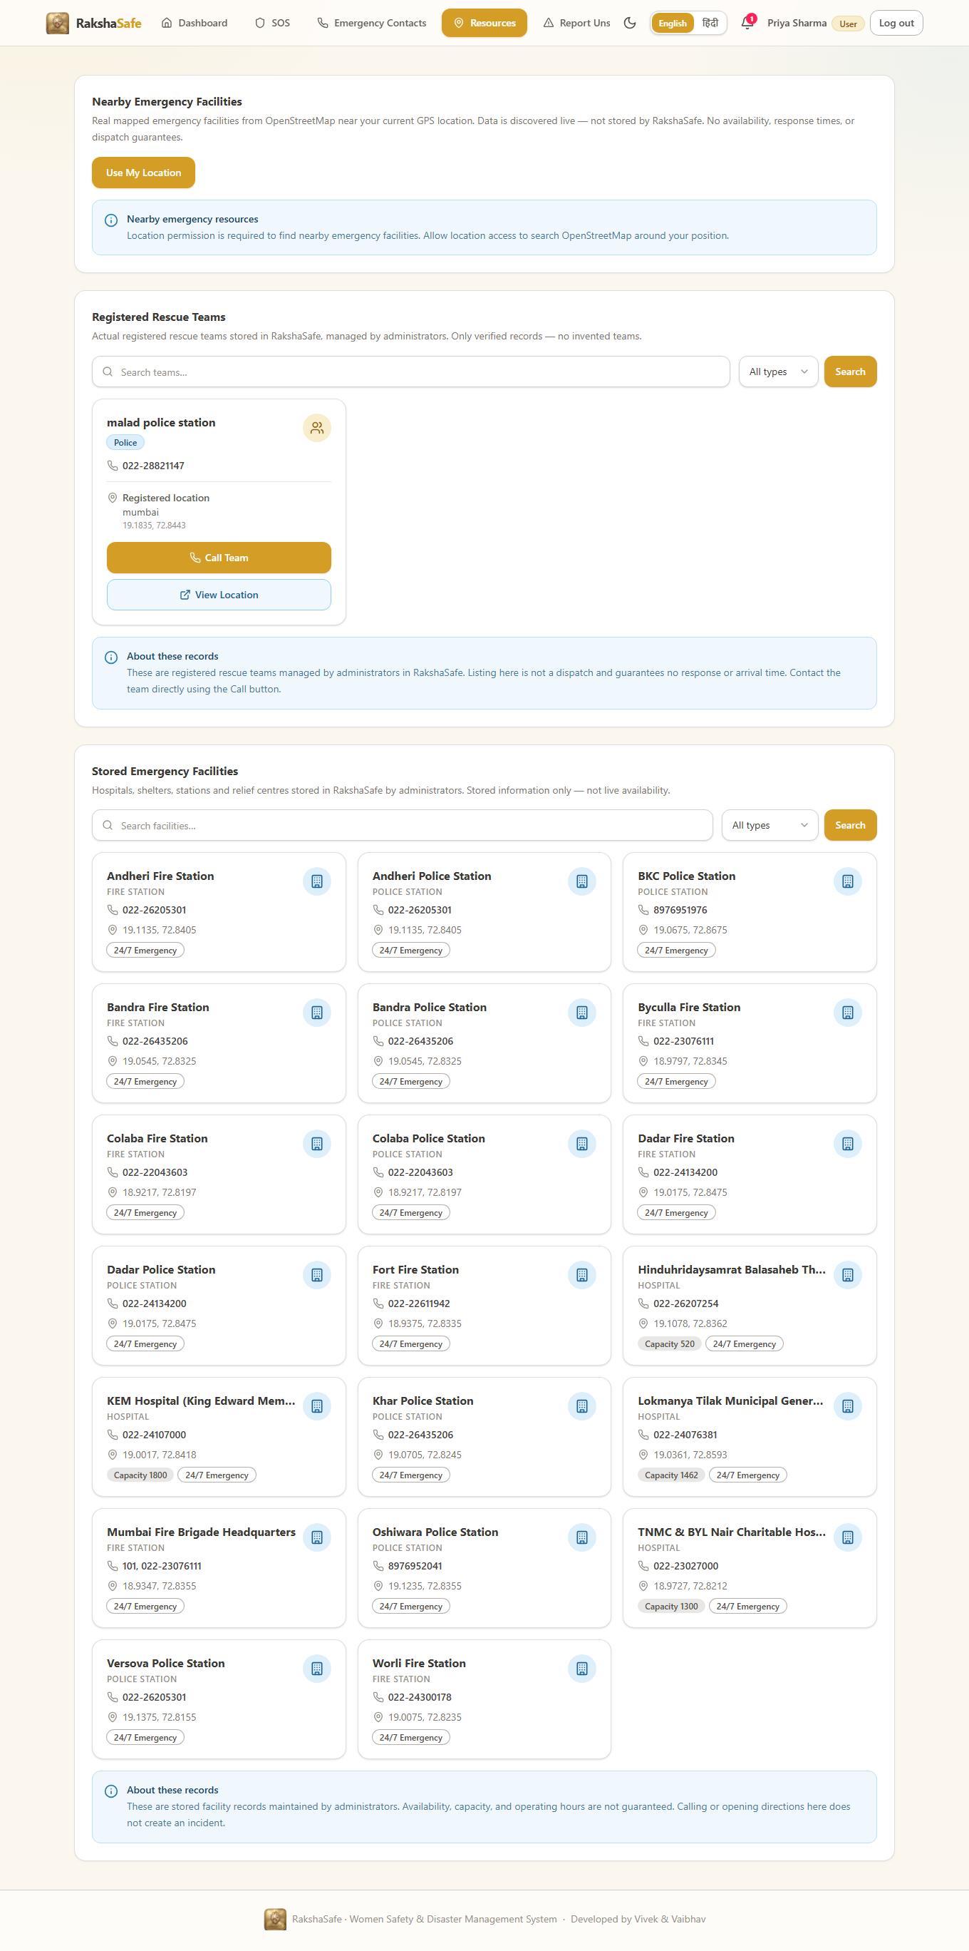
Figure C.3 - Nearby emergency resources page (live).
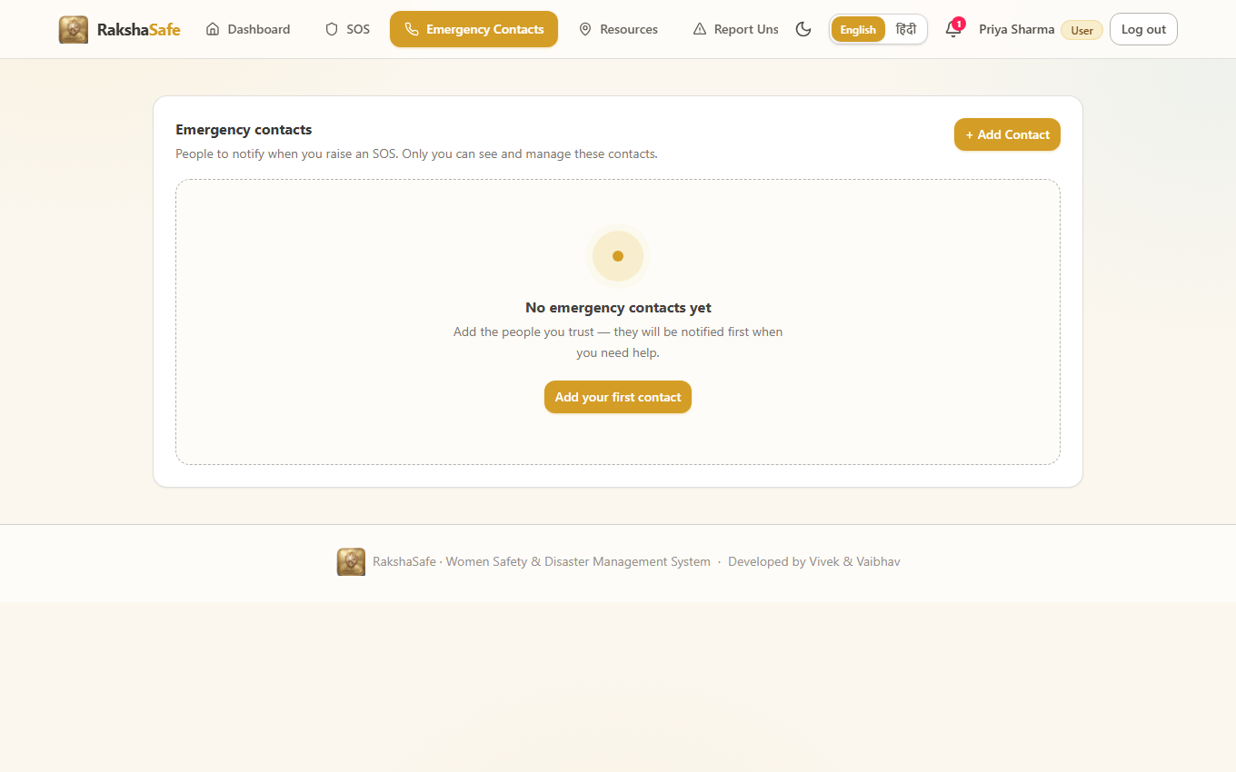
Figure C.4 - Emergency contacts page (live).
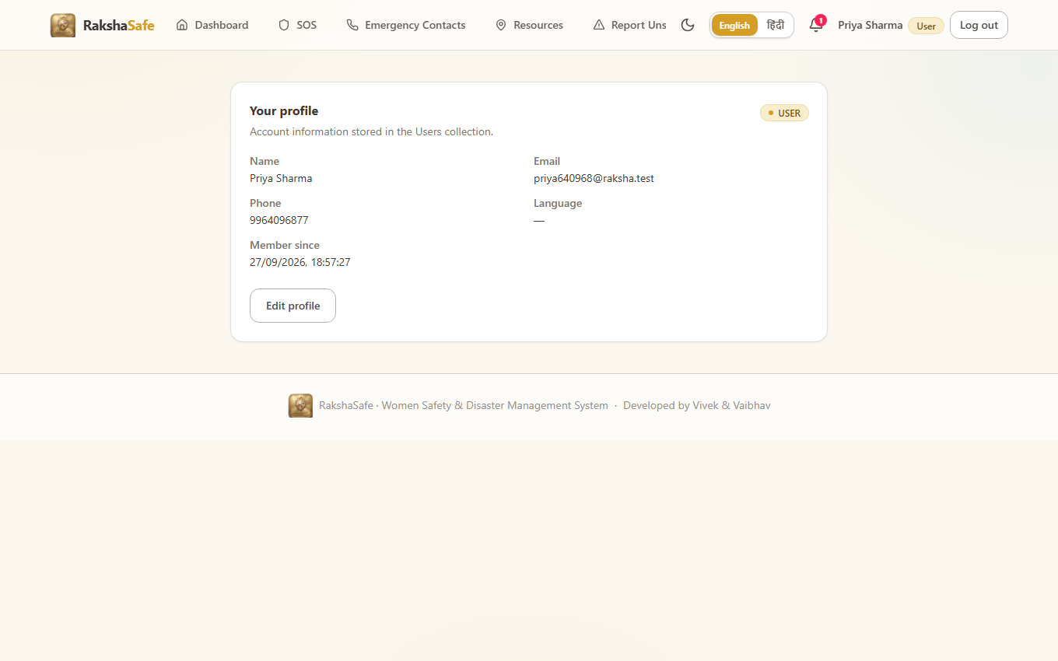
Figure C.5 - User profile page showing Priya Sharma (USER).
3.4 Phase D - Administrator Flow
The session was logged out and the seeded administrator account was signed in. All administrative screens were captured, proving the role-based access control grants the admin the full management interface.
Screen | What was verified
Admin login | Admin account accepted the seeded credentials
Admin dashboard | Live statistics panels render for the administrator
Incidents | Real incident list (including the incidents created in this session) rendered
Users | Registered users listed (including the live-registered test account)
Facilities | Facility management screens render
Rescue teams | Team management screens render
Unsafe area reports | Reports management screen renders
Reports | Reports / analytics page renders
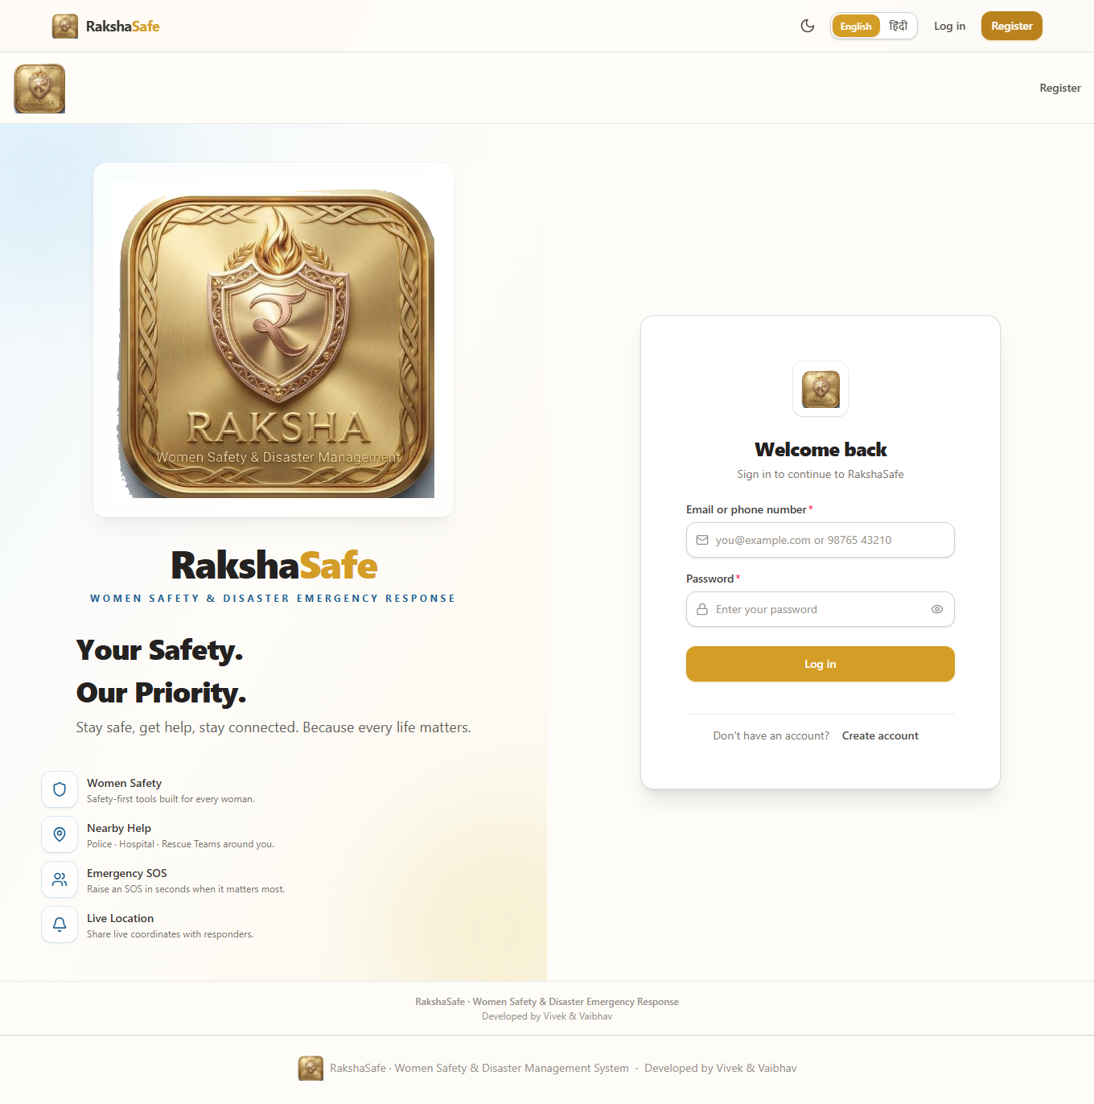
Figure D.1 - Logged-out state before admin sign-in.
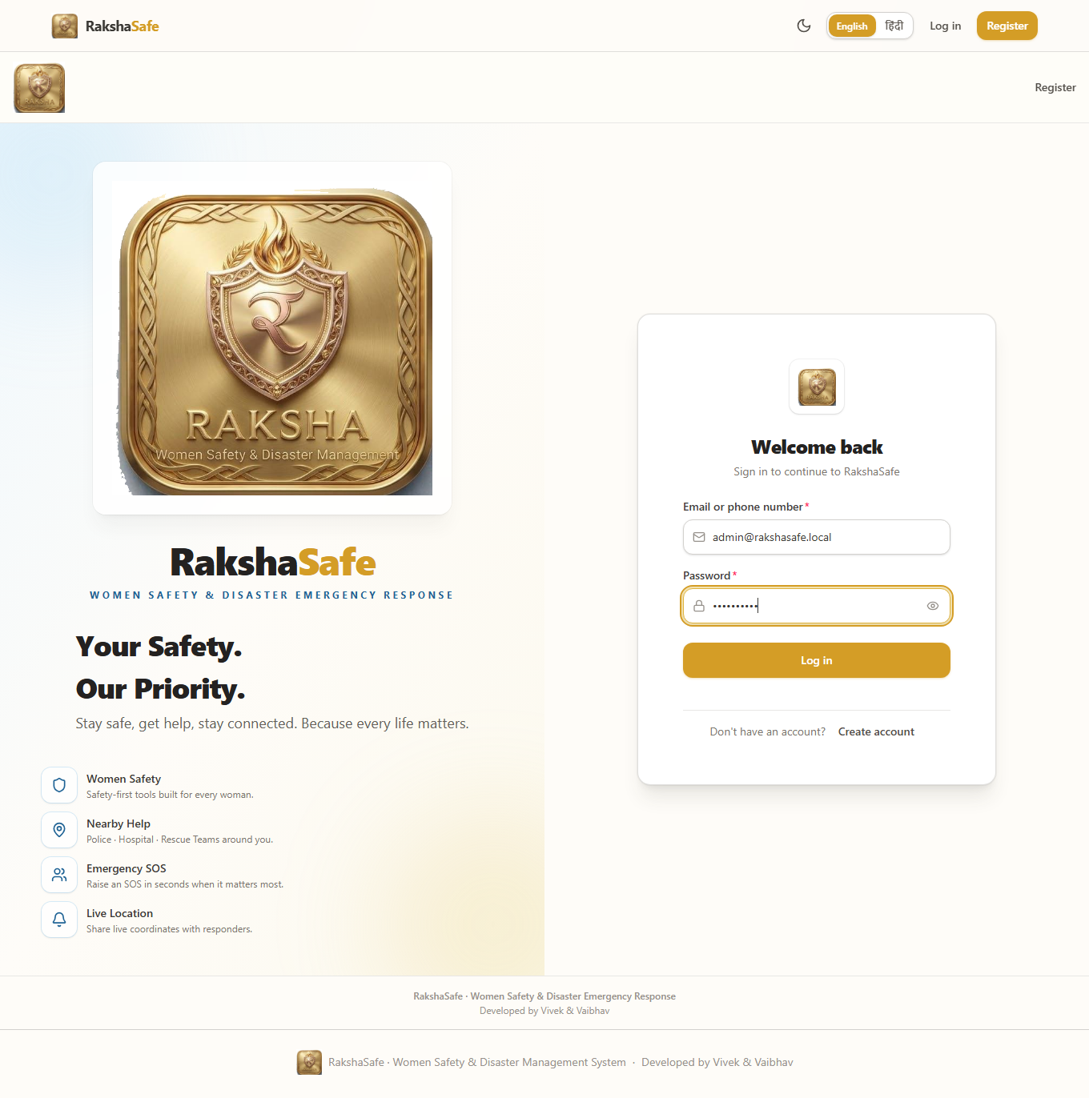
Figure D.2 - Admin login form filled with seeded credentials.
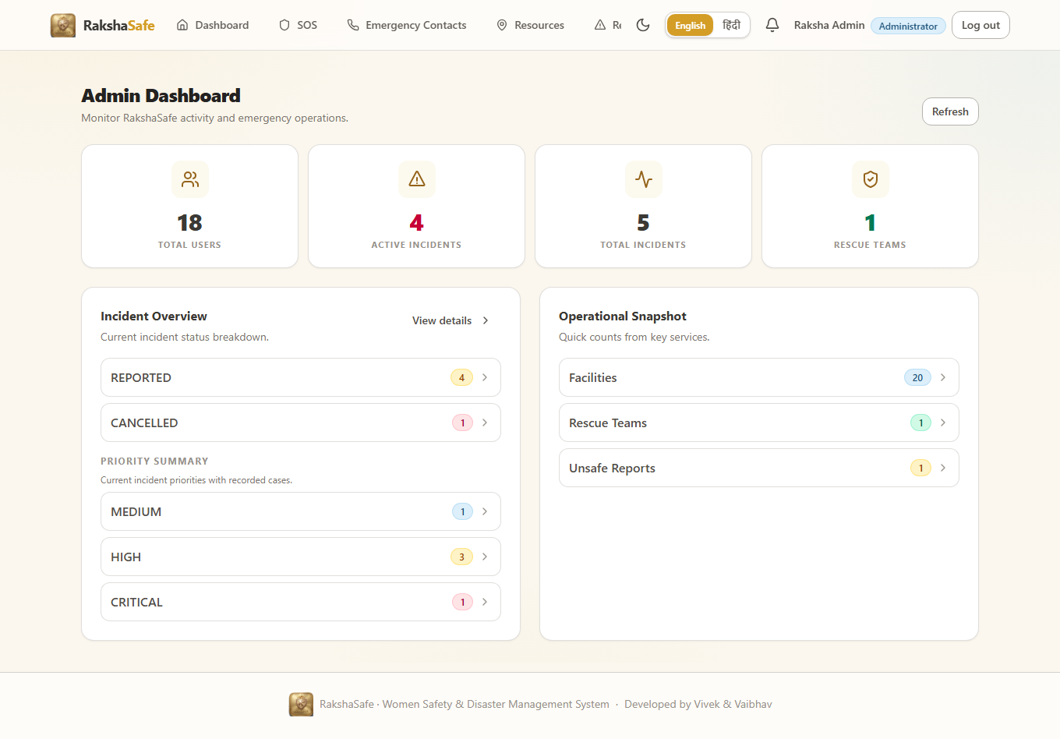
Figure D.3 - Admin dashboard (live).
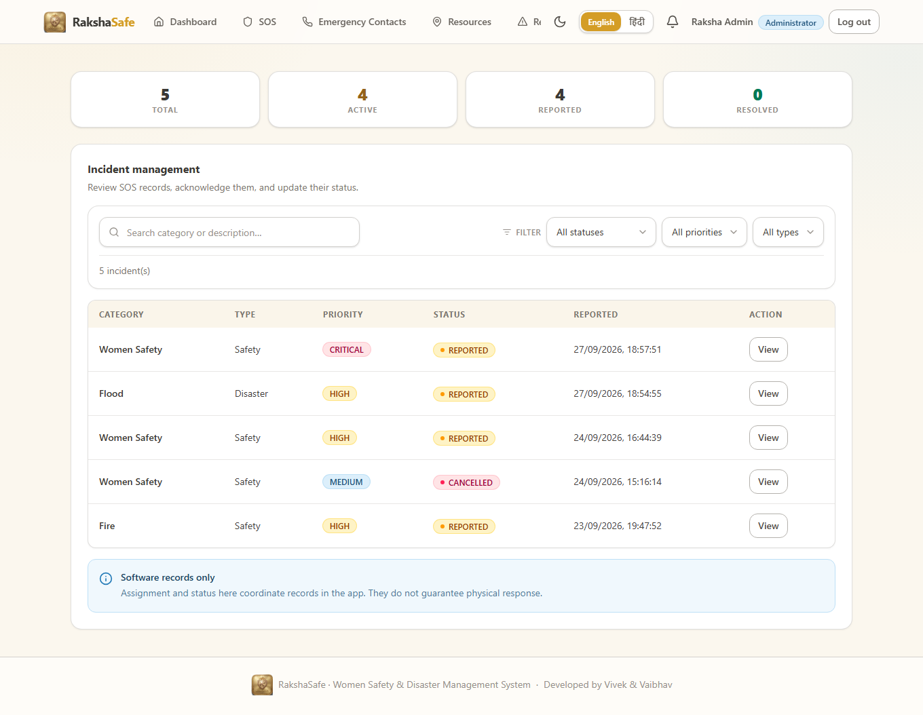
Figure D.4 - Admin incidents list containing the live test incidents.
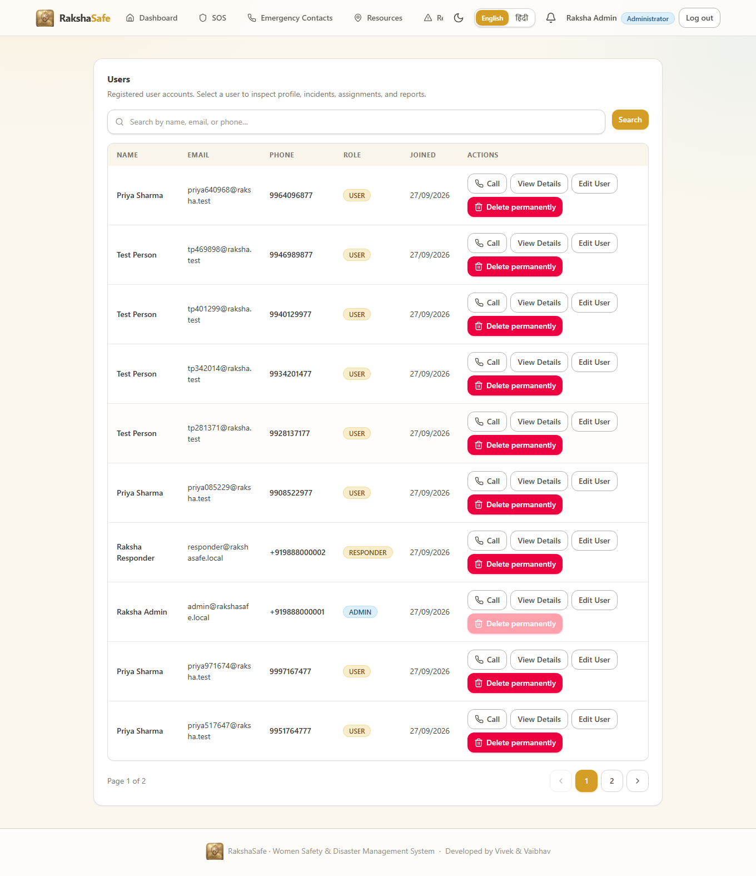
Figure D.5 - Admin users list.
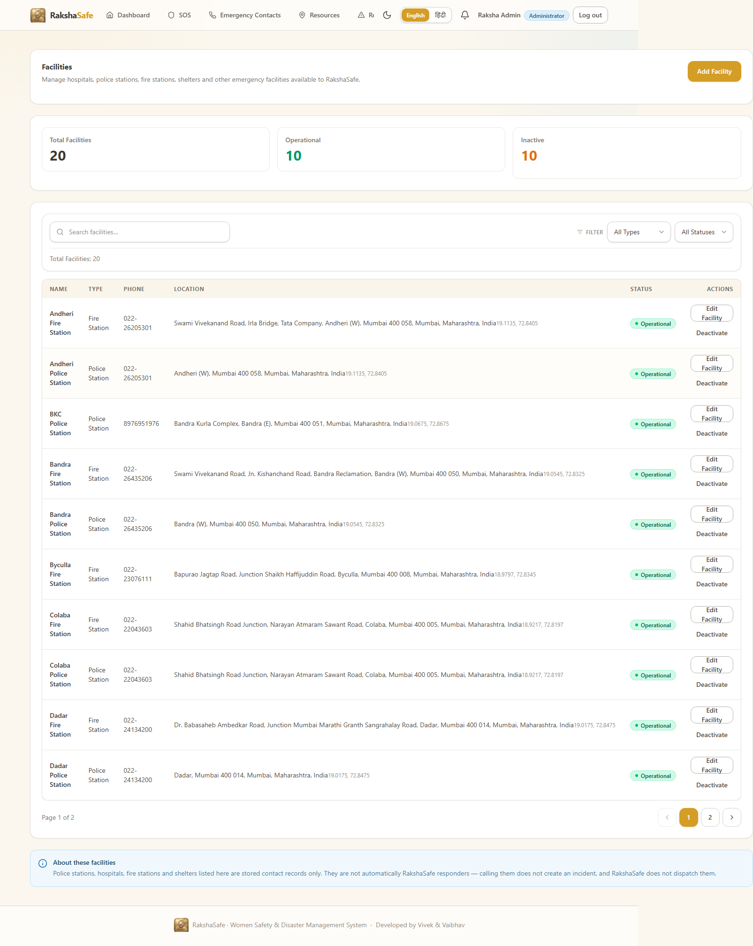
Figure D.6 - Admin facilities management.
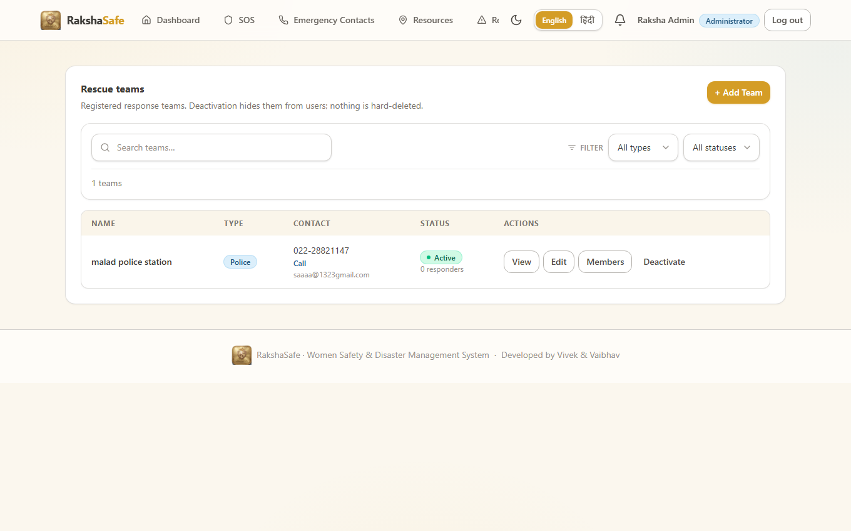
Figure D.7 - Admin rescue teams management.
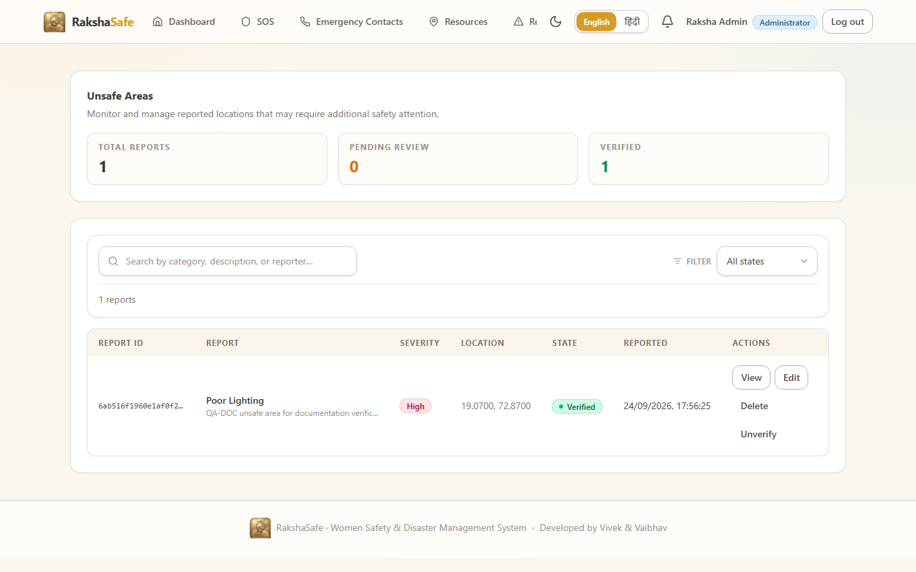
Figure D.8 - Admin unsafe-area reports.
Figure D.9 - Admin reports / analytics.
3.5 Phase E - Responder Flow
Finally the session was switched to the seeded responder account. The application recognised the responder role and rendered the responder dashboard, proving the third role of the RBAC model.
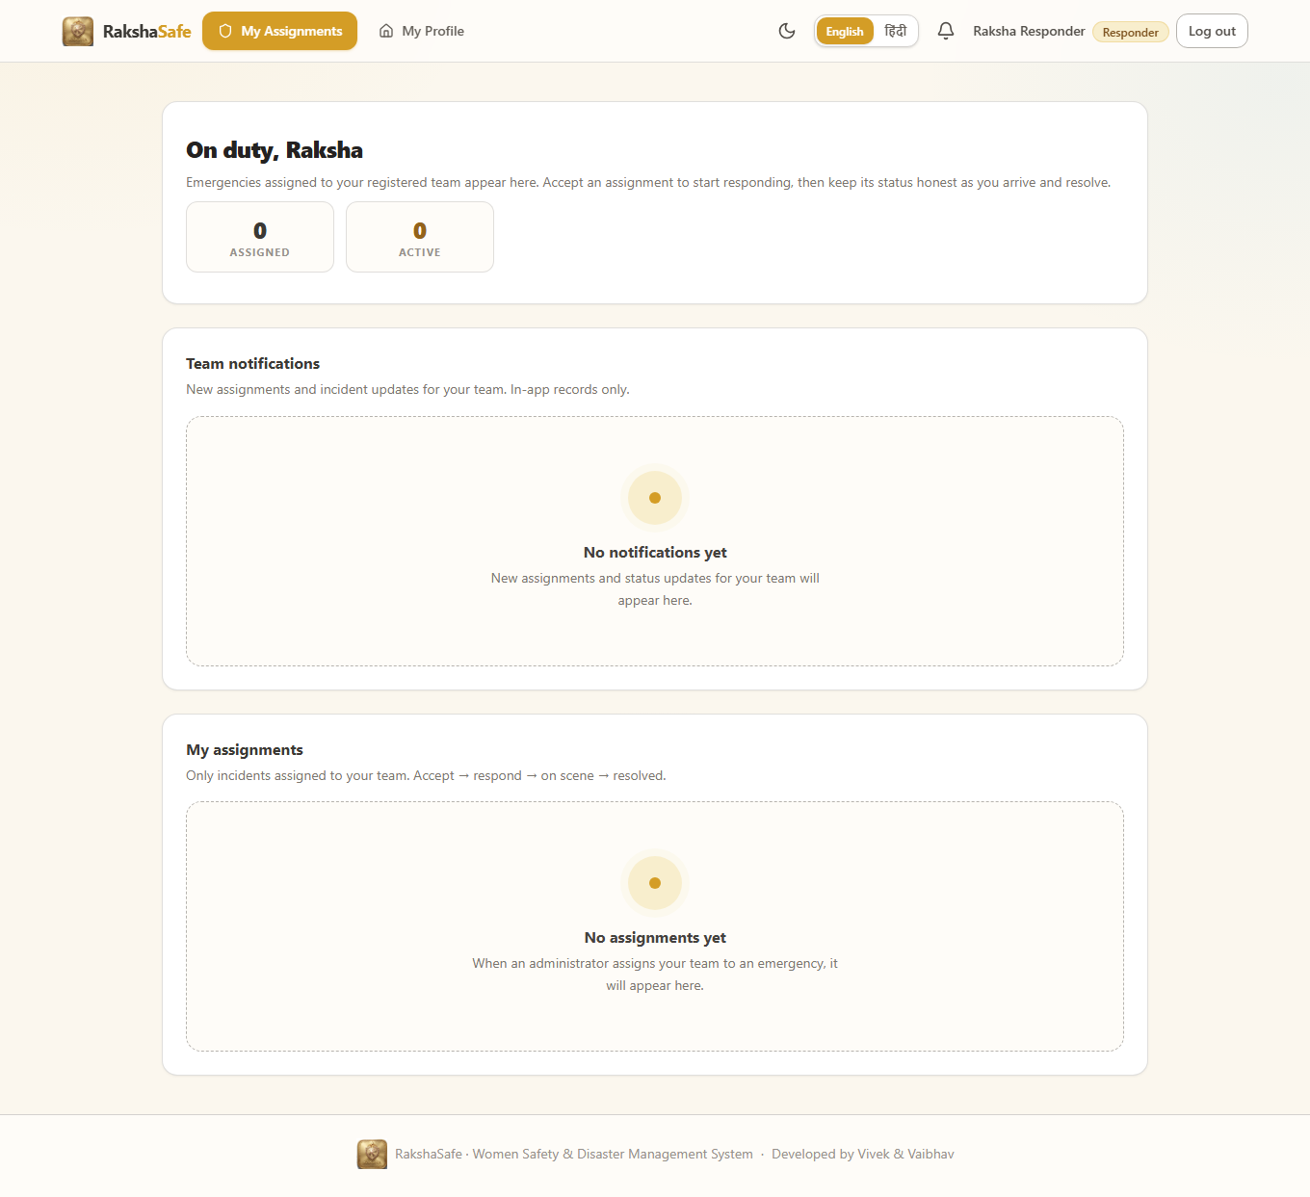
Figure E.1 - Responder dashboard after responder sign-in.
4. Consolidated Result Summary
Phase | Screens captured | Result
A - User registration | 4 (01-04) | PASS
B - SOS incident (full wizard) | 5 (05-09) | PASS - record persisted to MongoDB
C - User features | 5 (10-14) | PASS
D - Admin flow | 9 (15-23) | PASS
E - Responder flow | 1 (24) | PASS
TOTAL | 24 live screenshots | ALL PASS

Every screenshot in this chapter is a genuine capture of the running application. The screenshots were produced by the reusable automation script kept at documentation/test-evidence/real_full_test.js and can be regenerated at any time by starting the three services and running that script.
5. Conclusion
The live run demonstrates that Raksha Safe operates end to end exactly as designed in Chapter 3. A real user can register, can report a real emergency through the four-step SOS wizard, and the incident is durably stored and visible to the administrator. Three distinct roles (USER, ADMIN, RESPONDER) were exercised with live logins and their respective dashboards rendered correctly. No mock data or placeholder screens were used anywhere in this evidence.

