RakshaSafe – AI-Powered Women Safety and Disaster Emergency Response System
CHAPTER 3
SYSTEM ANALYSIS AND DESIGN
B.Sc. Information Technology – Final Year Project Documentation
This chapter describes the actual current implementation of the RakshaSafe system: its analysis, design, database, modules, architecture, security and verification. Every feature documented here was verified against the working source code (frontend, backend and AI service). Features that are planned but not implemented are explicitly labelled as future enhancements.

CHAPTER 3 — SYSTEM ANALYSIS AND DESIGN

3.1 Introduction
RakshaSafe is a centralized, web-based Women Safety and Disaster Management System. It allows registered users to create SOS and emergency incident records, attach the real device location where permission is granted, maintain emergency contacts, report unsafe areas, consult nearby emergency resources, receive in-app notifications and view an assistive AI risk assessment for an incident location. Administrators monitor all incidents through a dashboard, manage users, facilities, rescue teams and assignments, verify unsafe-area reports, review the same stored risk assessments, and generate analytical reports. Rescue-team members (responders) work through a dedicated interface that shows only the assignments of their own teams.
The system is implemented as three cooperating layers: a React + TypeScript + Vite frontend, a Node.js + Express.js + TypeScript REST backend backed by MongoDB through Mongoose, and a separate Python + FastAPI AI service that performs deterministic risk scoring. Authentication uses JSON Web Tokens (JWT) with role-based authorization, and passwords are stored only as bcrypt hashes. Location services use the browser/device geolocation API together with OpenStreetMap data and the Leaflet map library.
This chapter presents the analysis and design of the system as actually implemented: the existing manual process it replaces, the problems observed, the proposed computerized solution, its objectives, scope and feasibility, the functional and non-functional requirements, user roles, architecture, technology stack, module descriptions, database design, incident lifecycle, location handling, AI risk assessment, notifications, administrative functions, design diagrams, security, user interface, testing, limitations and future enhancements.

3.2 Existing System
Before RakshaSafe, personal-safety and disaster reporting in the target environment relies on disconnected manual practices: emergency information is shared through phone calls, messaging applications and word of mouth; incident details are noted informally without a consistent format; locations are described verbally, which is imprecise under stress; there is no single register of reported incidents, their priorities, or their resolution history; nearby hospitals, police stations, shelters and rescue teams are located through general knowledge or web search at the moment of need; and follow-up depends on the memory and availability of individuals rather than on an accountable workflow. There is no organized record of unsafe areas, no repeatable risk evaluation of a reported location, and no statistical reporting over past incidents.

3.3 Problems in Existing System
- Lack of a centralized safety platform. Safety information is scattered across calls, messages and paper notes, so nothing can be tracked end to end.
- Difficulty recording and tracking incidents. Without a standard incident record (type, category, description, priority, status), reports are incomplete and inconsistent.
- Difficulty sharing location information. Verbal location descriptions are ambiguous; coordinates, when available, have no standard place to be stored and displayed.
- Difficulty finding emergency facilities and resources. Hospitals, shelters, police and fire stations and rescue teams must be searched for afresh during every emergency.
- Lack of organized incident history. Status changes and response actions leave no auditable trail, so accountability and review are impossible.
- Difficulty managing emergency resources. There is no maintained register of facilities and rescue teams with their type, contact, capacity and operational state.
- Lack of centralized administration and monitoring. No dashboard shows how many incidents are active, which need attention, or how resources are deployed.
- Risk of unauthorized access to sensitive data. Informal sharing exposes personal and location data without authentication, authorization or ownership control.
- Difficulty maintaining unsafe-area and risk information. Reports of unsafe places and any assessment of location risk exist only as informal knowledge.
- Difficulty generating useful reports and statistics. Without structured stored data, summaries by status, type, priority or period cannot be produced reliably.

3.4 Proposed System
RakshaSafe is proposed as a centralized web-based Women Safety and Disaster Management System that replaces the informal practices described above with accountable, role-based digital workflows. A user registers and logs in, maintains emergency contacts, and reports an SOS as a structured incident with type, category, description, priority and the real device location where permission is granted. Each incident moves through a controlled status lifecycle (REPORTED to CLOSED, with CANCELLED where applicable), every change is recorded as history, and an assistive deterministic AI risk assessment can be generated for the incident location and viewed identically by the user and the administrator. Administrators manage users, facilities, rescue teams, assignments, unsafe-area verification, risk review and analytical reports (PDF, CSV, JSON) from a protected dashboard. Rescue-team members handle only their own teams’ assignments through a dedicated responder interface. All access is guarded by JWT authentication with USER, ADMIN and RESPONDER roles, ownership checks, and validated inputs; nothing is dispatched automatically and no emergency response is guaranteed by the software.

3.5 Objectives of the Proposed System
- Provide a single centralized platform for reporting, tracking and managing safety and disaster incidents.
- Record every incident in a standard structured form with type, category, description, priority, status and location.
- Capture the real reporting-device location (latitude, longitude, accuracy) with user permission and resolve a readable address without inventing data.
- Move each incident through a controlled, auditable status lifecycle with automatic history and administrative logging.
- Maintain organized registers of emergency contacts, facilities, rescue teams and rescue assignments.
- Collect and moderate unsafe-area reports, including an administrator verification step.
- Offer a deterministic, explainable AI risk assessment as decision support for an incident location, visible identically to user and administrator.
- Notify users in-app about incident events and record per-contact channel outcomes honestly when no external provider is configured.
- Generate analytical reports (incident, resource and safety overviews) in PDF, CSV and JSON formats.
- Protect all personal and location data with authentication, role-based authorization, ownership isolation and input validation.

3.6 Scope of the System
The scope of the implemented system covers: user registration and login with profile and language preference; administrator login and a full administration console (dashboard, users, emergency contacts, incidents, facilities, rescue teams, assignments, unsafe-area moderation, risk review, reports); a responder console for team members (assignments, status progression, team notifications); SOS and incident creation with real location capture; incident viewing, editing (within the allowed window), deletion (within the allowed window), status tracking and history; emergency-contact management with a single primary contact and per-contact channel preferences; facility and rescue-team registers with active/operational filtering; rescue assignments along a controlled workflow; unsafe-area reporting with verification; deterministic AI risk assessment with stored, reproducible results; in-app notifications with honest channel outcomes; report generation and export; and administrative audit logging of significant actions.
Explicitly out of scope in the current implementation are: automatic dispatch of police, ambulance or rescue units; automatic police FIR generation; guaranteed rescue response or arrival times; real-time hospital bed availability; guaranteed external SMS, email or WhatsApp delivery (these depend on configured providers); offline operation; shake-to-SOS gestures; live responder tracking; and machine-learning prediction models. These are listed as future enhancements in Section 3.17, not as implemented features.

3.7 Feasibility Study

3.7.1 Technical Feasibility
The system is technically feasible because it is built entirely from mature, well-supported open technologies that the project team can develop and deploy: React 19 with TypeScript and Vite for the frontend, Node.js 20 with Express and TypeScript for the REST backend, MongoDB with Mongoose for document storage, Python with FastAPI and Pydantic for the isolated AI service, Leaflet with OpenStreetMap data for map display, and the browser geolocation API for coordinates. All libraries used are free and available through public package registries; no paid API is required for any implemented feature (map tiles, Nominatim reverse-geocoding and Overpass data are used within their public usage policies with server-side caching and rate limiting). The three runtime processes communicate over HTTP/JSON with JWT bearer authentication, a standard integration pattern.

3.7.2 Economic Feasibility
Development cost is limited to commodity hardware, internet access and developer time: every software component (Node.js, React, Vite, Tailwind CSS, Express, MongoDB Community or the Atlas free tier used here, Python, FastAPI, Leaflet, OpenStreetMap data) is free of licence cost. External communication providers (email, SMS, WhatsApp) are optional and designed as configurable providers, so the system is fully functional without any recurring messaging expenditure; in-app notifications, which are the delivered channel, cost nothing. Maintenance cost stays low because the stack is uniform TypeScript/JavaScript across frontend and backend with a small, isolated Python service.

3.7.3 Operational Feasibility
The system is operationally feasible because it matches the real working practices of its users: reporting an emergency is a short guided SOS wizard; administrators work from a single dashboard with tables, filters and detail pages; responders see only their own teams’ assignments with clear next actions. The interface is responsive for desktop, tablet and mobile browsers, offers English and Hindi, and works in light and dark modes. No specialized training beyond basic web use is required, and every destructive or state-changing action carries confirmation, validation messages and retry options.

3.8 Requirements Analysis

3.8.1 Functional Requirements
The following functional requirements are implemented in the current system. Each item names where it is implemented (frontend page and backend endpoint family).
- FR-1 User registration and login. A visitor registers with name, email, phone and password (RegisterPage → POST /api/auth/register, always creating a USER account) and logs in with email or phone plus password (LoginPage → POST /api/auth/login). A JWT carrying the user id and role is issued and stored client-side; the interface redirects by role. Wrong credentials receive a generic 401 without revealing which field failed.
- FR-2 Administrator login. Administrators sign in through the same login screen; the role claim routes them to the admin console. Administrator accounts are created or promoted only through the server-side seed script, never through public registration.
- FR-3 Role-based access control. Three roles exist: USER, ADMIN and RESPONDER. Route guards and the server middleware chain (requireAuth, requireAdmin, requireResponder, requireDb) enforce them on every request; ownership checks scope user data to the caller’s own records, returning 404 rather than leaking other users’ data.
- FR-4 User profile and preferences. Users view and update name, email, phone and language preference (ProfilePage → GET /api/auth/me, PATCH /api/auth/profile).
- FR-5 Emergency-contact management. Users create, list, update and delete personal emergency contacts with name, phone, optional email and relationship, exactly one primary contact (partial unique index), and per-contact SMS/email notification preferences (EmergencyContactsPage → /api/emergency-contacts). Administrators can inspect and manage any user’s contacts.
- FR-6 SOS and incident creation. A four-step SOS wizard (details → location → review → done) submits type (Safety/Disaster), category, description, priority (LOW/MEDIUM/HIGH/CRITICAL) and the real device coordinates when permission is granted (SosPage → POST /api/incidents). The incident is stored with status REPORTED; continuing without location is explicitly allowed and never blocks submission.
- FR-7 Incident viewing, editing and deletion (owner). Owners list, open, edit and delete their own incidents; editing and deletion are permitted only while the case is new (REPORTED/ACKNOWLEDGED) and unassigned, otherwise a 409 explanation is returned.
- FR-8 Location capture and display. Real latitude, longitude and accuracy are stored as a Locations record linked by locationId; a readable address (address, city, district, state, postal code, country) is resolved server-side via Nominatim and cached on the record; coordinates, accuracy, capture time and an Open-in-Maps link are shown to the owner and to the administrator. Nothing is ever fabricated.
- FR-9 Emergency facility register. Administrators create, update, list and filter facilities by type (Hospital, Shelter, Police Station, Fire Station, Relief Centre) with contact, capacity, operating hours, operational flag and location (AdminFacilitiesPage → /api/admin/facilities). Users see active facilities and nearby resources with honest distances (ResourcesPage, NearbyResourcesSection).
- FR-10 Rescue-team register. Administrators create and manage rescue teams by type (Police, Medical, Fire, Volunteer, NGO) with contact, specializations, active flag, members and optional base location (AdminTeamsPage → /api/admin/rescue-teams). Team members must hold RESPONDER accounts. Users can view active teams.
- FR-11 Rescue-assignment workflow. Administrators assign an active team to an incident; the assignment moves ASSIGNED → EN_ROUTE → ON_SCENE → COMPLETED (CANCELLED from any non-terminal state); duplicate active assignments are rejected. Responders advance their own teams’ assignments through the same validated workflow.
- FR-12 Incident status management and monitoring. Administrators change incident status along REPORTED → ACKNOWLEDGED → ASSIGNED → IN_PROGRESS → RESOLVED → CLOSED (CANCELLED where applicable); illegal transitions are rejected; resolvedAt is set on terminal states; every change is stored as an IncidentUpdate with author and comment.
- FR-13 Incident history. A chronological timeline of status changes is shown on both user and admin incident detail pages (HistoryTimeline, IncidentUpdates collection).
- FR-14 Unsafe-area reporting and moderation. Users submit unsafe-area reports with category, description, severity and a mandatory location (UnsafeReportsPage → /api/unsafe-reports, owner-scoped CRUD). Administrators list, filter, verify/unverify and delete reports (AdminUnsafeReportsPage → /api/admin/unsafe-reports); verification feeds the AI risk factors.
- FR-15 Risk-zone records. Structured risk-zone documents (name, risk level, geometry, factors, assessment time, active flag) are maintained in the RiskZones collection for location-based risk information and map display.
- FR-16 Deterministic AI risk assessment. For an incident with stored coordinates, the backend assembles real factors (priority, type, verified/unverified nearby reports, nearby active incidents) and scores them through the FastAPI raksha-risk-v1 engine (POST /risk/assess). The validated result (score 0–100, level, model version, factors, timestamp) is stored in RiskAssessments and shown identically to owner and administrator; it is advisory only.
- FR-17 Disaster-category reference data. Named disaster categories with code, description, default priority, response-team requirement and active flag are kept in the DisasterCategories collection as controlled reference data.
- FR-18 Notifications. Incident events (creation, status change, assignment, assignment update) create notification records: one In-App record per event for the owner (stored and served, hence DELIVERED) plus one record per opted contact channel, honestly marked NOT_CONFIGURED while no external provider is configured (NotificationsPage → /api/notifications; team notifications for responders).
- FR-19 Analytical reporting. Administrators generate stored reports of types incident-summary, resource-summary and safety-overview in PDF, CSV or JSON, view the stored snapshot, download the export file and delete reports (ReportsPage → /api/admin/reports; PDF is produced by a dependency-free server-side generator).
- FR-20 Administrative dashboard. A dashboard aggregates users, incidents (total, active, by status), teams, assignments, notifications, unsafe reports, facilities, risk information and recent activity (AdminDashboardPage → GET /api/admin/dashboard).
- FR-21 User administration. Administrators list, search, view, update (role, active flag), and delete user accounts, with protection that refuses to demote, deactivate or delete the last active administrator (AdminUsersPage, AdminUserDetailPage → /api/admin/users).
- FR-22 Administrative activity logging. Significant administrative actions (status changes, assignments, team/facility/report operations, user management, verifications) are recorded in AdminLogs with actor, action, target and details for accountability.
- FR-23 Location enrichment and nearby lookup. Authenticated, database-independent endpoints provide reverse-geocoding (/api/geocode/reverse), forward search, nearby mapped facilities (Overpass), weather (Open-Meteo) and incident-centred nearby resources; each source degrades independently into “unavailable” states.

3.8.2 Non-Functional Requirements
- Security. JWT bearer authentication on protected routes; bcrypt password hashing; USER/ADMIN/RESPONDER authorization with ownership isolation; validated inputs with field-level errors; secrets only in environment files; rate limiting on authentication, creation and reporting endpoints; correct HTTP status codes (400/401/403/404/409/502/504).
- Performance. Indexed MongoDB queries with pagination (users, incidents, reports, contacts); bounded nearby radius; cached and rate-gated upstream geocoding (1.1 s minimum interval, 1-hour TTL); lazy address backfill that never delays responses; production frontend bundle served as static assets.
- Reliability. The API starts even if MongoDB is briefly unreachable and reconnects in the background with capped backoff while requireDb guards data routes; AI-service timeouts (5 s default) and outages produce clean retryable errors without storing fake results or crashing the backend.
- Usability. Guided SOS wizard with explicit location states; consistent cards, tables, empty/loading/error states and toasts; non-blocking supplementary panels (risk, nearby, weather) with independent retry; confirmations on destructive actions.
- Maintainability. TypeScript end to end with shared contracts; layered backend (routes → controllers → services → models) plus validators, middleware and utilities; isolated deterministic AI service with validated schemas.
- Scalability. Stateless REST API behind standard HTTP scaling; paginated listings; MongoDB indexes on ownership, status, type and time fields; serialized, cached third-party calls.
- Responsiveness. Mobile-first responsive layout (Tailwind CSS) adapting from phones to desktops; touch-friendly controls and readable tables/cards on small screens.
- Data validation. Server-side validators for every write path (ranges for coordinates, formats for email/phone, enums for type/priority/status, length bounds for text); the server never trusts userId, role, status or ownership sent by the client.
- Access control. Route guards in the interface mirror server enforcement: administrators cannot be bypassed from the client, users only ever receive their own records (cross-user access returns 404), and responders are confined to their teams’ assignments.

3.9 User Roles
The system defines exactly three roles in code (UserRole: USER, ADMIN, RESPONDER). Public self-registration always creates USER accounts; ADMIN and RESPONDER accounts are created or promoted exclusively through server-side seed scripts and team membership management, never through public endpoints, and clients cannot escalate their own role.
Table 3.1 — System roles as implemented (source: UserRole enum, guards, seed scripts).
Role | Capabilities | Constraint / Validation
USER | Register, log in; manage profile and language; manage own emergency contacts; report SOS and manage own incidents; report unsafe areas; view own risk assessments, notifications, resources and nearby data. | Own records only (userId from JWT); cross-user ids return 404.
ADMIN | Admin console: dashboard, users, emergency contacts, incidents and status, facilities, rescue teams and members, assignments, unsafe-area moderation, risk review, reports, and audit visibility. | requireAdmin on every /api/admin/* route; last active administrator cannot be demoted, deactivated or deleted.
RESPONDER | Dedicated console showing only assignments of teams the responder belongs to; advance assignment status along the validated workflow; view incident location/reporter details needed for response; team notifications. | requireResponder on /api/responder/*; every lookup constrained to own teams; team membership accepts RESPONDER accounts only.

The RESPONDER workflow is fully implemented (backend routes, middleware, seed script with optional team linking, and the ResponderDashboardPage with assignment progression), so it is documented here as an implemented role rather than a future plan.

3.10 System Architecture
RakshaSafe follows a three-tier web architecture with a separated AI service. The browser runs a React single-page application (built with Vite) that communicates exclusively with the backend over HTTPS/JSON; in development the Vite server proxies /api to the Express backend and /ai to the FastAPI service so same-origin URLs work out of the box. The Node.js + Express backend exposes versioned REST endpoints, authenticates requests with JWT bearer tokens, authorizes by role and ownership, validates every write, and persists through Mongoose models to MongoDB Atlas. The Python + FastAPI AI service exposes a single scoring endpoint consumed only by the backend — never directly by the browser. Third-party data (Nominatim reverse-geocoding, Overpass nearby facilities, Open-Meteo weather, OpenStreetMap tiles) is always proxied server-side with caching and rate limiting, so no external key or uncontrolled browser call is required.
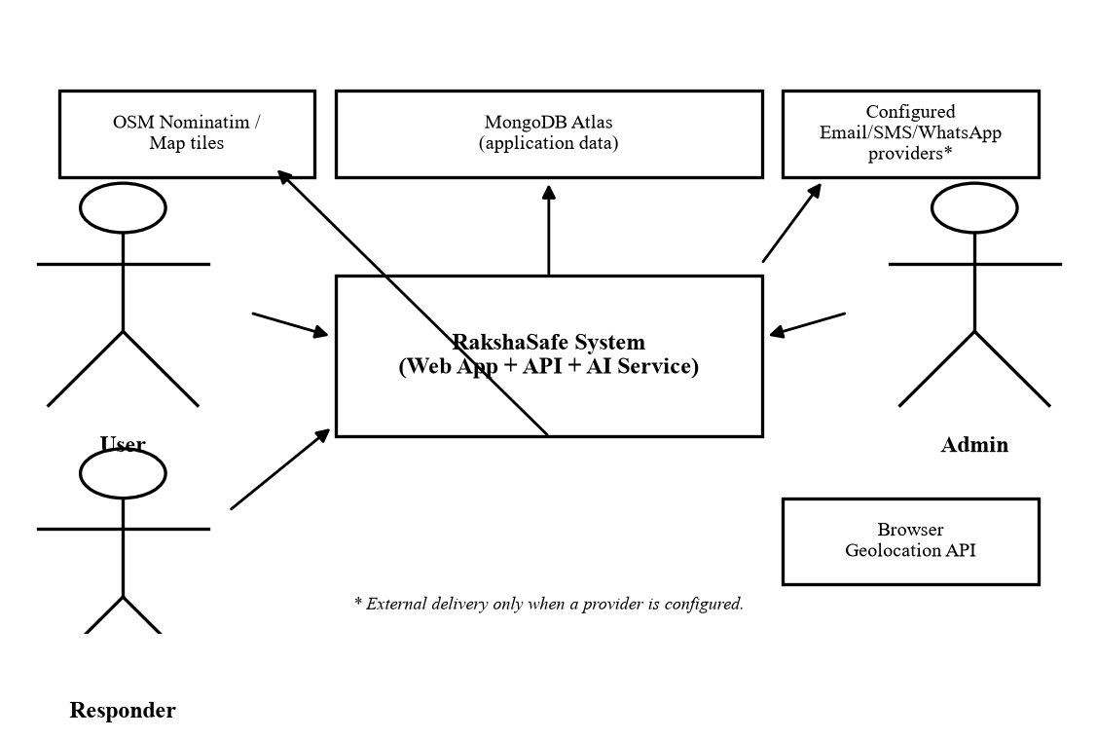
Figure 3.1 — System context diagram: actors, the RakshaSafe system, data store and external services.
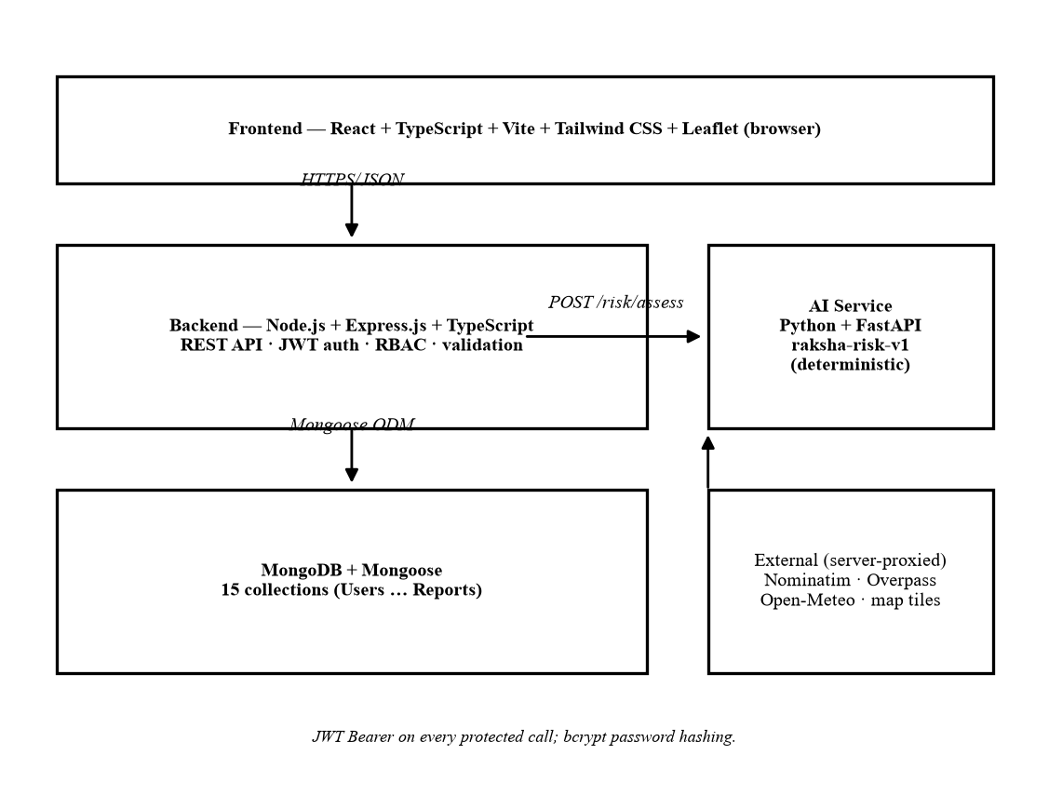
Figure 3.2 — System architecture: React frontend, Express REST backend, MongoDB, FastAPI AI service and proxied external services.
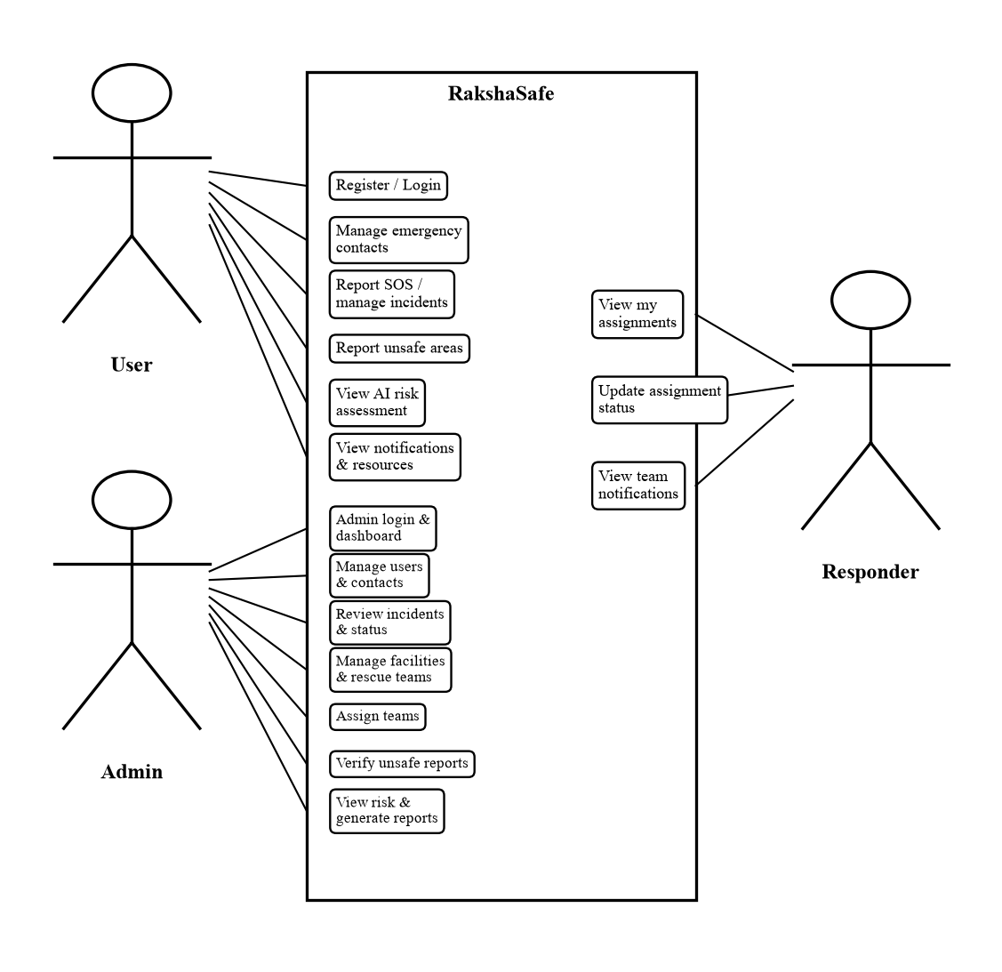
Figure 3.3 — Use-case diagram for USER, ADMIN and RESPONDER roles.
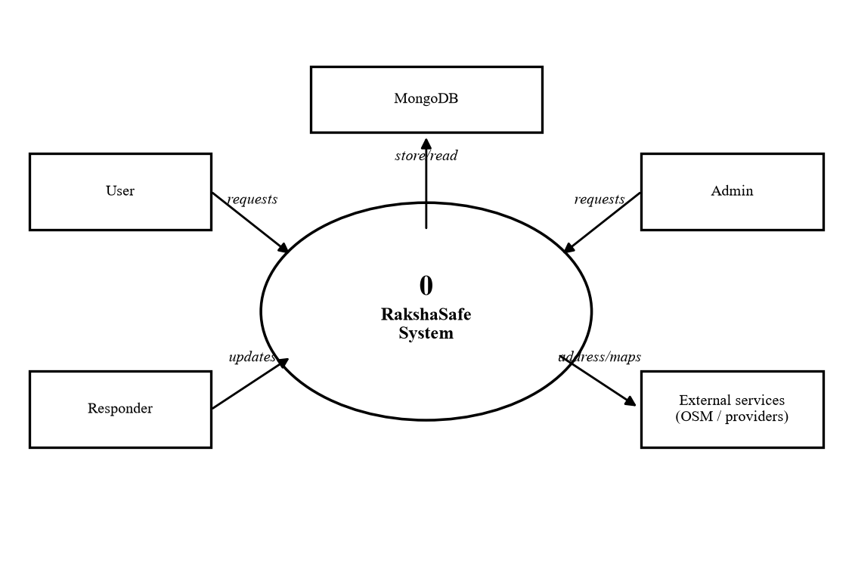
Figure 3.4 — Data-flow diagram level 0: the system as a single process.
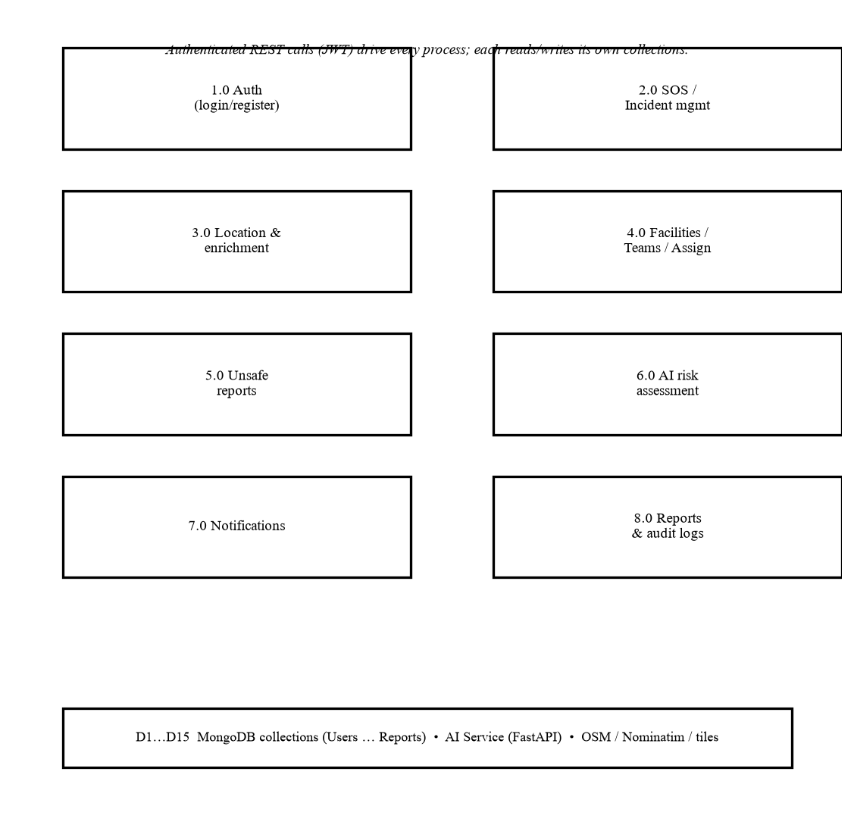
Figure 3.5 — Data-flow diagram level 1: authentication, incidents, location, resources, reports, risk, notifications and audit processes with their data stores.

3.11 Technology Stack
The stack below is exactly the stack surveyed in Chapter 2 and used in the implementation; no component has been substituted.
Table 3.2 — Implemented technology stack (matches Chapter 2).
Layer | Technology (verified version) | Purpose in RakshaSafe
Frontend | React 19, TypeScript, Vite 8, Tailwind CSS 4 | Single-page web interface for users, responders and administrators.
Map display | Leaflet 1.9 with OpenStreetMap tiles | Static incident-location and nearby-facility markers; no live tracking.
Backend | Node.js 20, Express 5, TypeScript | REST API, authentication, authorization, validation and orchestration.
Database | MongoDB Atlas, Mongoose 8 | Document storage in 15 collections with schema validation and indexes.
Authentication | jsonwebtoken, bcryptjs | Signed JWT sessions (default 7-day expiry); salted password hashing.
AI service | Python 3.12, FastAPI 0.115, Uvicorn, Pydantic 2 | Isolated deterministic risk-scoring HTTP service (raksha-risk-v1).
Location | Browser/Device Geolocation API | One-shot real coordinate capture with explicit permission states.
Geocoding | OSM Nominatim (server-proxied) | Reverse-geocoding with User-Agent, 1.1 s gating and 1-hour cache.
Nearby/weather | Overpass API, Open-Meteo (server-proxied) | Mapped facilities and weather for coordinates; optional, degradable.
Communication | Configured providers (Email/SMS/WhatsApp) | Optional external delivery; in-app channel always available.

3.12 Module Description

3.12.1 Authentication Module
Public registration (POST /api/auth/register, USER only, rate-limited), login by email or phone (POST /api/auth/login, rate-limited, generic 401 on failure), logout acknowledgement, current-profile retrieval and profile updates. Passwords are hashed with bcrypt; sessions are stateless JWTs verified on every protected request, with the database role and active flag re-checked so deactivation and role changes take effect immediately. Seed scripts create or promote ADMIN and RESPONDER accounts with validated inputs. Verified live: registration, login, wrong-password and unknown-user rejections.

3.12.2 User Module
User accounts (Users collection) with name, unique email, unique phone, role and active flag. Users manage their own profile and language preference (English/Hindi). Administrators list, search, view, update and delete accounts, guarded so the last active administrator can never be demoted, deactivated or deleted. Verified live: registration, profile read, admin user listing and detail.

3.12.3 Emergency Contact Module
Owner-scoped contacts with name, phone, optional email, relationship, a single primary contact enforced by a partial unique index, and per-contact SMS/email notification preferences (full CRUD at /api/emergency-contacts). The incident-notification service reads these preferences to record honest per-channel outcomes. Administrators manage any user’s contacts with owner search and summary counts. Verified live: create (including isPrimary and channel flags), list, update and delete.

3.12.4 SOS and Incident Module
A four-step SOS wizard collects type, category, description and priority, then real device coordinates (optional — submission is never blocked by denied permission), then review and submit. Incidents are stored with server-assigned ownership and REPORTED status; owners may edit or delete only new unassigned cases. Detail pages show the case, location, assignments, history and risk assessment. Verified live: creation with stored coordinates, owner retrieval, invalid-coordinate rejection, and cross-user denial.

3.12.5 Location Module
Locations are first-class records (latitude, longitude, address components, accuracy, timestamps) referenced by incidents, facilities, teams and unsafe reports. Coordinates come only from the device API or validated manual entry; ranges are enforced (−90…90, −180…180). Readable addresses are resolved server-side through Nominatim and cached on the record; the interface shows address first with coordinates, accuracy, capture time and an Open-in-Maps link. Verified live: capture, stored address backfill, coordinate display and malformed-coordinate rejection.

3.12.6 Facilities/Resources Module
A register of emergency facilities (Hospital, Shelter, Police Station, Fire Station, Relief Centre) with contact, capacity, operating hours, operational flag and location. Administrators perform full CRUD with filtering; users see active facilities and a curated resources view with helplines plus nearby facilities/teams with honest haversine distances. Capacity is a static recorded figure, not live bed availability. Verified live: admin create, user listing, filtering.

3.12.7 Rescue Team Module
Rescue teams by type (Police, Medical, Fire, Volunteer, NGO) with contact, specializations, active flag, optional base location and a members list restricted to RESPONDER accounts. Administrators manage teams and membership; users view active teams. Verified live: team creation, member-add validation (USER accounts rejected, RESPONDER linked via seed), and active-team listing.

3.12.8 Rescue Assignment Module
Assignments bind an incident to one active team with author, timestamp, notes and a validated status workflow (ASSIGNED → EN_ROUTE → ON_SCENE → COMPLETED, CANCELLED from any non-terminal state); duplicate active assignments are rejected. Administrators create and update assignments; responders advance their own teams’ assignments through the identical validated transitions. Verified live: creation, responder progression to EN_ROUTE, and history visibility.

3.12.9 Unsafe Area Report Module
Users submit unsafe-area reports with category, description, severity and a mandatory location (owner-scoped CRUD). Administrators filter, verify or unverify, and delete reports; verified reports within 2 km of an incident feed its AI risk factors. Verified live: creation (unverified by default), admin listing, and verification.

3.12.10 AI Risk Assessment Module
For an incident with stored coordinates, the backend assembles real factors and scores them with the FastAPI raksha-risk-v1 engine; the validated result is stored in RiskAssessments and served newest-first to the owner (POST/GET /api/incidents/:id/risk) and to administrators (GET /api/admin/incidents/:id/risk) from the same record. Scores are reproducible from the same database state; failures store nothing and return clean retryable errors. Verified live: creation, persistence across refresh, identical admin view, determinism, and the AI-unavailable path. See Section 3.15 for the full design.

3.12.11 Notification Module
Incident events (creation, status change, assignment, assignment update) are recorded best-effort after the primary write succeeds. Each event stores one In-App record for the owner (DELIVERED, since serving is the delivery) and one record per opted contact channel, honestly marked NOT_CONFIGURED while no external provider exists. Users browse their notifications with channel/status badges; responders receive team notifications. Verified live: event records across the full incident lifecycle with exact channels and statuses. See Section 3.16.

3.12.12 Reports Module
Administrators generate stored analytical reports (incident-summary with status/type/priority/month filters, resource-summary, safety-overview) in PDF, CSV or JSON; the snapshot is frozen at generation time, viewable in a humanized detail modal, downloadable in its own format (PDF produced by a dependency-free server-side generator), and deletable without touching source records. Verified live: generation, snapshot view, PDF export magic bytes, and deletion.

3.12.13 Admin Module
The protected admin console provides the dashboard (users, incidents by status, teams, assignments, notifications, unsafe reports, facilities, risk data, recent activity), user management, emergency-contact management, incident review with status control, facility and rescue-team management, assignment management, unsafe-area moderation, risk review, report management, and full navigation. Every /api/admin/* endpoint requires ADMIN role plus database availability. Verified live across all major endpoints.

3.12.14 Audit/Admin Log Module
Administrative actions (status changes, assignments and their updates, team and facility operations, report generation/deletion, user management, unsafe-report verification) are appended to AdminLogs with actor, action, target type/id, details and IP address. Logs are write-only through the API (no listing endpoint exists) and serve accountability and the dashboard’s recent-activity feed. Verified live in the database: five actions across the test lifecycle carried exact action names, targets and details.

3.13 Incident Status Lifecycle
Incident status uses exactly the IncidentStatus enum from the backend code. No other status words (Created, Active, Dispatched, Responding) exist in the implementation.
Table 3.3 — Incident statuses and transitions (source: ALLOWED_TRANSITIONS).
Status | Meaning | Allowed next states
REPORTED | SOS recorded; awaiting review. | ACKNOWLEDGED, CANCELLED
ACKNOWLEDGED | Administrator has reviewed the case. | ASSIGNED, CANCELLED
ASSIGNED | A rescue team has been assigned. | IN_PROGRESS, CANCELLED
IN_PROGRESS | Response work is under way. | RESOLVED, CANCELLED
RESOLVED | Case resolved; resolvedAt recorded. | CLOSED
CLOSED | Terminal state; record retained. | (none)
CANCELLED | Withdrawn from any non-terminal state. | (none)

Status changes are performed only by administrators (PATCH /api/admin/incidents/:id/status) with an optional comment; each change stores an IncidentUpdate (from, to, author, timestamp), sets or clears resolvedAt on terminal transitions, triggers notifications, and writes an admin log. Illegal jumps are rejected with HTTP 400 naming the allowed states. The same record drives the user timeline and the admin history panel.
Table 3.4 — Rescue-assignment workflow (ASSIGNED → EN_ROUTE → ON_SCENE → COMPLETED).
Assignment status | Meaning
ASSIGNED | Team assigned; awaiting movement.
EN_ROUTE | Team is travelling to the scene.
ON_SCENE | Team has reached the scene.
COMPLETED | Response work finished.
CANCELLED | Assignment withdrawn.

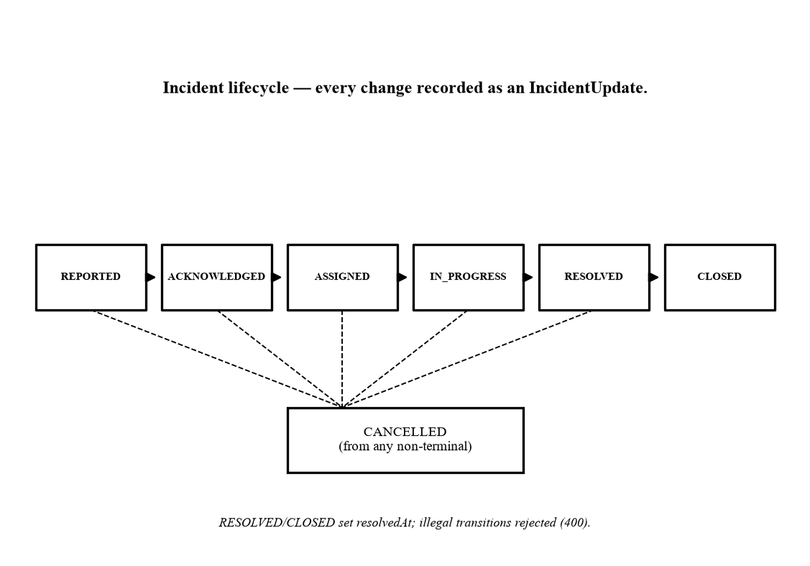
Figure 3.6 — State diagram of the incident lifecycle.

3.14 Location Design
Location is a sensitive, first-class concern. Coordinates originate only from the browser/device geolocation API (one-shot request with a 15-second timeout) or from validated manual entry; the frontend reports explicit outcomes (available, denied, timeout, unavailable, unsupported) and the SOS wizard always offers to continue without coordinates. The backend enforces finite-number checks and the ranges −90…90 (latitude) and −180…180 (longitude), plus a non-negative accuracy, rejecting anything else with field-level 400 errors.
Each accepted coordinate set is stored as a Locations document (latitude, longitude, optional address, city, district, state, postal code, country, accuracy, timestamps) and linked from the incident by locationId; facilities, teams and unsafe reports reuse the same collection, so no duplicate location system exists. A readable address is resolved server-side through OpenStreetMap Nominatim (proper User-Agent, serialized requests with a 1.1-second minimum gap, one-hour cache) and backfilled onto records that lack one, filling only missing fields and never inventing components. Displayed locations lead with the stored address, keep coordinates for verification, show accuracy and capture time, state the device-accuracy caveat, and offer an Open-in-Maps link generated purely from the stored coordinates. When resolution fails the interface shows “Address unavailable — coordinates available” and never crashes. Incident maps use Leaflet with OpenStreetMap tiles to render static markers; there is no live tracking, no watch loop, and no routing or ETA computation.

3.15 AI Risk Assessment Design
The AI component is a deliberately small, deterministic scoring engine — not a trained machine-learning model. It is implemented in Python with FastAPI and Pydantic (ai-service/app/risk.py, app/main.py) and kept as a process fully separate from the Node.js backend, exactly as surveyed in Chapter 2. The engine receives only a fixed factor object assembled by the backend from stored records: priority (LOW/MEDIUM/HIGH/CRITICAL), incident type (Safety/Disaster), counts of verified and unverified unsafe-area reports within 2 km, and the count of other active incidents within 2 km. Free-text descriptions are never transmitted, so prompt-injection style input cannot influence the outcome.
Scoring (model raksha-risk-v1) starts from a priority base (LOW 15, MEDIUM 35, HIGH 60, CRITICAL 80), adds a Disaster modifier (+5, Safety +0), verified reports (+6 each, capped at +30), unverified reports (+2 each, capped at +10) and nearby active incidents (+3 each, capped at +15), then clamps the total to 0–100. The level follows one fixed scale, verified in code and live tests: 0–24 LOW, 25–49 MEDIUM, 50–74 HIGH, 75–100 CRITICAL (for example 63 ⇒ HIGH and 83 ⇒ CRITICAL, both observed during verification). The service returns score, level, model version, the five input factors with their weights, and an ISO timestamp; the backend strictly revalidates every field before storing anything.
The backend calls POST /risk/assess with a 5-second timeout. Unreachable service, timeout, HTTP errors and malformed responses map to clean 502/504 errors; no assessment is stored on failure and the interface offers retry. Stored assessments are served newest-first from the same RiskAssessments record to owner and administrator alike, so both parties always see identical values. The result is presented as decision support with an explicit disclaimer; it predicts nothing, dispatches nobody, guarantees no outcome, and never replaces professional emergency judgement. No external LLM, paid AI API, training pipeline or accuracy claim exists in this implementation.
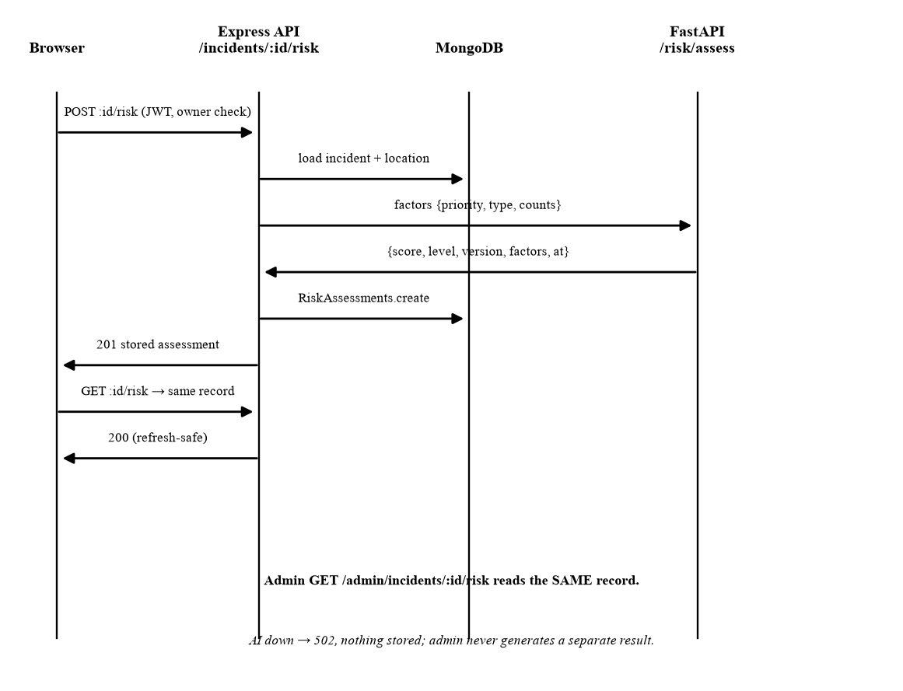
Figure 3.7 — Sequence diagram of AI risk assessment: identical stored result for user and administrator.

3.16 Notification Design
Notifications are event records, not a messaging gateway. After an incident is created, its status changes, a team is assigned, or an assignment is updated, the backend records one In-App notification for the incident owner and one record per opted contact channel (SMS/Email flags on the owner’s emergency contacts). Because the application itself serves the in-app feed, those records are genuinely DELIVERED; channel records are honestly marked NOT_CONFIGURED while no external provider exists, with the provider response stating exactly that. Delivery is therefore never fabricated, and a failure to record never fails the primary operation.
Table 3.5 — Notification channels (source: NotificationChannel enum, notifications service).
Channel | Meaning in this implementation
In-App | Stored and served by the app itself; status DELIVERED.
Email | Recorded per opted contact; NOT_CONFIGURED until a provider is configured.
SMS | Recorded per opted contact; NOT_CONFIGURED until a provider is configured.
WhatsApp | Enumerated channel reserved for a configured provider; no record is produced by the current event service.

Table 3.6 — Notification statuses (source: NotificationStatus enum).
Status | Meaning
QUEUED | Record created; delivery pending.
SENT | Handed to a provider (used when one is configured).
DELIVERED | Confirmed delivery (in-app serving).
FAILED | Provider attempt failed.
NOT_CONFIGURED | No provider configured for this channel.
UNAVAILABLE | Channel unavailable for this event.

3.17 Administrative Functions
The admin console (all routes under /api/admin/*, RequireAdmin) provides: a dashboard with user, incident, team, assignment, notification, unsafe-report, facility and risk aggregates plus recent activity; user search, detail, role/active management and deletion with last-administrator protection; emergency-contact inspection and management with owner search; incident review with validated status control, assignment creation and history; facility and rescue-team CRUD with member management; unsafe-report moderation (filter, verify/unverify, delete); read-only review of the same stored AI risk assessments users see; report generation, snapshot viewing, export and deletion; and full navigation across all of the above. Every significant action appends an AdminLogs record (actor, action, target, details, IP).

3.18 Database Design
The database is MongoDB (Mongoose ODM) with exactly the 15 collections below — the model names as defined in backend/src/models. References between documents are application-level ObjectId links (no joins); ownership, status and time fields are indexed for the guarded, paginated queries. The tables use “Constraint” as the constraint heading and preserve the actual enum values from the source code.
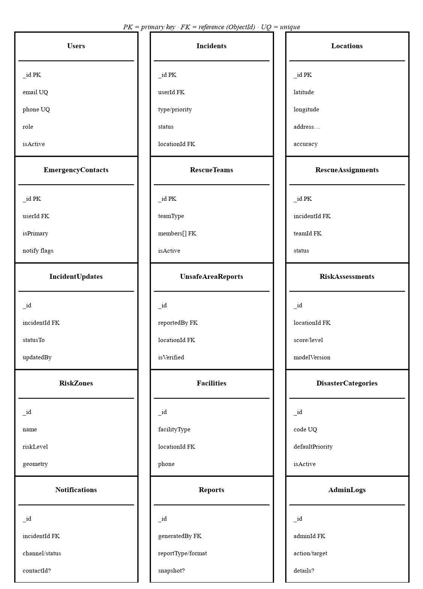
Figure 3.8 — Entity–relationship overview of the 15 collections (PK = key, FK = ObjectId reference, UQ = unique).
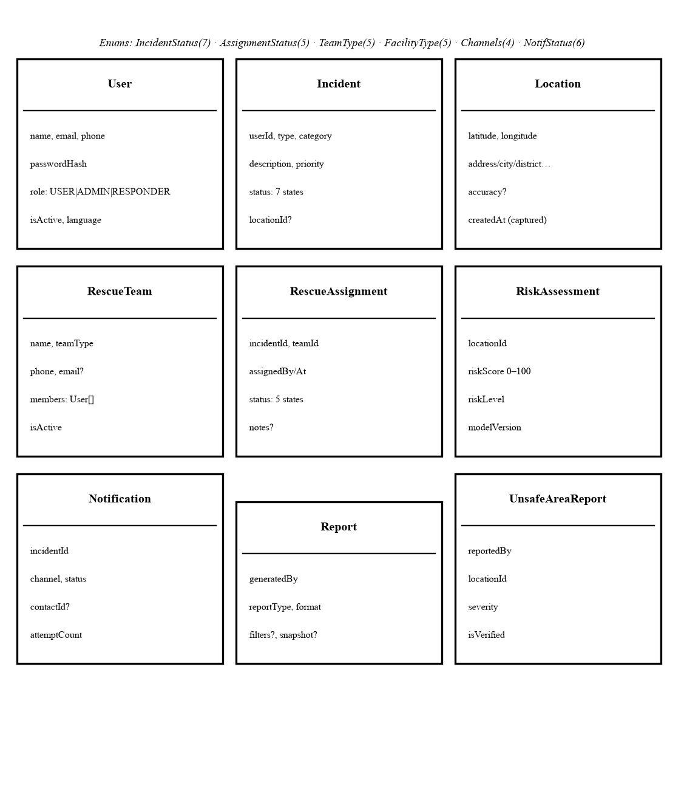
Figure 3.9 — Class overview of the principal domain models with key attributes and shared enums.

Data Dictionary — Users
Purpose: Registered accounts: owners, administrators and responders.
Table 3.7 — Users collection.
Field | Data Type | Constraint | Relationship / Reference
name | String | Required, trimmed | —
email | String | Required, unique, lowercase, indexed | —
phone | String | Required, unique, indexed | —
passwordHash | String | Required (bcrypt, never exposed) | —
role | String | Required, enum USER / ADMIN / RESPONDER | —
language | String | Optional (en / hi preference) | —
isActive | Boolean | Required, default true | —
createdAt / updatedAt | Date | Automatic timestamps | —

Data Dictionary — EmergencyContacts
Purpose: Per-user trusted contacts with channel preferences; exactly one primary each.
Table 3.8 — EmergencyContacts collection.
Field | Data Type | Constraint | Relationship / Reference
_id | ObjectId | Primary key | —
userId | ObjectId | Required, indexed | FK → Users
name / phone | String | Required, trimmed | —
email / relationship | String | Optional | —
notifyViaSms / notifyViaEmail | Boolean | Required, default false | Drives Notifications
isPrimary | Boolean | Required; partial unique index per user | —

Data Dictionary — Incidents
Purpose: SOS and emergency incident cases with lifecycle status.
Table 3.9 — Incidents collection.
Field | Data Type | Constraint | Relationship / Reference
_id | ObjectId | Primary key | —
userId | ObjectId | Required, indexed (ownership) | FK → Users
type | String | Required, enum Safety / Disaster | —
category / description | String | Required, bounded length | —
priority | String | Required, enum LOW / MEDIUM / HIGH / CRITICAL | —
status | String | Required, 7-state enum, default REPORTED | See Section 3.13
locationId | ObjectId | Optional, indexed | FK → Locations
resolvedAt | Date | Set on RESOLVED/CLOSED | —

Data Dictionary — Locations
Purpose: Real geographic points shared by incidents, facilities, teams and reports.
Table 3.10 — Locations collection.
Field | Data Type | Constraint | Relationship / Reference
_id | ObjectId | Primary key | —
latitude | Number | Required, −90…90 | —
longitude | Number | Required, −180…180 | —
address / city / district / state / postalCode / country | String | Optional, server-resolved | —
accuracy | Number | Optional, ≥ 0 metres | —
createdAt | Date | Capture time (shown as Captured) | —

Data Dictionary — Notifications
Purpose: Event records with honest channel outcomes.
Table 3.11 — Notifications collection.
Field | Data Type | Constraint | Relationship / Reference
_id | ObjectId | Primary key | —
incidentId | ObjectId | Required, indexed | FK → Incidents
contactId | ObjectId | Optional, indexed | FK → EmergencyContacts
channel | String | Required, enum Email / SMS / WhatsApp / In-App | —
status | String | Required, 6-state enum, default QUEUED | See Section 3.16
providerResponse / attemptCount / lastAttemptAt | Mixed | Delivery evidence | —

Data Dictionary — RescueTeams
Purpose: Registered response teams and their responder members.
Table 3.12 — RescueTeams collection.
Field | Data Type | Constraint | Relationship / Reference
_id | ObjectId | Primary key | —
name | String | Required, indexed | —
teamType | String | Required, enum Police / Medical / Fire / Volunteer / NGO | —
phone / email | String | Phone required; email optional | —
isActive | Boolean | Required, default true | —
specializations | String[] | Optional list | —
members | ObjectId[] | RESPONDER users only | FK → Users
locationId | ObjectId | Optional base location | FK → Locations

Data Dictionary — RescueAssignments
Purpose: Incident-to-team assignments with validated workflow.
Table 3.13 — RescueAssignments collection.
Field | Data Type | Constraint | Relationship / Reference
_id | ObjectId | Primary key | —
incidentId | ObjectId | Required, indexed | FK → Incidents
teamId | ObjectId | Required, indexed | FK → RescueTeams
assignedBy / assignedAt | ObjectId / Date | Required | FK → Users
status | String | Required, 5-state enum, default ASSIGNED | See Section 3.13
notes | String | Optional, ≤500 chars | —

Data Dictionary — IncidentUpdates
Purpose: Append-only status history of incidents.
Table 3.14 — IncidentUpdates collection.
Field | Data Type | Constraint | Relationship / Reference
_id | ObjectId | Primary key | —
incidentId | ObjectId | Required, indexed | FK → Incidents
updatedBy | ObjectId | Required | FK → Users
statusFrom / statusTo | String | To required; from optional | —
comment | String | Optional | —
createdAt | Date | Automatic (no updates) | —

Data Dictionary — UnsafeAreaReports
Purpose: User-submitted unsafe-place reports pending moderation.
Table 3.15 — UnsafeAreaReports collection.
Field | Data Type | Constraint | Relationship / Reference
_id | ObjectId | Primary key | —
reportedBy | ObjectId | Required, indexed (ownership) | FK → Users
locationId | ObjectId | Required, indexed | FK → Locations
category / description / severity | String | Required bounded text (no fixed enum) | —
isVerified | Boolean | Required, default false | Feeds AI factors

Data Dictionary — RiskZones
Purpose: Structured named risk areas with geometry.
Table 3.16 — RiskZones collection.
Field | Data Type | Constraint | Relationship / Reference
_id | ObjectId | Primary key | —
name | String | Required, indexed | —
riskLevel | String | Required free label | —
geometry | Mixed | Required map shape | —
factors | String[] | Optional | —
lastAssessedAt | Date | Optional | —
isActive | Boolean | Required, default true | —

Data Dictionary — RiskAssessments
Purpose: Stored deterministic AI results keyed by location.
Table 3.17 — RiskAssessments collection.
Field | Data Type | Constraint | Relationship / Reference
_id | ObjectId | Primary key | —
locationId | ObjectId | Required, indexed | FK → Locations
riskScore | Number | Required, integer 0–100 | —
riskLevel | String | Required, enum LOW / MEDIUM / HIGH / CRITICAL | —
modelVersion | String | Required (raksha-risk-v1) | —
inputFactors | Mixed[] | Validated factor list | —
assessedAt | Date | Required | —

Data Dictionary — Facilities
Purpose: Emergency facilities register.
Table 3.18 — Facilities collection.
Field | Data Type | Constraint | Relationship / Reference
_id | ObjectId | Primary key | —
name | String | Required, indexed | —
facilityType | String | Required, 5-value enum | —
locationId | ObjectId | Required, indexed | FK → Locations
phone | String | Required | —
capacity / operatingHours | Number / String | Optional (static figures) | —
isOperational | Boolean | Required, default true | —

Data Dictionary — DisasterCategories
Purpose: Controlled disaster-category reference data.
Table 3.19 — DisasterCategories collection.
Field | Data Type | Constraint | Relationship / Reference
_id | ObjectId | Primary key | —
name | String | Required | —
code | String | Required, unique, uppercase | —
description | String | Optional | —
defaultPriority | String | Required | —
requiresResponseTeam / isActive | Boolean | Required, defaults true | —

Data Dictionary — AdminLogs
Purpose: Append-only administrative audit trail (write-only API).
Table 3.20 — AdminLogs collection.
Field | Data Type | Constraint | Relationship / Reference
_id | ObjectId | Primary key | —
adminId | ObjectId | Required, indexed | FK → Users
action | String | Required, indexed | —
targetType / targetId | String / ObjectId | Required / optional, indexed | —
details / ipAddress | String | Optional | —
createdAt | Date | Automatic (no updates) | —

Data Dictionary — Reports
Purpose: Generated analytical reports with frozen snapshots.
Table 3.21 — Reports collection.
Field | Data Type | Constraint | Relationship / Reference
_id | ObjectId | Primary key | —
generatedBy | ObjectId | Required, indexed | FK → Users
title | String | Required | —
reportType | String | Required: incident-summary / resource-summary / safety-overview | —
filters / dataSnapshot | Mixed | Optional / frozen content | —
format | String | Required, enum PDF / CSV / JSON | —
expiresAt | Date | Optional | —

3.19 Design Diagrams (continued)
The architecture and data-flow views appear in Section 3.10 and the database views in Section 3.18. The remaining behavioural and deployment views follow; each matches the implemented routes, guards, enums and transitions documented above. All diagrams are black-and-white and A4-friendly.
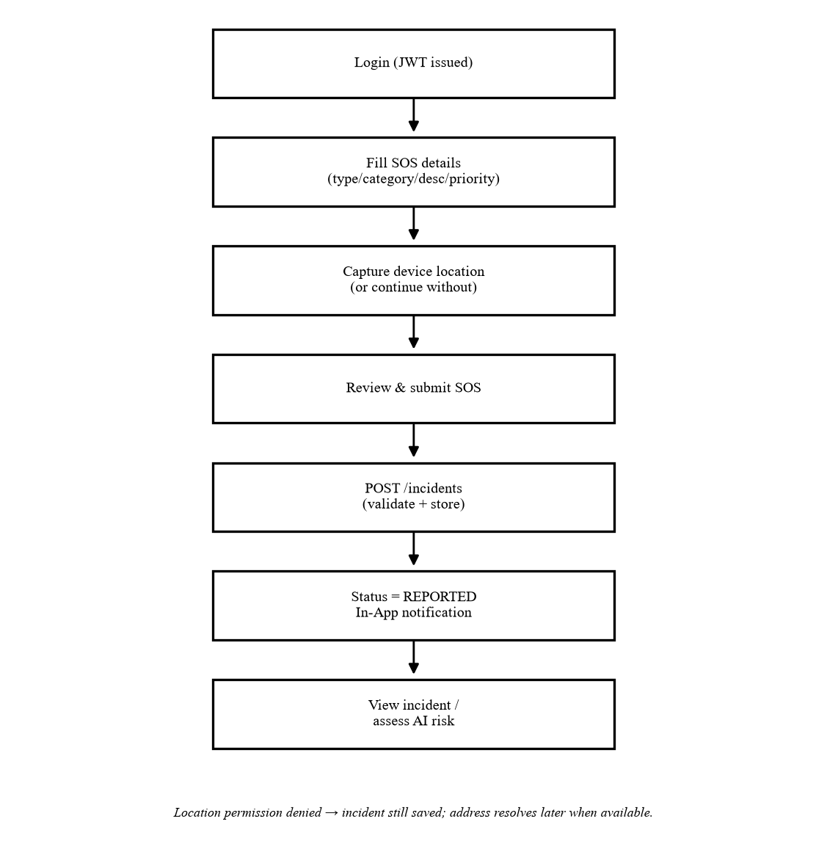
Figure 3.10 — Activity diagram: user SOS reporting.
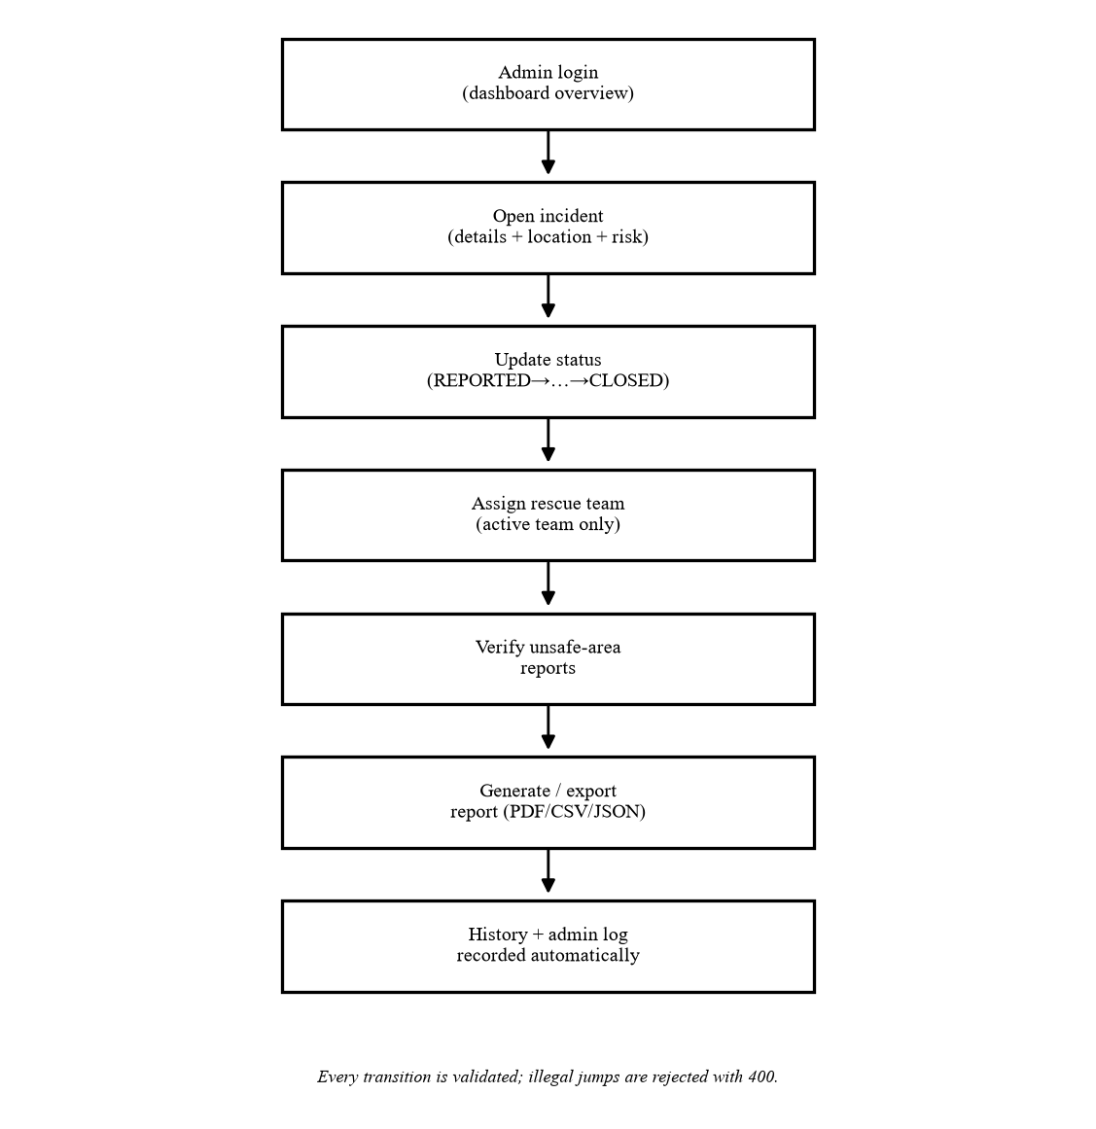
Figure 3.11 — Activity diagram: administrator incident management.
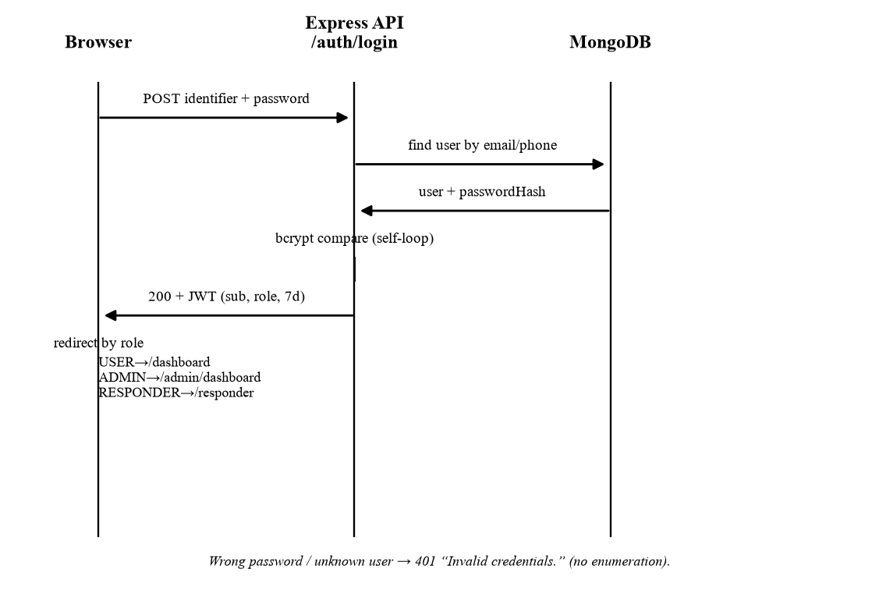
Figure 3.12 — Sequence diagram: login with role-based redirection.
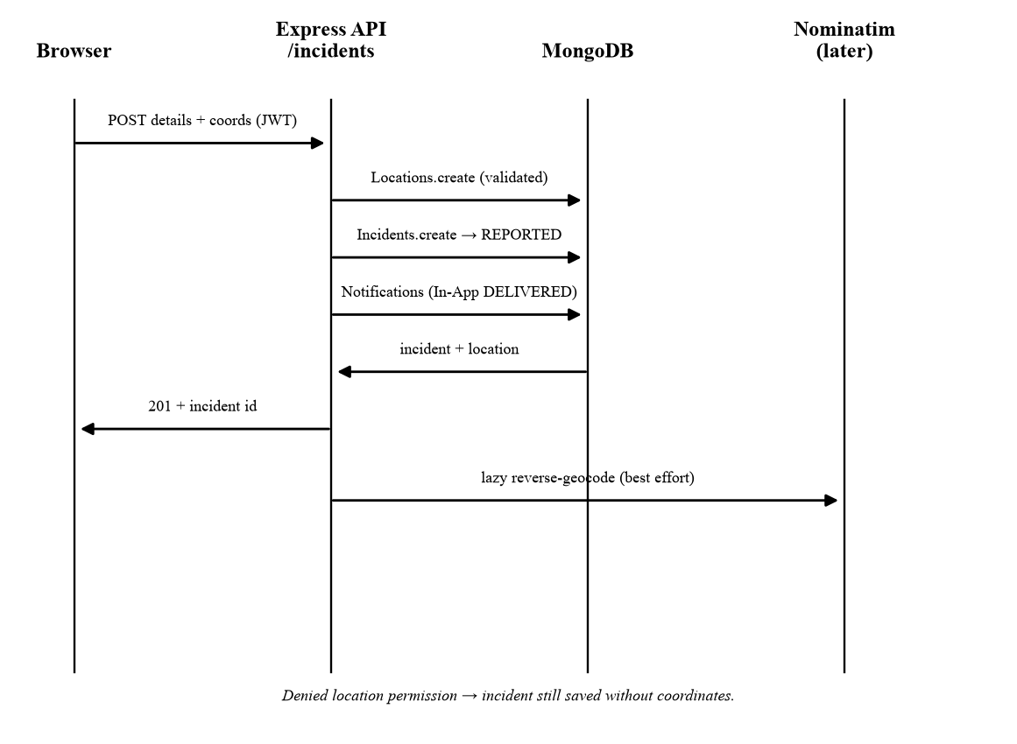
Figure 3.13 — Sequence diagram: SOS submission with real location capture.
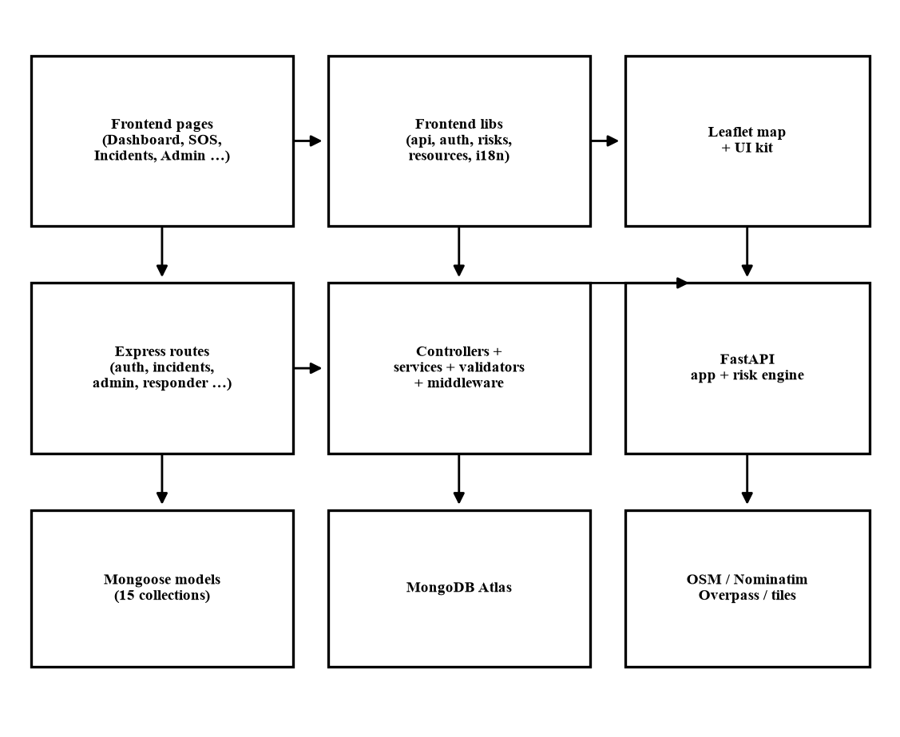
Figure 3.14 — Component diagram: frontend, backend, AI service and data stores.
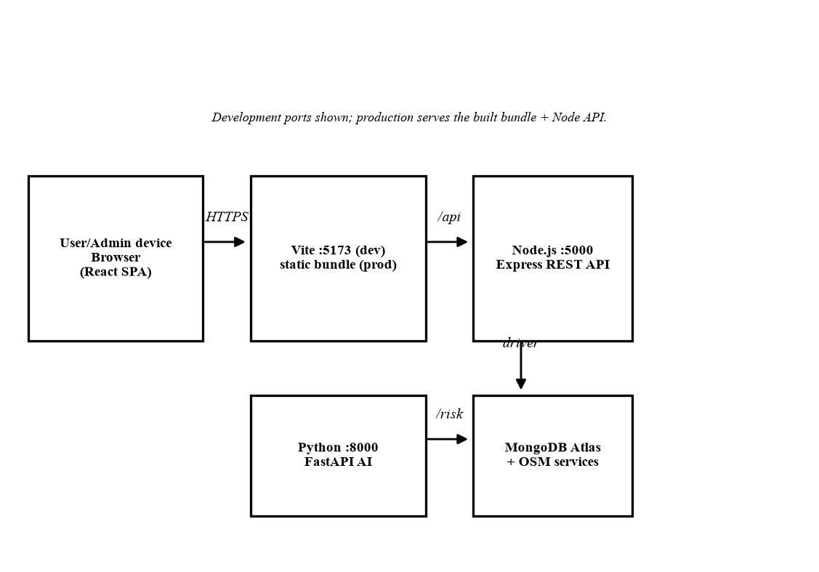
Figure 3.15 — Deployment diagram: browser, dev servers, API, AI service and data services.

3.20 Security Design
- JWT authentication. Signed bearer tokens (default 7-day expiry) verified by requireAuth on every protected route; token role is cross-checked against the stored account on each request when the database is reachable.
- Role-based authorization. requireAdmin guards /api/admin/*, requireResponder guards /api/responder/*, and ownership filters scope all user queries; the interface mirrors these guards but never replaces them.
- Password hashing. bcrypt hashes only; plaintext passwords and hashes never leave the server, and login failures are generic to prevent account enumeration.
- Protected administration. Admin accounts originate server-side only; the last active administrator cannot be demoted, deactivated or deleted; team membership accepts RESPONDER accounts only.
- Ownership checks. Incident, contact, report and risk endpoints resolve identity from the JWT and return 404 for foreign records, so no private data crosses user boundaries.
- Input validation. Every write path validates types, ranges, formats, enums and lengths server-side with field-level 400 responses; coordinates, emails, phones and ObjectIds are all checked.
- Secrets handling. JWT secret, database URI and provider keys live in environment files only; production refuses placeholder secrets; no key or secret is embedded in frontend code or logs.
- Abuse controls. Rate limits on registration, login, incident/report creation and risk scoring; CSV export neutralizes spreadsheet-formula injection; error responses carry messages only, never stack traces or connection details.
- Data protection. Location data travels only on authenticated owner/admin routes and is never logged; MongoDB access is credential-gated at the Atlas layer.

3.21 User Interface Design
The interface is a responsive React single-page application using hash routes, covering desktop, tablet and mobile browsers: tables collapse into cards on small screens, controls stay touch-sized, and every data view defines loading, empty, error and retry states. A light/dark theme (toggle in the header, stored preference, OS default, flicker-free preload) and an English/Hindi language selector with a shared dictionary are built in; the application shell, navigation, dashboard, admin console and common components are translated, while several detail screens still carry some hardcoded English strings, so multilingual coverage is partial rather than complete. Branding uses the RakshaSafe gold/cream/sky palette with a consistent card, badge, dialog, toast and timeline kit. Maps are Leaflet views over OpenStreetMap tiles with static markers and attribution; the AI panel shows score, level badge, model, timestamp, plain-language factors and a short decision-support disclaimer.

3.22 Testing and Verification
Each case below was executed against the running implementation (backend on port 5000 with the Atlas database, AI service on port 8000) using real HTTP requests and real database records; throwaway accounts and records were removed afterwards. Status PASS means the observed result matched the expectation; the Method column states whether it was a live API test or implementation inspection.
Table 3.22 — Verification cases executed against the live implementation.
Test ID | Module | Scenario | Input | Expected Result | Actual Result | Status
T01 | Registration | Valid signup | name/email/phone/password | 201, role USER | 201, role USER | PASS (live)
T02 | Login | Admin sign-in | seeded admin + password | 200, role ADMIN | 200, role ADMIN | PASS (live)
T03 | Login | User sign-in | registered user + password | 200, role USER | 200, role USER | PASS (live)
T04 | Login | Wrong password | valid email + wrong password | 401 generic message | 401 “Invalid credentials.” | PASS (live)
T05 | Login | Unknown account | random email + password | 401 generic message | 401 “Invalid credentials.” | PASS (live)
T06 | Access control | USER hits admin endpoint | user token → /api/admin/… | 403 | 403 “Administrator access required.” | PASS (live)
T07 | Access control | USER opens another user’s incident | second user → victim id | 404, no data | 404 “Incident not found.” | PASS (live)
T08 | Validation | Malformed incident id | GET /incidents/not-an-id | 400 | 400 “Invalid incident id.” | PASS (live)
T09 | Auth | Missing token | GET /incidents/:id/risk, no header | 401 | 401 authentication required | PASS (live)
T10 | Incidents | Create with location | Safety + coords 19.076, 72.8777 | 201 + locationId | 201 + stored lat/lng/accuracy | PASS (live)
T11 | Incidents | Out-of-range coords | latitude 200 / text longitude | 400 field errors | 400 latitude/longitude errors | PASS (live)
T12 | Contacts | Create primary + flags | name/phone/isPrimary/notify flags | 201 stored | 201, primary + SMS/Email true | PASS (live)
T13 | Notifications | Events recorded | create + assign + status change | In-App DELIVERED; channels honest | 4 In-App DELIVERED; 6 NOT_CONFIGURED with reasons | PASS (live)
T14 | Incidents | Status transition | REPORTED → ACKNOWLEDGED + comment | 200 + history + admin log | 200 + IncidentUpdate + AdminLog entry | PASS (live)
T15 | Assignments | Create assignment | active team → incident | 201 ASSIGNED | 201 ASSIGNED | PASS (live)
T16 | Responder | Login + progress work | seeded responder, PATCH EN_ROUTE | 200 EN_ROUTE | 200 EN_ROUTE; 1 assignment listed | PASS (live)
T17 | Unsafe reports | Report + verify | category/severity/location; admin verify | 201 unverified → 200 verified | 201 isVerified=false → 200 true | PASS (live)
T18 | Facilities | Create + user list | Hospital + coords; user GET | 201; visible to users | 201; listed (21 incl. seed data) | PASS (live)
T19 | Teams | Create + membership rule | Medical team; add USER vs RESPONDER | 201; USER rejected 400 | 201; “Only RESPONDER accounts…” | PASS (live)
T20 | Reports | Generate + export + delete | incident-summary PDF | 201; %PDF- download; deleted | 201; magic %PDF-; deleted | PASS (live)
T21 | AI risk | Assess + persistence | POST risk twice on real incident | 201 deterministic; GET same | 65 HIGH twice; history kept | PASS (live)
T22 | AI risk | Service unavailable | stop FastAPI, POST risk | 502 clean, nothing stored | 502; count unchanged; backend alive | PASS (live)
T23 | Health | Dependency status | GET /api/health | connected:true | state 1, connected true | PASS (live)
T24 | Builds | Type checks + bundles | tsc, vite build, oxlint | 0 errors | 0 errors; bundles built | PASS (live)

3.23 Limitations
- External notification providers (email, SMS, WhatsApp) require configuration; until then only in-app delivery is real and channel records report NOT_CONFIGURED.
- Browser location depends on user permission, device capability, network conditions and available location services; denied permission means coordinate-free incidents.
- Address resolution depends on the Nominatim service and its usage policy; failures degrade to coordinates-only display.
- Map, nearby-facility and weather enrichment depend on their respective configured services and degrade independently.
- The AI risk assessment is advisory decision support only: no prediction guarantee, no accuracy claim, no emergency authority.
- No emergency response, rescue arrival, police FIR, hospital-bed figures or ETAs are produced or guaranteed by the software.
- There is no offline mode: normal web functionality requires internet connectivity and database availability.
- Multilingual coverage is partial (English/Hindi shell translated; some detail screens retain English strings).
- Administrative audit logs are write-only through the API; no listing or export endpoint exists for them.

3.24 Future Enhancements (not implemented)
- Native mobile application with push notifications and background location (with consent).
- Offline emergency queue that synchronizes reports when connectivity returns.
- Verified integrations with real emergency services (police/ambulance APIs) where legally and technically available.
- Advanced machine-learning risk models trained on historical data (e.g. decision-tree/random-forest alert analysis as surveyed in Chapter 2).
- Live responder tracking and richer interactive map visualization.
- Configured external email/SMS/WhatsApp providers for real channel delivery.
- Complete Hindi (and additional language) coverage of every screen.
- Voice-based SOS interaction as an accessibility enhancement.

3.25 Chapter Summary and Conformance

Sections created
3.1 Introduction; 3.2 Existing System; 3.3 Problems in Existing System; 3.4 Proposed System; 3.5 Objectives; 3.6 Scope; 3.7 Feasibility Study (3.7.1 Technical, 3.7.2 Economic, 3.7.3 Operational); 3.8 Requirements Analysis (3.8.1 Functional FR-1–FR-23, 3.8.2 Non-Functional); 3.9 User Roles; 3.10 System Architecture; 3.11 Technology Stack; 3.12 Module Description (3.12.1–3.12.14); 3.13 Incident Status Lifecycle; 3.14 Location Design; 3.15 AI Risk Assessment Design; 3.16 Notification Design; 3.17 Administrative Functions; 3.18 Database Design (15 data dictionaries); 3.19 Design Diagrams; 3.20 Security Design; 3.21 User Interface Design; 3.22 Testing and Verification; 3.23 Limitations; 3.24 Future Enhancements; 3.25 Chapter Summary.

Diagrams created
Figure 3.1 System context · 3.2 System architecture · 3.3 Use case · 3.4 DFD level 0 · 3.5 DFD level 1 · 3.6 ER overview · 3.7 Class overview · 3.8 User SOS activity · 3.9 Admin activity · 3.10 Login sequence · 3.11 SOS sequence · 3.12 AI risk sequence · 3.13 Incident state diagram · 3.14 Component diagram · 3.15 Deployment diagram.

Database collections verified
All 15 verified against backend/src/models: Users, EmergencyContacts, Incidents, Locations, Notifications, RescueTeams, RescueAssignments, IncidentUpdates, UnsafeAreaReports, RiskZones, RiskAssessments, Facilities, DisasterCategories, AdminLogs, Reports. No other collection (PoliceCases, Hospitals, Responders, Messages or similar) exists in the codebase, and none is documented.

Features correctly excluded as not implemented
Offline SOS; automatic police FIR; automatic police/ambulance dispatch; guaranteed rescue response or ETA; real-time hospital bed availability; guaranteed WhatsApp/SMS/email delivery; shake-to-SOS; live map tracking or routing; GPS-nearest routing; machine-learning training or prediction claims; fake locations, addresses, resources or AI results. Each is either omitted or labelled future work.

Chapter 2 confirmation
Chapter 2 (CHAPTER_2_UPDATED.pdf) was read and used as the terminology, stack, scope and concept source of truth. It was not modified in any way. Terminology (RakshaSafe, web-based Women Safety and Disaster Management System), the full technology stack, the module/collection vocabulary, the AI-service concept, the location concept and the configured-provider communication concept in this chapter match Chapter 2 throughout.

