RAKSHASAFE WOMEN'S SAFETY SYSTEM
Data Flow Diagrams - Levels 0, 1 and 2
Black-and-white StarUML / Yourdon-DeMarco style
Rendered from PlantUML sources at native resolution
Each diagram is placed on its own portrait page

Contents
This document contains the complete data-flow decomposition of RakshaSafe: the level-0 context diagram, the level-1 major-process level, and three level-2 expansions (Incident Management, Admin Dashboard & Reports, and Notifications & AI Risk). Every diagram is derived from the implemented backend modules and the live API behaviours verified during testing (Chapter 6).
# | Diagram | Filename
1 | DFD Level 0 - Context Diagram | dfd-level0.puml
2 | DFD Level 1 - Major Processes (1.0 to 10.0) | dfd-level1.puml
3 | DFD Level 2 - Incident Management detail | dfd-level2-incident.puml
4 | DFD Level 2 - Admin Dashboard & Reports detail | dfd-level2-admin.puml
5 | DFD Level 2 - Notifications & AI Risk detail | dfd-level2-notifications.puml

Notation Legend
A strict black-and-white notation is used so the diagrams reproduce cleanly in print: processes are numbered circles or rounded boxes, external entities are squares / actor symbols, data stores are the classic open-ended D* symbols, and arrows carry the name of the data that moves.
Symbol | Meaning
Numbered circle / rounded box, e.g. 2.2 | Process - transforms incoming data; sub-numbering expands one higher-level process
Square / hollow rectangle | External entity - person or external system
Open-ended storage box D0...D10 | Data store - MongoDB collection (D2a = incident updates)
Directed arrow | Data flow; label states what data moves
Dashed arrow | Control / audit trigger, not a data flow

Figure D-1: DFD Level 0 - Context Diagram
The entire RakshaSafe system as a single process with its external actors: Citizen/User, Emergency Responder, Administrator, SMS Gateway, Email Provider and the AI Risk Service.
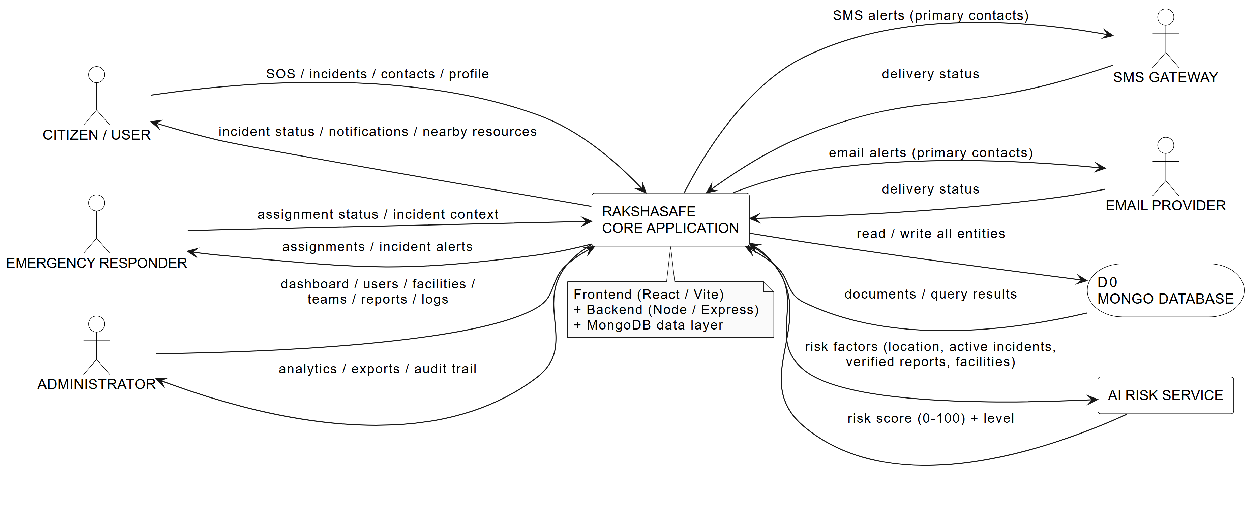
Captured from dfd-level0.puml - black-and-white, editable in draw.io / PlantUML.
The context diagram defines the system boundary. Human actors are the Citizen/User (SOS incidents, emergency contacts, profile), the Emergency Responder (assignments and incident context) and the Administrator (dashboard, users, facilities, teams, reports and logs). External systems communicate through SMS and email providers, and the AI Risk Service supplies a 0-100 risk score. All entities persist in the MongoDB data store (D0).

Figure D-2: DFD Level 1 - Major Processes (1.0 to 10.0)
Decomposition into ten major processes (1.0 to 10.0) with their associated data stores D1, D2, D3, D4, D5, D6, D7, D8, D9 and D10.
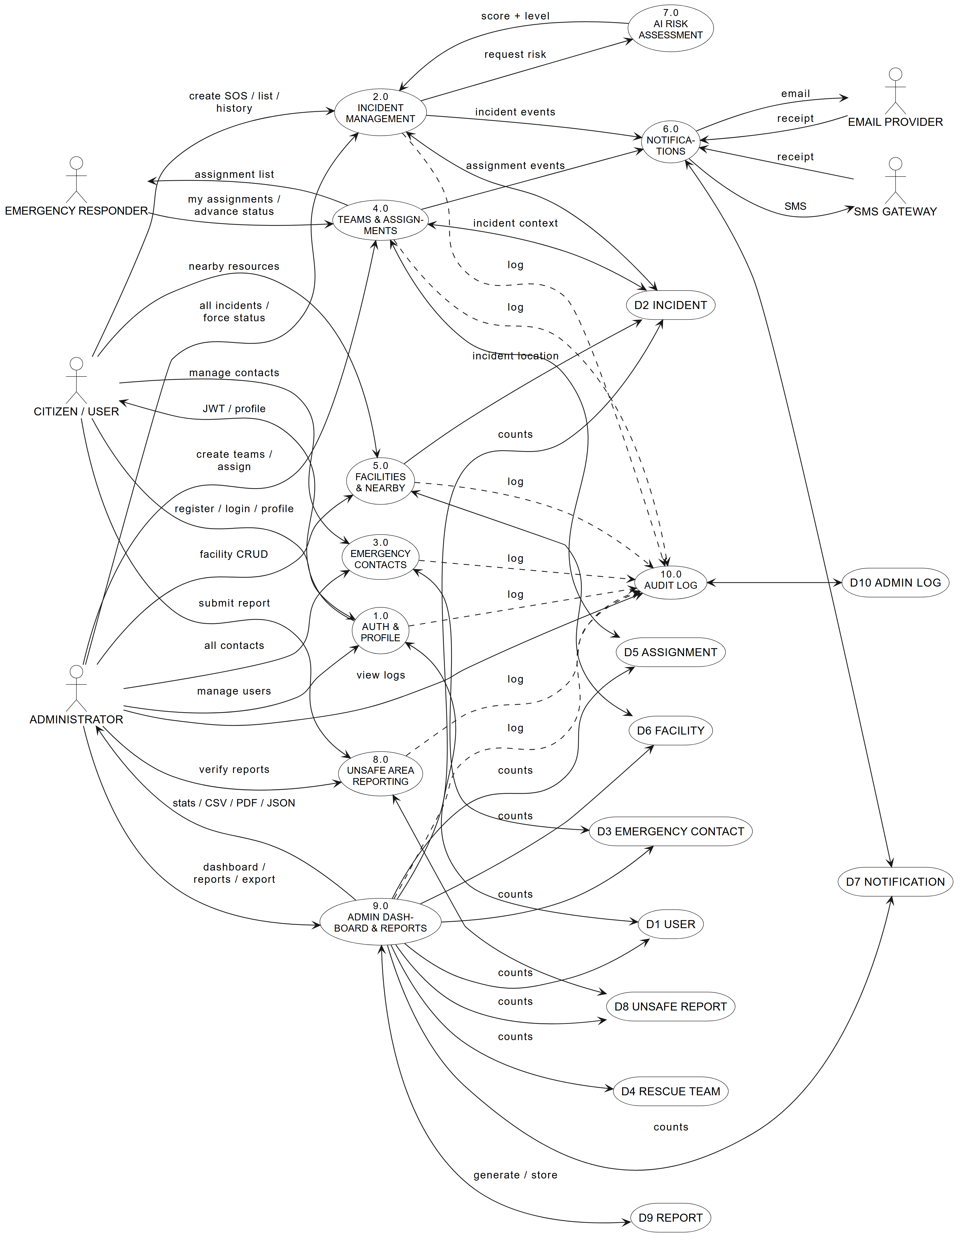
Captured from dfd-level1.puml - black-and-white, editable in draw.io / PlantUML.
Level 1 shows the ten processes that mirror the implemented modules: 1.0 Auth & Profile, 2.0 Incident Management, 3.0 Emergency Contacts, 4.0 Teams & Assignments, 5.0 Facilities & Nearby, 6.0 Notifications, 7.0 AI Risk Assessment, 8.0 Unsafe Area Reporting, 9.0 Admin Dashboard & Reports and 10.0 Audit Log. Notification dispatch (6.0) is driven by incident and assignment events; every administrative mutation is recorded to D10 ADMIN LOG through the dashed control flows.

Figure D-3: DFD Level 2 - Incident Management Detail
Expansion of process 2.0 into eight sub-processes (2.1 to 2.8) covering creation, validation, persistence, status workflow, ownership, risk trigger, history and assignment linking.
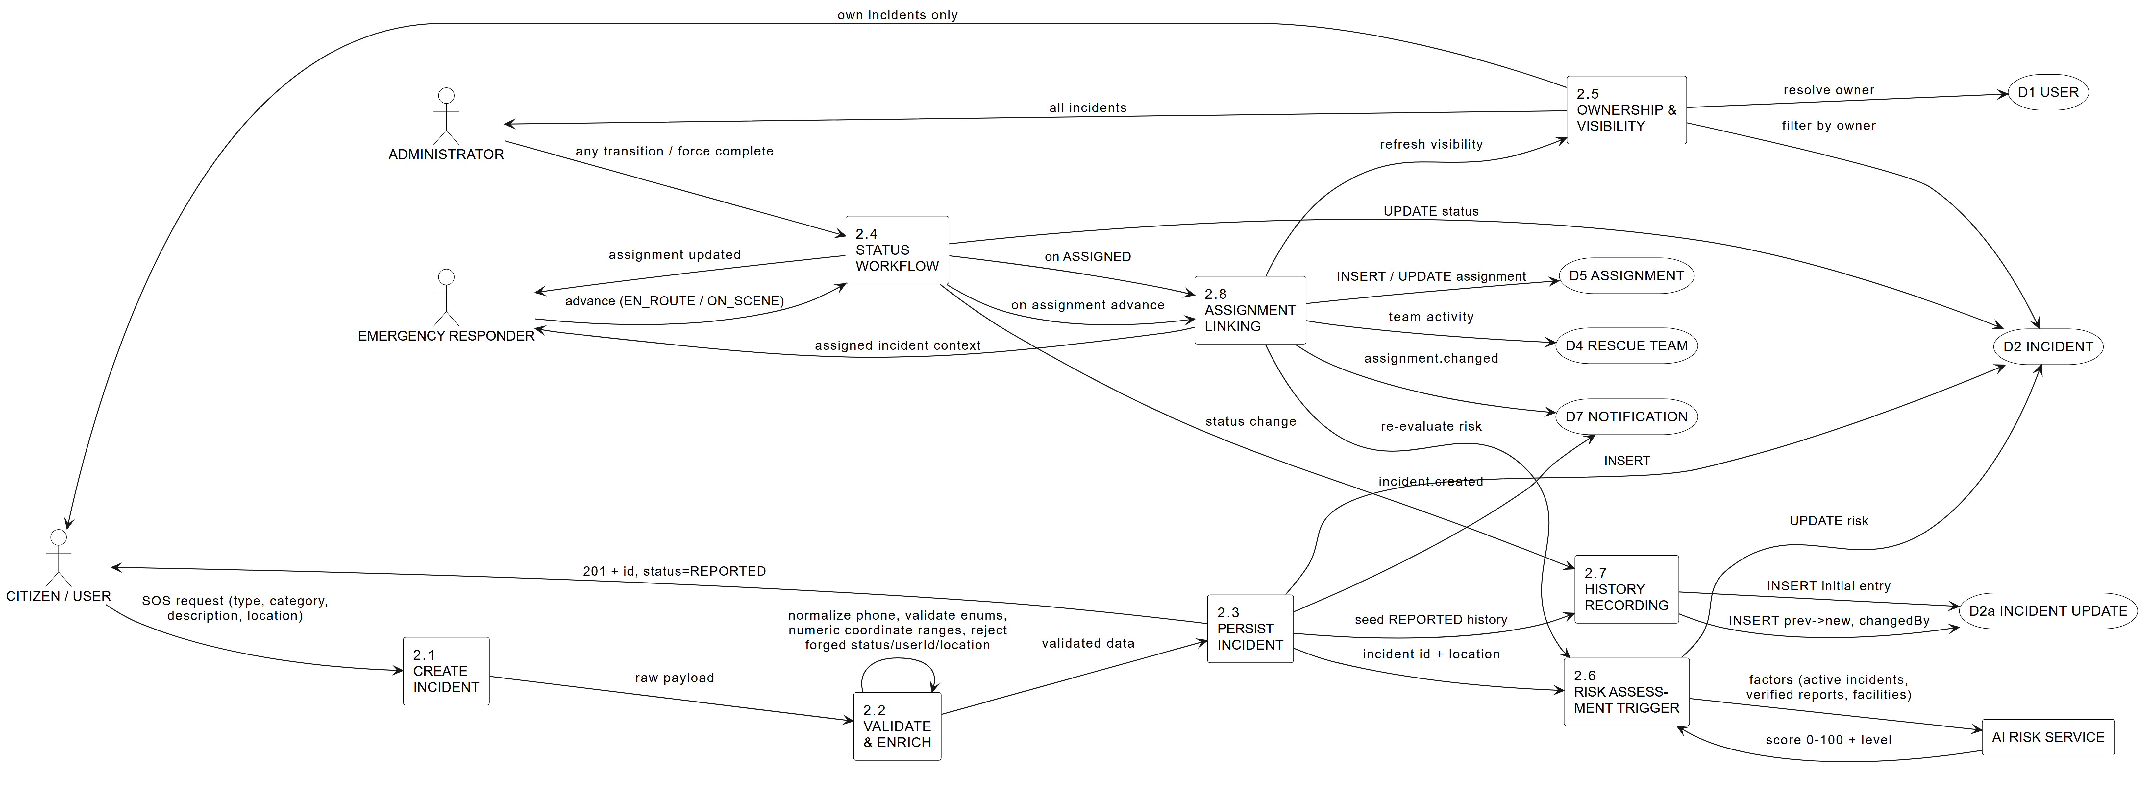
Captured from dfd-level2-incident.puml - black-and-white, editable in draw.io / PlantUML.
2.1 receives the SOS request; 2.2 applies the business rules proven by the unit validators (phone normalisation, enum checks, coordinate ranges, rejection of forged fields); 2.3 persists the incident and seeds its history in D2a; 2.4 enforces the status workflow (REPORTED, EN_ROUTE, ON_SCENE, RESOLVED, CLOSED); 2.6 triggers the AI risk service and 2.8 links assignments and re-evaluates risk after transitions. Notation events such as incident.created and assignment.changed are emitted to the notification store (D7).

Figure D-4: DFD Level 2 - Admin Dashboard & Reports Detail
Expansion of processes 9.0 and 10.0 into eight sub-processes (9.1 to 9.8) covering the dashboard, management screens, report generation, export and the audit-log viewer.
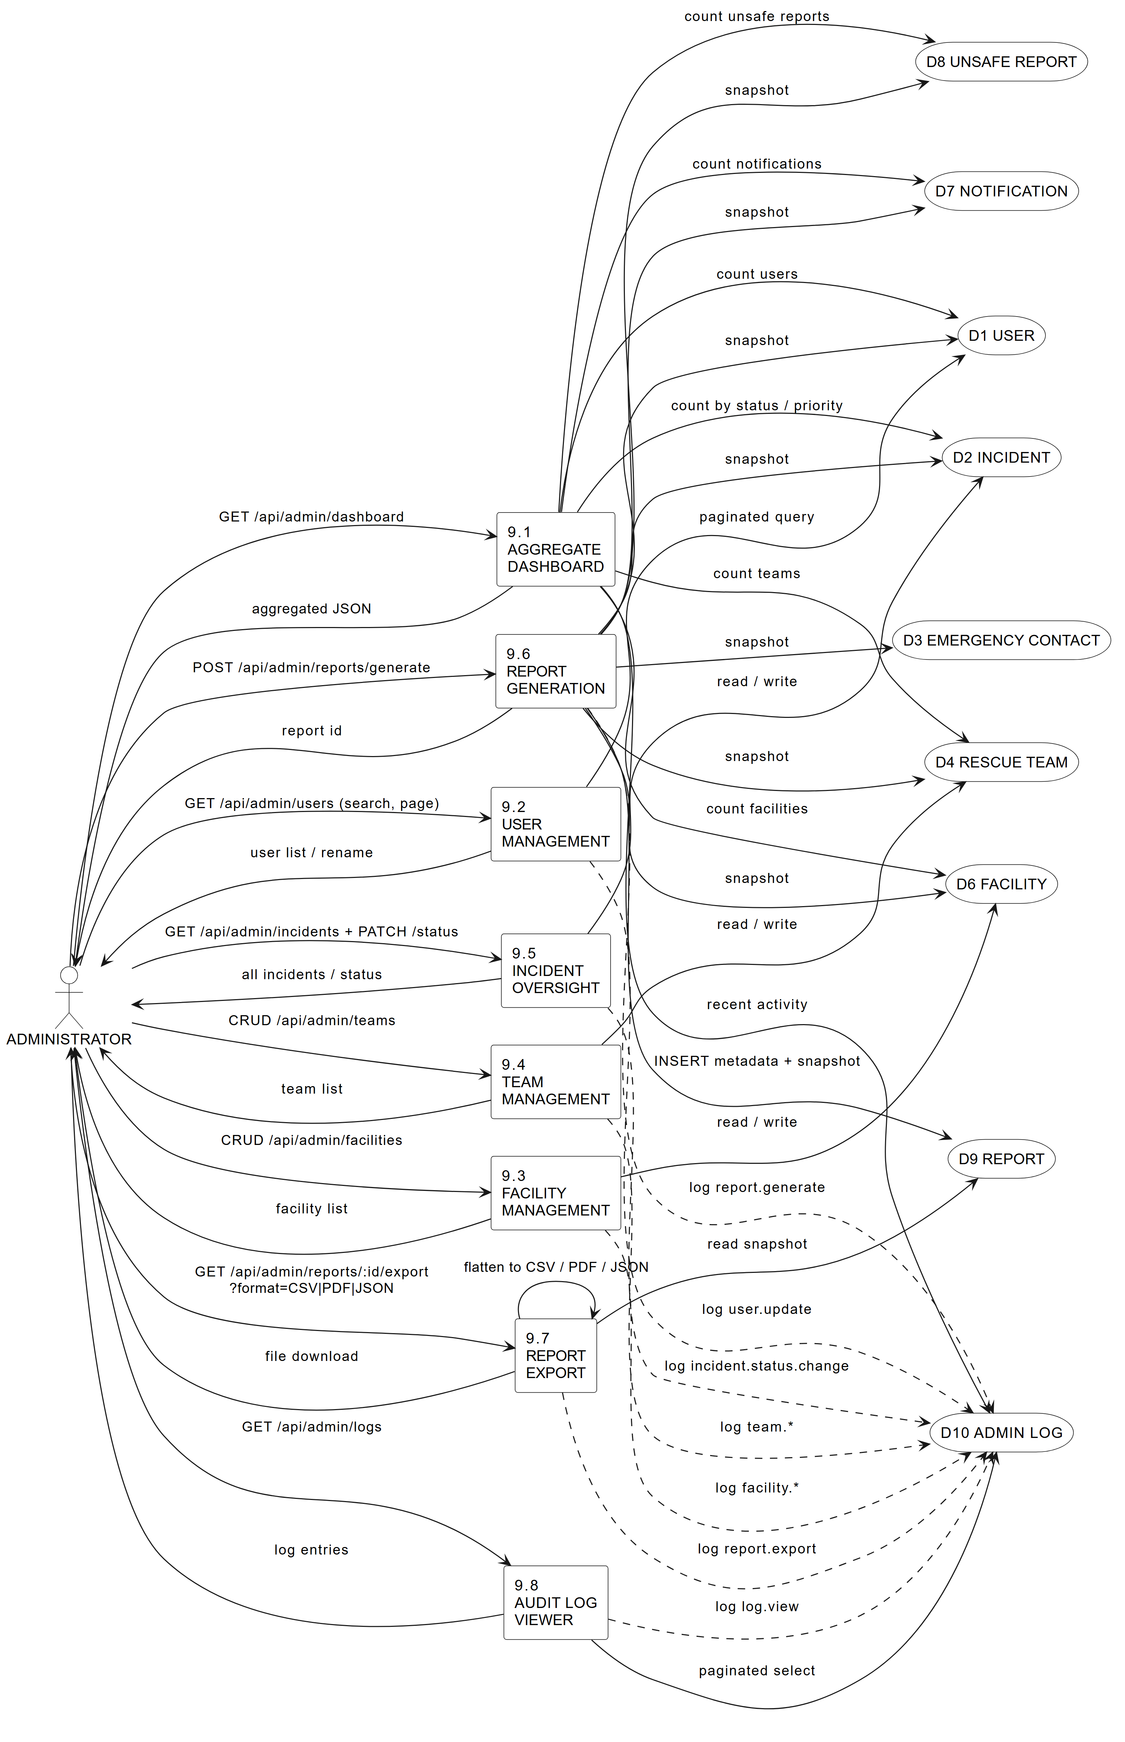
Captured from dfd-level2-admin.puml - black-and-white, editable in draw.io / PlantUML.
9.1 aggregates live counts across seven collections; 9.2-9.5 wrap the management end points and log every mutation to D10 ADMIN LOG; 9.6 snapshots seven stores and stores the report with its snapshot in D9; 9.7 exports CSV/PDF/JSON; 9.8 is the read side of the audit trail. Requests map to real API routes (GET /api/admin/dashboard, /users, /facilities, /teams, /incidents, /reports, /logs).

Figure D-5: DFD Level 2 - Notifications & AI Risk Detail
Expansion of processes 6.0 and 7.0 into six sub-processes (6.1 to 6.3, 7.1 to 7.3) covering notification channels, delivery status and AI risk factor scoring.
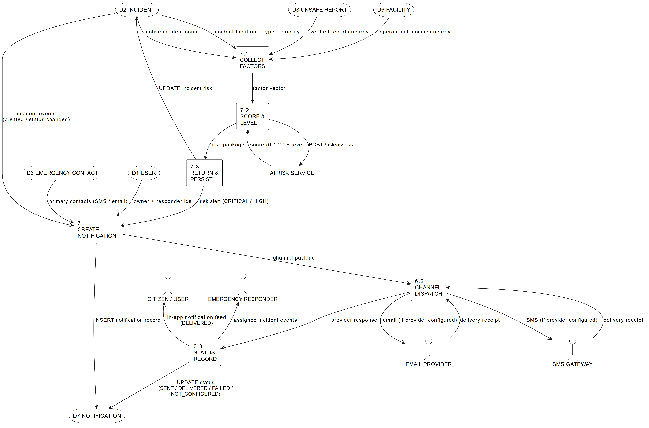
Captured from dfd-level2-notifications.puml - black-and-white, editable in draw.io / PlantUML.
6.1 materialises each notification from the incident event plus primary-contact and recipient lookups; 6.2 dispatches to SMS and email only when a provider is configured; 6.3 records the provider response (SENT / DELIVERED / FAILED / NOT_CONFIGURED) and feeds the in-app feed. On the risk side, 7.1 collects the live factor vector (incident location/type/priority, nearby verified reports, nearby operational facilities, active incident count), 7.2 calls POST /risk/assess, and 7.3 persists the score and raises CRITICAL/HIGH alerts back into the notification flow.

