Figure 1: ER Diagram - Entity Relationship Model
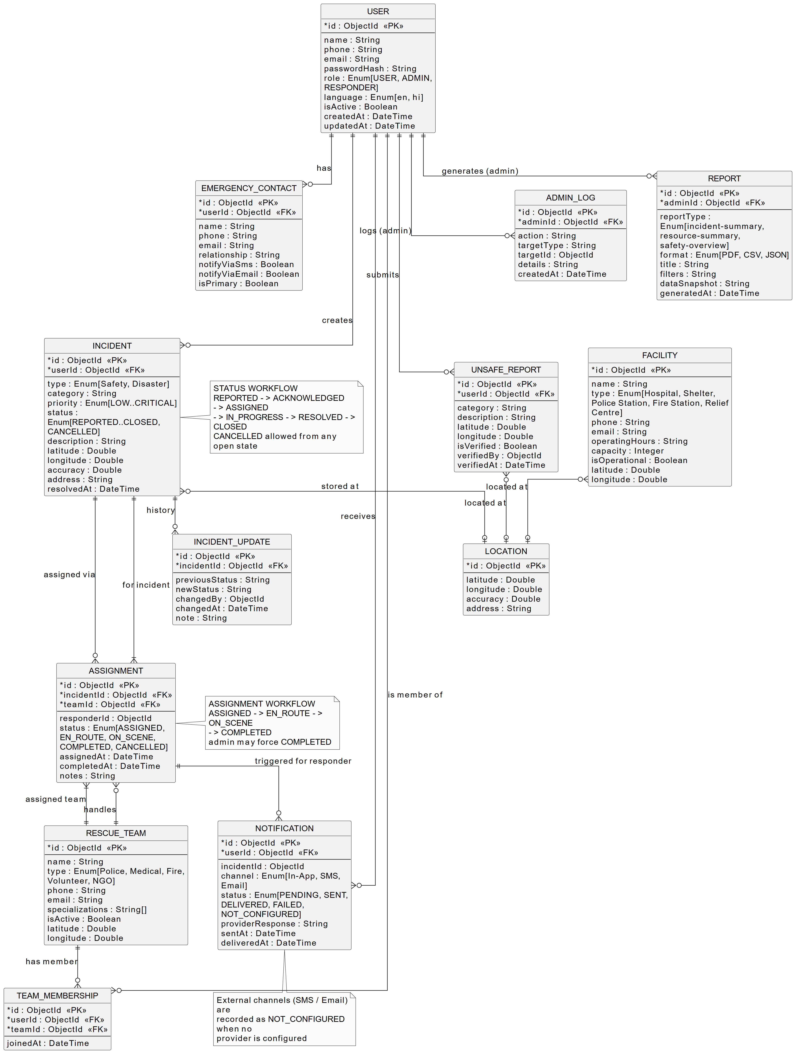

Figure 2: DFD Level 0 - Context Diagram
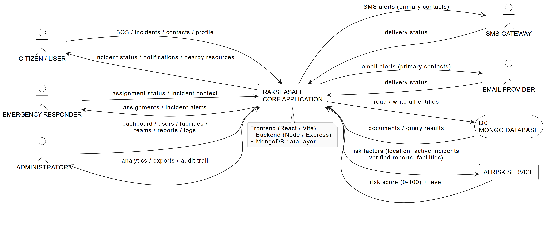

Figure 3: DFD Level 1 - Major Processes (1.0 to 10.0)
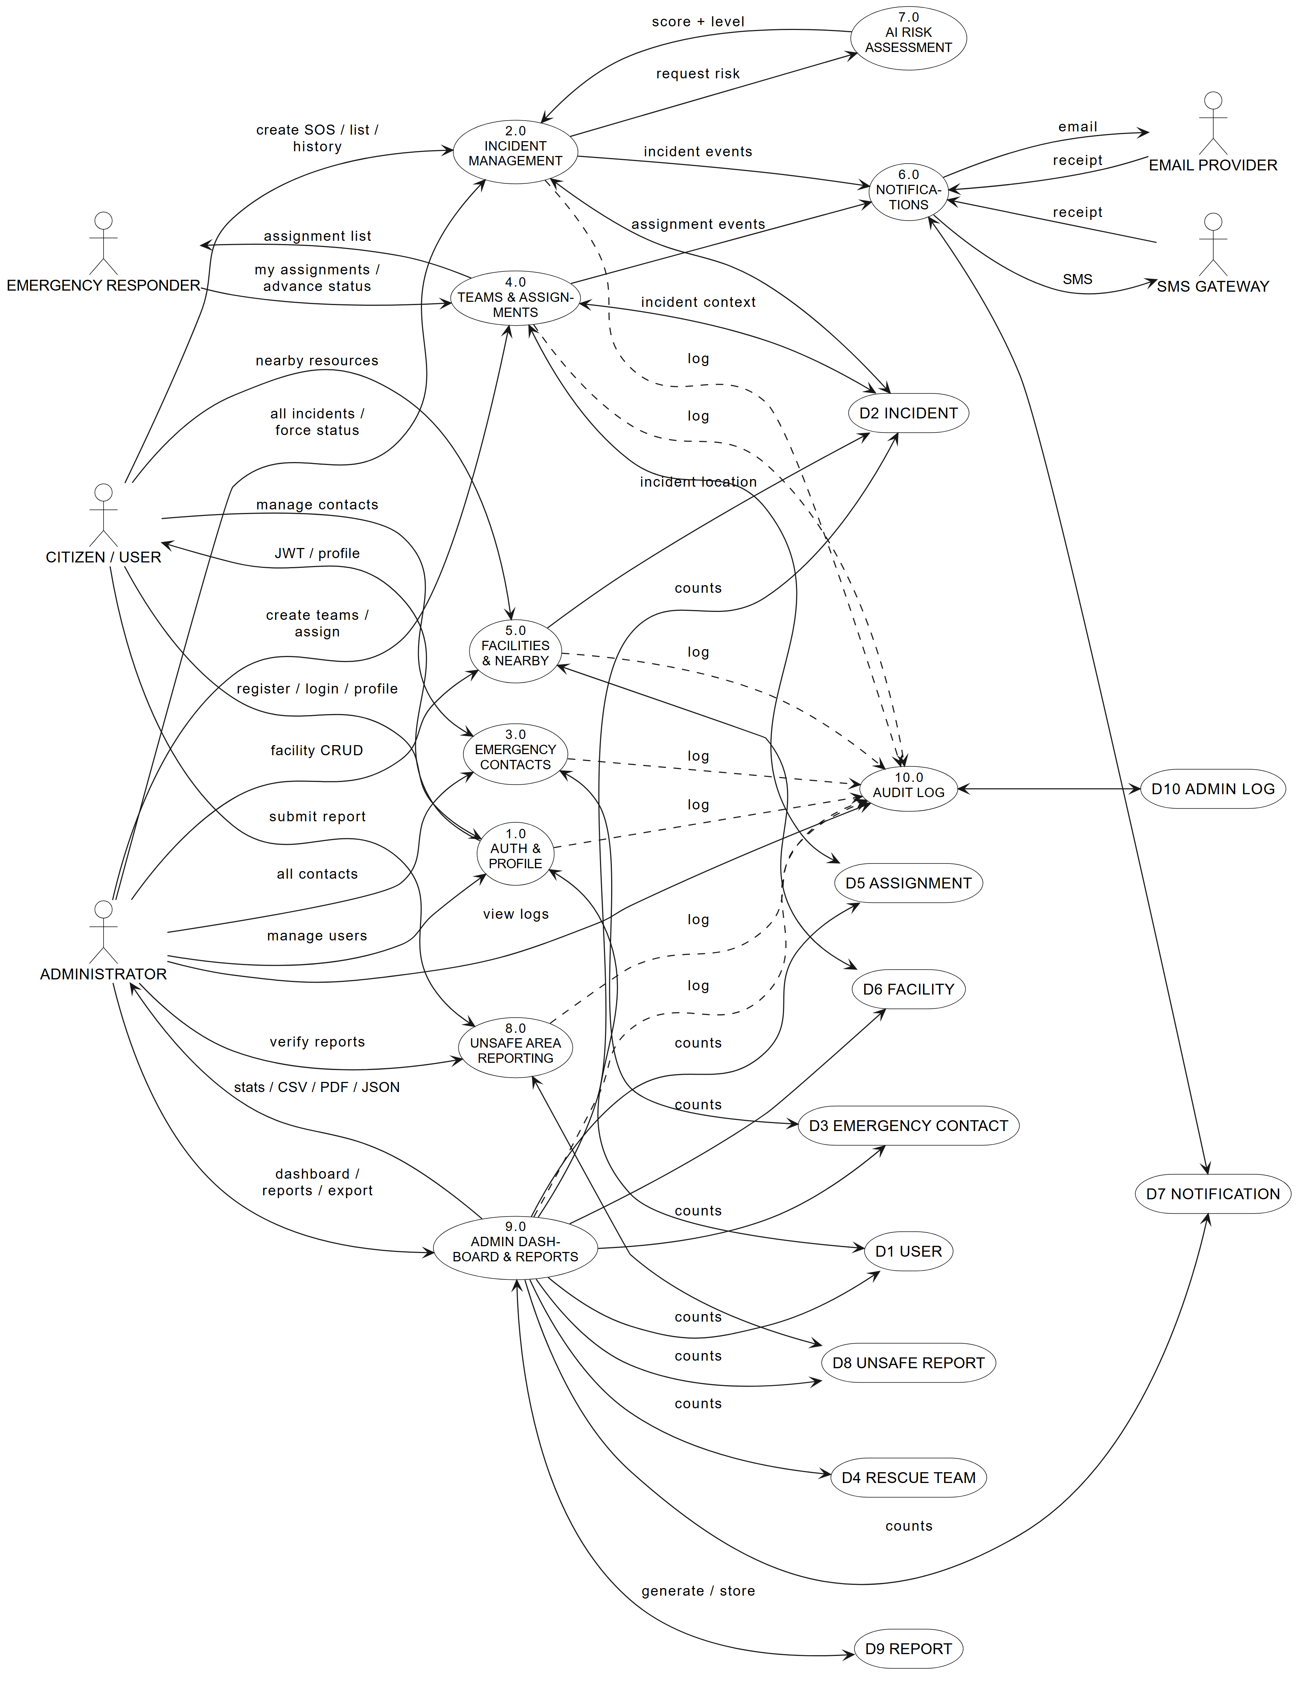

Figure 4: DFD Level 2 - Incident Management
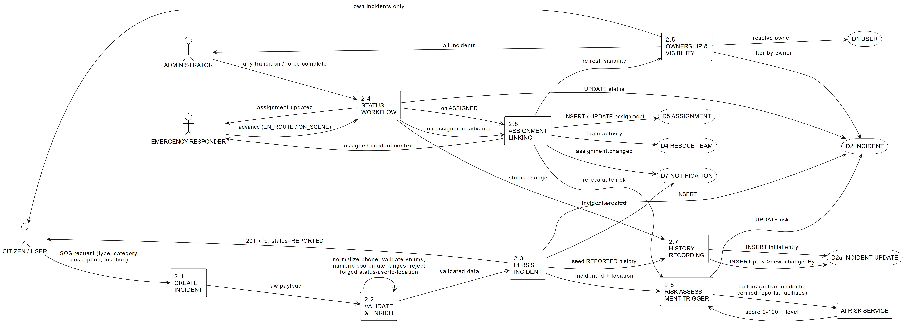

Figure 5: DFD Level 2 - Admin Dashboard & Reports
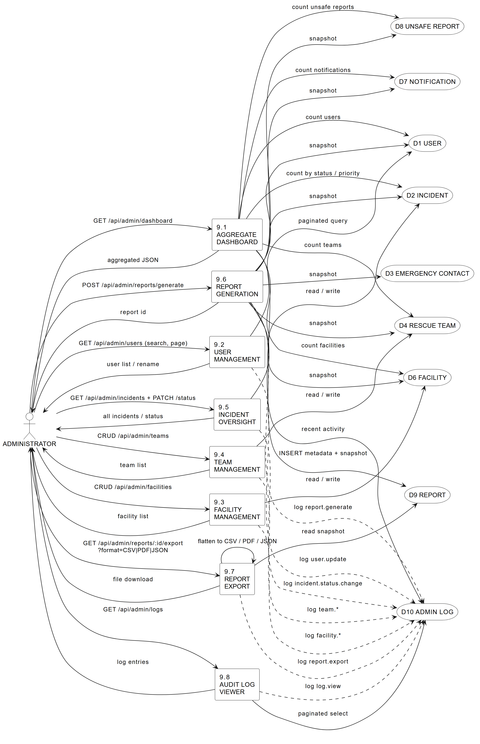

Figure 6: DFD Level 2 - Notifications & AI Risk
