RAKSHASAFE WOMEN'S SAFETY SYSTEM
Design Diagrams - ER Model and Data Flow Diagrams (Levels 0, 1, 2)
Black-and-white StarUML-style diagrams
Rendered from PlantUML sources (PlantUML public server + local rendering)
Diagrams are embedded at native resolution for print / submission

Contents
This document bundles the complete set of black-and-white design diagrams for RakshaSafe: one entity-relationship (ER) diagram and a three-level data-flow decomposition (context / major processes / detailed processes). Every diagram is derived from the implemented backend data model and the live API behaviours verified during testing (Chapter 6).
# | Diagram | Filename
1 | ER Diagram - Entity Relationship Model | er.puml
2 | DFD Level 0 - Context Diagram | dfd-level0.puml
3 | DFD Level 1 - Major Processes (1.0 to 10.0) | dfd-level1.puml
4 | DFD Level 2 - Incident Management detail | dfd-level2-incident.puml
5 | DFD Level 2 - Admin Dashboard & Reports detail | dfd-level2-admin.puml
6 | DFD Level 2 - Notifications & AI Risk detail | dfd-level2-notifications.puml

Notation Legend (StarUML / Yourdon-DeMarco style)
All diagrams use a strict black-and-white notation so they reproduce cleanly in print and comply with examination formatting: separate entities as rectangles (ER), processes as circles (DFD), external actors as squares, and data stores as the classic open-ended symbol. Arrows show the direction of data movement; numbered processes (for example “2.1 Create Incident”) allow each lower level to decompose one higher-level process.
Symbol | Meaning
Named rectangle with fields (ER) | Entity / table with attributes; PK and FK marked
Circle with number and name (DFD) | Process (17 classic list); e.g. 2.2 Validate & Enrich
Square / hollow rectangle | External entity - person or external system
Open-ended storage box (D*) | Data store - e.g. D2 INCIDENT (MongoDB collection)
Directed arrow | Data flow; label states what data moves
Dashed arrow | Control / audit trigger, not a data flow

Diagram 1 - ER Diagram - Entity Relationship Model
The model centres on USER (identity, role, language, isActive) and INCIDENT. INCIDENT carries single-owner semantics (one user creates many incidents) and keeps a full history through INCIDENT_UPDATE. RESCUE_TEAM links to users through TEAM_MEMBERSHIP and to incidents through ASSIGNMENT, whose status workflow is enforced by the assignment validator. NOTIFICATION records both in-app events (DELIVERED) and external channel outcomes, including NOT_CONFIGURED when no provider is set. ADMIN_LOG and REPORT records keep administrative actions accountable.
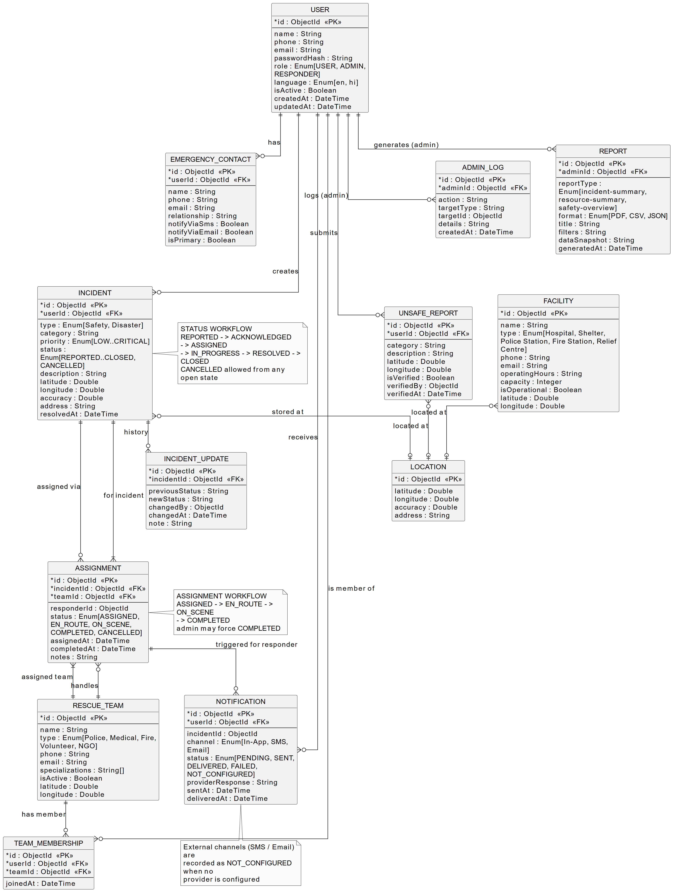
Figure 1: RakshaSafe ER model - eleven entities, user-centric core, incident workflow and assignment chains, notifications, unsafe reports, facilities and audit logging.

Diagram 2 - DFD Level 0 - Context Diagram
The context diagram shows RakshaSafe as one black box. Citizen/User, Emergency Responder and Administrator are the human actors; SMS Gateway and Email Provider are the external communication systems; AI Risk Service is the decision-support provider. All data ultimately persists to the MongoDB store (D0).
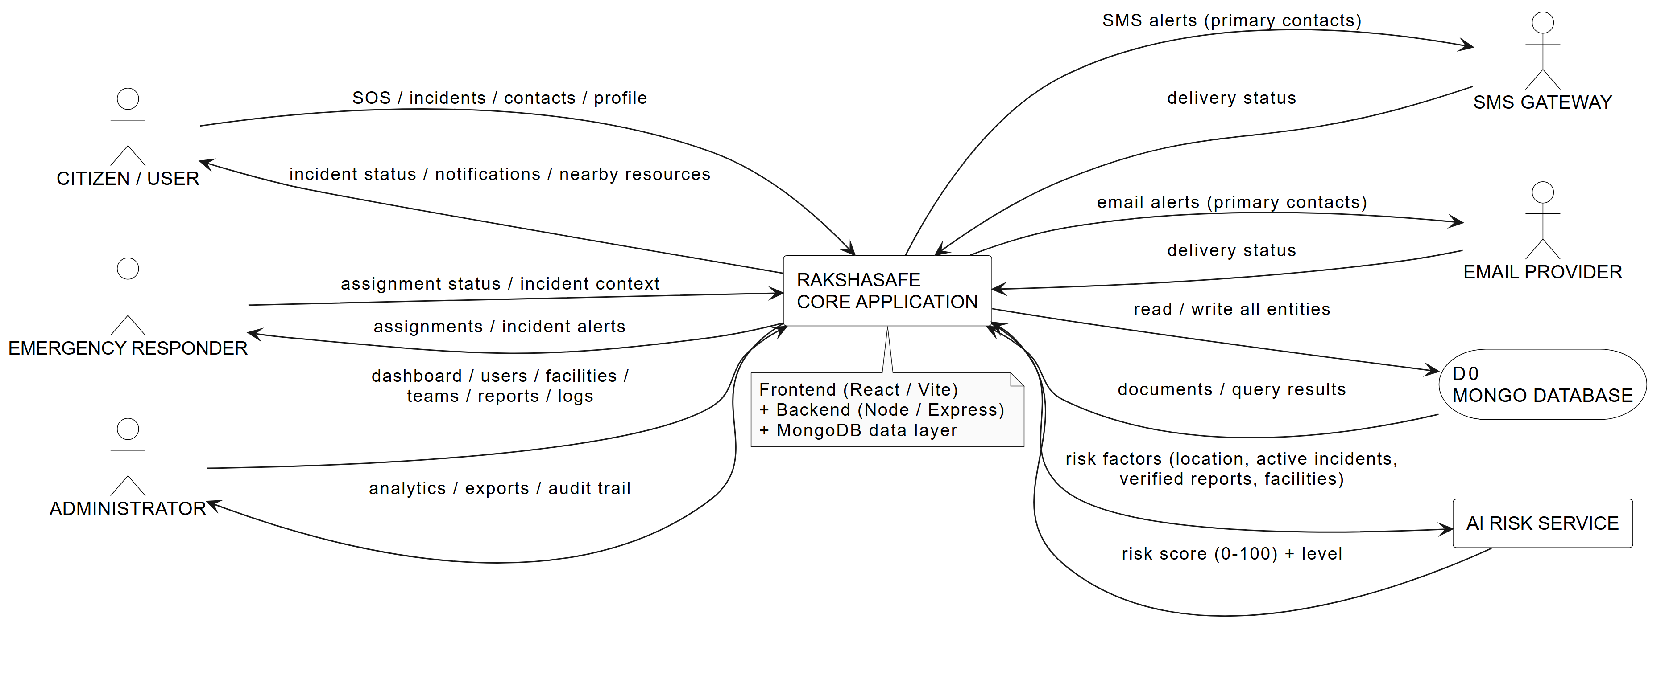
Figure 2: The whole system as a single process with its four user/system actors and the AI risk service, SMS and email providers.

Diagram 3 - DFD Level 1 - Major Processes
Level 1 decomposes the system into ten processes. 1.0 and 2.0 serve the citizen journey; 4.0 serves the responder; 9.0 and 10.0 serve only the administrator. Process 6.0 (Notifications) is triggered by incident and assignment events and fans out to In-App (D7) plus SMS and email providers. Every administrative mutation writes to D10 ADMIN LOG, shown as dashed control flows.
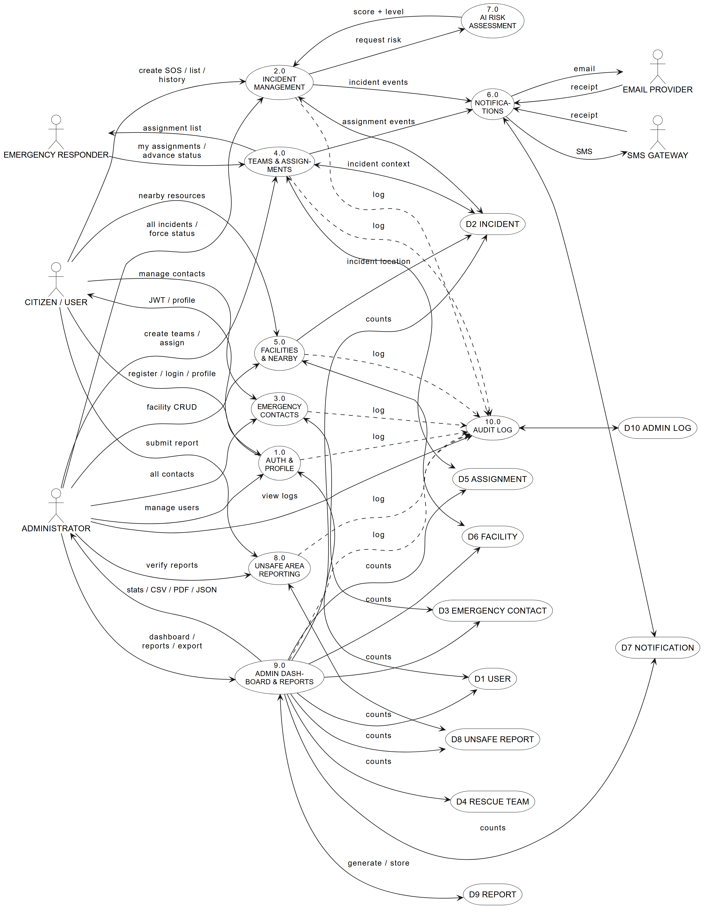
Figure 3: Ten major processes (1.0 to 10.0) and their data stores.

Diagram 4 - DFD Level 2 - Incident Management Detail
Process 2.0 is expanded into eight sub-processes. 2.2 enforces the business rules that were proven in the unit validators (phone normalisation, enum checks, coordinate ranges, and rejection of forged status/ownership/location fields). 2.6 calls the AI risk service with real incident factors and receives a 0-100 score plus a level. 2.8 links assignments and, with 2.6, re-evaluates risk after each transition.
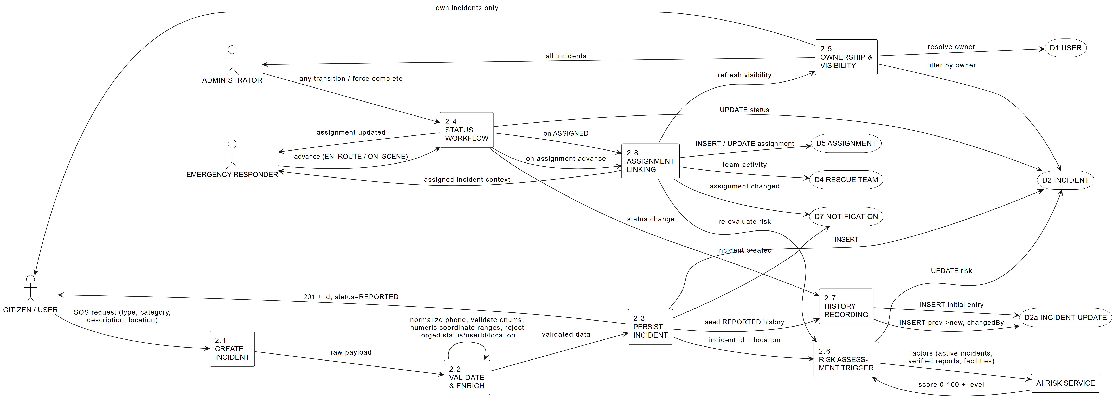
Figure 4: Expansion of process 2.0 with create, validate, persist, workflow, visibility, risk, history and assignment sub-processes.

Diagram 5 - DFD Level 2 - Admin Dashboard & Reports Detail
9.1 aggregates real counts across seven collections. 9.2-9.5 wrap the management end points and always write an ADMIN LOG entry. 9.6 snapshots seven data stores and stores the report metadata together with its snapshot in D9; 9.7 exports it as CSV/PDF/JSON. 9.8 is the read-side of the audit trail.
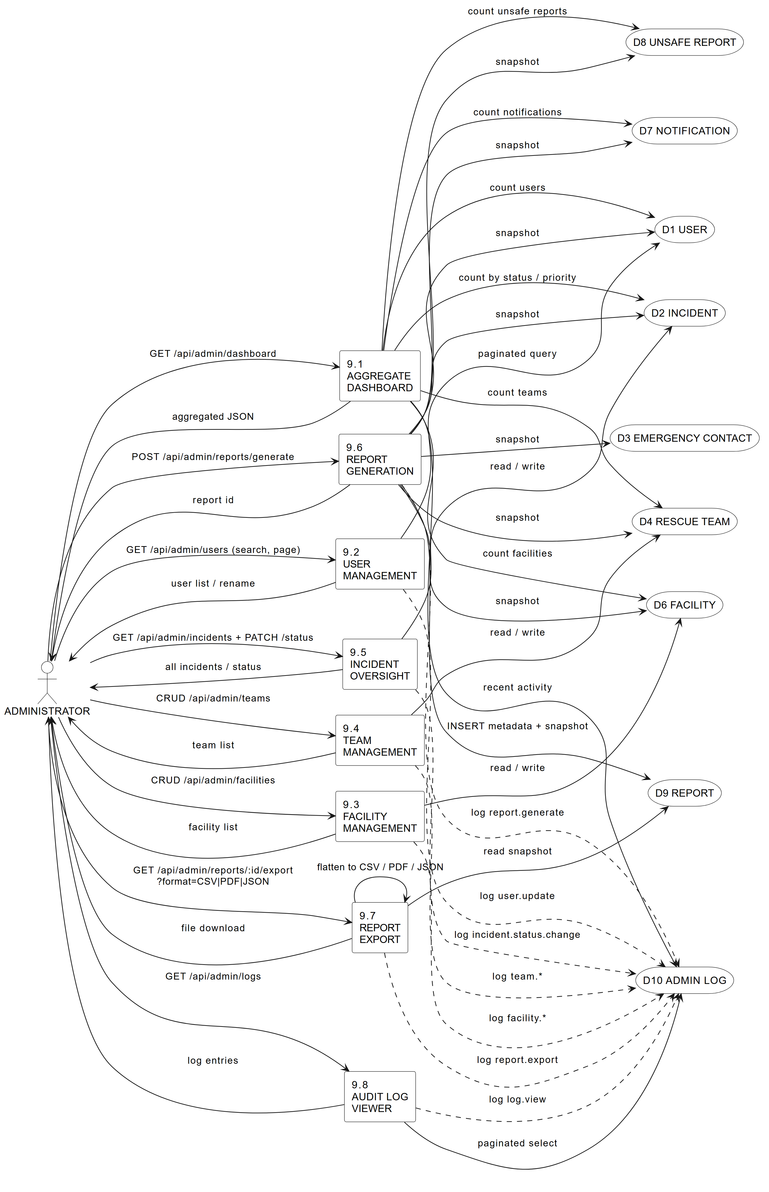
Figure 5: Expansion of processes 9.0 and 10.0 (dashboard, management, report generation, export and audit log).

Diagram 6 - DFD Level 2 - Notifications & AI Risk Detail
6.1 materialises a notification record from the incident event plus primary-contact and recipient lookups; 6.2 dispatches to SMS/email only when a provider is configured and 6.3 records the provider response (SENT/DELIVERED/FAILED/NOT_CONFIGURED). On the risk side, 7.1 collects the live factor vector - incident location/type, nearby verified reports, nearby operational facilities and the active-incident count - 7.2 calls /risk/assess, and 7.3 persists the score and raises CRITICAL/HIGH alerts back into the notification path.
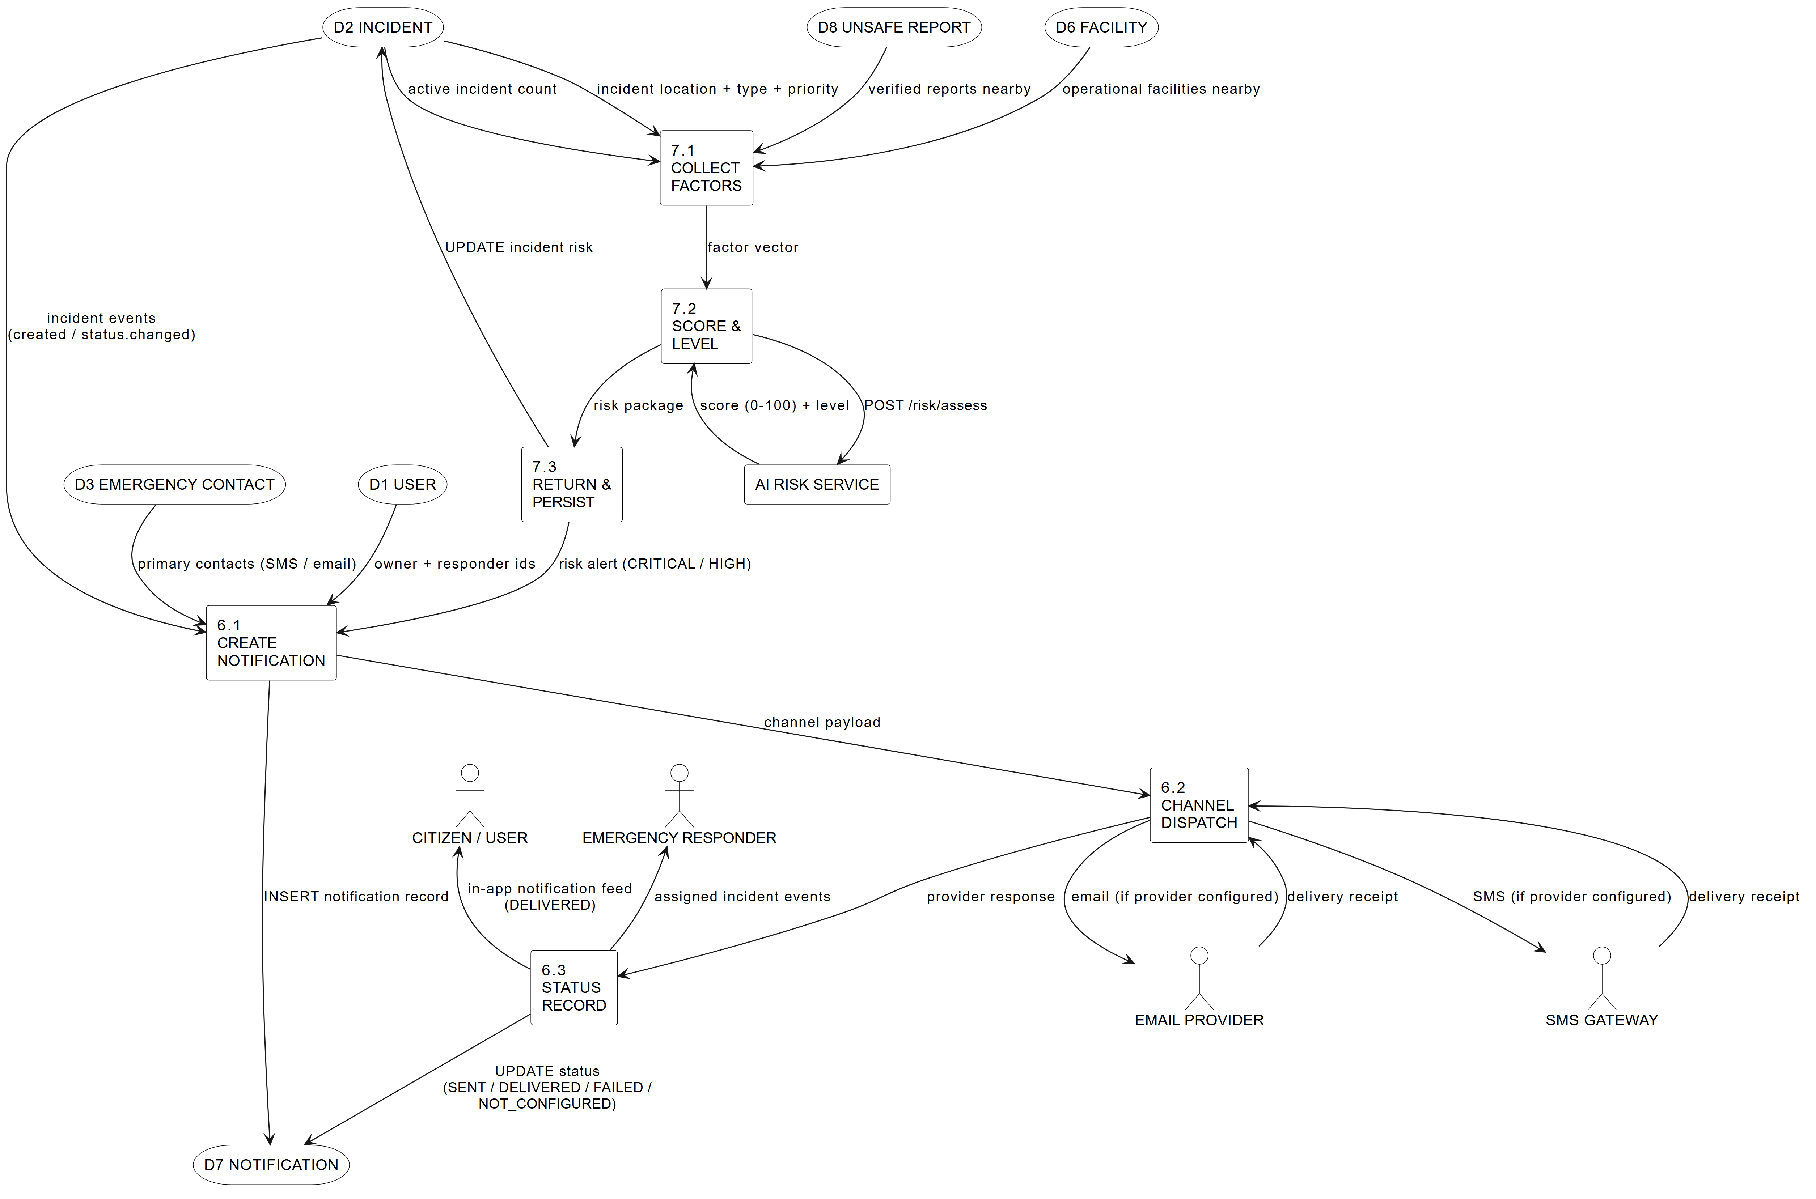
Figure 6: Expansion of processes 6.0 and 7.0 (notification dispatch/status and AI risk factor collection/scoring).

Source Files and Reproduction
All diagrams were generated from PlantUML sources maintained under documentation/chapter6_diagrams_bw/*.puml. They can be re-rendered by pasting a source into the PlantUML server, or inside draw.io (Arrange > Insert > Advanced > PlantUML). The matching SVG and PNG files are kept in the same folder as build artefacts. Because the sources live in the repository, every diagram is version-controlled and reproducible by the examiner.

