DPMI Bitrate and INFERNO RESTful API

**1. SYSTEM ARCHITECTURE:**

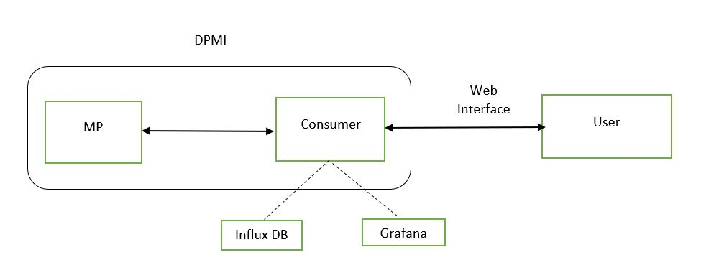

Figure 1: Architecture

**1.1 MP:**

The MP application taps one or more links and does packet capturing, packet filtering and distribute measurement data. It then transfers the captured data to the consumers attached to measuring area network (MArN).

**1.2 Consumer:**

Consumer filters the data transferred from MP and calculates the number of bits/time sample using bitrate application. Consumer is linked to an influx database which stores the data from bitrate application. The database stores the following:

1. Bitrate values.
2. Time stamp (Unix).
3. Tags which correspond to a specific stream.

Grafana is an opensource software for real time analytics used for data visualization with support for various databases including Influx db. Grafana runs on default port 3000. The Grafana dashboard will display the following

1. Data source which is linked to influx database.
2. Measurement Value.
3. Field key-value pairs.
4. Tag key-value pairs.
5. Time range.
6. Graph of the data.

The server program runs on a default port 5000. So, all the requests from the user have to made to 5000 port.

**1.3 User:**

As the server program runs on default port 5000, the clients/users can access the server from terminal (using CURL) or the web browser. User should have following functionalities.

1. User should be able to control measurement streams.
2. User should be able to view the bitrate data within a specified time.
3. Graphs and statistical analysis of the data should be displayed in Grafana.
4. The web interface should be simple and easy to use.