Self-link
Link to Supplementary Material
Mindful non-reactivity alters the neural construction of negative affect
Marta Čeko^{1*}
Noa Magal²
Gordon Matthewson³
Ke Bo⁴
Amin Dehghani⁴
David Spiegel⁶
Hedy Kober⁷
Tor D. Wager^{4*}

¹ Institute for Cognitive Science, University of Colorado, Boulder
² School of Psychological Sciences, University of Haifa, Haifa, Israel
³ Department of Neurology, Dartmouth Hitchcock Medical Center
⁴ Department of Psychological and Brain Sciences, Dartmouth College
⁶ Stanford University
⁷ University of California, Berkeley

Running Head: MINDFUL NON-REACTIVITY

* Please address correspondence to:

Marta Čeko
Institute of Cognitive Science
University of Colorado Boulder,
Boulder, CO, 80305
443-835-6587

Tor D. Wager
Diana L. Taylor Distinguished Professor
Presidential Cluster in Neuroscience and
Department of Psychological and Brain Sciences, HB 6207
Dartmouth College
Hanover, NH 03755
603-646-2196

Acknowledgements
We would like to thank Dan Ott, Erin Biringen, Jordan Griffin, Marina López-Solà, Wani Woo, Teryn Wilkes, Phil Kragel for assistance in data acquisition and helpful discussions. This project was supported by grant NIMH R37076136.

Data availability
Data (rating data, scored survey data, neuroimaging contrast maps) will be uploaded to Zenodo prior to publication.

Code availability
Matlab code for analyses is available at: https://github.com/canlab, with documentation and examples at https://canlab.github.io. Other code for analyses and documentations will be made available prior to publication at https://github.com/canlab/2025_Ceko_MPA2_Nonreact.

Abstract

SUMMARY - INCORPORATE SOME OF THIS IN THE ABSTRACT: Many cognitive regulation strategies influence appraisal and evaluation processes without substantially altering neural systems involved in affect generation. Our findings suggest that acceptance-based non-reactivity can modulate distributed neural representations and sensory-affective pathways underlying negative affect, indicating a potentially distinct and more proximal route for regulating emotional experience.
Practices that cultivate mindful awareness and acceptance have been used across cultures and history to promote equanimity and reduce negative affective reactivity. Recent neuroscientific studies suggest that many forms of cognitive regulation have limited effects on the neural representation of negative affect, but they leave open the possibility that mindful acceptance-based practices are particularly powerful. Here we developed a novel manipulation designed to maximize efficacy in down-regulating neural ingredients of affect based on past work, combining hypnotic suggestion, mindful acceptance, and embodied imagery to elicit a state of non-reactive acceptance. Participants (N = 55) received /completed this manipulation and a control manipulation in separate, counterbalanced fMRI scans and experienced four levels each of mechanical pain, thermal pain, aversive auditory, and aversive visual stimuli. The manipulation significantly reduced negative affect ratings across stimulus types (d = 0.77 - 1.91) and functional neuromarkers for thermal pain, auditory aversion, and visual aversion. The manipulation also consistently reduced activity in ascending sensory pathways, with variable engagement of prefrontal cortex across sensory modalities, including suppression during physical pain and increases during regulation of auditory and visual stimuli. Together, the findings indicate strong effects of acceptance-based regulatory states on the neural construction of affect, with partial differentiation across types of negative experiences.

Introduction
Affective responses are central to human life, pulling us towards desirable objects and events and pushing us away from harmful or aversive ones. Many, or even most, sensations are rapidly and automatically assigned a valence (Barrett 2006; Zajonc 1980; LeDoux 2000). Sounds are pleasing or displeasing, and sometimes unbearable; a touch on the skin is welcome or unwelcome, and sometimes painful. While affective responses can be transient and fade with the sensation itself, their effects can also endure due to the human capacity for reflection and memory. The capacity to regulate affective responses – to shape their intensity, qualitative experience, and time course in accord with their context and meaning – is a core human faculty. Affective dysregulation is a core feature of multiple mental health disorders including depression and anxiety, substance misuse, and chronic stress and pain (Cuthbert and Insel 2013; Ochsner and Gross 2005). In particular, intense negative reactivity is a transdiagnostic feature across disorders.

One family of techniques for affective regulation – reappraisal – emphasizes changing the cognitive interpretation of sensations, particularly their antecedents/causes and perceived future implications, which is thought to alter their meaning and consequently their valence and intensity (Buhle et al. 2014; Morawetz et al. 2020; Gross 1998). While it is often investigated as a standalone strategy in experimental psychology, reappraisal is also an important component of Cognitive Behavioral Therapy within clinical psychology (Beck 1969). A second family of techniques – mindful-acceptance – focuses on attention to present-moment sensory experience without cognitive elaboration, coupled with an attitude of openness to and curiosity about the sensations themselves, and importantly, accepting the sensations exactly as they are. Modern mindfulness practice (Bishop et al. 2004; Lutz et al. 2007) and clinical interventions including Acceptance and Commitment Therapy (Hayes et al. 2006), Dialectical Behavioral Therapy (Linehan 2001), Mindfulness Based Cognitive Therapy (Teasdale et al. 2000) and Mindfulness Based Stress Reduction (Kabat-Zinn 2003) include teaching of mindful-acceptance. We refer to this approach as “non-reactivity” here, because it focuses on mental “non-action,” acceptance of sensations as they are without endowing them with meaning, rather than cognitive change.

While both practices have ancient roots, the concept of non-reactivity has been particularly central across cultures dating back thousands of years, including original Vedic scriptures, Zen Buddhism, Taoism, and ancient Greek stoicism. For example, a fundamental concept in Taoism is wu wei, “not-forcing” or action through inaction (Laozi, Tao Te Ching; (Ames and Hall 2003). In the Bhagavad Gita, the practice of yoga is to achieve equanimity, “tranquility in pleasure and pain” (2.48; (Easwaran 2007)). However, non-reactivity has been less widely understood in Western cultures and its neural foundations much less widely studied than cognitive reappraisal and CBT.

Modern cognitive neuroscience has produced important literature on the neural correlates of both cognitive reappraisal and mindful acceptance, including varieties of meditative practice. An important question is whether cognitive techniques can influence the brain processes that generate affect, and which cognitive practices lead to the most profound effects. Early studies of reappraisal suggested that cognitive reframing re duces amygdala reactivity to negative stimuli (Frank et al. 2014; Buhle et al. 2014), but studies have often also failed to find reduced reactivity in amygdala and other regions closely associated with affect generation (Kanske et al. 2011; Pierce et al. 2022; McRae et al. 2012; Dörfel et al. 2014), including the PAG, anterior midcingulate (aMCC), and ventral pallidum. In fact, recent large-scale studies provide Bayesian evidence against modulation of subcortical reactivity with reappraisal (Bo et al. 2024). Similarly, reappraisal of pain has been associated with mediation by fronto-striatal evaluative systems but not reduced reactivity in regions associated with nociception (Woo et al. 2015), including the spinothalamic pathway (ventroposterior lateral thalamus (VPL), dorsal posterior insula (dpINS), aMCC, and anterior insula (aINS)). Together, these studies suggest that reappraisal as commonly practiced has limited effects on the construction of affective responses.

Our working hypotheses here are that (1) non-reactivity may be a particularly effective strategy, and (2) deep and consistent modulation of affect-generation requires engaging in a sustained state, as opposed to momentary cognitive change. Previous studies of mindful acceptance, for example, have found reductions in amygdala when viewing aversive images and in pain-related portions of aINS, aMCC, and somatosensory SII during pain (Zeidan et al. 2011; Taylor et al. 2011; Zeidan et al. 2015). A stronger test is provided by the application of neural ‘signatures’ (or neuromarkers). Distributed neuromarkers are sensitive and specific for pain and negative affect, with very large effect sizes and generalizability across studies (Wager et al. 2013; Woo et al. 2017; Chang et al. 2015; Van Oudenhove et al. 2020; Krishnan et al. 2016; Lee et al. 2021; Spisak et al. 2020; Zhou et al. 2020). In pain paradigms, mindful acceptance (Kober et al. 2019; Zeidan et al. 2011; Farb et al. 2013), MBSR (Wielgosz et al. 2022) and meditation practices (Kabat-Zinn 2004) focused on attentive non-reactive acceptance have been shown to reduce the Neurologic Pain Signature (NPS) - associated with nociceptive (sensory) pain processing - with larger effect sizes than reappraisal and other cognitive manipulations (Riegner et al. 2025; Kober et al. 2019; Dean et al. 2022; Botvinik-Nezer et al. 2024; Woo et al. 2015). In visual aversion, a recent study comparing acceptance and reappraisal applied to dynamic visual stimuli shows modulation of sensory regions and the amygdala with acceptance, but not with reappraisal, which on the other hand modulated fronto-parietal control systems (Jiang et al. 2026). Thus, traditional reappraisal-based cognitive strategies may be limited in the degree to which they modulate the neural systems underlying negative affective reactivity, but cultivation of states of mindful acceptance – i.e., attentive non-reactivity – could have more powerful effects. Converging evidence from hypnosis supports this view: a randomized clinical trial during surgery involving venous catheterization showed reduced pain and anxiety, shortened procedure time, and decreased complications while cutting opioid use in half (Lang et al. 2000). At the neural level, hypnosis is associated with reduced aMCC activity and greater functional connectivity between dLPFC and the insula (Jiang et al. 2016; Rainville et al. 1997). Together, these findings suggest that engaging sustained, non-reactive arousal-modulating states may alter interactions among executive control, salience, and pain-related systems, reducing distress and exerting control over interoceptive processing.

We developed a composite psychological manipulation centered in non-reactivity, designed to reduce negative affectivity from first principles. The manipulation – which we term Non-Reactivity (NR) included three phases: (1) an induction delivered just before fMRI scanning, intended to create a state of receptivity using techniques commonly used in hypnosis, which has been remarkably effective at reducing pain in some studies (Rainville et al. 1997, 1999; Faymonville et al. 2000; Lang et al. 2000); (2) delivery of instructions, while in the receptive state, on maintaining a state of attentive non-reactivity; and (3) the maintenance of this non-reactive state during fMRI scanning, while experiencing four kinds of aversive stimuli (mechanical pain, thermal pain, aversive sounds, and aversive images). Participants experienced these stimuli twice – once while practicing Non-Reactivity and once while responding naturally to the stimuli (the Control treatment) – in separate fMRI scans two hours apart in counterbalanced order.

We tested NRI vs. Control effects on the NPS, SIIPS-1, and five neuromarkers previously developed in this sample. In earlier work (Čeko et al. 2022), these neuromarkers selectively tracked trial-by-trial aversiveness for mechanical pain, thermal pain, aversive sounds, and aversive images. A general aversion neuromarker tracked aversiveness across all types. All neuromarkers showed large effect sizes, strong specificity, and were validated in independent datasets (Čeko et al. 2022). In addition, we tested effects on regional brain activity, focusing on (1) early sensory pathways that track affective response intensity in earlier studies (Čeko et al. 2022; Wager et al. 2013) and (2) prefrontal activity that may contribute to affect generation or regulation (Zhang et al. 2025). Non-reactivity strongly reduced negative affect across all stimulus types and reduced neuromarkers in all stimulus types except mechanical pain. At the region level, non-reactivity reduced activity within stimulus type-specific sensory and spinothalamic pathways as well as regions encoding aversiveness across multiple stimulus types (e.g., aMCC, aINS, and amygdala), though again not for mechanical pain. These findings are consistent with dampening of sensory processing of aversive input for most stimulus types. In addition, the effects of non-reactivity in the prefrontal cortex varied across stimulus types, showing attenuation during thermal stimulation but increased prefrontal recruitment for visual stimuli.

Results

Manipulation effects on aversion ratings
We first tested the effect of the manipulation on self-reported negative affect (i.e., aversion ratings) induced by four types of negative (aversive) stimuli: mechanical (pressure pain), thermal (heat pain), auditory (aversive sounds), or visual (aversive images) stimuli. Each stimulus type was administered at four pre-selected intensity levels (Fig. 1) and rated on a uniform aversiveness scale across stimulus types. Post-trial ratings were averaged within each intensity level for each stimulus type and compared across the two MRI scans: one in which participants applied Non-Reactivity and one in which they were instructed to experience the sensations as they come (Control). We examined the main effect of manipulated State (Non-Reactivity vs. Control) and Stimulus Intensity, as well as their interaction.
Aversion ratings increased robustly with stimulus intensity for each stimulus type across both conditions (Stimulus Intensity main effect, ps < 0.001, d = 0.96 - 1.98; Supplementary Table 1). Aversion ratings were significantly lower during Non-Reactivity vs. Control for all four stimulus types, with large effect sizes (State main effect: mechanical t = -5.72, p < 0.001, d = 0.77; thermal, t = -8.83, p < 0.001, d = 1.91; auditory, t = -6.49, p < 0.001, d = 0.87; visual t = -6.20, p < 0.001, d = 0.84; Fig. 1b, Supplementary Table 1). In addition, the manipulation reduced the effects of Stimulus Intensity for all stimulus types – indicating a flatter dose-response effect of stimulus intensity – as revealed by a significant Intensity x State interaction for each stimulus type (ps ≤ 0.02, d = 0.33 - 0.54 Fig. 1b, Supplementary Table 1). The effect of manipulation on ratings remained significant after controlling for scan order, sex, and age (Supplementary Methods and Supplementary Table 2).

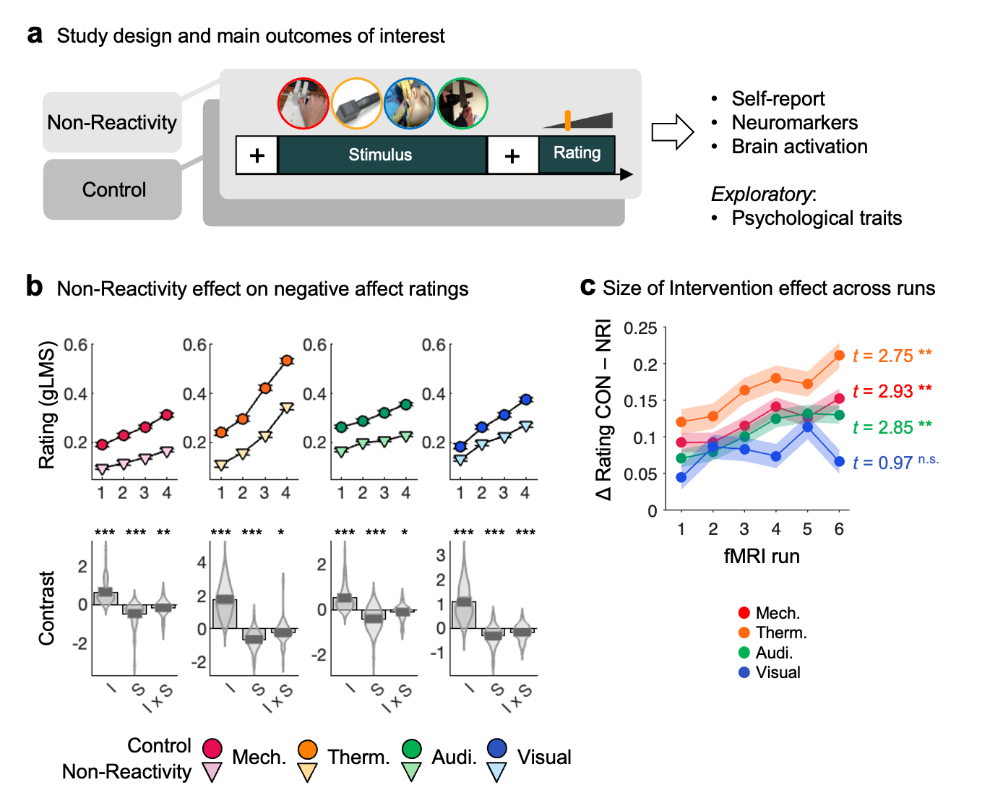
WILL EDIT THIS AND OTHER FIGS ONCE TERMINOLOGY IS FINALIZED
Figure 1. Study design and behavioral findings. a) Study design: two counterbalanced fMRI scans within a single day; 55 participants; negative affect was induced by 4 types of aversive stimuli (mechanical, thermal, auditory, visual) administered at 4 intensity levels and rated on a common scale after each stimulus presentation; effect of Non-Reactivity (NR) vs. Control (CON) was evaluated on self-reported negative affect, neuromarker response and brain activation, and in exploratory analysis the relationship with psychological traits. Contrast-coded contrasts of interest for 4 levels each of CON and NRI included Stimulus Intensity main effect across scans, [-3 -1 1 3 -3 -1 1 3]; State main effect, [-1 -1 -1 -1 1 1 1 1]; and Stimulus Intensity by State interaction, [3 1 -1 -3 -3 -1 1 3]; For intensity effects, positive contrast values are the expected direction, with greater responses for higher stimulus intensities. For state effects and state x intensity interactions, negative contrast values are in the expected direction, with lower responses for NR vs. CON. b) Nonreactivity effect on ratings. Upper panels show mean ratings across participants for each stimulus level and each scan (CON, dark circles; NR; light triangles). Error bars reflect within-participant s.e.m. Lower panels show primary effects of interest: I, main effect of Stimulus Intensity; S, main effect of State, I x S, Intensity by State interaction. * p < 0.05; ** p < 0.01; *** p < 0.001, two-sided. c) Mean within-participant slopes of treatment effects (CON - NR rating difference) by run. One sample t-test on slopes; ** p < 0.01, two-sided.

Manipulation effects on aversion ratings (State main effect) were correlated across stimulus types: Thermal and mechanical, r = 0.40, p = 0.002; thermal and visual, r = 0.41, p = 0.021; and visual and auditory, r = 0.33, p = 0.018. These findings point to individual differences in a common regulatory capacity.
Participants’ expectations about their ability to regulate aversive stimuli (assessed immediately prior to the NR scan) were positively correlated with their perceived success (assessed immediately after the NR scan; r = 0.43, p = 0.003), indicating consistent confidence in self-regulatory capacity across the sample. However, neither expectation nor perceived success correlated significantly with actual regulation success derived from immediate post-stimulus ratings (State main effect; rs < 0.26, ps > 0.085), suggesting that subjective beliefs about the manipulation did not drive behavioral outcomes.
Manipulation effects were significant in each of the six fMRI runs for all stimulus types (Supplementary Fig. 1). The magnitude of the effect increased across runs for all but visual stimuli (significant within-subject slopes of treatment differences; Fig. 1c), consistent with a sustained (and potentially deepening) regulatory state. Together, these results confirm that the Non-Reactivity manipulation was effective, sustained, and unlikely to reflect expectancy or demand effects.
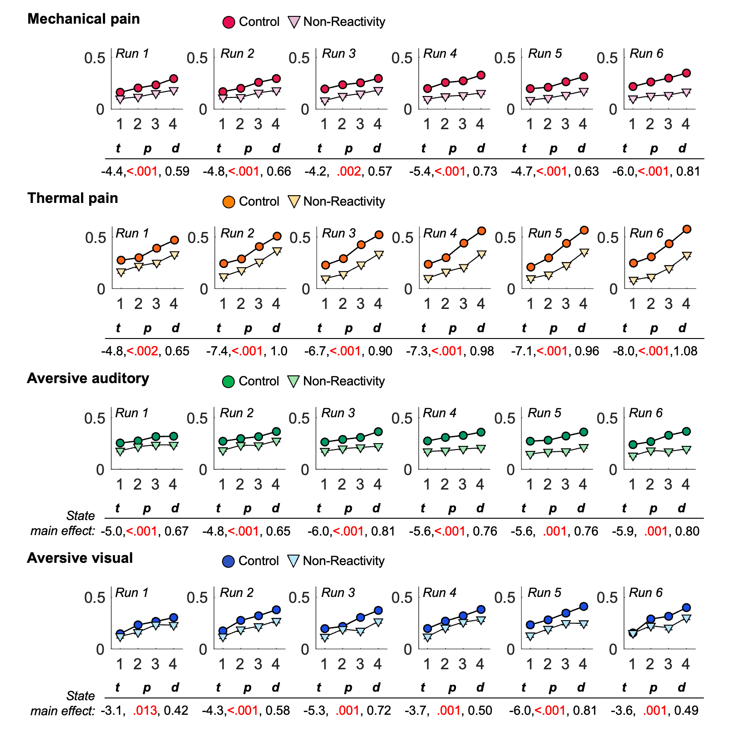
Supplementary Figure 1. State main effect (Non-Reactivity vs. Control) on subjective ratings for each fMRI run. Non-Reactivity, dark circles; Control, light triangles. * p < 0.05; ** p < 0.01; *** p < 0.001, two-sided p values; d, Cohen’s d effect size. Negative t-values are in the expected direction, with lower responses for Non-Reactivity vs. Control.

Analysis of physiological arousal, measured using skin conductance response (SCR) during stimulation, showed a reduction of SCR during thermal stimulation only (t_{Intensity x State} = -2.16, p = 0.033, d = 0.28) and no other significant reductions by Non-Reactivity (see Supplementary Material; Supplementary Table 3).

Manipulation effects on neuromarkers for negative affect
We next tested whether the Non-Reactivity manipulation reduced neuromarkers predictive of each type of negative affect. The neuromarkers were five multi-system activity patterns trained to optimally predict trial-by-trial aversion ratings to each stimulus type in Control data and published in our prior work (Čeko et al. 2022). A Common Multimodal Negative Affect neuromarker tracked aversion across all four stimulus types, and stimulus type-specific neuromarkers tracked aversion for each stimulus type individually but not others (Mechanical-specific, Thermal-specific, Auditory-specific, Visual-specific). Each neuromarker was validated for predictive accuracy in independent datasets (Čeko et al. 2022). Here, we applied a five-fold leave-whole-subject-out cross-validation design: In each fold, we identified the neuromarker patterns in 80% of the sample and tested pattern responses (scores) in Non-Reactivity vs. Control scans in the held-out 20% of participants, such that each participant was included in exactly one test set. This yields a valid and unbiased test of manipulation effects under the null hypothesis that the manipulation conditions are interchangeable. For each stimulus type we tested the main effect of State and the Stimulus Intensity by State interaction.
Non-Reactivity (vs. Control) significantly reduced stimulus type-specific neuromarker responses for aversive thermal (t_{Intensity x State} = -2.29, p = 0.026, d = 0.31), aversive auditory, (t_{State} = -2.06, p = 0.044, d = 0.28) and visual stimuli (t_{State} = -2.45, p = 0.017, d = 0.33), indicating reduced distributed representations of aversive experience (Fig. 2a, Supplementary Table 4). Non-Reactivity did not significantly alter the aversive mechanical pattern (ps > 0.180). Non-Reactivity also reduced the expression of the general (common) multimodal negative affect pattern for aversive thermal (t_{Intensity x State} = -2.30, p = 0.025, d = 0.31) and visual stimuli (t_{State} = -2.95, p = 0.005, d = 0.40; (Fig. 2b, Supplementary Table 4), but had no significant effects on the expression of this pattern for aversive mechanical or auditory stimuli (ps > 0.132).
To confirm specificity, we tested potential off-target manipulation effects by applying each stimulus-type specific pattern to data from the other three modalities. No significant off-target effects were detected in 21 out of 24 possible cases (4 stimulus types x 3 off-target State effects x 3 off-target Intensity by State effects; Supplementary Table 4).
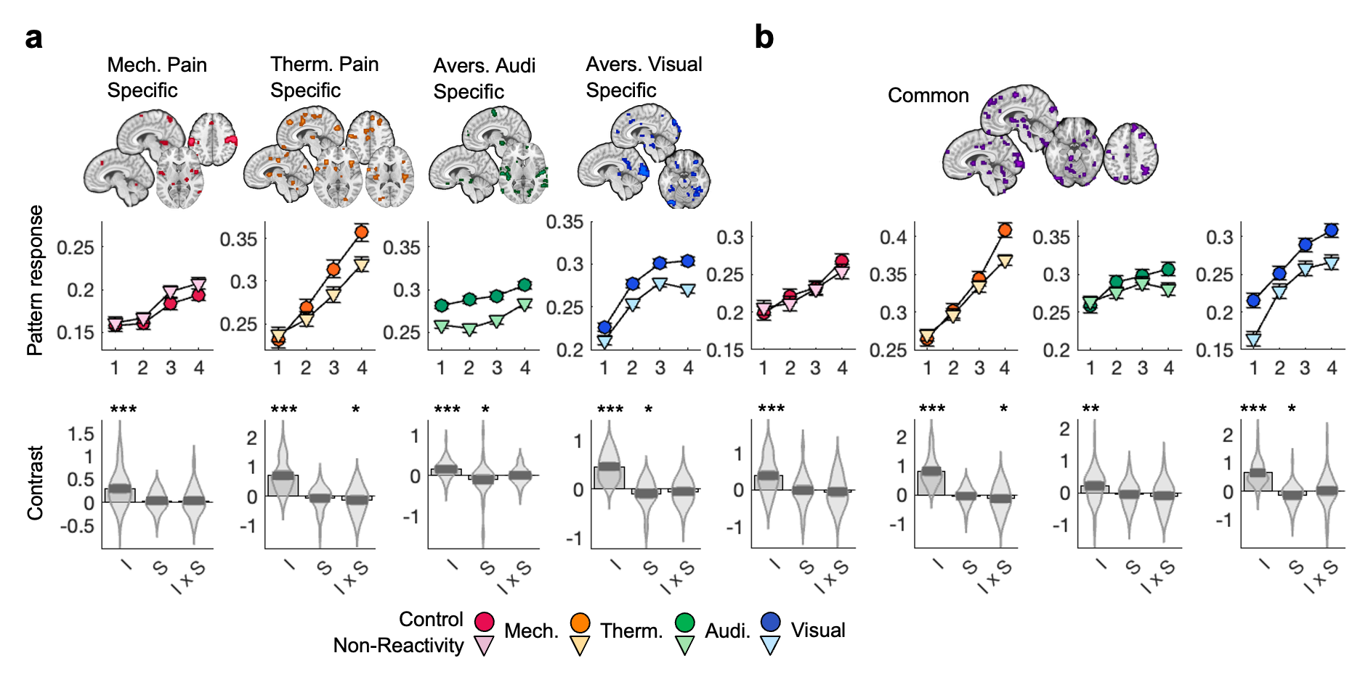
Figure 2. Non-Reactivity effects on neuromarkers of multisensory negative affect. a) Stimulus type-specific neuromarkers of negative affect (Čeko et al. 2022). b) Common neuromarker of negative affect (Čeko et al. 2022). Upper panels show mean pattern response across participants for each stimulus level and each scan (Non-Reactivity, dark circles; Control; light triangles). Error bars reflect within-participant s.e.m. Lower panels show primary effects of interest: I, main effect of Stimulus Intensity; S, main effect of State (Non-Reactivity, Control), I x S, Intensity by State interaction. * p < 0.05; ** p < 0.01; *** p < 0.001, two-sided p values. For intensity effects, positive contrast values are the expected direction, with greater responses for higher stimulus intensities. For state effects and state x intensity interactions, negative contrast values are in the expected direction, with lower responses for Non-Reactivity vs. Control.

Validation and manipulation effects on prior neuromarkers
To benchmark our results against other established neuromarkers of pain and visual aversion, we tested the effects of the Non-Reactivity manipulation on three additional, validated brain signatures: the Neurologic Pain Signature (NPS (Wager et al. 2013)) and Stimulus-Independent Intensity Pain Signature (SIIPS (Woo et al. 2017)), both validated for pain across multiple studies, and the Picture-Induced Negative Affect Signature (PINES (Chang et al. 2015)), validated for negative affect evoked by visual images.
Both the NPS and SIIPS increased robustly with stimulus intensity for both thermal and mechanical stimuli across both scans, with very large effect sizes (d = 0.88 - 1.86, p < 0.001 in all cases; see Supplementary Fig. 2a and Supplementary Table 4), replicating their well-established sensitivity to physical pain (Botvinik-Nezer et al. 2024; Wager et al. 2013; Geuter et al. 2020; Han et al. 2022; Bräscher et al. 2016; Frangos et al. 2021; Krishnan et al. 2016; Woo et al. 2015; López-Solà et al. 2017; Chang et al. 2015; Van Oudenhove et al. 2020). Both also responded to increasing aversive auditory stimulus intensity, though with smaller effect sizes (d = 0.39 - 0.53) and neither responded significantly to aversive visual stimulus intensity, consistent with levels of specificity previously reported for the NPS (Van Oudenhove et al. 2020; Chang et al. 2015; Krishnan et al. 2016; Zhou et al. 2020). The PINES responded strongly to increasing visual stimulus intensity (d = 1.01, p < 0.001) and to thermal stimulus intensity with a smaller effect size (d = 0.69), but not to mechanical pain or aversive auditory stimulation, providing evidence for sensitivity and partial specificity (see Supplementary Fig. 2b and Supplementary Table 4). Together, these validation analyses confirm that established affect neuromarkers behave as expected in this dataset, showing selectivity for their target modalities and limited cross-modal generalization.
After confirming expected intensity-related responses, we tested whether Nonreactivity modulated responses in these neuromarkers. Non-Reactivity reduced NPS responses during thermal pain (t_{State} = -2.51, p = 0.015, d = 0.34), with stronger reductions at higher stimulus intensities (t_{Intensity x State} = -2.05, p = 0.045, d = 0.28; Supplementary Fig. 2a and Supplementary Table 4). In contrast, SIIPS responses were not significantly affected by Non-Reactivity (ps > 0.46). Neither neuromarker showed significant manipulation effects for mechanical pain (ps > .30; see Supplementary Fig. 2a and Supplementary Table 4). In addition, the Non-Reactivity manipulation significantly reduced the PINES response to aversive visual stimuli (t_{Intensity x State} = -3.09, p = 0.003, d = 0.42 Supplementary Fig. 2b and Supplementary Table 4).
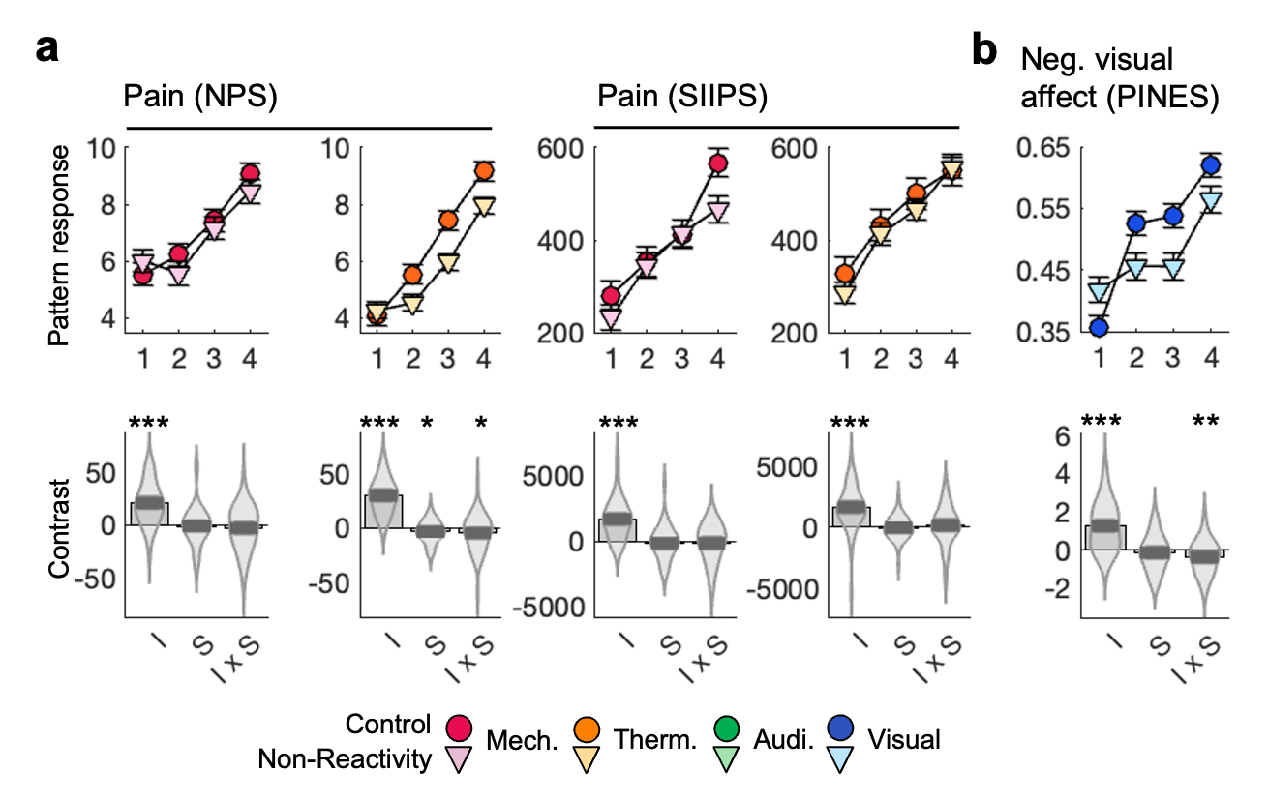
Supplementary Figure 2. Non-Reactivity effects on benchmark neuromarkers. a) Neurologic Pain Signature, NPS (Wager et al. 2013); Stimulus-Intensity Independent Pain Signature, SIIPS (Woo et al. 2017). b) Picture-Induced Negative Emotion Signature, PINES (Chang et al. 2015). Upper panels show mean pattern response across participants for each stimulus level and each scan (Non-Reactivity, dark circles; Control; light triangles). Error bars reflect within-participant s.e.m. Lower panels show primary effects of interest: I, main effect of stimulus intensity; S, main effect of State (Non-Reactivity, Control), I x S, Intensity by State interaction. * p < 0.05; ** p < 0.01; *** p < 0.001, two-sided p values. For intensity effects, positive contrast values are the expected direction, with greater responses for higher stimulus intensities. For State effects and State x Intensity interactions, negative contrast values are in the expected direction, with lower responses for Non-Reactivity vs. Control.

Intensity-coding effects on stimulus-evoked responses across both scans
Whole brain analysis across 489 labeled brain parcels (Geuter et al. 2020), Supplementary Table 5) revealed robust intensity coding effects across both Non-Reactivity and Control scans (i.e., significant main effect of Stimulus Intensity across scans, q < 0.05 FDR-corrected across all parcels and across contrasts; Supplementary Fig. 3) for all stimulus types. We observed increased activity with most types of aversive stimulus intensity (mechanical, thermal, visual) in anterior cingulate, opercular-insular, sensorimotor, and anterior temporal cortices, along with basal ganglia, midbrain regions covering PAG, cerebellum, and medial thalamus. Aversive auditory intensity was encoded by increases in peri-auditory opercular and temporal regions, midbrain, and brainstem, and decreases in vMPFC.
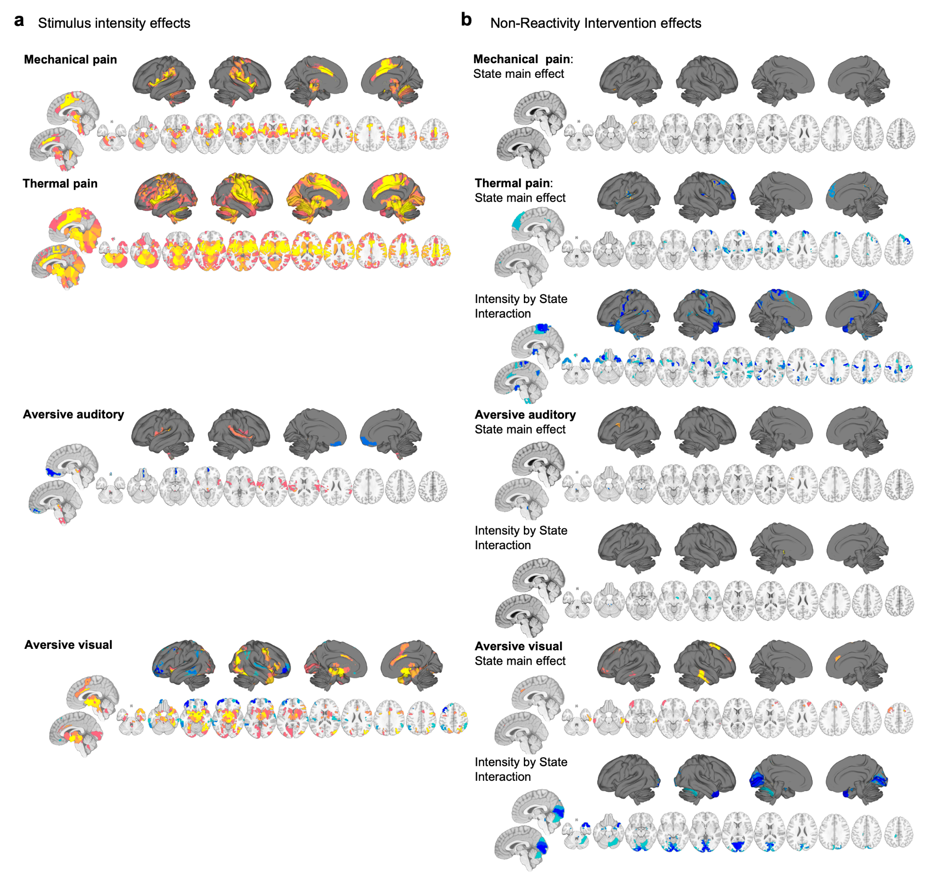
Supplementary Figure 3. Whole-brain results. a) Brain regions showing significant stimulus intensity coding across scans (Stimulus Intensity main effect); orange, increased activation with increasing stimulus intensity; blue, decreased activation with increasing stimulus intensity. b) Brain regions showing significant downward shift (blue) or upward shift (orange) of activation in Non-Reactivity vs. Control (State main effect) and significant flattening (orange), or steepening (blue) of the intensity-coding response in Non-Reactivity vs. Control (Intensity by State interaction). Whole brain analysis across 489 labeled brain parcels, q < 0.05 FDR-corrected across all parcels and across contrasts.

During mechanical and thermal pain, intensity coding effects were observed across many areas within the Somatomotor Network and Ventral Attention Network, including somatosensory cortices, aINS and dpINS, as well as aMCC/dACC and supplementary motor area (SMA). Intensity-coding effects were also observed across the thalamus and brainstem, including nociceptive dynamic nuclei (ventral posterio-lateral, VPL; and intralaminar nucleus), periaqueductal gray (PAG) and rostro-ventral medulla (RVM), parabrachial nucleus (PBN), locus coeruleus (LC)) as well as amygdala, multiple areas within the basal ganglia (including putamen and globus pallidus (GP)), and multiple parts of the superior cerebellum. In addition to the areas listed above, thermal pain intensity produced more widespread increases in cortical, frontal, parietal, limbic (nucleus accumbens (NAc) and caudate), and temporal regions, and in the hippocampus, and more extensive activation of the cerebellum. There were no areas in which stimulus intensity was encoded by activation decreases for pain stimuli. These effects are listed in Supplementary Tables 6 (mechanical pain) and 7 (thermal pain).
Aversive auditory stimulus intensity was encoded in a smaller set of regions (see Supplementary Table 8). Cortical regions included activation in areas associated with the Somatomotor Network B, including early and association auditory regions (lateral belt, retroinsula (RI) and A4) and secondary somatosensory (S2) regions, and insulo-opercular areas associated with the Ventral Attention Network A. Brainstem regions included increases in inferior colliculus (IC), dorsal raphe, PAG, and LC. Intensity was also encoded by activation decreases in the vMPFC.
Aversive visual stimulus intensity was encoded in multiple areas of the dorsal and ventral attention, and visual networks, and multiple areas within the forebrain, brainstem, and cerebellum (see Supplementary Table 9). These included the amygdala, PAG, superior colliculus (SC), PBN, dorsal raphe, hypothalamus, as well as the medial thalamus and visual thalamic nuclei (lateral geniculate nucleus (LGN), pulvinar). Intensity was also encoded by activation decreases in the vMPFC, vLPFC, inferior parietal, as well as temporal cortex.

Manipulation effects on neural activity in ascending affect-generating pathways
Non-Reactivity (vs. Control) robustly decreased intensity-coding effects in thermal and visual stimulus types in multiple intensity-coding regions (significant Intensity x State interaction; Fig. 3a-b; Supplementary Tables 10 and 11) paralleling effects on self-report and pattern responses described above. For both types of stimuli, we observed a flattening of the intensity-coding response in the brainstem, cerebellum, and respective sensory- and affect-related cortical areas in the Non-Reactivity vs. Control scans. For thermal pain, these regions included the dpINS, S2, and VPL - a key somatosensory nucleus of the thalamus (Sherman and Guillery 1996) (Fig. 3c). For visual stimuli, these regions included the occipital (V1-V4) and higher visual areas (V7, LO2, VMV3), temporal pole and the amygdala (Fig. 3e). For thermal pain, we also observed significant reductions with Non-Reactivity vs. Control across intensity levels (significant State main effect), most notably in nociceptive pathways (dpINS and thalamus VPL), anterior prefrontal cortex (aPFC), and dMPFC and PCC regions associated with the Default Mode Network (Supplementary Fig. 3).
Non-Reactivity (vs. Control) both reduced auditory stimulus-evoked activity across intensities (State main effect) and flattened the intensity-coding response to auditory stimuli (State x Intensity interaction) in brainstem regions consistent with PBN and LC (Fig. 3a-b,d). Flattening of the intensity-coding response was also observed in the basal ganglia (globus pallidus, GPa).
Finally, regulating mechanical pain did not significantly affect intensity-coding activity (i.e., no significant State main effect or Intensity by State interaction; Fig. 3a-b), paralleling the lack of effects on both the mechanical pain-specific and the stimulus-general pattern response. These results stand in contrast to robust manipulation-related decreases in self-reported pain (d = 0.77, Fig. 1b).

Manipulation effects on thermal vs. auditory neural activity in the brainstem
For thermal pain, Non-Reactivity-related decreases in pain ratings were positively correlated with decreases in neural activity in S2/dpINS bilaterally, left aINS, and VPL nucleus of the thalamus (r = 0.42 - 0.55, p ≤ 0.001; Fig. 3f; Supplementary Table 12), consistent with suppression of pain-coding activity in the ascending spinothalamic nociceptive pathway with effective regulation. However, decreases in pain ratings were negatively correlated with brainstem RVM (r = -0.31, p = 0.023) and cerebellar decreases in neural activity (r = -0.32, p = 0.018), suggesting that effective pain regulation by the Non-Reactivity manipulation was associated with maintained or enhanced neural activity in these regions (Fig. 3f; Supplementary Table 12). As RVM activity is thought to produce descending spinal inhibition, resulting in suppression of spinothalamic afferents (Ossipov et al. 2010; Tracey and Mantyh 2007; Heinricher et al. 2009), we tested whether the association between RVM increases (X in mediation) and pain reductions (Y) was mediated by reductions in the VPL (which was also correlated with reductions in dpINS and aINS). Both effects of RVM increases on thalamic decreases (Path a) and effects of thalamic decreases on pain (Path b), and a significant a×b product indicated a significant mediation effect (a×b; Fig. 3g). These findings are consistent with the idea that the Non-Reactivity manipulation reduced pain by actively inhibiting nociceptive transmission at the spinal level (Tracey and Mantyh 2007; Bushnell et al. 2013).
In contrast, for aversive auditory stimulation, decreases in ratings were positively correlated with manipulation-related decreases in neural activity in the brainstem LC (r = 0.34, p = 0.010) and PBN (r = 0.37, p = 0.005; Fig. 3h; Supplementary Table 12). Given that the LC is the brain’s primary source of norepinephrine and involved in arousal regulation (Schwarz and Luo 2015), reduced LC activation during regulation likely reflects reduced noradrenergic arousal and vigilance to aversive auditory input. Similarly, because the PBN is implicated in affective and threat signaling (Sara and Bouret 2012; Chiang et al. 2019), its suppression suggests a downregulation of ascending aversive signals - consistent with reduced transmission of affective salience to limbic structures during successful regulation of aversive auditory input. Together, these results indicate modality-specific brainstem mechanisms of non-reactive affect regulation: active inhibitory control via RVM during thermal pain and reduced central arousal and affective drive via LC-PBN disengagement during aversive auditory stimulation.
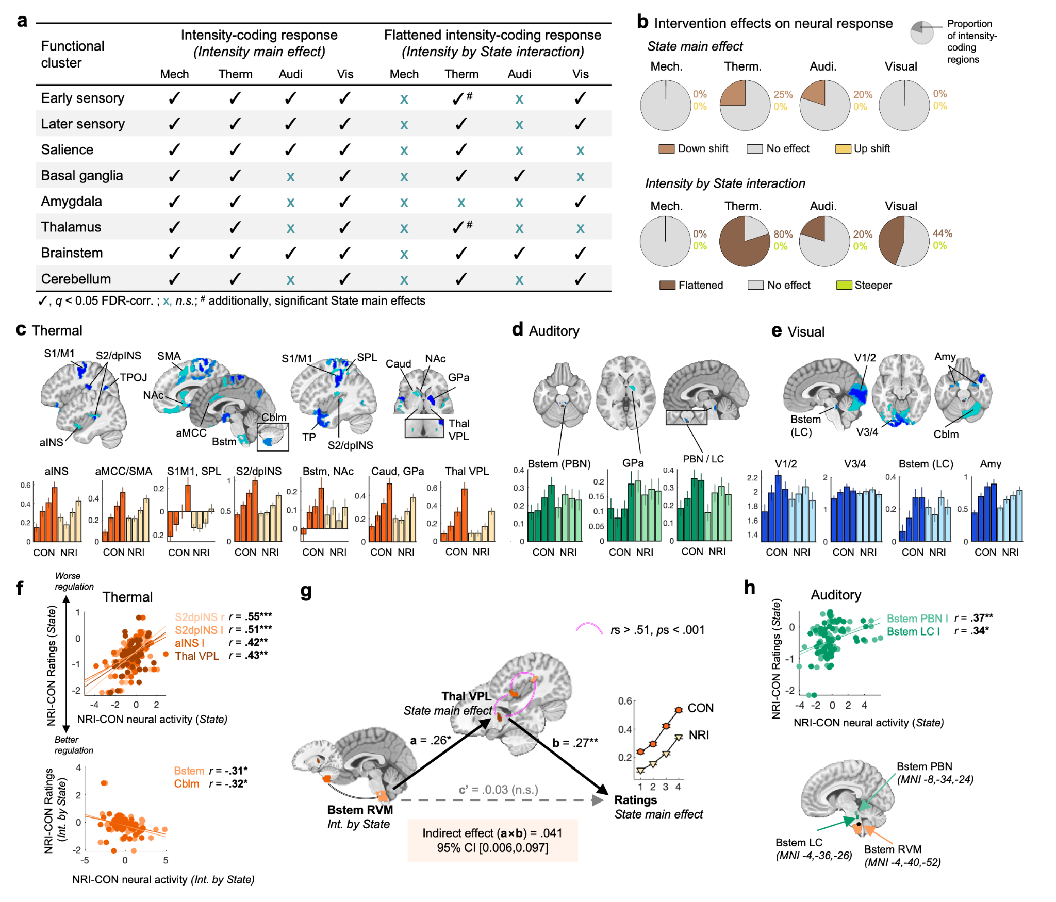
Figure 3. Non-Reactivity effects on stimulus-evoked responses in ascending sensory and affect generating pathways. a) Table lists main intensity-coding regions grouped by functional cluster and manipulation effects. b) Pie charts show the proportion of all intensity-coding regions with significant manipulation effects (NR-CON, q < 0.05 FDR-corrected). Upper row: State main effect; Lower row: Intensity by State interaction. ‘Flattened’ means the effect of increasing stimulus intensity is reduced with NRI. ‘Steeper’ means larger effects of stimulus intensity with NR. c)-e) Brain maps show parcels with significant Intensity by State effects per stimulus type. Barplots show average activation across 55 participants per stimulus level (1-4, low to high in order) for NRI (lighter color) and CON (darker color) averaged over voxels in the parcel. Error bars are SEM. f) Scatter plots show significant correlations between NRI effects on neural response and on ratings for thermal pain. Each dot is a participant; Axes show NRI-CON effects. Note that multiple regions are shown for display purposes; statistics were calculated on individual regions. r = Pearson correlation for individual regions, N = 55 per region, * p < 0.05, ** p < 0.01, *** p < 0.001. g) Mediation analysis shows the relationship between NRI effects on thalamic VPL activation (M), RVM activation (X) and ratings (Y); CI bootstrapped with n = 5000. The mediation (indirect) effect (ab) is significant as the 95% CI does not contain zero. Though mediation analysis focused on the RVM → VPL → Pain pathway, RVM is correlated with ventral cerebellum, and VPL is correlated with posterior and anterior insula changes. h) Scatterplots of manipulation effects on aversive auditory stimulation. Details as in (f). aMCC, anterior midcingulate; pACC, perigenual anterior cingulate; PCC, posterior cingulate; SMA, supplementary motor area; S1/M1 primary sensory / primary motor cortex; S2/dpINS, secondary somatosensory cortex / dorsal posterior insula; aINS, anterior insula; V1-4, visual cortex; TP, temporal pole; NAc, nucleus accumbens; Caud; caudate; Amy, amygdala; GPa, globus pallidus; Thal VPL; ventroposterior lateral nucleus of the thalamus; PBN; parabrachial nucleus; LC, locus coeruleus; Cblm, cerebellum. CON, Control; NR, Non-Reactivity.

Manipulation effects on neural activity in prefrontal cortices
Previous literature suggests that mindfulness manipulations may reduce affective brain responses without activating prefrontal regulatory systems (Kober et al. 2019; Zeidan et al. 2011; Farb et al. 2013). Non-Reactivity (vs. Control) produced both increases and decreases in prefrontal activity (Fig. 4a), with effects across stimulus types clustered in spatially overlapping and adjacent regions (Fig. 4b), but with different effect directions depending on stimulus type. Non-Reactivity increased prefrontal responses to aversive mechanical (reflected in decreased deactivation; Fig. 4c), auditory (increased activation; Fig. 4d), and visual stimulation (increased activation; Fig 4e), in contrast with previous research showing relative absence of prefrontal recruitment during mindful acceptance (Kober et al. 2019; Zeidan et al. 2011; Farb et al. 2013), but in line with prefrontal engagement during active reappraisal (Woo et al. 2015; Bo et al. 2024; Buhle et al. 2014). In contrast, Non-Reactivity reduced prefrontal responses to thermal pain (Fig. 4f), aligning with prior studies of mindful acceptance (Kober et al. 2019; Zeidan et al. 2011; Farb et al. 2013).
For aversive mechanical stimuli, although Non-Reactivity increased activity (reduced deactivation) in left OFC, these increases were associated with less effective regulation (r = 0.45, p = 0.001; Fig. 4g). A similar relationship was observed for thermal pain, where prefrontal activation including dMPFC, dLPFC, and aPFC was associated with less effective regulation (r = 0.35 - 0.44; p = 0.008 - 0.001; Fig. 4g; Supplementary Table 12). Thus, in pain, reduced prefrontal activity predicted greater regulatory success. In contrast, manipulation-induced increases in bilateral dLPFC responses to visual stimulation were associated with greater regulatory success (r = -0.34 to -0.44; p = 0.012 - 0.001; Supplementary Table 12).
In sum, while Non-Reactivity consistently dampened ascending sensory and affect signaling across stimulus types, it had mixed effects on prefrontal activity, increasing ventrolateral and dorsolateral prefrontal responses to most stimulus types but decreasing responses to thermal pain. Additionally, prefrontal increases predicted better regulation of visual stimuli but worse regulation of pain. Together, these findings suggest a functional dissociation between regulation of physical and non-physical stimuli: Successful regulation of pain entailed disengagement of prefrontal control systems, whereas successful regulation of responses to external visual and auditory stimuli entailed prefrontal increases, suggesting the engagement of cognitive control mechanisms.
Despite these differences, the spatial proximity of Non-Reactivity effects for different stimulus types in the prefrontal cortex (Fig. 4b) suggests some level of common processing, so we next tested whether individual differences in neural regulation effects were correlated across prefrontal regions and stimulus types. We observed positive correlations across both (Fig. 4h), indicating coherent individual differences in the magnitude of prefrontal modulation despite different effects (increases vs. decreases) across stimulus types, with several interconnected groups: coherent effects (1) on dLPFC, vLPFC, and OFC across external (visual and auditory) stimuli; (2) dMPFC and dLPFC responses during thermal pain; and (3) OFC and vMPFC responses during thermal pain. Non-Reactivity effects on right dLPFC were the most consistently related to other individual differences, with right dLPFC effects in visual regulation exhibiting the highest centrality within the network and the strongest correlations with other prefrontal regions and stimulus types. This positions the right dLPFC as a potential transmodal hub for negative affect regulation, consistent with prior work identifying the dLPFC as one of the most highly integrated cortical brain areas (Margulies et al. 2016, 2020) and a key target for neuromodulation manipulations (Sikka et al. 2022; Seminowicz and Moayedi 2017; Zhu et al. 2022).
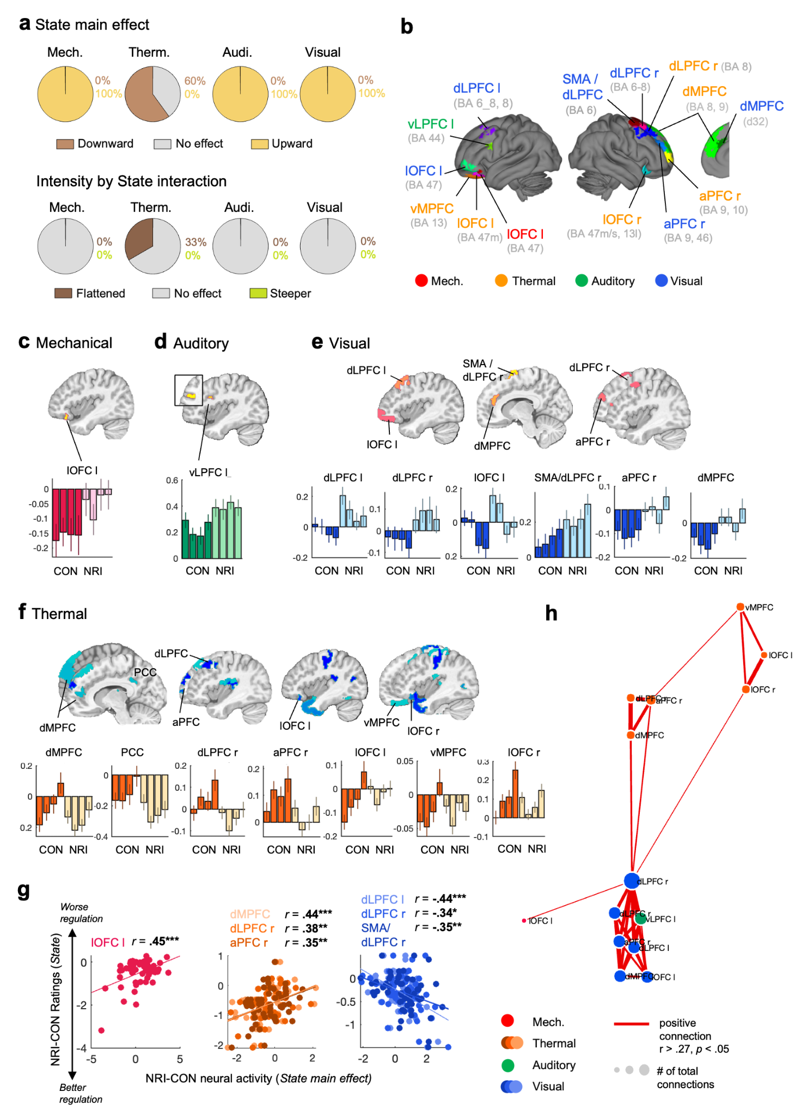
Figure 4. Non-Reactivity effects on stimulus-evoked responses in the prefrontal cortex. a) Pie charts summarize the proportion of prefrontal regions showing manipulation effects per stimulus type for each contrast of interest; upper row, State main effect; lower row, Intensity by State interaction. ‘Flattened’ means the effect of increasing stimulus intensity is reduced with NR. ‘Steeper’ means larger effects of stimulus intensity with NR. b) Brain surface map shows the anatomical distribution of prefrontal parcels in which we observed significant manipulation effects (State main effect for all stimulus types; additionally Intensity by State interaction for thermal stimuli), with labels color-coded by the stimulus type showing the effect. Parcel labels in the Glasser cortical atlas (Glasser et al. 2016) are as follows: mechanical pain (lOFC l, lateral orbitofrontal cortex, left, parcel label ‘Ctx_47m_L’); thermal pain (vMPFC/OFC, ventromedial prefrontal cortex / orbitofrontal cortex, ‘Ctx_13l_L’; lOFC l, ‘Ctx_47m_L’; dLPFC r, dorsolateral prefrontal cortex, right, ‘Ctx_8Ad_R’, ‘Ctx_8Av_R’; dMPFC, dorsomedial prefrontal cortex, ‘Ctx_9m_R’, ‘Ctx_8BL_R’; aPFC r, anterior prefrontal cortex, right, ‘Ctx_p10p_R’, ‘Ctx_9a_R’; lOFC r, ‘Ctx_47m_R’, ‘Ctx_13l_L’,PCC, posterior cingulate, ‘Ctx_31pv_R’); aversive auditory (vLPFC l, ventrolateral prefrontal cortex, left, ‘Ctx_IFJa_L’), aversive visual (dLPFC l, ‘Ctx_s6_8_L’, ‘Ctx_8Av_L’; lOFC l, ‘Ctx_a47r_L’; SMA/dLPFC r, supplementary motor area/dLPFC, right, ‘Ctx_6ma_R’; dLPFC r, ‘Ctx_s6_8_R’, ‘Ctx_i6_8_R’; aPFC r, ‘Ctx_9_46d_R’; dMPFC, ‘Ctx_d32_R’); c) - f) Brain maps show parcels with significant manipulation effects per stimulus type. Barplots show average activation across 55 participants per stimulus level for CON (darker color) and NR (lighter color) extracted from respective parcels. Error bars show SEM. g) Scatterplots show significant correlations between manipulation effects on prefrontal cortical responses (x-axis) and manipulation effects on ratings (y-axis) for mechanical (red), thermal (orange), and visual (blue); auditory correlations were not significant. Each dot is a participant. N = 55 participants; r = Pearson correlation, * p < 0.05, ** p < 0.01, *** p < 0.001. h) Network graph shows a weighted network derived from correlations across participants in activation contrast values (NR - CON; negative). Parcels with p < 0.05 are included in the network. Node size signifies number of edges, and color indicates stimulus type. Red e; edges show positive correlations; no negative correlations survived thresholding. CON, Control; NRI, Non-Reactivity.

Exploratory relationships with psychological traits
To situate our findings within the broader context of psychological traits, we conducted exploratory analyses correlating neural regulation effects with a predefined set of self-reported measures, including trait mindfulness, mental absorption, positive and negative affect, emotion regulation capacity, mind-wandering and distractibility. Several other modality-related associations may warrant investigation in future studies (for the full correlation matrix, see Supplementary Fig. 4).
Trait mindfulness is the most theoretically relevant for the current study, and it also showed the strongest association with neural regulation effects. Greater FFMQ mindfulness was associated with greater manipulation-related reductions in thermal pain ratings (FFMQ Non-judge, r = -0.33, p = 0.017) and manipulation-related reductions of neural activity during thermal pain in afferent nociceptive pathways (VPL, insula), as well as prefrontal cortical regions and PCC (FFMQ Non-judge, r = -0.27, p = 0.048, in vMPFC/OFC, Fig. 5a; FFMQ Acting with Awareness, r = -0.28 to -0.38, p = 0.005 - 0.046, in left S2/dpINS, left aINS, Thal VPL, right dLPFC, dMPFC and PCC, Fig. 5b; among several other sensory-motor regions, Supplementary Table 13). These facets are thought to reflect greater deliberate attentional presence and non-judgmental acceptance, suggesting that individuals who can sustain attention towards and accept (i.e., “be present with”) sensory experience show stronger down-modulation of ascending sensory-affective regions and deeper suppression of the Default Mode Network (MPFC, PCC). Similarly, inverse functional connectivity between activity in the left dLPFC and the PCC has been observed during hypnosis (Jiang et al. 2016). In contrast, manipulation-related reduction of neural activity during aversive auditory regulation was associated with lower FFMQ Acting with Awareness scores (PBN, r = 0.2, p = 0.049; Fig. 5c), indicating heterogeneity in the role of mindfulness across stimulus types. Combined with modality-specific brainstem effects (Fig. 3f-h), these trait associations may suggest the existence of multiple regulatory modes: increased focused, non-judgmental presence linked to neural suppression of ascending sensory pathways and DMN activity during thermal pain, and on the other hand reduced attentional engagement linked to suppression of arousal-related nuclei during auditory stimulation.
In addition, participants reported using a mix of acceptance, reappraisal and imagery transformation strategies to regulate aversive experiences (as summarized in Supplementary Methods, Supplementary Results, Supplementary Fig. 5, and Supplementary Table 14). This is in line with the notion that - like any real-world strategy - the manipulation in our study contained multiple facets, which operate differently depending on stimulus type or person. Thus, in addition to showing different behavioral and neural effects across stimulus types, our findings support prior research showing that affect regulation interacts with the context and strategy choice (Sheppes et al. 2011; Vaughan-Johnston et al. 2020; Dörfel et al. 2014; Braunstein et al. 2017; Ochsner and Gross 2005). Hypnotic analgesia can also alter how much pain is felt or how subjects feel about the pain they experience depending upon the hypnotic instruction (Rainville et al. 1997).
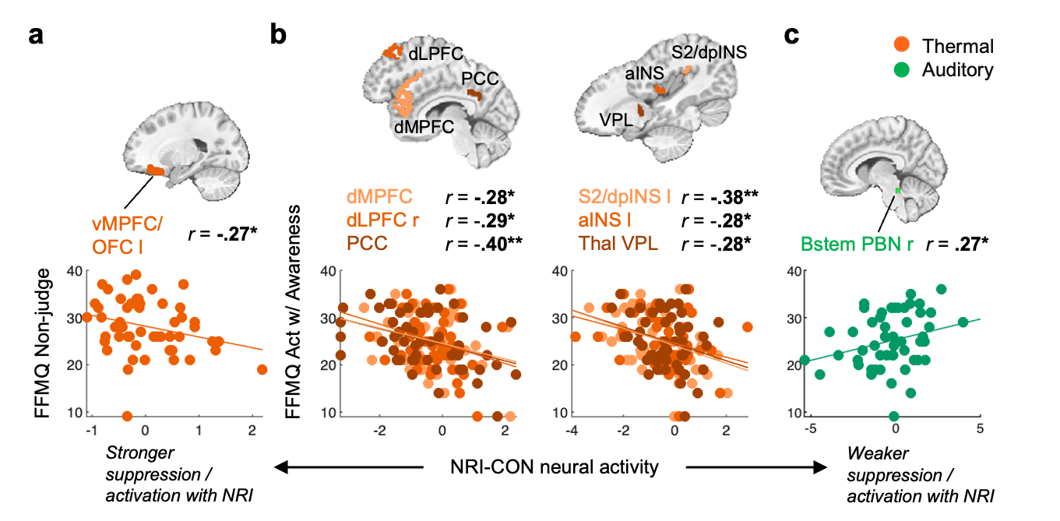
Figure 5. Relationship between manipulation effects on neural responses and trait mindfulness. a) - c) Scatterplots show significant correlations between manipulation effects on neural response (contrast value derived from State main effect or Intensity by State interaction) and the scores on the Five Facets of Mindfulness Questionnaire (FFMQ) ’Non-judge’ and ‘Acting with Awareness’ sub-scales (higher score indicates greater non-judgment of internal experiences and greater attentional presence, respectively); each dot is a participant; N = 55 participants; r = Pearson correlation, * p < 0.05, ** p < 0.01. v/d MPFC, ventro/dorsomedial prefrontal cortex; dLPFC, dorsolateral PFC; OFC, orbitofrontal cortex; PCC, posterior cingulate cortex; VPL, ventroposteriolateral nucleus of the thalamus; S2/dpINS, secondary somatosensory cortex / dorsal posterior insula; aINS, anterior insula; Bstem PBN, brainstem parabrachial nucleus. Orange, thermal pain; green, aversive auditory stimulation. CON, Control; NRI, Non-Reactivity.

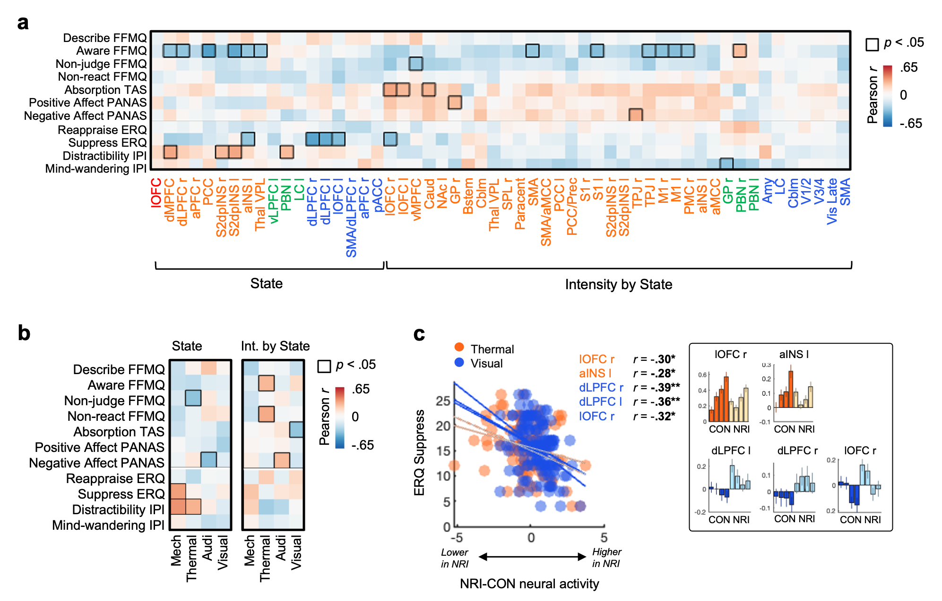
Supplementary Figure 4. Relationship between neural effects of manipulation and psychological traits. The matrix shows correlations between psychological traits and significant manipulation effects (State main effect, Intensity by State interaction) on (a) neural activity and (b) ratings. Negative correlations indicate greater suppression of negative affect in NRI vs. CON, or flattening in the case of the interaction. FFMQ, Five-Facet Mindfulness Questionnaire (39-item); TAS, Tellegen Absorption Scale (34-item); PANAS, Positive and Negative Affect Schedule (20-item); ERQ, Emotion Regulation Questionnaire (10-item); Imaginal Processes Inventory (IPI) Distractibility (12-item) and Mind-wandering (12-item). Survey data available in N = 53 participants for FFMQ, TAS, PANAS and N = 50 participants for ERQ and IPI. c) Scatterplot shows significant correlations between manipulation effects on neural response (contrast value derived from State main effect or Intensity by State interaction) and the score on the ERQ Suppress sub-scale (higher score indicates higher tendency to suppress emotion-expressive behavior); each dot is a participant; N = 55 participants; r = Pearson correlation, * p < 0.05, ** p < 0.01. Inset displays barplots of average activation across 55 participants per stimulus level for CON (darker color) and NRI (lighter color), extracted from respective parcels. Error bars are SEM. lOFC, lateral orbitofrontal cortex; aINS, anterior insula; dLPFC, dorsolateral prefrontal cortex; orange, thermal pain; blue, aversive visual stimulation. CON, Control; NRI, Non-Reactivity.

Discussion
A central question in affective neuroscience is whether regulatory strategies can meaningfully modulate neural systems that give rise to negative affect. On one hand, both cognitive reappraisal and mindful acceptance-based strategies can influence activity in transmodal hubs like the anterior cingulate and insula (Fox et al. 2016; Buhle et al. 2014; Kober et al. 2019), but those regions afford little limited specificity about the affected processes (Yarkoni et al. 2011; Kragel et al. 2018; Shackman et al. 2011). On the other hand, converging evidence indicates that specific types of negative affect are reflected in distributed, partially modality-specific sensory pathways (Čeko et al. 2022; Van Oudenhove et al. 2020; Kragel and LaBar 2015; Saarimäki et al. 2016; Chikazoe et al. 2014; Wager et al. 2013; Chang et al. 2015), consistent with embodied emotion and evolutionary theories that conceive of affect as a collection of survival-related sensory and interoceptive processes responding to environmental demands (Damasio and Carvalho 2013; Niedenthal 2007; Al-Shawaf et al. 2016). Modulation of these affect-related sensory pathways would signal a significant shift in how affect is constructed. However, it is unclear whether cognitive strategies impact activity in affect-linked sensory processes, and multiple recent studies argue against effects of standard reappraisal-based cognitive strategies (Bo et al. 2024; Botvinik-Nezer et al. 2024; Denny et al. 2023; Jiang et al. 2026).

In the current study, we hypothesized that inducing a sustained state of mindful non-reactivity may be a particularly effective strategy to modulate neural affect-generating systems. Our Non-Reactivity manipulation produced robust reductions in negative affect ratings across sensory modalities (d = 0.77 - 1.91; 0.7 is considered a “large effect”) that (a) were sustained across runs, with increasing effectiveness over time, (b) showed no moderation by demographic variables and scan order, (c) were related to trait mindfulness, and (d) were unrelated to expectations about effectiveness. The NRI also reduced validated neuromarkers for negative affect induced by thermal, auditory, and visual (but not mechanical) aversive stimuli, and reduced activity in affect-linked sensory pathways related to each of these three stimulus types. Together, these findings indicate that the NRI induced a sustained state of non-reactive acceptance of stimuli that reduced negative affective reactivity across sensory domains. The NRI also consistently engaged altered lateral and medial prefrontal activity, though in different directions across stimulus types. Together, the findings suggest that non-reactivity engages both shared and modality-specific mechanisms that dampen negative affective reactivity, with robust but selective effects on neuromarkers and sensory pathways implicated in affective processing.

Tests of a priori, validated neuromarkers for negative affect provide a particularly important way of testing affect-linked brain systems. Activity in individual regions, including transmodal hubs like aMCC and aINS and affect-associated regions like amygdala, reflects a mix of cognitive and affective processes (Yarkoni et al. 2011; Shackman et al. 2011), and thus their modulation by a manipulation does not necessarily imply modulation of circuits involved in representing or constructing affect. An advantage of neuromarkers is that they can be trained to closely track affective behavior and validated to be specific to particular types of affect. Across studies, we have found that different neuromarkers track affect induced by visual, auditory, and pain, with further differentiation possible for thermal vs. mechanical pain (Van Oudenhove et al. 2020; Chang et al. 2015; Čeko et al. 2022; Krishnan et al. 2016; Lee et al. 2021). Here, we tested two types of neuromarkers – those trained on out-of-sample participants in this study (and validated in independent studies) and those trained on independent studies. The NRI reduced stimulus type-specific neuromarkers trained on this cohort for thermal, visual, and auditory stimuli, and modality-general (common) negative affect neuromarkers in thermal and visual stimuli only. Findings were similar from neuromarkers trained on other studies. The NRI reduced thermal pain responses in the NPS (Wager et al. 2013) and visual responses in the PINES (Chang et al. 2015). The NPS is the most extensively validated neuromarker to date and tracks nociceptive pain across stimulus types, body sites, and other features, but is not activated by other types of negative affect. Interestingly, the NRI did not reduce responses in a second pain signature, the SIIPS, thought to track evaluative aspects of pain (Woo et al. 2017; Botvinik-Nezer et al. 2024). These findings mirror a double dissociation in the literature, with mindfulness and meditation selectively reducing NPS activity (Kober et al. 2019; Dean et al. 2022; Riegner et al. 2025) and placebo and cognitive regulation selectively affecting the SIIPS (Dean et al. 2022; Riegner et al. 2025)(Botvinik-Nezer et al. 2024, 2025; Riegner et al. 2025), and is further supported by recent work showing distinct distributed neural representations associated with acceptance vs. reappraisal of dynamic visual stimuli, with acceptance modulating visual cortex and amygdala activation, and reappraisal modulating frontoparietal control systems (Jiang et al. 2026). Taken together, despite similar effects behaviorally, the manipulation had distinct effects on neuromarkers of negative affect, potentially related to the differences in the structure of neural representations (Čeko et al. 2022) .
At the region level, the manipulation reduced activity within sensory and affect-generating systems, though again not for mechanical pain. Regulation of thermal and visual stimuli produced widespread dampening of stimulus-evoked neural activity along sensory-affective pathways, including cerebellum, brainstem, limbic, and sensory cortical areas - with little to no effect for mechanical and auditory stimuli. This flattening of the intensity-coding responses indicates a general decrease in ascending affective signal processing. These findings extend prior work on mindful acceptance (Kober et al. 2019; Zeidan et al. 2011; Dean et al. 2022; Riegner et al. 2025; Taylor et al. 2011) and hypnosis-related (Rainville et al. 1997, 1999; Faymonville et al. 2000; Lang et al. 2000) modulation of pain and emotion, indicating that sustained non-reactive regulatory states can down-regulate early sensory-affective drivers of aversive experience under some conditions. Additionally, trait hypnotizability has been associated with higher functional connectivity between the left dLPFC and aMCC, indicating greater cognitive control of arousal (Hoeft et al. 2012). Relative resistance to the effects of regulation observed for mechanical and auditory stimuli - for the latter confined to brainstem nuclei - was supported by both stimulus types demonstrating intensity-coding effects in a much narrower set of sensory and midline regions in univariate analyses, potentially indicating fewer neural entry points for regulation.
Within the prefrontal cortex, regulation effects diverged across sensory domains, with effects constrained largely to thermal and visual stimuli, whereas the effect was minimal for mechanical and auditory stimuli and restricted to the ventral PFC. Regulation of thermal pain produced widespread prefrontal suppression, whereas regulation of aversive visual stimuli produced widespread prefrontal engagement. Importantly, both types of effects (suppression for thermal, engagement for visual) were correlated with respective behavioral regulation success, underscoring functional relevance. Despite the opposite sign, these neural effects were anatomically adjacent and correlated across all four stimulus types, with the right dLPFC in the center of this correlation network, indicating a shared neural substrate. Across studies, the right dLPFC presents itself as a potential hub capable of both engagement and disengagement depending on regulatory demands, with an integrative modulatory role demonstrated across affective and cognitive domains (Sikka et al. 2022; Seminowicz and Moayedi 2017; Zhu et al. 2022; Margulies et al. 2016, 2020; Denny et al. 2023).
These findings refine existing theories of affect regulation. For thermal pain, successful regulation relied on reduced prefrontal engagement, consistent with theories of mindful acceptance that emphasize attenuated evaluative processing and reduced cognitive elaboration. However, contrary to contemporary models where mindful acceptance approaches increase interoceptive attention and the engagement of salience systems (Farb et al. 2013; Fox et al. 2016), thermal pain regulation was characterized by widespread neural activity reductions in salience and ascending sensory-affective pathways (vMPFC, lOFC, aINS, S2/dpINS, VPL thalamus, brainstem). Our findings thus help clarify a key question in the field (Kober et al. 2019): how appraisal and perceptual shifts can be enacted without involvement of prefrontal control systems - potentially by coordinated system-wide suppression across valuation, salience and sensory circuits.
For aversive visual stimulation, successful regulation was associated with increased prefrontal engagement. This finding is at odds with prior work using nonreactive mindful regulation (Kober et al. 2019; Zeidan et al. 2011; Farb et al. 2013) - which largely show a relative absence of prefrontal recruitment (during brief regulation instances), but it does suggest the engagement of prefrontal cognitive control mechanisms, similar to what has been observed in prior studies when effortfully reappraising negative stimuli (Buhle et al. 2014; Woo et al. 2015; Bo et al. 2024; Denny et al. 2023; Jiang et al. 2026). Together, these findings reveal distinct regulatory modes across modalities, with different combinations of sensory and prefrontal processes supporting successful regulation.
Brainstem findings support distinct regulatory modes. For thermal pain, greater regulation success was associated with preserved or enhanced activity in the RVM - a key player in the descending inhibition of nociceptive input (Ossipov et al. 2010; Tracey and Mantyh 2007; Heinricher et al. 2009). Together with suppression in thalamus and sensory cortices, this result converges with a large body of work showing that prefrontal suppression of thermal pain is paired with bottom-up inhibition of nociceptive signaling (Bushnell et al. 2013; Martucci and Mackey 2018), extending this framework to sustained, non-reactive regulatory states. In contrast, for aversive auditory stimulation, greater regulation success was associated with neural suppression in the brainstem nuclei LC and PBN - implicating regulation success primarily via reduced arousal and affective drive (Sara and Bouret 2012; Chiang et al. 2019; Schwarz and Luo 2015). These results highlight that sustained regulation interacts with brainstem systems in stimulus-specific ways.
Finally, trait associations provide converging, though exploratory, evidence for distinct regulatory modes. Trait mindfulness - particularly facets reflecting attentional awareness and non-judgement - showed the strongest relationships with neural regulation effects. During thermal pain regulation, higher mindfulness was associated with greater pain reduction and greater reductions in neural activity across sensory-affective, prefrontal and default mode regions. These effects may indicate enhanced capacity for sustained, non-judgemental attention to sensory experience, enabling down-modulation of evaluative and sensory-affective systems. In contrast, during auditory regulation, higher mindfulness was associated with lower reduction in neural activity in the brainstem, indicating heterogeneity in the role of mindfulness traits across contexts, and potentially indicating reduced attentional engagement linked to suppression of arousal-related nuclei during auditory stimulation.
Synthesizing these findings, we propose a two-level model of sustained affect regulation. First, the neural impact of regulation may be constrained by the representational architecture of affective systems, such that different forms of aversive input show different susceptibility to neural modulation. Concretely, neural representations for thermal and visual aversion span a wider set of systems and may provide more “entry points” for sustained regulation, enabling coordinated modulation across sensory and higher-order processes, whereas more narrowly localized representations for mechanical and auditory stimuli may limit the extent of neural modulation. Second, within these systems the regulation may flexibly deploy prefrontal suppression and engagement depending on context.
Several factors may contribute to the observed differences in neural regulation across sensory domains. For example, stimulus types did not differ only in the structure of their neural representation but also in the strength and range of neural intensity coding, which may influence the extent to which neural activity can be modulated. Differences in the nature of sensory input may also play a role. For example, the regulation of internally focused stimuli (e.g., thermal pain) may require different neural mechanisms than externally focused stimuli (e.g. aversive visual stimuli). Future work directly testing these factors may be able to address these speculations.
This study has several limitations. The manipulation likely engaged multiple processes in addition to non-reactivity, which likely differed across subjects and stimulus types - above and beyond what we captured in the qualitative data. Differences across stimulus types may reflect differences in salience, task demands or combination of factors not sufficiently isolated by our study design. Although neuromarkers provide sensitive and fairly specific indices of affective processing, they do not capture all aspects of subjective experience.
In conclusion, sustained non-reactivity alters affect-generating systems, producing robust effects on behavior and selective modulation of neural systems. These effects reflect flexible recruitment of sensory and prefrontal pathways and highlight the importance of sustained regulatory states in shaping affective experience. This work advances mechanistic understanding of affect regulation and identifies potential neural targets for precision interventions across pain and emotion disorders.

Methods

Participants
The study included 55 healthy participants (mean ± SD age: 24.9 ± 6.8; 31 males, 24 females; 9 left-handed; 47 white and 8 non-white (1 Hispanic, 5 Asian, 1 Black and 1 American Indian) with no self-reported history of psychiatric, physiological, or pain disorders and neurological conditions, no current pain symptoms, and no MRI contraindications. Eligibility was assessed with a general health questionnaire, a pain safety screening, and an MRI safety screening. Participants were recruited from the Boulder/Denver Metro Area. The Institutional Review Board of the University of Colorado Boulder approved the study. All participants provided written consent and were compensated for their time. Data collection and analysis were not performed blind to the conditions of the experiments. No statistical methods were used to predetermine the sample size, but our sample size is similar to those reported in previous publications (Coll et al. 2022; Spisak et al. 2020; Van Oudenhove et al. 2020; Woo et al. 2014, 2017). No participants were excluded from analysis.

Study design
All participants underwent two counterbalanced fMRI scans in a single day (Fig. 1a). During the ‘Control’ (CON) scan , participants were asked to passively experience a set of aversive affective stimuli without attempting to regulate their experience. Brain and behavioral outcomes from this scan were published previously (Čeko et al. 2022). During the ‘Non-Reactivity ’ (NR) scan, participants were asked to maintain a state of Non-Reactivity throughout the scan while experiencing aversive stimuli. . Preparation for the NRI scan comprised several components, including training in the NRI procedure Preparation for the CON scan was approximately matched in duration and attentional demand. . Details for both are included below.

fMRI task and contrasts of interest
The same stimuli were administered in each scan, but with different instructions displayed on the screen before the task began. In the Control scan, participants were instructed to ‘Experience the following sensations as they come’. In the Non-Reactivity scan, participants were instructed to apply the NRI practiced just prior to the scan (see ‘Non-Reactivity Training’ below for details). They were specifically reminded: ‘Focus on your breath. Feel your body float. Accept the following sensations as they come. Transform negative sensations into positive’. Across fMRI scans, the task included a randomized series of brief (6 - 10 sec) negative affective stimuli of different types (painful pressure, painful heat, aversive sound, aversive images). Each stimulus type repeated multiple times over the course of the fMRI scan, at 4 different intensity levels, for a total of 96 negative stimuli over 6 fMRI runs (4 types x 4 intensities x 6 runs). Of note, the task also included a positive stimulus condition (positive images; 24 stimuli; 4 intensities x 6 runs; randomly interleaved with negative stimuli), which are not reported in the current paper. Participants rated each stimulus on each trial on the avoidance scale, described below. The negative stimuli (described in detail in (Čeko et al. 2022)) were: (1) mechanical pressure administered by an in-house pneumonic device to the left thumbnail (range 4 - 7 kg/cm²); (2) contact heat administered by an ATS Pathway System (Medoc) to the thenar eminence of the left hand (range 45 - 48 °C); (3) sound of a knife scraping on a bottle, retrieved from YouTube, delivered at 2000 Hz (intensity levels created by a stepwise dB reduction from the original sound file); and (4) aversive images from the International Affective Picture System (IAPS) database (range based on normative ratings).

Negative affect ratings
Participants rated their subjective experience of negative stimuli on a uniform scale across different types of stimuli, by rating how much they wanted ‘to avoid this experience in the future’ on a gLMS scale. The scale was anchored at ‘not at all’ (0) to ‘most’ (1), with intermediate labels (displayed during training but omitted during the fMRI task to avoid clustering of ratings around the labels (Hayes et al. 2013)) indicating ‘a little bit’ (0.061), ‘moderately’ (0.172), ‘strongly’ (0.354) and ‘very strongly’ (0.533). Across fMRI scans (CON, NR), ratings collected after each stimulus instance (total of 6 per intensity level per scan) were averaged for further analyses, for a total of 8 values (4 intensity levels x 2 scans) per stimulus per participant.

Self-report surveys
Participants completed a battery of self-report surveys to assess individual differences in trait mindfulness, emotional regulation tendencies, and mental health (for correlations among surveys, see Supplementary Figure 6). These included the 10-item Emotional Regulation Questionnaire (ERQ; Gross and John 2003), measuring habitual use of cognitive reappraisal and expressive suppression; the 20-item Positive and Negative Affect Schedule (PANAS; REF), measuring general affective state; the 12-item Mindwandering and Distractibility subscales of the Imaginal Processes Inventory (IPI; Antrobus et al. 1970), measuring tendency for attention to drift from current tasks or external stimuli toward unrelated thoughts and concerns; the 34-item Tellegen Absorption Scale (TAS; Tellegen and Atkinson 1974), assessing the tendency to become fully absorbed in experiences; and the 39-item Five Facet Mindfulness Questionnaire (FFMQ; Baer et al., 2006), which assesses dimensions of dispositional mindfulness (Observe, Describe, Act with Awareness, Non-judge, and Non-react). Consistent with prior work, the Observe facet was excluded from analyses, as it has shown poor reliability and factorial validity in non-meditating samples (Williams et al. 2014; Baer et al. 2008).
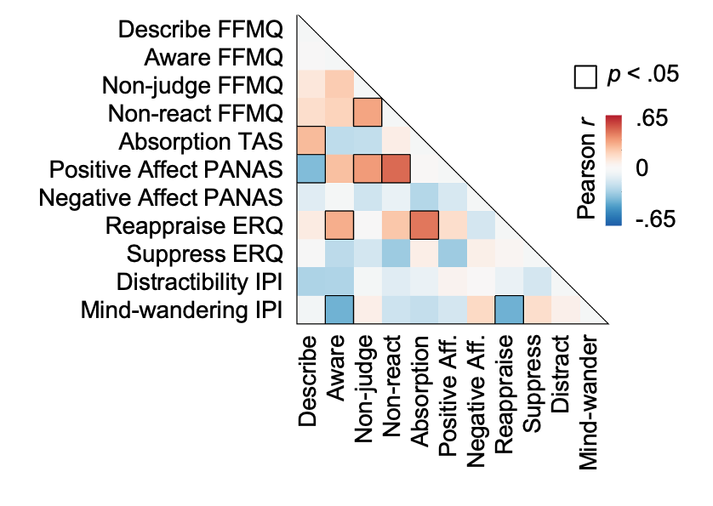
Supplementary Figure 6. Correlations among surveys. FFMQ, Five-Facet Mindfulness Questionnaire (39-item); TAS, Tellegen Absorption Scale (34-item); PANAS, Positive and Negative Affect Schedule (20-item); ERQ, Emotion Regulation Questionnaire (10-item); Imaginal Processes Inventory (IPI) Distractibility (12-item) and Mind-wandering (12-item). Survey data was missing in some participants, for a total sample of N = 53 participants for FFMQ, TAS, PANAS and N = 50 participants for ERQ and IPI.

Non-Reactivity Training
Prior to the fMRI scan, participants were trained to adopt an affect regulation strategy characterized by a sustained state of cognitive non-reactivity to incoming stimuli (see ‘Intervention training script’ in Supplementary Methods). Mindfulness – attention to ongoing sensations with a stance of acceptance and curiosity – can be combined with compatible techniques (Teasdale et al. 2000) that could enhance receptivity to instructions and make it easier to adopt an accepting and curious attitude towards sensations. As mindful acceptance is embodied – the focus of attention is on bodily sensations, both ongoing and elicited by sensory stimuli – it is compatible with techniques like hypnosis that involve suggestions about the quality and intensity of sensory experience (Spiegel and Spiegel 2004). Hypnosis is particularly interesting in this context because it involves progressive suggestions about the body and experience that may increase receptivity, a sense of agency, and promote an attitude of curiosity. It is also successful in reducing threat in experimental and clinical contexts (Spiegel and Spiegel 2004; Rainville et al. 1999; Faymonville et al. 2000; Jensen and Patterson 2014). Our non-reactivity training included: (1) educational information that the brain is connected to and regulates the body in profound ways; (2) induction of a state of openness to suggestion by administering the Hypnotic Induction Profile (HIP; (Spiegel and Spiegel 2004) and (3) instructions on how to adopt a state of mindful acceptance. In Stage 1 (~2 min), participants received a brief neuroscience education program, teaching them that the brain sends neural projections to the spinal cord that can powerfully inhibit pain, and that similar pathways allow the brain to control vision, audition, and other types of sensations as well. This provided a rational foundation for suggestions of enhanced self-regulatory capacities, by providing simple and credible scientific evidence. In Stage 2 (~10 min), the HIP was used to induce a state of receptivity by (a) placing the participant in a reclined posture associated with safety and rest, (b) making suggestions that the ability to respond to hypnotic suggestions is an ability that can be achieved and that the person is always in control, and (c) making somatic suggestions, particularly that the body is getting heavier and one’s arm is becoming lighter. The result is often a state in which participants experience the suggested phenomena in a way that is surprising to them, potentially indicating a state of high receptivity and surrender of control. Before the next stage, we also administered a brief guided ‘body scan’, a technique adopted from mindfulness meditation (~2 min) to serve as relaxation. In Stage 3 (~5 min), specific suggestions were made for how to dissociate oneself from pain and other negative affect and adopt a state of non-reactivity to incoming negative stimuli. This provides strategies and suggestions of enhanced self-control and self-regulatory capacity. Two kinds of suggestions were made directly following Stage 2, while participants were in an open and receptive state. First, it was suggested that negative emotion arises from the urgency for action, the need to “do something” about an aversive stimulus or event – but that it is not necessary to react. Instead, participants can choose to do nothing in response, to simply notice and accept sensations in the body and mind without trying to avoid them or divert their attention. It was further suggested that they can “filter the hurt out of the pain,” and adopt a non-reactive stance to all incoming sensory stimuli. Pain becomes an “interesting sensation”, aversive images become “a collection of interesting shapes and colors”. Feelings of anxiety that might arise are “passing bodily sensations” that one does not have to respond to. Participants were encouraged to visualize these suggestions in a multi-sensory fashion, by creating visual images of pain (“What color is it? What shape? Sharp or dull?”) and to visualize “filtering the hurt out” and transforming the visual image.

Preparation for the Control fMRI scan
Prior to the fMRI scan, participants completed only the body-scan/relaxation component of the NR protocol above. Unlike the NR condition, they did not receive hypnotizability assessment, acceptance-based training, imagery instructions, or practice in regulating painful or aversive sensations. They were instructed to experience the stimuli naturally, without attempting to regulate their responses, during the upcoming fMRI scan. Next, participants viewed an engaging but neutral video on MRI Physics. Combined, the relaxation and video were approximately matched in duration to the NRI preparation above.

fMRI data acquisition
As reported previously (Čeko et al. 2022), whole-brain fMRI data were acquired on a 3T Siemens MAGNETOM Prisma MRI scanner at the Intermountain Neuroimaging Consortium facility at the University of Colorado, Boulder. Structural images were acquired using high-resolution T1 spoiled gradient recall images and were used for anatomical localization and warping to the standard Montreal Neurological Institute (MNI) space only. Functional images were acquired with a multiband EPI sequence (repetition time = 460 ms, echo time = 27.2 ms, field of view = 220 mm, multiband acceleration factor = 8, flip angle = 44°, 64 × 64 matrix, 2.7 × 2.7 × 2.7 mm voxels, 56 interleaved ascending slices, phase encoding posterior » anterior). In each scan (CON, NR) six runs of 7.17 min in duration ( = 934 measurements) were acquired. Stimulus presentation and behavioral data acquisition were controlled using Psychtoolbox (MATLAB, MathWorks).

fMRI data preprocessing
As reported previously (Čeko et al. 2022), fMRI data were preprocessed using an automated pipeline based on AFNI, FSL, and SPM5, and implemented by the Mind Research Network. The preprocessing steps included distortion correction using FSL’s top-up tool (https://fsl.fmrib.ox.ac.uk/fsl/), motion correction (affine alignment of first EPI volume (reference image) to T1, followed by affine alignment of all EPI volumes to the reference image and estimation of the motion parameter file (sepi_vr_motion.1D, AFNI; https://afni.nimh.nih.gov/), spatial normalization via the participant’s T1 image (T1 normalization to MNI space (nonlinear transform), normalization of EPI image to MNI space (3dNWarpApply, AFNI; https://afni.nimh.nih.gov/), interpolation to 2 × 2 × 2 mm3 voxels and smoothing with a 6-mm FWHM kernel (SPM 8; https://www.fil.ion.ucl.ac.uk/spm/software/spm8/). Before first-level analysis, the first 15 volumes of the fMRI data in each run were removed to allow for image intensity stabilization and identified severe global motion outliers (spikes) in the data. Spikes were defined as time points in the data with either the absolute global signal intensity or the Mahalanobis distance across slice-specific global means and spatial standard deviations exceeding ten median absolute deviations.

fMRI GLM analysis
fMRI data were analyzed using a general linear model (GLM) implemented in SPM12 (http://www.fil.ion.ucl.ac.uk/spm/) and custom MATLAB (2019a, MathWorks) code available from the authors’ website (https://github.com/canlab/CanlabCore/). Data distribution was assumed to be normal but was not formally tested. The six runs for each fMRI scan were concatenated for each participant. Boxcar regressors, convolved with the canonical hemodynamic response function, were constructed to model the 6–10-s stimulation and 4–7-s rating periods. The fixation cross epoch was used as an implicit baseline. A high-pass filter of 180 s was applied. Nuisance variables included: (a) ‘dummy’ regressors coding for each run (intercept for each run); (b) linear drift over time within each run; (c) the six estimated head movement parameters (x, y, z, roll, pitch and yaw), their mean-centered squares, their derivatives, and squared derivative for each run (total = 24 columns); and (d) motion outliers (spikes). The resulting participant-level contrast images of interest (beta images) included stimulation periods averaged across six trials for each stimulus intensity level (each against implicit baseline) and each scan (Non-Reactivity vs. Control) for a total of 32 images per participant (4 stimulus types x 4 intensity levels x 2 scans)
Group-level analyses of participant-level contrast images were conducted using robust parcel-wise regression across 489 labeled brain parcels regions defined by the CANLab 2018 atlas (see Supplementary Table 4) using robust_parcelwise (CANlab Tools, MATLAB). The results were thresholded using FDR q < .05 across all parcels and across contrasts.

fMRI neuromarker responses
We tested whether brain patterns of negative affect were significantly altered in the Non-Reactivity vs. Control using neuromarkers (whole-brain multivariate neural patterns) developed to predict affect in independent samples in prior studies (Neurologic Pain Signature, NPS (Wager et al. 2013); Stimulus-Intensity Independent Pain Signature, SIIPS (Woo et al. 2017); Picture-Induced Negative Emotion Signature (Chang et al. 2015)). Pattern responses were estimated for each participant in each test condition by computing the dot product of a pattern weight map with the participant’s brain activation map for each stimulus intensity level, yielding a single scalar value per level. Cross-validated pattern weight maps were used for patterns predicting stimulus-type specific negative affect (Specific patterns for mechanical pain, thermal pain, negative auditory affect and negative visual affect) and negative affect across stimulus types (Common Multimodal Negative Affect pattern), as these were previously developed in the same participants (Čeko et al. 2022).

Behavioral data analysis
Analyses were conducted separately for each stimulus type (mechanical pain, thermal pain, aversive auditory aversive visual) and scan.
Main contrasts. Behavioral data were analyzed using a multilevel generalized linear model implemented in MATLAB using glmfit_multilevel.m (Statistics Tools, (https://github.com/canlab/CanlabCore/). This mixed-effects model treats participants as a random effect by estimating participant-level regression models (first-level) and then performing group (second-level) inference on the resulting coefficients using precision-weighted least squares. The outcome variable (Y) was negative affect ratings. At the within-participant level (X1) the predictors included stimulus intensity (4 levels), scan (CON vs. NR) and their interaction, modeled using contrast weights: [-3 -1 1 3 -3 -1 1 3] for the Intensity main effect (I); [-1 -1 -1 -1 1 1 1 1] for the State main effect (S); and [3 1 -1 -3 -3 -1 1 3] for the Intensity by State interaction (I x S). First-level models were estimated separately for each participant and the coefficients were entered into a second-level random-effect analysis, yielding population-level estimates for each contrast. The model corresponds to a random-intercept, random-slope specification in Wilkinson notation: Y ~ I + S + (I x S) + (1 + I + S + (I x S) | participant). Inference was performed using bootstrap resampling (10,000), with precision-weighted least square estimation to account for first-level variability, and yielding population-level estimates for each contrast.
Effect sizes across runs. To examine changes in intervention effects over time, we computed run-level treatment differences (Control − Non-Reactivity) within each participant, collapsed across intensity levels. For each modality, linear slopes of these differences across runs (1–6) were estimated separately for each participant using ordinary least-squares regression. These subject-specific slopes were then entered into one-sample t-tests against zero to assess whether intervention effects systematically increased or decreased over runs.

Correlation analyses
Relationships between behavioral and neural effects were tested using two-tailed Pearson’s linear correlations across participants. For each participant, beta estimates from the multilevel GLM corresponding to the State main effect and Intensity by State contrasts were extracted and correlated with corresponding neural effect estimates (per each parcel of interest) for each stimulus type separately. Results were considered significant at p < 0.05 (uncorrected).
In separate analyses, behavioral and neural effect estimates were each correlated with individual differences in survey measures using two-tailed Pearson’s linear correlations. Results were considered significant at p < 0.05 (uncorrected).

References

Al-Shawaf, Laith, Daniel Conroy-Beam, Kelly Asao, and David M. Buss. 2016. “Human Emotions: An Evolutionary Psychological Perspective.” Emotion Review: Journal of the International Society for Research on Emotion 8 (2): 173–186.
Ames, R. T., and D. E. Hall. 2003. Dao De Jing: A Philosophical Translation. Ballantine Books.
Antrobus, J. S., J. L. Singer, S. Goldstein, and M. Fortgang. 1970. “Mindwandering and Cognitive Structure.” Transactions of the New York Academy of Sciences 32 (2): 242–252.
Baer, Ruth A., Gregory T. Smith, Emily Lykins, et al. 2008. “Construct Validity of the Five Facet Mindfulness Questionnaire in Meditating and Nonmeditating Samples.” Assessment 15 (3): 329–342.
Barrett, Lisa Feldman. 2006. “Solving the Emotion Paradox: Categorization and the Experience of Emotion.” Personality and Social Psychology Review: An Official Journal of the Society for Personality and Social Psychology, Inc 10 (1): 20–46.
Beck, Aaron T. 1969. Depression: Clinical, Experimental, and Theoretical Aspects. Staples Press.
Bishop, Scott R., Mark Lau, Shauna Shapiro, et al. 2004. “Mindfulness: A Proposed Operational Definition.” Clinical Psychology 11 (3): 230–241.
Bo, Ke, Thomas E. Kraynak, Mijin Kwon, Michael Sun, Peter J. Gianaros, and Tor D. Wager. 2024. “A Systems Identification Approach Using Bayes Factors to Deconstruct the Brain Bases of Emotion Regulation.” Nature Neuroscience 27 (5): 975–987.
Botvinik-Nezer, Rotem, Stephan Geuter, Martin A. Lindquist, and Tor D. Wager. 2025. “Expectation Generation and Its Effect on Subsequent Pain and Visual Perception.” PLoS Computational Biology 21 (5): e1013053.
Botvinik-Nezer, Rotem, Bogdan Petre, Marta Ceko, Martin A. Lindquist, Naomi P. Friedman, and Tor D. Wager. 2024. “Placebo Treatment Affects Brain Systems Related to Affective and Cognitive Processes, but Not Nociceptive Pain.” Nature Communications 15 (1): 6017.
Bräscher, Anne-Kathrin, Susanne Becker, Marie-Eve Hoeppli, and Petra Schweinhardt. 2016. “Different Brain Circuitries Mediating Controllable and Uncontrollable Pain.” The Journal of Neuroscience: The Official Journal of the Society for Neuroscience 36 (18): 5013–5025.
Braunstein, Laura Martin, James J. Gross, and Kevin N. Ochsner. 2017. “Explicit and Implicit Emotion Regulation: A Multi-Level Framework.” Social Cognitive and Affective Neuroscience 12 (10): 1545–1557.
Buhle, Jason T., Jennifer A. Silvers, Tor D. Wager, et al. 2014. “Cognitive Reappraisal of Emotion: A Meta-Analysis of Human Neuroimaging Studies.” Cerebral Cortex 24 (11): 2981–2990.
Bushnell, M. Catherine, Marta Ceko, and Lucie A. Low. 2013. “Cognitive and Emotional Control of Pain and Its Disruption in Chronic Pain.” Nature Reviews. Neuroscience 14 (7): 502–511.
Čeko, Marta, Philip A. Kragel, Choong-Wan Woo, Marina López-Solà, and Tor D. Wager. 2022. “Common and Stimulus-Type-Specific Brain Representations of Negative Affect.” Nature Neuroscience 25 (6): 760–770.
Chang, Luke J., Peter J. Gianaros, Stephen B. Manuck, Anjali Krishnan, and Tor D. Wager. 2015. “A Sensitive and Specific Neural Signature for Picture-Induced Negative Affect.” PLoS Biology 13 (6): e1002180.
Chiang, Michael C., Anna Bowen, Lindsey A. Schier, Domenico Tupone, Olivia Uddin, and Mary M. Heinricher. 2019. “Parabrachial Complex: A Hub for Pain and Aversion.” The Journal of Neuroscience: The Official Journal of the Society for Neuroscience 39 (42): 8225–8230.
Chikazoe, Junichi, Daniel H. Lee, Nikolaus Kriegeskorte, and Adam K. Anderson. 2014. “Population Coding of Affect across Stimuli, Modalities and Individuals.” Nature Neuroscience 17 (8): 1114–1122.
Coll, Michel-Pierre, Hocine Slimani, Choong-Wan Woo, et al. 2022. “The Neural Signature of the Decision Value of Future Pain.” Proceedings of the National Academy of Sciences of the United States of America 119 (23): e2119931119.
Cuthbert, Bruce N., and Thomas R. Insel. 2013. “Toward the Future of Psychiatric Diagnosis: The Seven Pillars of RDoC.” BMC Medicine 11 (May): 126.
Damasio, Antonio, and Gil B. Carvalho. 2013. “The Nature of Feelings: Evolutionary and Neurobiological Origins.” Nature Reviews. Neuroscience 14 (2): 143–152.
Dean, Jon G., Gabriel Riegner, Grace Posey, et al. 2022. “Mindfulness Meditation Modulates Nociceptive-Specific but Not Placebo-Related Pain-Predictive Patterns.” The Journal of Pain: Official Journal of the American Pain Society 23 (5): 46.
Denny, Bryan T., Mallory L. Jungles, Pauline N. Goodson, et al. 2023. “Unpacking Reappraisal: A Systematic Review of fMRI Studies of Distancing and Reinterpretation.” Social Cognitive and Affective Neuroscience 18 (1): nsad050.
Dörfel, Denise, Jan-Peter Lamke, Falk Hummel, Ullrich Wagner, Susanne Erk, and Henrik Walter. 2014. “Common and Differential Neural Networks of Emotion Regulation by Detachment, Reinterpretation, Distraction, and Expressive Suppression: A Comparative fMRI Investigation.” In NeuroImage, vol. 101, 101. Preprint. https://doi.org/10.1016/j.neuroimage.2014.06.051.
Easwaran, Eknath. 2007. The Bhagavad Gītā. Nilgiri Press.
Farb, Norman A. S., Zindel V. Segal, and Adam K. Anderson. 2013. “Mindfulness Meditation Training Alters Cortical Representations of Interoceptive Attention.” Social Cognitive and Affective Neuroscience 8 (1): 15–26.
Faymonville, M. E., S. Laureys, C. Degueldre, et al. 2000. “Neural Mechanisms of Antinociceptive Effects of Hypnosis.” Anesthesiology 92 (5): 1257–1267.
Fox, Kieran C. R., Matthew L. Dixon, Savannah Nijeboer, et al. 2016. “Functional Neuroanatomy of Meditation: A Review and Meta-Analysis of 78 Functional Neuroimaging Investigations.” Neuroscience and Biobehavioral Reviews 65 (June): 208–228.
Frangos, Eleni, Marta Čeko, Binquan Wang, et al. 2021. “Neural Effects of Placebo Analgesia in Fibromyalgia Patients and Healthy Individuals.” Pain 162 (2): 641–652.
Frank, D. W., M. Dewitt, M. Hudgens-Haney, et al. 2014. “Emotion Regulation: Quantitative Meta-Analysis of Functional Activation and Deactivation.” Neuroscience and Biobehavioral Reviews 45 (September): 202–211.
Geuter, Stephan, Elizabeth A. Reynolds Losin, Mathieu Roy, et al. 2020. “Multiple Brain Networks Mediating Stimulus-Pain Relationships in Humans.” Cerebral Cortex (New York, N.Y.: 1991) 30 (7): 4204–4219.
Glasser, Matthew F., Timothy S. Coalson, Emma C. Robinson, et al. 2016. “A Multi-Modal Parcellation of Human Cerebral Cortex.” Nature 536 (7615): 171–178.
Gross, James J. 1998. “The Emerging Field of Emotion Regulation: An Integrative Review.” Review of General Psychology: Journal of Division 1, of the American Psychological Association 2 (3): 271–299.
Gross, James J., and Oliver P. John. 2003. “Individual Differences in Two Emotion Regulation Processes: Implications for Affect, Relationships, and Well-Being.” Journal of Personality and Social Psychology 85 (2): 348–362.
Han, Xiaochun, Yoni K. Ashar, Philip Kragel, et al. 2022. “Effect Sizes and Test-Retest Reliability of the fMRI-Based Neurologic Pain Signature.” NeuroImage 247 (118844): 118844.
Hayes, John E., Alissa L. Allen, and Samantha M. Bennett. 2013. “Direct Comparison of the Generalized Visual Analog Scale (gVAS) and General Labeled Magnitude Scale (gLMS).” Food Quality and Preference 28 (1): 36–44.
Hayes, Steven C., Jason B. Luoma, Frank W. Bond, Akihiko Masuda, and Jason Lillis. 2006. “Acceptance and Commitment Therapy: Model, Processes and Outcomes.” Behaviour Research and Therapy 44 (1): 1–25.
Heinricher, M. M., I. Tavares, J. L. Leith, and B. M. Lumb. 2009. “Descending Control of Nociception: Specificity, Recruitment and Plasticity.” Brain Research Reviews 60 (1): 214–225.
Hoeft, Fumiko, John D. E. Gabrieli, Susan Whitfield-Gabrieli, et al. 2012. “Functional Brain Basis of Hypnotizability.” Archives of General Psychiatry 69 (10): 1064–1072.
Jensen, Mark P., and David R. Patterson. 2014. “Hypnotic Approaches for Chronic Pain Management: Clinical Implications of Recent Research Findings.” The American Psychologist 69 (2): 167–177.
Jiang, Heidi, Matthew P. White, Michael D. Greicius, Lynn C. Waelde, and David Spiegel. 2016. “Brain Activity and Functional Connectivity Associated with Hypnosis.” Cerebral Cortex , ahead of print, July 28. https://doi.org/10.1093/cercor/bhw220.
Jiang, Heng, Jingxian He, Kaeli Zimmermann, et al. 2026. “Common and Distinct Neurofunctional Signatures of Dynamic Naturalistic Emotion Regulation Strategies.” Nature Communications, ahead of print, March 17. https://doi.org/10.1038/s41467-026-70708-5.
Kabat-Zinn, J. 2003. “Mindfulness-Based Interventions in Context: Past, Present, and Future.” Clinical Psychology 10 (2): 144–156.
Kabat-Zinn, Jon. 2004. Wherever You Go, There You Are. Little, Brown Book Group.
Kanske, Philipp, Janine Heissler, Sandra Schönfelder, André Bongers, and Michèle Wessa. 2011. “How to Regulate Emotion? Neural Networks for Reappraisal and Distraction.” Cerebral Cortex (New York, N.Y.: 1991) 21 (6): 1379–1388.
Kober, Hedy, Jason Buhle, Jochen Weber, Kevin N. Ochsner, and Tor D. Wager. 2019. “Let It Be: Mindful Acceptance down-Regulates Pain and Negative Emotion.” Social Cognitive and Affective Neuroscience 14 (11): 1147–1158.
Kragel, Philip A., Leonie Koban, Lisa Feldman Barrett, and Tor D. Wager. 2018. “Representation, Pattern Information, and Brain Signatures: From Neurons to Neuroimaging.” Neuron 99 (2): 257–273.
Kragel, Philip A., and Kevin S. LaBar. 2015. “Multivariate Neural Biomarkers of Emotional States Are Categorically Distinct.” Social Cognitive and Affective Neuroscience 10 (11): 1437–1448.
Krishnan, Anjali, Choong-Wan Woo, Luke J. Chang, et al. 2016. “Somatic and Vicarious Pain Are Represented by Dissociable Multivariate Brain Patterns.” eLife 5 (June). https://doi.org/10.7554/eLife.15166.
Lang, E. V., E. G. Benotsch, L. J. Fick, et al. 2000. “Adjunctive Non-Pharmacological Analgesia for Invasive Medical Procedures: A Randomised Trial.” Lancet 355 (9214): 1486–1490.
LeDoux, J. E. 2000. “Emotion Circuits in the Brain.” Annual Review of Neuroscience 23 (1): 155–184.
Lee, Jae-Joong, Hong Ji Kim, Marta Čeko, et al. 2021. “A Neuroimaging Biomarker for Sustained Experimental and Clinical Pain.” Nature Medicine 27 (1): 174–182.
Linehan, M. M. 2001. “Dialectical Behavior Therapy.” In International Encyclopedia of the Social & Behavioral Sciences. Elsevier.
López-Solà, Marina, Leonie Koban, Anjali Krishnan, and Tor D. Wager. 2017. “When Pain Really Matters: A Vicarious-Pain Brain Marker Tracks Empathy for Pain in the Romantic Partner.” Neuropsychologia, ahead of print, July 14. https://doi.org/10.1016/j.neuropsychologia.2017.07.012.
Lutz, Antoine, John D. Dunne, and Richard J. Davidson. 2007. “Meditation and the Neuroscience of Consciousness: An Introduction.” In The Cambridge Handbook of Consciousness, edited by Philip David Zelazo, Morris Moscovitch, and Evan Thompson. Cambridge University Press.
Margulies, Daniel S., Satrajit S. Ghosh, Alexandros Goulas, et al. 2016. “Situating the Default-Mode Network along a Principal Gradient of Macroscale Cortical Organization.” Proceedings of the National Academy of Sciences of the United States of America 113 (44): 12574–12579.
Margulies, Daniel S., Smadar Ovadia-Caro, Noam Saadon-Grosman, Boris Bernhardt, Beth Jefferies, and Jonathan Smallwood. 2020. Cortical Gradients and Their Role in Cognition.
Martucci, Katherine T., and Sean C. Mackey. 2018. “Neuroimaging of Pain: Human Evidence and Clinical Relevance of Central Nervous System Processes and Modulation: Human Evidence and Clinical Relevance of Central Nervous System Processes and Modulation.” Anesthesiology 128 (6): 1241–1254.
McRae, Kateri, Supriya Misra, Aditya K. Prasad, Sean C. Pereira, and James J. Gross. 2012. “Bottom-up and Top-down Emotion Generation: Implications for Emotion Regulation.” Social Cognitive and Affective Neuroscience 7 (3): 253–262.
Morawetz, Carmen, Michael C. Riedel, Taylor Salo, et al. 2020. “Multiple Large-Scale Neural Networks Underlying Emotion Regulation.” Neuroscience and Biobehavioral Reviews 116 (September): 382–395.
Niedenthal, Paula M. 2007. “Embodying Emotion.” Science (New York, N.Y.) 316 (5827): 1002–1005.
Ochsner, Kevin N., and James J. Gross. 2005. “The Cognitive Control of Emotion.” Trends in Cognitive Sciences 9 (5): 242–249.
Ossipov, Michael H., Gregory O. Dussor, and Frank Porreca. 2010. “Central Modulation of Pain.” The Journal of Clinical Investigation 120 (11): 3779–3787.
Pierce, Jordan E., R. James R. Blair, Kayla R. Clark, and Maital Neta. 2022. “Reappraisal-Related Downregulation of Amygdala BOLD Activation Occurs Only during the Late Trial Window.” Cognitive, Affective & Behavioral Neuroscience 22 (4): 777–787.
Rainville, P., B. Carrier, R. K. Hofbauer, M. C. Bushnell, and G. H. Duncan. 1999. “Dissociation of Sensory and Affective Dimensions of Pain Using Hypnotic Modulation.” Pain 82 (2): 159–171.
Rainville, P., G. H. Duncan, D. D. Price, B. Carrier, and M. C. Bushnell. 1997. “Pain Affect Encoded in Human Anterior Cingulate but Not Somatosensory Cortex.” Science (New York, N.Y.) 277 (5328): 968–971.
Riegner, Gabriel, Jon Dean, Tor D. Wager, and Fadel Zeidan. 2025. “Mindfulness Meditation and Placebo Modulate Distinct Multivariate Neural Signatures to Reduce Pain.” Biological Psychiatry 97 (1): 81–88.
Saarimäki, Heini, Athanasios Gotsopoulos, Iiro P. Jääskeläinen, et al. 2016. “Discrete Neural Signatures of Basic Emotions.” Cerebral Cortex 26 (6): 2563–2573.
Sara, Susan J., and Sebastien Bouret. 2012. “Orienting and Reorienting: The Locus Coeruleus Mediates Cognition through Arousal.” Neuron 76 (1): 130–141.
Schwarz, Lindsay A., and Liqun Luo. 2015. “Organization of the Locus Coeruleus-Norepinephrine System.” Current Biology: CB 25 (21): R1051–R1056.
Seminowicz, David A., and Massieh Moayedi. 2017. “The Dorsolateral Prefrontal Cortex in Acute and Chronic Pain.” The Journal of Pain: Official Journal of the American Pain Society 18 (9): 1027–1035.
Shackman, Alexander J., Tim V. Salomons, Heleen A. Slagter, Andrew S. Fox, Jameel J. Winter, and Richard J. Davidson. 2011. “The Integration of Negative Affect, Pain and Cognitive Control in the Cingulate Cortex.” Nature Reviews. Neuroscience 12 (3): 154–167.
Sheppes, Gal, Susanne Scheibe, Gaurav Suri, and James J. Gross. 2011. “Emotion-Regulation Choice.” Psychological Science 22 (11): 1391–1396.
Sherman, S. M., and R. W. Guillery. 1996. “Functional Organization of Thalamocortical Relays.” Journal of Neurophysiology 76 (3): 1367–1395.
Sikka, Pilleriin, Jonathan Stenberg, Victor Vorobyev, and James J. Gross. 2022. “The Neural Bases of Expressive Suppression: A Systematic Review of Functional Neuroimaging Studies.” Neuroscience and Biobehavioral Reviews 138 (104708): 104708.
Spiegel, Herbert, and David Spiegel. 2004. Trance and Treatment. 2nd ed. American Psychiatric Publishing.
Spisak, Tamas, Balint Kincses, Frederik Schlitt, et al. 2020. “Pain-Free Resting-State Functional Brain Connectivity Predicts Individual Pain Sensitivity.” Nature Communications 11 (1): 1–12.
Taylor, Véronique A., Joshua Grant, Véronique Daneault, et al. 2011. “Impact of Mindfulness on the Neural Responses to Emotional Pictures in Experienced and Beginner Meditators.” NeuroImage 57 (4): 1524–1533.
Teasdale, J. D., Z. V. Segal, J. M. Williams, V. A. Ridgeway, J. M. Soulsby, and M. A. Lau. 2000. “Prevention of Relapse/recurrence in Major Depression by Mindfulness-Based Cognitive Therapy.” Journal of Consulting and Clinical Psychology 68 (4): 615–623.
Tellegen, A., and G. Atkinson. 1974. “Openness to Absorbing and Self-Altering Experiences (‘absorption’), a Trait Related to Hypnotic Susceptibility.” Journal of Abnormal Psychology 83 (3): 268–277.
Tracey, Irene, and Patrick W. Mantyh. 2007. “The Cerebral Signature for Pain Perception and Its Modulation.” Neuron 55 (3): 377–391.
Van Oudenhove, Lukas, Philip A. Kragel, Patrick Dupont, et al. 2020. “Common and Distinct Neural Representations of Aversive Somatic and Visceral Stimulation in Healthy Individuals.” Nature Communications 11 (1): 5939.
Vaughan-Johnston, Thomas I., Robyn A. Jackowich, Chloe C. Hudson, Kalee De France, Tom Hollenstein, and Jill A. Jacobson. 2020. “The Role of Individual Differences in Emotion Regulation Efficacy.” Journal of Research in Personality 84 (103904): 103904.
Wager, Tor D., Lauren Y. Atlas, Martin A. Lindquist, Mathieu Roy, Choong-Wan Woo, and Ethan Kross. 2013. “An fMRI-Based Neurologic Signature of Physical Pain.” The New England Journal of Medicine 368 (15): 1388–1397.
Wielgosz, Joseph, Tammi R. A. Kral, David M. Perlman, et al. 2022. “Neural Signatures of Pain Modulation in Short-Term and Long-Term Mindfulness Training: A Randomized Active-Control Trial.” The American Journal of Psychiatry 179 (10): 758–767.
Williams, Matthew J., Tim Dalgleish, Anke Karl, and Willem Kuyken. 2014. “Examining the Factor Structures of the Five Facet Mindfulness Questionnaire and the Self-Compassion Scale.” Psychological Assessment 26 (2): 407–418.
Woo, Choong-Wan, Leonie Koban, Ethan Kross, et al. 2014. “Separate Neural Representations for Physical Pain and Social Rejection.” Nature Communications 5 (November): 5380.
Woo, Choong-Wan, Mathieu Roy, Jason T. Buhle, and Tor D. Wager. 2015. “Distinct Brain Systems Mediate the Effects of Nociceptive Input and Self-Regulation on Pain.” PLoS Biology 13 (1): e1002036.
Woo, Choong-Wan, Liane Schmidt, Anjali Krishnan, et al. 2017. “Quantifying Cerebral Contributions to Pain beyond Nociception.” Nature Communications 8 (February): 14211.
Yarkoni, Tal, Russell A. Poldrack, Thomas E. Nichols, David C. Van Essen, and Tor D. Wager. 2011. “Large-Scale Automated Synthesis of Human Functional Neuroimaging Data.” Nature Methods 8 (8): 665–670.
Zajonc, R. B. 1980. “Feeling and Thinking: Preferences Need No Inferences.” The American Psychologist 35 (2): 151–175.
Zeidan, Fadel, Nichole M. Emerson, Suzan R. Farris, et al. 2015. “Mindfulness Meditation-Based Pain Relief Employs Different Neural Mechanisms Than Placebo and Sham Mindfulness Meditation-Induced Analgesia.” The Journal of Neuroscience: The Official Journal of the Society for Neuroscience 35 (46): 15307–15325.
Zeidan, Fadel, Katherine T. Martucci, Robert A. Kraft, Nakia S. Gordon, John G. McHaffie, and Robert C. Coghill. 2011. “Brain Mechanisms Supporting the Modulation of Pain by Mindfulness Meditation.” The Journal of Neuroscience: The Official Journal of the Society for Neuroscience 31 (14): 5540–5548.
Zhang, Jin-Xiao, Ke Bo, Tor D. Wager, and James J. Gross. 2025. “The Brain Bases of Emotion Generation and Emotion Regulation.” Trends in Cognitive Sciences 29 (10): 879–891.
Zhou, Feng, Jialin Li, Weihua Zhao, et al. 2020. “Empathic Pain Evoked by Sensory and Emotional-Communicative Cues Share Common and Process-Specific Neural Representations.” eLife 9 (September). https://doi.org/10.7554/eLife.56929.
Zhu, Yuanliang, Dan Li, Yucheng Zhou, et al. 2022. “Systematic Review and Meta-Analysis of High-Frequency rTMS over the Dorsolateral Prefrontal Cortex .On Chronic Pain and Chronic-Pain-Accompanied Depression.” ACS Chemical Neuroscience 13 (17): 2547–2556.

