**IBM Applied Data Science Capstone**

Project By:

Divyansh Tiwari

**Best Hostel Locations For Students**

***INDEX***

1. **Introduction** - - - - - - - - - - - - - - - - - - - - - - - - - - - - - - - - - - - - - - - 03

* Business Problem - - - - - - - - - - - - - - - - - - - - - - - - - - - - - - - - - - 03

INTRODUCTION

The "coaching capital of India", the small town of Kota in Rajasthan is home to more than 150 coaching institutes that prepare aspirants for engineering entrance exams like JEE Main, JEE Advanced and medical entrance exams like NEET-UG, AIIMS. There is no dearth of coaching centres in this sleepy little town whose economy is now sustained purely by the coaching industries.

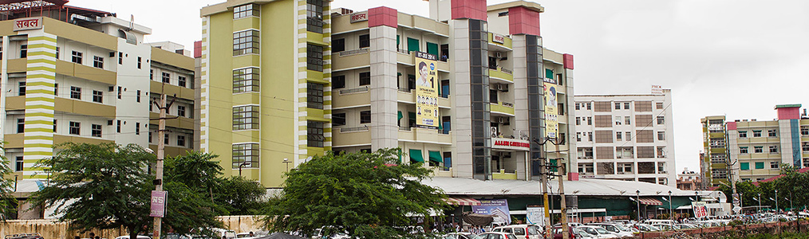

There are more than 1.5 lakh students at any given point of time in Kota, busy preparing for various entrance exams, some from as young an age as 13 years. Deciding a coaching institute is an important decision that should be taken after giving enough thought to each option and comparing the pros & cons of every coaching centre in Kota And so is the decision of choosing your place to stay.

A Student looking for a Hostel/PG considers many factors ranging from Cost to Timings, but most important ones are Distance from their respectice Coaching building and Number of Mess around them. Because a student in Kota won’t like to waste his time in travelling because most of students use bicycle. And also he/she should haver mess options around him so that he never falls sick due to bad food/monotonus food that being the primary reason students not staying in Kota.

Considering the Students comming to kota as target audience, this project aims to find Coachings in a given location so that a business perosn, aiming to start a hostel/mess, can recive assistance to persue a profitable business.

**Business Problem:**

For a business person to run a hostel or mess, it will be utterly problamatic to acquire profits if its located in a location with few coaching institutes around and lot of competition for other hostel/PG or mess.