**P3. DATABASE DESIGN, FINAL ERD**

**GROUP 6:** **Team Members**

1. Vivek Sharma
2. Shreya Ghate
3. Aayushi Pandey
4. Peng Chen
5. Mayuri More

TOPIC: Blood Bank Management Database System

**Abstract:**

A blood bank is a place where blood is collected and stored before providing it to the patients in need. Blood banks are usually scattered all over the place and are not easily accessible to the individuals who need them because of either health emergencies or blood shortages. Hence it is vital that the blood banks have an organized database by which blood units can be supplied within the shortest time possible. In this database we are managing information of blood donors, Organizations, partners of the blood bank, receivers and records of blood units consumed.

In this database we have the following 12 main entities - Blood Bank, Blood, Hospital, Organization, Partners, Donor, Collector, Receiver, Record, System Administrators, Person, and Order Request.

**Key Design:**

| **ENTITY** | **PK** | **FK** | **ATTRIBUTE** |
| --- | --- | --- | --- |
| BLOOD BANK | BloodBank_ID |  | BloodBank_Name,  BloodBank_Address,  BloodBank_Telephone |
| BLOOD | Blood_ID |  | Units_Required Blood_ID Blood_Group Hospital_id  Receiver_ID BloodRecord_ID |
| HOSPITAL | Hospital_ID |  | Hospital_name,  Hospital_address,  Hospital_Telephone_Number |
| ORGANIZATION | Organization |  | Organization_Type,  Organization_Name,  Organization_Address,  Organization_Contact_Detail |
| PARTNERS |  |  | Organization_ID,  BloodBank_ID |
| ORDER REQUEST |  |  | OrderRequest_ID,  BloodBank_ID,  Units_Required,  Blood_Group,  Hospital_id |
| PERSON | Person_ID |  | Person_name,  Person_address,  Person_Telephone_Number |
| DONOR | Donor_ID |  | Blood-Group |
| COLLECTOR | Collector_ID | BloodBank_ID |  |
| RECEIVER | Receiver_ID |  | Blood-Group,  Receiver Reason for Consuming |
| RECORD | Record_ID | Organization_ID,  Receiver_ID,  BloodBank_ID,  Donor_ID,  Collector_ID | No of blood group bottle  Expiry Date of the blood |
| SYSTEM ADMINISTRATOR | Admin_ID |  | Admin_name,  Username,  Password,  Blood_bank_id |

**ERD:**

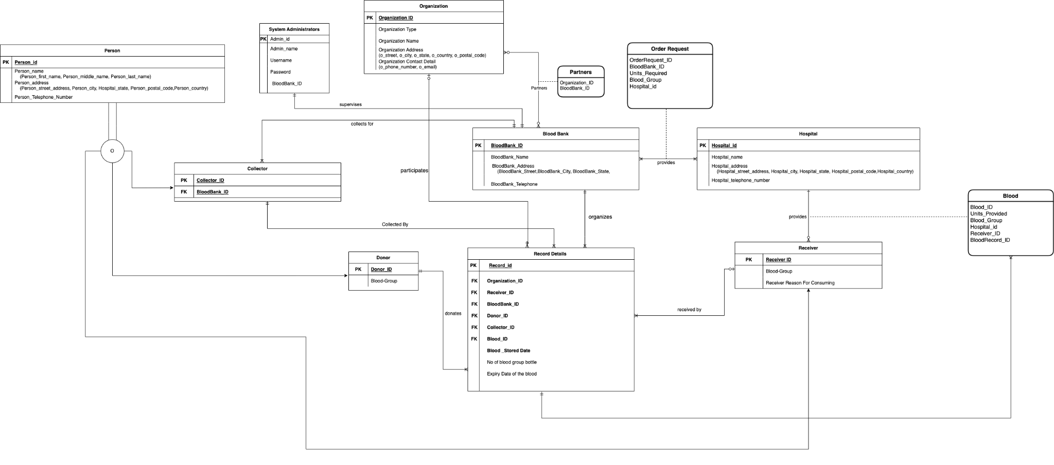

**Summary of ERD:**

1. This ER diagram is a summary of blood banks and the supply chain we are building to form the connectivity among people, hospitals and other organizations helping in providing blood facilities.
2. So, In the ER diagrams we have created 12 entities and with different attributes associated with it.
3. Starting with System Administrator it will store all the basic information of login details of a person (Admin) in which the Admin Id is considered as a primary key for system administrator. It will act as the first page of the website in which we need to enter Admin_name, Username, Password and Blood_id_number. After entering all the details, we will be able to fetch all user details.
4. The Record entity is the main entity which will link all the various entities involved in any blood donation encounter. It has Record_id as it’s primary keys and BloodRecord_id(also called blood bag number) as FK for Blood, BloodBank_id as FK for Blood Bank, Donor_id for donor, Receiver_id as FK for receiver and many more.
5. Person is super class which has some attributes. Its subclasses are Donor, Receiver and collector. A person can be a donor as well as a receiver at different times.
6. For the Blood entity, the Blood has its primary key BloodRecord_id which will be unique for every blood bag. It will also have an expiry date for the blood.
7. A collector is a person, who is supposed to collect blood from the donor like a nurse. It will always be linked to a single blood bank.
8. Hospital Entity will put an order request (associative entity) with the blood bank. Hospital will also provide the blood bags to the receiver. Blood Bank will provide the blood bags to the hospital for every order request.
9. Organizations (like companies, NGO, etc.) will partner (associative entity) up with the Blood Bank to hold drives for blood collection. If in any record, organization_id is null, then it will be considered that this encounter was not in any drive. But if otherwise, then it was a part of the drive.
10. Initially we login through system admin it will fetch data from Blood Bank and records. From records, the admin will be able to access everything for any record. They can also access the order requests with any hospitals placed and process them. As we can see through the ER diagram the relationship between system administrator and a Blood Bank is mandatory one and only one, which means that each blood bank should have only one administrator who should have mandatory unique ID and password.
11. The relationship between Blood Bank and collector is mandatory, many to mandatory one which means one blood bank can have many collectors but for each collector will have one blood bank.
12. Entity Organization has Organization ID as a primary key and other attributes like Organization type , organization name and organization address . In this organization, we build a direct relationship with Record which is optional one to optional many relationships. As we know that each organization can have zero or many records, also each record can have either zero or one relationship.
13. In the Record entity we have many foreign keys are they all are the derived attributes from the different entity like:
    1. Organization_ID
    2. Receiver_ID
    3. BloodBank_ID
    4. Donor_ID
    5. Collector_ID
14. Entity Hospital in the ER diagram defines the Hospital_ID as a primary key and Hospital_Name, Hospital Address and hospital telephone_Number.
15. Blood bank entity and hospital entity has a relationship of one-to-many mandatory on both the sides which means that each blood bank can be linked to many hospitals whereas each hospital can have many blood banks.
16. Hospital further builds a relationship with the receiver in which reciever_ID is the primary key and other attributes are Blood group and receiver reason for consuming. Receivers form a relationship with records in order to create a record of a receiver and store it into a database.
17. Hospital provides blood to the receiver in case of emergency. The Blood_ID acts as a primary key to this ternary relationship.

**Design Changes in ERD:**

1. Revised the ERD to separate out the Blood entity to be addressed differently and now it is a part of a ternary relationship and acts as an associative entity.
2. The Record entity is updated to capture the timestamp of when the blood was stored at the Blood Bank and the expiry date of the blood.
3. The Units_Required and Units_Provided attributes are the amount of bottles of blood stored during the donation/providing transaction.
4. Hospital entity provides blood to the receiver whenever required. Hospital partners with a Blood Bank to provide blood to the receiver.
5. A donor can donate multiple times, this more than once. We have updated it to a mandatory many relationship