High-Level Architecture (Seucrity):
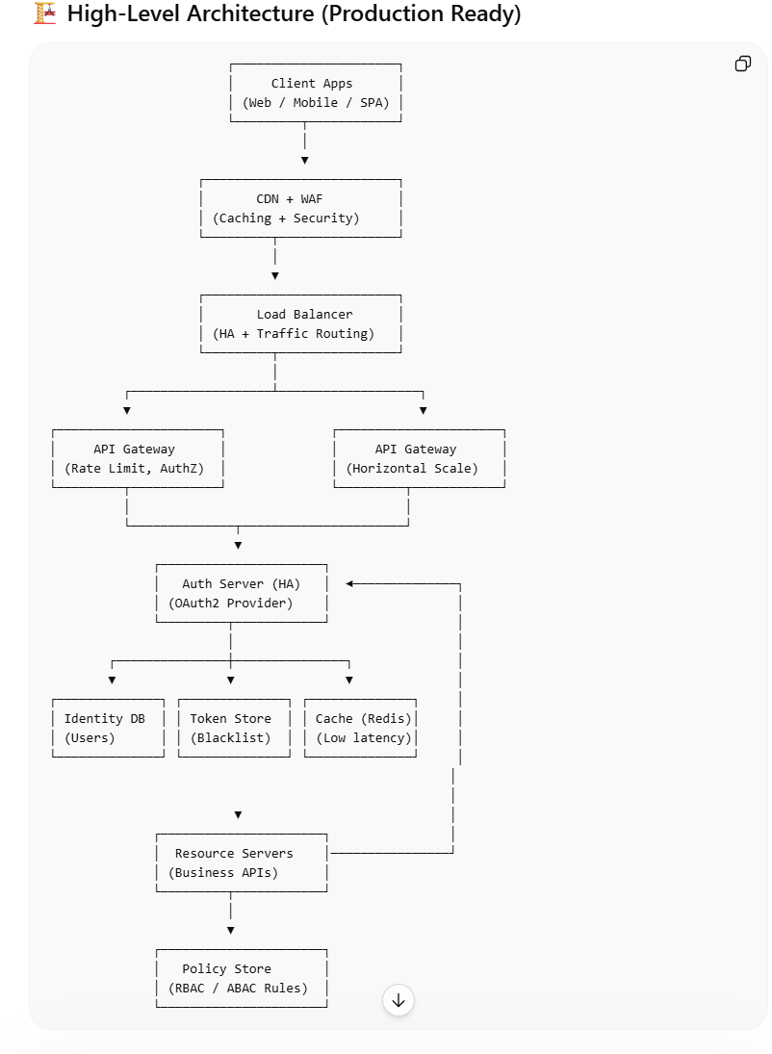

Key Design Decisions (Why this works)

⚡ 1. Low Latency Design

✅ CDN + Caching
- Static content served from CDN
- Reduces load on backend

✅ Redis Cache
- Store:
  - Token blacklist
  - User session metadata
- Avoid DB hits

🟢 2. High Availability (HA)

✅ Load Balancer
- Distributes traffic across instances
- Health checks remove unhealthy nodes

✅ Horizontal Scaling
- API Gateway (multiple instances)
- Auth Server (stateless → easy scaling)
- Resource Servers

🔐 3. Stateless Authentication (JWT)

Why?
- No DB lookup per request
- Faster validation

Flow:
JWT → verified using public key → no DB call
👉 This is critical for low latency + scalability

🔑 4. Auth Server Design

Responsibilities:
- Login validation
- Token generation
- Refresh tokens

HA Strategy:
- Multiple instances
- Shared:
  - Identity DB
  - Redis

🗄️ 5. Identity Store (DB)

Best Practices:
- Use Primary + Read Replicas
- Encrypt sensitive data
- Passwords → BCrypt

🚫 6. Token Revocation (Important)
Problem:
JWT is stateless → hard to revoke

Solution:
- Maintain blacklist in Redis
if (token in blacklist) → reject

📜 7. Policy Store (Authorization)

Options:
- DB (dynamic policies)
- Config (simple RBAC)
- External (OPA)

Example:
ADMIN → /admin/*
USER → /profile/*

🔄 8. API Gateway Responsibilities
- Authentication check (JWT validation)
- Rate limiting
- Routing
- Centralized security
👉 Reduces load on backend services

🔄 End-to-End Flow (Optimized)

🟢 Step 1: Login
Client → Auth Server
- Validate password (BCrypt)
- Generate JWT + Refresh Token

🟢 Step 2: API Call
Client → API Gateway → Resource Server
- JWT validated at gateway
- Forward request

🟢 Step 3: Authorization
Resource Server → Policy Store
- Check role/permissions
- Allow/Deny

🚀 Advanced Enhancements

🔁 Refresh Token Flow
- Short-lived access token (15 min)
- Long-lived refresh token

🔐 Key Management
- Use RSA keys
- Rotate keys periodically

📊 Observability
- Metrics (Prometheus)
- Logs (ELK)
- Tracing (Jaeger)

🛡️ Security Add-ons
- WAF (protect from attacks)
- Rate limiting (DDOS protection)
- HTTPS everywhere

⚡ Final Summary

To achieve:

🟢 High Availability
- Load balancer
- Stateless services
- Horizontal scaling

⚡ Low Latency
- JWT (no DB lookup)
- Redis caching
- CDN

