Q. Explain how to mount and adjust the forked supports with diagrams?

Step-by-step Instructions:

1. • Push forked support (11) into the support guide (12)

2. • Fix the forked support (11) by the hexagon bolt

3. Fit the second washer on both sides on the inside, afterwards screw down the lock nut (13b)

4. Attention: The conveyor belt has to be placed below the lock nut.

5. Transporting, setting up, connecting, dismounting and storing the machine

6. Position of the forked support (11) when the machine table is hinged down.

7. What to watch out for when mounting the forked supports on machines equipped with the "Cutomat" cutting device:

8. The feet (14) of the forked support must be set in such a manner that the table stands level. This is the only way to ensure optimal functioning of the safety guard.

No tables found in this chunk.

Relevant images for these instructions:

Image 1: images/355e1ea8c6d4df4dde3c2feffac5e2e3bdaddd4d5396174fae7cc89593118535.jpg

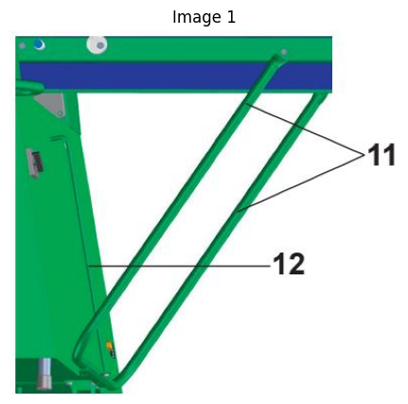

Image 2: images/cd29bb0ea55c4d9a8c4df9602115f99d8542216cdd8e815b10f075e8a99621d2.jpg

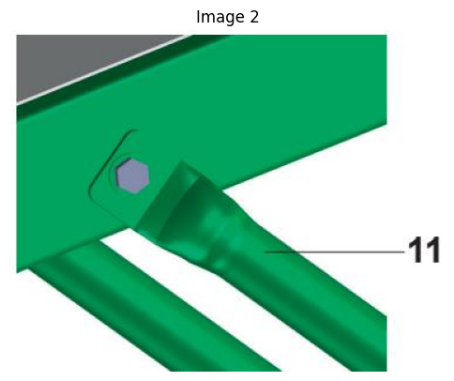

Image 3: images/1fc88ac567752db7b1fa36eee344d3248dbc5a6c9cc4311068cca8442796eb02.jpg

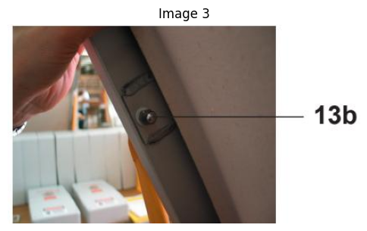

Image 4: images/f9471989b9ea9de821cc6e976211b5388fa92d47704b37544ded72af7c39b7b8.jpg

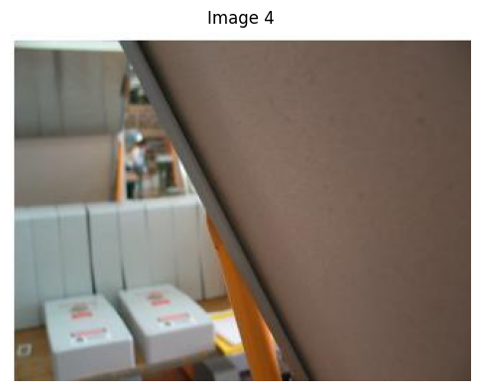

Image 5: images/85eea1dc1d2b7a2d5c7a74c8024a0542cfc312fe8fe2852a223b606f67d79644.jpg

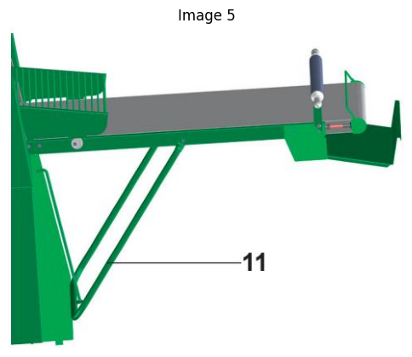

Image 6: images/28379fa93293255fba7c4ba2b2fdcfd7600f1d6f11c339248bf32226a350fbfe.jpg

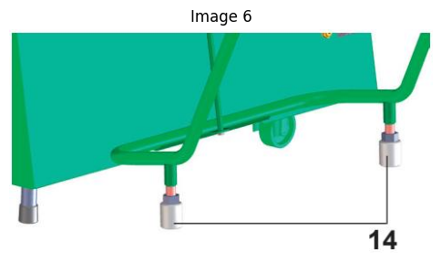

Q. How do I operate the fast tension release device for the conveyor belt?

Step-by-step Instructions:

1. The fast tension release device for conveyor belt (7) serves to release the tension of the conveyor belt for cleaning the machine. It can be found at the machine table ends.

2. To release the tension of the conveyor belt, proceed as follows:

3. Grab the fast tension release device for conveyor belt (7) on the idle roller (8) or on the stanchion of the automatic dough reeler (9) with both hands, lift it and fold it down to the limit stop. Proceed in the reverse sequence in order to reset the fast tension release device for conveyor belt (7).

4. For putting the machine into operation the conveyor belt must be tensioned!

No tables found in this chunk.

Relevant images for these instructions:

Image 1: images/15a1d279f9bf511a85415fd03f7253faf152dd6db12fe380318596ae3a4ed8a0.jpg

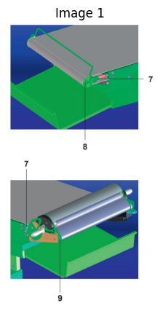

Q. What are the steps to assemble the dough catch pan with visuals?

Step-by-step Instructions:

1. • Remove the protective foil on the dough catch pan (20) • Push in the dough catch pan on both sides

2. # Option:

3. • Attach the flour catch pan (21) to the holder (22)

No tables found in this chunk.

Relevant images for these instructions:

Image 1: images/cd71f1cbdfff87636d8d899803ae1e12cf90002d3c633eb655800f6d8e65ce15.jpg

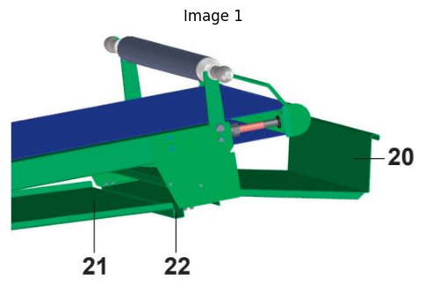

Q.How to correctly mount machine tables with fast tension release device for conveyor belt (option)

Step-by-step Instructions:

1. Tighten the conveyor belts only enough that the heaviest pieces of dough (maximum $1 5 ~ \mathsf { k g } )$ are still transported along without the conveyor belt dragging.

2. Proceed as follows:

3. The fast tension release device for conveyor belt must be in the tensioned position.

4. Unscrew the check nut (41).

5. Retighten the left and right tension nuts (42) evenly and parallel. Remeasure Distance “X” on both sides using a millimetre measuring instrument.

6. The distance “X” must be identical on both sides.

7. Fasten the check nut (41).

8. Switch on the machine (see 5.3 Switch on the machine, initial screen).

9. Observe running movement of the conveyor belt in both directions.

10. If the belt runs off towards one side, proceed as follows:

11. • Retighten tension nut (42) on the side where it runs off

12. or

13. • Loosen the tension nut (42) on the opposite side Monitor the belt and, if necessary, correct it until it runs exactly in the middle of the table

14. If necessary, repeat this procedure several times. Routinely monitor the belt during the initial hours that the machine is operational and, if necessary, correct it again.

15. # Tightening and adjusting the conveyor belts demands patience!

16. Prior to carrying out each further correction, allow the machine to run for at least 30 seconds.

17. Before putting the machine into operation, the conveyor belts must be lightly rubbed with flour in order to prevent the dough from sticking to the belt.

18. # Attention:

19. A gap can develop between the synthetic conveyor belt and the idle roller if the belt is worn on the edge or is damaged. If this is the case, the belt must be replaced.

20. Reason: Risk of injuries to fingers in the area of the idle roller.

No tables found in this chunk.

Relevant images for these instructions:

Image 1: images/372fa4b6baf4e2f6854cddf913d928b3572ffa27882c42f58d3962aa114a889b.jpg

