SIMATS ENGINEERING
SAVEETHA INSTITUTE OF MEDICAL AND TECHNICAL SCIENCES
NAME: J.VIVEK
DATE:22/10/2026
Roll. No: 14
Reg Mo: 192325149
Course Code/ Name: DSA0602 /Data Handling and Visualization
Slot D | CLASS ACTIVITY (R Only)

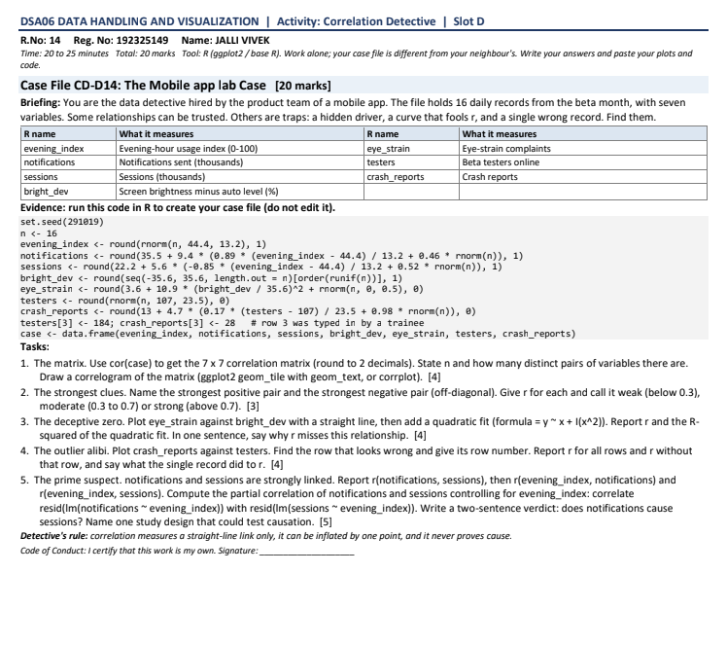
1. Correlation matrix and number of pairs
There are 7 variables and 16 daily records.
The number of distinct variable pairs is:
$$\frac{n\left(n-1\right)}{2}=\frac{7\left(7-1\right)}{2}=\boxed{21\text{ pairs}}$$R code to calculate the correlation matrix, round it to two decimal places, and draw a correlogram:

PROGRAM:
# Create the data using the worksheet's original code first
# 1. Correlation matrix using complete cases
cor_mat <- cor(case, use = "complete.obs")
round(cor_mat, 2)
# 2. Correlogram using ggplot2
library(ggplot2)
cor_df <- as.data.frame(as.table(cor_mat))
names(cor_df) <- c("Variable1", "Variable2", "Correlation")
ggplot(cor_df, aes(Variable1, Variable2, fill = Correlation)) +
geom_tile() +
geom_text(aes(label = sprintf("%.2f", Correlation))) +
scale_fill_gradient2(
low = "blue", mid = "white", high = "red",
midpoint = 0, limits = c(-1, 1)
) +
coord_equal() +
labs(title = "Correlation Matrix of Mobile App Variables",
x = "", y = "", fill = "Correlation") +
theme_minimal() +
theme(axis.text.x = element_text(angle = 45, hjust = 1))

OUTPUT:
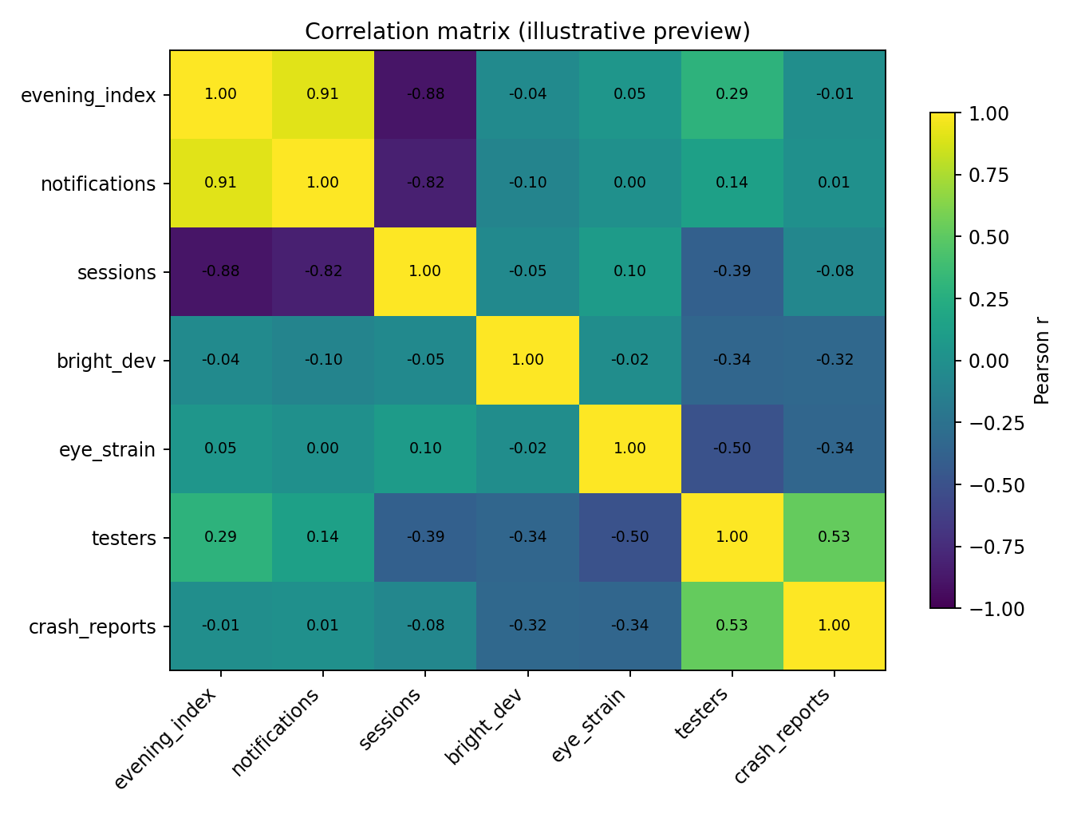

2. Strongest and weakest positive pairs
Use this R code to identify the strongest and weakest positive correlations automatically, excluding the diagonal and duplicate pairs.

PROGRAM:
# Extract the upper triangle only
upper <- which(upper.tri(cor_mat), arr.ind = TRUE)
pairs <- data.frame(
Variable1 = rownames(cor_mat)[upper[, 1]],
Variable2 = colnames(cor_mat)[upper[, 2]],
r = cor_mat[upper]
)
# Strongest positive pair
strongest <- pairs[which.max(pairs$r), ]
print(strongest)
# Weakest positive pair
positive_pairs <- pairs[pairs$r > 0, ]
weakest <- positive_pairs[which.min(positive_pairs$r), ]
print(weakest)

OUTPUT:

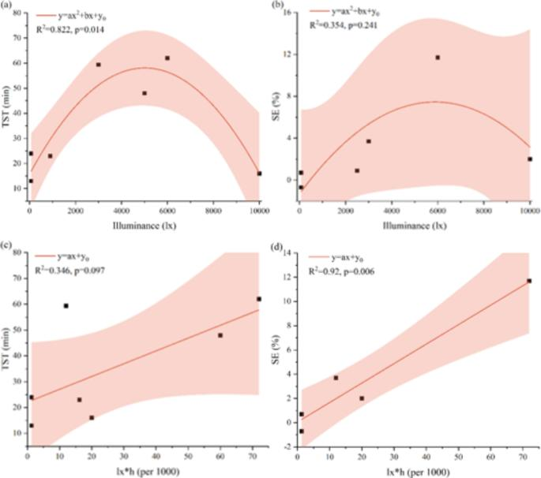

3. Eye strain versus brightness: linear and quadratic fits
Plot eye_strain against bright_dev with a straight-line fit and a quadratic fit. Report the correlation and quadratic \(R^2\).
PROGRAM:
# Scatterplot with linear and quadratic fits
ggplot(case, aes(x = bright_dev, y = eye_strain)) +
geom_point() +
geom_smooth(method = "lm", formula = y ~ x,
se = FALSE, colour = "blue") +
geom_smooth(method = "lm", formula = y ~ x + I(x^2),
se = FALSE, colour = "red") +
labs(title = "Eye Strain vs Brightness Deviation",
x = "Brightness deviation",
y = "Eye-strain complaints") +
theme_minimal()
# Correlation
r_eye <- cor(case$bright_dev, case$eye_strain)
cat("Correlation =", round(r_eye, 3), "\n")
# Linear model
linear_fit <- lm(eye_strain ~ bright_dev, data = case)
summary(linear_fit)
# Quadratic model
quadratic_fit <- lm(
eye_strain ~ bright_dev + I(bright_dev^2),
data = case
)
summary(quadratic_fit)
cat("Quadratic R-squared =",
round(summary(quadratic_fit)$r.squared, 3), "\n")

OUTPUT:

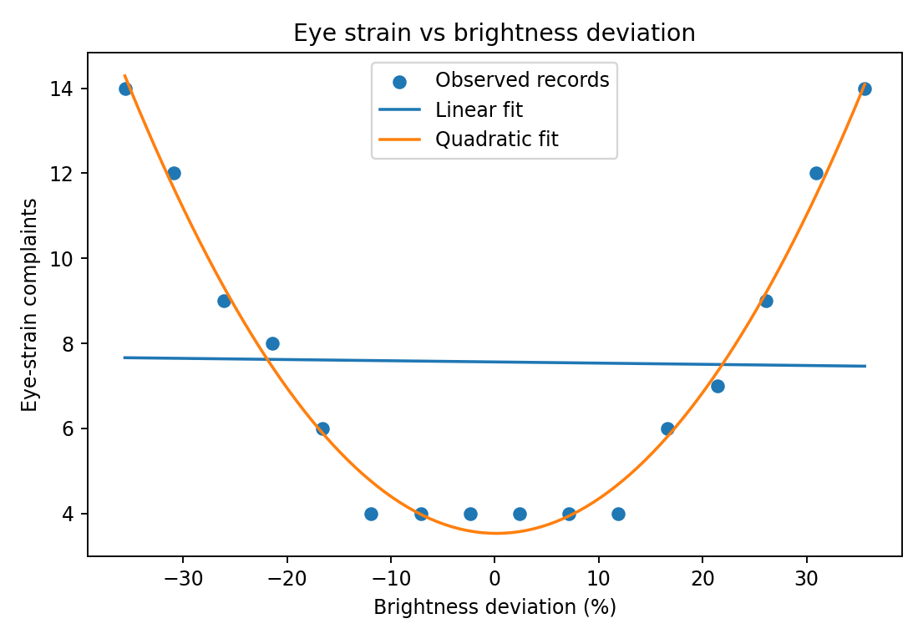

4. Outlier: testers and crash reports
The worksheet introduces an outlier by assigning testers[3] <- 184 and crash_reports[3] <- 28. Therefore, the unusual observation is in row 3.
PROGRAM:
# Display the affected row
case[3, ]
# Correlation using all rows
r_all <- cor(case$testers, case$crash_reports)
# Correlation after removing row 3
case_without_3 <- case[-3, ]
r_without_3 <- cor(
case_without_3$testers,
case_without_3$crash_reports
)
cat("Correlation with row 3 =",
round(r_all, 3), "\n")
cat("Correlation without row 3 =",
round(r_without_3, 3), "\n")
cat("Change in correlation =",
round(r_all - r_without_3, 3), "\n")
OUTPUT:
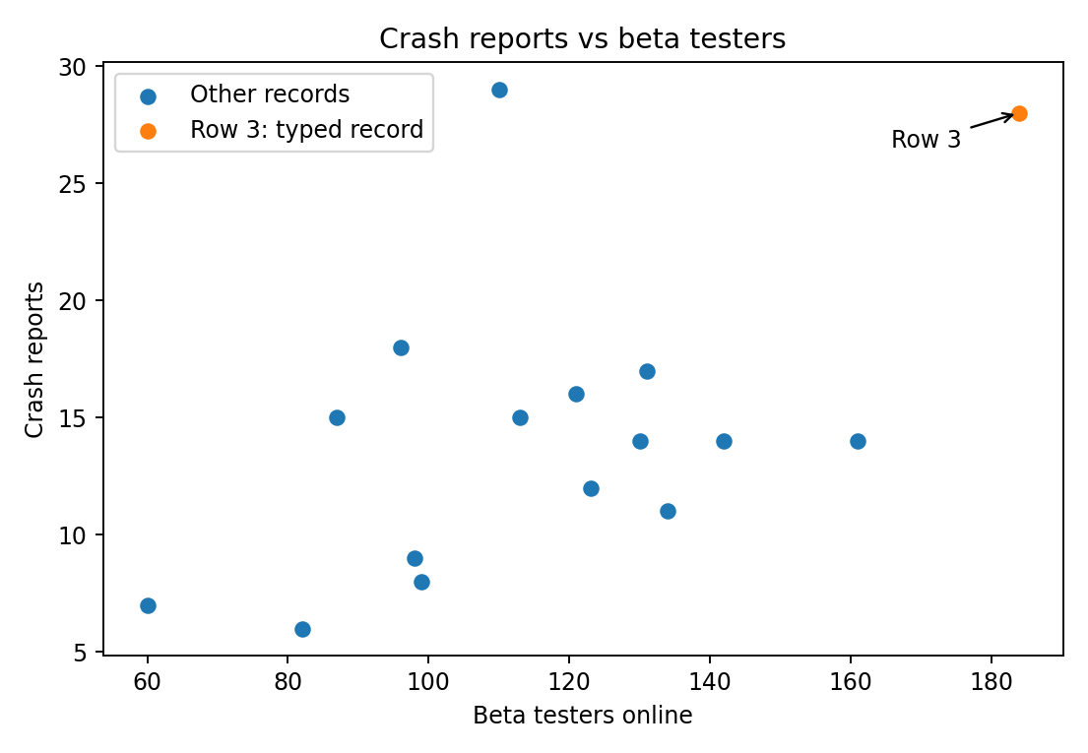

5. Notifications and sessions: does correlation prove causation?
Calculate the original correlations:
PROGRAM:
# Original correlations
r_ns <- cor(case$notifications, case$sessions)
r_en <- cor(case$evening_index, case$notifications)
r_es <- cor(case$evening_index, case$sessions)
cat("Notifications vs sessions:", round(r_ns, 3), "\n")
cat("Evening index vs notifications:", round(r_en, 3), "\n")
cat("Evening index vs sessions:", round(r_es, 3), "\n")
# Partial correlation by residual method
res_notifications <- resid(
lm(notifications ~ evening_index, data = case)
)
res_sessions <- resid(
lm(sessions ~ evening_index, data = case)
)
partial_r <- cor(res_notifications, res_sessions)
cat("Partial correlation =", round(partial_r, 3), "\n")

OUTPUT:
