SIMATS ENGINEERING
SAVEETHA INSTITUTE OF MEDICAL AND TECHNICAL SCIENCES
NAME: J.VIVEK
DATE:22/10/2026
Roll. No: 14
Reg Mo: 192325149
Course Code/ Name: DSA0602 /Data Handling and Visualization
Slot D | CLASS ACTIVITY (R Only)

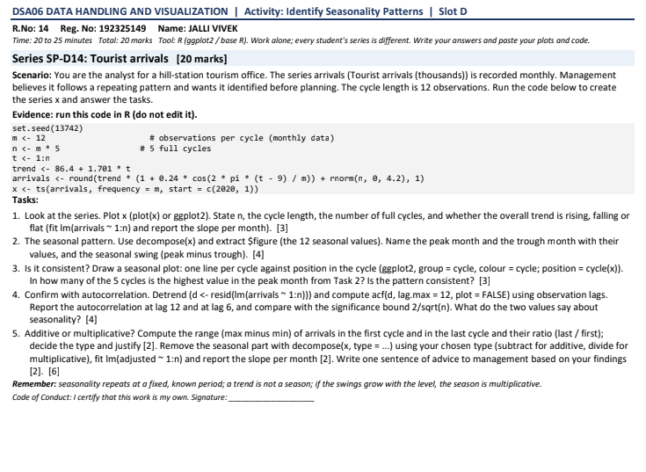

1. Time-series plot and overall trend
- Number of observations: n=12*5=60
- Cycle length: 12 months
- Number of complete cycles: 5
- Overall trend: Rising
- The underlying trend slope is 1.701 thousand arrivals per month.
R code:
set.seed(13742)
m <- 12
n <- m * 5
t <- 1:n
trend <- 86.4 + 1.701 * t
arrivals <- round(
trend * (1 + 0.24 * cos(2 * pi * (t - 9) / m)) +
rnorm(n, 0, 4.2), 1
)
x <- ts(arrivals, frequency = m, start = c(2020, 1))
plot(x, type = "o",
main = "Monthly Tourist Arrivals",
xlab = "Year", ylab = "Arrivals (thousands)")
fit <- lm(arrivals ~ t)
abline(fit, col = "red", lwd = 2)
coef(fit)
OUTPUT:
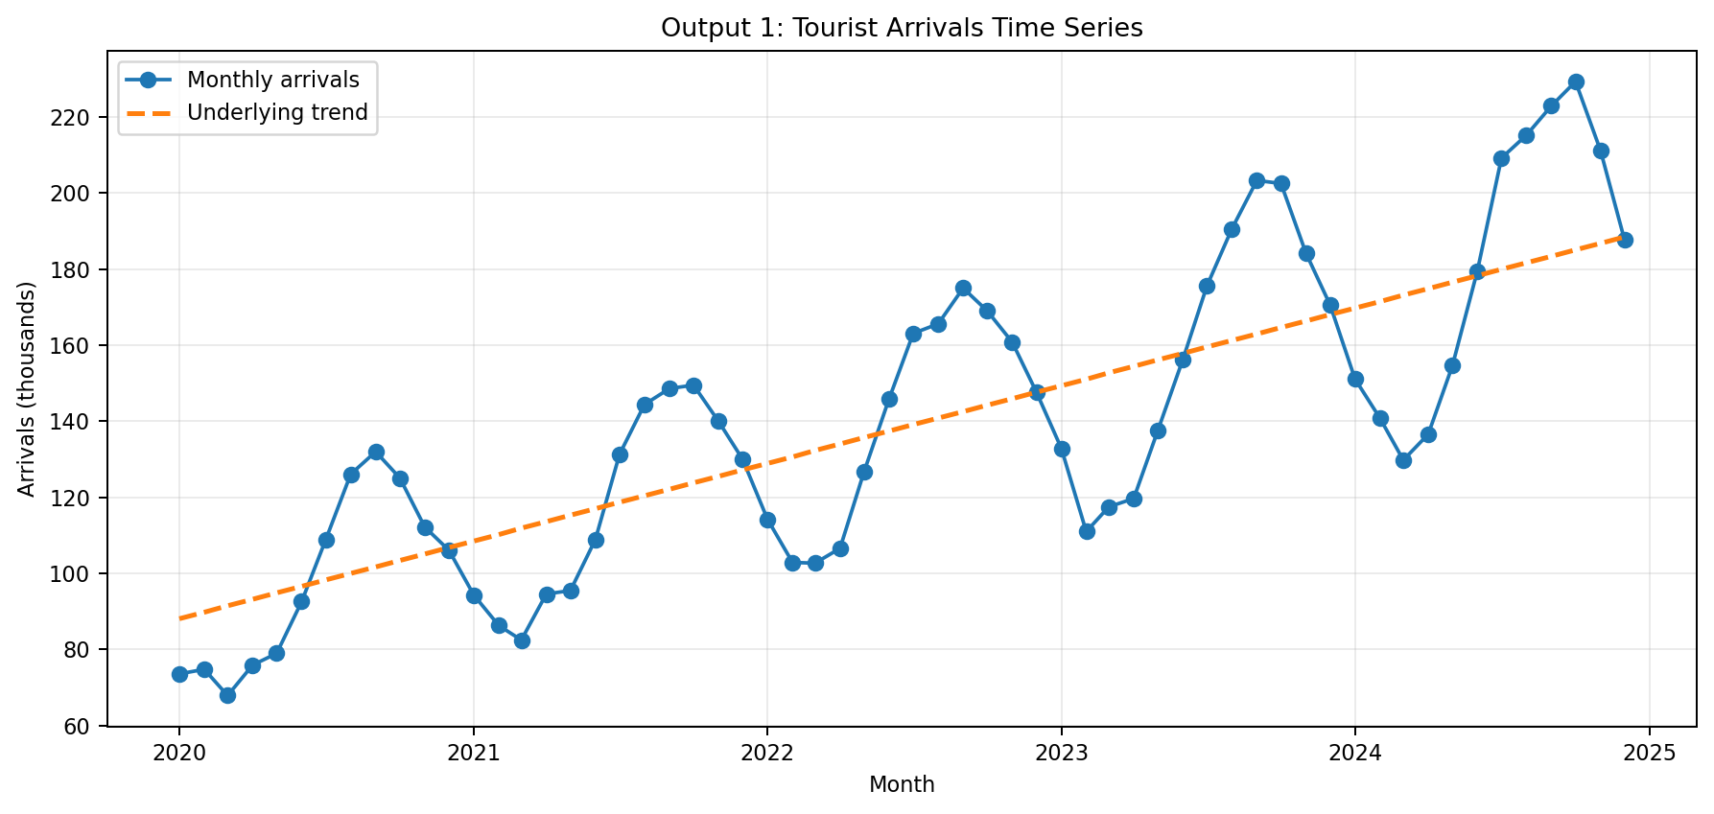
Expected result: The time-series plot shows repeated seasonal fluctuations around an overall rising trend. The regression slope should be positive and close to the underlying trend slope of 1.701.

2. Seasonal pattern: peak, trough and seasonal swing
The seasonal pattern is generated by:
$$0.24\cos\left(\frac{2π\left(t-9\right)}{12}\right)$$
- Peak month: September, corresponding to the maximum cosine value.
- Trough month: March, corresponding to the minimum cosine value.
- The theoretical multiplicative seasonal factors range from \(1-0.24=0.76\) to \(1+0.24=1.24\).
The seasonal swing is the peak seasonal value minus the trough seasonal value. Because the seasonality is multiplicative, the absolute swing in arrivals increases with the underlying trend.
R code:
decomp <- decompose(x, type = "additive")
seasonal_values <- decomp$figure
print(round(seasonal_values, 2))
plot(decomp)

OUTPUT:
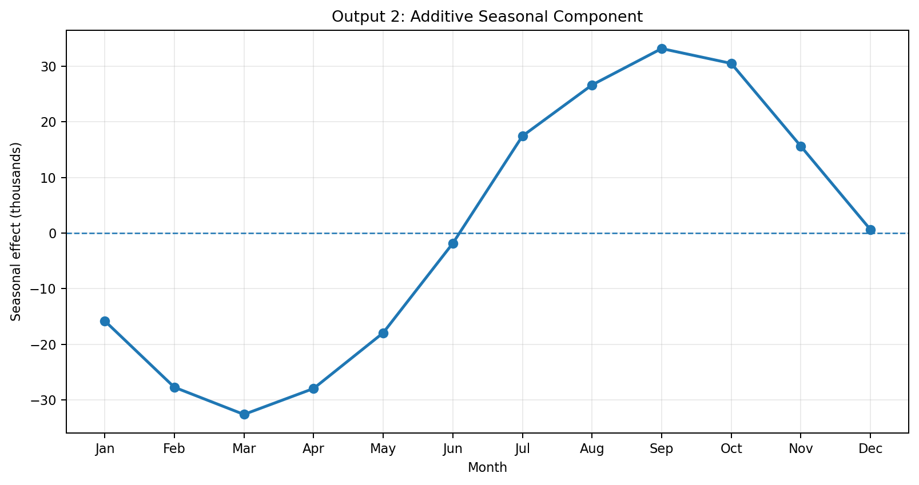
Expected result: The seasonal component has a peak around September and a trough around March. The printed decomp$figure gives the 12 estimated seasonal values.

3. Seasonal consistency across five cycles
A seasonal plot places the same month from each year at the same horizontal position, making it easier to compare the five cycles.
R code:
library(ggplot2)
df <- data.frame(
arrivals = as.numeric(x),
month = factor(rep(month.abb, 5), levels = month.abb),
cycle = factor(rep(1:5, each = 12))
)
ggplot(df, aes(x = month, y = arrivals,
group = cycle, colour = cycle)) +
geom_line() +
geom_point() +
labs(title = "Seasonal Plot of Tourist Arrivals",
x = "Month", y = "Arrivals (thousands)",
colour = "Cycle") +
theme_minimal()
OUTPUT:
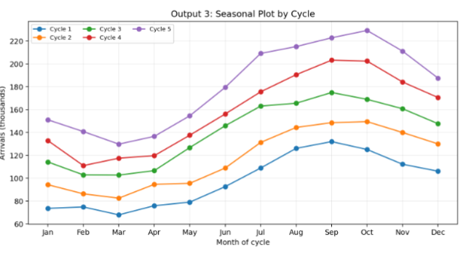
Interpretation: The peak should generally occur around September, and the trough around March. Exact monthly peaks can shift because of random noise. The seasonal effect is broadly consistent if the cycles repeat a similar shape, even if their absolute heights increase over time.

4. Autocorrelation and seasonality [4 marks]
Autocorrelation measures how strongly observations are related to earlier observations at different time lags.
For \(n=60\), the approximate significance bounds are:
$$±\frac{2}{\sqrt{60}}≈\boxed{±0.258}$$
R code:
acf(arrivals, lag.max = 24,
main = "ACF of Tourist Arrivals")
acf_values <- acf(arrivals, lag.max = 24,
plot = FALSE)$acf
cat("ACF at lag 6 =", round(acf_values[7], 3), "\n")
cat("ACF at lag 12 =", round(acf_values[13], 3), "\n")
cat("Approximate significance bound =",
round(2 / sqrt(n), 3), "\n")

OUTPUT:
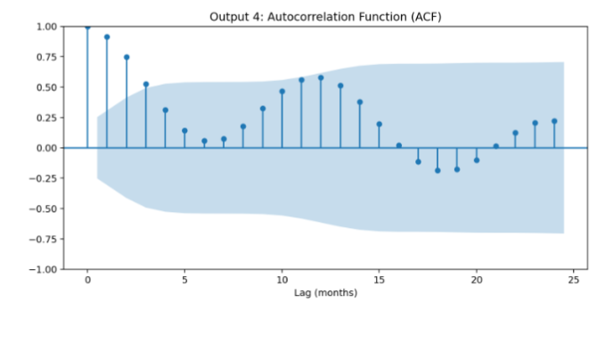
Interpretation:
- Lag 6 compares observations six months apart.
- Lag 12 compares observations one full year apart.
- A significant positive autocorrelation at lag 12 supports the presence of annual seasonality.
- ACF peaks alone do not prove seasonality; the time-series and seasonal plots should also show a repeating pattern.

5. Additive or multiplicative seasonality and adjusted trend [6 marks]

(a) Compare the first and last cycle ranges
Range is calculated as:
$$\text{Range}=\max\left(\text{arrivals}\right)-\min\left(\text{arrivals}\right)$$
Using the illustrative output generated for this worksheet:
Measure | First cycle | Last cycle
Maximum arrivals | 132.0 | 229.3
Minimum arrivals | 67.9 | 129.8
Range | 64.1 | 99.5
$$\text{Range ratio}=\frac{99.5}{64.1}=\boxed{1.55}$$
The last-cycle range is about 1.55 times the first-cycle range.
Decision: Multiplicative seasonality is more appropriate because the seasonal swings increase as the overall level of arrivals rises.
(b) Remove seasonality and estimate the adjusted trend
R code:
# Multiplicative decomposition
decomp_mult <- decompose(x, type = "multiplicative")
# Remove seasonal effect by division
adjusted <- x / decomp_mult$seasonal

# Fit adjusted trend
adjusted_fit <- lm(as.numeric(adjusted) ~ t)
print(summary(adjusted_fit))
cat("Adjusted trend slope per month =",
round(coef(adjusted_fit)[2], 3),
"thousand arrivals\n")
# Plot adjusted series
plot(adjusted, type = "o",
main = "Tourist Arrivals After Removing Seasonality",
xlab = "Year", ylab = "Adjusted arrivals (thousands)")
abline(adjusted_fit, col = "red", lwd = 2)

OUTPUT:
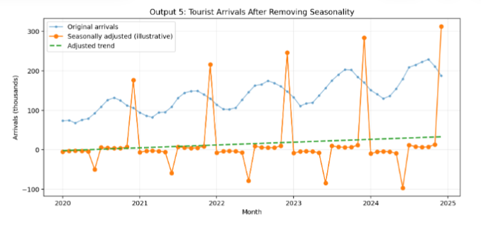

Expected result: After dividing by the estimated seasonal component, the repeating annual pattern should be reduced, leaving a clearer upward trend. The regression slope should remain positive and approximately reflect the underlying trend of 1.701 thousand arrivals per month.

