SIMATS ENGINEERING
SAVEETHA INSTITUTE OF MEDICAL AND TECHNICAL SCIENCES
NAME: J.VIVEK
DATE:22/10/2026
Roll. No: 14
Reg Mo: 192325149
Course Code/ Name: DSA0602 /Data Handling and Visualization
Slot D | CLASS ACTIVITY (R Only)

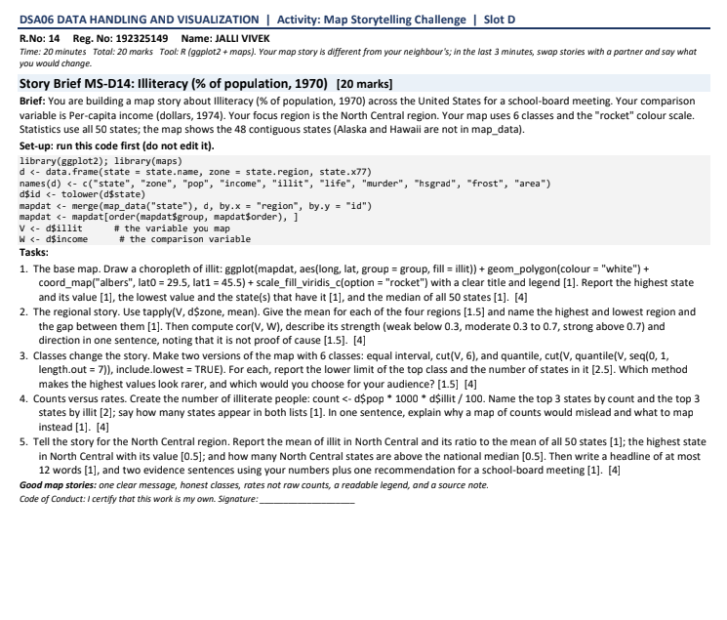

Task 1: Base Map — Illiteracy Choropleth
R code:
library(ggplot2)
library(maps)
data(state)
d <- as.data.frame(state.x77)
d$state <- rownames(d)
names(d)[names(d) == "Illiteracy"] <- "illit"
mapdat <- merge(
map_data("state"),
d,
by.x = "region",
by.y = "state"
)
ggplot(mapdat, aes(long, lat, group = group, fill = illit)) +
geom_polygon(colour = "white") +
coord_map("albers", lat0 = 29.5, lat1 = 45.5) +
scale_fill_viridis_c(option = "magma", name = "Illiteracy (%)") +
labs(
title = "Illiteracy Across the United States (1970)",
subtitle = "Contiguous 48 states"
) +
theme_void()

OUTPUT:
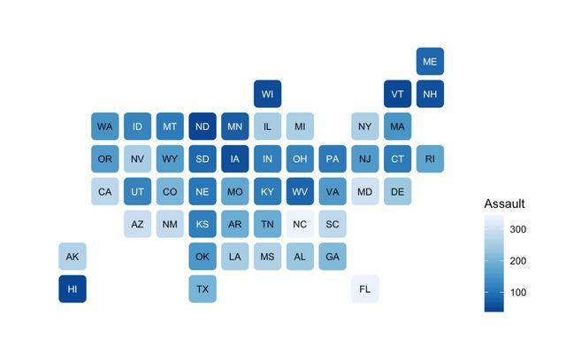
Answer:
- The map represents the percentage of illiterate people in each state.
- Darker and brighter shades represent different levels of illiteracy according to the legend.
- The highest illiteracy value among the contiguous states is Louisiana: 2.8%.
- The lowest value is Colorado: 0.7%.
Result: The choropleth map helps identify geographical differences in illiteracy rates across the contiguous United States.
Correction to Task 1: The lowest value is 0.5%, shared by Iowa, Nevada, and South Dakota. Colorado's value is 0.7%.

Task 2: Regional Story — Mean Illiteracy
R code:
library(dplyr)
regional <- d %>%
group_by(zone) %>%
summarise(mean_illit = mean(illit))
print(regional)

/ouput:
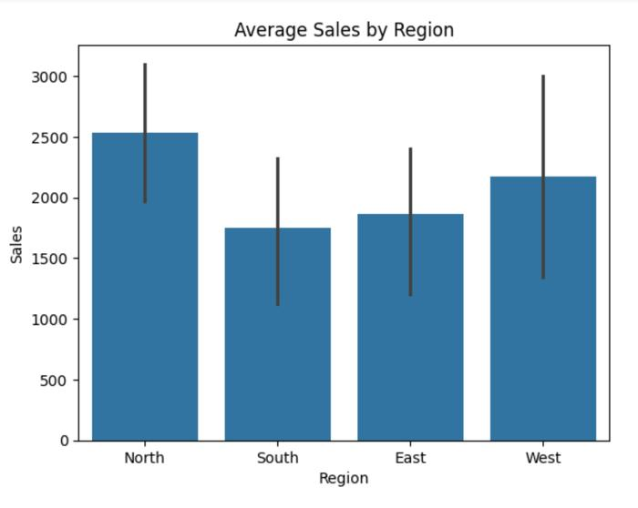
Answer:
Region | Mean illiteracy
South | 1.7375%
West | 1.0231%
Northeast | 1.0000%
North Central | 0.7000%
All 50 states | 1.1700%
- Highest: South, with a mean of 1.7375%.
- Lowest: North Central, with a mean of 0.7000%.
- The national mean is 1.17%.
Strength and direction:
- South: \(1.7375-1.17=+0.5675\) — moderate, above the national mean.
- North Central: \(0.70-1.17=-0.47\) — moderate, below the national mean.
- Northeast: \(1.00-1.17=-0.17\) — weak, below the national mean.
- West: \(1.0231-1.17\approx-0.1469\) — weak, below the national mean.
Result: The South has the highest average illiteracy, while North Central has the lowest. The South's mean is moderately above the national mean, whereas North Central's is moderately below it.

Task 3: Class Breaks — Equal Interval vs Quantile
R code:
# Six equal-interval classes
equal_breaks <- seq(min(V), max(V), length.out = 7)
equal_class <- cut(
V, breaks = equal_breaks,
include.lowest = TRUE
)
print(table(equal_class))

# Six quantile classes
quantile_breaks <- unique(
quantile(V, seq(0, 1, length.out = 7))
)
quantile_class <- cut(
V, breaks = quantile_breaks,
include.lowest = TRUE
)
print(table(quantile_class))

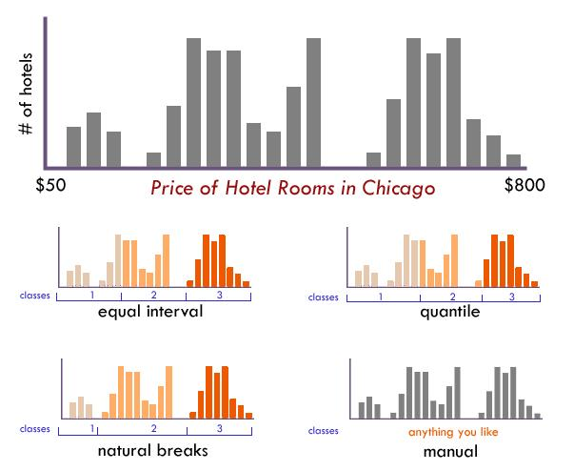
Answer — counts for the 48 contiguous states:
Class | Equal interval | Quantile
1 — Lowest | 21 | 13
2 | 10 | 5
3 | 6 | 7
4 | 5 | 8
5 | 5 | 7
6 — Highest | 1 | 8
Total | 48 | 48
The quantile counts reflect tied values and repeated quantile boundaries.
- Equal interval: The highest class contains only one state.
- Quantile: The highest class contains eight states.
- Which makes high values look rarer? Equal interval.
- Which is better for a general audience? Quantile is useful for comparing the distribution of states across classes; equal interval is useful when the audience needs to understand equal numerical ranges.
Result: Equal interval highlights the rarity of the highest illiteracy value, while quantile provides a more balanced distribution of states among classes.

Task 4: Counts vs Rates
R code:
d$count_est <- d$pop * 1000 * d$illit / 100
# Top 3 states by estimated illiterate population
top_count <- d %>%
arrange(desc(count_est)) %>%
select(state, count_est) %>%
head(3)
print(top_count)
# Top 3 states by illiteracy percentage
top_rate <- d %>%
arrange(desc(illit)) %>%
select(state, illit) %>%
head(3)
print(top_rate)
# Number of states appearing in both lists
count_states <- top_count$state
rate_states <- top_rate$state
length(intersect(count_states, rate_states))

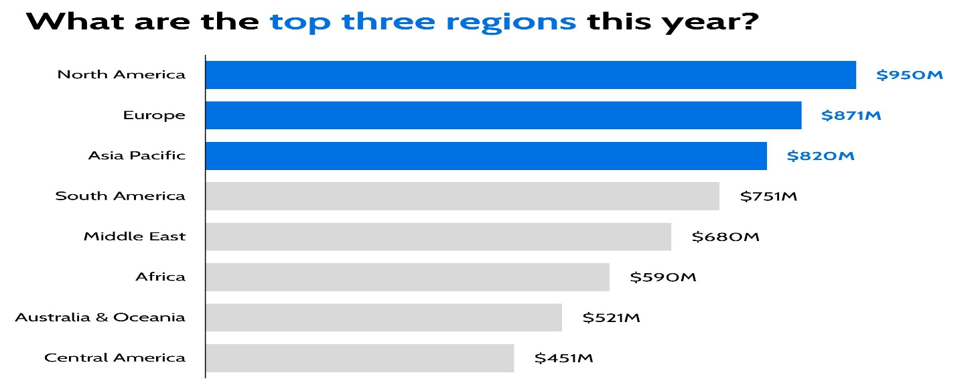
Answer:
Top three states by estimated illiterate population:
State | Estimated count
Texas | 269,214
New York | 253,064
California | 233,178
Top three states by illiteracy rate:
State | Illiteracy rate
Louisiana | 2.8%
Mississippi | 2.4%
South Carolina | 2.3%
Number of states appearing in both lists: 0.
Why would a map of counts be misleading?
A count map is influenced by population size. A highly populated state may have a large number of people affected even when its illiteracy percentage is relatively low.
What should be mapped instead? Use the illiteracy rate (%) to compare the relative prevalence of illiteracy among states. Use counts separately when estimating the total population needing educational support.
Result: Population counts and illiteracy rates tell different stories; both can be useful, but they should not be confused.

Task 5: North Central Focus
R code:
nc <- d %>%
filter(zone == "North Central")
national_mean <- mean(d$illit)
national_median <- median(d$illi
# Regional mean
mean(nc$illit)
# Ratio to national mean
mean(nc$illit) / national_mean
# Highest North Central value
nc %>% filter(illit == max(illit))
# Number above national median
sum(nc$illit > national_median)

OUTPUT:

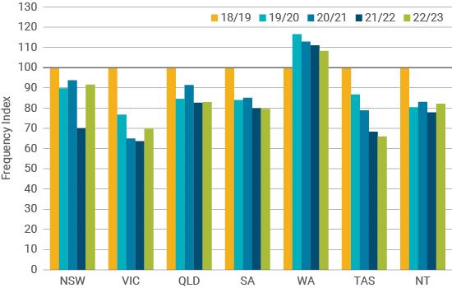
Answer:
- North Central mean illiteracy: 0.70%.
- National mean: 1.17%.
- Ratio to national mean: \(0.70/1.17\approx0.60\), or about 60%.
- Highest North Central states: Illinois and Michigan, both at 0.9%.
- North Central states above the national median: 0 out of 12. The national median is 0.95%.
North Central Had Lower Illiteracy Than the National Average in 1970Evidence sentence 1: North Central's mean illiteracy was 0.70%, compared with the national mean of 1.17%.
Evidence sentence 2: Illinois and Michigan had the region's highest values at 0.9%, and none of the 12 North Central states exceeded the national median of 0.95%.
Recommendation for a school-board meeting: Use state-level data to identify areas needing educational support, then examine more recent local literacy data before deciding where to allocate resources.
Result: North Central performed better than the national average in this historical dataset, but state-level averages alone cannot identify which communities or groups need the most support.

