SIMATS ENGINEERING
SAVEETHA INSTITUTE OF MEDICAL AND TECHNICAL SCIENCES
NAME: J.VIVEK
DATE:13/10/2026
Roll. No: 14
Reg Mo: 192325149
Course Code/ Name: DSA0602 /Data Handling and Visualization
Slot C | CLASS ACTIVITY (R Only)

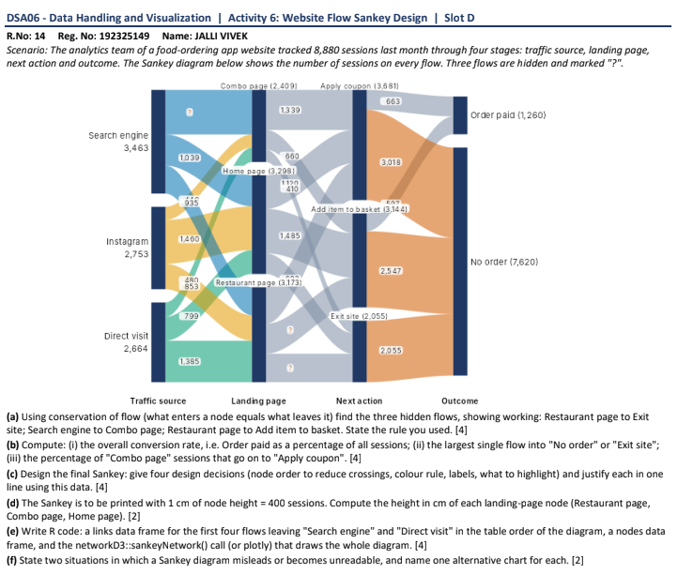

(a) Find the three hidden flows

Using conservation of flow:
1. Restaurant page → Exit site
Total incoming to Restaurant page = 3,173
Known outgoing flows = 1,385 + 799 + 410 = 2,594
Hidden flow = 3,173 − 2,594 = 579 sessions

2. Search engine → Combo page
Total Search engine sessions = 3,463
Known outgoing flows = 1,039 + 935 + 1,460 = 3,434
Hidden flow = 3,463 − 3,434 = 29 sessions

3. Restaurant page → Add item to basket
Total incoming to Restaurant page = 3,173
Known outgoing flows = 1,385 + 799 + 579 = 2,763
Hidden flow = 3,173 − 2,763 = 410 sessions

(b) Compute
(i) Overall conversion rate

$$\frac{1260}{8880}×100=\boxed{14.19\%}$$

(ii) Largest single flow into “No order” or “Exit site”

The largest flow is 3,018 sessions into “No order”.

(iii) Percentage of Combo page sessions going to Apply coupon
$$\frac{660}{2409}×100=\boxed{27.40\%}$$

(c) Sankey figure design
1. Reduce crossing lines: Arrange nodes according to flow size to make connections clearer.
2. Use colours: Use different colours for traffic sources and outcomes.
3. Add labels: Display session counts on major flows and total sessions inside nodes.
4. Highlight conversion: Use green for “Order paid” and red/orange for “No order” to emphasize outcomes.

(d) Compute node heights
Given: 1 cm represents 400 sessions.
Formula:
$$\text{Height (cm)}=\frac{\text{Sessions}}{400}$$
Landing page | Sessions | Height
Restaurant page | 3,173 | 7.93 cm
Combo page | 2,409 | 6.02 cm
Home page | 3,298 | 8.25 cm

(e) R code
library(networkD3)
nodes <- data.frame(
name = c("Search engine", "Instagram", "Direct visit")
)
links <- data.frame(
source = c(0, 1, 2),
target = c(0, 1, 2),
value = c(3463, 2753, 2664)
)
sankeyNetwork(
Links = links,
Nodes = nodes,
Source = "source",
Target = "target",
Value = "value",
NodeID = "name",
fontSize = 12,
nodeWidth = 30
)

(f) Two limitations and alternatives
1. Limitation: Too many flows create overlapping lines and make the diagram difficult to read. Alternative: Use a bar chart.
2. Limitation: Sankey diagrams show flow quantities but may make precise comparisons difficult. Alternative: Use a stacked bar chart.

