SIMATS ENGINEERING
SAVEETHA INSTITUTE OF MEDICAL AND TECHNICAL SCIENCES
NAME: J.VIVEK
DATE:01/10/2026
LAB EXP: 4
Reg Mo: 192325102
Course Code/ Name: DSA0601 / Data Handling and Visualization
Set 4: Product Inventory Management
Dataset: Product Inventory
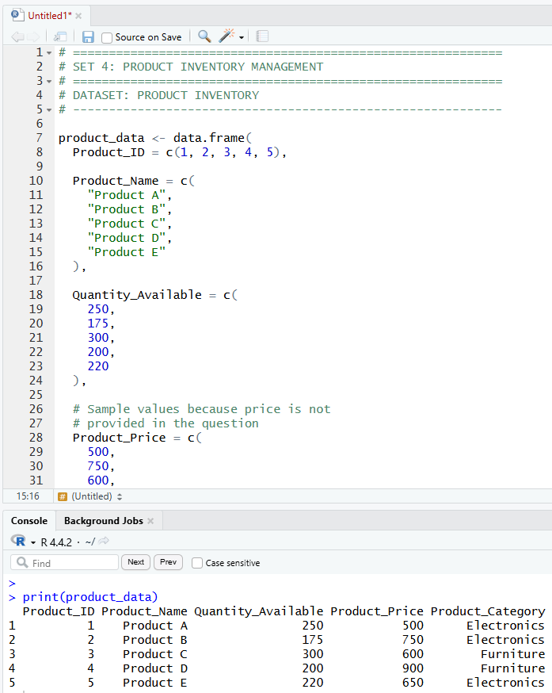
1. Create a bar chart to visualize the quantity of each product in the inventory. Label the axes and title the chart.

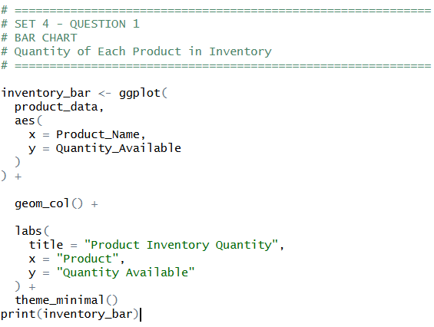
OUTPUT:
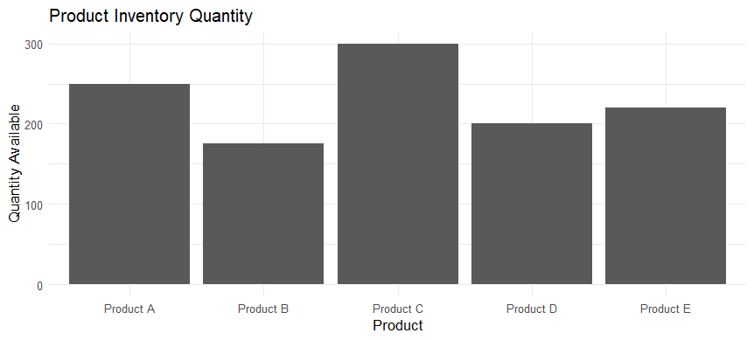

2. Generate a stacked bar chart to show the quantity of each product within different product categories.
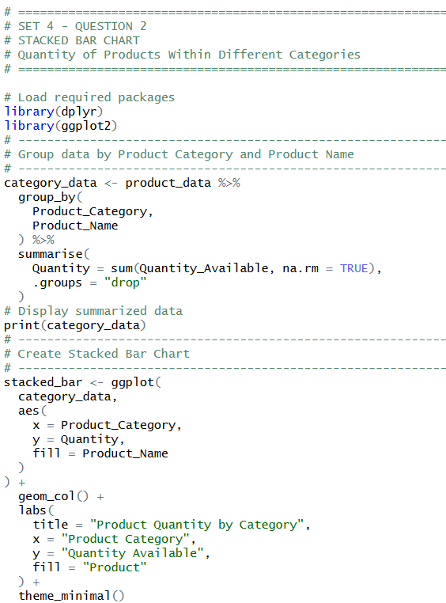
OUTPUT:
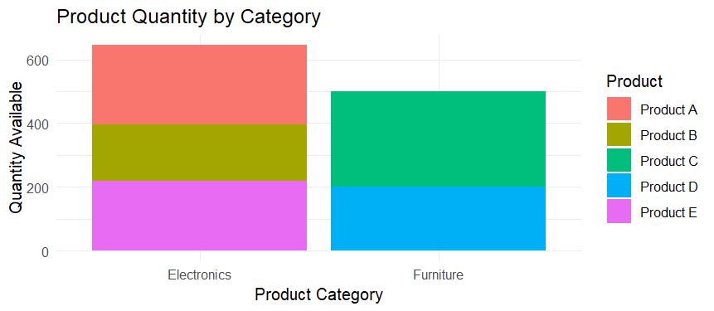
3. Build a scatter plot to explore the relationship between product price and quantity available. Explain the findings.
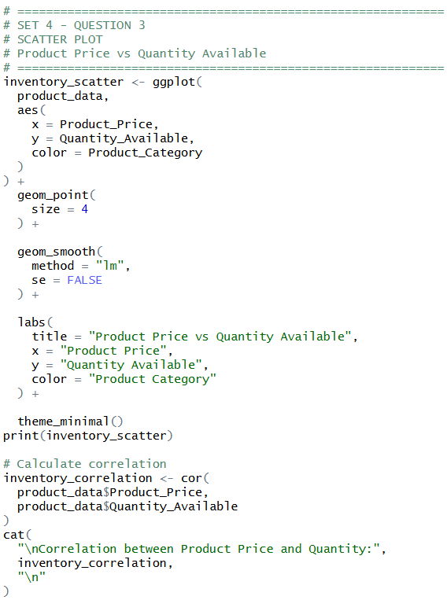
OUTPUT:
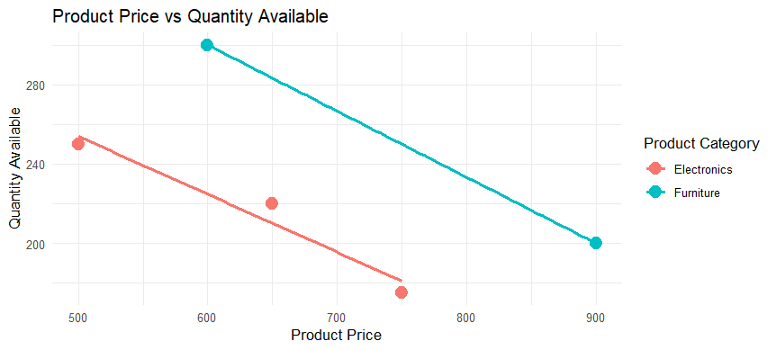
4. Develop a Tableau dashboard with the bar chart and stacked bar chart to allow users to interact with the data.
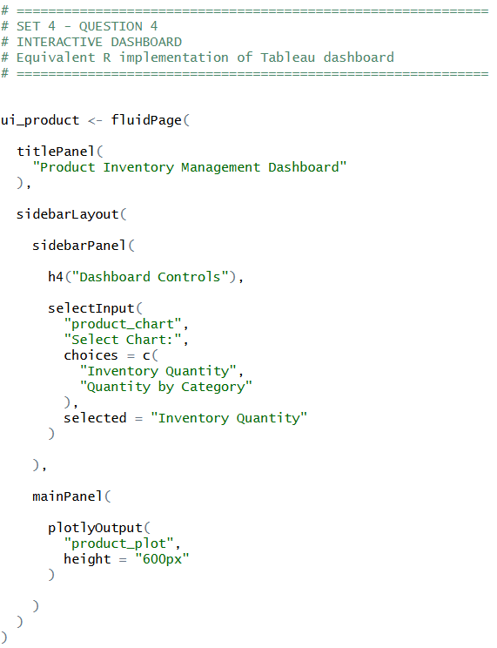
OUTPUT:
