SIMATS ENGINEERING
SAVEETHA INSTITUTE OF MEDICAL AND TECHNICAL SCIENCES
NAME: J.VIVEK
DATE:06/10/2026
LAB EXP: 10
Reg Mo: 192325102
Course Code/ Name: DSA0601 / Data Handling and Visualization
Set 10 Survey Responses Analysis
Dataset: Survey Responses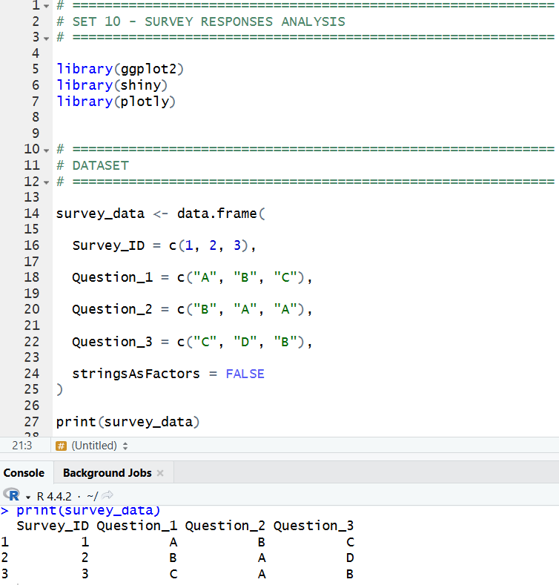
1. Create a grouped bar chart to visualize the distribution of answers for Question Label the chart
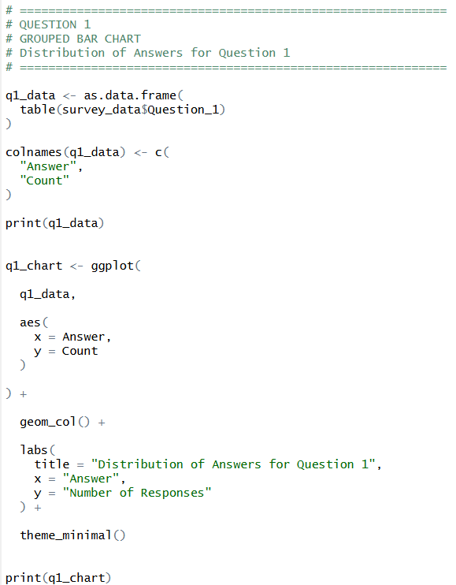
OUTPUT:
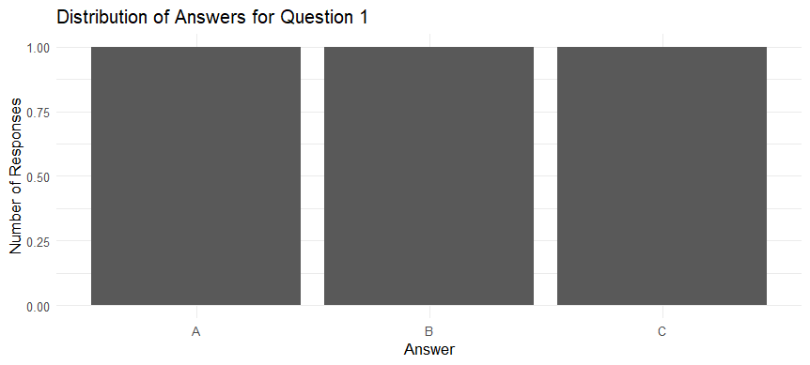
2. Generate a stacked bar chart to represent the overall distribution of responses for all three questions.
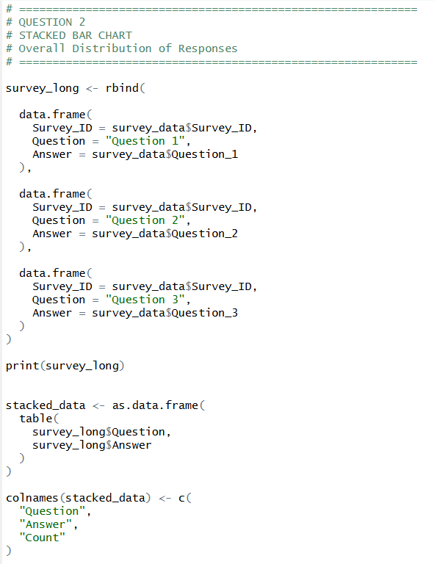
OUTPUT:
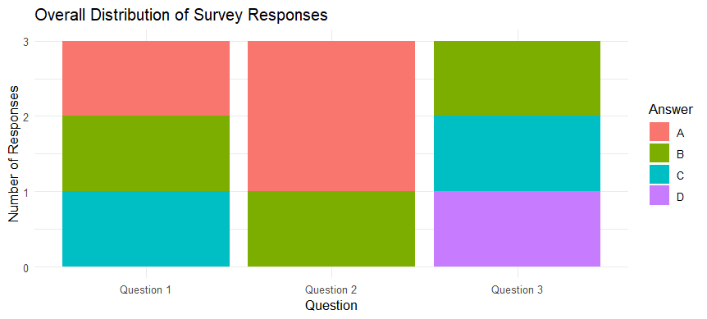
3. Build a table to show the survey response data for each survey. Label the table elements.

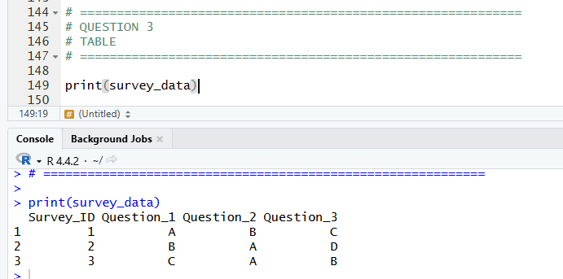

4. Develop a Tableau dashboard combining the grouped bar chart, stacked bar chart, and the table for interactive exploration of survey responses.
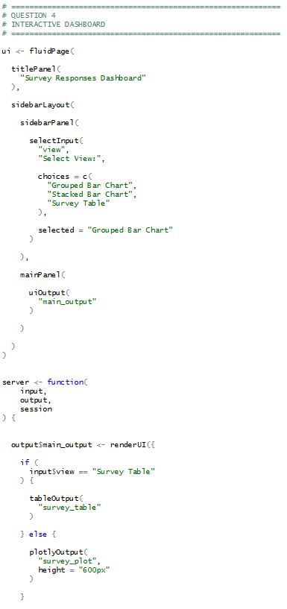
OUTPUT:
