SIMATS ENGINEERING
SAVEETHA INSTITUTE OF MEDICAL AND TECHNICAL SCIENCES
NAME: J.VIVEK
DATE:06/10/2026
LAB EXP: 12
Reg Mo: 192325102
Course Code/ Name: DSA0601 / Data Handling and Visualization
Set 12
Dataset: Website Traffic
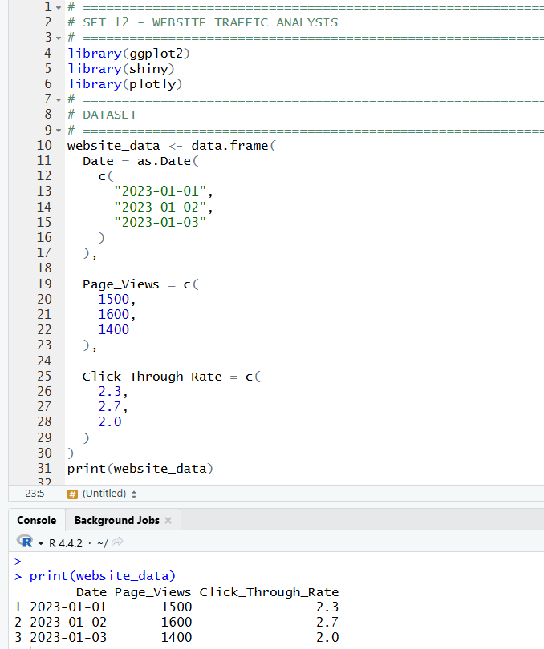
1. Create a line chart to visualize the trend in daily page views over time. Label the axes and title the chart.
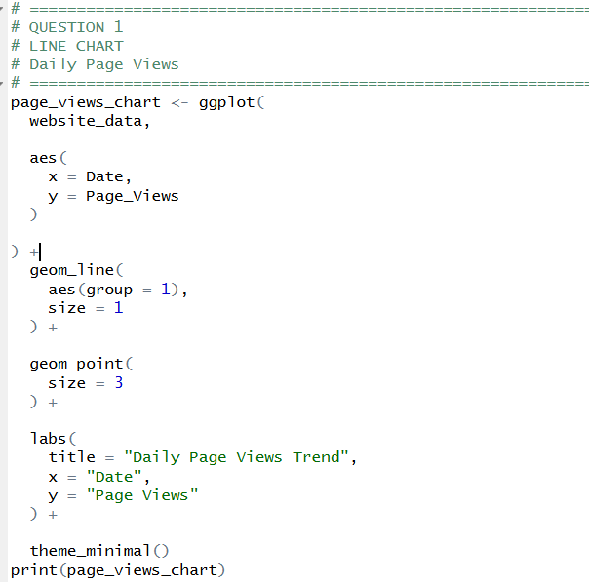
OUTPUT:
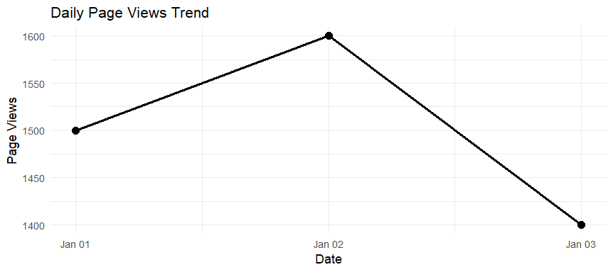

2. Generate a bar chart showing the top N days with the highest click-through rates. Label the chart elements.
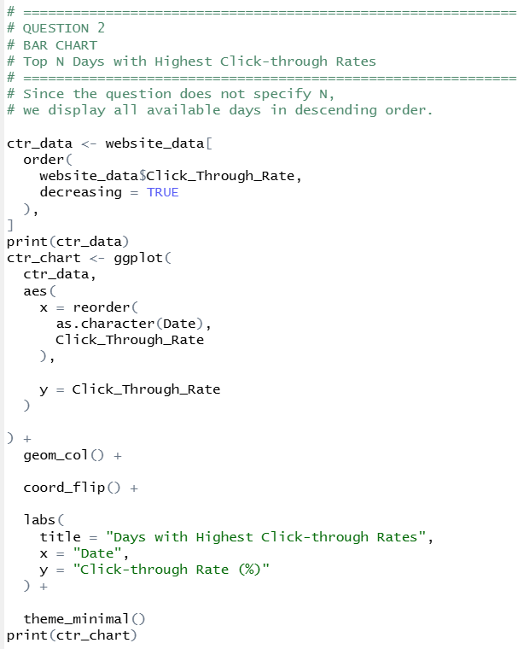
OUTPUT:
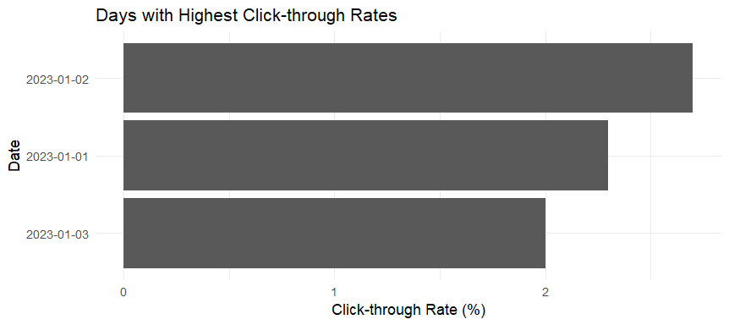
3. Build a table to show the website traffic data for each day. Label the table elements.

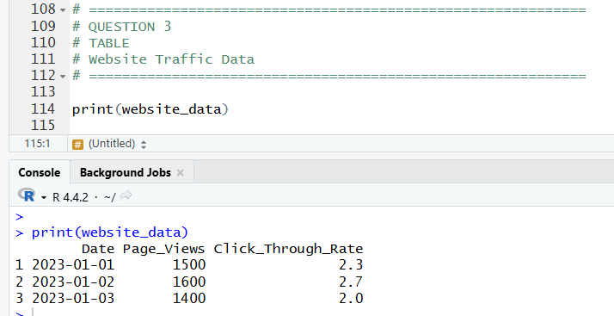

4. Develop a Tableau dashboard combining the line chart, bar chart, and the table for interactive exploration of website traffic data.
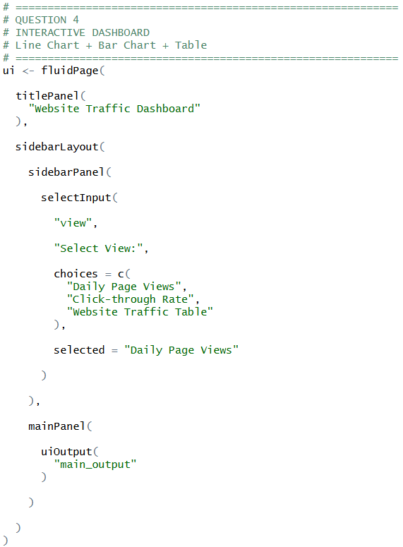
OUTPUT:
