SIMATS ENGINEERING
SAVEETHA INSTITUTE OF MEDICAL AND TECHNICAL SCIENCES
NAME: J.VIVEK
DATE:01/10/2026
LAB EXP: 9
Reg Mo: 192325102
Course Code/ Name: DSA0601 / Data Handling and Visualization
Set 9
Dataset: Online_Learning_Activity.csv
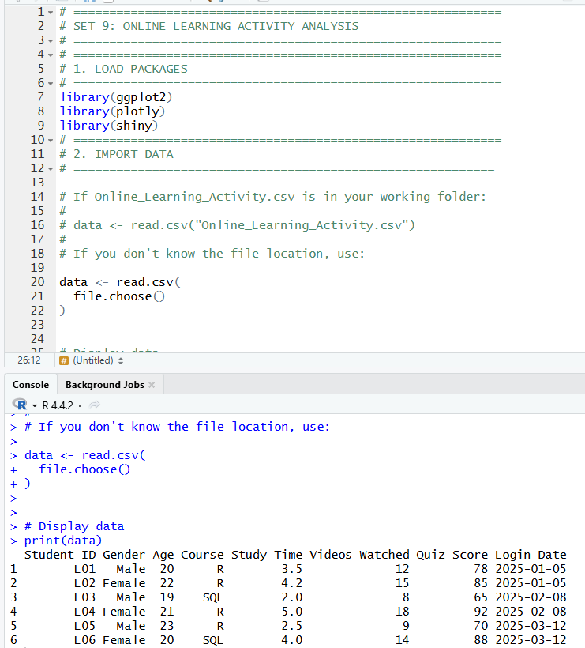
1. Import the dataset in R. Plot a histogram for Quiz_Score. Draw a boxplot of Quiz_Score by Course. Add title and labels. Interpret student performance.
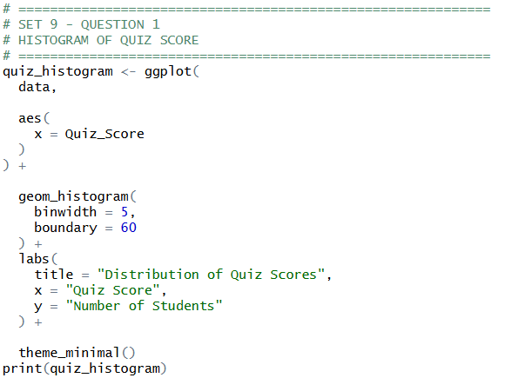
OUTPUT:
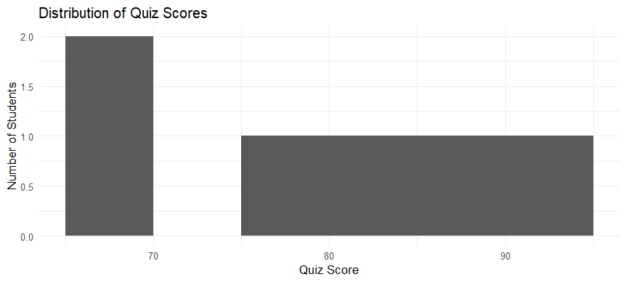

B)
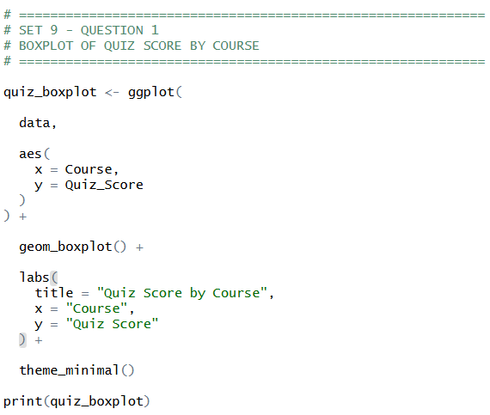
OUTPUT:
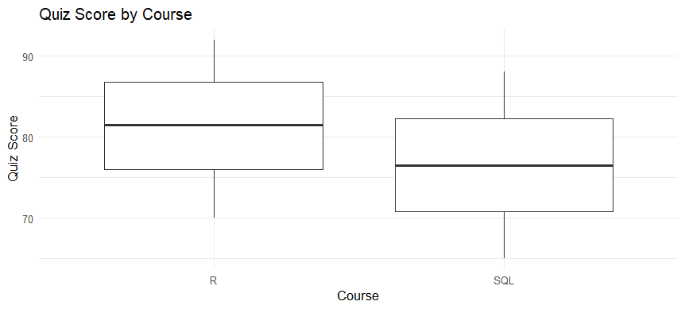

2. Create a scatter plot using R programming between Study_Time and Quiz_Score. Represent Videos_Watched using bubble size. Apply transparency. Explain the learning pattern.
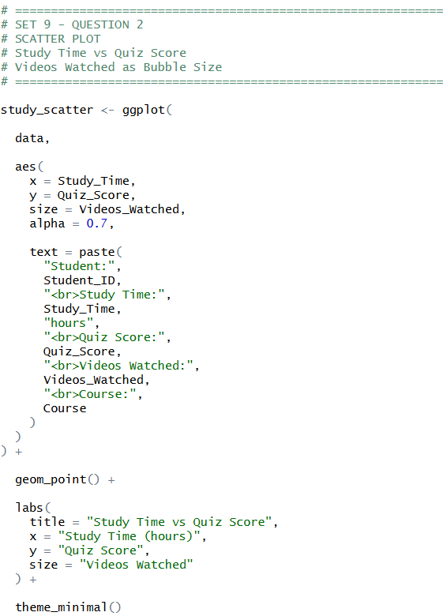
OUTPUT:
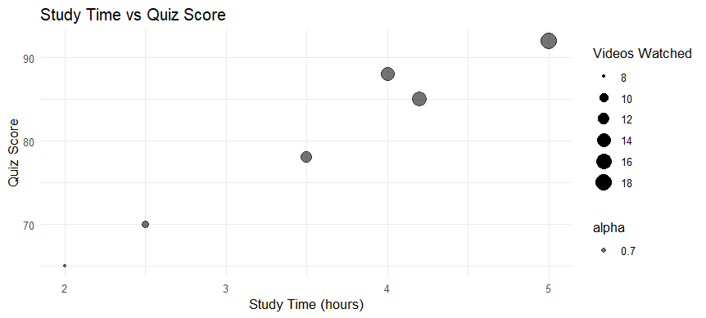
3. Using R programming, convert Login_Date into Date format. Calculate average quiz score per month. Plot a line chart. Apply moving average smoothing. Identify the trend.
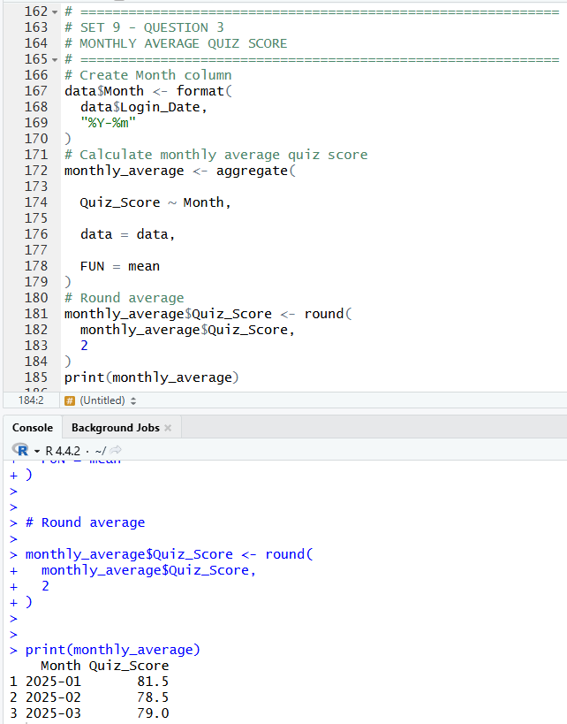

4. Import Online_Learning_Activity.csv into Tableau. Create a bar chart showing average quiz score by Course. Create a scatter plot (Study Time vs Quiz Score). Add filter for Gender and Course. Design a mini interactive dashboard.
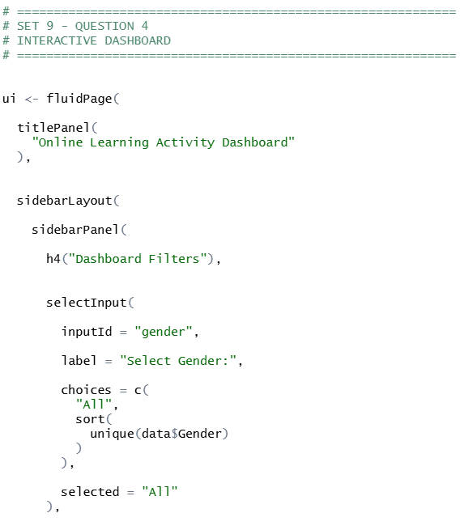
OUTPUT:
