SIMATS ENGINEERING
SAVEETHA INSTITUTE OF MEDICAL AND TECHNICAL SCIENCES
NAME: J.VIVEK
DATE:13/10/2026
Roll. No: 14
Reg Mo: 192325149
Course Code/ Name: DSA0602 /Data Handling and Visualization
Slot C | CLASS ACTIVITY (R Only)

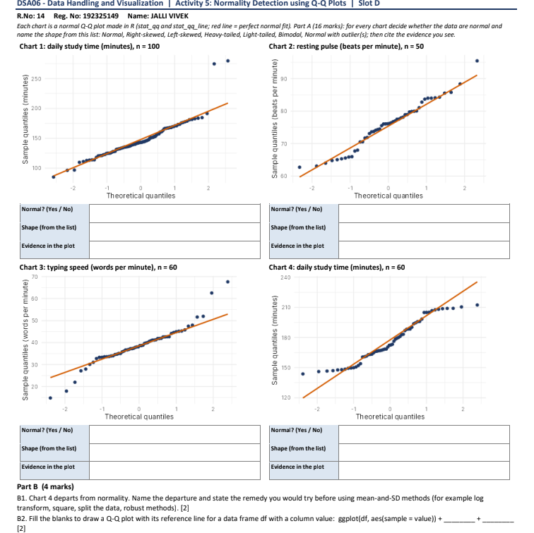

Part A – Answers
Chart 1: Daily study time (n = 100)
- Normal? No
- Shape: Right-skewed
- Evidence: Two extreme high values in the upper tail deviate from the reference line.

Chart 2: Resting pulse (n = 50)
- Normal? Yes
- Shape: Normal
- Evidence: Most points follow the reference line, with only small deviations.

Chart 3: Typing speed (n = 60)
- Normal? No
- Shape: Heavy-tailed
- Evidence: Extreme values at both ends deviate from the reference line.

Chart 4: Daily study time (n = 60)
- Normal? No
- Shape: Left-skewed
- Evidence: The points curve away from the reference line, with the upper tail flattening and the lower tail deviating.

Part B Answers

B1. Departure and remedy:
Chart 4 shows a left-skewed distribution. Apply a square transformation or another suitable transformation before using mean-and-SD methods.

B2. Fill in the blanks:
ggplot(df, aes(sample = value)) +
stat_qq() +
stat_qq_line()

