SESSION 1 — ACTIVITY (20 MIN) • STUDENT HANDOUT (Set 1 of 40 — every set uses different data) Decode the Chart
Name: ____________JALLI VIVEK_______________ Roll No: ____14__________ For each chart below, answer: What is it trying to tell you? Do you trust it? Why or why not?
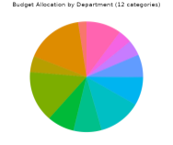
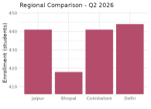
Chart 1
Chart 2
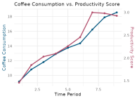
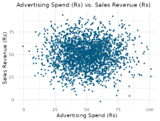
Chart
3_{Chart 4}
Your notes:
_________________________________________________________________________ _________________________________________________________________________
Chart 1
What is it trying to tell me?
The chart is trying to show a comparison between different categories using the heights of the bars.
Do you trust it? Why or why not?
I do not fully trust this chart because the Y-axis does not start from zero. This makes small differences between the bars look much larger than they actually are. A bar chart should normally use a zero baseline so that the visual size of the bars represents the actual differences fairly.
Chart 2
What is it trying to tell me?
The chart is trying to show how a total is divided among several different categories using a pie chart.
Do you trust it? Why or why not?
I do not fully trust it for comparing the categories because it contains too many slices. When there are many wedges, it becomes difficult to accurately compare their sizes and identify which categories are larger or smaller. A sorted bar chart would make the comparison clearer.
Chart 3
What is it trying to tell me?
The chart is trying to show that two different variables appear to change together, suggesting that there may be a relationship between them.
Do you trust it? Why or why not?
I do not trust the apparent relationship without further evidence. The chart uses two independent Y-axes, and their scales can be chosen so that the two lines appear to move together even when there is no real relationship. This can create a false or misleading impression of correlation.
Chart 4
What is it trying to tell me?
The chart is trying to show the relationship and distribution of a large number of data points.
Do you trust it? Why or why not?
I do not fully trust the visual pattern because there are too many opaque points overlapping each other. Dense areas become solid-looking blobs, making it difficult to see the actual concentration and distribution of the data. Transparency, a 2D histogram, or a hexbin plot would make the pattern easier to understand.

