SESSION — ACTIVITY (20 MIN) • STUDENT HANDOUT • SLOT D
Redesign the Misleading Colored Chart
R.No: 14 Reg. No: 192325149 Name: JALLI VIVEK
Each chart below uses color in a misleading or confusing way. For each one, answer the three questions in your own words. Chart 1

- What is this chart trying to show?

It compares on-time shipments vs. delayed shipments across four groups (Group 1–4). The stacked bars show the total number of shipments and how many were on-time or delayed. _____________________________________________________________________________

- What's wrong with the color choice?

• Red and green can be difficult for people with red-green color blindness to distinguish.
• Red and green also carry strong meanings (bad/good), which can be misleading if the goal is simply to compare categories.
• The colors are very bright, making the chart look less professional.
_________________________________________________________________________________
- Propose a better color scheme (describe it in words):

Use a color-blind-friendly combination, for example:
- On-Time: Blue
- Delayed: Orange
A darker blue for “On-Time” and a warm orange for “Delayed” would provide clear contrast while remaining professional and accessible.
_________________________________________________________________________________

___________________________

Chart 2

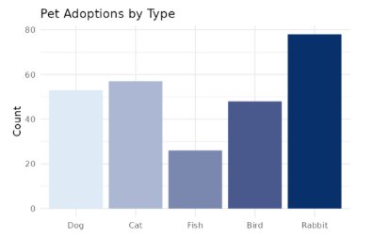
- What is this chart trying to show?

It shows the number of pet adoptions by pet type—Dog, Cat, Fish, Bird, and Rabbit.
Rabbit has the highest number of adoptions, while Fish has the lowest.
._________________________________________________________________________________
- What's wrong with the color choice?

• All bars use different shades of the same blue, making the categories less visually distinct.
• The light-to-dark progression may imply an ordered scale, even though pet types are simply different categories.
• Some lighter shades have low contrast, which can reduce readability.
_________________________________________________________________________________
3. Propose a better color scheme (describe it in words):

Use a color-blind-friendly categorical palette where each pet type has a clearly distinct color, for example:
- 🐶 Dog: Blue
- 🐱 Cat: Orange
- 🐟 Fish: Teal
- 🐦 Bird: Purple
- 🐰 Rabbit: Yellow
The colors should be moderately saturated and distinct, rather than different shades of one color.

_________________________________________________________________________________
__

